# APPENDIX C

# FACTORS AFFECTING CHANGE IN EACH METRO AREA BY MODE

**LIST OF METRO AREAS**

Akron, OH Metro Area-Bus 7

Albany-Schenectady-Troy, NY Metro Area-Bus 9

Albany, GA Metro Area-Bus 11

Albuquerque, NM Metro Area-Bus 13

Albuquerque, NM Metro Area-Rail 15

Allentown-Bethlehem-Easton, PA-NJ Metro Area-Bus 17

Altoona, PA Metro Area-Bus 19

Ames, IA Metro Area-Bus 21

Anchorage, AK Metro Area-Bus 23

Ann Arbor, MI Metro Area-Bus 25

Appleton, WI Metro Area-Bus 27

Asheville, NC Metro Area-Bus 29

Athens-Clarke County, GA Metro Area-Bus 31

Atlanta-Sandy Springs-Marietta, GA Metro Area-Bus 33

Atlanta-Sandy Springs-Marietta, GA Metro Area-Rail 35

Augusta-Richmond County, GA-SC Metro Area-Bus 37

Austin-Round Rock-San Marcos, TX Metro Area-Bus 39

Bakersfield-Delano, CA Metro Area-Bus 41

Baltimore-Towson, MD Metro Area-Bus 43

Baltimore-Towson, MD Metro Area-Rail 45

Baton Rouge, LA Metro Area-Bus 47

Bay City, MI Metro Area-Bus 49

Beaumont-Port Arthur, TX Metro Area-Bus 51

Bellingham, WA Metro Area-Bus 53

Billings, MT Metro Area-Bus 55

Binghamton, NY Metro Area-Bus 57

Birmingham-Hoover, AL Metro Area-Bus 59

Blacksburg-Christiansburg-Radford, VA Metro Area-Bus 61

Bloomington-Normal, IL Metro Area-Bus 63

Bloomington, IN Metro Area-Bus 65

Boise City-Nampa, ID Metro Area-Bus 67

Boston-Cambridge-Quincy, MA-NH Metro Area-Bus 69

Boston-Cambridge-Quincy, MA-NH Metro Area-Rail 71

Bremerton-Silverdale, WA Metro Area-Bus 73

Bridgeport-Stamford-Norwalk, CT Metro Area-Bus 75

Brownsville-Harlingen, TX Metro Area-Bus 77

Buffalo-Niagara Falls, NY Metro Area-Bus 79

Buffalo-Niagara Falls, NY Metro Area-Rail 81

Burlington-South Burlington, VT Metro Area-Bus 83

Canton-Massillon, OH Metro Area-Bus 85

Cape Coral-Fort Myers, FL Metro Area-Bus 87

Cedar Rapids, IA Metro Area-Bus 89

Champaign-Urbana, IL Metro Area-Bus 91

Charleston-North Charleston-Summerville, SC Metro Area-Bus 93

Charleston, WV Metro Area-Bus 95

Charlotte-Gastonia-Rock Hill, NC-SC Metro Area-Bus 97

Charlotte-Gastonia-Rock Hill, NC-SC Metro Area-Rail 99

Chattanooga, TN-GA Metro Area-Bus 101

Chicago-Joliet-Naperville, IL-IN-WI Metro Area-Bus 103

Chicago-Joliet-Naperville, IL-IN-WI Metro Area-Rail 105

Chico, CA Metro Area-Bus 107

Cincinnati-Middletown, OH-KY-IN Metro Area-Bus 109

Cleveland-Elyria-Mentor, OH Metro Area-Bus 111

Cleveland-Elyria-Mentor, OH Metro Area-Rail 113

Colorado Springs, CO Metro Area-Bus 115

Columbia, MO Metro Area-Bus 117

Columbia, SC Metro Area-Bus 119

Columbus, OH Metro Area-Bus 121

Corpus Christi, TX Metro Area-Bus 123

Corvallis, OR Metro Area-Bus 125

Crestview-Fort Walton Beach-Destin, FL Metro Area-Bus 127

Dallas-Fort Worth-Arlington, TX Metro Area-Bus 129

Dallas-Fort Worth-Arlington, TX Metro Area-Rail 131

Davenport-Moline-Rock Island, IA-IL Metro Area-Bus 133

Dayton, OH Metro Area-Bus 135

Decatur, IL Metro Area-Bus 137

Deltona-Daytona Beach-Ormond Beach, FL Metro Area-Bus 139

Denver-Aurora-Broomfield, CO Metro Area-Bus 141

Denver-Aurora-Broomfield, CO Metro Area-Rail 143

Des Moines-West Des Moines, IA Metro Area-Bus 145

Detroit-Warren-Livonia, MI Metro Area-Bus 147

Duluth, MN-WI Metro Area-Bus 149

Durham-Chapel Hill, NC Metro Area-Bus 151

Eau Claire, WI Metro Area-Bus 153

El Centro, CA Metro Area-Bus 155

El Paso, TX Metro Area-Bus 157

Elkhart-Goshen, IN Metro Area-Bus 159

Erie, PA Metro Area-Bus 161

Eugene-Springfield, OR Metro Area-Bus 163

Evansville, IN-KY Metro Area-Bus 165

Harrisonburg, VA Metro Area-Bus 197

Houston-Sugar Land-Baytown, TX Metro Area-Bus 203

Houston-Sugar Land-Baytown, TX Metro Area-Rail 205

Huntsville, AL Metro Area-Bus 207

Indianapolis-Carmel, IN Metro Area-Bus 209

Iowa City, IA Metro Area-Bus 211

Ithaca, NY Metro Area-Bus 213

Jackson, MI Metro Area-Bus 215

Jackson, MS Metro Area-Bus 217

Jacksonville, FL Metro Area-Bus 219

Johnstown, PA Metro Area-Bus 221

Kalamazoo-Portage, MI Metro Area-Bus 223

Kankakee-Bradley, IL Metro Area-Bus 225

Kansas City, MO-KS Metro Area-Bus 227

Kennewick-Pasco-Richland, WA Metro Area-Bus 229

Killeen-Temple-Fort Hood, TX Metro Area-Bus 231

Knoxville, TN Metro Area-Bus 233

La Crosse, WI-MN Metro Area-Bus 235

Lafayette, IN Metro Area-Bus 237

Lafayette, LA Metro Area-Bus 239

Lakeland-Winter Haven, FL Metro Area-Bus 241

Lansing-East Lansing, MI Metro Area-Bus 243

Laredo, TX Metro Area-Bus 245

Las Vegas-Paradise, NV Metro Area-Bus 247

Lebanon, PA Metro Area-Bus 249

Lexington-Fayette, KY Metro Area-Bus 251

Lincoln, NE Metro Area-Bus 253

Little Rock-North Little Rock-Conway, AR Metro Area-Bus 255

Logan, UT-ID Metro Area-Bus 257

Los Angeles-Long Beach-Santa Ana, CA Metro Area-Bus 259

Los Angeles-Long Beach-Santa Ana, CA Metro Area-Rail 261

Louisville/Jefferson County, KY-IN Metro Area-Bus 263

Lubbock, TX Metro Area-Bus 265

Lynchburg, VA Metro Area-Bus 267

Madison, WI Metro Area-Bus 269

Medford, OR Metro Area-Bus 271

Memphis, TN-MS-AR Metro Area-Bus 273

Merced, CA Metro Area-Bus 275

Miami-Fort Lauderdale-Pompano Beach, FL Metro Area-Bus 277

Miami-Fort Lauderdale-Pompano Beach, FL Metro Area-Rail 279

Milwaukee-Waukesha-West Allis, WI Metro Area-Bus 281

Minneapolis-St. Paul-Bloomington, MN-WI Metro Area-Bus 283

Minneapolis-St. Paul-Bloomington, MN-WI Metro Area-Rail 285

Missoula, MT Metro Area-Bus 287

Mobile, AL Metro Area-Bus 289

Modesto, CA Metro Area-Bus 291

Montgomery, AL Metro Area-Bus 293

Mount Vernon-Anacortes, WA Metro Area-Bus 295

Muncie, IN Metro Area-Bus 297

Napa, CA Metro Area-Bus 299

Nashville-Davidson--Murfreesboro--Franklin, TN Metro Area-Bus 301

New Haven-Milford, CT Metro Area-Bus 303

New Orleans-Metairie-Kenner, LA Metro Area-Bus 305

New Orleans-Metairie-Kenner, LA Metro Area-Rail 307

Ocala, FL Metro Area-Bus 309

Oklahoma City, OK Metro Area-Bus 311

Olympia, WA Metro Area-Bus 313

Omaha-Council Bluffs, NE-IA Metro Area-Bus 315

Orlando-Kissimmee-Sanford, FL Metro Area-Bus 317

Oshkosh-Neenah, WI Metro Area-Bus 319

Oxnard-Thousand Oaks-Ventura, CA Metro Area-Bus 321

Palm Bay-Melbourne-Titusville, FL Metro Area-Bus 323

Pensacola-Ferry Pass-Brent, FL Metro Area-Bus 325

Peoria, IL Metro Area-Bus 327

Philadelphia-Camden-Wilmington, PA-NJ-DE-MD Metro Area-Bus 329

Philadelphia-Camden-Wilmington, PA-NJ-DE-MD Metro Area-Rail 331

Phoenix-Mesa-Glendale, AZ Metro Area-Bus 333

Phoenix-Mesa-Glendale, AZ Metro Area-Rail 335

Pittsburgh, PA Metro Area-Bus 337

Pittsburgh, PA Metro Area-Rail 339

Portland-South Portland-Biddeford, ME Metro Area-Bus 341

Portland-South Portland-Biddeford, ME Metro Area-Rail 343

Portland-Vancouver-Hillsboro, OR-WA Metro Area-Bus 345

Portland-Vancouver-Hillsboro, OR-WA Metro Area-Rail 347

Providence-New Bedford-Fall River, RI-MA Metro Area-Bus 349

Pueblo, CO Metro Area-Bus 351

Racine, WI Metro Area-Bus 353

Raleigh-Cary, NC Metro Area-Bus 355

Redding, CA Metro Area-Bus 357

Reno-Sparks, NV Metro Area-Bus 359

Richmond, VA Metro Area-Bus 361

Riverside-San Bernardino-Ontario, CA Metro Area-Bus 363

Roanoke, VA Metro Area-Bus 365

Rochester, MN Metro Area-Bus 367

Rochester, NY Metro Area-Bus 369

Rockford, IL Metro Area-Bus 371

Sacramento--Arden-Arcade--Roseville, CA Metro Area-Bus 373

Sacramento--Arden-Arcade--Roseville, CA Metro Area-Rail 375

Saginaw-Saginaw Township North, MI Metro Area-Bus 377

Salem, OR Metro Area-Bus 379

Salinas, CA Metro Area-Bus 381

Salt Lake City, UT Metro Area-Bus 383

Salt Lake City, UT Metro Area-Rail 385

San Antonio-New Braunfels, TX Metro Area-Bus 387

San Diego-Carlsbad-San Marcos, CA Metro Area-Bus 389

San Diego-Carlsbad-San Marcos, CA Metro Area-Rail 391

San Francisco-Oakland-Fremont, CA Metro Area-Bus 393

San Francisco-Oakland-Fremont, CA Metro Area-Rail 395

San Jose-Sunnyvale-Santa Clara, CA Metro Area-Bus 397

San Jose-Sunnyvale-Santa Clara, CA Metro Area-Rail 399

Santa Cruz-Watsonville, CA Metro Area-Bus 401

Santa Fe, NM Metro Area-Bus 403

Santa Rosa-Petaluma, CA Metro Area-Bus 405

Savannah, GA Metro Area-Bus 407

Scranton--Wilkes-Barre, PA Metro Area-Bus 409

Seattle-Tacoma-Bellevue, WA Metro Area-Bus 411

Seattle-Tacoma-Bellevue, WA Metro Area-Rail 413

Shreveport-Bossier City, LA Metro Area-Bus 415

Sioux City, IA-NE-SD Metro Area-Bus 417

Sioux Falls, SD Metro Area-Bus 419

Spokane, WA Metro Area-Bus 421

Springfield, IL Metro Area-Bus 423

Springfield, MO Metro Area-Bus 425

St. Cloud, MN Metro Area-Bus 427

St. Louis, MO-IL Metro Area-Bus 429

St. Louis, MO-IL Metro Area-Rail 431

State College, PA Metro Area-Bus 433

Stockton, CA Metro Area-Bus 435

Syracuse, NY Metro Area-Bus 437

Tallahassee, FL Metro Area-Bus 439

Tampa-St. Petersburg-Clearwater, FL Metro Area-Bus 441

Tampa-St. Petersburg-Clearwater, FL Metro Area-Rail 443

Terre Haute, IN Metro Area-Bus 445

Toledo, OH Metro Area-Bus 447

Topeka, KS Metro Area-Bus 449

Tucson, AZ Metro Area-Bus 451

Tulsa, OK Metro Area-Bus 453

Vallejo-Fairfield, CA Metro Area-Bus 455

Virginia Beach-Norfolk-Newport News, VA-NC Metro Area-Bus 457

Virginia Beach-Norfolk-Newport News, VA-NC Metro Area-Rail 459

Visalia-Porterville, CA Metro Area-Bus 461

Waco, TX Metro Area-Bus 463

Washington-Arlington-Alexandria, DC-VA-MD-WV Metro Area-Bus 465

Washington-Arlington-Alexandria, DC-VA-MD-WV Metro Area-Rail 467

Wenatchee-East Wenatchee, WA Metro Area-Bus 469

Wheeling, WV-OH Metro Area-Bus 471

Wichita, KS Metro Area-Bus 473

Williamsport, PA Metro Area-Bus 475

Winston-Salem, NC Metro Area-Bus 477

Worcester, MA Metro Area-Bus 479

York-Hanover, PA Metro Area-Bus 481

Youngstown-Warren-Boardman, OH-PA Metro Area-Bus 483

Yuba City, CA Metro Area-Bus 485

|  |  |  |  |  |  |
| --- | --- | --- | --- | --- | --- |
| Akron, OH Metro Area-Bus | | | | | |
|  |  |  |  |  |  |
|  | **Average Values** | | | **Ridership Effect** | |
| **Description** | **2012** | **2018** | **% Diff** | **Absolute** | **% Diff** |
|  |  |  |  |  |  |
| **Vehicle Revenue Miles** | 3,862,980 | 4,437,370 | 14.9% | 380,450 | **6.4%** |
| **Average Fare (2018$)** | 1.06 | 0.96 | -9.5% | 167,770 | **2.8%** |
| **Network Restructure** | - | - | - | - | **0.0%** |
| **Major Maintenance Event** | - | - | - | - | **0.0%** |
| **Population + Employment** | 1,035,790 | 1,050,320 | 1.4% | 17,520 | **0.3%** |
| **Share of Population and Employment in Transit Supportive Density** | 0.18 | 0.18 | 0.3% | 1,220 | **0.0%** |
| **Average Gas Price (2018$)** | 3.93 | 2.72 | -30.9% | -245,340 | **-4.1%** |
| **Median Per Capita Income (2018$)** | 27,860 | 31,390 | 12.7% | -47,120 | **-0.8%** |
| **% of Households with 0 Vehicles** | 9 | 7 | -12.9% | -12,370 | **-0.2%** |
| **% Working at Home** | 3.0 | 5.5 | 84.2% | -109,020 | **-1.8%** |
| **Years Since Ride-hail Start** | - | 4 | 4 | -758,330 | **-12.8%** |
| **Bike Share** | - | - | - | - | **0.0%** |
| **Electric Scooters** | - | - | - | - | **0.0%** |
| **New Reporters** |  |  |  | - | **0.0%** |
| **Total Modeled Ridership** | 5,921,681 | 5,299,077 | -10.51% | -622603.8571 | **-10.5%** |
| **Total Observed Ridership** | 5,996,224 | 5,427,486 | -9.48% | -568738 | **-9.5%** |
| **Unexplained Change** |  |  |  |  | **1.0%** |

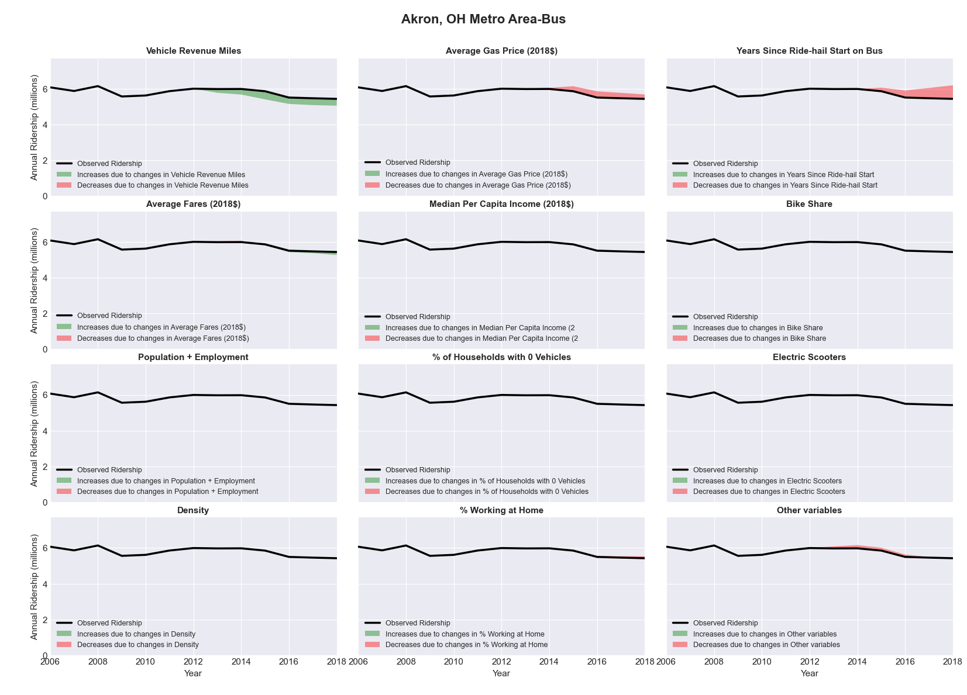

|  |  |  |  |  |  |
| --- | --- | --- | --- | --- | --- |
| Albany-Schenectady-Troy, NY Metro Area-Bus | | | | | |
|  |  |  |  |  |  |
|  | **Average Values** | | | **Ridership Effect** | |
| **Description** | **2012** | **2018** | **% Diff** | **Absolute** | **% Diff** |
|  |  |  |  |  |  |
| **Vehicle Revenue Miles** | 7,450,810 | 8,389,540 | 12.6% | 880,310 | **5.3%** |
| **Average Fare (2018$)** | 1.07 | 1.27 | 17.9% | -838,780 | **-5.1%** |
| **Network Restructure** | - | - | - | - | **0.0%** |
| **Major Maintenance Event** | - | - | - | - | **0.0%** |
| **Population + Employment** | 1,296,640 | 1,323,660 | 2.1% | 72,460 | **0.4%** |
| **Share of Population and Employment in Transit Supportive Density** | 0.29 | 0.29 | -2.3% | -43,880 | **-0.3%** |
| **Average Gas Price (2018$)** | 4.11 | 2.92 | -28.9% | -610,560 | **-3.7%** |
| **Median Per Capita Income (2018$)** | 33,710 | 37,220 | 10.4% | -117,310 | **-0.7%** |
| **% of Households with 0 Vehicles** | 10 | 11 | 10.9% | 37,230 | **0.2%** |
| **% Working at Home** | 3.6 | 4.4 | 20.8% | -91,230 | **-0.6%** |
| **Years Since Ride-hail Start** | - | 1 | 1 | -544,090 | **-3.3%** |
| **Bike Share** | - | 1 | 1 | - 178,050 | **-1.1%** |
| **Electric Scooters** | - | - | - | - | **0.0%** |
| **New Reporters** |  |  |  | - | **0.0%** |
| **Total Modeled Ridership** | 16,492,020 | 15,083,349 | -8.54% | -1408670.769 | **-8.5%** |
| **Total Observed Ridership** | 15,213,240 | 15,395,053 | 1.20% | 181813 | **1.2%** |
| **Unexplained Change** |  |  |  |  | **9.7%** |

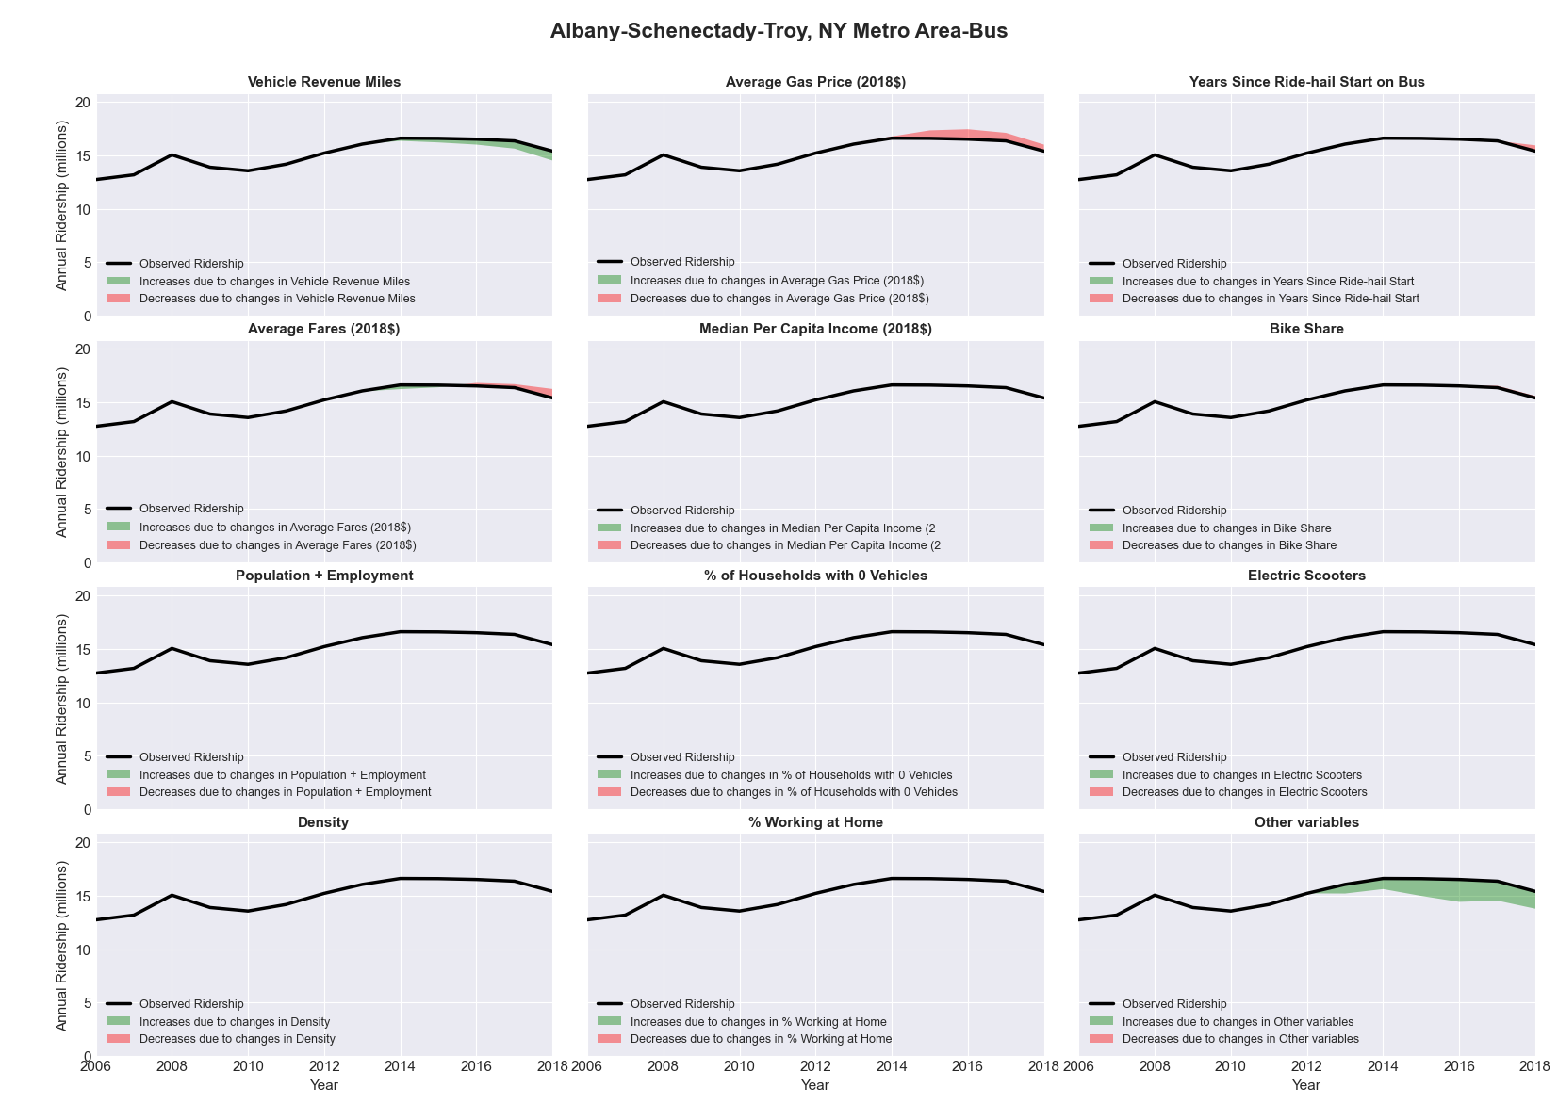

|  |  |  |  |  |  |
| --- | --- | --- | --- | --- | --- |
| Albany, GA Metro Area-Bus | | | | | |
|  |  |  |  |  |  |
|  | **Average Values** | | | **Ridership Effect** | |
| **Description** | **2012** | **2018** | **% Diff** | **Absolute** | **% Diff** |
|  |  |  |  |  |  |
| **Vehicle Revenue Miles** | 523,490 | 659,040 | 25.9% | 92,400 | **11.0%** |
| **Average Fare (2018$)** | 0.56 | 0.58 | 3.4% | -24,020 | **-2.9%** |
| **Network Restructure** | - | - | - | - | **0.0%** |
| **Major Maintenance Event** | - | - | - | - | **0.0%** |
| **Population + Employment** | 217,560 | 215,650 | -0.9% | -1,850 | **-0.2%** |
| **Share of Population and Employment in Transit Supportive Density** | 0.05 | 0.04 | -12.1% | -2,420 | **-0.3%** |
| **Average Gas Price (2018$)** | 3.95 | 2.71 | -31.3% | -38,270 | **-4.5%** |
| **Median Per Capita Income (2018$)** | 21,790 | 22,240 | 2.1% | -2,710 | **-0.3%** |
| **% of Households with 0 Vehicles** | 10 | 9 | -8.8% | -0,190 | **-0.0%** |
| **% Working at Home** | 2.8 | 7.1 | 153.6% | -24,910 | **-3.0%** |
| **Years Since Ride-hail Start** | - | 1 | 1 | -24,060 | **-2.9%** |
| **Bike Share** | - | 1 | 1 | - 7,500 | **-0.9%** |
| **Electric Scooters** | - | - | - | - | **0.0%** |
| **New Reporters** |  |  |  | - | **0.0%** |
| **Total Modeled Ridership** | 842,007 | 817,398 | -2.92% | -24609.235 | **-2.9%** |
| **Total Observed Ridership** | 1,017,648 | 739,896 | -27.29% | -277752 | **-27.3%** |
| **Unexplained Change** |  |  |  |  | **-24.4%** |

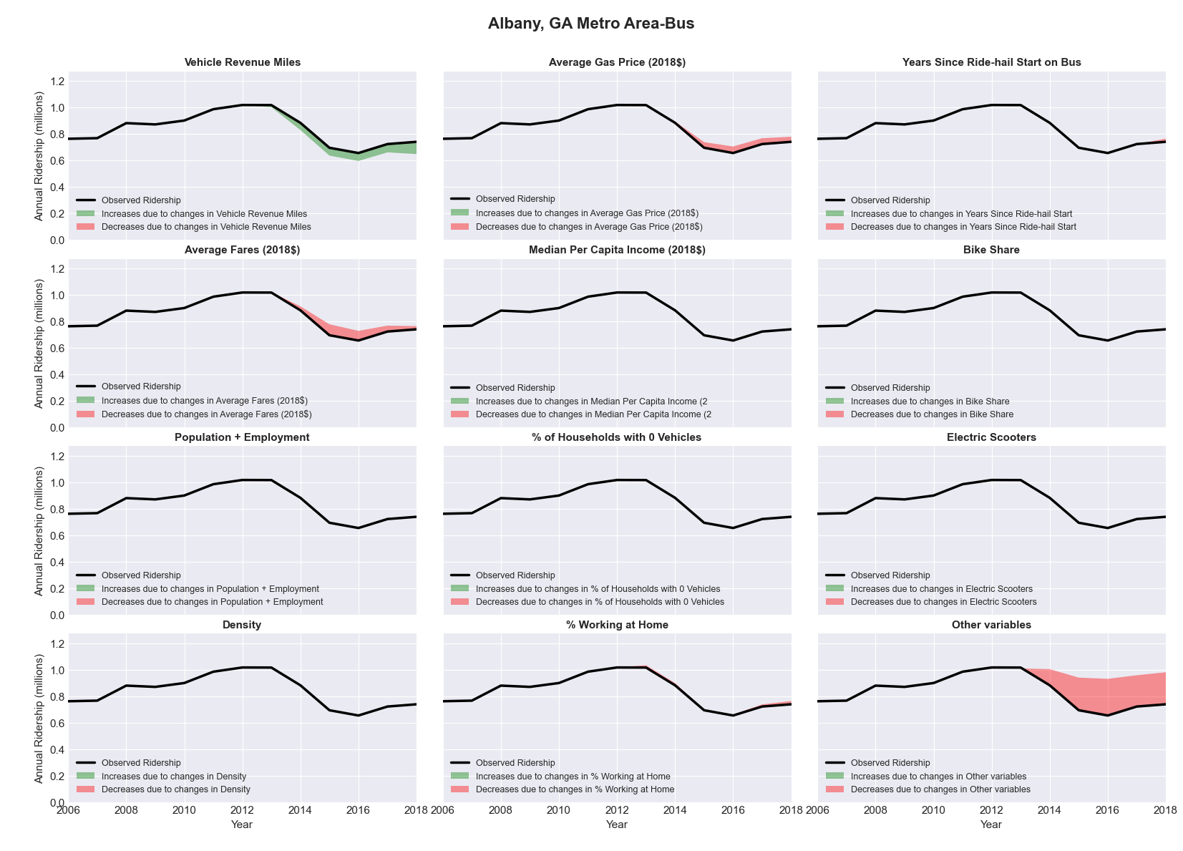

|  |  |  |  |  |  |
| --- | --- | --- | --- | --- | --- |
| Albuquerque, NM Metro Area-Bus | | | | | |
|  |  |  |  |  |  |
|  | **Average Values** | | | **Ridership Effect** | |
| **Description** | **2012** | **2018** | **% Diff** | **Absolute** | **% Diff** |
|  |  |  |  |  |  |
| **Vehicle Revenue Miles** | 5,316,550 | 5,341,920 | 0.5% | 49,360 | **0.4%** |
| **Average Fare (2018$)** | 0.35 | 0.31 | -12.4% | 198,160 | **1.6%** |
| **Network Restructure** | - | - | - | - | **0.0%** |
| **Major Maintenance Event** | - | - | - | - | **0.0%** |
| **Population + Employment** | 1,290,550 | 1,328,120 | 2.9% | 69,940 | **0.6%** |
| **Share of Population and Employment in Transit Supportive Density** | 0.37 | 0.36 | -2.7% | -51,190 | **-0.4%** |
| **Average Gas Price (2018$)** | 3.80 | 2.58 | -32.2% | -570,630 | **-4.6%** |
| **Median Per Capita Income (2018$)** | 27,920 | 27,710 | -0.8% | 6,000 | **0.0%** |
| **% of Households with 0 Vehicles** | 6 | 5 | -20.4% | -26,770 | **-0.2%** |
| **% Working at Home** | 4.4 | 6.2 | 41.5% | -155,000 | **-1.3%** |
| **Years Since Ride-hail Start** | - | 4 | 4 | -1,505,700 | **-12.1%** |
| **Bike Share** | - | 1 | 1 | - 138,900 | **-1.1%** |
| **Electric Scooters** | - | - | - | - | **0.0%** |
| **New Reporters** |  |  |  | - | **0.0%** |
| **Total Modeled Ridership** | 12,397,970 | 10,347,053 | -16.54% | -2050917.387 | **-16.5%** |
| **Total Observed Ridership** | 13,003,221 | 9,571,883 | -26.39% | -3431338 | **-26.4%** |
| **Unexplained Change** |  |  |  |  | **-9.8%** |

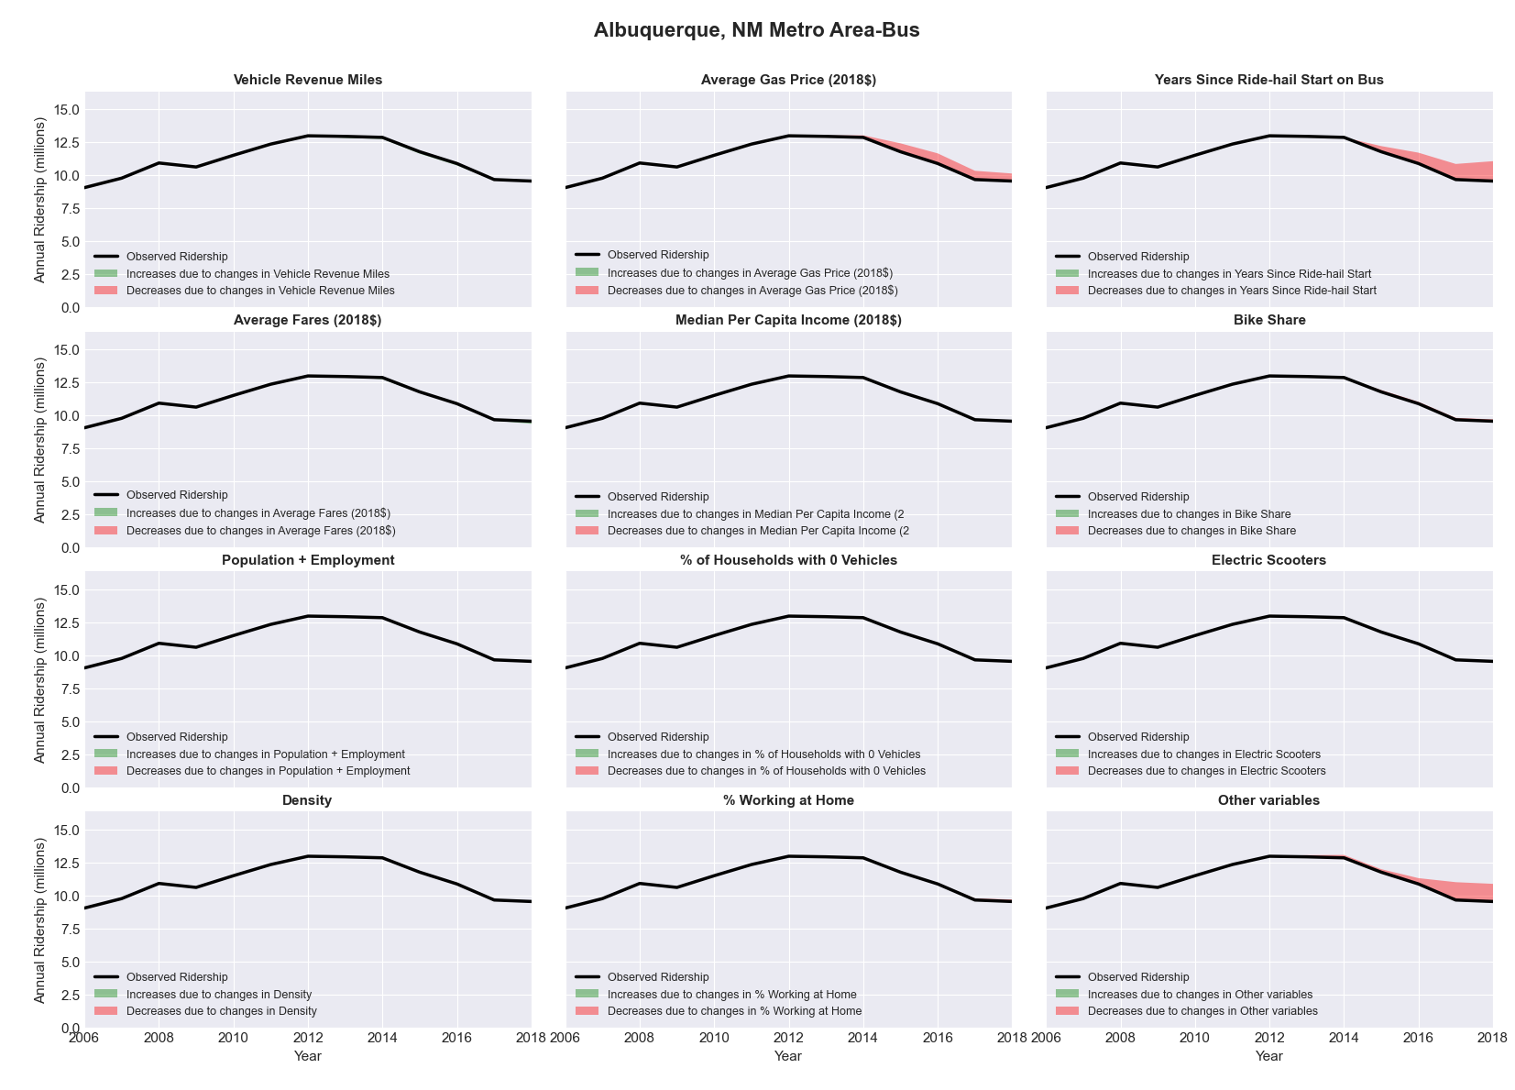

|  |  |  |  |  |  |
| --- | --- | --- | --- | --- | --- |
| Albuquerque, NM Metro Area-Rail | | | | | |
|  |  |  |  |  |  |
|  | **Average Values** | | | **Ridership Effect** | |
| **Description** | **2012** | **2018** | **% Diff** | **Absolute** | **% Diff** |
|  |  |  |  |  |  |
| **Vehicle Revenue Miles** | 1,424,740 | 1,337,510 | -6.1% | -38,660 | **-3.7%** |
| **Average Fare (2018$)** | 2.53 | 2.51 | -0.7% | -7,980 | **-0.8%** |
| **Network Restructure** | - | - | - | - | **0.0%** |
| **Major Maintenance Event** | - | - | - | - | **0.0%** |
| **Population + Employment** | 1,290,550 | 1,328,120 | 2.9% | 5,680 | **0.5%** |
| **Share of Population and Employment in Transit Supportive Density** | 0.37 | 0.36 | -2.7% | -4,160 | **-0.4%** |
| **Average Gas Price (2018$)** | 3.80 | 2.58 | -32.2% | -47,340 | **-4.5%** |
| **Median Per Capita Income (2018$)** | 27,920 | 27,710 | -0.8% | 0,560 | **0.1%** |
| **% of Households with 0 Vehicles** | 6 | 5 | -20.4% | -2,160 | **-0.2%** |
| **% Working at Home** | 4.4 | 6.2 | 41.5% | -12,440 | **-1.2%** |
| **Years Since Ride-hail Start** | - | 4 | 4 | -82,800 | **-7.8%** |
| **Bike Share** | - | 1 | 1 | - 11,470 | **-1.1%** |
| **Electric Scooters** | - | - | - | - | **0.0%** |
| **New Reporters** |  |  |  | - | **0.0%** |
| **Total Modeled Ridership** | 1,056,668 | 866,486 | -18.00% | -190181.8047 | **-18.0%** |
| **Total Observed Ridership** | 1,129,303 | 771,602 | -31.67% | -357701 | **-31.7%** |
| **Unexplained Change** |  |  |  |  | **-13.7%** |



|  |  |  |  |  |  |
| --- | --- | --- | --- | --- | --- |
| Allentown-Bethlehem-Easton, PA-NJ Metro Area-Bus | | | | | |
|  |  |  |  |  |  |
|  | **Average Values** | | | **Ridership Effect** | |
| **Description** | **2012** | **2018** | **% Diff** | **Absolute** | **% Diff** |
|  |  |  |  |  |  |
| **Vehicle Revenue Miles** | 1,424,740 | 1,337,510 | -6.1% | -38,660 | **-3.7%** |
| **Average Fare (2018$)** | 2.53 | 2.51 | -0.7% | -7,980 | **-0.8%** |
| **Network Restructure** | - | - | - | - | **0.0%** |
| **Major Maintenance Event** | - | - | - | - | **0.0%** |
| **Population + Employment** | 1,290,550 | 1,328,120 | 2.9% | 5,680 | **0.5%** |
| **Share of Population and Employment in Transit Supportive Density** | 0.37 | 0.36 | -2.7% | -4,160 | **-0.4%** |
| **Average Gas Price (2018$)** | 3.80 | 2.58 | -32.2% | -47,340 | **-4.5%** |
| **Median Per Capita Income (2018$)** | 27,920 | 27,710 | -0.8% | 0,560 | **0.1%** |
| **% of Households with 0 Vehicles** | 6 | 5 | -20.4% | -2,160 | **-0.2%** |
| **% Working at Home** | 4.4 | 6.2 | 41.5% | -12,440 | **-1.2%** |
| **Years Since Ride-hail Start** | - | 4 | 4 | -82,800 | **-7.8%** |
| **Bike Share** | - | 1 | 1 | - 11,470 | **-1.1%** |
| **Electric Scooters** | - | - | - | - | **0.0%** |
| **New Reporters** |  |  |  | - | **0.0%** |
| **Total Modeled Ridership** | 1,056,668 | 866,486 | -18.00% | -190181.8047 | **-18.0%** |
| **Total Observed Ridership** | 1,129,303 | 771,602 | -31.67% | -357701 | **-31.7%** |
| **Unexplained Change** |  |  |  |  | **-13.7%** |

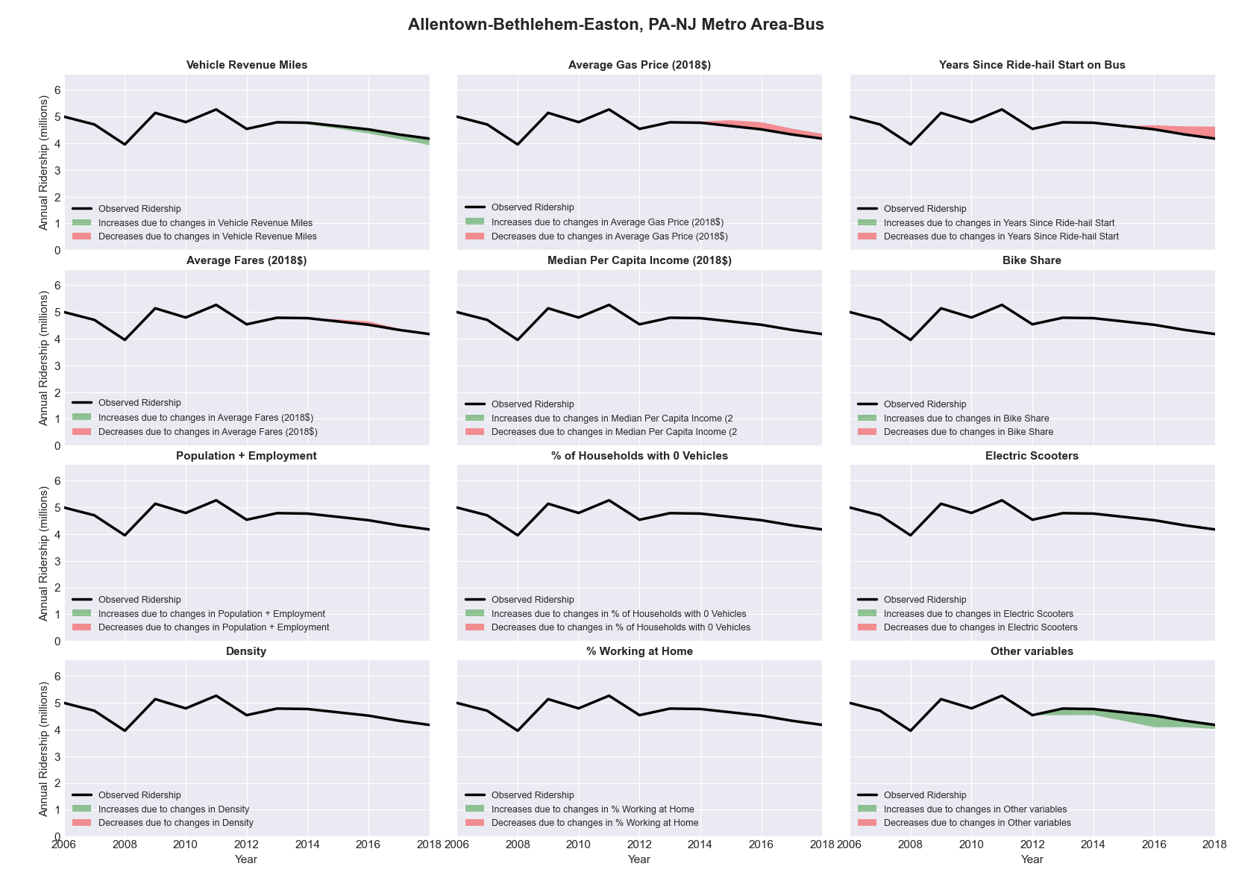

|  |  |  |  |  |  |
| --- | --- | --- | --- | --- | --- |
| Altoona, PA Metro Area-Bus | | | | | |
|  |  |  |  |  |  |
|  | **Average Values** | | | **Ridership Effect** | |
| **Description** | **2012** | **2018** | **% Diff** | **Absolute** | **% Diff** |
|  |  |  |  |  |  |
| **Vehicle Revenue Miles** | 533,340 | 503,330 | -5.6% | -17,600 | **-2.7%** |
| **Average Fare (2018$)** | 1.26 | 1.25 | -1.2% | 2,700 | **0.4%** |
| **Network Restructure** | - | - | - | - | **0.0%** |
| **Major Maintenance Event** | - | - | - | - | **0.0%** |
| **Population + Employment** | 184,360 | 179,470 | -2.7% | -3,460 | **-0.5%** |
| **Share of Population and Employment in Transit Supportive Density** | 0.24 | 0.22 | -9.0% | -5,460 | **-0.8%** |
| **Average Gas Price (2018$)** | 4.11 | 2.92 | -28.9% | -23,880 | **-3.7%** |
| **Median Per Capita Income (2018$)** | 24,060 | 24,580 | 2.2% | -1,040 | **-0.2%** |
| **% of Households with 0 Vehicles** | 9 | 9 | -4.1% | -0,260 | **-0.0%** |
| **% Working at Home** | 1.8 | 4.4 | 141.7% | -11,580 | **-1.8%** |
| **Years Since Ride-hail Start** | - | 2 | 2 | -37,350 | **-5.7%** |
| **Bike Share** | - | - | - | - | **0.0%** |
| **Electric Scooters** | - | - | - | - | **0.0%** |
| **New Reporters** |  |  |  | - | **0.0%** |
| **Total Modeled Ridership** | 650,101 | 551,760 | -15.13% | -98340.04068 | **-15.1%** |
| **Total Observed Ridership** | 687,954 | 544,498 | -20.85% | -143456 | **-20.9%** |
| **Unexplained Change** |  |  |  |  | **-5.7%** |

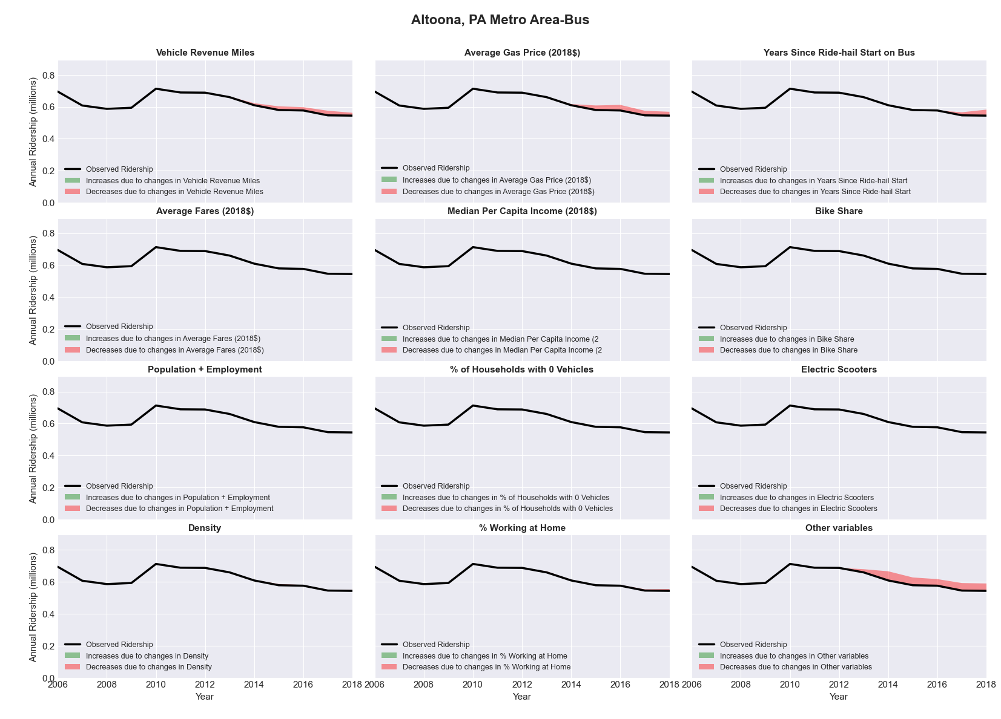

|  |  |  |  |  |  |
| --- | --- | --- | --- | --- | --- |
| Ames, IA Metro Area-Bus | | | | | |
|  |  |  |  |  |  |
|  | **Average Values** | | | **Ridership Effect** | |
| **Description** | **2012** | **2018** | **% Diff** | **Absolute** | **% Diff** |
|  |  |  |  |  |  |
| **Vehicle Revenue Miles** | 1,157,700 | 1,312,890 | 13.4% | 368,410 | **5.5%** |
| **Average Fare (2018$)** | 0.70 | 0.82 | 17.5% | -259,460 | **-3.9%** |
| **Network Restructure** | - | - | - | - | **0.0%** |
| **Major Maintenance Event** | - | - | - | - | **0.0%** |
| **Population + Employment** | 142,560 | 155,400 | 9.0% | 119,420 | **1.8%** |
| **Share of Population and Employment in Transit Supportive Density** | 0.16 | 0.14 | -13.0% | -52,050 | **-0.8%** |
| **Average Gas Price (2018$)** | 3.93 | 2.72 | -30.9% | -262,320 | **-3.9%** |
| **Median Per Capita Income (2018$)** | 21,950 | 24,640 | 12.3% | -56,040 | **-0.8%** |
| **% of Households with 0 Vehicles** | 6 | 7 | 15.7% | 11,000 | **0.2%** |
| **% Working at Home** | 3.5 | 6.3 | 79.3% | -132,540 | **-2.0%** |
| **Years Since Ride-hail Start** | - | 3 | 3 | -663,300 | **-9.9%** |
| **Bike Share** | - | - | - | - | **0.0%** |
| **Electric Scooters** | - | - | - | - | **0.0%** |
| **New Reporters** |  |  |  | - | **0.0%** |
| **Total Modeled Ridership** | 6,673,230 | 5,786,353 | -13.29% | -886876.8508 | **-13.3%** |
| **Total Observed Ridership** | 5,765,067 | 6,431,375 | 11.56% | 666308 | **11.6%** |
| **Unexplained Change** |  |  |  |  | **24.8%** |

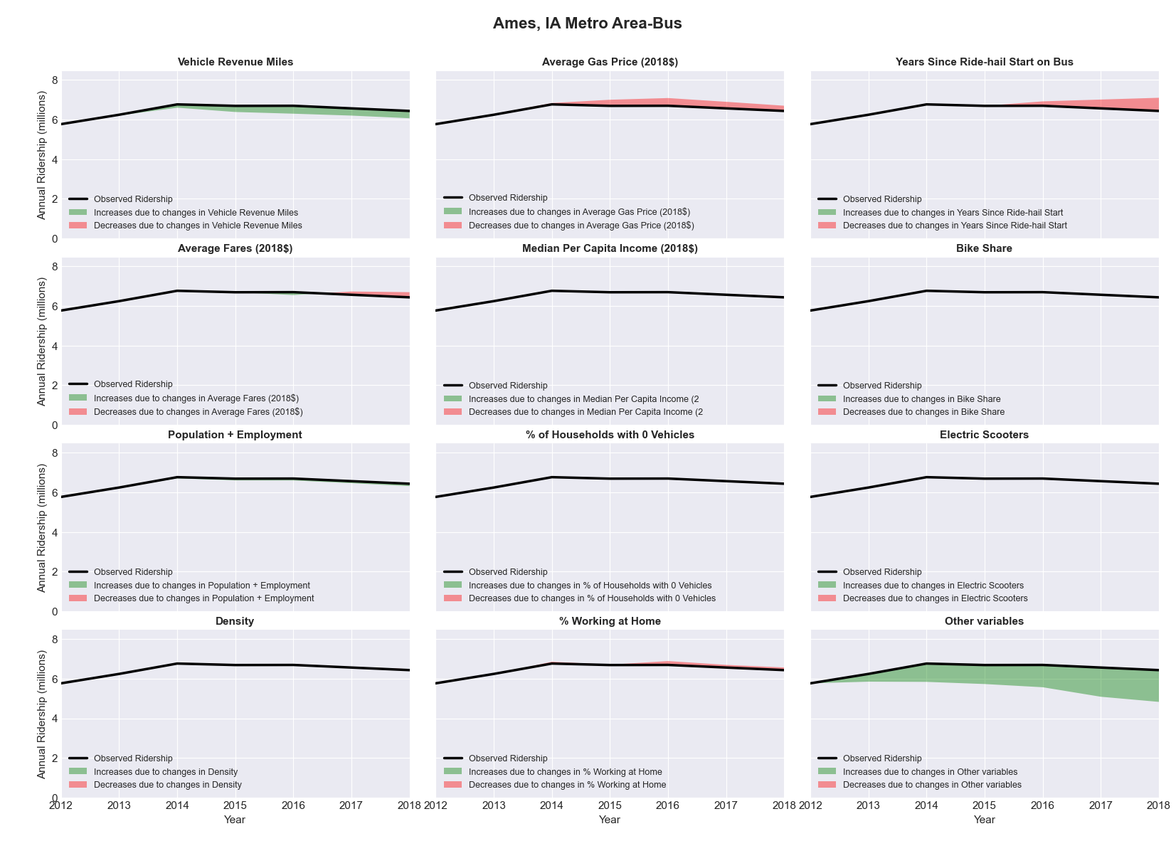

|  |  |  |  |  |  |
| --- | --- | --- | --- | --- | --- |
| Anchorage, AK Metro Area-Bus | | | | | |
|  |  |  |  |  |  |
|  | **Average Values** | | | **Ridership Effect** | |
| **Description** | **2012** | **2018** | **% Diff** | **Absolute** | **% Diff** |
|  |  |  |  |  |  |
| **Vehicle Revenue Miles** | 1,870,510 | 2,195,800 | 17.4% | 249,900 | **6.8%** |
| **Average Fare (2018$)** | 1.16 | 0.85 | -26.4% | 299,140 | **8.1%** |
| **Network Restructure** | - | - | - | - | **0.0%** |
| **Major Maintenance Event** | - | - | - | - | **0.0%** |
| **Population + Employment** | 582,390 | 588,250 | 1.0% | 9,750 | **0.3%** |
| **Share of Population and Employment in Transit Supportive Density** | 0.46 | 0.48 | 4.3% | -17,180 | **-0.5%** |
| **Average Gas Price (2018$)** | 4.35 | 3.40 | -21.8% | -117,440 | **-3.2%** |
| **Median Per Capita Income (2018$)** | 34,180 | 34,430 | 0.7% | -3,210 | **-0.1%** |
| **% of Households with 0 Vehicles** | 5 | 6 | 28.8% | 10,470 | **0.3%** |
| **% Working at Home** | 4.9 | 4.0 | -18.4% | 26,090 | **0.7%** |
| **Years Since Ride-hail Start** | - | 1 | 1 | -107,830 | **-2.9%** |
| **Bike Share** | - | - | - | - | **0.0%** |
| **Electric Scooters** | - | - | - | - | **0.0%** |
| **New Reporters** |  |  |  | - | **0.0%** |
| **Total Modeled Ridership** | 3,671,104 | 4,131,809 | 12.55% | 460705.2 | **12.5%** |
| **Total Observed Ridership** | 4,088,549 | 3,227,500 | -21.06% | -861049 | **-21.1%** |
| **Unexplained Change** |  |  |  |  | **-33.6%** |

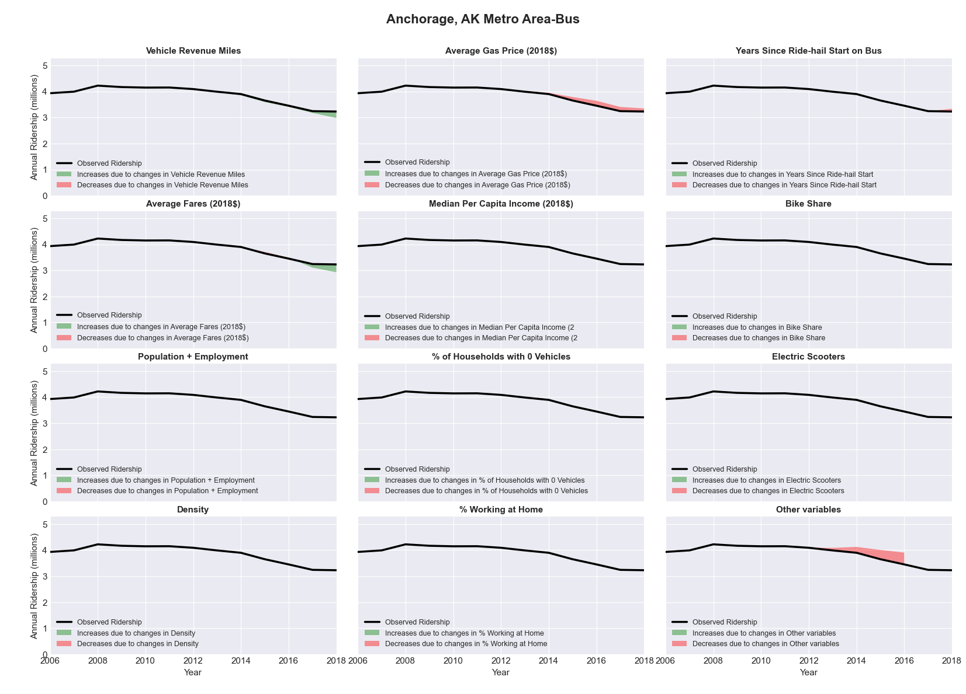

|  |  |  |  |  |  |
| --- | --- | --- | --- | --- | --- |
| Ann Arbor, MI Metro Area-Bus | | | | | |
|  |  |  |  |  |  |
|  | **Average Values** | | | **Ridership Effect** | |
| **Description** | **2012** | **2018** | **% Diff** | **Absolute** | **% Diff** |
|  |  |  |  |  |  |
| **Vehicle Revenue Miles** | 3,318,800 | 4,411,090 | 32.9% | 1,567,740 | **12.9%** |
| **Average Fare (2018$)** | 0.54 | 0.44 | -18.4% | 494,290 | **4.1%** |
| **Network Restructure** | - | - | - | - | **0.0%** |
| **Major Maintenance Event** | - | - | - | - | **0.0%** |
| **Population + Employment** | 521,740 | 560,270 | 7.4% | 188,840 | **1.6%** |
| **Share of Population and Employment in Transit Supportive Density** | 0.36 | 0.37 | 4.8% | 85,970 | **0.7%** |
| **Average Gas Price (2018$)** | 3.93 | 2.72 | -30.9% | -476,500 | **-3.9%** |
| **Median Per Capita Income (2018$)** | 29,830 | 33,530 | 12.4% | -101,110 | **-0.8%** |
| **% of Households with 0 Vehicles** | 8 | 6 | -26.6% | -54,220 | **-0.4%** |
| **% Working at Home** | 5.6 | 5.3 | -4.9% | 26,300 | **0.2%** |
| **Years Since Ride-hail Start** | - | 4 | 4 | -1,617,150 | **-13.3%** |
| **Bike Share** | - | 1 | 1 | -131450 | **-1.1%** |
| **Electric Scooters** | - | - | - | 0 | **0.0%** |
| **New Reporters** |  |  |  | - | **0.0%** |
| **Total Modeled Ridership** | 12,163,008 | 12,065,044 | -0.81% | -97964.4 | **-0.8%** |
| **Total Observed Ridership** | 12,234,588 | 12,689,761 | 3.72% | 455173 | **3.7%** |
| **Unexplained Change** |  |  |  |  | **4.5%** |

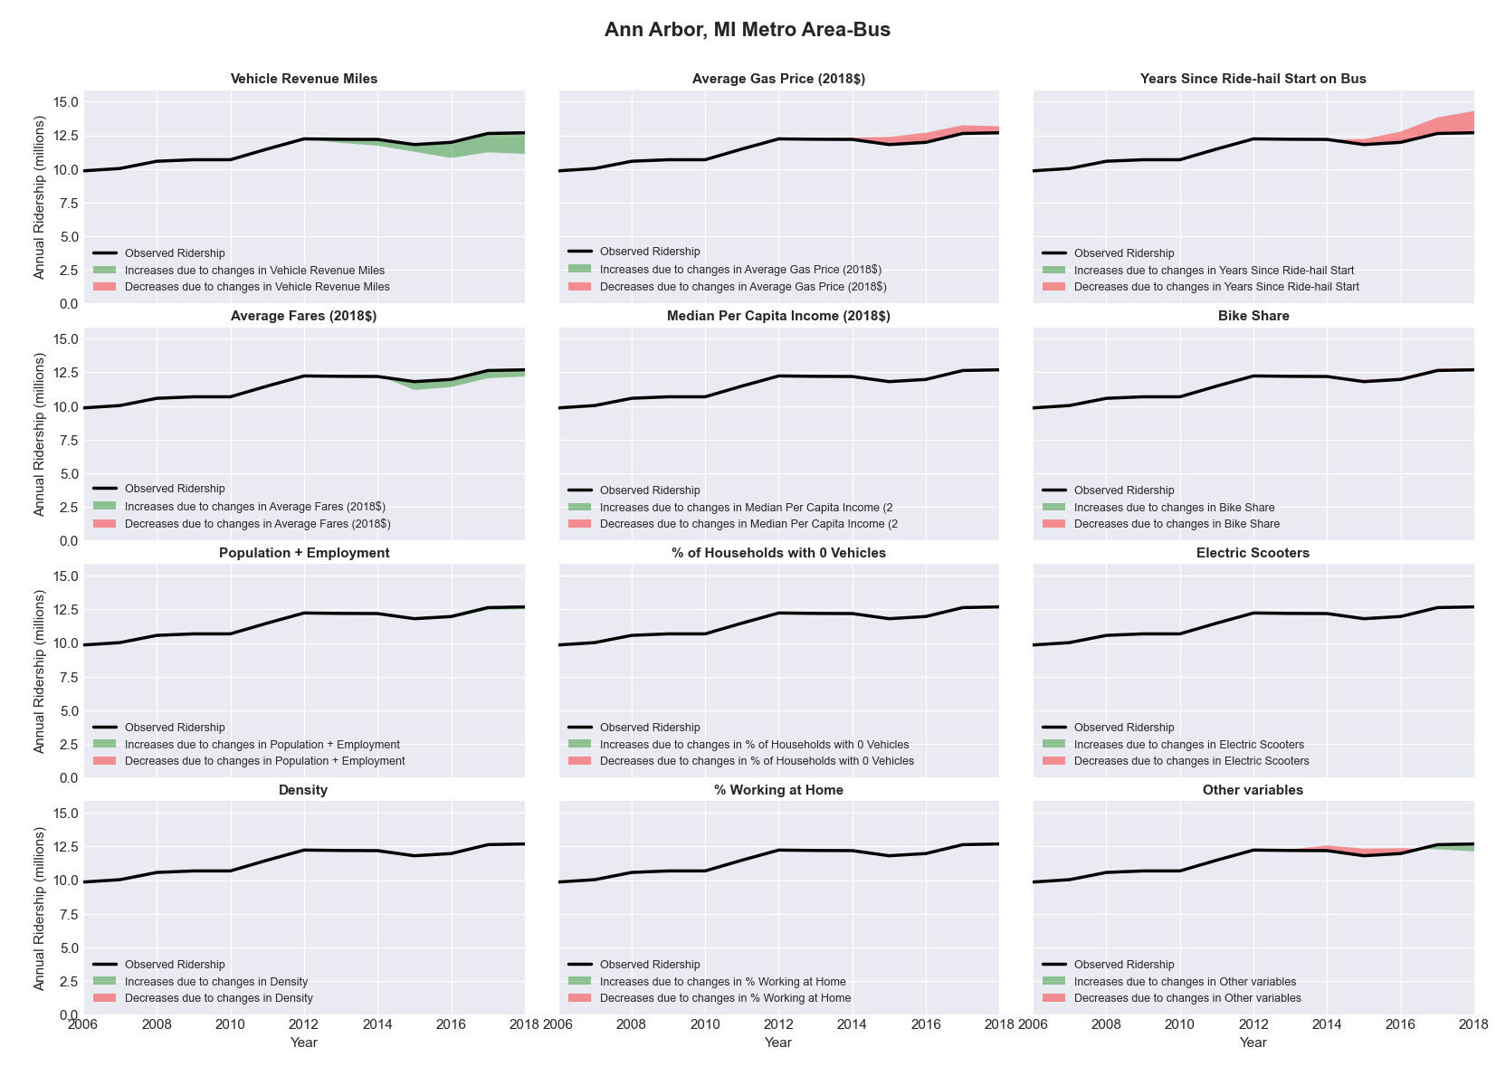

|  |  |  |  |  |  |
| --- | --- | --- | --- | --- | --- |
| Appleton, WI Metro Area-Bus | | | | | |
|  |  |  |  |  |  |
|  | **Average Values** | | | **Ridership Effect** | |
| **Description** | **2012** | **2018** | **% Diff** | **Absolute** | **% Diff** |
|  |  |  |  |  |  |
| **Vehicle Revenue Miles** | 739,150 | 735,310 | -0.5% | -0,490 | **-0.1%** |
| **Average Fare (2018$)** | 0.82 | 0.77 | -5.3% | 9,900 | **1.2%** |
| **Network Restructure** | - | - | - | - | **0.0%** |
| **Major Maintenance Event** | - | - | - | - | **0.0%** |
| **Population + Employment** | 348,170 | 368,170 | 5.7% | 9,350 | **1.2%** |
| **Share of Population and Employment in Transit Supportive Density** | 0.12 | 0.12 | 3.9% | 1,430 | **0.2%** |
| **Average Gas Price (2018$)** | 3.93 | 2.72 | -30.9% | -32,720 | **-4.1%** |
| **Median Per Capita Income (2018$)** | 32,730 | 37,060 | 13.2% | -6,450 | **-0.8%** |
| **% of Households with 0 Vehicles** | 4 | 5 | 14.1% | 0,730 | **0.1%** |
| **% Working at Home** | 3.7 | 6.1 | 63.5% | -13,010 | **-1.6%** |
| **Years Since Ride-hail Start** | - | 3 | 3 | -73,630 | **-9.2%** |
| **Bike Share** | - | - | - | 0 | **0.0%** |
| **Electric Scooters** | - | - | - | 0 | **0.0%** |
| **New Reporters** |  |  |  | - | **0.0%** |
| **Total Modeled Ridership** | 797,798 | 692,243 | -13.23% | -105555 | **-13.2%** |
| **Total Observed Ridership** | 802,650 | 711,660 | -11.34% | -90990 | **-11.3%** |
| **Unexplained Change** |  |  |  |  | **1.9%** |

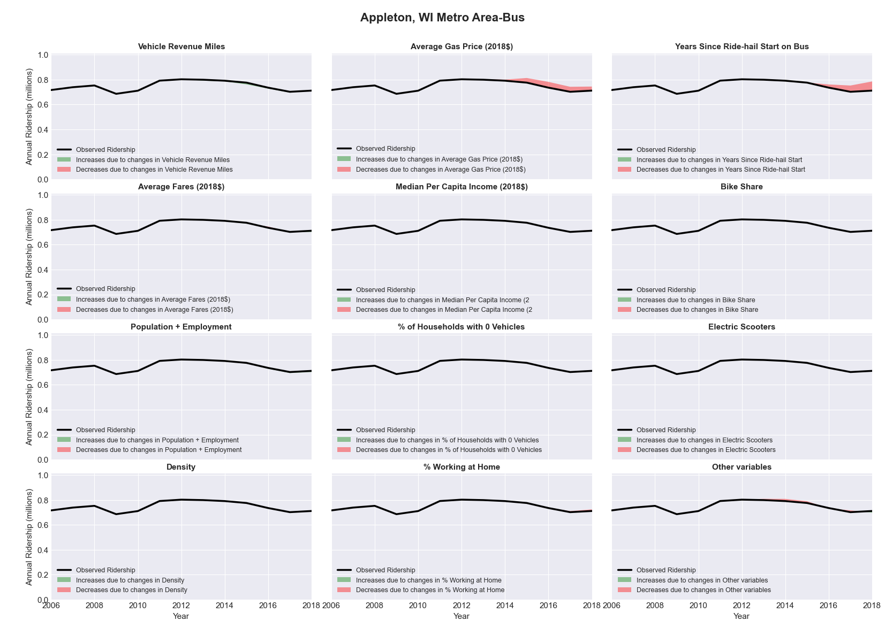

|  |  |  |  |  |  |
| --- | --- | --- | --- | --- | --- |
| Asheville, NC Metro Area-Bus | | | | | |
|  |  |  |  |  |  |
|  | **Average Values** | | | **Ridership Effect** | |
| **Description** | **2012** | **2018** | **% Diff** | **Absolute** | **% Diff** |
|  |  |  |  |  |  |
| **Vehicle Revenue Miles** | 854,180 | 1,108,880 | 29.8% | 214,310 | **13.0%** |
| **Average Fare (2018$)** | 0.58 | 0.33 | -43.7% | 167,820 | **10.2%** |
| **Network Restructure** | - | - | - | - | **0.0%** |
| **Major Maintenance Event** | - | - | - | - | **0.0%** |
| **Population + Employment** | 628,200 | 684,620 | 9.0% | 32,200 | **2.0%** |
| **Share of Population and Employment in Transit Supportive Density** | 0.06 | 0.07 | 22.0% | 7,550 | **0.5%** |
| **Average Gas Price (2018$)** | 3.95 | 2.71 | -31.3% | -51,360 | **-3.1%** |
| **Median Per Capita Income (2018$)** | 25,570 | 27,750 | 8.5% | -9,830 | **-0.6%** |
| **% of Households with 0 Vehicles** | 7 | 5 | -26.4% | -4,900 | **-0.3%** |
| **% Working at Home** | 5.5 | 11.8 | 114.1% | -91,080 | **-5.5%** |
| **Years Since Ride-hail Start** | - | 2 | 2 | -139,310 | **-8.4%** |
| **Bike Share** | - | - | - | 0 | **0.0%** |
| **Electric Scooters** | - | - | - | 0 | **0.0%** |
| **New Reporters** |  |  |  | - | **0.0%** |
| **Total Modeled Ridership** | 1,649,329 | 1,780,722 | 7.97% | 131393 | **8.0%** |
| **Total Observed Ridership** | 1,466,247 | 1,949,255 | 32.94% | 483008 | **32.9%** |
| **Unexplained Change** |  |  |  |  | **25.0%** |

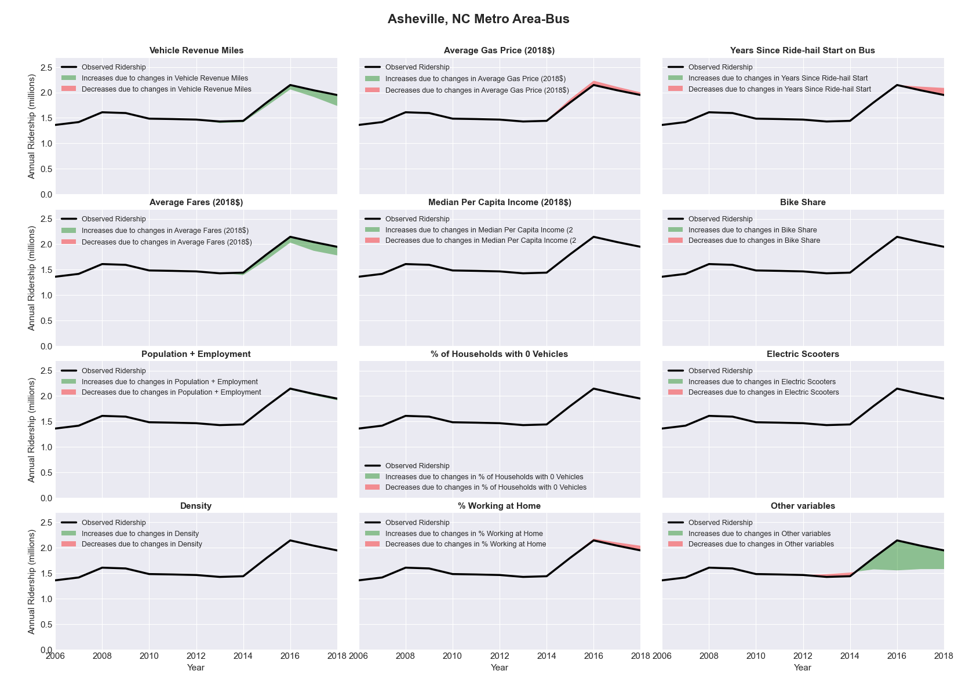

|  |  |  |  |  |  |
| --- | --- | --- | --- | --- | --- |
| Athens-Clarke County, GA Metro Area-Bus | | | | | |
|  |  |  |  |  |  |
|  | **Average Values** | | | **Ridership Effect** | |
| **Description** | **2012** | **2018** | **% Diff** | **Absolute** | **% Diff** |
|  |  |  |  |  |  |
| **Vehicle Revenue Miles** | 1,569,810 | 1,866,220 | 18.9% | 807,620 | **7.0%** |
| **Average Fare (2018$)** | 0.68 | 1.29 | 88.8% | -2,096,080 | **-18.1%** |
| **Network Restructure** | - | - | - | - | **0.0%** |
| **Major Maintenance Event** | - | - | - | - | **0.0%** |
| **Population + Employment** | 281,660 | 308,880 | 9.7% | 212,950 | **1.8%** |
| **Share of Population and Employment in Transit Supportive Density** | 0.24 | 0.20 | -14.4% | -171,890 | **-1.5%** |
| **Average Gas Price (2018$)** | 3.95 | 2.71 | -31.3% | -591,760 | **-5.1%** |
| **Median Per Capita Income (2018$)** | 21,560 | 23,400 | 8.5% | -69,510 | **-0.6%** |
| **% of Households with 0 Vehicles** | 6 | 6 | -8.2% | -2,930 | **-0.0%** |
| **% Working at Home** | 3.0 | 7.9 | 164.2% | -348,510 | **-3.0%** |
| **Years Since Ride-hail Start** | - | 4 | 4 | -1,308,220 | **-11.3%** |
| **Bike Share** | - | 1 | 1 | -79260 | **-0.7%** |
| **Electric Scooters** | - | - | - | 0 | **0.0%** |
| **New Reporters** |  |  |  | - | **0.0%** |
| **Total Modeled Ridership** | 11,564,569 | 8,349,012 | -27.81% | -321556 | **-27.8%** |
| **Total Observed Ridership** | 12,936,904 | 7,252,138 | -43.94% | -568466 | **-43.9%** |
| **Unexplained Change** |  |  |  |  | **-16.1%** |

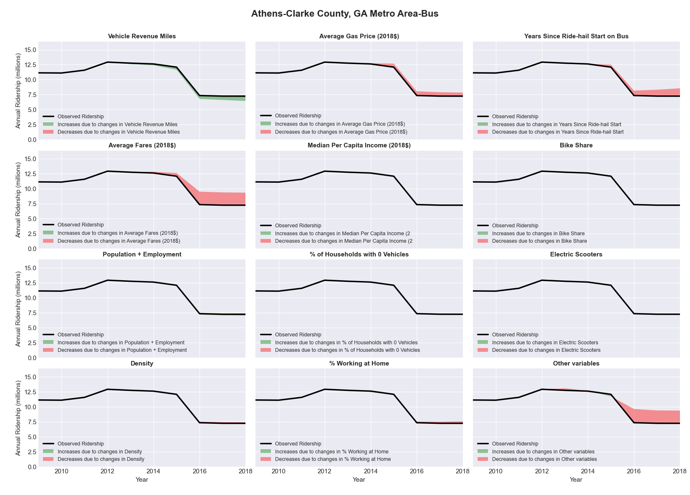

|  |  |  |  |  |  |
| --- | --- | --- | --- | --- | --- |
| Atlanta-Sandy Springs-Marietta, GA Metro Area-Bus | | | | | |
|  |  |  |  |  |  |
|  | **Average Values** | | | **Ridership Effect** | |
| **Description** | **2012** | **2018** | **% Diff** | **Absolute** | **% Diff** |
|  |  |  |  |  |  |
| **Vehicle Revenue Miles** | 22,698,560 | 27,713,920 | 22.1% | 5,467,120 | **8.9%** |
| **Average Fare (2018$)** | 1.07 | 1.09 | 2.8% | -449,910 | **-0.7%** |
| **Network Restructure** | - | - | - | - | **0.0%** |
| **Major Maintenance Event** | - | - | - | - | **0.0%** |
| **Population + Employment** | 7,979,810 | 8,942,480 | 12.1% | 1,481,440 | **2.4%** |
| **Share of Population and Employment in Transit Supportive Density** | 0.20 | 0.21 | 4.3% | 207,890 | **0.3%** |
| **Average Gas Price (2018$)** | 3.95 | 2.71 | -31.3% | -2,547,720 | **-4.1%** |
| **Median Per Capita Income (2018$)** | 30,280 | 32,700 | 8.0% | -333,780 | **-0.5%** |
| **% of Households with 0 Vehicles** | 6 | 5 | -16.6% | -120,780 | **-0.2%** |
| **% Working at Home** | 5.9 | 7.7 | 30.1% | -808,340 | **-1.3%** |
| **Years Since Ride-hail Start** | - | 6 | 6 | -6,870,090 | **-11.1%** |
| **Bike Share** | - | 1 | 1 | -665080 | **-1.1%** |
| **Electric Scooters** | - | 1 | 1 | -2190080 | **-3.5%** |
| **New Reporters** |  |  |  | - | **0.0%** |
| **Total Modeled Ridership** | 61,769,360 | 54,799,568 | -11.28% | -669792 | **-11.3%** |
| **Total Observed Ridership** | 59,778,703 | 49,099,634 | -17.86% | -1.1E+07 | **-17.9%** |
| **Unexplained Change** |  |  |  |  | **-6.6%** |

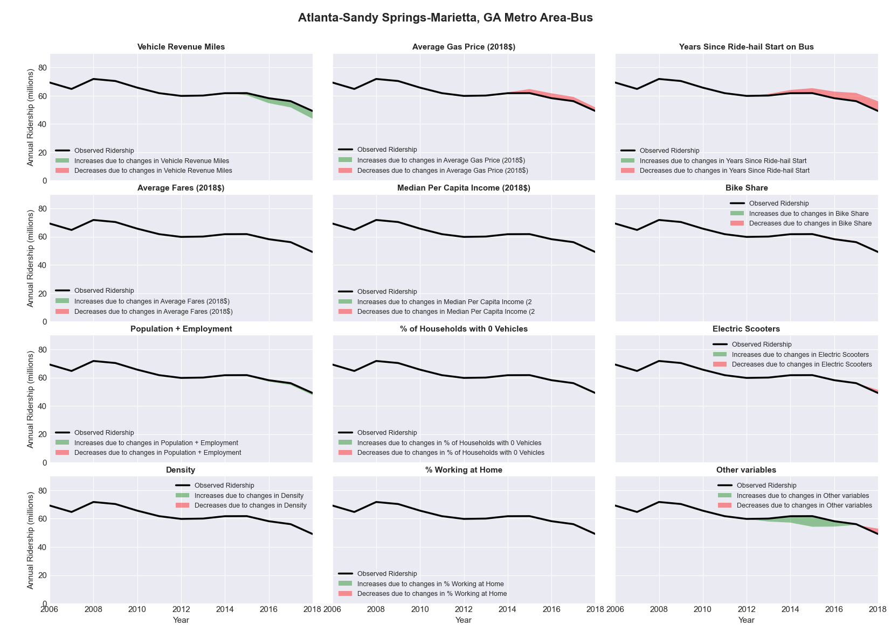

|  |  |  |  |  |  |
| --- | --- | --- | --- | --- | --- |
| Atlanta-Sandy Springs-Marietta, GA Metro Area-Rail | | | | | |
|  |  |  |  |  |  |
|  | **Average Values** | | | **Ridership Effect** | |
| **Description** | **2012** | **2018** | **% Diff** | **Absolute** | **% Diff** |
|  |  |  |  |  |  |
| **Vehicle Revenue Miles** | 17,714,780 | 22,301,780 | 25.9% | 11,106,740 | **17.1%** |
| **Average Fare (2018$)** | 1.09 | 1.16 | 6.5% | -817,100 | **-1.3%** |
| **Network Restructure** | - | - | - | - | **0.0%** |
| **Major Maintenance Event** | - | - | - | - | **0.0%** |
| **Population + Employment** | 7,979,810 | 8,942,480 | 12.1% | 1,740,910 | **2.7%** |
| **Share of Population and Employment in Transit Supportive Density** | 0.20 | 0.21 | 4.3% | 240,380 | **0.4%** |
| **Average Gas Price (2018$)** | 3.95 | 2.71 | -31.3% | -2,924,250 | **-4.5%** |
| **Median Per Capita Income (2018$)** | 30,280 | 32,700 | 8.0% | -388,900 | **-0.6%** |
| **% of Households with 0 Vehicles** | 6 | 5 | -16.6% | -142,510 | **-0.2%** |
| **% Working at Home** | 5.9 | 7.7 | 30.1% | -952,220 | **-1.5%** |
| **Years Since Ride-hail Start** | - | 6 | 6 | 915,520 | **1.4%** |
| **Bike Share** | - | 1 | 1 | -767580 | **-1.2%** |
| **Electric Scooters** | - | 1 | 1 | -2638220 | **-4.1%** |
| **New Reporters** |  |  |  | - | **0.0%** |
| **Total Modeled Ridership** | 65,126,501 | 69,791,184 | 7.16% | 4664683 | **7.2%** |
| **Total Observed Ridership** | 70,196,148 | 65,024,528 | -7.37% | -517162 | **-7.4%** |
| **Unexplained Change** |  |  |  |  | **-14.5%** |

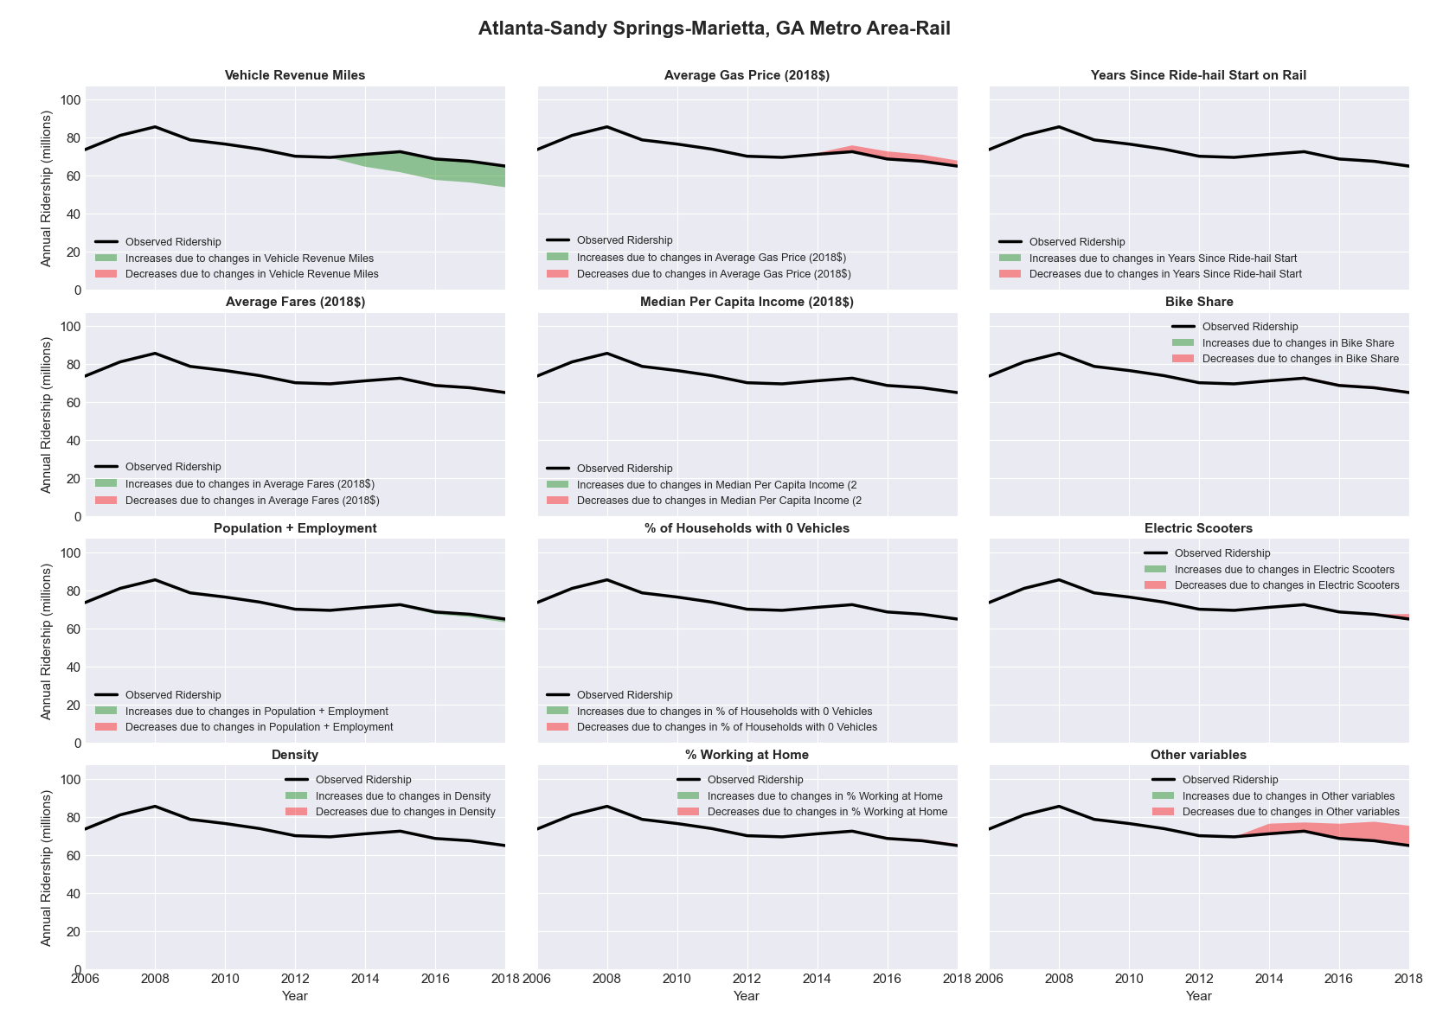

|  |  |  |  |  |  |
| --- | --- | --- | --- | --- | --- |
| Augusta-Richmond County, GA-SC Metro Area-Bus | | | | | |
|  |  |  |  |  |  |
|  | **Average Values** | | | **Ridership Effect** | |
| **Description** | **2012** | **2018** | **% Diff** | **Absolute** | **% Diff** |
|  |  |  |  |  |  |
| **Vehicle Revenue Miles** | 507,760 | 545,660 | 7.5% | 25,960 | **3.4%** |
| **Average Fare (2018$)** | 0.94 | 0.90 | -4.8% | 12,510 | **1.7%** |
| **Network Restructure** | - | - | - | - | **0.0%** |
| **Major Maintenance Event** | - | - | - | - | **0.0%** |
| **Population + Employment** | 800,380 | 862,920 | 7.8% | 12,300 | **1.6%** |
| **Share of Population and Employment in Transit Supportive Density** | 0.08 | 0.09 | 13.4% | 2,940 | **0.4%** |
| **Average Gas Price (2018$)** | 3.95 | 2.71 | -31.3% | -32,350 | **-4.3%** |
| **Median Per Capita Income (2018$)** | 25,240 | 24,940 | -1.2% | 0,280 | **0.0%** |
| **% of Households with 0 Vehicles** | 6 | 6 | 3.0% | 0,140 | **0.0%** |
| **% Working at Home** | 1.5 | 3.2 | 111.7% | -8,880 | **-1.2%** |
| **Years Since Ride-hail Start** | - | 3 | 3 | -74,860 | **-9.9%** |
| **Bike Share** | - | 1 | 1 | -8550 | **-1.1%** |
| **Electric Scooters** | - | - | - | 0 | **0.0%** |
| **New Reporters** |  |  |  | - | **0.0%** |
| **Total Modeled Ridership** | 754,476 | 683,883 | -9.36% | -70593.2 | **-9.4%** |
| **Total Observed Ridership** | 718,406 | 659,598 | -8.19% | -58808 | **-8.2%** |
| **Unexplained Change** |  |  |  |  | **1.2%** |

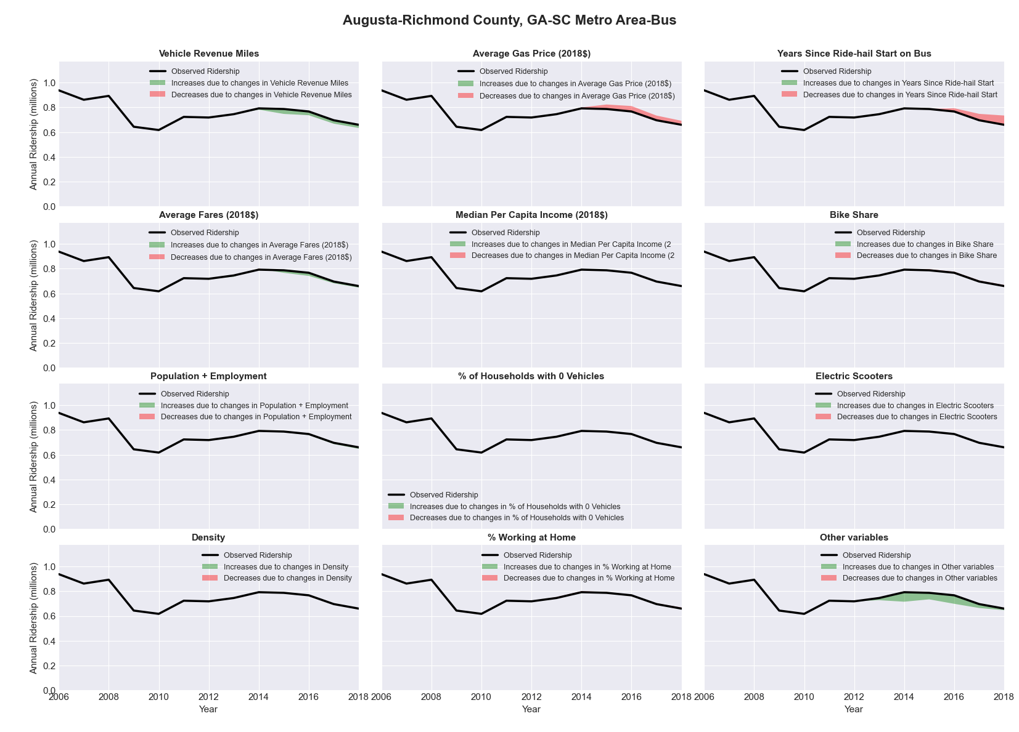

|  |  |  |  |  |  |
| --- | --- | --- | --- | --- | --- |
| Austin-Round Rock-San Marcos, TX Metro Area-Bus | | | | | |
|  |  |  |  |  |  |
|  | **Average Values** | | | **Ridership Effect** | |
| **Description** | **2012** | **2018** | **% Diff** | **Absolute** | **% Diff** |
|  |  |  |  |  |  |
| **Vehicle Revenue Miles** | 13,621,910 | 16,576,090 | 21.7% | 2,732,460 | **8.0%** |
| **Average Fare (2018$)** | 0.52 | 0.68 | 31.4% | -2,040,940 | **-6.0%** |
| **Network Restructure** | - | - | - | - | **0.0%** |
| **Major Maintenance Event** | - | - | - | - | **0.0%** |
| **Population + Employment** | 2,765,880 | 3,328,690 | 20.3% | 1,282,280 | **3.8%** |
| **Share of Population and Employment in Transit Supportive Density** | 0.37 | 0.36 | -3.3% | -165,660 | **-0.5%** |
| **Average Gas Price (2018$)** | 3.80 | 2.58 | -32.2% | -1,445,130 | **-4.2%** |
| **Median Per Capita Income (2018$)** | 32,770 | 38,260 | 16.8% | -349,620 | **-1.0%** |
| **% of Households with 0 Vehicles** | 5 | 4 | -12.3% | -38,170 | **-0.1%** |
| **% Working at Home** | 6.4 | 9.0 | 39.8% | -630,110 | **-1.8%** |
| **Years Since Ride-hail Start** | - | 4 | 4 | -3,999,860 | **-11.7%** |
| **Bike Share** | - | 1 | 1 | -347900 | **-1.0%** |
| **Electric Scooters** | - | 1 | 1 | -1079990 | **-3.2%** |
| **New Reporters** |  |  |  | - | **0.0%** |
| **Total Modeled Ridership** | 34,129,428 | 28,074,874 | -17.74% | -654554 | **-17.7%** |
| **Total Observed Ridership** | 35,220,067 | 27,672,728 | -21.43% | 7547339 | **-21.4%** |
| **Unexplained Change** |  |  |  |  | **-3.7%** |

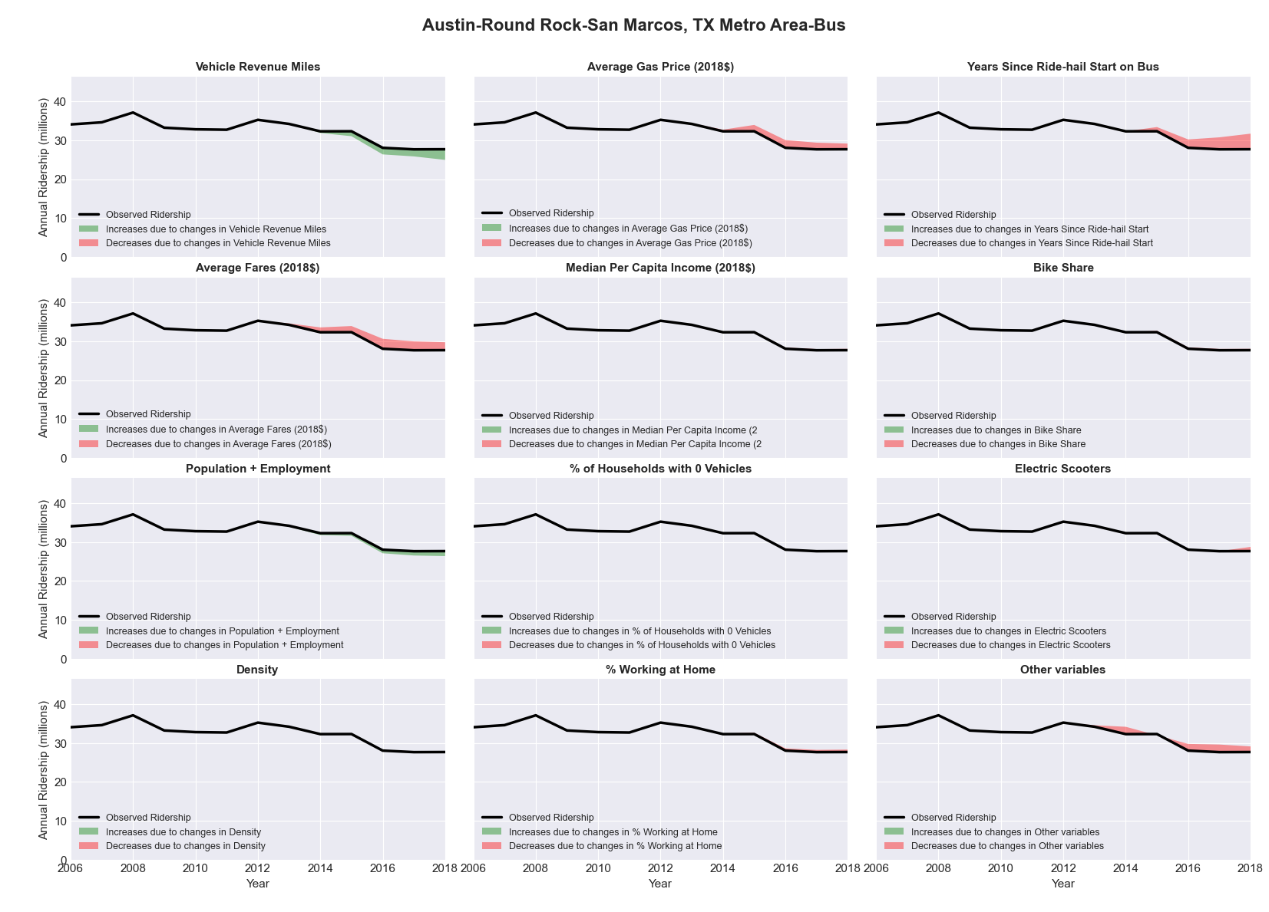

|  |  |  |  |  |  |
| --- | --- | --- | --- | --- | --- |
| Bakersfield-Delano, CA Metro Area-Bus | | | | | |
|  |  |  |  |  |  |
|  | **Average Values** | | | **Ridership Effect** | |
| **Description** | **2012** | **2018** | **% Diff** | **Absolute** | **% Diff** |
|  |  |  |  |  |  |
| **Vehicle Revenue Miles** | 3,841,870 | 3,899,170 | 1.5% | 45,470 | **0.7%** |
| **Average Fare (2018$)** | 0.85 | 0.70 | -16.9% | 254,910 | **4.0%** |
| **Network Restructure** | - | - | - | - | **0.0%** |
| **Major Maintenance Event** | - | - | - | - | **0.0%** |
| **Population + Employment** | 1,196,510 | 1,253,570 | 4.8% | 60,960 | **1.0%** |
| **Share of Population and Employment in Transit Supportive Density** | 0.31 | 0.29 | -5.3% | -40,590 | **-0.6%** |
| **Average Gas Price (2018$)** | 4.35 | 3.40 | -21.8% | -165,010 | **-2.6%** |
| **Median Per Capita Income (2018$)** | 22,010 | 23,610 | 7.3% | -30,540 | **-0.5%** |
| **% of Households with 0 Vehicles** | 7 | 7 | -3.5% | -0,680 | **-0.0%** |
| **% Working at Home** | 2.7 | 3.5 | 27.8% | -33,790 | **-0.5%** |
| **Years Since Ride-hail Start** | - | 4 | 4 | -742,950 | **-11.7%** |
| **Bike Share** | - | - | - | 0 | **0.0%** |
| **Electric Scooters** | - | - | - | 0 | **0.0%** |
| **New Reporters** |  |  |  | - | **0.0%** |
| **Total Modeled Ridership** | 6,354,105 | 5,649,405 | -11.09% | -704700 | **-11.1%** |
| **Total Observed Ridership** | 6,833,733 | 6,333,242 | -7.32% | -500491 | **-7.3%** |
| **Unexplained Change** |  |  |  |  | **3.8%** |

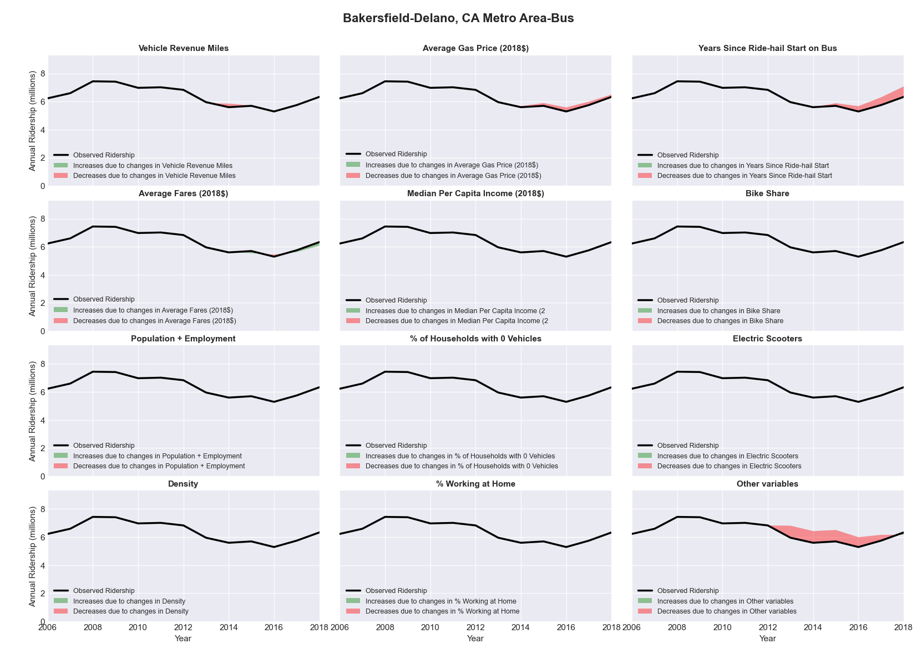

|  |  |  |  |  |  |
| --- | --- | --- | --- | --- | --- |
| Baltimore-Towson, MD Metro Area-Bus | | | | | |
|  |  |  |  |  |  |
|  | **Average Values** | | | **Ridership Effect** | |
| **Description** | **2012** | **2018** | **% Diff** | **Absolute** | **% Diff** |
|  |  |  |  |  |  |
| **Vehicle Revenue Miles** | 24,945,290 | 26,918,880 | 7.9% | 2,610,840 | **3.4%** |
| **Average Fare (2018$)** | 1.12 | 1.08 | -4.0% | 847,790 | **1.1%** |
| **Network Restructure** | - | 1.000 | - | ######### | **4.8%** |
| **Major Maintenance Event** | - | - | - | - | **0.0%** |
| **Population + Employment** | 4,102,810 | 4,260,180 | 3.8% | 614,470 | **0.8%** |
| **Share of Population and Employment in Transit Supportive Density** | 0.41 | 0.40 | -3.3% | -411,180 | **-0.5%** |
| **Average Gas Price (2018$)** | 4.11 | 2.92 | -28.9% | -3,035,820 | **-4.0%** |
| **Median Per Capita Income (2018$)** | 36,470 | 38,950 | 6.8% | -355,570 | **-0.5%** |
| **% of Households with 0 Vehicles** | 12 | 11 | -9.6% | -162,400 | **-0.2%** |
| **% Working at Home** | 4.1 | 5.0 | 22.0% | -540,220 | **-0.7%** |
| **Years Since Ride-hail Start** | - | 5 | 5 | -7,223,420 | **-9.5%** |
| **Bike Share** | - | 1 | 1 | -850530 | **-1.1%** |
| **Electric Scooters** | - | 1 | 1 | -2666440 | **-3.5%** |
| **New Reporters** |  |  |  | - | **0.0%** |
| **Total Modeled Ridership** | 76,249,622 | 68,766,633 | -9.81% | -748299 | **-9.8%** |
| **Total Observed Ridership** | 71,023,438 | 66,180,222 | -6.82% | -484316 | **-6.8%** |
| **Unexplained Change** |  |  |  |  | **3.0%** |

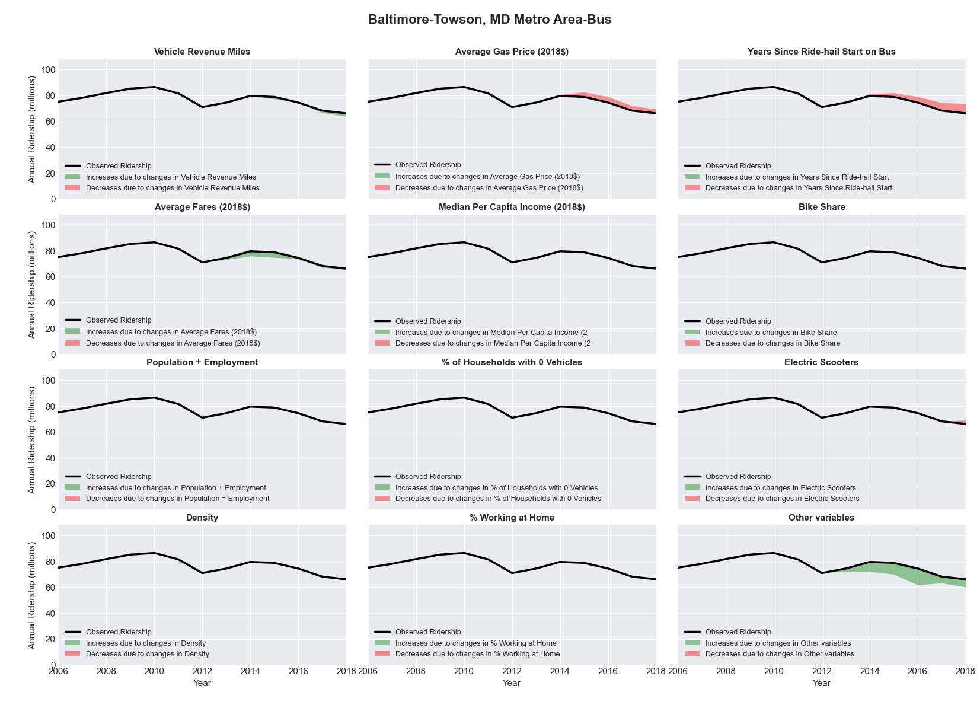

|  |  |  |  |  |  |
| --- | --- | --- | --- | --- | --- |
| Baltimore-Towson, MD Metro Area-Rail | | | | | |
|  |  |  |  |  |  |
|  | **Average Values** | | | **Ridership Effect** | |
| **Description** | **2012** | **2018** | **% Diff** | **Absolute** | **% Diff** |
|  |  |  |  |  |  |
| **Vehicle Revenue Miles** | 14,274,160 | 13,455,480 | -5.7% | -1,111,000 | **-3.5%** |
| **Average Fare (2018$)** | 1.99 | 3.16 | 59.0% | -3,217,480 | **-10.2%** |
| **Network Restructure** | - | - | - | - | **0.0%** |
| **Major Maintenance Event** | - | - | - | - | **0.0%** |
| **Population + Employment** | 4,102,810 | 4,260,180 | 3.8% | 245,250 | **0.8%** |
| **Share of Population and Employment in Transit Supportive Density** | 0.41 | 0.40 | -3.3% | -166,380 | **-0.5%** |
| **Average Gas Price (2018$)** | 4.11 | 2.92 | -28.9% | -1,221,660 | **-3.9%** |
| **Median Per Capita Income (2018$)** | 36,470 | 38,950 | 6.8% | -139,700 | **-0.4%** |
| **% of Households with 0 Vehicles** | 12 | 11 | -9.6% | -67,490 | **-0.2%** |
| **% Working at Home** | 4.1 | 5.0 | 22.0% | -200,590 | **-0.6%** |
| **Years Since Ride-hail Start** | - | 5 | 5 | 315,060 | **1.0%** |
| **Bike Share** | - | 1 | 1 | -304640 | **-1.0%** |
| **Electric Scooters** | - | 1 | 1 | -1013280 | **-3.2%** |
| **New Reporters** |  |  |  | - | **0.0%** |
| **Total Modeled Ridership** | 31,670,460 | 24,851,039 | -21.53% | -681421 | **-21.5%** |
| **Total Observed Ridership** | 32,152,728 | 23,436,709 | -27.11% | -871609 | **-27.1%** |
| **Unexplained Change** |  |  |  |  | **-5.6%** |

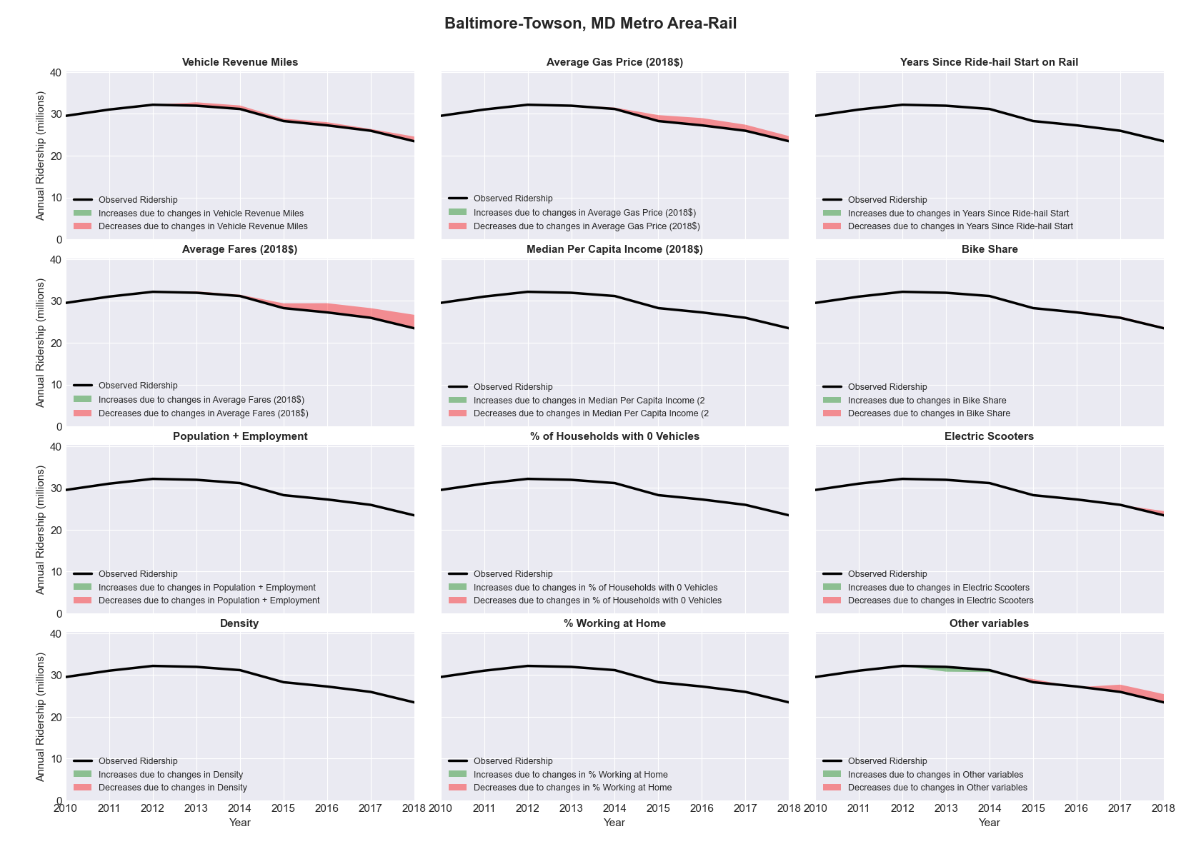

|  |  |  |  |  |  |
| --- | --- | --- | --- | --- | --- |
| Baton Rouge, LA Metro Area-Bus | | | | | |
|  |  |  |  |  |  |
|  | **Average Values** | | | **Ridership Effect** | |
| **Description** | **2012** | **2018** | **% Diff** | **Absolute** | **% Diff** |
|  |  |  |  |  |  |
| **Vehicle Revenue Miles** | 1,699,220 | 3,236,050 | 90.4% | 1,174,620 | **35.8%** |
| **Average Fare (2018$)** | 0.54 | 0.47 | -11.7% | 89,000 | **2.7%** |
| **Network Restructure** | - | - | - | - | **0.0%** |
| **Major Maintenance Event** | - | - | - | - | **0.0%** |
| **Population + Employment** | 1,181,220 | 1,240,270 | 5.0% | 39,980 | **1.2%** |
| **Share of Population and Employment in Transit Supportive Density** | 0.16 | 0.16 | -0.1% | -0,180 | **-0.0%** |
| **Average Gas Price (2018$)** | 3.80 | 2.58 | -32.2% | -162,910 | **-5.0%** |
| **Median Per Capita Income (2018$)** | 27,810 | 28,520 | 2.6% | -6,290 | **-0.2%** |
| **% of Households with 0 Vehicles** | 5 | 7 | 31.7% | 12,080 | **0.4%** |
| **% Working at Home** | 2.5 | 3.0 | 20.0% | -14,040 | **-0.4%** |
| **Years Since Ride-hail Start** | - | 4 | 4 | -510,440 | **-15.6%** |
| **Bike Share** | - | - | - | 0 | **0.0%** |
| **Electric Scooters** | - | - | - | 0 | **0.0%** |
| **New Reporters** |  |  |  | - | **0.0%** |
| **Total Modeled Ridership** | 3,277,794 | 3,788,709 | 15.59% | 510914.7 | **15.6%** |
| **Total Observed Ridership** | 3,611,582 | 3,875,024 | 7.29% | 263442 | **7.3%** |
| **Unexplained Change** |  |  |  |  | **-8.3%** |

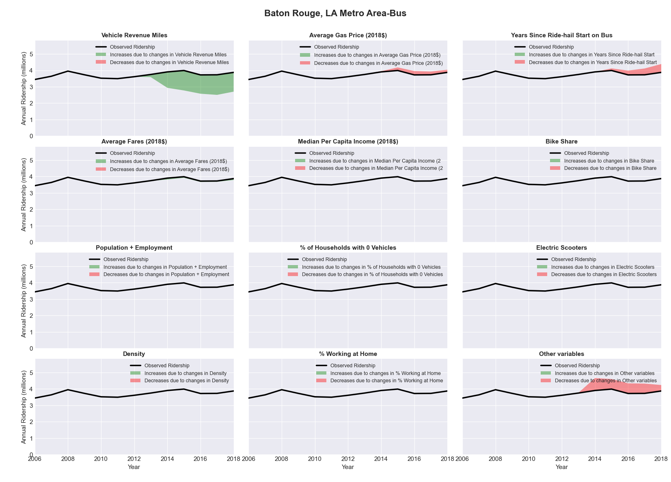

|  |  |  |  |  |  |
| --- | --- | --- | --- | --- | --- |
| Bay City, MI Metro Area-Bus | | | | | |
|  |  |  |  |  |  |
|  | **Average Values** | | | **Ridership Effect** | |
| **Description** | **2012** | **2018** | **% Diff** | **Absolute** | **% Diff** |
|  |  |  |  |  |  |
| **Vehicle Revenue Miles** | 1,034,760 | 975,900 | -5.7% | -14,270 | **-2.6%** |
| **Average Fare (2018$)** | 1.37 | 1.36 | -0.7% | 2,300 | **0.4%** |
| **Network Restructure** | - | - | - | - | **0.0%** |
| **Major Maintenance Event** | - | - | - | - | **0.0%** |
| **Population + Employment** | 155,160 | 151,880 | -2.1% | -2,290 | **-0.4%** |
| **Share of Population and Employment in Transit Supportive Density** | 0.07 | 0.07 | -5.2% | -0,760 | **-0.1%** |
| **Average Gas Price (2018$)** | 3.93 | 2.72 | -30.9% | -20,820 | **-3.8%** |
| **Median Per Capita Income (2018$)** | 24,630 | 27,670 | 12.3% | -4,190 | **-0.8%** |
| **% of Households with 0 Vehicles** | 7 | 9 | 32.2% | 2,530 | **0.5%** |
| **% Working at Home** | 1.9 | 2.4 | 25.0% | -1,840 | **-0.3%** |
| **Years Since Ride-hail Start** | - | 1 | 1 | -16,170 | **-2.9%** |
| **Bike Share** | - | - | - | 0 | **0.0%** |
| **Electric Scooters** | - | - | - | 0 | **0.0%** |
| **New Reporters** |  |  |  | - | **0.0%** |
| **Total Modeled Ridership** | 548,258 | 490,093 | -10.61% | -58164.7 | **-10.6%** |
| **Total Observed Ridership** | 575,698 | 478,910 | -16.81% | -96788 | **-16.8%** |
| **Unexplained Change** |  |  |  |  | **-6.2%** |

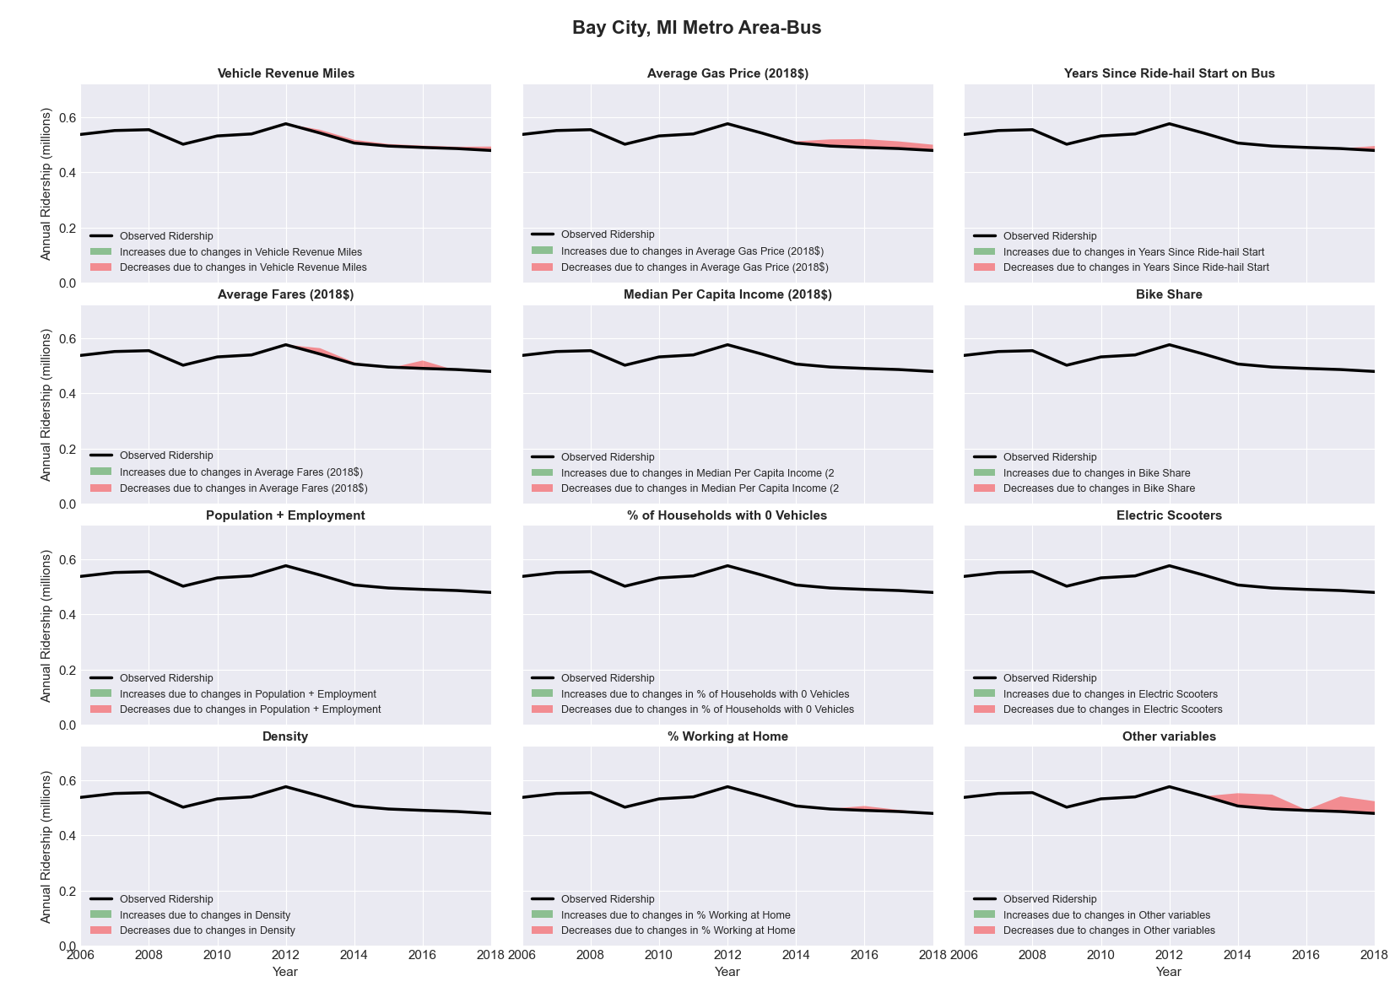

|  |  |  |  |  |  |
| --- | --- | --- | --- | --- | --- |
| Beaumont-Port Arthur, TX Metro Area-Bus | | | | | |
|  |  |  |  |  |  |
|  | **Average Values** | | | **Ridership Effect** | |
| **Description** | **2012** | **2018** | **% Diff** | **Absolute** | **% Diff** |
|  |  |  |  |  |  |
| **Vehicle Revenue Miles** | 720,290 | 705,820 | -2.0% | -4,900 | **-0.9%** |
| **Average Fare (2018$)** | 0.85 | 0.85 | 0.4% | -5,430 | **-1.0%** |
| **Network Restructure** | - | - | - | - | **0.0%** |
| **Major Maintenance Event** | - | - | - | - | **0.0%** |
| **Population + Employment** | 549,550 | 570,560 | 3.8% | 4,470 | **0.8%** |
| **Share of Population and Employment in Transit Supportive Density** | 0.09 | 0.09 | -1.0% | -0,180 | **-0.0%** |
| **Average Gas Price (2018$)** | 3.80 | 2.58 | -32.2% | -24,190 | **-4.5%** |
| **Median Per Capita Income (2018$)** | 24,300 | 26,920 | 10.8% | -4,310 | **-0.8%** |
| **% of Households with 0 Vehicles** | 7 | 7 | -1.4% | -0,180 | **-0.0%** |
| **% Working at Home** | 1.4 | 3.1 | 117.9% | -5,460 | **-1.0%** |
| **Years Since Ride-hail Start** | - | 3 | 3 | -46,060 | **-8.5%** |
| **Bike Share** | - | - | - | 0 | **0.0%** |
| **Electric Scooters** | - | - | - | 0 | **0.0%** |
| **New Reporters** |  |  |  | - | **0.0%** |
| **Total Modeled Ridership** | 540,501 | 457,770 | -15.31% | -82730.6 | **-15.3%** |
| **Total Observed Ridership** | 579,242 | 412,847 | -28.73% | -166395 | **-28.7%** |
| **Unexplained Change** |  |  |  |  | **-13.4%** |

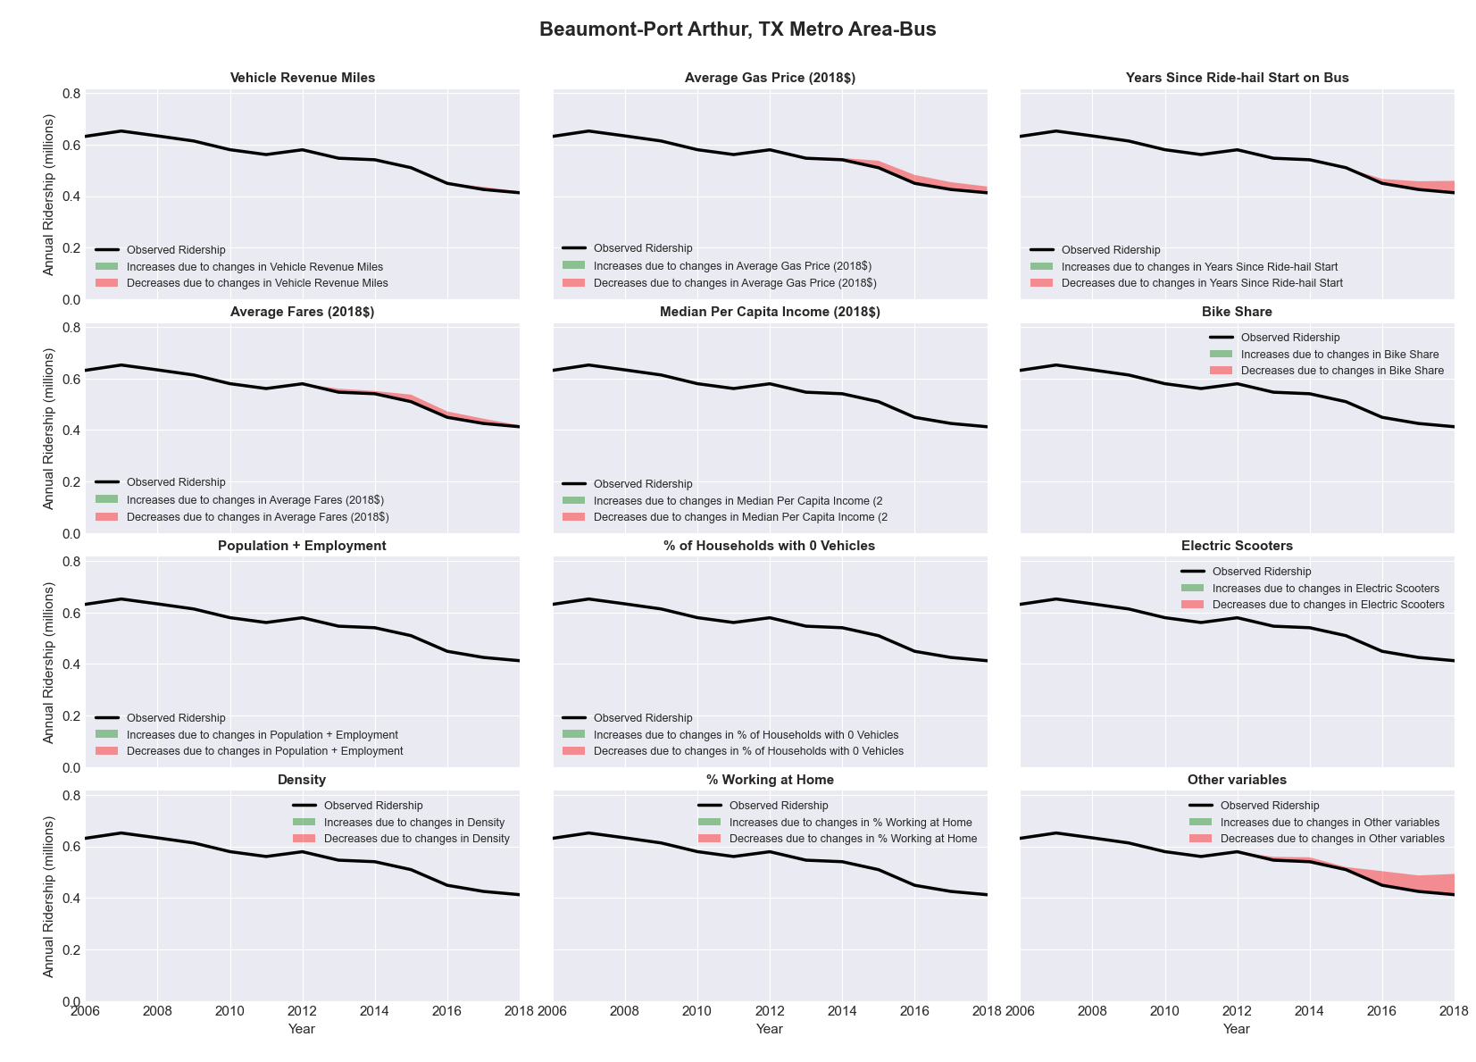

|  |  |  |  |  |  |
| --- | --- | --- | --- | --- | --- |
| Bellingham, WA Metro Area-Bus | | | | | |
|  |  |  |  |  |  |
|  | **Average Values** | | | **Ridership Effect** | |
| **Description** | **2012** | **2018** | **% Diff** | **Absolute** | **% Diff** |
|  |  |  |  |  |  |
| **Vehicle Revenue Miles** | 1,776,140 | 2,100,480 | 18.3% | 373,480 | **6.8%** |
| **Average Fare (2018$)** | 0.35 | 0.66 | 91.9% | -583,540 | **-10.6%** |
| **Network Restructure** | - | - | - | - | **0.0%** |
| **Major Maintenance Event** | - | - | - | - | **0.0%** |
| **Population + Employment** | 299,990 | 331,960 | 10.7% | 113,340 | **2.1%** |
| **Share of Population and Employment in Transit Supportive Density** | 0.25 | 0.25 | -0.4% | -1,470 | **-0.0%** |
| **Average Gas Price (2018$)** | 4.35 | 3.40 | -21.8% | -173,690 | **-3.2%** |
| **Median Per Capita Income (2018$)** | 24,490 | 31,680 | 29.4% | -91,570 | **-1.7%** |
| **% of Households with 0 Vehicles** | 9 | 9 | -0.5% | -5,140 | **-0.1%** |
| **% Working at Home** | 6.7 | 6.2 | -7.8% | 39,250 | **0.7%** |
| **Years Since Ride-hail Start** | - | 3 | 3 | -473,620 | **-8.6%** |
| **Bike Share** | - | - | - | 0 | **0.0%** |
| **Electric Scooters** | - | - | - | 0 | **0.0%** |
| **New Reporters** |  |  |  | - | **0.0%** |
| **Total Modeled Ridership** | 5,495,858 | 4,639,171 | -15.59% | -856687 | **-15.6%** |
| **Total Observed Ridership** | 5,860,120 | 4,542,536 | -22.48% | -131584 | **-22.5%** |
| **Unexplained Change** |  |  |  |  | **-6.9%** |

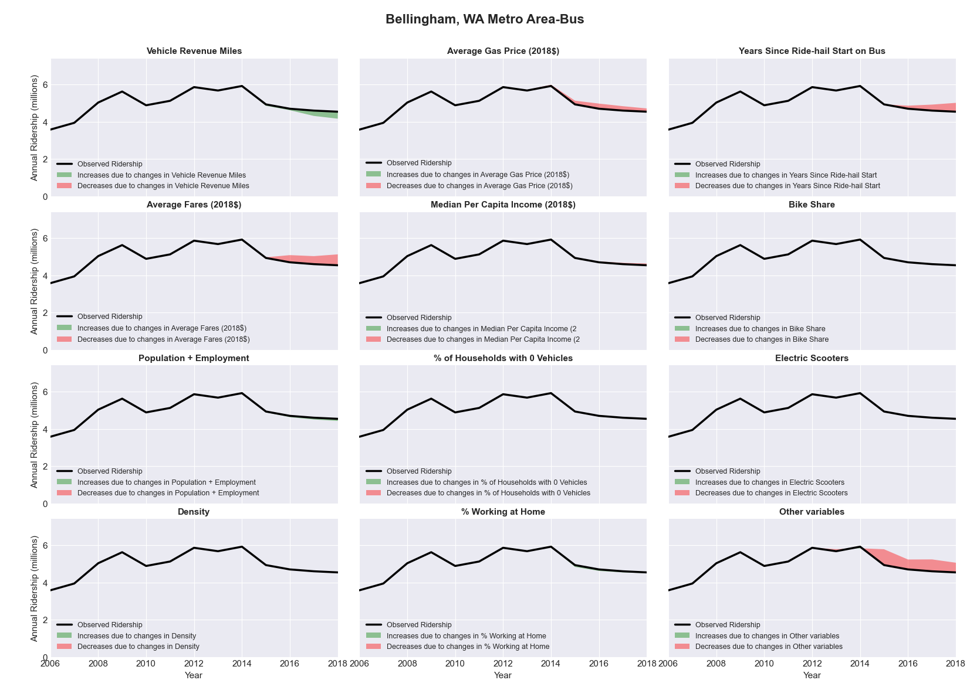

|  |  |  |  |  |  |
| --- | --- | --- | --- | --- | --- |
| Billings, MT Metro Area-Bus | | | | | |
|  |  |  |  |  |  |
|  | **Average Values** | | | **Ridership Effect** | |
| **Description** | **2012** | **2018** | **% Diff** | **Absolute** | **% Diff** |
|  |  |  |  |  |  |
| **Vehicle Revenue Miles** | 601,430 | 603,080 | 0.3% | -2,350 | **-0.4%** |
| **Average Fare (2018$)** | 0.61 | 0.87 | 41.6% | -40,030 | **-6.9%** |
| **Network Restructure** | - | - | - | - | **0.0%** |
| **Major Maintenance Event** | - | - | - | - | **0.0%** |
| **Population + Employment** | 241,630 | 257,450 | 6.5% | 7,890 | **1.4%** |
| **Share of Population and Employment in Transit Supportive Density** | 0.19 | 0.18 | -3.9% | -1,800 | **-0.3%** |
| **Average Gas Price (2018$)** | 3.88 | 2.89 | -25.5% | -21,030 | **-3.6%** |
| **Median Per Capita Income (2018$)** | 28,190 | 30,510 | 8.2% | -3,680 | **-0.6%** |
| **% of Households with 0 Vehicles** | 5 | 6 | 24.4% | 1,210 | **0.2%** |
| **% Working at Home** | 3.0 | 5.8 | 92.5% | -11,410 | **-2.0%** |
| **Years Since Ride-hail Start** | - | 2 | 2 | -31,440 | **-5.4%** |
| **Bike Share** | - | - | - | 0 | **0.0%** |
| **Electric Scooters** | - | - | - | 0 | **0.0%** |
| **New Reporters** |  |  |  | - | **0.0%** |
| **Total Modeled Ridership** | 577,415 | 473,882 | -17.93% | -103532 | **-17.9%** |
| **Total Observed Ridership** | 615,546 | 447,045 | -27.37% | -168501 | **-27.4%** |
| **Unexplained Change** |  |  |  |  | **-9.4%** |

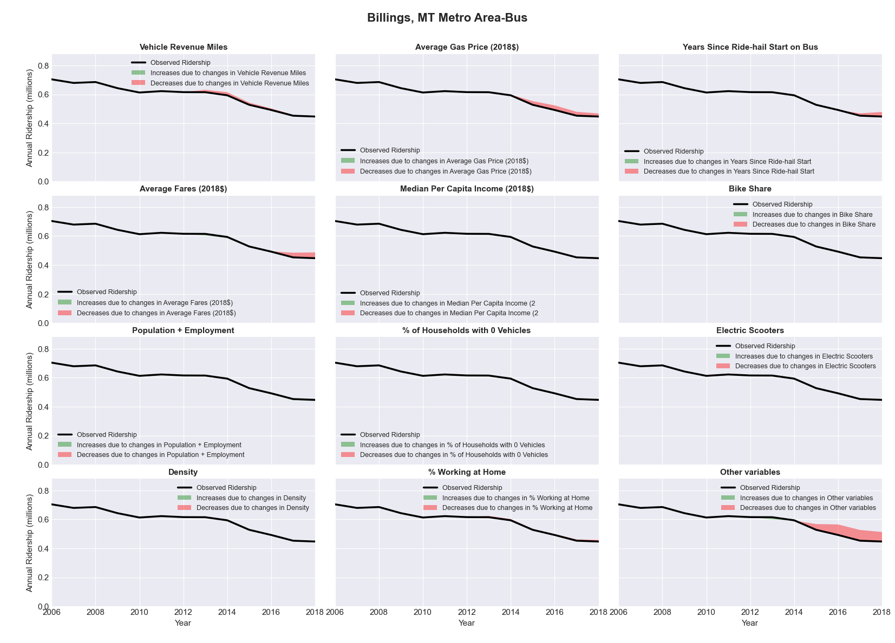

|  |  |  |  |  |  |
| --- | --- | --- | --- | --- | --- |
| Binghamton, NY Metro Area-Bus | | | | | |
|  |  |  |  |  |  |
|  | **Average Values** | | | **Ridership Effect** | |
| **Description** | **2012** | **2018** | **% Diff** | **Absolute** | **% Diff** |
|  |  |  |  |  |  |
| **Vehicle Revenue Miles** | 1,108,420 | 1,140,200 | 2.9% | 30,130 | **1.3%** |
| **Average Fare (2018$)** | 1.15 | 1.56 | 36.1% | -204,260 | **-8.9%** |
| **Network Restructure** | - | - | - | - | **0.0%** |
| **Major Maintenance Event** | - | - | - | - | **0.0%** |
| **Population + Employment** | 357,830 | 342,690 | -4.2% | -20,420 | **-0.9%** |
| **Share of Population and Employment in Transit Supportive Density** | 0.19 | 0.20 | 6.9% | 11,170 | **0.5%** |
| **Average Gas Price (2018$)** | 4.11 | 2.92 | -28.9% | -91,080 | **-4.0%** |
| **Median Per Capita Income (2018$)** | 25,820 | 26,750 | 3.6% | -5,310 | **-0.2%** |
| **% of Households with 0 Vehicles** | 10 | 14 | 31.7% | 13,260 | **0.6%** |
| **% Working at Home** | 3.8 | 2.6 | -30.9% | 19,770 | **0.9%** |
| **Years Since Ride-hail Start** | - | 3 | 3 | -206,490 | **-9.0%** |
| **Bike Share** | - | - | - | 0 | **0.0%** |
| **Electric Scooters** | - | - | - | 0 | **0.0%** |
| **New Reporters** |  |  |  | - | **0.0%** |
| **Total Modeled Ridership** | 2,284,221 | 1,832,723 | -19.77% | -451498 | **-19.8%** |
| **Total Observed Ridership** | 2,335,329 | 1,922,806 | -17.66% | -412523 | **-17.7%** |
| **Unexplained Change** |  |  |  |  | **2.1%** |

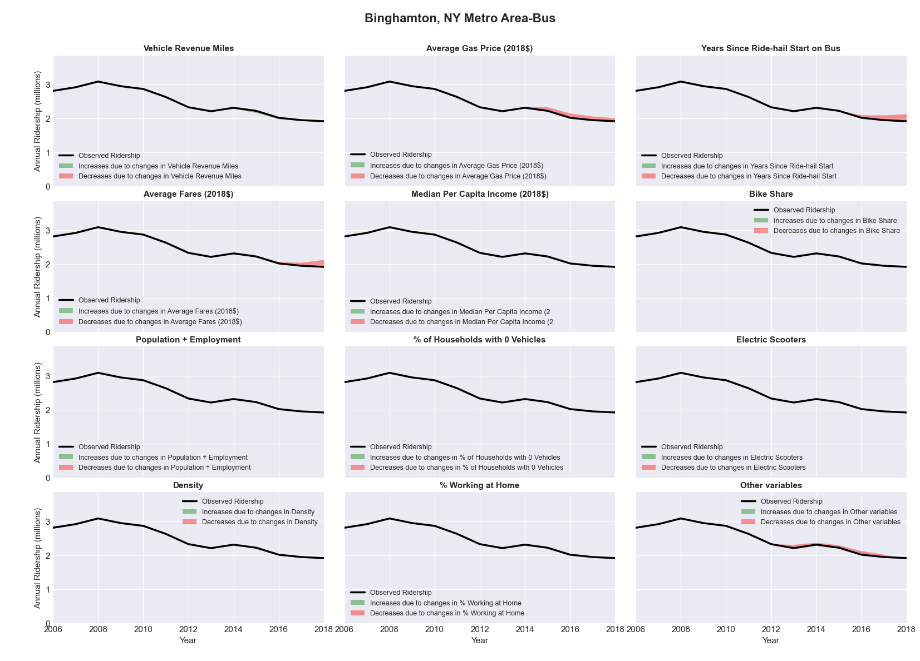

|  |  |  |  |  |  |
| --- | --- | --- | --- | --- | --- |
| Birmingham-Hoover, AL Metro Area-Bus | | | | | |
|  |  |  |  |  |  |
|  | **Average Values** | | | **Ridership Effect** | |
| **Description** | **2012** | **2018** | **% Diff** | **Absolute** | **% Diff** |
|  |  |  |  |  |  |
| **Vehicle Revenue Miles** | 2,508,550 | 2,892,640 | 15.3% | 197,830 | **6.6%** |
| **Average Fare (2018$)** | 0.87 | 0.55 | -36.2% | 338,780 | **11.3%** |
| **Network Restructure** | - | - | - | - | **0.0%** |
| **Major Maintenance Event** | - | - | - | - | **0.0%** |
| **Population + Employment** | 1,639,100 | 1,675,140 | 2.2% | 13,830 | **0.5%** |
| **Share of Population and Employment in Transit Supportive Density** | 0.17 | 0.17 | 0.4% | 0,830 | **0.0%** |
| **Average Gas Price (2018$)** | 3.80 | 2.58 | -32.2% | -135,080 | **-4.5%** |
| **Median Per Capita Income (2018$)** | 27,270 | 29,810 | 9.3% | -18,860 | **-0.6%** |
| **% of Households with 0 Vehicles** | 7 | 6 | -13.2% | -5,240 | **-0.2%** |
| **% Working at Home** | 2.9 | 4.3 | 46.6% | -29,980 | **-1.0%** |
| **Years Since Ride-hail Start** | - | 3 | 3 | -294,760 | **-9.8%** |
| **Bike Share** | - | 1 | 1 | -34610 | **-1.2%** |
| **Electric Scooters** | - | - | - | 0 | **0.0%** |
| **New Reporters** |  |  |  | - | **0.0%** |
| **Total Modeled Ridership** | 3,003,344 | 3,012,635 | 0.31% | 9290.903 | **0.3%** |
| **Total Observed Ridership** | 2,774,313 | 3,180,277 | 14.63% | 405964 | **14.6%** |
| **Unexplained Change** |  |  |  |  | **14.3%** |

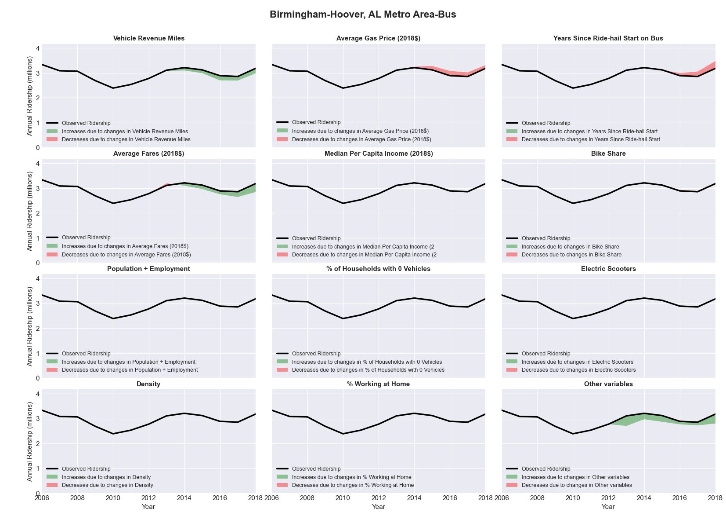

|  |  |  |  |  |  |
| --- | --- | --- | --- | --- | --- |
| Blacksburg-Christiansburg-Radford, VA Metro Area-Bus | | | | | |
|  |  |  |  |  |  |
|  | **Average Values** | | | **Ridership Effect** | |
| **Description** | **2012** | **2018** | **% Diff** | **Absolute** | **% Diff** |
|  |  |  |  |  |  |
| **Vehicle Revenue Miles** | 769,470 | 957,010 | 24.4% | 375,430 | **9.8%** |
| **Average Fare (2018$)** | 0.89 | 0.29 | -68.0% | 888,660 | **23.3%** |
| **Network Restructure** | - | - | - | - | **0.0%** |
| **Major Maintenance Event** | - | - | - | - | **0.0%** |
| **Population + Employment** | 242,940 | 261,340 | 7.6% | 56,730 | **1.5%** |
| **Share of Population and Employment in Transit Supportive Density** | 0.10 | 0.09 | -10.6% | -15,650 | **-0.4%** |
| **Average Gas Price (2018$)** | 3.95 | 2.71 | -31.3% | -144,770 | **-3.8%** |
| **Median Per Capita Income (2018$)** | 21,130 | 27,020 | 27.9% | -62,980 | **-1.6%** |
| **% of Households with 0 Vehicles** | 7 | 7 | 9.9% | 5,130 | **0.1%** |
| **% Working at Home** | 3.8 | 7.6 | 100.0% | -106,580 | **-2.8%** |
| **Years Since Ride-hail Start** | - | 4 | 4 | -488,290 | **-12.8%** |
| **Bike Share** | - | 1 | 1 | -41700 | **-1.1%** |
| **Electric Scooters** | - | - | - | 0 | **0.0%** |
| **New Reporters** |  |  |  | - | **0.0%** |
| **Total Modeled Ridership** | 3,822,110 | 4,228,774 | 10.64% | 406664 | **10.6%** |
| **Total Observed Ridership** | 3,520,526 | 4,336,566 | 23.18% | 816040 | **23.2%** |
| **Unexplained Change** |  |  |  |  | **12.5%** |

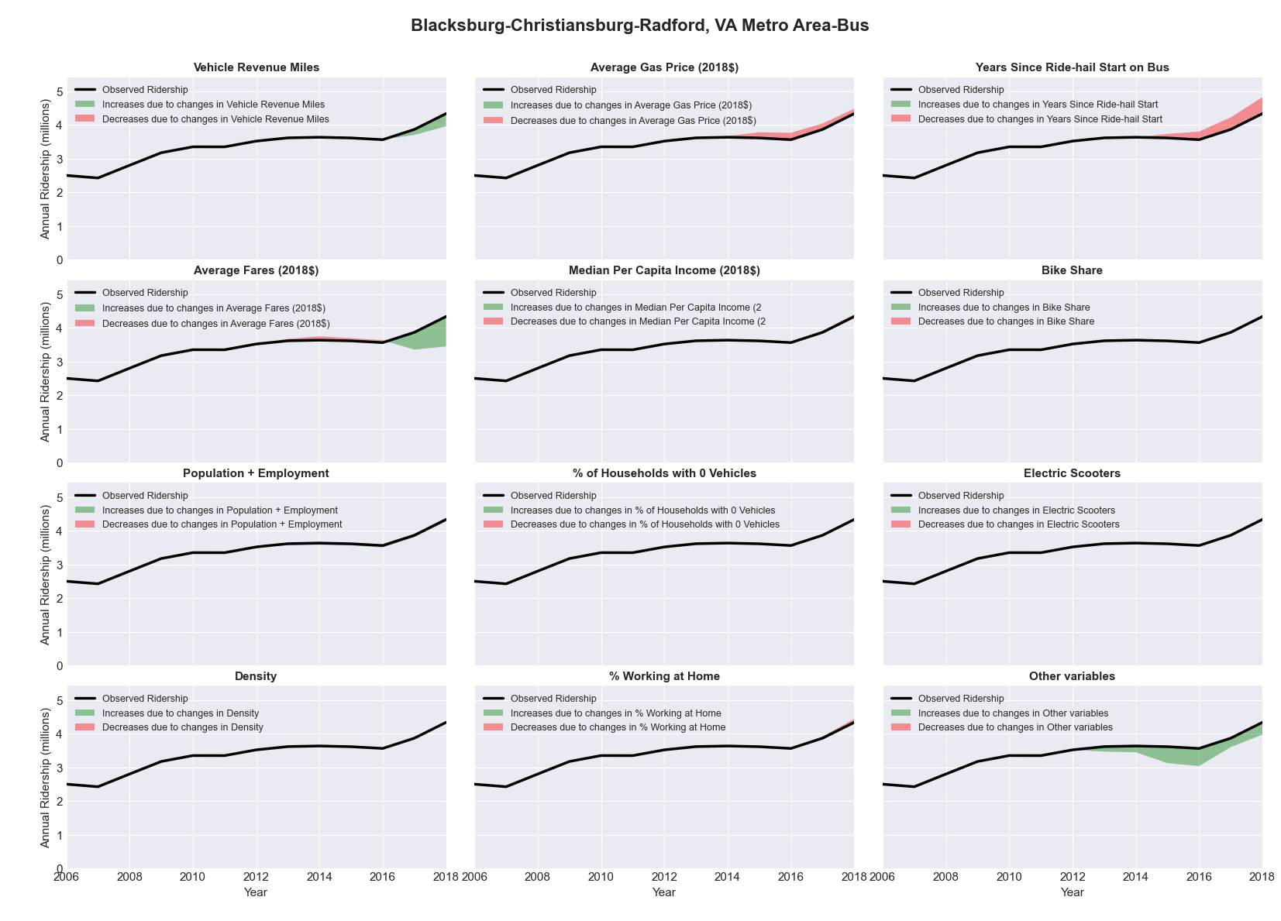

|  |  |  |  |  |  |
| --- | --- | --- | --- | --- | --- |
| Bloomington-Normal, IL Metro Area-Bus | | | | | |
|  |  |  |  |  |  |
|  | **Average Values** | | | **Ridership Effect** | |
| **Description** | **2012** | **2018** | **% Diff** | **Absolute** | **% Diff** |
|  |  |  |  |  |  |
| **Vehicle Revenue Miles** | 1,314,720 | 1,296,250 | -1.4% | -9,040 | **-0.4%** |
| **Average Fare (2018$)** | 0.57 | 0.45 | -21.3% | 99,570 | **4.1%** |
| **Network Restructure** | - | - | - | - | **0.0%** |
| **Major Maintenance Event** | - | - | - | - | **0.0%** |
| **Population + Employment** | 260,810 | 271,310 | 4.0% | 16,480 | **0.7%** |
| **Share of Population and Employment in Transit Supportive Density** | 0.35 | 0.37 | 6.1% | 18,560 | **0.8%** |
| **Average Gas Price (2018$)** | 3.93 | 2.72 | -30.9% | -105,480 | **-4.3%** |
| **Median Per Capita Income (2018$)** | 30,300 | 33,260 | 9.8% | -16,860 | **-0.7%** |
| **% of Households with 0 Vehicles** | 6 | 7 | 11.0% | 3,050 | **0.1%** |
| **% Working at Home** | 3.3 | 5.5 | 66.7% | -42,470 | **-1.7%** |
| **Years Since Ride-hail Start** | - | 3 | 3 | -235,630 | **-9.6%** |
| **Bike Share** | - | 1 | 1 | -23990 | **-1.0%** |
| **Electric Scooters** | - | - | - | 0 | **0.0%** |
| **New Reporters** |  |  |  | - | **0.0%** |
| **Total Modeled Ridership** | 2,450,074 | 2,178,838 | -11.07% | -271235 | **-11.1%** |
| **Total Observed Ridership** | 2,055,793 | 2,310,524 | 12.39% | 254731 | **12.4%** |
| **Unexplained Change** |  |  |  |  | **23.5%** |

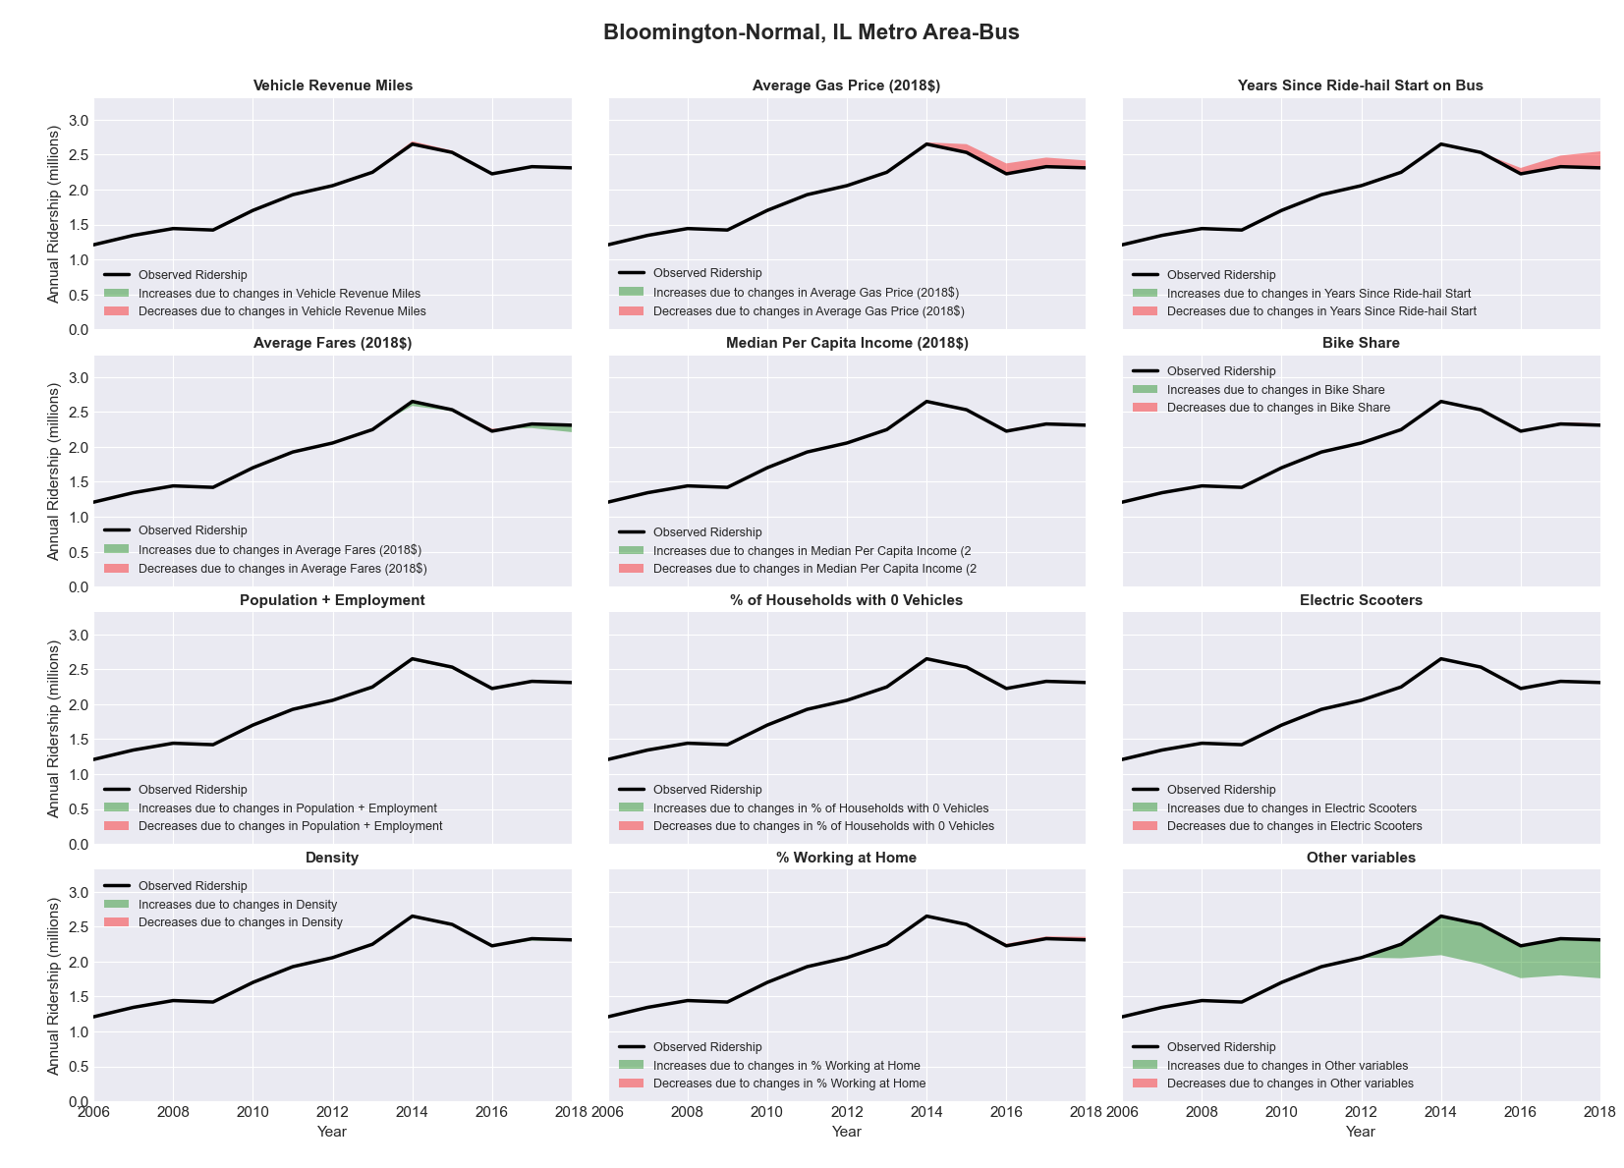

|  |  |  |  |  |  |
| --- | --- | --- | --- | --- | --- |
| Bloomington, IN Metro Area-Bus | | | | | |
|  |  |  |  |  |  |
|  | **Average Values** | | | **Ridership Effect** | |
| **Description** | **2012** | **2018** | **% Diff** | **Absolute** | **% Diff** |
|  |  |  |  |  |  |
| **Vehicle Revenue Miles** | 999,980 | 982,940 | -1.7% | -25,170 | **-0.7%** |
| **Average Fare (2018$)** | 0.49 | 0.52 | 5.8% | -36,910 | **-1.0%** |
| **Network Restructure** | - | - | - | - | **0.0%** |
| **Major Maintenance Event** | - | - | - | - | **0.0%** |
| **Population + Employment** | 278,360 | 254,530 | -8.6% | -64,610 | **-1.7%** |
| **Share of Population and Employment in Transit Supportive Density** | 0.28 | 0.28 | -2.1% | -8,400 | **-0.2%** |
| **Average Gas Price (2018$)** | 3.93 | 2.72 | -30.9% | -140,960 | **-3.8%** |
| **Median Per Capita Income (2018$)** | 20,300 | 24,230 | 19.4% | -42,870 | **-1.1%** |
| **% of Households with 0 Vehicles** | 6 | 9 | 52.6% | 21,850 | **0.6%** |
| **% Working at Home** | 4.9 | 7.1 | 43.9% | -53,030 | **-1.4%** |
| **Years Since Ride-hail Start** | - | 4 | 4 | -457,500 | **-12.2%** |
| **Bike Share** | 1.00 | 1 | - | 0 | **0.0%** |
| **Electric Scooters** | - | - | - | 0 | **0.0%** |
| **New Reporters** |  |  |  | - | **0.0%** |
| **Total Modeled Ridership** | 3,755,132 | 2,956,818 | -21.26% | -798314 | **-21.3%** |
| **Total Observed Ridership** | 3,402,150 | 3,104,755 | -8.74% | -297395 | **-8.7%** |
| **Unexplained Change** |  |  |  |  | **12.5%** |

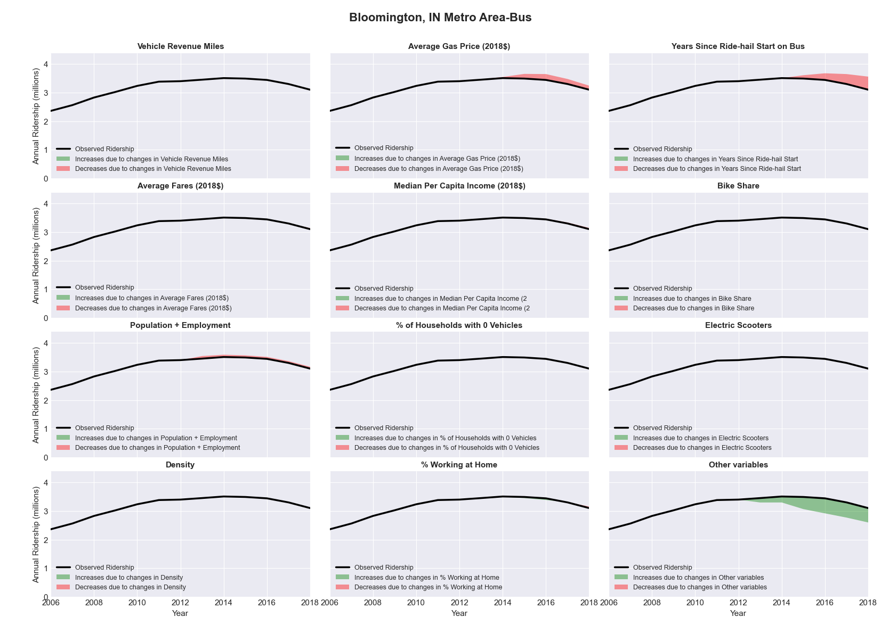

|  |  |  |  |  |  |
| --- | --- | --- | --- | --- | --- |
| Boise City-Nampa, ID Metro Area-Bus | | | | | |
|  |  |  |  |  |  |
|  | **Average Values** | | | **Ridership Effect** | |
| **Description** | **2012** | **2018** | **% Diff** | **Absolute** | **% Diff** |
|  |  |  |  |  |  |
| **Vehicle Revenue Miles** | 1,314,540 | 1,582,830 | 20.4% | 116,870 | **8.2%** |
| **Average Fare (2018$)** | 0.65 | 0.62 | -5.3% | 16,690 | **1.2%** |
| **Network Restructure** | - | - | - | - | **0.0%** |
| **Major Maintenance Event** | - | - | - | - | **0.0%** |
| **Population + Employment** | 920,980 | 1,075,500 | 16.8% | 46,970 | **3.3%** |
| **Share of Population and Employment in Transit Supportive Density** | 0.23 | 0.22 | -3.2% | -4,250 | **-0.3%** |
| **Average Gas Price (2018$)** | 3.88 | 2.89 | -25.5% | -45,930 | **-3.2%** |
| **Median Per Capita Income (2018$)** | 26,700 | 27,960 | 4.7% | -4,630 | **-0.3%** |
| **% of Households with 0 Vehicles** | 5 | 3 | -30.5% | -3,900 | **-0.3%** |
| **% Working at Home** | 6.6 | 5.8 | -11.7% | 7,510 | **0.5%** |
| **Years Since Ride-hail Start** | - | 4 | 4 | -181,430 | **-12.7%** |
| **Bike Share** | - | 1 | 1 | -15190 | **-1.1%** |
| **Electric Scooters** | - | 1 | 1 | -51680 | **-3.6%** |
| **New Reporters** |  |  |  | - | **0.0%** |
| **Total Modeled Ridership** | 1,424,445 | 1,299,135 | -8.80% | -125310 | **-8.8%** |
| **Total Observed Ridership** | 1,436,882 | 1,285,338 | -10.55% | -151544 | **-10.5%** |
| **Unexplained Change** |  |  |  |  | **-1.7%** |

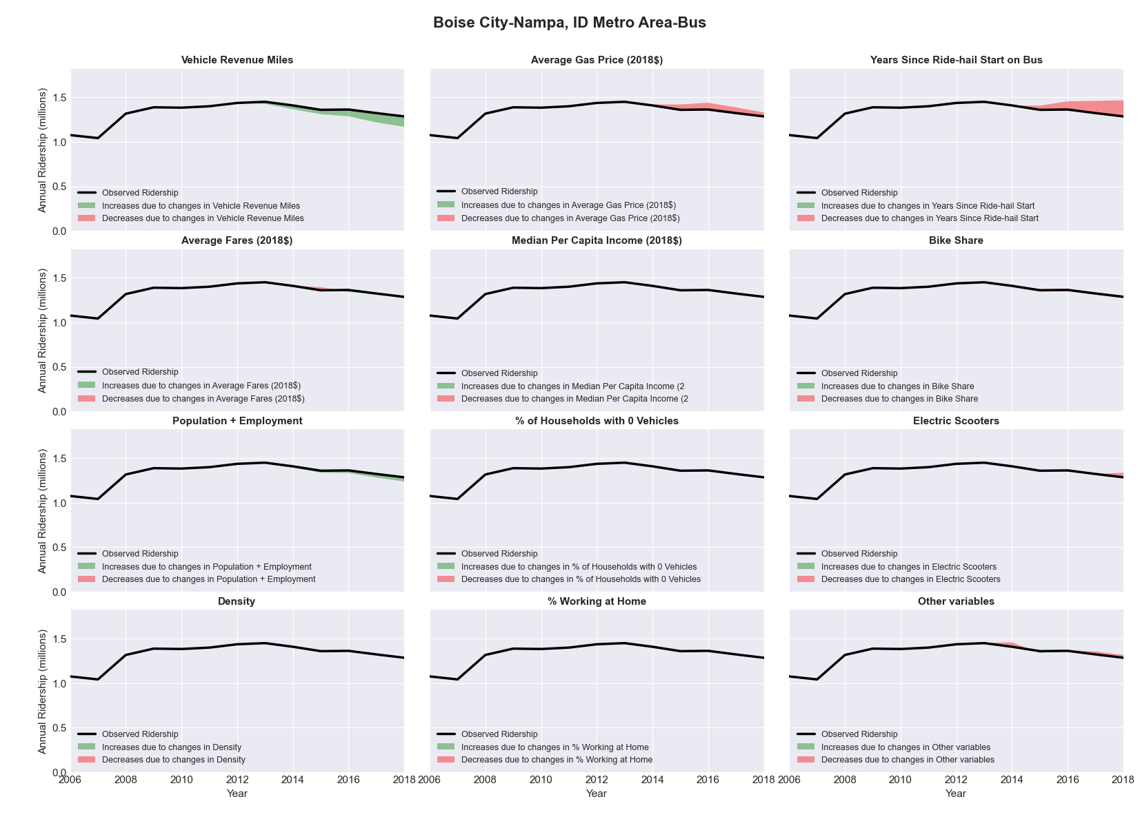

|  |  |  |  |  |  |
| --- | --- | --- | --- | --- | --- |
| Boston-Cambridge-Quincy, MA-NH Metro Area-Bus | | | | | |
|  |  |  |  |  |  |
|  | **Average Values** | | | **Ridership Effect** | |
| **Description** | **2012** | **2018** | **% Diff** | **Absolute** | **% Diff** |
|  |  |  |  |  |  |
| **Vehicle Revenue Miles** | 23,459,510 | 22,235,830 | -5.2% | -2,714,510 | **-2.0%** |
| **Average Fare (2018$)** | 0.78 | 0.98 | 25.4% | -7,018,690 | **-5.3%** |
| **Network Restructure** | - | - | - | - | **0.0%** |
| **Major Maintenance Event** | - | - | - | - | **0.0%** |
| **Population + Employment** | 6,983,270 | 7,521,850 | 7.7% | 1,892,720 | **1.4%** |
| **Share of Population and Employment in Transit Supportive Density** | 0.04 | 0.05 | 6.1% | 129,820 | **0.1%** |
| **Average Gas Price (2018$)** | 4.13 | 2.85 | -31.0% | -5,003,000 | **-3.7%** |
| **Median Per Capita Income (2018$)** | 35,660 | 41,690 | 16.9% | -1,304,940 | **-1.0%** |
| **% of Households with 0 Vehicles** | 13 | 13 | -5.0% | -152,880 | **-0.1%** |
| **% Working at Home** | 4.4 | 5.5 | 23.9% | -921,250 | **-0.7%** |
| **Years Since Ride-hail Start** | - | 6 | 6 | -13,530,990 | **-10.1%** |
| **Bike Share** | 1.00 | 1 | - | 0 | **0.0%** |
| **Electric Scooters** | - | 1 | 1 | -4450530 | **-3.3%** |
| **New Reporters** |  |  |  | - | **0.0%** |
| **Total Modeled Ridership** | 133,611,749 | 100,396,113 | -24.86% | -3.3E+07 | **-24.9%** |
| **Total Observed Ridership** | 114,604,861 | 112,160,608 | -2.13% | -244253 | **-2.1%** |
| **Unexplained Change** |  |  |  |  | **22.7%** |

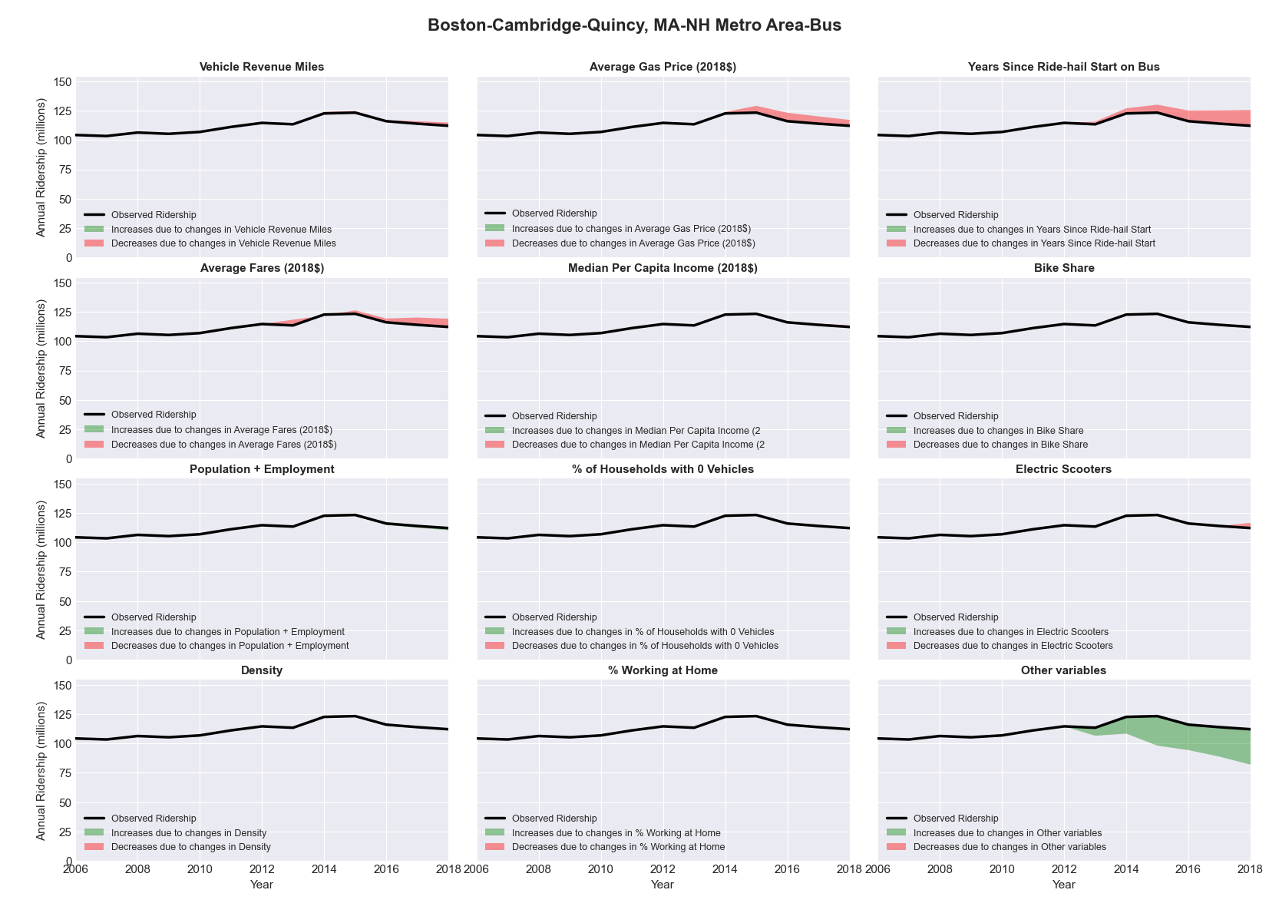

|  |  |  |  |  |  |
| --- | --- | --- | --- | --- | --- |
| Boston-Cambridge-Quincy, MA-NH Metro Area-Rail | | | | | |
|  |  |  |  |  |  |
|  | **Average Values** | | | **Ridership Effect** | |
| **Description** | **2012** | **2018** | **% Diff** | **Absolute** | **% Diff** |
|  |  |  |  |  |  |
| **Vehicle Revenue Miles** | 49,831,430 | 51,940,820 | 4.2% | 6,984,430 | **2.5%** |
| **Average Fare (2018$)** | 1.48 | 2.25 | 52.2% | -24,170,100 | **-8.8%** |
| **Network Restructure** | - | - | - | - | **0.0%** |
| **Major Maintenance Event** | - | - | - | - | **0.0%** |
| **Population + Employment** | 6,983,270 | 7,521,850 | 7.7% | 4,196,200 | **1.5%** |
| **Share of Population and Employment in Transit Supportive Density** | 0.04 | 0.05 | 6.1% | 289,110 | **0.1%** |
| **Average Gas Price (2018$)** | 4.13 | 2.85 | -31.0% | -11,013,810 | **-4.0%** |
| **Median Per Capita Income (2018$)** | 35,660 | 41,690 | 16.9% | -2,865,230 | **-1.0%** |
| **% of Households with 0 Vehicles** | 13 | 13 | -5.0% | -329,750 | **-0.1%** |
| **% Working at Home** | 4.4 | 5.5 | 23.9% | -2,069,290 | **-0.8%** |
| **Years Since Ride-hail Start** | - | 6 | 6 | 3,397,170 | **1.2%** |
| **Bike Share** | 1.00 | 1 | - | 0 | **0.0%** |
| **Electric Scooters** | - | 1 | 1 | -9618260 | **-3.5%** |
| **New Reporters** |  |  |  | - | **0.0%** |
| **Total Modeled Ridership** | 275,893,837 | 240,468,072 | -12.84% | -3.5E+07 | **-12.8%** |
| **Total Observed Ridership** | 265,206,408 | 235,388,524 | -11.24% | -3E+07 | **-11.2%** |
| **Unexplained Change** |  |  |  |  | **1.6%** |

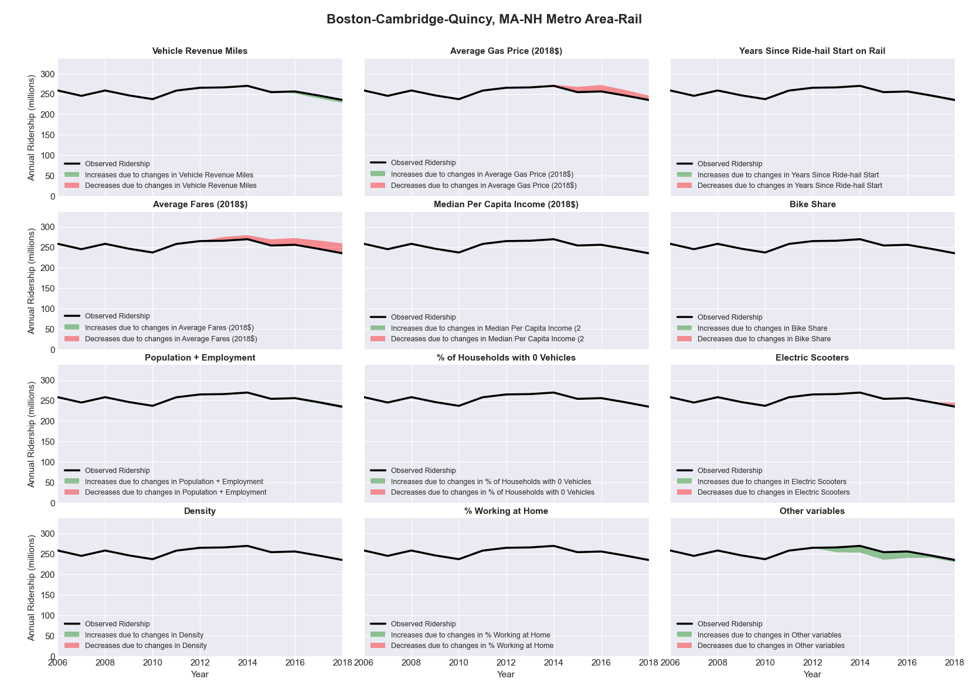

|  |  |  |  |  |  |
| --- | --- | --- | --- | --- | --- |
| Bremerton-Silverdale, WA Metro Area-Bus | | | | | |
|  |  |  |  |  |  |
|  | **Average Values** | | | **Ridership Effect** | |
| **Description** | **2012** | **2018** | **% Diff** | **Absolute** | **% Diff** |
|  |  |  |  |  |  |
| **Vehicle Revenue Miles** | 1,964,660 | 2,178,080 | 10.9% | 124,370 | **4.7%** |
| **Average Fare (2018$)** | 2.01 | 1.44 | -28.7% | 339,660 | **12.8%** |
| **Network Restructure** | - | - | - | - | **0.0%** |
| **Major Maintenance Event** | - | - | - | - | **0.0%** |
| **Population + Employment** | 361,930 | 384,610 | 6.3% | 36,240 | **1.4%** |
| **Share of Population and Employment in Transit Supportive Density** | 0.09 | 0.10 | 12.7% | 13,230 | **0.5%** |
| **Average Gas Price (2018$)** | 4.35 | 3.40 | -21.8% | -84,170 | **-3.2%** |
| **Median Per Capita Income (2018$)** | 33,010 | 38,390 | 16.3% | -27,540 | **-1.0%** |
| **% of Households with 0 Vehicles** | 6 | 5 | -5.3% | -1,490 | **-0.1%** |
| **% Working at Home** | 7.4 | 8.4 | 12.8% | -15,570 | **-0.6%** |
| **Years Since Ride-hail Start** | - | 3 | 3 | -264,090 | **-9.9%** |
| **Bike Share** | - | - | - | 0 | **0.0%** |
| **Electric Scooters** | - | - | - | 0 | **0.0%** |
| **New Reporters** |  |  |  | - | **0.0%** |
| **Total Modeled Ridership** | 2,658,409 | 2,766,310 | 4.06% | 107901.2 | **4.1%** |
| **Total Observed Ridership** | 2,875,831 | 2,510,211 | -12.71% | -365620 | **-12.7%** |
| **Unexplained Change** |  |  |  |  | **-16.8%** |

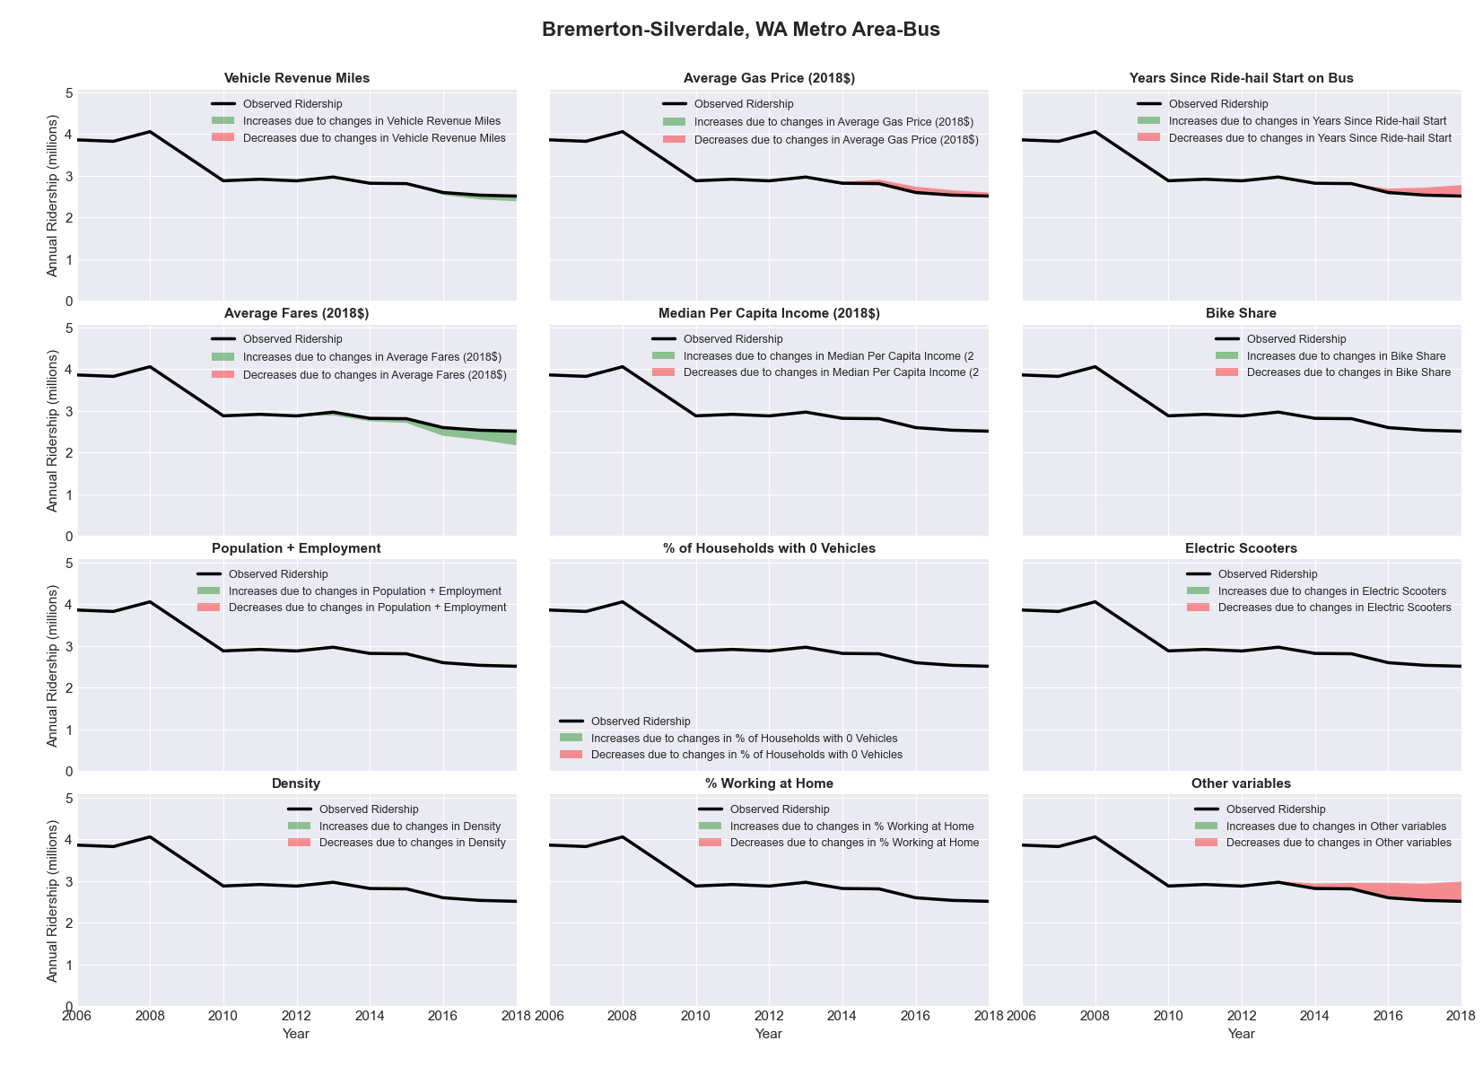

|  |  |  |  |  |  |
| --- | --- | --- | --- | --- | --- |
| Bridgeport-Stamford-Norwalk, CT Metro Area-Bus | | | | | |
|  |  |  |  |  |  |
|  | **Average Values** | | | **Ridership Effect** | |
| **Description** | **2012** | **2018** | **% Diff** | **Absolute** | **% Diff** |
|  |  |  |  |  |  |
| **Vehicle Revenue Miles** | 4,570,280 | 4,211,710 | -7.8% | -332,790 | **-3.3%** |
| **Average Fare (2018$)** | 1.13 | 1.09 | -3.3% | 66,490 | **0.7%** |
| **Network Restructure** | - | - | - | - | **0.0%** |
| **Major Maintenance Event** | - | - | - | - | **0.0%** |
| **Population + Employment** | 1,370,730 | 1,415,060 | 3.2% | 67,010 | **0.7%** |
| **Share of Population and Employment in Transit Supportive Density** | 0.41 | 0.41 | 0.6% | 9,800 | **0.1%** |
| **Average Gas Price (2018$)** | 4.13 | 2.85 | -31.0% | -420,170 | **-4.2%** |
| **Median Per Capita Income (2018$)** | 38,880 | 37,720 | -3.0% | 18,440 | **0.2%** |
| **% of Households with 0 Vehicles** | 9 | 8 | -9.9% | -16,310 | **-0.2%** |
| **% Working at Home** | 5.2 | 6.4 | 22.6% | -81,790 | **-0.8%** |
| **Years Since Ride-hail Start** | - | 4 | 4 | -1,219,560 | **-12.1%** |
| **Bike Share** | - | - | - | 0 | **0.0%** |
| **Electric Scooters** | - | - | - | 0 | **0.0%** |
| **New Reporters** |  |  |  | - | **0.0%** |
| **Total Modeled Ridership** | 10,111,042 | 8,248,076 | -18.43% | -186966 | **-18.4%** |
| **Total Observed Ridership** | 9,805,041 | 7,988,956 | -18.52% | -181085 | **-18.5%** |
| **Unexplained Change** |  |  |  |  | **-0.1%** |

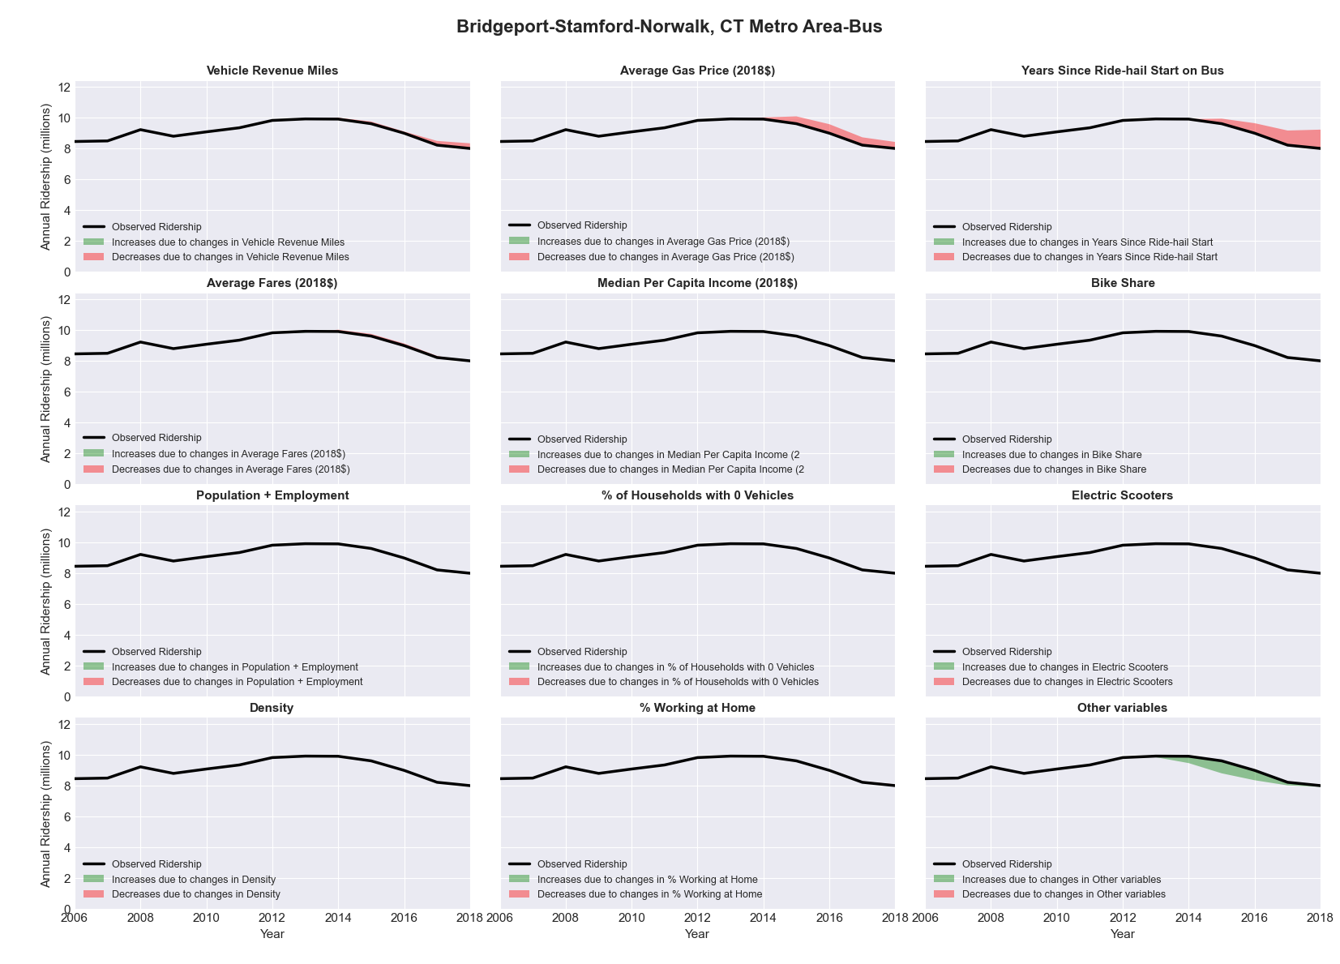

|  |  |  |  |  |  |
| --- | --- | --- | --- | --- | --- |
| Brownsville-Harlingen, TX Metro Area-Bus | | | | | |
|  |  |  |  |  |  |
|  | **Average Values** | | | **Ridership Effect** | |
| **Description** | **2012** | **2018** | **% Diff** | **Absolute** | **% Diff** |
|  |  |  |  |  |  |
| **Vehicle Revenue Miles** | 821,560 | 1,216,860 | 48.1% | 370,470 | **25.0%** |
| **Average Fare (2018$)** | 0.66 | 0.89 | 35.0% | -118,960 | **-8.0%** |
| **Network Restructure** | - | - | - | - | **0.0%** |
| **Major Maintenance Event** | - | - | - | - | **0.0%** |
| **Population + Employment** | 564,720 | 581,440 | 3.0% | 10,450 | **0.7%** |
| **Share of Population and Employment in Transit Supportive Density** | 0.28 | 0.28 | -2.1% | -4,000 | **-0.3%** |
| **Average Gas Price (2018$)** | 3.80 | 2.58 | -32.2% | -72,050 | **-4.9%** |
| **Median Per Capita Income (2018$)** | 18,190 | 19,720 | 8.4% | -8,830 | **-0.6%** |
| **% of Households with 0 Vehicles** | 10 | 8 | -17.1% | -7,150 | **-0.5%** |
| **% Working at Home** | 1.7 | 4.3 | 152.9% | -31,320 | **-2.1%** |
| **Years Since Ride-hail Start** | - | 1 | 1 | -51,700 | **-3.5%** |
| **Bike Share** | - | 1 | 1 | -16760 | **-1.1%** |
| **Electric Scooters** | - | - | - | 0 | **0.0%** |
| **New Reporters** |  |  |  | - | **0.0%** |
| **Total Modeled Ridership** | 1,482,088 | 1,466,509 | -1.05% | -15579.4 | **-1.1%** |
| **Total Observed Ridership** | 1,824,049 | 1,566,039 | -14.14% | -258010 | **-14.1%** |
| **Unexplained Change** |  |  |  |  | **-13.1%** |

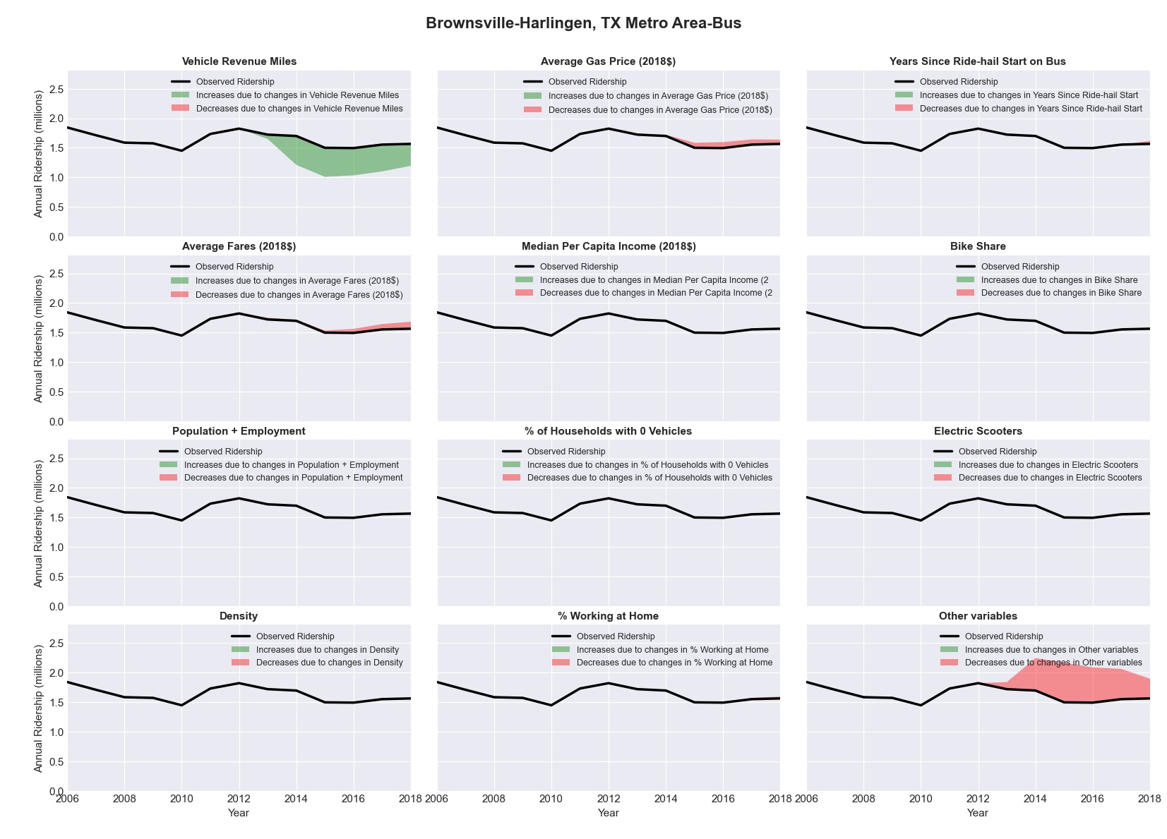

|  |  |  |  |  |  |
| --- | --- | --- | --- | --- | --- |
| Buffalo-Niagara Falls, NY Metro Area-Bus | | | | | |
|  |  |  |  |  |  |
|  | **Average Values** | | | **Ridership Effect** | |
| **Description** | **2012** | **2018** | **% Diff** | **Absolute** | **% Diff** |
|  |  |  |  |  |  |
| **Vehicle Revenue Miles** | 8,732,470 | 8,431,730 | -3.4% | -348,390 | **-1.4%** |
| **Average Fare (2018$)** | 1.27 | 1.58 | 24.5% | -1,663,980 | **-6.6%** |
| **Network Restructure** | - | - | - | - | **0.0%** |
| **Major Maintenance Event** | - | - | - | - | **0.0%** |
| **Population + Employment** | 1,653,500 | 1,664,080 | 0.6% | 29,590 | **0.1%** |
| **Share of Population and Employment in Transit Supportive Density** | 0.35 | 0.35 | -0.9% | -25,070 | **-0.1%** |
| **Average Gas Price (2018$)** | 4.11 | 2.92 | -28.9% | -838,040 | **-3.3%** |
| **Median Per Capita Income (2018$)** | 29,100 | 30,900 | 6.2% | -95,230 | **-0.4%** |
| **% of Households with 0 Vehicles** | 13 | 12 | -4.1% | -23,330 | **-0.1%** |
| **% Working at Home** | 2.3 | 3.3 | 44.6% | -174,830 | **-0.7%** |
| **Years Since Ride-hail Start** | - | 4 | 4 | -2,908,990 | **-11.6%** |
| **Bike Share** | - | 1 | 1 | -246750 | **-1.0%** |
| **Electric Scooters** | - | - | - | 0 | **0.0%** |
| **New Reporters** |  |  |  | - | **0.0%** |
| **Total Modeled Ridership** | 25,137,420 | 18,860,290 | -24.97% | 6277130 | **-25.0%** |
| **Total Observed Ridership** | 23,303,285 | 19,138,055 | -17.87% | 4165230 | **-17.9%** |
| **Unexplained Change** |  |  |  |  | **7.1%** |

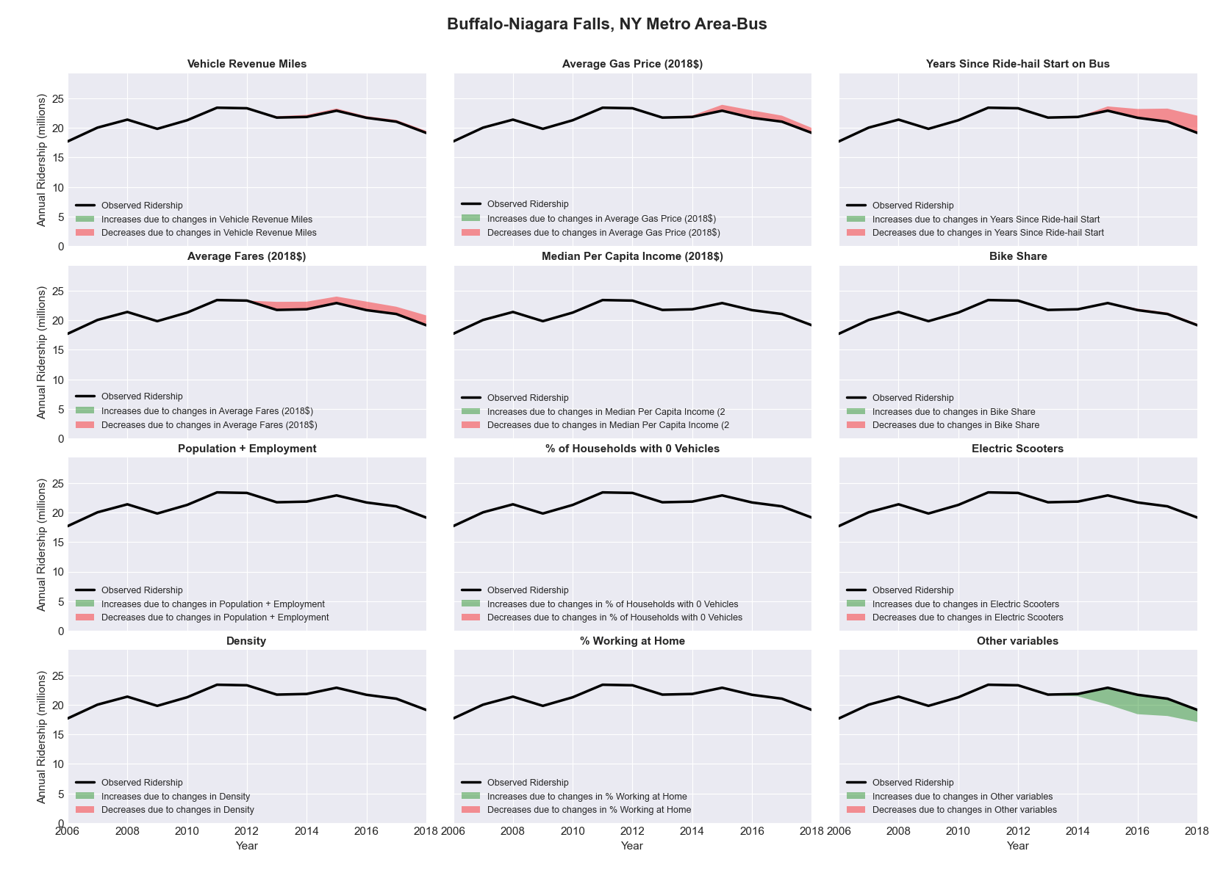

|  |  |  |  |  |  |
| --- | --- | --- | --- | --- | --- |
| Buffalo-Niagara Falls, NY Metro Area-Rail | | | | | |
|  |  |  |  |  |  |
|  | **Average Values** | | | **Ridership Effect** | |
| **Description** | **2012** | **2018** | **% Diff** | **Absolute** | **% Diff** |
|  |  |  |  |  |  |
| **Vehicle Revenue Miles** | 987,040 | 910,270 | -7.8% | -355,730 | **-6.0%** |
| **Average Fare (2018$)** | 0.83 | 1.29 | 56.5% | -491,150 | **-8.3%** |
| **Network Restructure** | - | - | - | - | **0.0%** |
| **Major Maintenance Event** | - | - | - | - | **0.0%** |
| **Population + Employment** | 1,653,500 | 1,664,080 | 0.6% | 6,570 | **0.1%** |
| **Share of Population and Employment in Transit Supportive Density** | 0.35 | 0.35 | -0.9% | -2,560 | **-0.0%** |
| **Average Gas Price (2018$)** | 4.11 | 2.92 | -28.9% | -174,890 | **-3.0%** |
| **Median Per Capita Income (2018$)** | 29,100 | 30,900 | 6.2% | -17,720 | **-0.3%** |
| **% of Households with 0 Vehicles** | 13 | 12 | -4.1% | -5,170 | **-0.1%** |
| **% Working at Home** | 2.3 | 3.3 | 44.6% | -43,880 | **-0.7%** |
| **Years Since Ride-hail Start** | - | 4 | 4 | -429,030 | **-7.3%** |
| **Bike Share** | - | 1 | 1 | -56260 | **-1.0%** |
| **Electric Scooters** | - | - | - | 0 | **0.0%** |
| **New Reporters** |  |  |  | - | **0.0%** |
| **Total Modeled Ridership** | 5,898,094 | 4,432,253 | -24.85% | -146841 | **-24.9%** |
| **Total Observed Ridership** | 6,460,209 | 4,492,168 | -30.46% | -196041 | **-30.5%** |
| **Unexplained Change** |  |  |  |  | **-5.6%** |

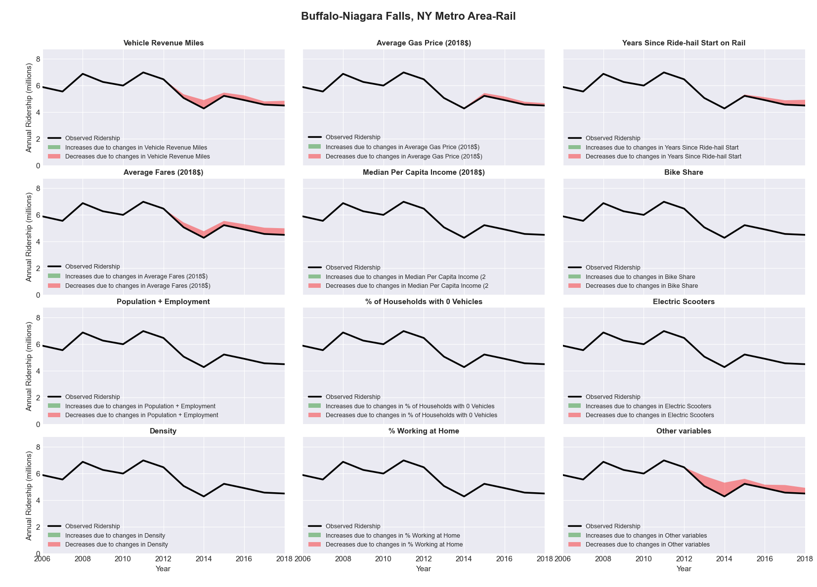

|  |  |  |  |  |  |
| --- | --- | --- | --- | --- | --- |
| Burlington-South Burlington, VT Metro Area-Bus | | | | | |
|  |  |  |  |  |  |
|  | **Average Values** | | | **Ridership Effect** | |
| **Description** | **2012** | **2018** | **% Diff** | **Absolute** | **% Diff** |
|  |  |  |  |  |  |
| **Vehicle Revenue Miles** | 1,525,590 | 1,621,080 | 6.3% | 71,500 | **2.7%** |
| **Average Fare (2018$)** | 1.00 | 0.89 | -11.3% | 75,200 | **2.9%** |
| **Network Restructure** | - | - | - | - | **0.0%** |
| **Major Maintenance Event** | - | - | - | - | **0.0%** |
| **Population + Employment** | 336,010 | 343,960 | 2.4% | 12,780 | **0.5%** |
| **Share of Population and Employment in Transit Supportive Density** | 0.20 | 0.22 | 6.6% | 14,080 | **0.5%** |
| **Average Gas Price (2018$)** | 4.13 | 2.85 | -31.0% | -110,000 | **-4.2%** |
| **Median Per Capita Income (2018$)** | 31,000 | 32,210 | 3.9% | -7,810 | **-0.3%** |
| **% of Households with 0 Vehicles** | 7 | 7 | 1.0% | -0,050 | **-0.0%** |
| **% Working at Home** | 7.2 | 5.0 | -30.9% | 44,580 | **1.7%** |
| **Years Since Ride-hail Start** | - | 4 | 4 | -325,150 | **-12.4%** |
| **Bike Share** | - | 1 | 1 | -24030 | **-0.9%** |
| **Electric Scooters** | - | - | - | 0 | **0.0%** |
| **New Reporters** |  |  |  | - | **0.0%** |
| **Total Modeled Ridership** | 2,620,784 | 2,367,837 | -9.65% | -252947 | **-9.7%** |
| **Total Observed Ridership** | 2,702,852 | 2,305,024 | -14.72% | -397828 | **-14.7%** |
| **Unexplained Change** |  |  |  |  | **-5.1%** |

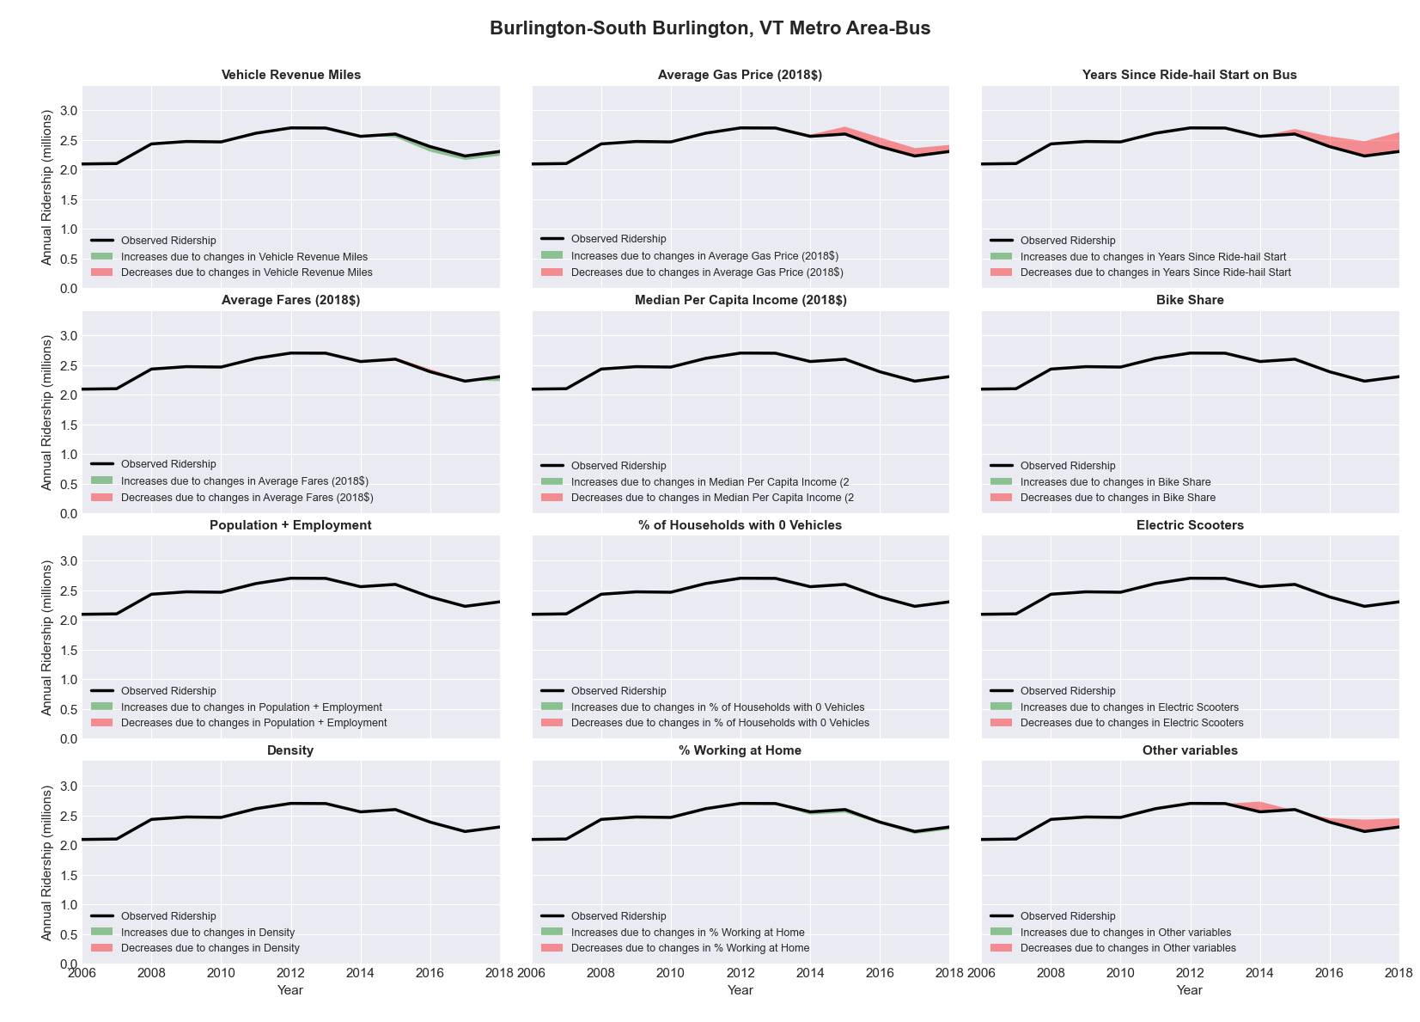

|  |  |  |  |  |  |
| --- | --- | --- | --- | --- | --- |
| Canton-Massillon, OH Metro Area-Bus | | | | | |
|  |  |  |  |  |  |
|  | **Average Values** | | | **Ridership Effect** | |
| **Description** | **2012** | **2018** | **% Diff** | **Absolute** | **% Diff** |
|  |  |  |  |  |  |
| **Vehicle Revenue Miles** | 2,116,830 | 2,311,240 | 9.2% | 97,050 | **3.7%** |
| **Average Fare (2018$)** | 0.60 | 0.60 | -0.6% | -4,710 | **-0.2%** |
| **Network Restructure** | - | - | - | - | **0.0%** |
| **Major Maintenance Event** | - | - | - | - | **0.0%** |
| **Population + Employment** | 589,970 | 589,140 | -0.1% | -0,730 | **-0.0%** |
| **Share of Population and Employment in Transit Supportive Density** | 0.11 | 0.11 | 3.1% | 3,300 | **0.1%** |
| **Average Gas Price (2018$)** | 3.93 | 2.72 | -30.9% | -109,420 | **-4.1%** |
| **Median Per Capita Income (2018$)** | 25,830 | 26,410 | 2.2% | -5,480 | **-0.2%** |
| **% of Households with 0 Vehicles** | 7 | 9 | 23.0% | 7,130 | **0.3%** |
| **% Working at Home** | 3.1 | 4.8 | 54.0% | -31,930 | **-1.2%** |
| **Years Since Ride-hail Start** | - | 4 | 4 | -325,170 | **-12.2%** |
| **Bike Share** | - | 1 | 1 | -28610 | **-1.1%** |
| **Electric Scooters** | - | - | - | 0 | **0.0%** |
| **New Reporters** |  |  |  | - | **0.0%** |
| **Total Modeled Ridership** | 2,658,570 | 2,274,911 | -14.43% | -383660 | **-14.4%** |
| **Total Observed Ridership** | 2,510,846 | 2,282,689 | -9.09% | -228157 | **-9.1%** |
| **Unexplained Change** |  |  |  |  | **5.3%** |

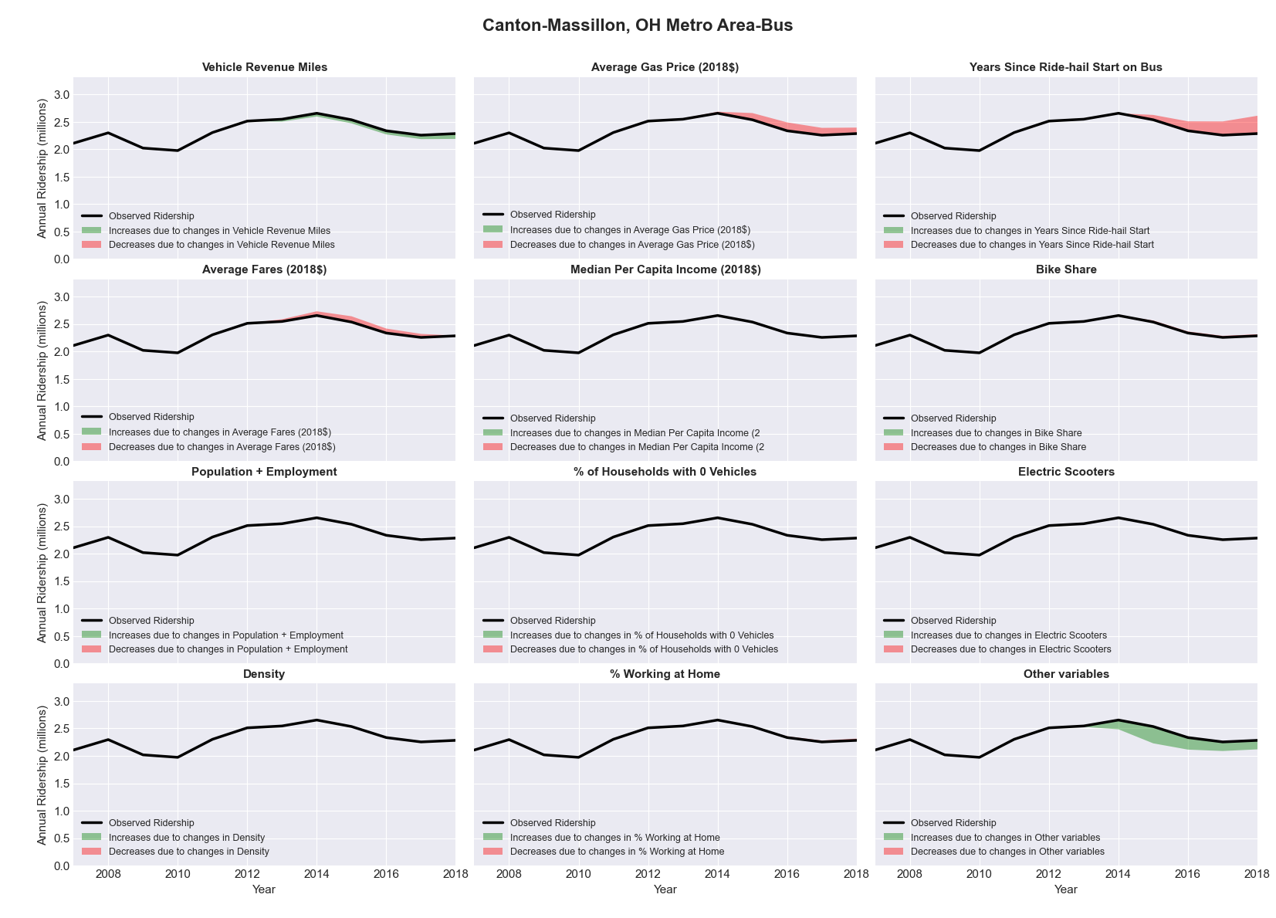

|  |  |  |  |  |  |
| --- | --- | --- | --- | --- | --- |
| Cape Coral-Fort Myers, FL Metro Area-Bus | | | | | |
|  |  |  |  |  |  |
|  | **Average Values** | | | **Ridership Effect** | |
| **Description** | **2012** | **2018** | **% Diff** | **Absolute** | **% Diff** |
|  |  |  |  |  |  |
| **Vehicle Revenue Miles** | 3,154,690 | 3,169,800 | 0.5% | 6,800 | **0.2%** |
| **Average Fare (2018$)** | 0.79 | 0.83 | 5.8% | -78,900 | **-2.0%** |
| **Network Restructure** | - | - | - | - | **0.0%** |
| **Major Maintenance Event** | - | - | - | - | **0.0%** |
| **Population + Employment** | 911,820 | 1,084,790 | 19.0% | 146,970 | **3.7%** |
| **Share of Population and Employment in Transit Supportive Density** | 0.11 | 0.10 | -8.0% | -14,510 | **-0.4%** |
| **Average Gas Price (2018$)** | 3.95 | 2.71 | -31.3% | -175,830 | **-4.4%** |
| **Median Per Capita Income (2018$)** | 26,040 | 26,910 | 3.3% | -11,340 | **-0.3%** |
| **% of Households with 0 Vehicles** | 6 | 5 | -19.8% | -9,560 | **-0.2%** |
| **% Working at Home** | 6.0 | 4.8 | -20.0% | 33,070 | **0.8%** |
| **Years Since Ride-hail Start** | - | 4 | 4 | -482,700 | **-12.0%** |
| **Bike Share** | - | - | - | 0 | **0.0%** |
| **Electric Scooters** | - | - | - | 0 | **0.0%** |
| **New Reporters** |  |  |  | - | **0.0%** |
| **Total Modeled Ridership** | 4,026,385 | 3,465,300 | -13.94% | -561085 | **-13.9%** |
| **Total Observed Ridership** | 4,073,030 | 3,206,240 | -21.28% | -866790 | **-21.3%** |
| **Unexplained Change** |  |  |  |  | **-7.3%** |

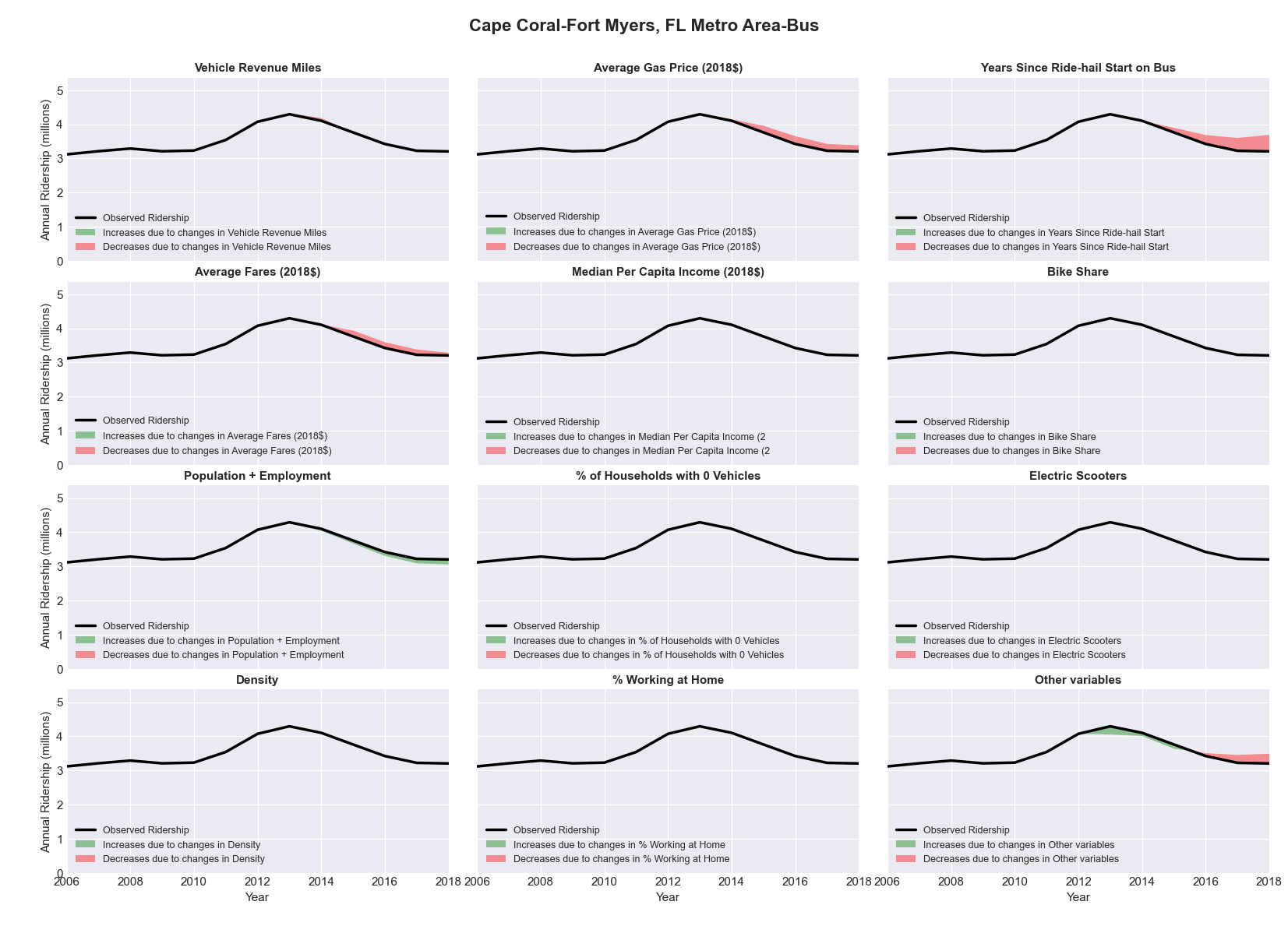

|  |  |  |  |  |  |
| --- | --- | --- | --- | --- | --- |
| Cedar Rapids, IA Metro Area-Bus | | | | | |
|  |  |  |  |  |  |
|  | **Average Values** | | | **Ridership Effect** | |
| **Description** | **2012** | **2018** | **% Diff** | **Absolute** | **% Diff** |
|  |  |  |  |  |  |
| **Vehicle Revenue Miles** | 986,810 | 1,030,730 | 4.5% | 23,630 | **1.7%** |
| **Average Fare (2018$)** | 0.69 | 0.59 | -15.0% | 44,350 | **3.3%** |
| **Network Restructure** | - | - | - | - | **0.0%** |
| **Major Maintenance Event** | - | - | - | - | **0.0%** |
| **Population + Employment** | 397,600 | 411,670 | 3.5% | 9,430 | **0.7%** |
| **Share of Population and Employment in Transit Supportive Density** | 0.18 | 0.18 | -0.6% | -0,570 | **-0.0%** |
| **Average Gas Price (2018$)** | 3.93 | 2.72 | -30.9% | -54,060 | **-4.0%** |
| **Median Per Capita Income (2018$)** | 32,200 | 33,490 | 4.0% | -3,690 | **-0.3%** |
| **% of Households with 0 Vehicles** | 6 | 3 | -56.2% | -8,520 | **-0.6%** |
| **% Working at Home** | 5.3 | 5.7 | 6.6% | -3,800 | **-0.3%** |
| **Years Since Ride-hail Start** | - | 4 | 4 | -170,420 | **-12.5%** |
| **Bike Share** | - | - | - | 0 | **0.0%** |
| **Electric Scooters** | - | - | - | 0 | **0.0%** |
| **New Reporters** |  |  |  | - | **0.0%** |
| **Total Modeled Ridership** | 1,361,056 | 1,201,180 | -11.75% | -159876 | **-11.7%** |
| **Total Observed Ridership** | 1,216,293 | 1,281,279 | 5.34% | 64986 | **5.3%** |
| **Unexplained Change** |  |  |  |  | **17.1%** |

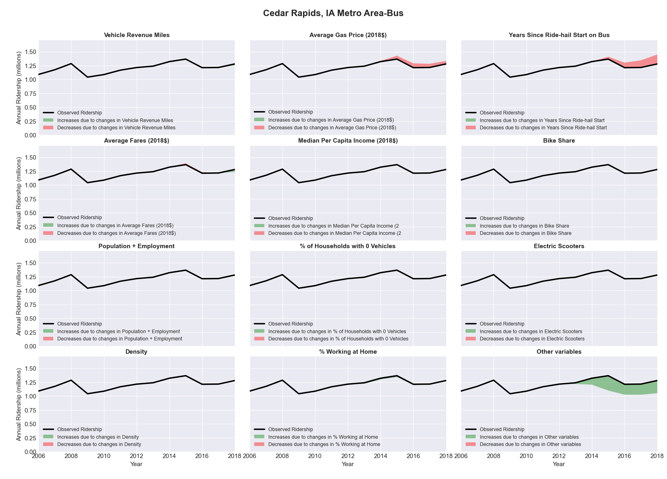

|  |  |  |  |  |  |
| --- | --- | --- | --- | --- | --- |
| Champaign-Urbana, IL Metro Area-Bus | | | | | |
|  |  |  |  |  |  |
|  | **Average Values** | | | **Ridership Effect** | |
| **Description** | **2012** | **2018** | **% Diff** | **Absolute** | **% Diff** |
|  |  |  |  |  |  |
| **Vehicle Revenue Miles** | 2,937,720 | 3,184,740 | 8.4% | 414,950 | **3.3%** |
| **Average Fare (2018$)** | 0.61 | 0.64 | 4.5% | -169,930 | **-1.3%** |
| **Network Restructure** | - | - | - | - | **0.0%** |
| **Major Maintenance Event** | - | - | - | - | **0.0%** |
| **Population + Employment** | 344,830 | 358,820 | 4.1% | 109,730 | **0.9%** |
| **Share of Population and Employment in Transit Supportive Density** | 0.33 | 0.32 | -2.9% | -51,600 | **-0.4%** |
| **Average Gas Price (2018$)** | 3.93 | 2.72 | -30.9% | -544,050 | **-4.3%** |
| **Median Per Capita Income (2018$)** | 25,720 | 25,590 | -0.5% | -14,010 | **-0.1%** |
| **% of Households with 0 Vehicles** | 11 | 12 | 4.6% | 10,100 | **0.1%** |
| **% Working at Home** | 4.6 | 6.2 | 34.8% | -111,670 | **-0.9%** |
| **Years Since Ride-hail Start** | - | 3 | 3 | -1,221,650 | **-9.6%** |
| **Bike Share** | - | 1 | 1 | -123630 | **-1.0%** |
| **Electric Scooters** | - | - | - | 0 | **0.0%** |
| **New Reporters** |  |  |  | - | **0.0%** |
| **Total Modeled Ridership** | 12,675,767 | 11,102,829 | -12.41% | -157298 | **-12.4%** |
| **Total Observed Ridership** | 11,258,845 | 11,664,375 | 3.60% | 405530 | **3.6%** |
| **Unexplained Change** |  |  |  |  | **16.0%** |

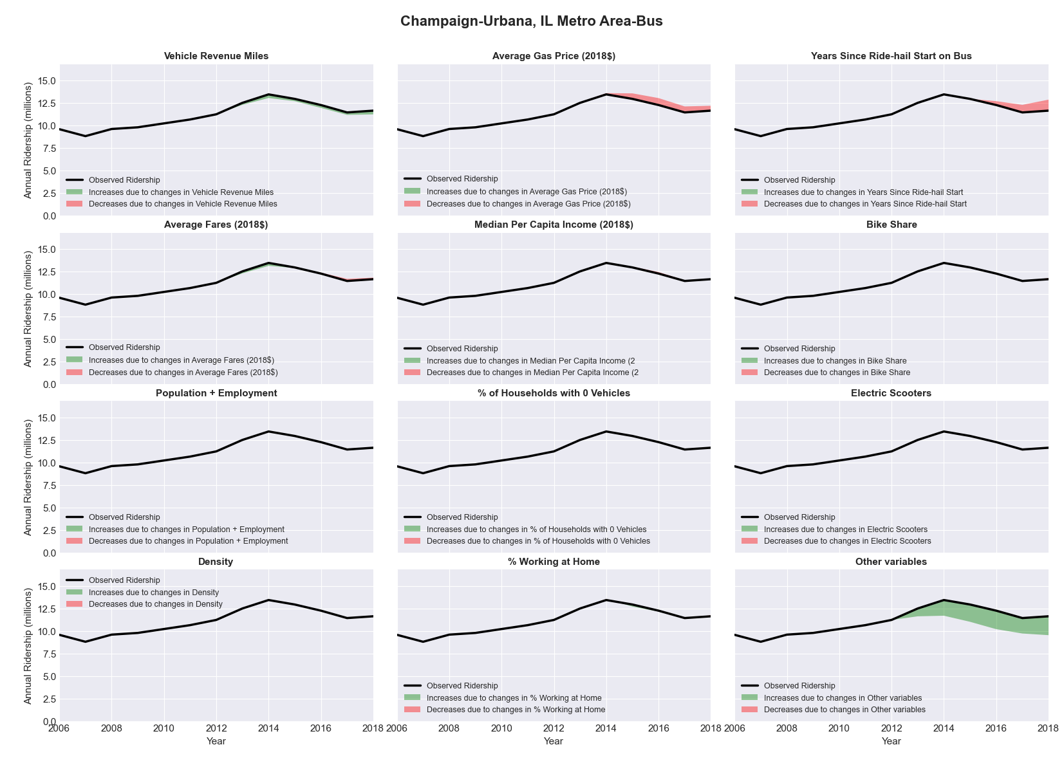

|  |  |  |  |  |  |
| --- | --- | --- | --- | --- | --- |
| Charleston-North Charleston-Summerville, SC Metro Area-Bus | | | | | |
|  |  |  |  |  |  |
|  | **Average Values** | | | **Ridership Effect** | |
| **Description** | **2012** | **2018** | **% Diff** | **Absolute** | **% Diff** |
|  |  |  |  |  |  |
| **Vehicle Revenue Miles** | 2,901,350 | 2,563,400 | -11.6% | -249,310 | **-5.0%** |
| **Average Fare (2018$)** | 0.80 | 1.63 | 102.8% | -825,920 | **-16.7%** |
| **Network Restructure** | - | - | - | - | **0.0%** |
| **Major Maintenance Event** | - | - | - | - | **0.0%** |
| **Population + Employment** | 1,014,440 | 1,157,250 | 14.1% | 130,610 | **2.6%** |
| **Share of Population and Employment in Transit Supportive Density** | 0.12 | 0.11 | -6.4% | -15,060 | **-0.3%** |
| **Average Gas Price (2018$)** | 3.95 | 2.71 | -31.3% | -216,780 | **-4.4%** |
| **Median Per Capita Income (2018$)** | 28,310 | 31,360 | 10.8% | -38,730 | **-0.8%** |
| **% of Households with 0 Vehicles** | 7 | 4 | -48.6% | -29,130 | **-0.6%** |
| **% Working at Home** | 3.7 | 7.7 | 108.1% | -128,140 | **-2.6%** |
| **Years Since Ride-hail Start** | - | 4 | 4 | -569,050 | **-11.5%** |
| **Bike Share** | - | 1 | 1 | -41200 | **-0.8%** |
| **Electric Scooters** | - | - | - | 0 | **0.0%** |
| **New Reporters** |  |  |  | - | **0.0%** |
| **Total Modeled Ridership** | 4,956,075 | 3,064,331 | -38.17% | -189744 | **-38.2%** |
| **Total Observed Ridership** | 4,859,889 | 3,064,526 | -36.94% | -179363 | **-36.9%** |
| **Unexplained Change** |  |  |  |  | **1.2%** |

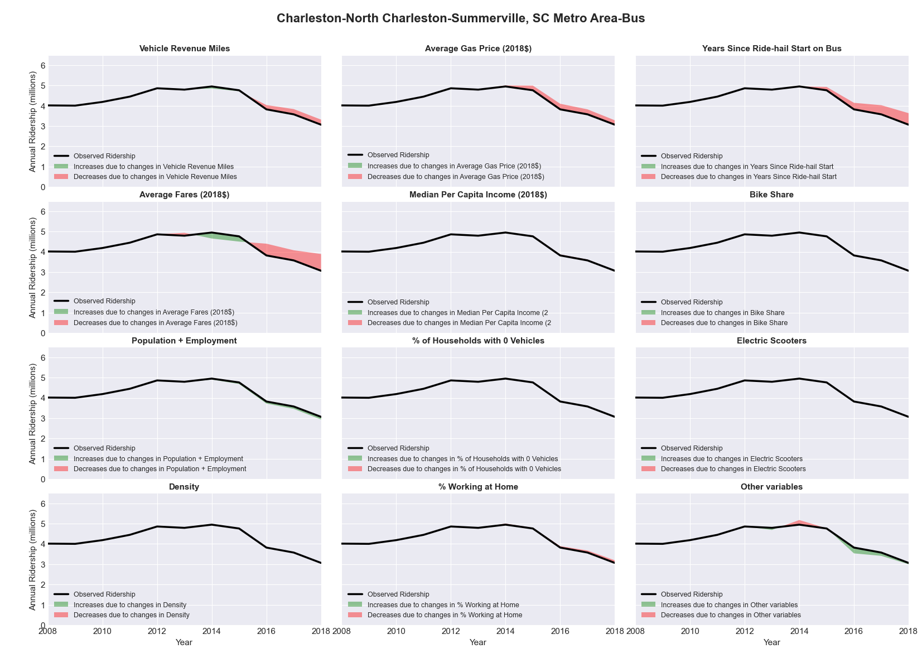

|  |  |  |  |  |  |
| --- | --- | --- | --- | --- | --- |
| Charleston, WV Metro Area-Bus | | | | | |
|  |  |  |  |  |  |
|  | **Average Values** | | | **Ridership Effect** | |
| **Description** | **2012** | **2018** | **% Diff** | **Absolute** | **% Diff** |
|  |  |  |  |  |  |
| **Vehicle Revenue Miles** | 2,499,270 | 2,288,710 | -8.4% | -93,430 | **-3.5%** |
| **Average Fare (2018$)** | 0.79 | 1.10 | 38.9% | -239,730 | **-8.9%** |
| **Network Restructure** | - | - | - | - | **0.0%** |
| **Major Maintenance Event** | - | - | - | - | **0.0%** |
| **Population + Employment** | 433,080 | 333,250 | -23.1% | -156,470 | **-5.8%** |
| **Share of Population and Employment in Transit Supportive Density** | 0.19 | 0.20 | 5.2% | 11,440 | **0.4%** |
| **Average Gas Price (2018$)** | 3.95 | 2.71 | -31.3% | -127,360 | **-4.7%** |
| **Median Per Capita Income (2018$)** | 27,230 | 25,630 | -5.9% | 12,570 | **0.5%** |
| **% of Households with 0 Vehicles** | 8 | 8 | -1.3% | 5,780 | **0.2%** |
| **% Working at Home** | 3.6 | 4.7 | 29.9% | -9,060 | **-0.3%** |
| **Years Since Ride-hail Start** | - | 4 | 4 | -288,140 | **-10.7%** |
| **Bike Share** | - | 1 | 1 | -19190 | **-0.7%** |
| **Electric Scooters** | - | - | - | 0 | **0.0%** |
| **New Reporters** |  |  |  | - | **0.0%** |
| **Total Modeled Ridership** | 2,697,262 | 1,851,219 | -31.37% | -846043 | **-31.4%** |
| **Total Observed Ridership** | 2,903,578 | 1,740,814 | -40.05% | -116764 | **-40.0%** |
| **Unexplained Change** |  |  |  |  | **-8.7%** |

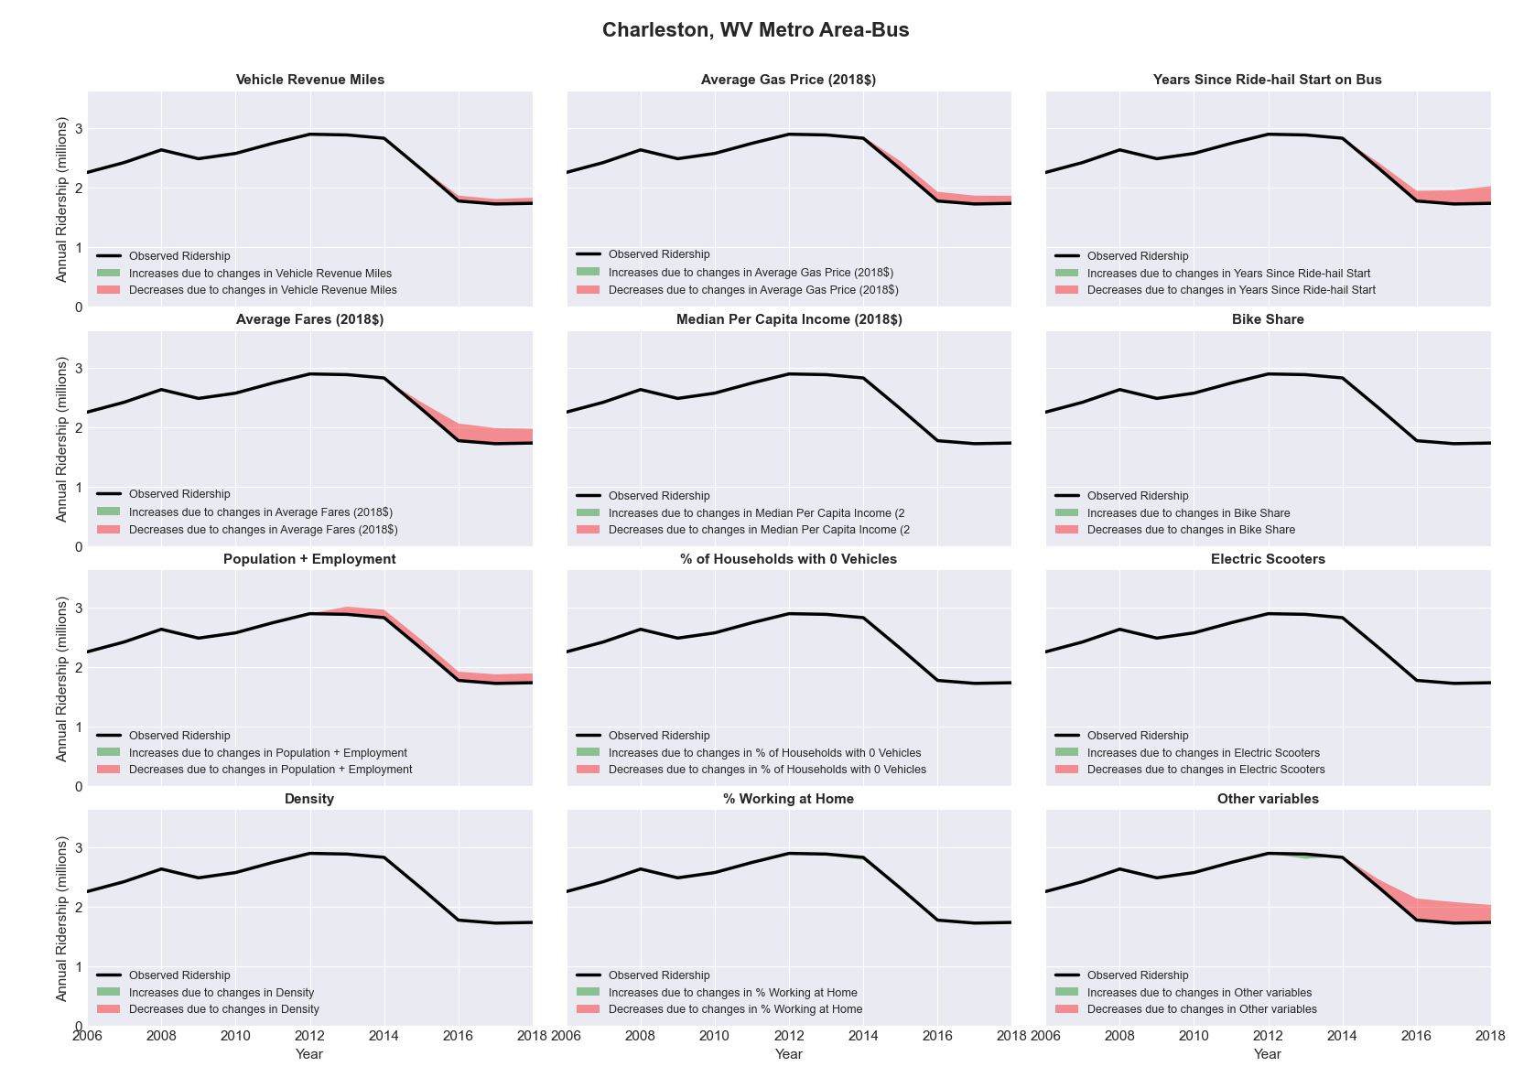

|  |  |  |  |  |  |
| --- | --- | --- | --- | --- | --- |
| Charlotte-Gastonia-Rock Hill, NC-SC Metro Area-Bus | | | | | |
|  |  |  |  |  |  |
|  | **Average Values** | | | **Ridership Effect** | |
| **Description** | **2012** | **2018** | **% Diff** | **Absolute** | **% Diff** |
|  |  |  |  |  |  |
| **Vehicle Revenue Miles** | 9,888,670 | 10,247,760 | 3.6% | 389,250 | **1.9%** |
| **Average Fare (2018$)** | 0.94 | 1.83 | 94.8% | -3,846,570 | **-18.6%** |
| **Network Restructure** | - | - | - | - | **0.0%** |
| **Major Maintenance Event** | - | - | - | - | **0.0%** |
| **Population + Employment** | 2,699,750 | 3,633,470 | 34.6% | 1,318,720 | **6.4%** |
| **Share of Population and Employment in Transit Supportive Density** | 0.12 | 0.12 | 0.7% | 7,930 | **0.0%** |
| **Average Gas Price (2018$)** | 3.95 | 2.71 | -31.3% | -884,200 | **-4.3%** |
| **Median Per Capita Income (2018$)** | 29,250 | 31,910 | 9.1% | -119,630 | **-0.6%** |
| **% of Households with 0 Vehicles** | 6 | 5 | -23.6% | -57,300 | **-0.3%** |
| **% Working at Home** | 5.9 | 7.3 | 23.3% | -169,630 | **-0.8%** |
| **Years Since Ride-hail Start** | - | 5 | 5 | -3,148,320 | **-15.3%** |
| **Bike Share** | 1.00 | 1 | - | 0 | **0.0%** |
| **Electric Scooters** | - | 1 | 1 | -622080 | **-3.0%** |
| **New Reporters** |  |  |  | - | **0.0%** |
| **Total Modeled Ridership** | 20,625,265 | 13,722,982 | -33.47% | -690283 | **-33.5%** |
| **Total Observed Ridership** | 20,850,513 | 12,881,425 | -38.22% | -796988 | **-38.2%** |
| **Unexplained Change** |  |  |  |  | **-4.8%** |

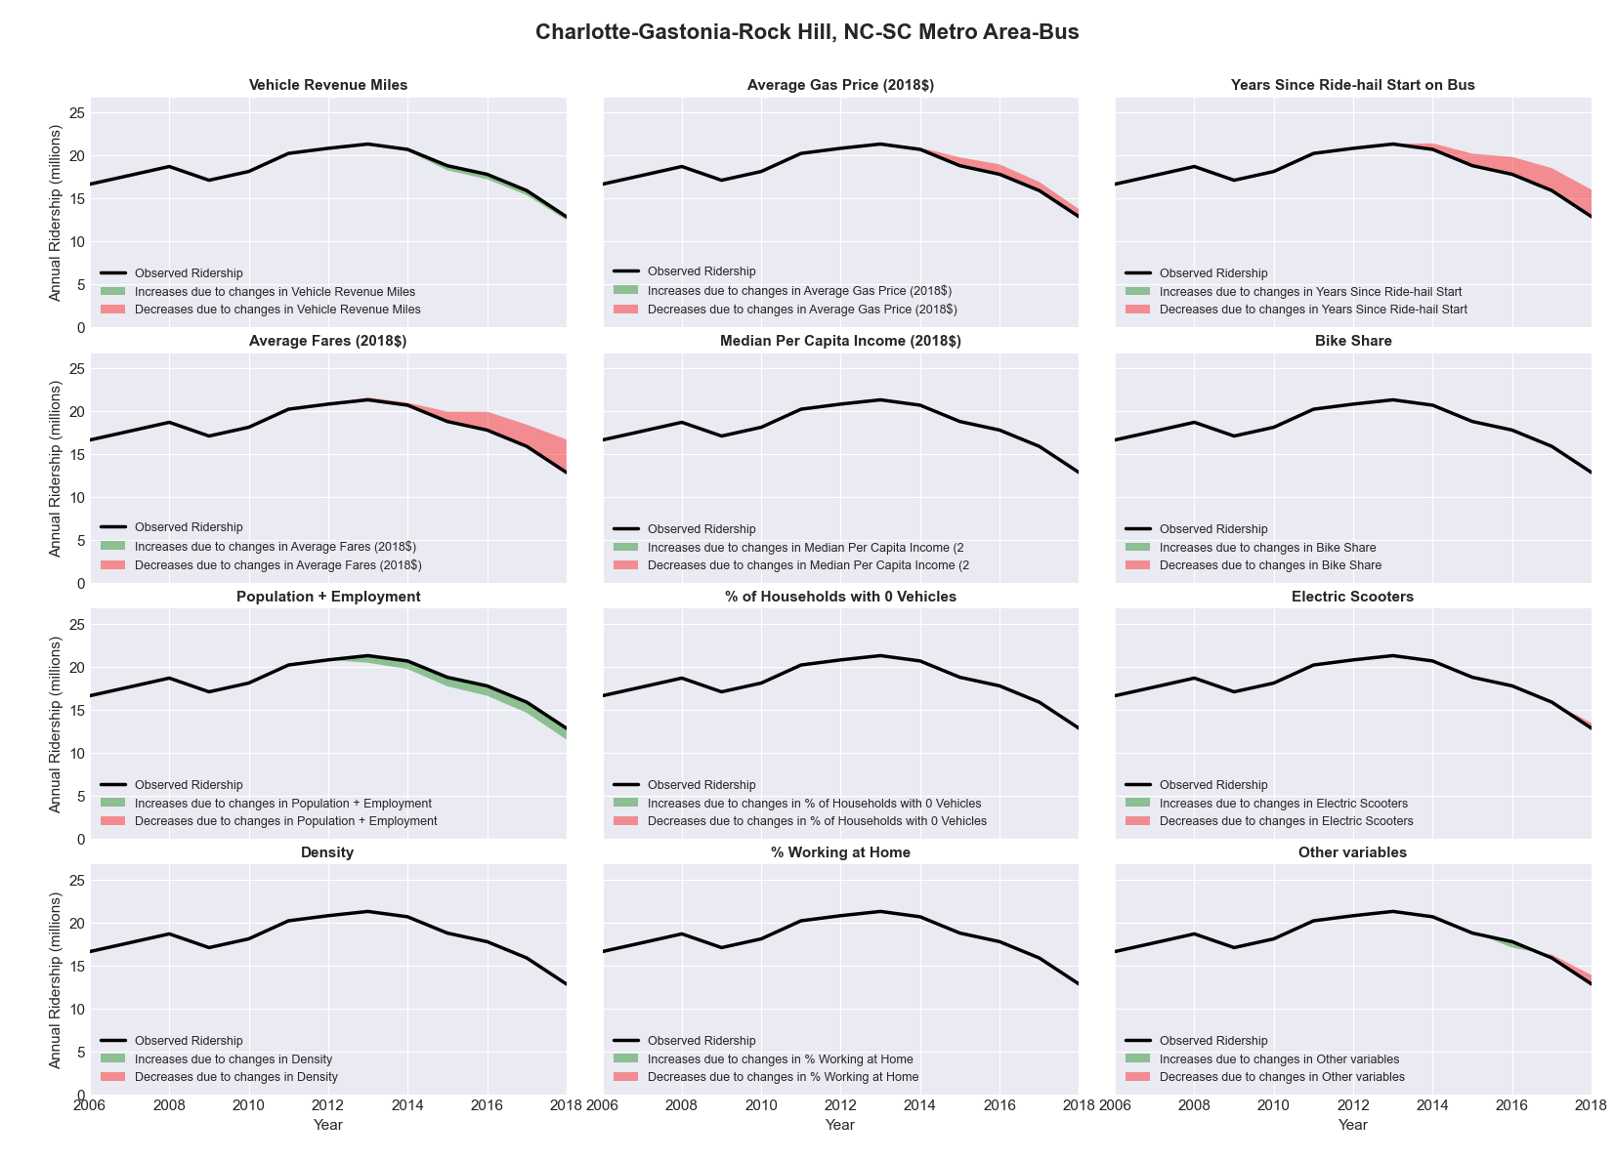

|  |  |  |  |  |  |
| --- | --- | --- | --- | --- | --- |
| Charlotte-Gastonia-Rock Hill, NC-SC Metro Area-Rail | | | | | |
|  |  |  |  |  |  |
|  | **Average Values** | | | **Ridership Effect** | |
| **Description** | **2012** | **2018** | **% Diff** | **Absolute** | **% Diff** |
|  |  |  |  |  |  |
| **Vehicle Revenue Miles** | 789,350 | 1,890,100 | 139.5% | 3,282,340 | **75.5%** |
| **Average Fare (2018$)** | 0.83 | 0.39 | -53.3% | 478,260 | **11.0%** |
| **Network Restructure** | - | - | - | - | **0.0%** |
| **Major Maintenance Event** | - | - | - | - | **0.0%** |
| **Population + Employment** | 2,699,750 | 3,633,470 | 34.6% | 297,810 | **6.8%** |
| **Share of Population and Employment in Transit Supportive Density** | 0.12 | 0.12 | 0.7% | 1,630 | **0.0%** |
| **Average Gas Price (2018$)** | 3.95 | 2.71 | -31.3% | -182,880 | **-4.2%** |
| **Median Per Capita Income (2018$)** | 29,250 | 31,910 | 9.1% | -28,710 | **-0.7%** |
| **% of Households with 0 Vehicles** | 6 | 5 | -23.6% | -13,290 | **-0.3%** |
| **% Working at Home** | 5.9 | 7.3 | 23.3% | -50,380 | **-1.2%** |
| **Years Since Ride-hail Start** | - | 5 | 5 | -526,910 | **-12.1%** |
| **Bike Share** | 1.00 | 1 | - | 0 | **0.0%** |
| **Electric Scooters** | - | 1 | 1 | -185740 | **-4.3%** |
| **New Reporters** |  |  |  | - | **0.0%** |
| **Total Modeled Ridership** | 4,350,101 | 7,346,610 | 68.88% | 2996509 | **68.9%** |
| **Total Observed Ridership** | 4,473,086 | 6,655,446 | 48.79% | 2182360 | **48.8%** |
| **Unexplained Change** |  |  |  |  | **-20.1%** |

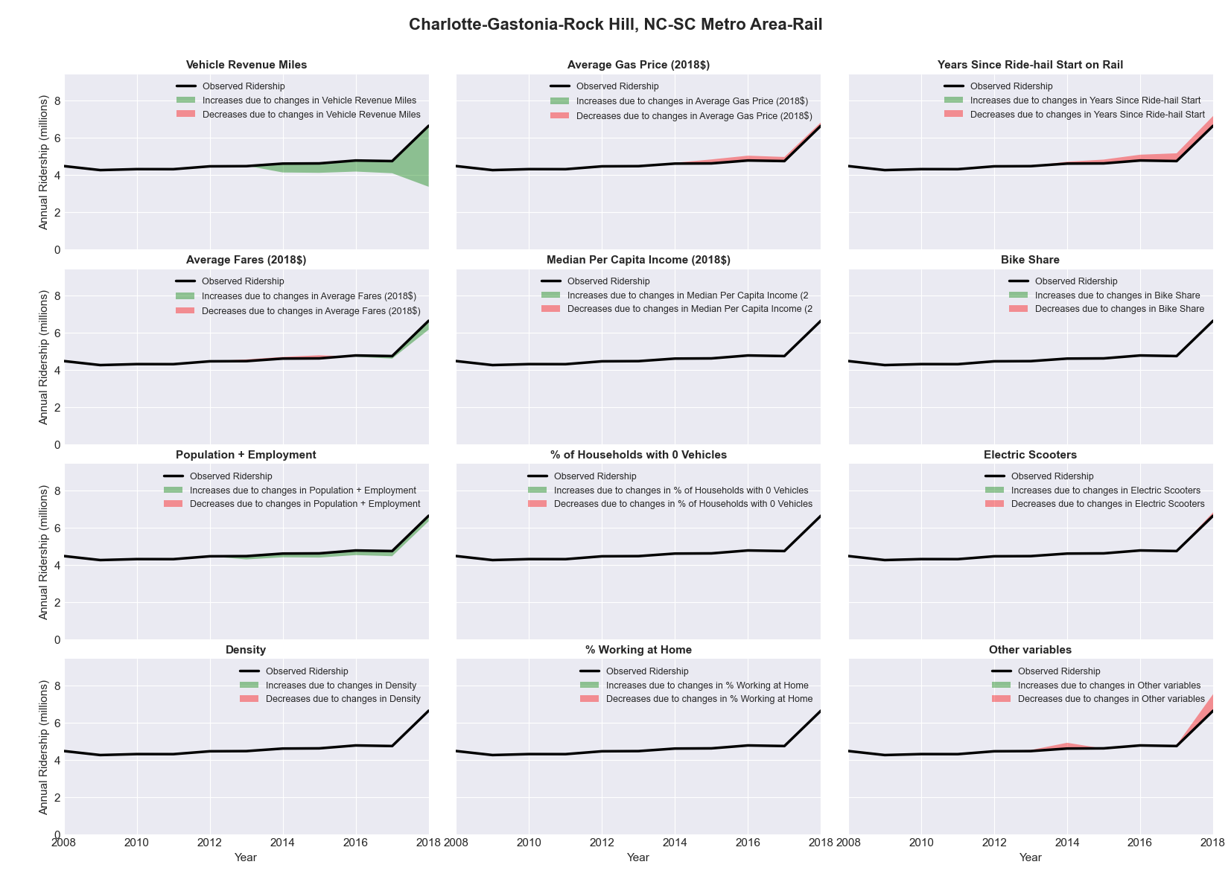

|  |  |  |  |  |  |
| --- | --- | --- | --- | --- | --- |
| Chattanooga, TN-GA Metro Area-Bus | | | | | |
|  |  |  |  |  |  |
|  | **Average Values** | | | **Ridership Effect** | |
| **Description** | **2012** | **2018** | **% Diff** | **Absolute** | **% Diff** |
|  |  |  |  |  |  |
| **Vehicle Revenue Miles** | 1,907,910 | 2,268,800 | 18.9% | 210,180 | **8.1%** |
| **Average Fare (2018$)** | 0.86 | 0.90 | 4.8% | -29,950 | **-1.2%** |
| **Network Restructure** | - | - | - | - | **0.0%** |
| **Major Maintenance Event** | - | - | - | - | **0.0%** |
| **Population + Employment** | 780,680 | 822,970 | 5.4% | 28,370 | **1.1%** |
| **Share of Population and Employment in Transit Supportive Density** | 0.12 | 0.12 | -0.7% | -1,060 | **-0.0%** |
| **Average Gas Price (2018$)** | 3.95 | 2.71 | -31.3% | -110,120 | **-4.2%** |
| **Median Per Capita Income (2018$)** | 24,300 | 28,130 | 15.8% | -26,310 | **-1.0%** |
| **% of Households with 0 Vehicles** | 7 | 5 | -23.5% | -8,700 | **-0.3%** |
| **% Working at Home** | 3.7 | 6.3 | 68.9% | -48,920 | **-1.9%** |
| **Years Since Ride-hail Start** | - | 4 | 4 | -332,380 | **-12.8%** |
| **Bike Share** | 1.00 | 1 | - | 0 | **0.0%** |
| **Electric Scooters** | - | - | - | 0 | **0.0%** |
| **New Reporters** |  |  |  | - | **0.0%** |
| **Total Modeled Ridership** | 2,599,929 | 2,275,252 | -12.49% | -324678 | **-12.5%** |
| **Total Observed Ridership** | 2,873,163 | 2,130,144 | -25.86% | -743019 | **-25.9%** |
| **Unexplained Change** |  |  |  |  | **-13.4%** |

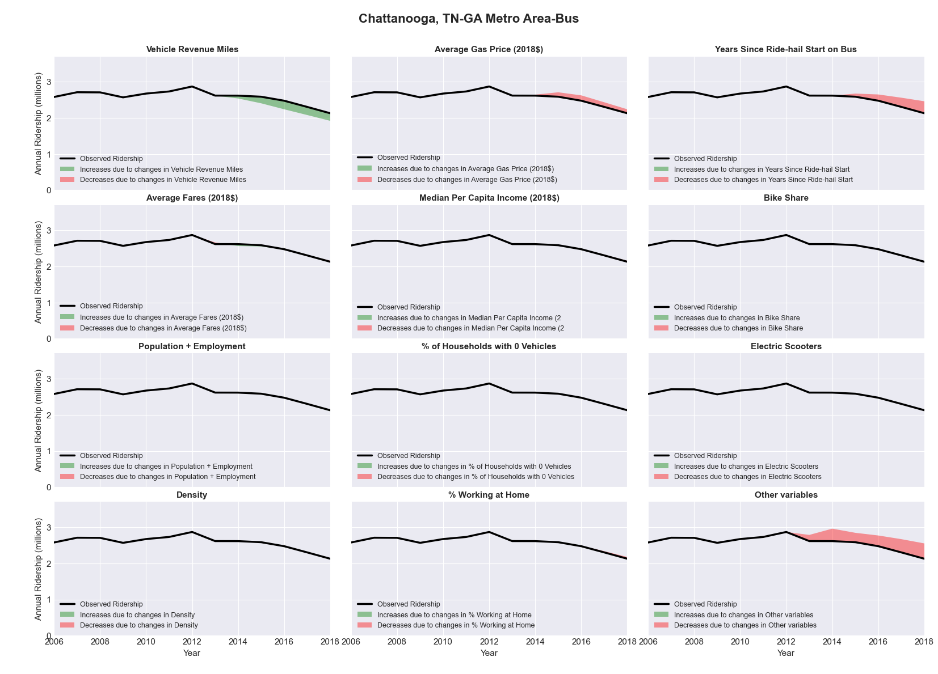

|  |  |  |  |  |  |
| --- | --- | --- | --- | --- | --- |
| Chicago-Joliet-Naperville, IL-IN-WI Metro Area-Bus | | | | | |
|  |  |  |  |  |  |
|  | **Average Values** | | | **Ridership Effect** | |
| **Description** | **2012** | **2018** | **% Diff** | **Absolute** | **% Diff** |
|  |  |  |  |  |  |
| **Vehicle Revenue Miles** | 74,171,180 | 78,482,830 | 5.8% | 7,837,860 | **2.3%** |
| **Average Fare (2018$)** | 1.00 | 1.07 | 7.4% | -8,025,620 | **-2.3%** |
| **Network Restructure** | - | - | - | - | **0.0%** |
| **Major Maintenance Event** | - | - | - | - | **0.0%** |
| **Population + Employment** | 13,960,840 | 14,226,680 | 1.9% | 1,310,400 | **0.4%** |
| **Share of Population and Employment in Transit Supportive Density** | 0.51 | 0.50 | -0.0% | 5,300 | **0.0%** |
| **Average Gas Price (2018$)** | 3.93 | 2.72 | -30.9% | -13,071,560 | **-3.8%** |
| **Median Per Capita Income (2018$)** | 31,470 | 34,240 | 8.8% | -1,847,920 | **-0.5%** |
| **% of Households with 0 Vehicles** | 13 | 12 | -4.3% | -371,410 | **-0.1%** |
| **% Working at Home** | 4.2 | 5.2 | 24.4% | -2,452,380 | **-0.7%** |
| **Years Since Ride-hail Start** | 1.0 | 7 | 6 | -35,925,310 | **-10.5%** |
| **Bike Share** | - | 1 | 1 | -3609020 | **-1.1%** |
| **Electric Scooters** | - | - | - | 0 | **0.0%** |
| **New Reporters** |  |  |  | - | **0.0%** |
| **Total Modeled Ridership** | 342,358,817 | 287,621,816 | -15.99% | -5.5E+07 | **-16.0%** |
| **Total Observed Ridership** | 348,782,215 | 271,969,765 | -22.02% | -7.7E+07 | **-22.0%** |
| **Unexplained Change** |  |  |  |  | **-6.0%** |

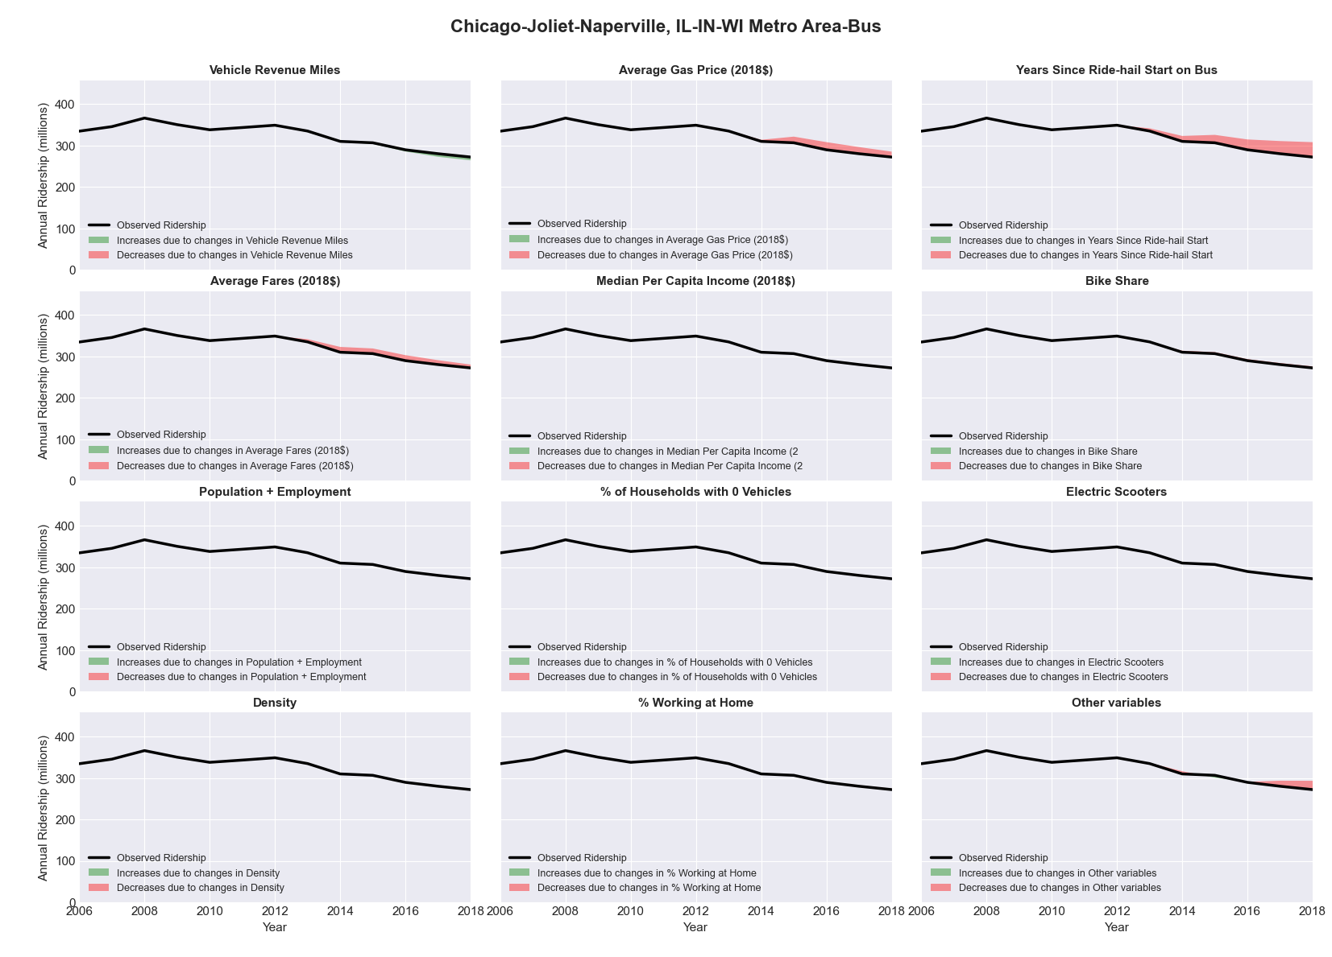

|  |  |  |  |  |  |
| --- | --- | --- | --- | --- | --- |
| Chicago-Joliet-Naperville, IL-IN-WI Metro Area-Rail | | | | | |
|  |  |  |  |  |  |
|  | **Average Values** | | | **Ridership Effect** | |
| **Description** | **2012** | **2018** | **% Diff** | **Absolute** | **% Diff** |
|  |  |  |  |  |  |
| **Vehicle Revenue Miles** | 111,850,000 | 121,364,970 | 8.5% | 16,956,210 | **5.4%** |
| **Average Fare (2018$)** | 2.05 | 2.28 | 11.4% | -7,990,450 | **-2.5%** |
| **Network Restructure** | - | - | - | - | **0.0%** |
| **Major Maintenance Event** | - | - | - | - | **0.0%** |
| **Population + Employment** | 13,960,840 | 14,226,680 | 1.9% | 1,276,810 | **0.4%** |
| **Share of Population and Employment in Transit Supportive Density** | 0.51 | 0.50 | -0.0% | -11,600 | **-0.0%** |
| **Average Gas Price (2018$)** | 3.93 | 2.72 | -30.9% | -12,601,760 | **-4.0%** |
| **Median Per Capita Income (2018$)** | 31,470 | 34,240 | 8.8% | -1,861,460 | **-0.6%** |
| **% of Households with 0 Vehicles** | 13 | 12 | -4.3% | -329,080 | **-0.1%** |
| **% Working at Home** | 4.2 | 5.2 | 24.4% | -2,450,730 | **-0.8%** |
| **Years Since Ride-hail Start** | 1.0 | 7 | 6 | 4,073,990 | **1.3%** |
| **Bike Share** | - | 1 | 1 | -3302870 | **-1.1%** |
| **Electric Scooters** | - | - | - | 0 | **0.0%** |
| **New Reporters** |  |  |  | - | **0.0%** |
| **Total Modeled Ridership** | 314,232,116 | 307,816,642 | -2.04% | -641547 | **-2.0%** |
| **Total Observed Ridership** | 309,109,150 | 297,780,958 | -3.66% | -1.1E+07 | **-3.7%** |
| **Unexplained Change** |  |  |  |  | **-1.6%** |

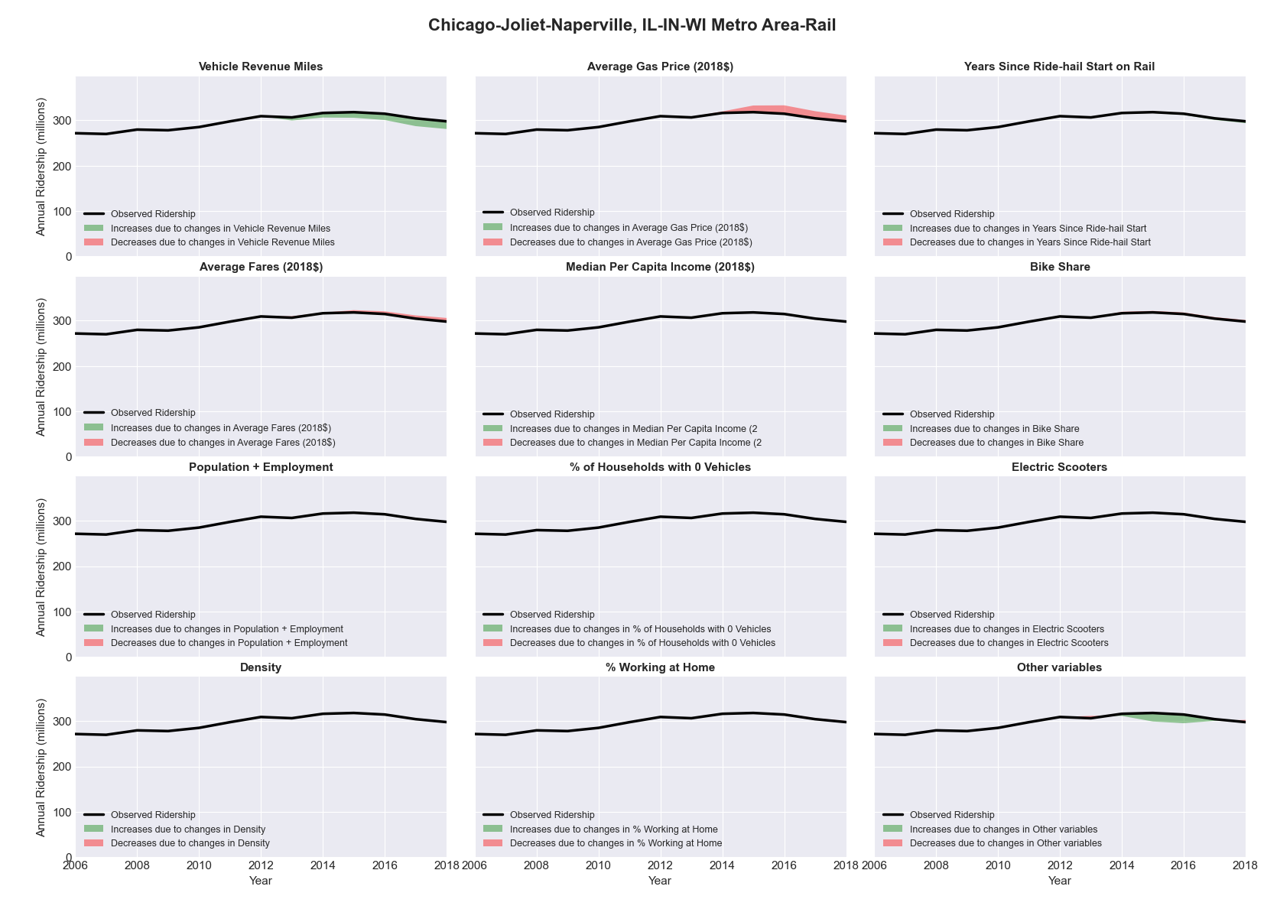

|  |  |  |  |  |  |
| --- | --- | --- | --- | --- | --- |
| Chico, CA Metro Area-Bus | | | | | |
|  |  |  |  |  |  |
|  | **Average Values** | | | **Ridership Effect** | |
| **Description** | **2012** | **2018** | **% Diff** | **Absolute** | **% Diff** |
|  |  |  |  |  |  |
| **Vehicle Revenue Miles** | 1,109,320 | 1,024,840 | -7.6% | -47,290 | **-3.6%** |
| **Average Fare (2018$)** | 1.01 | 1.25 | 23.9% | -82,270 | **-6.2%** |
| **Network Restructure** | - | - | - | - | **0.0%** |
| **Major Maintenance Event** | - | - | - | - | **0.0%** |
| **Population + Employment** | 310,250 | 330,410 | 6.5% | 17,400 | **1.3%** |
| **Share of Population and Employment in Transit Supportive Density** | 0.21 | 0.23 | 11.2% | 12,430 | **0.9%** |
| **Average Gas Price (2018$)** | 4.35 | 3.40 | -21.8% | -41,770 | **-3.1%** |
| **Median Per Capita Income (2018$)** | 22,030 | 23,330 | 5.9% | -5,160 | **-0.4%** |
| **% of Households with 0 Vehicles** | 6 | 6 | 0.2% | 0,450 | **0.0%** |
| **% Working at Home** | 6.0 | 4.4 | -26.3% | 15,160 | **1.1%** |
| **Years Since Ride-hail Start** | - | 3 | 3 | -119,700 | **-9.0%** |
| **Bike Share** | - | - | - | 0 | **0.0%** |
| **Electric Scooters** | - | - | - | 0 | **0.0%** |
| **New Reporters** |  |  |  | - | **0.0%** |
| **Total Modeled Ridership** | 1,331,001 | 1,089,797 | -18.12% | -241204 | **-18.1%** |
| **Total Observed Ridership** | 1,347,894 | 987,595 | -26.73% | -360299 | **-26.7%** |
| **Unexplained Change** |  |  |  |  | **-8.6%** |

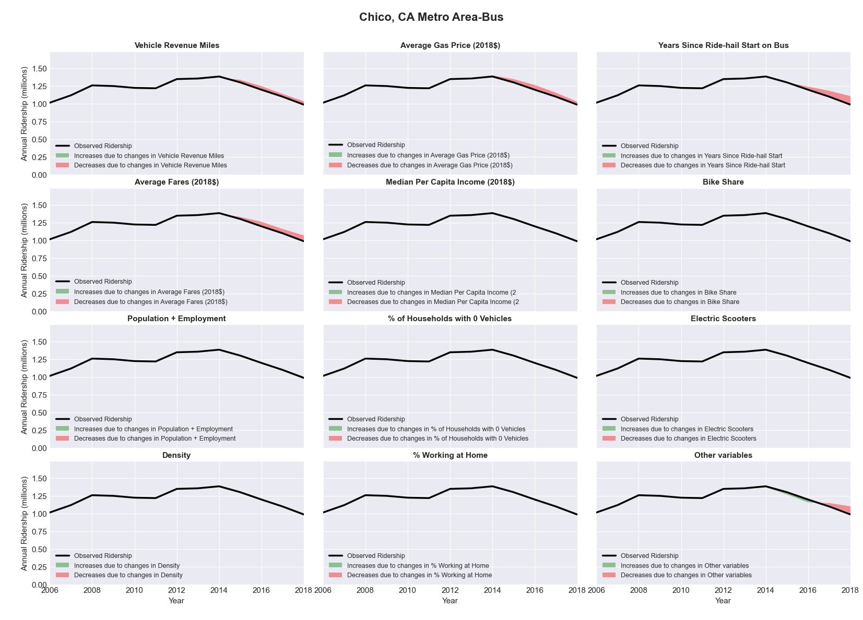

|  |  |  |  |  |  |
| --- | --- | --- | --- | --- | --- |
| Cincinnati-Middletown, OH-KY-IN Metro Area-Bus | | | | | |
|  |  |  |  |  |  |
|  | **Average Values** | | | **Ridership Effect** | |
| **Description** | **2012** | **2018** | **% Diff** | **Absolute** | **% Diff** |
|  |  |  |  |  |  |
| **Vehicle Revenue Miles** | 12,219,570 | 12,659,930 | 3.6% | 339,360 | **1.6%** |
| **Average Fare (2018$)** | 1.80 | 1.76 | -2.3% | 151,600 | **0.7%** |
| **Network Restructure** | - | - | - | - | **0.0%** |
| **Major Maintenance Event** | - | - | - | - | **0.0%** |
| **Population + Employment** | 3,149,390 | 3,274,360 | 4.0% | 160,330 | **0.8%** |
| **Share of Population and Employment in Transit Supportive Density** | 0.23 | 0.23 | 0.1% | 1,740 | **0.0%** |
| **Average Gas Price (2018$)** | 3.93 | 2.72 | -30.9% | -834,610 | **-4.1%** |
| **Median Per Capita Income (2018$)** | 29,610 | 32,130 | 8.5% | -116,180 | **-0.6%** |
| **% of Households with 0 Vehicles** | 8 | 8 | -8.0% | -25,330 | **-0.1%** |
| **% Working at Home** | 3.5 | 4.6 | 31.4% | -177,980 | **-0.9%** |
| **Years Since Ride-hail Start** | - | 4 | 4 | -2,500,160 | **-12.1%** |
| **Bike Share** | - | 1 | 1 | -218490 | **-1.1%** |
| **Electric Scooters** | - | 1 | 1 | -679130 | **-3.3%** |
| **New Reporters** |  |  |  | - | **0.0%** |
| **Total Modeled Ridership** | 20,604,699 | 16,717,892 | -18.86% | -388807 | **-18.9%** |
| **Total Observed Ridership** | 20,944,431 | 16,681,391 | -20.35% | -426340 | **-20.4%** |
| **Unexplained Change** |  |  |  |  | **-1.5%** |

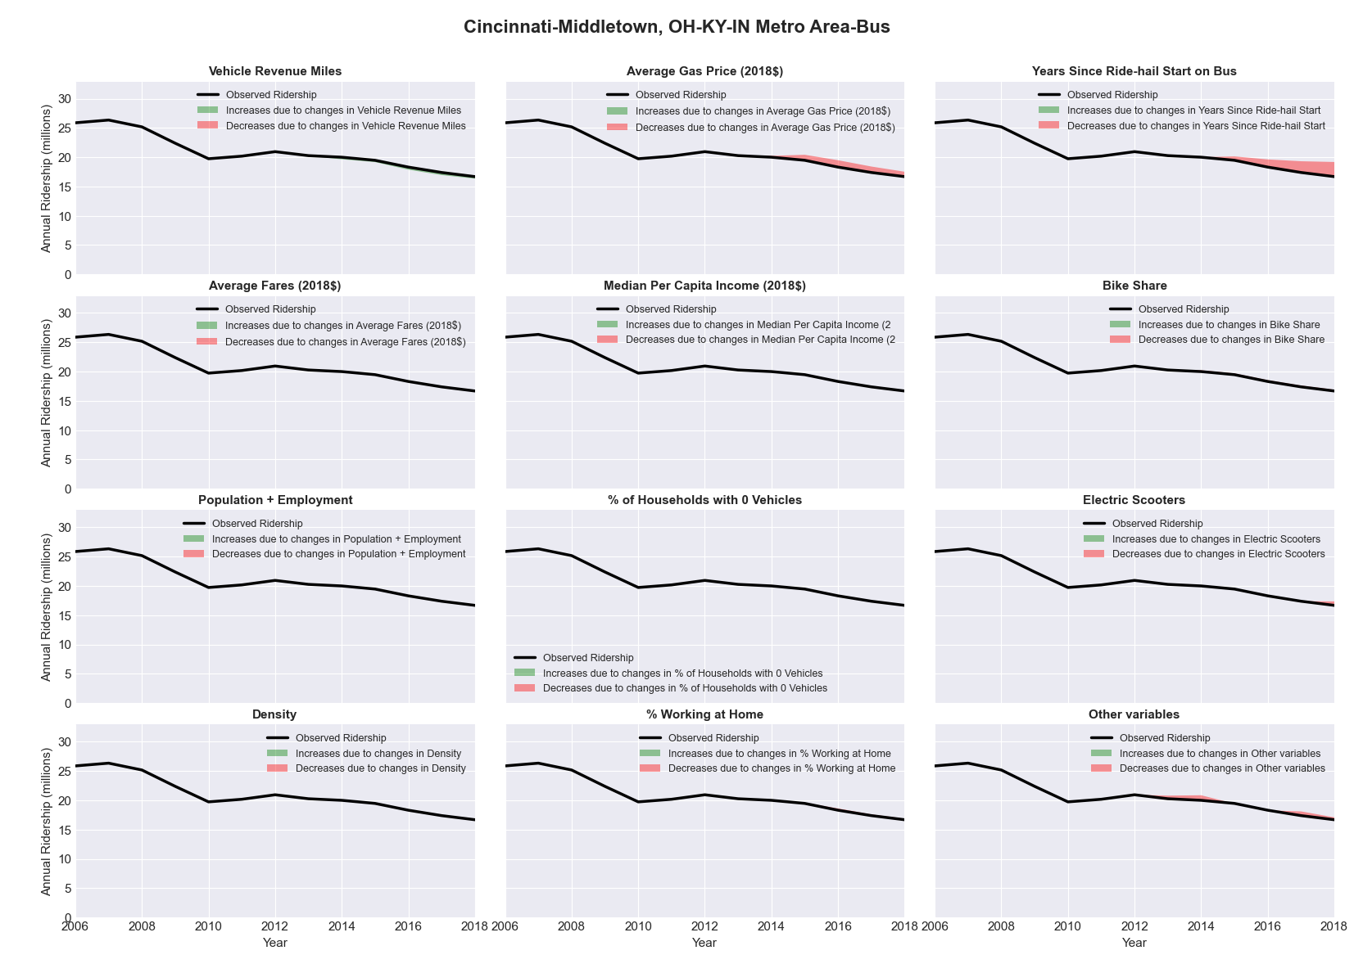

|  |  |  |  |  |  |
| --- | --- | --- | --- | --- | --- |
| Cleveland-Elyria-Mentor, OH Metro Area-Bus | | | | | |
|  |  |  |  |  |  |
|  | **Average Values** | | | **Ridership Effect** | |
| **Description** | **2012** | **2018** | **% Diff** | **Absolute** | **% Diff** |
|  |  |  |  |  |  |
| **Vehicle Revenue Miles** | 12,842,080 | 12,846,610 | 0.0% | 216,790 | **0.6%** |
| **Average Fare (2018$)** | 1.14 | 1.27 | 11.0% | -931,280 | **-2.6%** |
| **Network Restructure** | - | - | - | - | **0.0%** |
| **Major Maintenance Event** | - | - | - | - | **0.0%** |
| **Population + Employment** | 3,031,150 | 3,042,220 | 0.4% | 23,550 | **0.1%** |
| **Share of Population and Employment in Transit Supportive Density** | 0.30 | 0.30 | 0.5% | 23,750 | **0.1%** |
| **Average Gas Price (2018$)** | 3.93 | 2.72 | -30.9% | -1,582,320 | **-4.4%** |
| **Median Per Capita Income (2018$)** | 27,860 | 30,230 | 8.5% | -209,880 | **-0.6%** |
| **% of Households with 0 Vehicles** | 11 | 10 | -13.5% | -104,430 | **-0.3%** |
| **% Working at Home** | 3.6 | 4.5 | 25.0% | -242,330 | **-0.7%** |
| **Years Since Ride-hail Start** | - | 4 | 4 | -4,511,530 | **-12.6%** |
| **Bike Share** | - | 1 | 1 | -405090 | **-1.1%** |
| **Electric Scooters** | - | - | - | 0 | **0.0%** |
| **New Reporters** |  |  |  | - | **0.0%** |
| **Total Modeled Ridership** | 35,788,020 | 28,326,822 | -20.85% | -7461198 | **-20.8%** |
| **Total Observed Ridership** | 36,622,141 | 25,447,862 | -30.51% | -1.1E+07 | **-30.5%** |
| **Unexplained Change** |  |  |  |  | **-9.7%** |

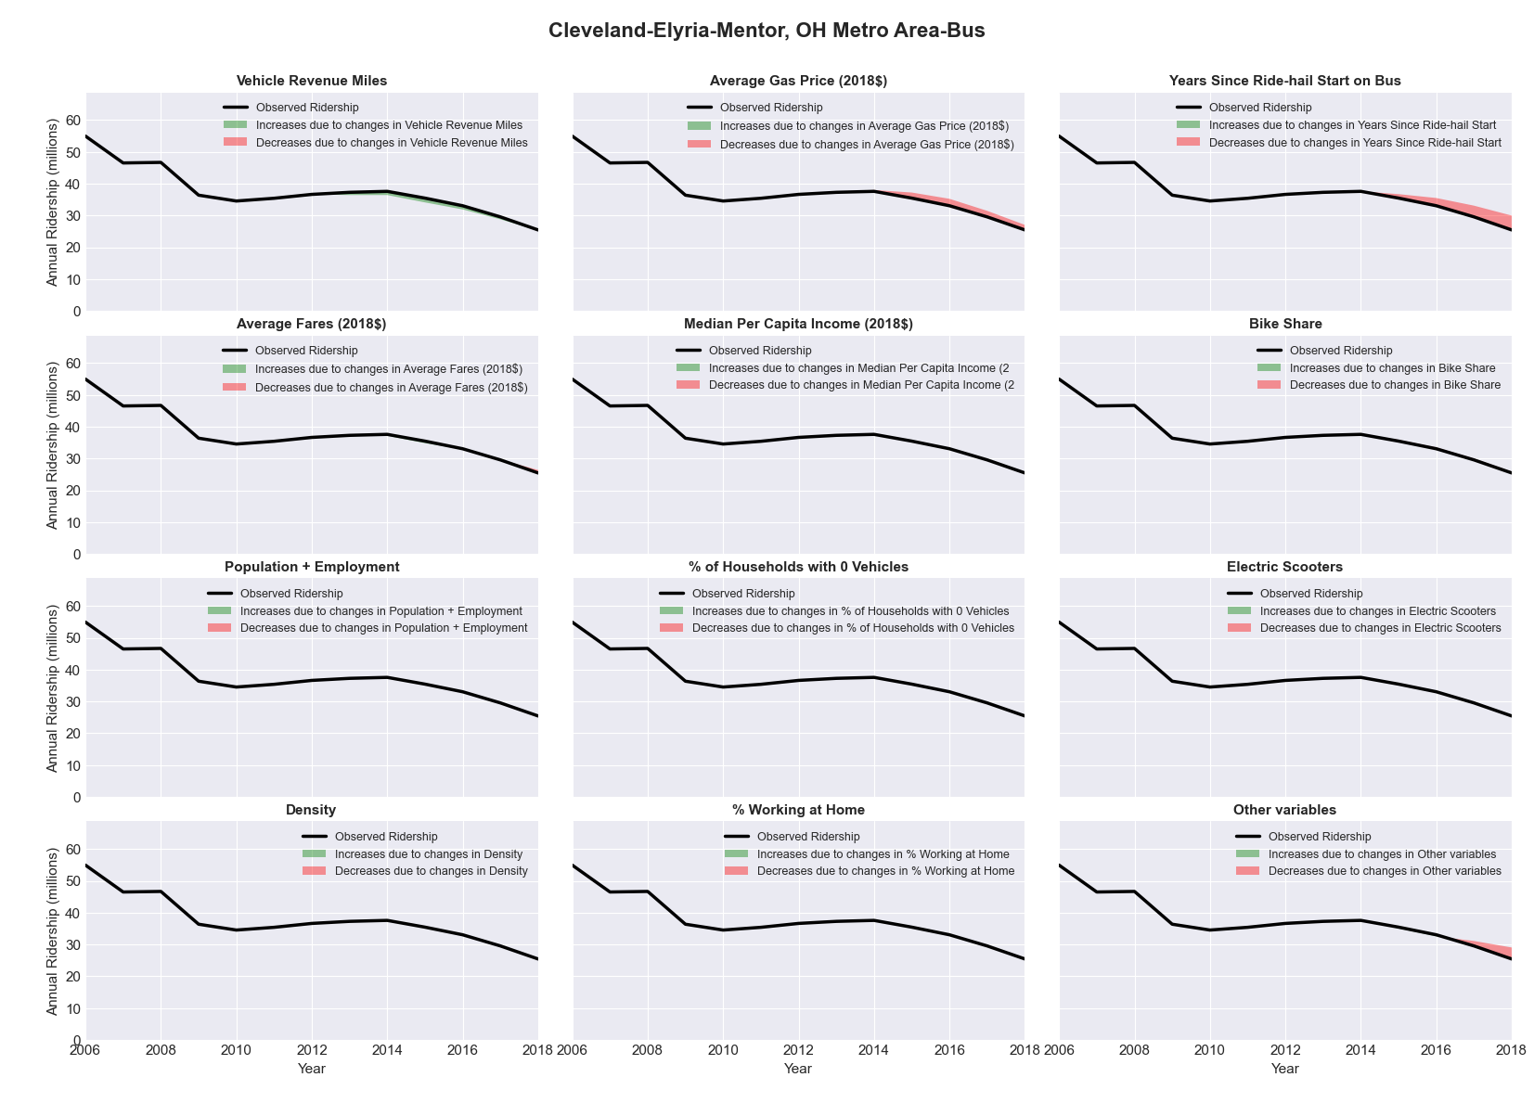

|  |  |  |  |  |  |
| --- | --- | --- | --- | --- | --- |
| Cleveland-Elyria-Mentor, OH Metro Area-Rail | | | | | |
|  |  |  |  |  |  |
|  | **Average Values** | | | **Ridership Effect** | |
| **Description** | **2012** | **2018** | **% Diff** | **Absolute** | **% Diff** |
|  |  |  |  |  |  |
| **Vehicle Revenue Miles** | 2,524,910 | 3,075,290 | 21.8% | 1,199,620 | **15.2%** |
| **Average Fare (2018$)** | 1.13 | 1.37 | 20.9% | -290,730 | **-3.7%** |
| **Network Restructure** | - | - | - | - | **0.0%** |
| **Major Maintenance Event** | - | - | - | - | **0.0%** |
| **Population + Employment** | 3,031,150 | 3,042,220 | 0.4% | 6,030 | **0.1%** |
| **Share of Population and Employment in Transit Supportive Density** | 0.30 | 0.30 | 0.5% | 5,350 | **0.1%** |
| **Average Gas Price (2018$)** | 3.93 | 2.72 | -30.9% | -348,430 | **-4.4%** |
| **Median Per Capita Income (2018$)** | 27,860 | 30,230 | 8.5% | -48,680 | **-0.6%** |
| **% of Households with 0 Vehicles** | 11 | 10 | -13.5% | -24,880 | **-0.3%** |
| **% Working at Home** | 3.6 | 4.5 | 25.0% | -58,040 | **-0.7%** |
| **Years Since Ride-hail Start** | - | 4 | 4 | -742,770 | **-9.4%** |
| **Bike Share** | - | 1 | 1 | -90960 | **-1.2%** |
| **Electric Scooters** | - | - | - | 0 | **0.0%** |
| **New Reporters** |  |  |  | - | **0.0%** |
| **Total Modeled Ridership** | 7,904,416 | 7,420,731 | -6.12% | -483685 | **-6.1%** |
| **Total Observed Ridership** | 8,543,784 | 7,430,527 | -13.03% | -1113257 | **-13.0%** |
| **Unexplained Change** |  |  |  |  | **-6.9%** |

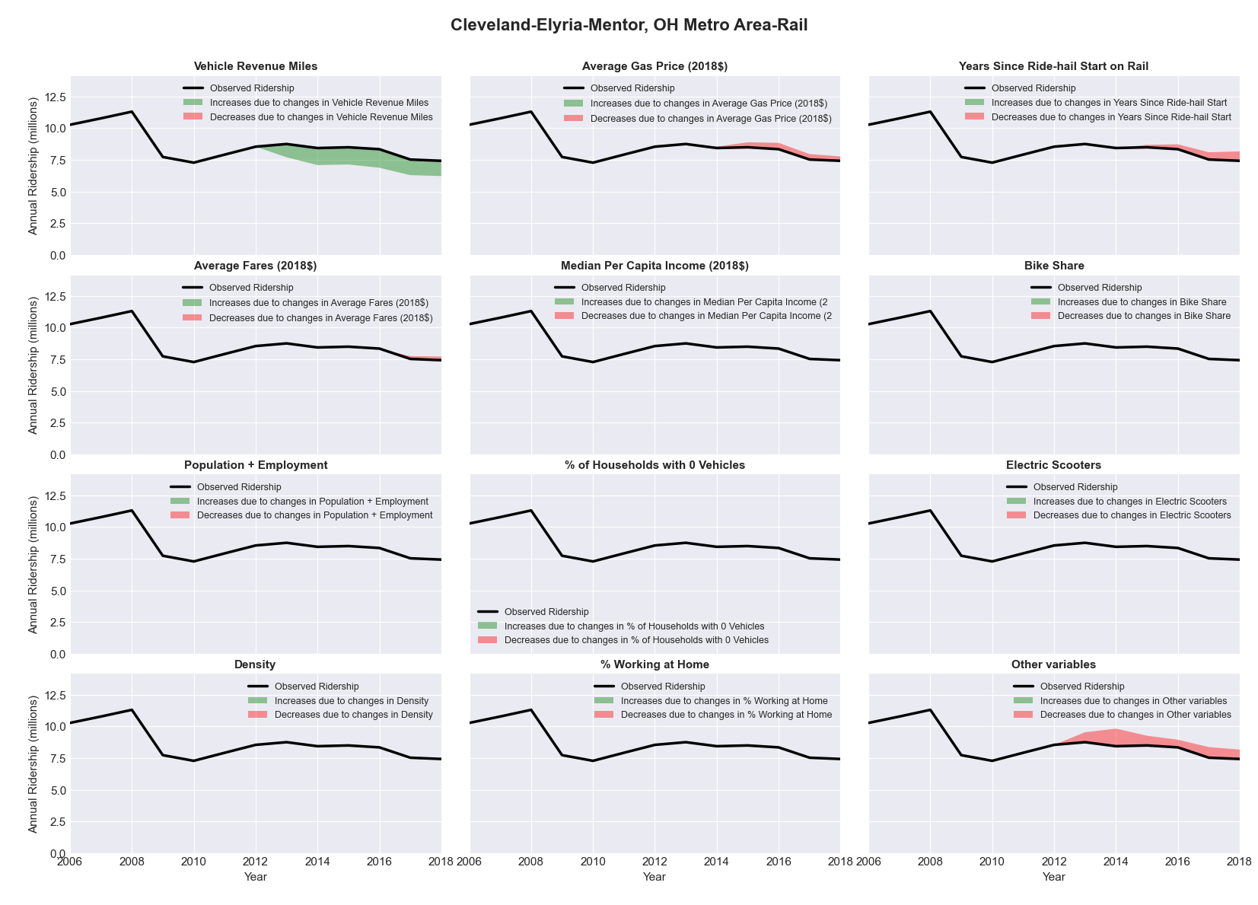

|  |  |  |  |  |  |
| --- | --- | --- | --- | --- | --- |
| Colorado Springs, CO Metro Area-Bus | | | | | |
|  |  |  |  |  |  |
|  | **Average Values** | | | **Ridership Effect** | |
| **Description** | **2012** | **2018** | **% Diff** | **Absolute** | **% Diff** |
|  |  |  |  |  |  |
| **Vehicle Revenue Miles** | 1,846,590 | 2,290,880 | 24.1% | 340,980 | **11.6%** |
| **Average Fare (2018$)** | 1.19 | 0.85 | -28.1% | 267,930 | **9.1%** |
| **Network Restructure** | - | - | - | - | **0.0%** |
| **Major Maintenance Event** | - | - | - | - | **0.0%** |
| **Population + Employment** | 959,090 | 1,076,910 | 12.3% | 75,120 | **2.5%** |
| **Share of Population and Employment in Transit Supportive Density** | 0.22 | 0.22 | -3.7% | -8,690 | **-0.3%** |
| **Average Gas Price (2018$)** | 3.88 | 2.89 | -25.5% | -86,260 | **-2.9%** |
| **Median Per Capita Income (2018$)** | 30,000 | 32,420 | 8.1% | -15,090 | **-0.5%** |
| **% of Households with 0 Vehicles** | 4 | 4 | -6.6% | -2,000 | **-0.1%** |
| **% Working at Home** | 5.5 | 7.6 | 38.2% | -47,890 | **-1.6%** |
| **Years Since Ride-hail Start** | - | 4 | 4 | -407,670 | **-13.8%** |
| **Bike Share** | - | 1 | 1 | -34410 | **-1.2%** |
| **Electric Scooters** | - | - | - | 0 | **0.0%** |
| **New Reporters** |  |  |  | - | **0.0%** |
| **Total Modeled Ridership** | 2,948,684 | 2,990,523 | 1.42% | 41838.95 | **1.4%** |
| **Total Observed Ridership** | 2,587,742 | 3,082,673 | 19.13% | 494931 | **19.1%** |
| **Unexplained Change** |  |  |  |  | **17.7%** |

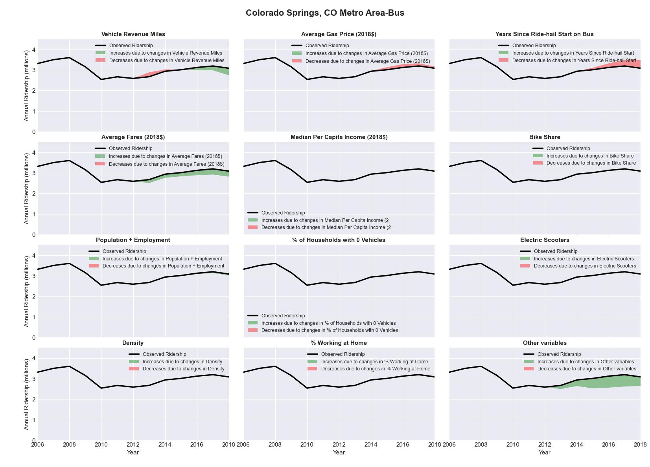

|  |  |  |  |  |  |
| --- | --- | --- | --- | --- | --- |
| Columbia, MO Metro Area-Bus | | | | | |
|  |  |  |  |  |  |
|  | **Average Values** | | | **Ridership Effect** | |
| **Description** | **2012** | **2018** | **% Diff** | **Absolute** | **% Diff** |
|  |  |  |  |  |  |
| **Vehicle Revenue Miles** | 676,370 | 730,210 | 8.0% | 94,000 | **5.3%** |
| **Average Fare (2018$)** | 0.87 | 1.22 | 39.1% | -202,850 | **-11.5%** |
| **Network Restructure** | - | - | - | - | **0.0%** |
| **Major Maintenance Event** | - | - | - | - | **0.0%** |
| **Population + Employment** | 274,690 | 279,900 | 1.9% | 7,040 | **0.4%** |
| **Share of Population and Employment in Transit Supportive Density** | 0.14 | 0.14 | 0.2% | 0,560 | **0.0%** |
| **Average Gas Price (2018$)** | 3.93 | 2.72 | -30.9% | -91,920 | **-5.2%** |
| **Median Per Capita Income (2018$)** | 26,730 | 25,620 | -4.2% | 1,500 | **0.1%** |
| **% of Households with 0 Vehicles** | 5 | 5 | 6.8% | 3,540 | **0.2%** |
| **% Working at Home** | 3.3 | 6.4 | 92.4% | -27,290 | **-1.5%** |
| **Years Since Ride-hail Start** | - | 4 | 4 | -217,960 | **-12.4%** |
| **Bike Share** | - | 1 | 1 | -14970 | **-0.8%** |
| **Electric Scooters** | - | 1 | 1 | -54210 | **-3.1%** |
| **New Reporters** |  |  |  | - | **0.0%** |
| **Total Modeled Ridership** | 1,763,845 | 1,300,695 | -26.26% | -463150 | **-26.3%** |
| **Total Observed Ridership** | 1,903,088 | 1,180,354 | -37.98% | -722734 | **-38.0%** |
| **Unexplained Change** |  |  |  |  | **-11.7%** |

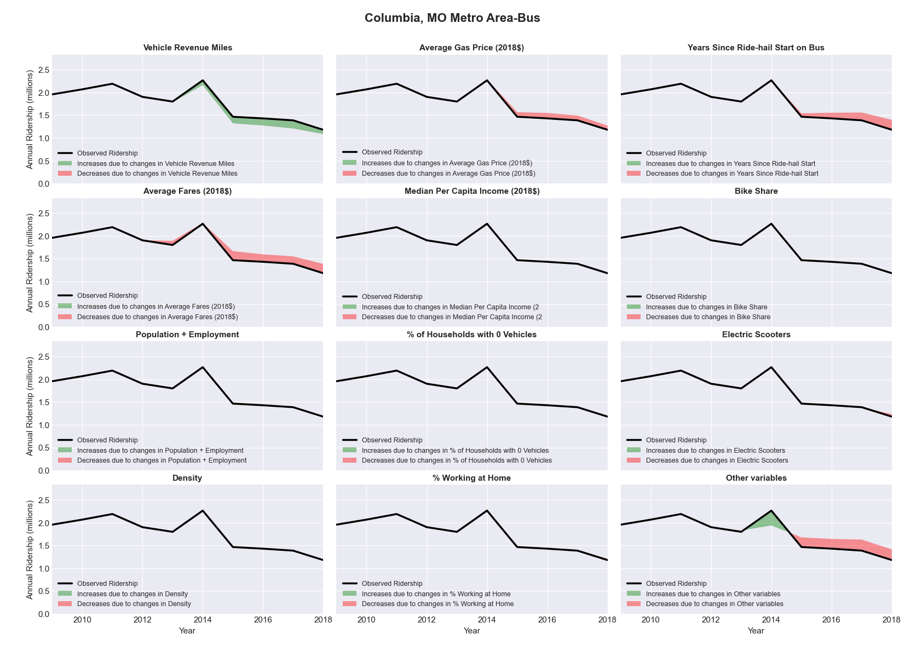

|  |  |  |  |  |  |
| --- | --- | --- | --- | --- | --- |
| Columbia, SC Metro Area-Bus | | | | | |
|  |  |  |  |  |  |
|  | **Average Values** | | | **Ridership Effect** | |
| **Description** | **2012** | **2018** | **% Diff** | **Absolute** | **% Diff** |
|  |  |  |  |  |  |
| **Vehicle Revenue Miles** | 976,610 | 2,680,390 | 174.5% | 899,410 | **59.4%** |
| **Average Fare (2018$)** | 1.39 | 0.71 | -48.7% | 342,330 | **22.6%** |
| **Network Restructure** | - | - | - | - | **0.0%** |
| **Major Maintenance Event** | - | - | - | - | **0.0%** |
| **Population + Employment** | 1,135,040 | 1,218,190 | 7.3% | 28,250 | **1.9%** |
| **Share of Population and Employment in Transit Supportive Density** | 0.16 | 0.13 | -15.5% | -14,680 | **-1.0%** |
| **Average Gas Price (2018$)** | 3.95 | 2.71 | -31.3% | -60,740 | **-4.0%** |
| **Median Per Capita Income (2018$)** | 27,950 | 27,610 | -1.2% | 1,800 | **0.1%** |
| **% of Households with 0 Vehicles** | 6 | 5 | -6.5% | -3,670 | **-0.2%** |
| **% Working at Home** | 3.7 | 4.7 | 25.7% | -19,530 | **-1.3%** |
| **Years Since Ride-hail Start** | - | 4 | 4 | -296,160 | **-19.6%** |
| **Bike Share** | - | 1 | 1 | -26770 | **-1.8%** |
| **Electric Scooters** | - | - | - | 0 | **0.0%** |
| **New Reporters** |  |  |  | - | **0.0%** |
| **Total Modeled Ridership** | 1,514,407 | 2,395,329 | 58.17% | 880922.7 | **58.2%** |
| **Total Observed Ridership** | 1,431,055 | 2,762,614 | 93.05% | 1331559 | **93.0%** |
| **Unexplained Change** |  |  |  |  | **34.9%** |

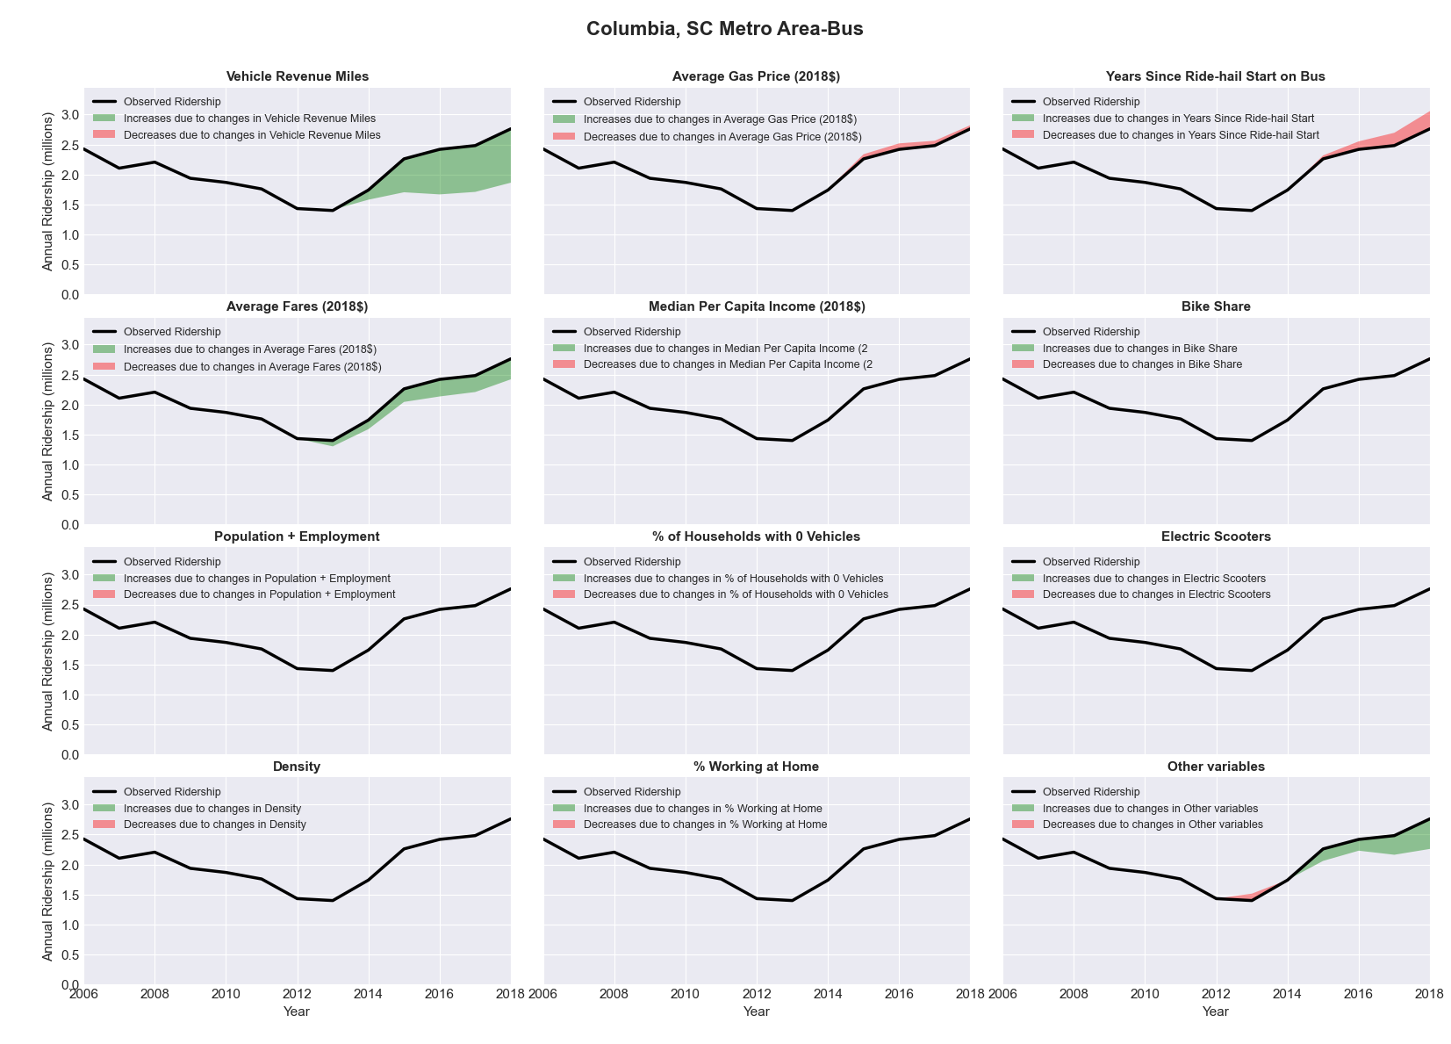

|  |  |  |  |  |  |
| --- | --- | --- | --- | --- | --- |
| Columbus, OH Metro Area-Bus | | | | | |
|  |  |  |  |  |  |
|  | **Average Values** | | | **Ridership Effect** | |
| **Description** | **2012** | **2018** | **% Diff** | **Absolute** | **% Diff** |
|  |  |  |  |  |  |
| **Vehicle Revenue Miles** | 9,689,680 | 13,619,990 | 40.6% | 2,902,940 | **15.4%** |
| **Average Fare (2018$)** | 1.14 | 0.99 | -13.6% | 820,910 | **4.4%** |
| **Network Restructure** | - | 1.000 | - | 874,411.23 | **4.7%** |
| **Major Maintenance Event** | - | - | - | - | **0.0%** |
| **Population + Employment** | 2,790,800 | 3,125,010 | 12.0% | 459,090 | **2.4%** |
| **Share of Population and Employment in Transit Supportive Density** | 0.32 | 0.32 | -0.2% | -5,040 | **-0.0%** |
| **Average Gas Price (2018$)** | 3.93 | 2.72 | -30.9% | -758,220 | **-4.0%** |
| **Median Per Capita Income (2018$)** | 31,170 | 33,070 | 6.1% | -79,060 | **-0.4%** |
| **% of Households with 0 Vehicles** | 7 | 6 | -19.1% | -48,790 | **-0.3%** |
| **% Working at Home** | 4.3 | 5.7 | 31.4% | -191,520 | **-1.0%** |
| **Years Since Ride-hail Start** | - | 5 | 5 | -3,106,320 | **-16.5%** |
| **Bike Share** | - | 1 | 1 | -198620 | **-1.1%** |
| **Electric Scooters** | - | 1 | 1 | -718780 | **-3.8%** |
| **New Reporters** |  |  |  | - | **0.0%** |
| **Total Modeled Ridership** | 18,809,330 | 18,630,011 | -0.95% | -179319 | **-1.0%** |
| **Total Observed Ridership** | 18,423,352 | 18,913,789 | 2.66% | 490437 | **2.7%** |
| **Unexplained Change** |  |  |  |  | **3.6%** |

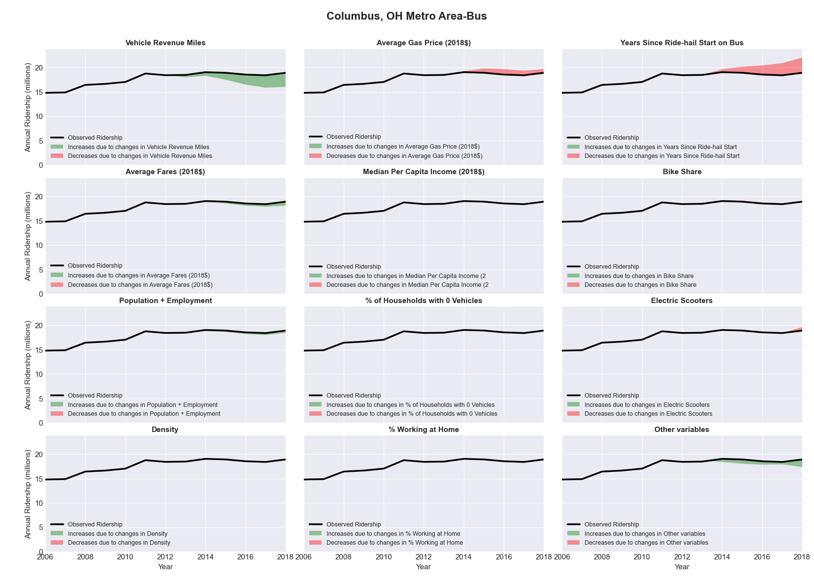

|  |  |  |  |  |  |
| --- | --- | --- | --- | --- | --- |
| Corpus Christi, TX Metro Area-Bus | | | | | |
|  |  |  |  |  |  |
|  | **Average Values** | | | **Ridership Effect** | |
| **Description** | **2012** | **2018** | **% Diff** | **Absolute** | **% Diff** |
|  |  |  |  |  |  |
| **Vehicle Revenue Miles** | 3,004,790 | 3,721,240 | 23.8% | 547,210 | **9.6%** |
| **Average Fare (2018$)** | 0.27 | 0.28 | 7.1% | -51,790 | **-0.9%** |
| **Network Restructure** | - | - | - | - | **0.0%** |
| **Major Maintenance Event** | - | - | - | - | **0.0%** |
| **Population + Employment** | 629,030 | 645,090 | 2.6% | 31,910 | **0.6%** |
| **Share of Population and Employment in Transit Supportive Density** | 0.37 | 0.35 | -4.0% | -33,700 | **-0.6%** |
| **Average Gas Price (2018$)** | 3.80 | 2.58 | -32.2% | -240,770 | **-4.2%** |
| **Median Per Capita Income (2018$)** | 24,460 | 25,530 | 4.4% | -18,840 | **-0.3%** |
| **% of Households with 0 Vehicles** | 7 | 5 | -29.0% | -22,000 | **-0.4%** |
| **% Working at Home** | 2.5 | 3.7 | 48.0% | -47,860 | **-0.8%** |
| **Years Since Ride-hail Start** | - | 4 | 4 | -716,650 | **-12.6%** |
| **Bike Share** | - | 1 | 1 | -59010 | **-1.0%** |
| **Electric Scooters** | - | - | - | 0 | **0.0%** |
| **New Reporters** |  |  |  | - | **0.0%** |
| **Total Modeled Ridership** | 5,699,409 | 5,066,888 | -11.10% | -632521 | **-11.1%** |
| **Total Observed Ridership** | 5,765,135 | 5,153,005 | -10.62% | -612130 | **-10.6%** |
| **Unexplained Change** |  |  |  |  | **0.5%** |

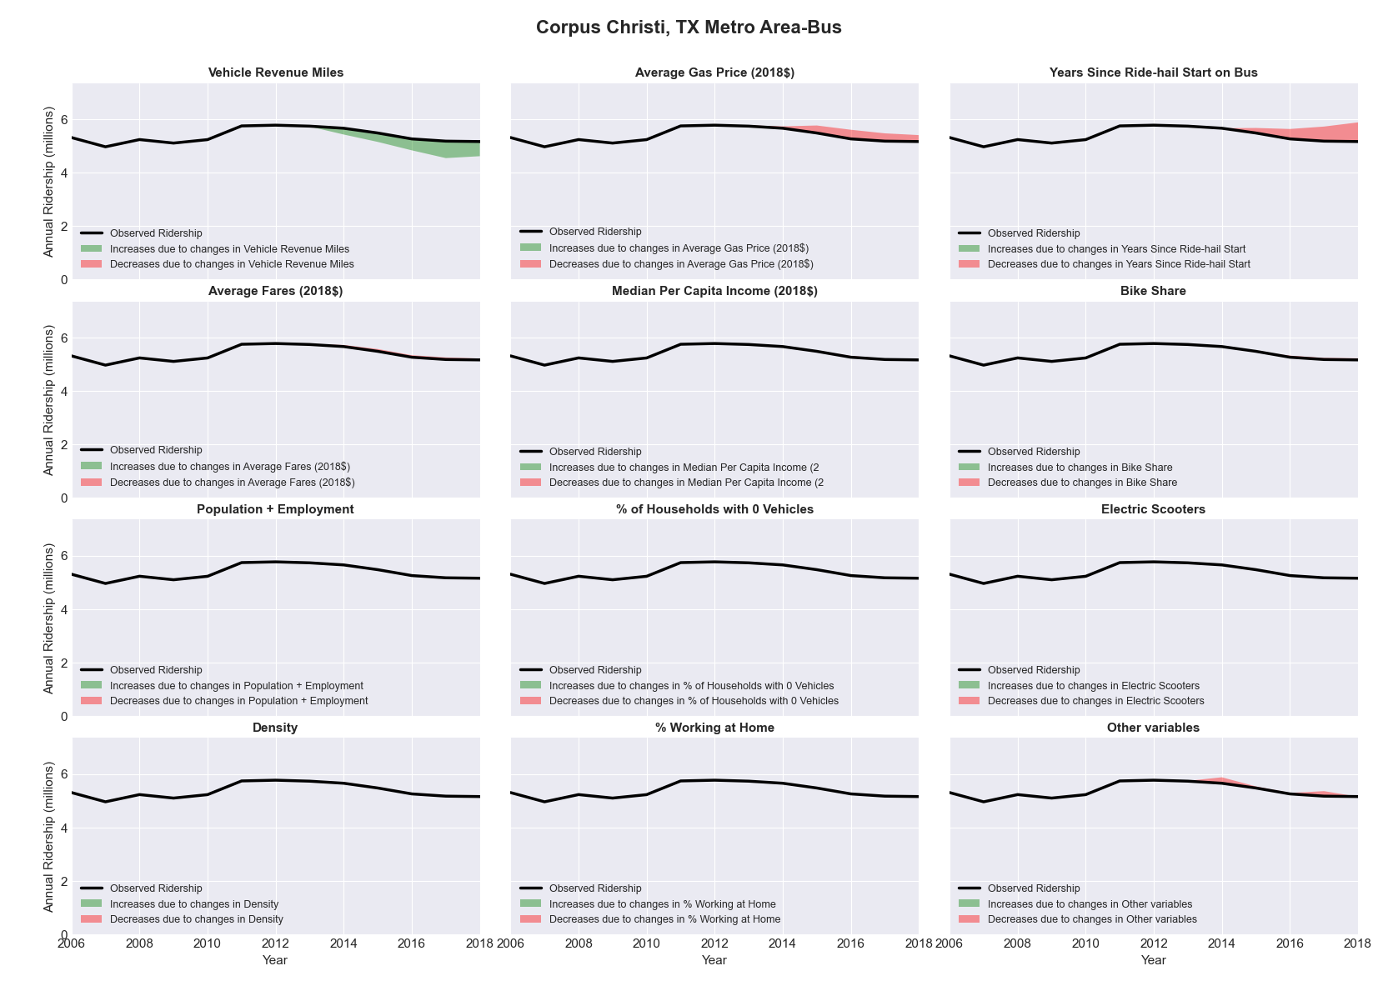

|  |  |  |  |  |  |
| --- | --- | --- | --- | --- | --- |
| Corvallis, OR Metro Area-Bus | | | | | |
|  |  |  |  |  |  |
|  | **Average Values** | | | **Ridership Effect** | |
| **Description** | **2012** | **2018** | **% Diff** | **Absolute** | **% Diff** |
|  |  |  |  |  |  |
| **Vehicle Revenue Miles** | 395,940 | 431,990 | 9.1% | 46,070 | **4.0%** |
| **Average Fare (2018$)** | - | - | - | 0,000 | **0.0%** |
| **Network Restructure** | - | - | - | - | **0.0%** |
| **Major Maintenance Event** | - | - | - | - | **0.0%** |
| **Population + Employment** | 128,690 | 139,190 | 8.2% | 19,890 | **1.7%** |
| **Share of Population and Employment in Transit Supportive Density** | 0.33 | 0.31 | -4.8% | -6,280 | **-0.5%** |
| **Average Gas Price (2018$)** | 4.35 | 3.40 | -21.8% | -32,620 | **-2.8%** |
| **Median Per Capita Income (2018$)** | 22,550 | 24,480 | 8.6% | -6,900 | **-0.6%** |
| **% of Households with 0 Vehicles** | 8 | 5 | -30.1% | -5,500 | **-0.5%** |
| **% Working at Home** | 7.6 | 10.6 | 39.8% | -24,650 | **-2.1%** |
| **Years Since Ride-hail Start** | - | 1 | 1 | -38,260 | **-3.3%** |
| **Bike Share** | - | 1 | 1 | -12720 | **-1.1%** |
| **Electric Scooters** | - | - | - | 0 | **0.0%** |
| **New Reporters** |  |  |  | - | **0.0%** |
| **Total Modeled Ridership** | 1,164,898 | 1,101,187 | -5.47% | -63711.2 | **-5.5%** |
| **Total Observed Ridership** | 1,172,297 | 1,101,849 | -6.01% | -70448 | **-6.0%** |
| **Unexplained Change** |  |  |  |  | **-0.5%** |

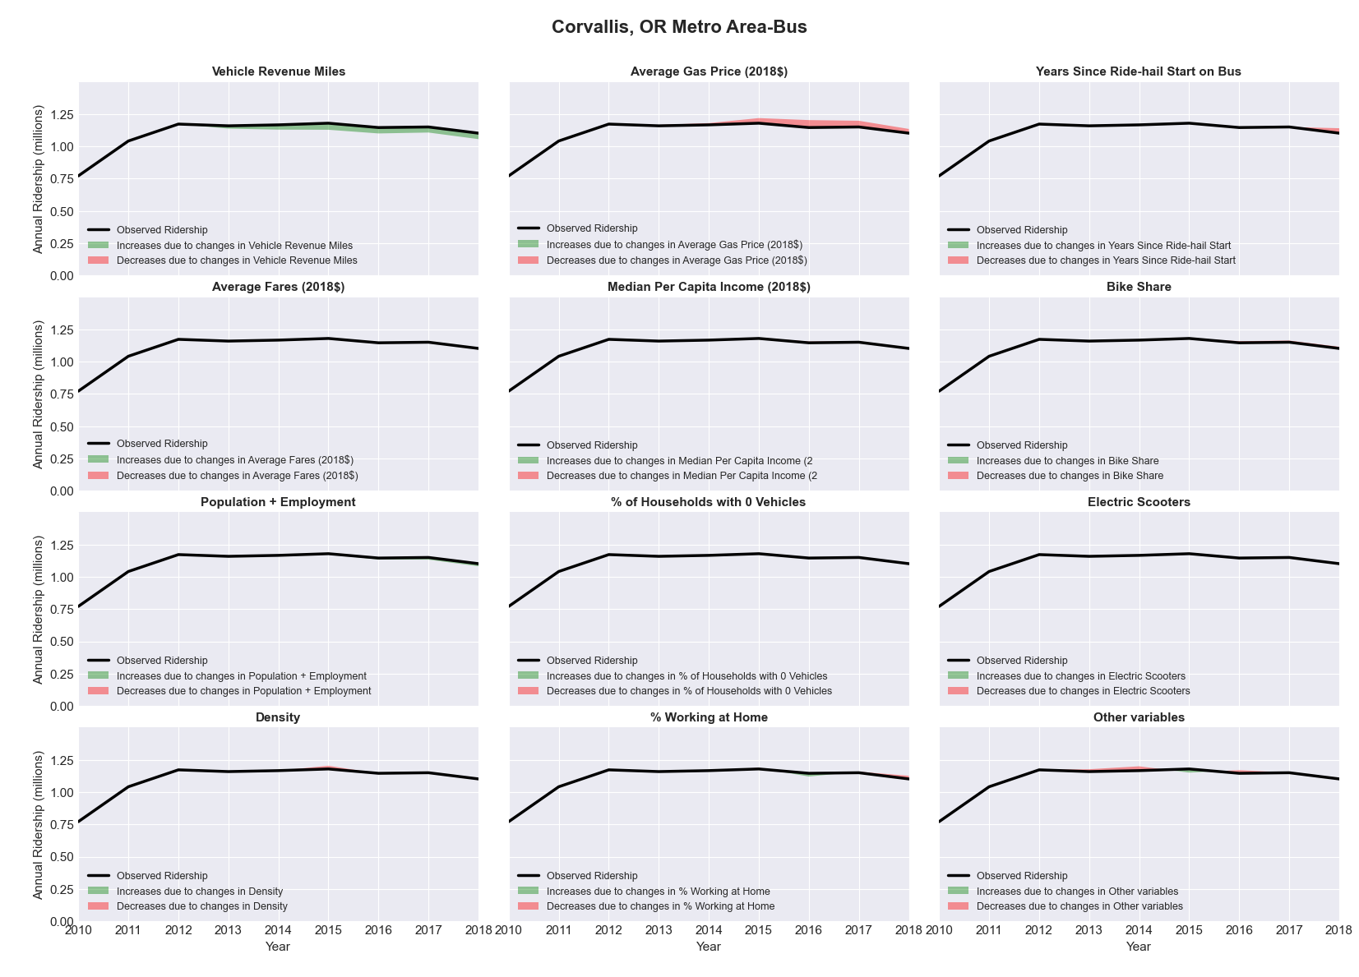

|  |  |  |  |  |  |
| --- | --- | --- | --- | --- | --- |
| Crestview-Fort Walton Beach-Destin, FL Metro Area-Bus | | | | | |
|  |  |  |  |  |  |
|  | **Average Values** | | | **Ridership Effect** | |
| **Description** | **2012** | **2018** | **% Diff** | **Absolute** | **% Diff** |
|  |  |  |  |  |  |
| **Vehicle Revenue Miles** | 289,690 | 214,340 | -26.0% | -13,410 | **-12.3%** |
| **Average Fare (2018$)** | 0.75 | 0.84 | 12.4% | -4,950 | **-4.6%** |
| **Network Restructure** | - | - | - | - | **0.0%** |
| **Major Maintenance Event** | - | - | - | - | **0.0%** |
| **Population + Employment** | 275,390 | 372,380 | 35.2% | 7,290 | **6.7%** |
| **Share of Population and Employment in Transit Supportive Density** | 0.09 | 0.09 | 2.7% | 0,090 | **0.1%** |
| **Average Gas Price (2018$)** | 3.95 | 2.71 | -31.3% | -4,420 | **-4.1%** |
| **Median Per Capita Income (2018$)** | 28,930 | 31,820 | 10.0% | -0,600 | **-0.6%** |
| **% of Households with 0 Vehicles** | 5 | 7 | 34.3% | 0,310 | **0.3%** |
| **% Working at Home** | 2.0 | 4.3 | 113.8% | -2,070 | **-1.9%** |
| **Years Since Ride-hail Start** | - | 2 | 2 | -5,600 | **-5.1%** |
| **Bike Share** | - | - | - | - | **0.0%** |
| **Electric Scooters** | - | - | - | - | **0.0%** |
| **New Reporters** |  |  |  | - | **0.0%** |
| **Total Modeled Ridership** | 108,760 | 86,543 | -20.43% | -22216.9 | **-20.4%** |
| **Total Observed Ridership** | 115,518 | 80,273 | -30.51% | -35245 | **-30.5%** |
| **Unexplained Change** |  |  |  |  | **-10.1%** |

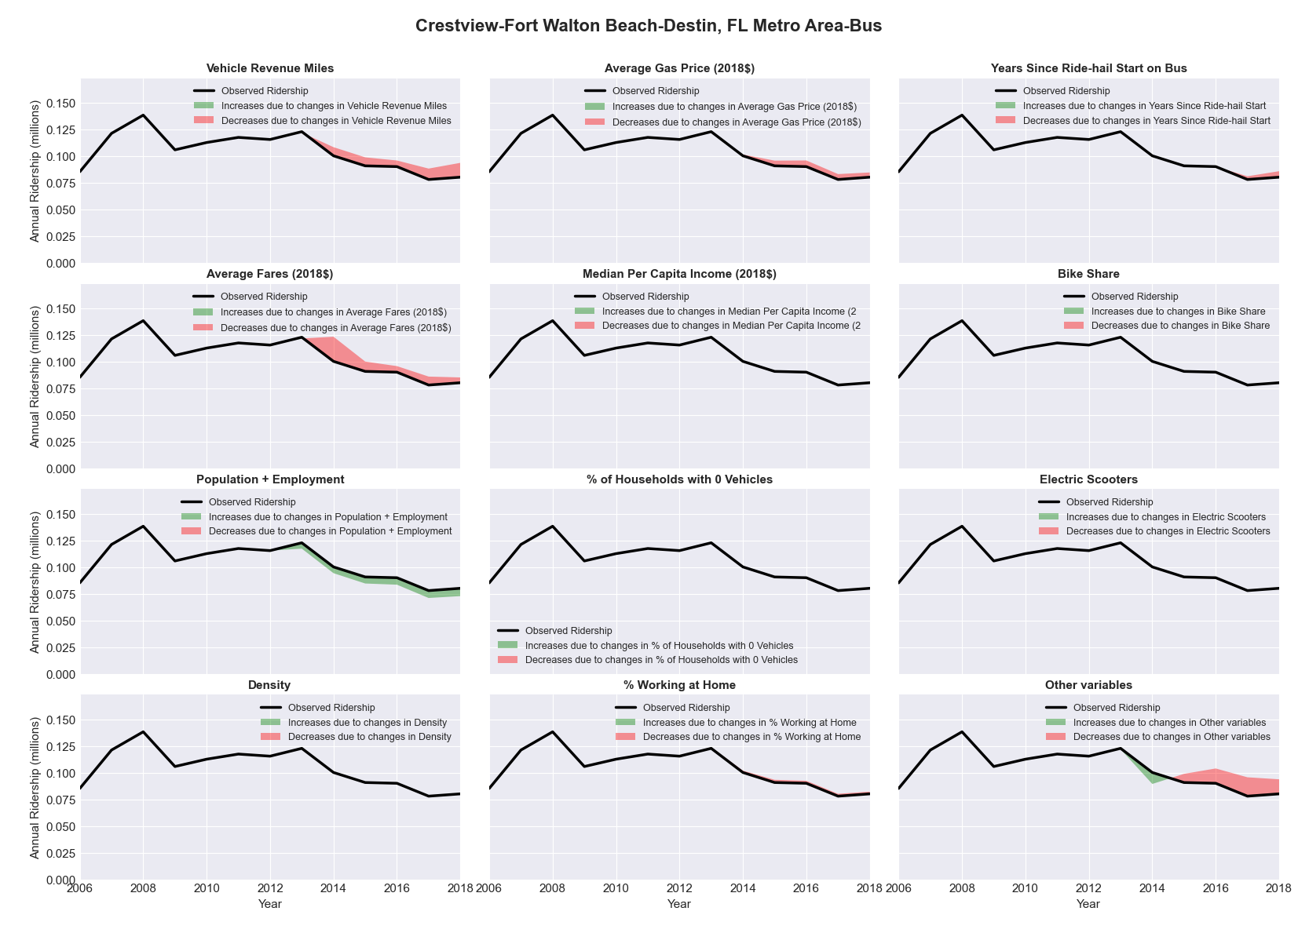

|  |  |  |  |  |  |
| --- | --- | --- | --- | --- | --- |
| Dallas-Fort Worth-Arlington, TX Metro Area-Bus | | | | | |
|  |  |  |  |  |  |
|  | **Average Values** | | | **Ridership Effect** | |
| **Description** | **2012** | **2018** | **% Diff** | **Absolute** | **% Diff** |
|  |  |  |  |  |  |
| **Vehicle Revenue Miles** | 30,756,780 | 34,501,190 | 12.2% | 2,421,580 | **5.1%** |
| **Average Fare (2018$)** | 0.89 | 0.84 | -5.3% | 521,670 | **1.1%** |
| **Network Restructure** | - | - | - | - | **0.0%** |
| **Major Maintenance Event** | - | - | - | - | **0.0%** |
| **Population + Employment** | 9,819,010 | 11,295,210 | 15.0% | 1,379,270 | **2.9%** |
| **Share of Population and Employment in Transit Supportive Density** | 0.38 | 0.37 | -1.2% | -86,740 | **-0.2%** |
| **Average Gas Price (2018$)** | 3.80 | 2.58 | -32.2% | -2,071,050 | **-4.3%** |
| **Median Per Capita Income (2018$)** | 31,490 | 34,860 | 10.7% | -320,780 | **-0.7%** |
| **% of Households with 0 Vehicles** | 5 | 5 | -11.4% | -52,980 | **-0.1%** |
| **% Working at Home** | 4.6 | 5.7 | 23.4% | -386,420 | **-0.8%** |
| **Years Since Ride-hail Start** | - | 6 | 6 | -5,208,790 | **-10.9%** |
| **Bike Share** | - | 1 | 1 | - 504,940 | **-1.1%** |
| **Electric Scooters** | - | 1 | 1 | - 1,561,870 | **-3.3%** |
| **New Reporters** |  |  |  | - | **0.0%** |
| **Total Modeled Ridership** | 47,650,258 | 41,804,262 | -12.27% | -5846.28 | **-12.3%** |
| **Total Observed Ridership** | 48,996,429 | 39,573,528 | -19.23% | -942201 | **-19.2%** |
| **Unexplained Change** |  |  |  |  | **-7.0%** |

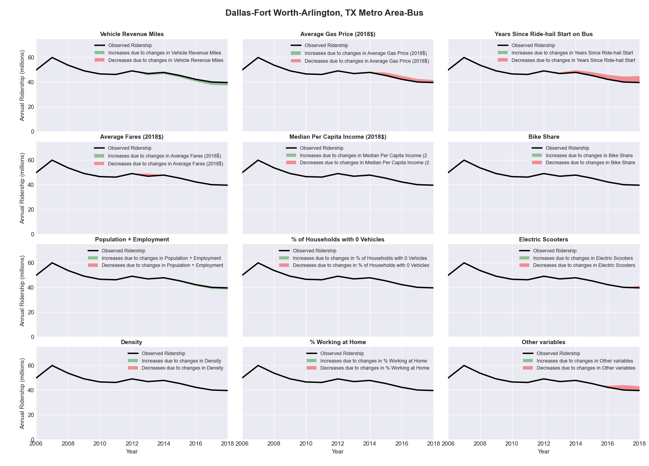

|  |  |  |  |  |  |  |  |
| --- | --- | --- | --- | --- | --- | --- | --- |
| Dallas-Fort Worth-Arlington, TX Metro Area-Rail | | | | | | | |
|  |  |  |  |  | |  | |
|  | **Average Values** | | | **Ridership Effect** | | | |
| **Description** | **2012** | **2018** | **% Diff** | **Absolute** | | **% Diff** | |
|  |  |  |  |  | |  | |
| **Vehicle Revenue Miles** | 9,686,030 | 12,298,330 | 27.0% | 5,156,930 | | **16.7%** | |
| **Average Fare (2018$)** | 0.90 | 1.20 | 33.2% | -1,561,280 | | **-5.0%** | |
| **Network Restructure** | - | - | - | - | | **0.0%** | |
| **Major Maintenance Event** | - | - | - | - | | **0.0%** | |
| **Population + Employment** | 9,819,010 | 11,295,210 | 15.0% | 984,590 | | **3.2%** | |
| **Share of Population and Employment in Transit Supportive Density** | 0.38 | 0.37 | -1.2% | -57,940 | | **-0.2%** | |
| **Average Gas Price (2018$)** | 3.80 | 2.58 | -32.2% | -1,344,800 | | **-4.3%** | |
| **Median Per Capita Income (2018$)** | 31,490 | 34,860 | 10.7% | -233,680 | | **-0.8%** | |
| **% of Households with 0 Vehicles** | 5 | 5 | -11.4% | -38,750 | | **-0.1%** | |
| **% Working at Home** | 4.6 | 5.7 | 23.4% | -267,740 | | **-0.9%** | |
| **Years Since Ride-hail Start** | - | 6 | 6 | 421,190 | | **1.4%** | |
| **Bike Share** | - | 1 | 1 | - 341,360 | **-1.1%** | |
| **Electric Scooters** | - | 1 | 1 | - 1,268,740 | **-4.1%** | |
| **New Reporters** |  |  |  | - | | **0.0%** | |
| **Total Modeled Ridership** | 30,932,610 | 32,187,619 | 4.06% | 1255009.5 | | **4.1%** | |
| **Total Observed Ridership** | 31,175,080 | 31,315,790 | 0.45% | 140710 | | **0.5%** | |
| **Unexplained Change** |  |  |  |  | | **-3.6%** | |

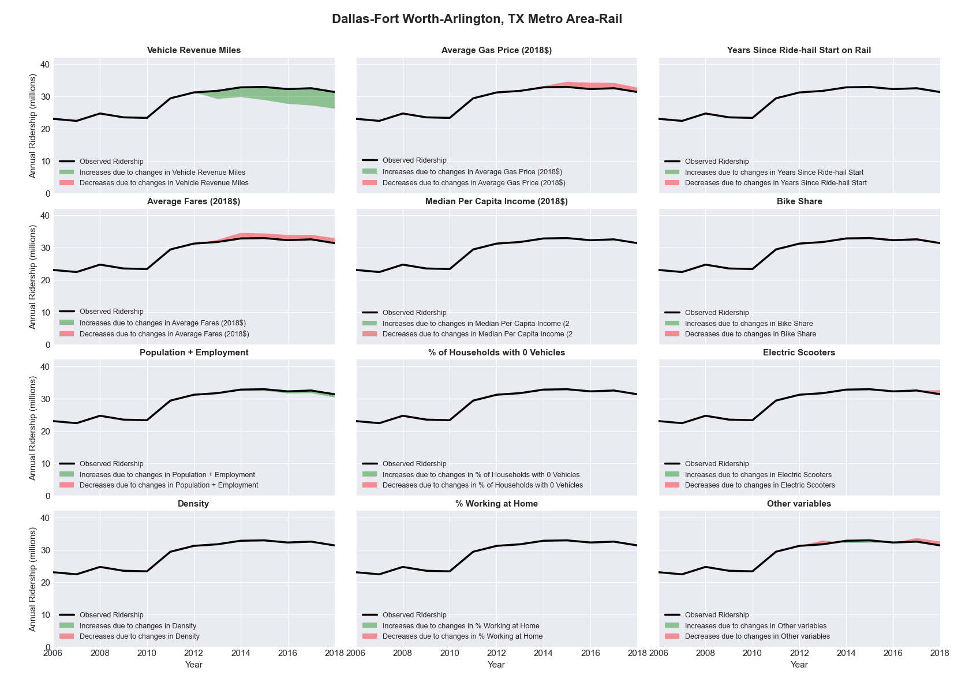

|  |  |  |  |  |  |  |
| --- | --- | --- | --- | --- | --- | --- |
| Davenport-Moline-Rock Island, IA-IL Metro Area-Bus | | | | | | |
|  |  |  |  |  |  | |
|  | **Average Values** | | | **Ridership Effect** | | |
| **Description** | **2012** | **2018** | **% Diff** | **Absolute** | **% Diff** | |
|  |  |  |  |  |  | |
| **Vehicle Revenue Miles** | 2,217,480 | 2,345,320 | 5.8% | 81,290 | | **2.3%** | |
| **Average Fare (2018$)** | 0.34 | 0.25 | -26.0% | 132,710 | | **3.8%** | |
| **Network Restructure** | - | - | - | - | | **0.0%** | |
| **Major Maintenance Event** | - | - | - | - | | **0.0%** | |
| **Population + Employment** | 565,410 | 566,270 | 0.2% | 0,980 | | **0.0%** | |
| **Share of Population and Employment in Transit Supportive Density** | 0.17 | 0.16 | -3.1% | -7,150 | | **-0.2%** | |
| **Average Gas Price (2018$)** | 3.93 | 2.72 | -30.9% | -140,180 | | **-4.0%** | |
| **Median Per Capita Income (2018$)** | 30,330 | 29,770 | -1.8% | 3,670 | | **0.1%** | |
| **% of Households with 0 Vehicles** | 7 | 7 | -0.6% | -0,560 | | **-0.0%** | |
| **% Working at Home** | 2.9 | 4.6 | 58.6% | -42,920 | | **-1.2%** | |
| **Years Since Ride-hail Start** | - | 3 | 3 | -325,970 | | **-9.4%** | |
| **Bike Share** | - | - | - | - | | **0.0%** | |
| **Electric Scooters** | - | - | - | - | | **0.0%** | |
| **New Reporters** |  |  |  | - | | **0.0%** | |
| **Total Modeled Ridership** | 3,461,613 | 3,160,615 | -8.70% | -300998.56 | | **-8.7%** | |
| **Total Observed Ridership** | 3,441,841 | 3,149,496 | -8.49% | -292345 | | **-8.5%** | |
| **Unexplained Change** |  |  |  |  | | **0.2%** | |

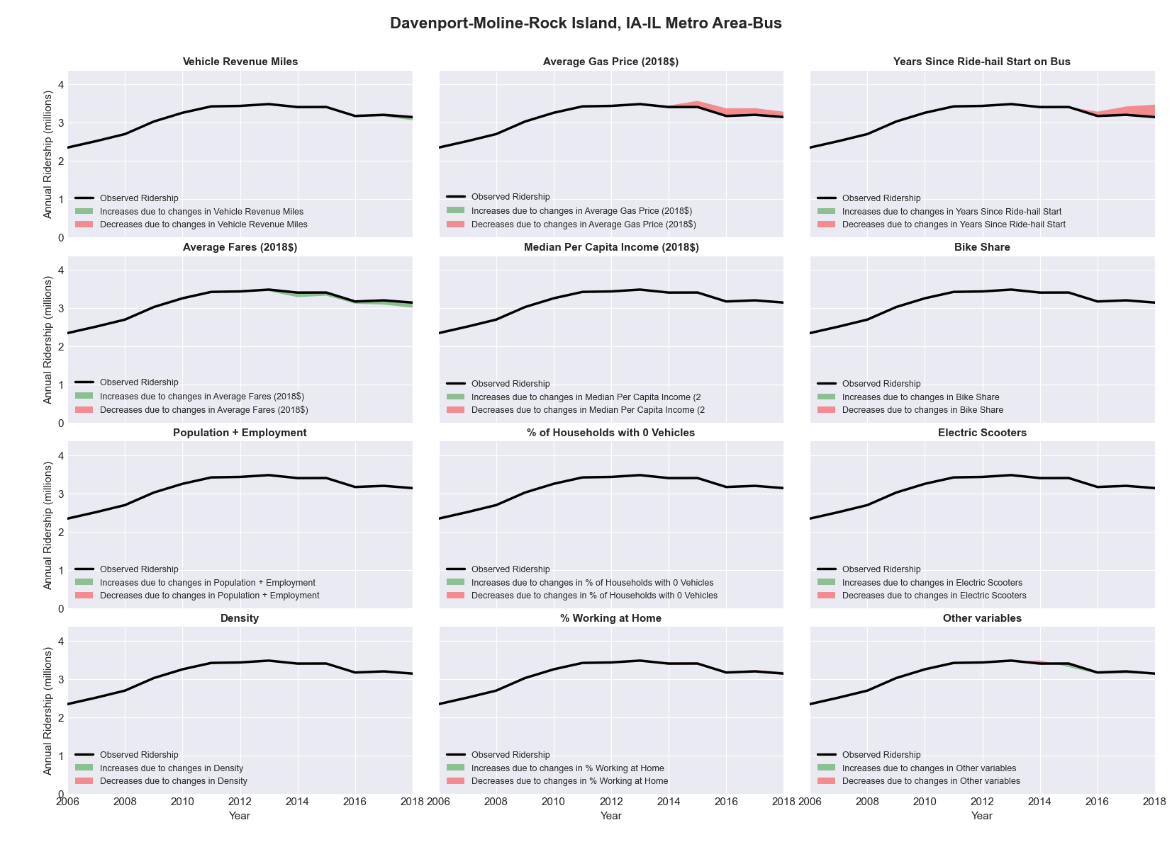

|  |  |  |  |  |  |  |
| --- | --- | --- | --- | --- | --- | --- |
| Dayton, OH Metro Area-Bus | | | | | | |
|  |  |  |  |  |  | |
|  | **Average Values** | | | **Ridership Effect** | | |
| **Description** | **2012** | **2018** | **% Diff** | **Absolute** | **% Diff** | |
|  |  |  |  |  |  | |
| **Vehicle Revenue Miles** | 5,672,970 | 5,970,030 | 5.2% | 244,090 | | **2.6%** | |
| **Average Fare (2018$)** | 0.98 | 0.70 | -28.9% | 813,840 | | **8.7%** | |
| **Network Restructure** | - | - | - | - | | **0.0%** | |
| **Major Maintenance Event** | - | - | - | - | | **0.0%** | |
| **Population + Employment** | 1,219,820 | 1,199,840 | -1.6% | -33,050 | | **-0.4%** | |
| **Share of Population and Employment in Transit Supportive Density** | 0.14 | 0.14 | -0.8% | -4,060 | | **-0.0%** | |
| **Average Gas Price (2018$)** | 3.93 | 2.72 | -30.9% | -396,870 | | **-4.2%** | |
| **Median Per Capita Income (2018$)** | 26,900 | 28,760 | 6.9% | -42,770 | | **-0.5%** | |
| **% of Households with 0 Vehicles** | 8 | 7 | -16.9% | -25,400 | | **-0.3%** | |
| **% Working at Home** | 3.4 | 3.6 | 6.6% | -16,240 | | **-0.2%** | |
| **Years Since Ride-hail Start** | - | 4 | 4 | -1,217,310 | | **-13.0%** | |
| **Bike Share** | - | 1 | 1 | - 105,500 | | **-1.1%** | |
| **Electric Scooters** | - | - | - | - | | **0.0%** | |
| **New Reporters** |  |  |  | - | | **0.0%** | |
| **Total Modeled Ridership** | 9,344,023 | 8,559,975 | -8.39% | -784047.551 | | **-8.4%** | |
| **Total Observed Ridership** | 9,164,987 | 8,284,605 | -9.61% | -880382 | | **-9.6%** | |
| **Unexplained Change** |  |  |  |  | | **-1.2%** | |

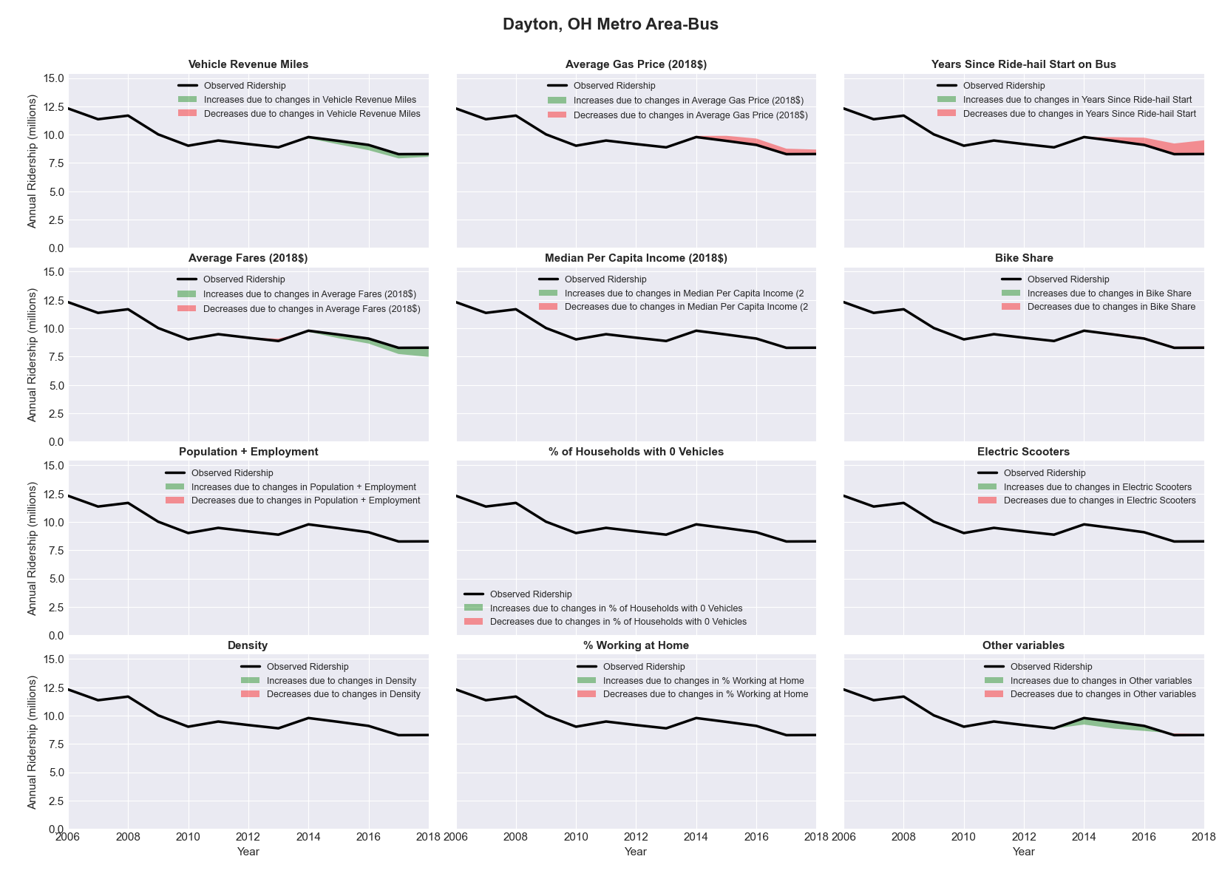

|  |  |  |  |  |  |  |
| --- | --- | --- | --- | --- | --- | --- |
| Decatur, IL Metro Area-Bus | | | | | | |
|  |  |  |  |  |  | |
|  | **Average Values** | | | **Ridership Effect** | | |
| **Description** | **2012** | **2018** | **% Diff** | **Absolute** | **% Diff** | |
|  |  |  |  |  |  | |
| **Vehicle Revenue Miles** | 968,330 | 977,210 | 0.9% | 4,300 | | **0.3%** | |
| **Average Fare (2018$)** | 0.39 | 0.41 | 7.0% | -15,980 | | **-1.2%** | |
| **Network Restructure** | - | - | - | - | | **0.0%** | |
| **Major Maintenance Event** | - | - | - | - | | **0.0%** | |
| **Population + Employment** | 159,040 | 152,400 | -4.2% | -12,850 | | **-0.9%** | |
| **Share of Population and Employment in Transit Supportive Density** | 0.24 | 0.25 | 2.0% | 3,410 | | **0.2%** | |
| **Average Gas Price (2018$)** | 3.93 | 2.72 | -30.9% | -62,510 | | **-4.5%** | |
| **Median Per Capita Income (2018$)** | 26,520 | 28,100 | 6.0% | -5,400 | | **-0.4%** | |
| **% of Households with 0 Vehicles** | 11 | 7 | -33.1% | -8,970 | | **-0.6%** | |
| **% Working at Home** | 2.9 | 4.6 | 56.9% | -17,040 | | **-1.2%** | |
| **Years Since Ride-hail Start** | - | 1 | 1 | -38,580 | | **-2.8%** | |
| **Bike Share** | - | - | - | - | | **0.0%** | |
| **Electric Scooters** | - | - | - | - | | **0.0%** | |
| **New Reporters** |  |  |  | - | | **0.0%** | |
| **Total Modeled Ridership** | 1,383,030 | 1,235,677 | -10.65% | -17353.195 | | **-10.7%** | |
| **Total Observed Ridership** | 1,407,156 | 1,132,622 | -19.51% | -274534 | | **-19.5%** | |
| **Unexplained Change** |  |  |  |  | | **-8.9%** | |

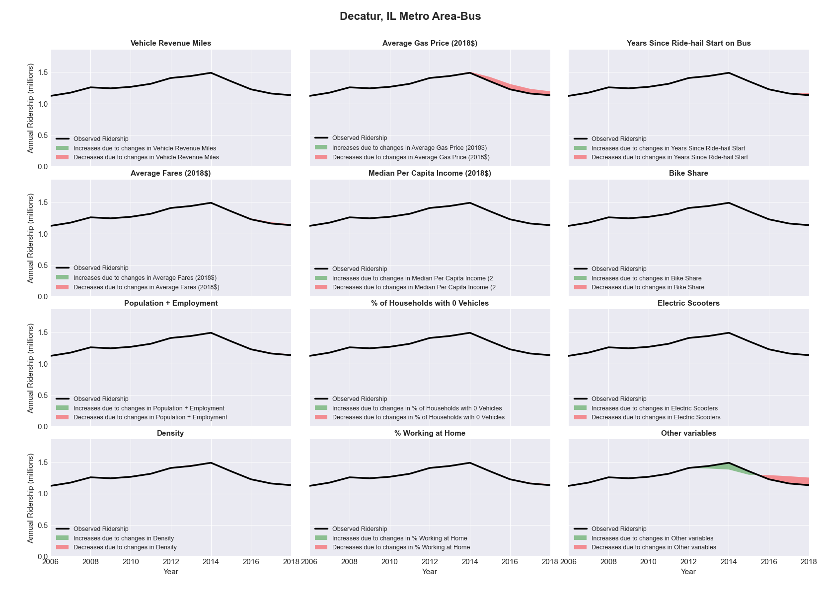

|  |  |  |  |  |  |  |
| --- | --- | --- | --- | --- | --- | --- |
| Deltona-Daytona Beach-Ormond Beach, FL Metro Area-Bus | | | | | | |
|  |  |  |  |  |  | |
|  | **Average Values** | | | **Ridership Effect** | | |
| **Description** | **2012** | **2018** | **% Diff** | **Absolute** | **% Diff** | |
|  |  |  |  |  |  | |
| **Vehicle Revenue Miles** | 1,770,520 | 2,325,030 | 31.3% | 321,000 | | **12.1%** | |
| **Average Fare (2018$)** | 0.74 | 0.72 | -3.0% | 5,030 | | **0.2%** | |
| **Network Restructure** | - | - | - | - | | **0.0%** | |
| **Major Maintenance Event** | - | - | - | - | | **0.0%** | |
| **Population + Employment** | 711,820 | 907,110 | 27.4% | 142,500 | | **5.4%** | |
| **Share of Population and Employment in Transit Supportive Density** | 0.09 | 0.08 | -11.5% | -11,270 | | **-0.4%** | |
| **Average Gas Price (2018$)** | 3.95 | 2.71 | -31.3% | -115,790 | | **-4.4%** | |
| **Median Per Capita Income (2018$)** | 23,540 | 26,390 | 12.1% | -21,500 | | **-0.8%** | |
| **% of Households with 0 Vehicles** | 7 | 4 | -43.3% | -14,900 | | **-0.6%** | |
| **% Working at Home** | 4.8 | 6.7 | 38.5% | -36,010 | | **-1.4%** | |
| **Years Since Ride-hail Start** | - | 4 | 4 | -338,010 | | **-12.7%** | |
| **Bike Share** | - | - | - | - | | **0.0%** | |
| **Electric Scooters** | - | - | - | - | | **0.0%** | |
| **New Reporters** |  |  |  | - | | **0.0%** | |
| **Total Modeled Ridership** | 2,653,112 | 2,584,956 | -2.57% | -68156.709 | | **-2.6%** | |
| **Total Observed Ridership** | 2,735,510 | 2,391,448 | -12.58% | -344062 | | **-12.6%** | |
| **Unexplained Change** |  |  |  |  | | **-10.0%** | |

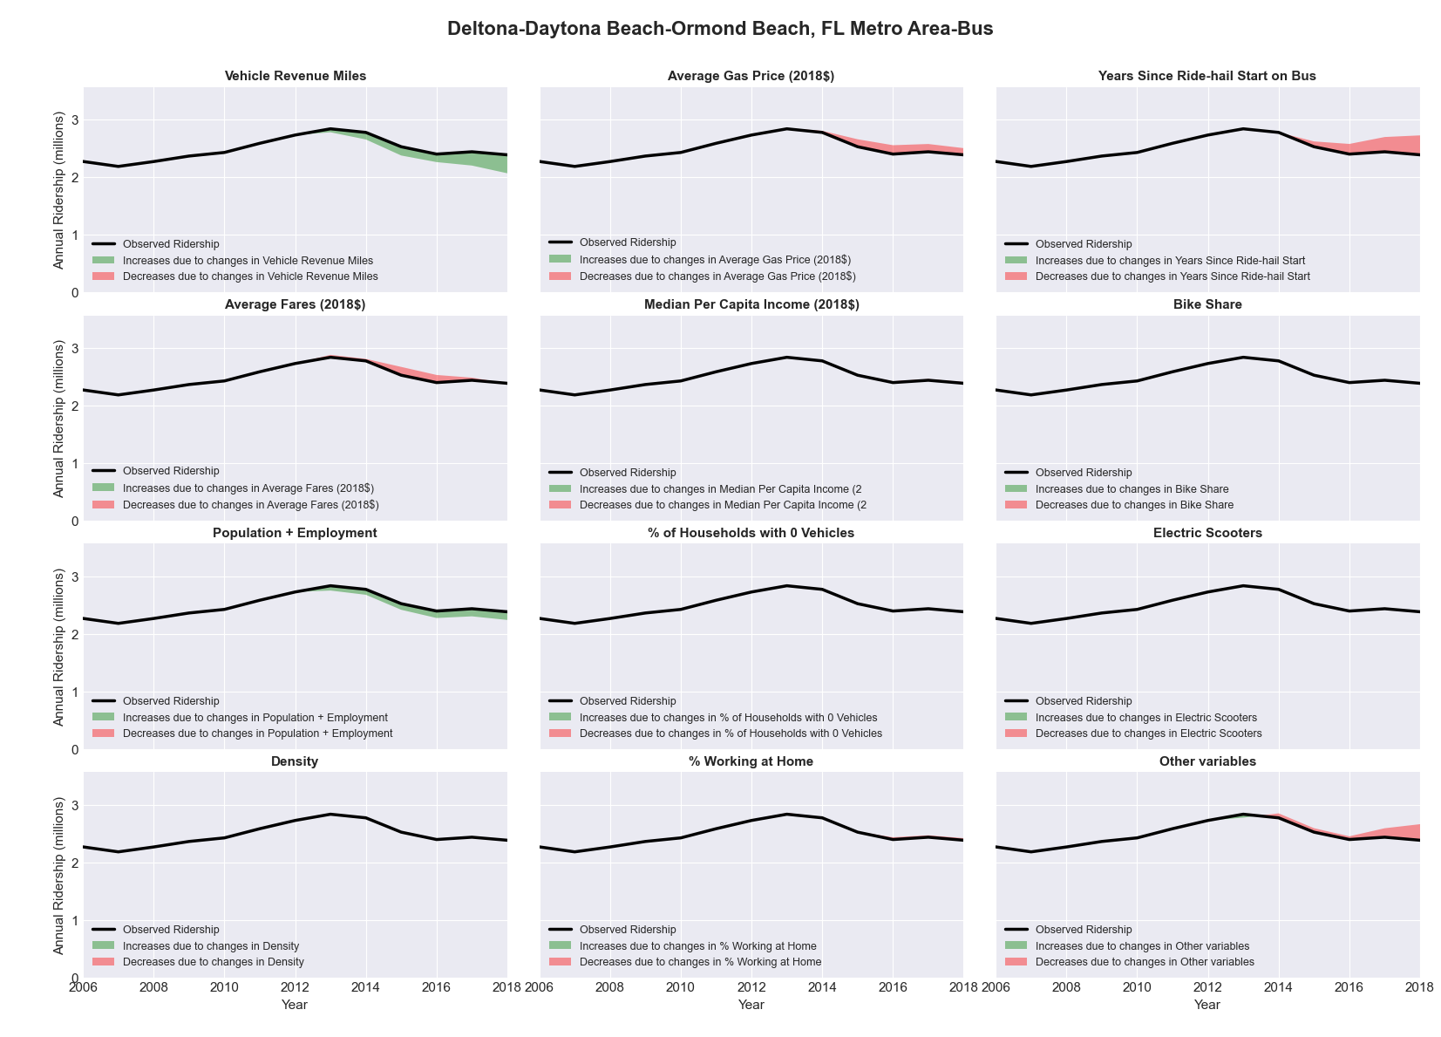

|  |  |  |  |  |  |  |
| --- | --- | --- | --- | --- | --- | --- |
| Denver-Aurora-Broomfield, CO Metro Area-Bus | | | | | | |
|  |  |  |  |  |  | |
|  | **Average Values** | | | **Ridership Effect** | | |
| **Description** | **2012** | **2018** | **% Diff** | **Absolute** | **% Diff** | |
|  |  |  |  |  |  | |
| **Vehicle Revenue Miles** | 33,500,860 | 35,973,310 | 7.4% | 2,492,800 | | **3.3%** | |
| **Average Fare (2018$)** | 1.17 | 1.08 | -8.1% | 1,971,260 | | **2.6%** | |
| **Network Restructure** | - | - | - | - | | **0.0%** | |
| **Major Maintenance Event** | - | - | - | - | | **0.0%** | |
| **Population + Employment** | 3,981,440 | 4,514,510 | 13.4% | 2,036,680 | | **2.7%** | |
| **Share of Population and Employment in Transit Supportive Density** | 0.49 | 0.49 | 0.0% | -9,590 | | **-0.0%** | |
| **Average Gas Price (2018$)** | 3.88 | 2.89 | -25.5% | -2,596,210 | | **-3.4%** | |
| **Median Per Capita Income (2018$)** | 34,700 | 39,680 | 14.4% | -704,660 | | **-0.9%** | |
| **% of Households with 0 Vehicles** | 6 | 6 | -14.2% | -139,600 | | **-0.2%** | |
| **% Working at Home** | 6.3 | 9.0 | 42.9% | -1,517,280 | | **-2.0%** | |
| **Years Since Ride-hail Start** | - | 5 | 5 | -7,049,520 | | **-9.3%** | |
| **Bike Share** | 1.00 | 1 | - | - | | **0.0%** | |
| **Electric Scooters** | - | 1 | 1 | - 2,547,810 | | **-3.4%** | |
| **New Reporters** |  |  |  | - | | **0.0%** | |
| **Total Modeled Ridership** | 75,588,499 | 67,302,132 | -10.96% | -8286366.63 | | **-11.0%** | |
| **Total Observed Ridership** | 76,670,969 | 70,498,190 | -8.05% | -6172779 | | **-8.1%** | |
| **Unexplained Change** |  |  |  |  | | **2.9%** | |

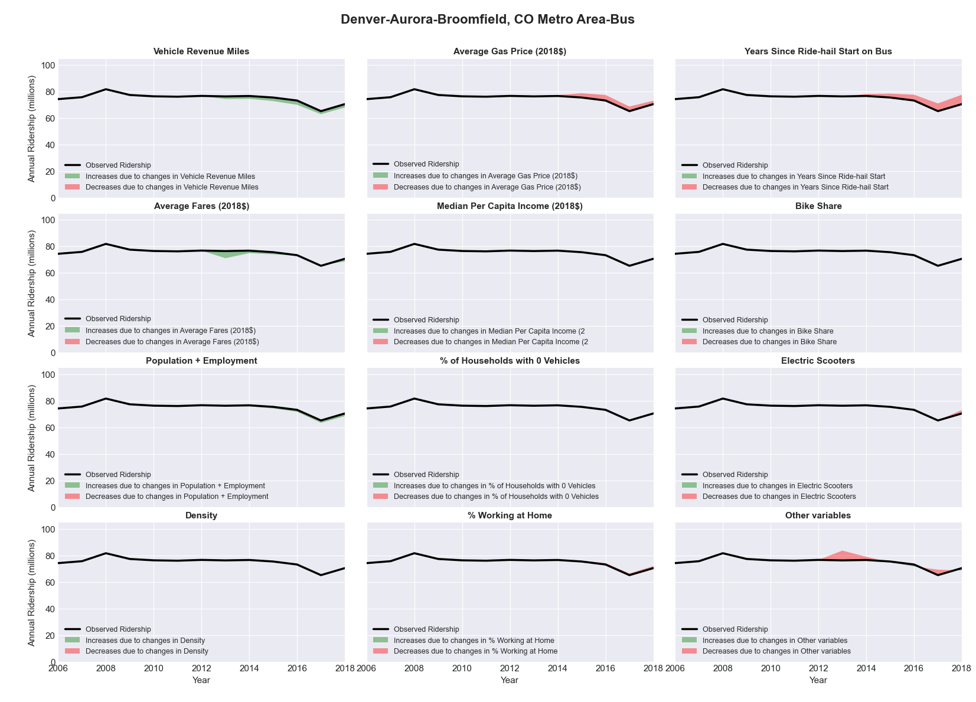

|  |  |  |  |  |  |  |
| --- | --- | --- | --- | --- | --- | --- |
| Denver-Aurora-Broomfield, CO Metro Area-Rail | | | | | | |
|  |  |  |  |  |  | |
|  | **Average Values** | | | **Ridership Effect** | | |
| **Description** | **2012** | **2018** | **% Diff** | **Absolute** | **% Diff** | |
|  |  |  |  |  |  | |
| **Vehicle Revenue Miles** | 8,441,560 | 14,313,000 | 69.6% | 8,848,280 | | **38.5%** | |
| **Average Fare (2018$)** | 1.51 | 2.09 | 38.0% | -1,534,540 | | **-6.7%** | |
| **Network Restructure** | - | - | - | - | | **0.0%** | |
| **Major Maintenance Event** | - | - | - | - | | **0.0%** | |
| **Population + Employment** | 3,981,440 | 4,514,510 | 13.4% | 710,540 | | **3.1%** | |
| **Share of Population and Employment in Transit Supportive Density** | 0.49 | 0.49 | 0.0% | 4,130 | | **0.0%** | |
| **Average Gas Price (2018$)** | 3.88 | 2.89 | -25.5% | -698,500 | | **-3.0%** | |
| **Median Per Capita Income (2018$)** | 34,700 | 39,680 | 14.4% | -257,100 | | **-1.1%** | |
| **% of Households with 0 Vehicles** | 6 | 6 | -14.2% | -45,230 | | **-0.2%** | |
| **% Working at Home** | 6.3 | 9.0 | 42.9% | -539,800 | | **-2.3%** | |
| **Years Since Ride-hail Start** | - | 5 | 5 | 296,700 | | **1.3%** | |
| **Bike Share** | 1.00 | 1 | - | - | | **0.0%** | |
| **Electric Scooters** | - | 1 | 1 | - 1,233,410 | | **-5.4%** | |
| **New Reporters** |  |  |  | - | | **0.0%** | |
| **Total Modeled Ridership** | 23,005,678 | 28,442,119 | 23.63% | 5436440.7 | | **23.6%** | |
| **Total Observed Ridership** | 20,626,685 | 32,921,882 | 59.61% | 12295197 | | **59.6%** | |
| **Unexplained Change** |  |  |  |  | | **36.0%** | |

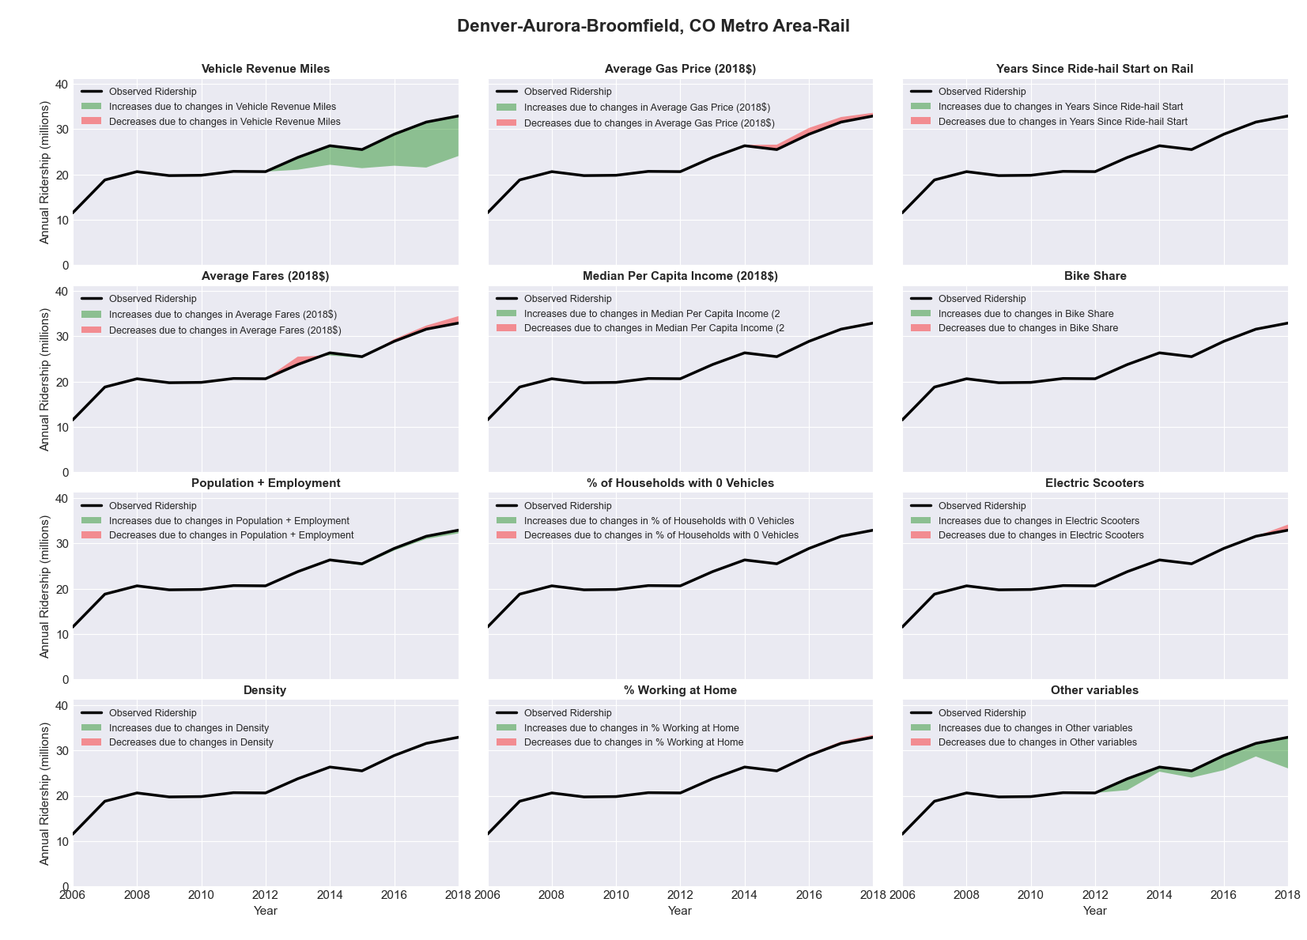

|  |  |  |  |  |  |  |
| --- | --- | --- | --- | --- | --- | --- |
| Des Moines-West Des Moines, IA Metro Area-Bus | | | | | | |
|  |  |  |  |  |  | |
|  | **Average Values** | | | **Ridership Effect** | | |
| **Description** | **2012** | **2018** | **% Diff** | **Absolute** | **% Diff** | |
|  |  |  |  |  |  | |
| **Vehicle Revenue Miles** | 2,373,560 | 3,107,600 | 30.9% | 521,030 | | **12.4%** | |
| **Average Fare (2018$)** | 1.17 | 1.14 | -2.2% | 25,930 | | **0.6%** | |
| **Network Restructure** | - | - | - | - | | **0.0%** | |
| **Major Maintenance Event** | - | - | - | - | | **0.0%** | |
| **Population + Employment** | 895,700 | 1,002,310 | 11.9% | 104,640 | | **2.5%** | |
| **Share of Population and Employment in Transit Supportive Density** | 0.21 | 0.21 | -3.2% | -11,540 | | **-0.3%** | |
| **Average Gas Price (2018$)** | 3.93 | 2.72 | -30.9% | -173,540 | | **-4.1%** | |
| **Median Per Capita Income (2018$)** | 34,730 | 36,700 | 5.7% | -17,240 | | **-0.4%** | |
| **% of Households with 0 Vehicles** | 5 | 6 | 10.8% | 5,150 | | **0.1%** | |
| **% Working at Home** | 4.0 | 6.2 | 54.4% | -70,910 | | **-1.7%** | |
| **Years Since Ride-hail Start** | - | 4 | 4 | -578,810 | | **-13.8%** | |
| **Bike Share** | 1.00 | 1 | - | - | | **0.0%** | |
| **Electric Scooters** | - | - | - | - | | **0.0%** | |
| **New Reporters** |  |  |  | - | | **0.0%** | |
| **Total Modeled Ridership** | 4,190,338 | 4,004,834 | -4.43% | -18550798 | | **-4.4%** | |
| **Total Observed Ridership** | 4,094,122 | 4,178,236 | 2.05% | 84114 | | **2.1%** | |
| **Unexplained Change** |  |  |  |  | | **6.5%** | |

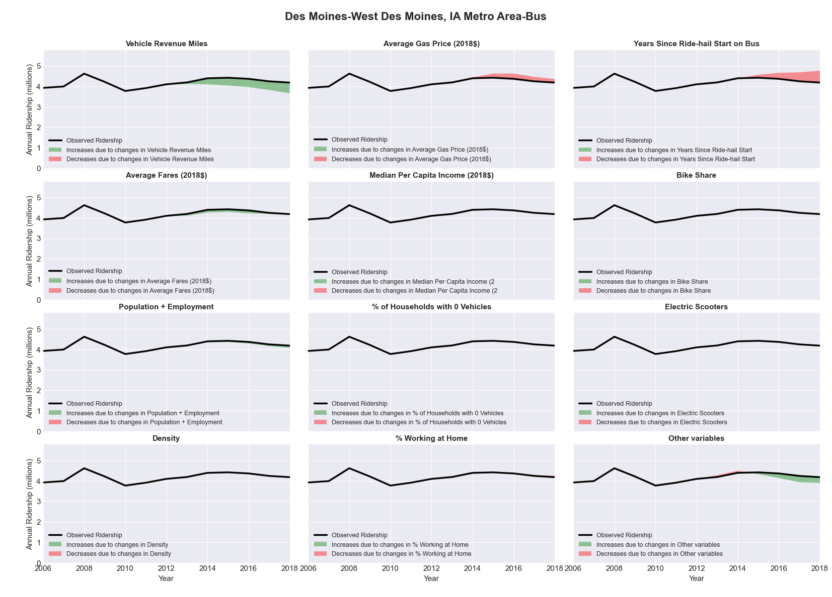

|  |  |  |  |  |  |  |
| --- | --- | --- | --- | --- | --- | --- |
| Detroit-Warren-Livonia, MI Metro Area-Bus | | | | | | |
|  |  |  |  |  |  | |
|  | **Average Values** | | | **Ridership Effect** | | |
| **Description** | **2012** | **2018** | **% Diff** | **Absolute** | **% Diff** | |
|  |  |  |  |  |  | |
| **Vehicle Revenue Miles** | 19,625,060 | 23,290,660 | 18.7% | 2,397,800 | | **6.0%** | |
| **Average Fare (2018$)** | 0.95 | 0.90 | -5.5% | 536,200 | | **1.3%** | |
| **Network Restructure** | - | - | - | - | | **0.0%** | |
| **Major Maintenance Event** | - | - | - | - | | **0.0%** | |
| **Population + Employment** | 6,096,220 | 6,348,000 | 4.1% | 320,970 | | **0.8%** | |
| **Share of Population and Employment in Transit Supportive Density** | 0.29 | 0.28 | -2.2% | -94,280 | | **-0.2%** | |
| **Average Gas Price (2018$)** | 3.93 | 2.72 | -30.9% | -1,449,920 | | **-3.6%** | |
| **Median Per Capita Income (2018$)** | 28,300 | 32,640 | 15.3% | -356,210 | | **-0.9%** | |
| **% of Households with 0 Vehicles** | 10 | 8 | -16.7% | -119,380 | | **-0.3%** | |
| **% Working at Home** | 3.4 | 4.2 | 22.8% | -196,580 | | **-0.5%** | |
| **Years Since Ride-hail Start** | - | 5 | 5 | -5,857,620 | | **-14.6%** | |
| **Bike Share** | - | 1 | 1 | - 374,140 | | **-0.9%** | |
| **Electric Scooters** | - | 1 | 1 | - 1,269,990 | | **-3.2%** | |
| **New Reporters** |  |  |  | - | | **0.0%** | |
| **Total Modeled Ridership** | 40,041,627 | 33,429,061 | -16.51% | -6612566.2 | | **-16.5%** | |
| **Total Observed Ridership** | 42,875,049 | 32,742,196 | -23.63% | -10132853 | | **-23.6%** | |
| **Unexplained Change** |  |  |  |  | | **-7.1%** | |

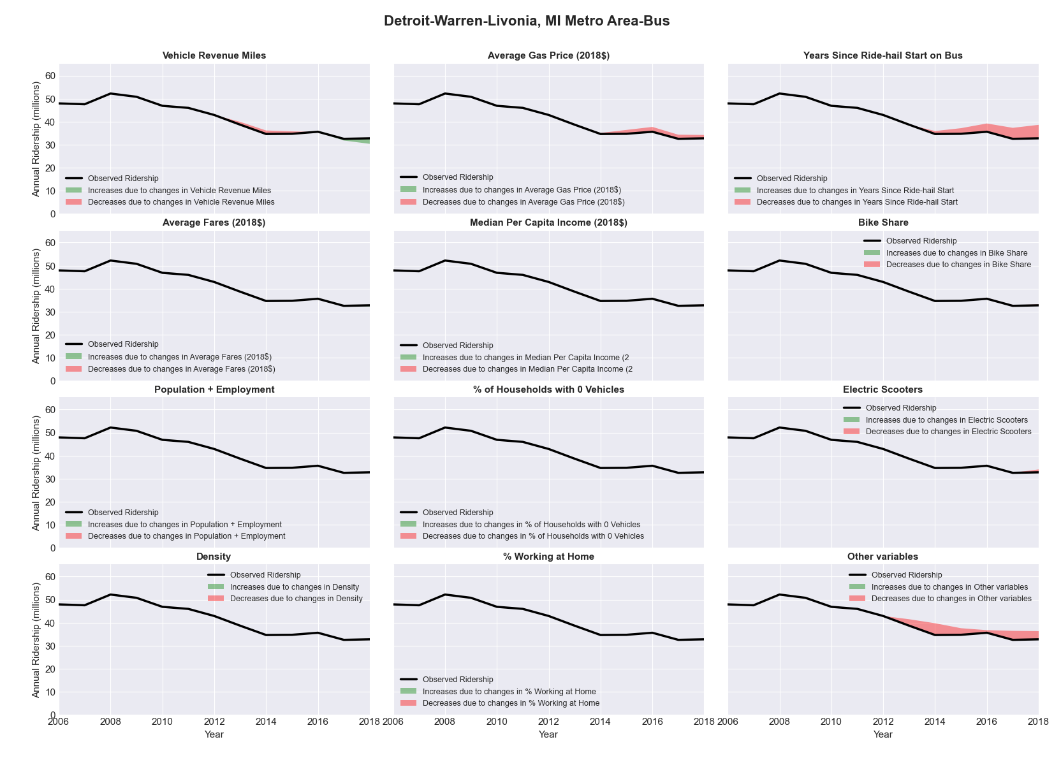

|  |  |  |  |  |  |  |
| --- | --- | --- | --- | --- | --- | --- |
| Duluth, MN-WI Metro Area-Bus | | | | | | |
|  |  |  |  |  |  | |
|  | **Average Values** | | | **Ridership Effect** | | |
| **Description** | **2012** | **2018** | **% Diff** | **Absolute** | **% Diff** | |
|  |  |  |  |  |  | |
| **Vehicle Revenue Miles** | 1,803,840 | 2,162,050 | 19.9% | 230,620 | | **7.4%** | |
| **Average Fare (2018$)** | 0.82 | 0.82 | 0.5% | -15,060 | | **-0.5%** | |
| **Network Restructure** | - | - | - | - | | **0.0%** | |
| **Major Maintenance Event** | - | - | - | - | | **0.0%** | |
| **Population + Employment** | 412,510 | 418,140 | 1.4% | 8,990 | | **0.3%** | |
| **Share of Population and Employment in Transit Supportive Density** | 0.23 | 0.24 | 2.6% | 7,700 | | **0.2%** | |
| **Average Gas Price (2018$)** | 3.93 | 2.72 | -30.9% | -129,570 | | **-4.2%** | |
| **Median Per Capita Income (2018$)** | 25,640 | 29,640 | 15.6% | -30,780 | | **-1.0%** | |
| **% of Households with 0 Vehicles** | 8 | 6 | -24.5% | -11,230 | | **-0.4%** | |
| **% Working at Home** | 4.6 | 5.1 | 10.3% | -7,260 | | **-0.2%** | |
| **Years Since Ride-hail Start** | - | 1 | 1 | -92,700 | | **-3.0%** | |
| **Bike Share** | - | 1 | 1 | - 30,050 | | **-1.0%** | |
| **Electric Scooters** | - | - | - | - | | **0.0%** | |
| **New Reporters** |  |  |  | - | | **0.0%** | |
| **Total Modeled Ridership** | 3,121,360 | 3,066,466 | -1.76% | -5484.1778 | | **-1.8%** | |
| **Total Observed Ridership** | 3,261,494 | 2,760,475 | -15.36% | -501019 | | **-15.4%** | |
| **Unexplained Change** |  |  |  |  | | **-13.6%** | |

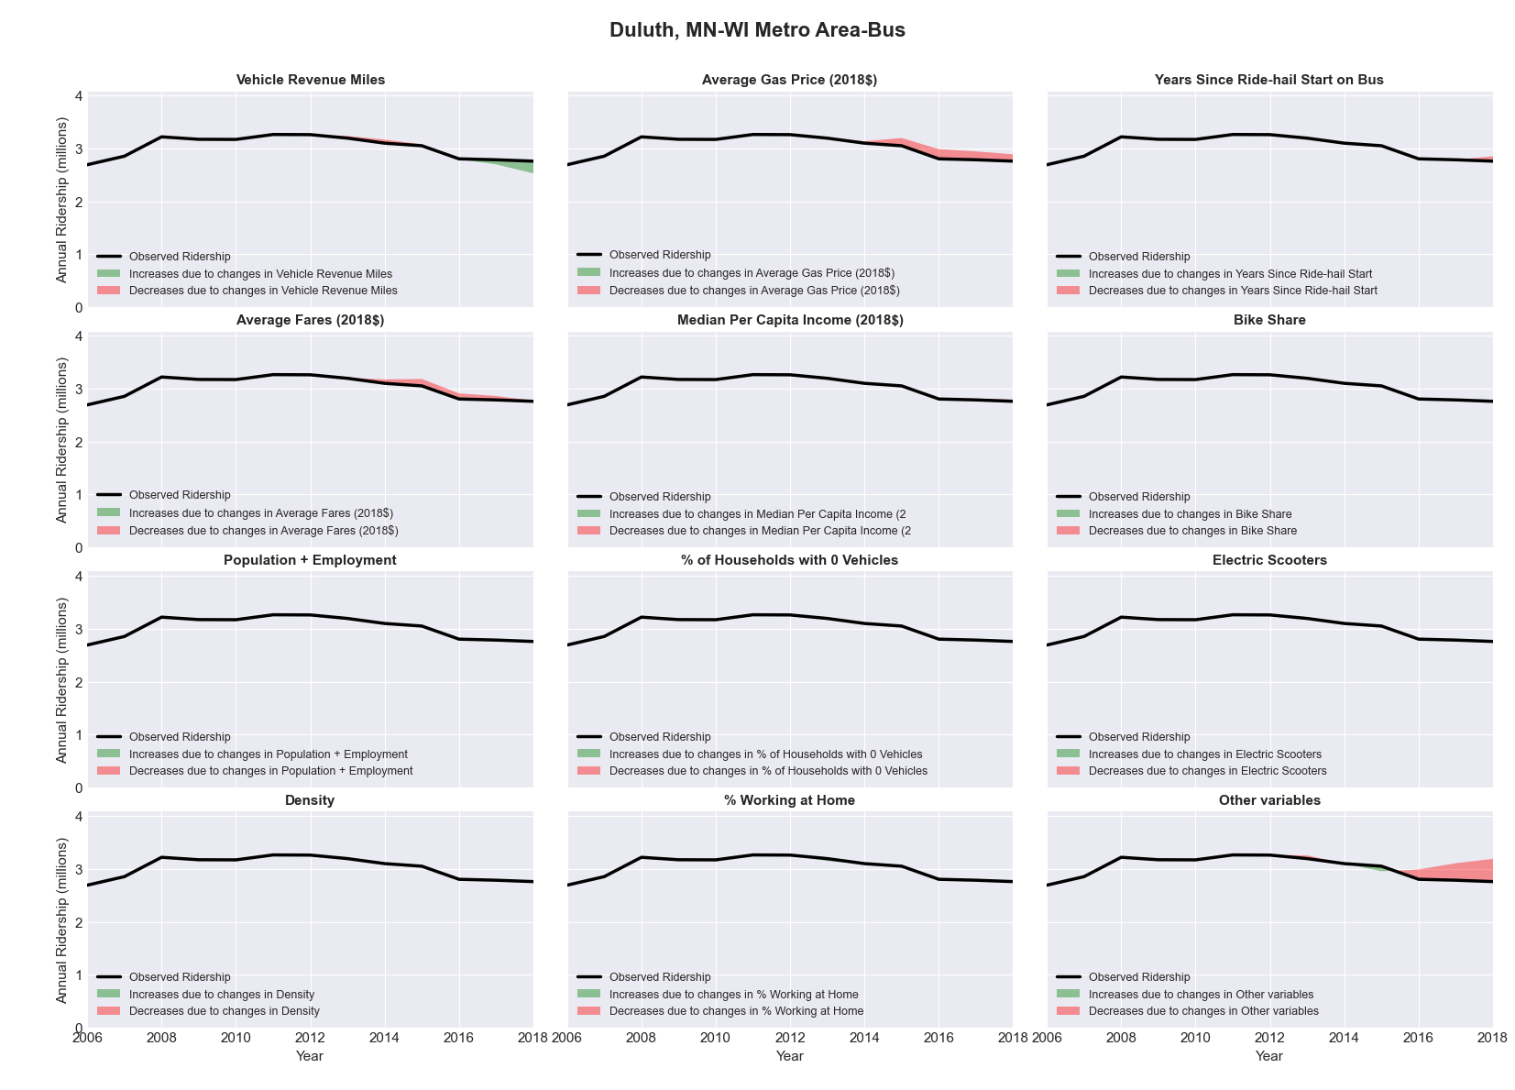

|  |  |  |  |  |  |  |
| --- | --- | --- | --- | --- | --- | --- |
| Durham-Chapel Hill, NC Metro Area-Bus | | | | | | |
|  |  |  |  |  |  | |
|  | **Average Values** | | | **Ridership Effect** | | |
| **Description** | **2012** | **2018** | **% Diff** | **Absolute** | **% Diff** | |
|  |  |  |  |  |  | |
| **Vehicle Revenue Miles** | 6,659,030 | 7,241,070 | 8.7% | 559,970 | | **3.6%** | |
| **Average Fare (2018$)** | 0.87 | 0.83 | -4.9% | 159,620 | | **1.0%** | |
| **Network Restructure** | - | - | - | - | | **0.0%** | |
| **Major Maintenance Event** | - | - | - | - | | **0.0%** | |
| **Population + Employment** | 773,690 | 864,430 | 11.7% | 353,930 | | **2.2%** | |
| **Share of Population and Employment in Transit Supportive Density** | 0.15 | 0.16 | 5.2% | 47,930 | | **0.3%** | |
| **Average Gas Price (2018$)** | 3.95 | 2.71 | -31.3% | -607,640 | | **-3.9%** | |
| **Median Per Capita Income (2018$)** | 27,710 | 32,960 | 18.9% | -180,020 | | **-1.1%** | |
| **% of Households with 0 Vehicles** | 9 | 7 | -22.9% | -58,840 | | **-0.4%** | |
| **% Working at Home** | 5.0 | 6.6 | 31.5% | -177,910 | | **-1.1%** | |
| **Years Since Ride-hail Start** | - | 4 | 4 | -1,917,020 | | **-12.2%** | |
| **Bike Share** | - | 1 | 1 | - 146,560 | | **-0.9%** | |
| **Electric Scooters** | - | 1 | 1 | - 579,840 | | **-3.7%** | |
| **New Reporters** |  |  |  | - | | **0.0%** | |
| **Total Modeled Ridership** | 15,765,276 | 13,208,097 | -16.22% | -2557179 | | **-16.2%** | |
| **Total Observed Ridership** | 15,004,578 | 13,572,307 | -9.55% | -1432271 | | **-9.5%** | |
| **Unexplained Change** |  |  |  |  | | **6.7%** | |

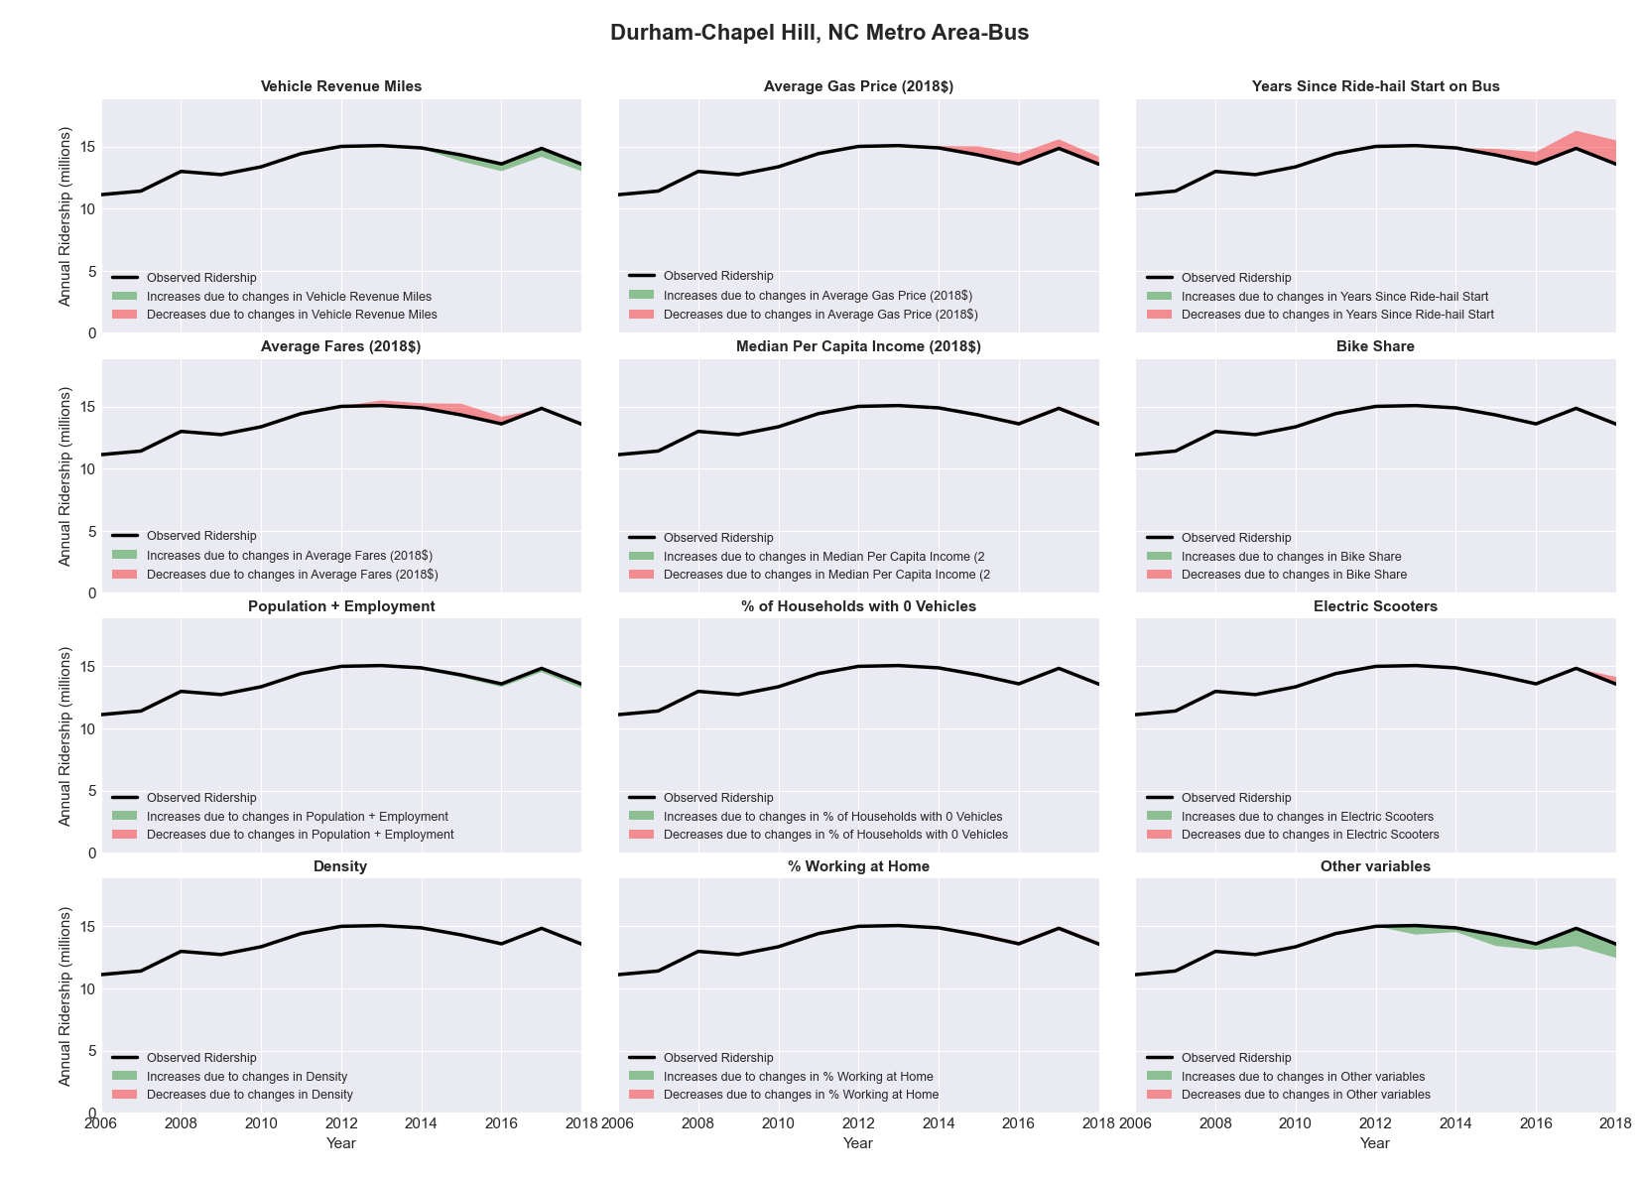

|  |  |  |  |  |  |  |
| --- | --- | --- | --- | --- | --- | --- |
| Eau Claire, WI Metro Area-Bus | | | | | | |
|  |  |  |  |  |  | |
|  | **Average Values** | | | **Ridership Effect** | | |
| **Description** | **2012** | **2018** | **% Diff** | **Absolute** | **% Diff** | |
|  |  |  |  |  |  | |
| **Vehicle Revenue Miles** | 666,400 | 693,350 | 4.0% | 19,540 | | **2.0%** | |
| **Average Fare (2018$)** | 0.75 | 0.90 | 19.4% | -45,940 | | **-4.7%** | |
| **Network Restructure** | - | - | - | - | | **0.0%** | |
| **Major Maintenance Event** | - | - | - | - | | **0.0%** | |
| **Population + Employment** | 249,490 | 259,520 | 4.0% | 7,850 | | **0.8%** | |
| **Share of Population and Employment in Transit Supportive Density** | 0.14 | 0.13 | -1.9% | -0,850 | | **-0.1%** | |
| **Average Gas Price (2018$)** | 3.93 | 2.72 | -30.9% | -39,630 | | **-4.1%** | |
| **Median Per Capita Income (2018$)** | 26,280 | 26,830 | 2.1% | -1,530 | | **-0.2%** | |
| **% of Households with 0 Vehicles** | 5 | 6 | 7.6% | 0,920 | | **0.1%** | |
| **% Working at Home** | 5.1 | 8.0 | 56.9% | -19,290 | | **-2.0%** | |
| **Years Since Ride-hail Start** | - | 1 | 1 | -28,790 | | **-2.9%** | |
| **Bike Share** | - | - | - | - | | **0.0%** | |
| **Electric Scooters** | - | - | - | - | | **0.0%** | |
| **New Reporters** |  |  |  | - | | **0.0%** | |
| **Total Modeled Ridership** | 977,741 | 868,767 | -11.15% | -108974.506 | | **-11.1%** | |
| **Total Observed Ridership** | 986,602 | 906,130 | -8.16% | -80472 | | **-8.2%** | |
| **Unexplained Change** |  |  |  |  | | **3.0%** | |

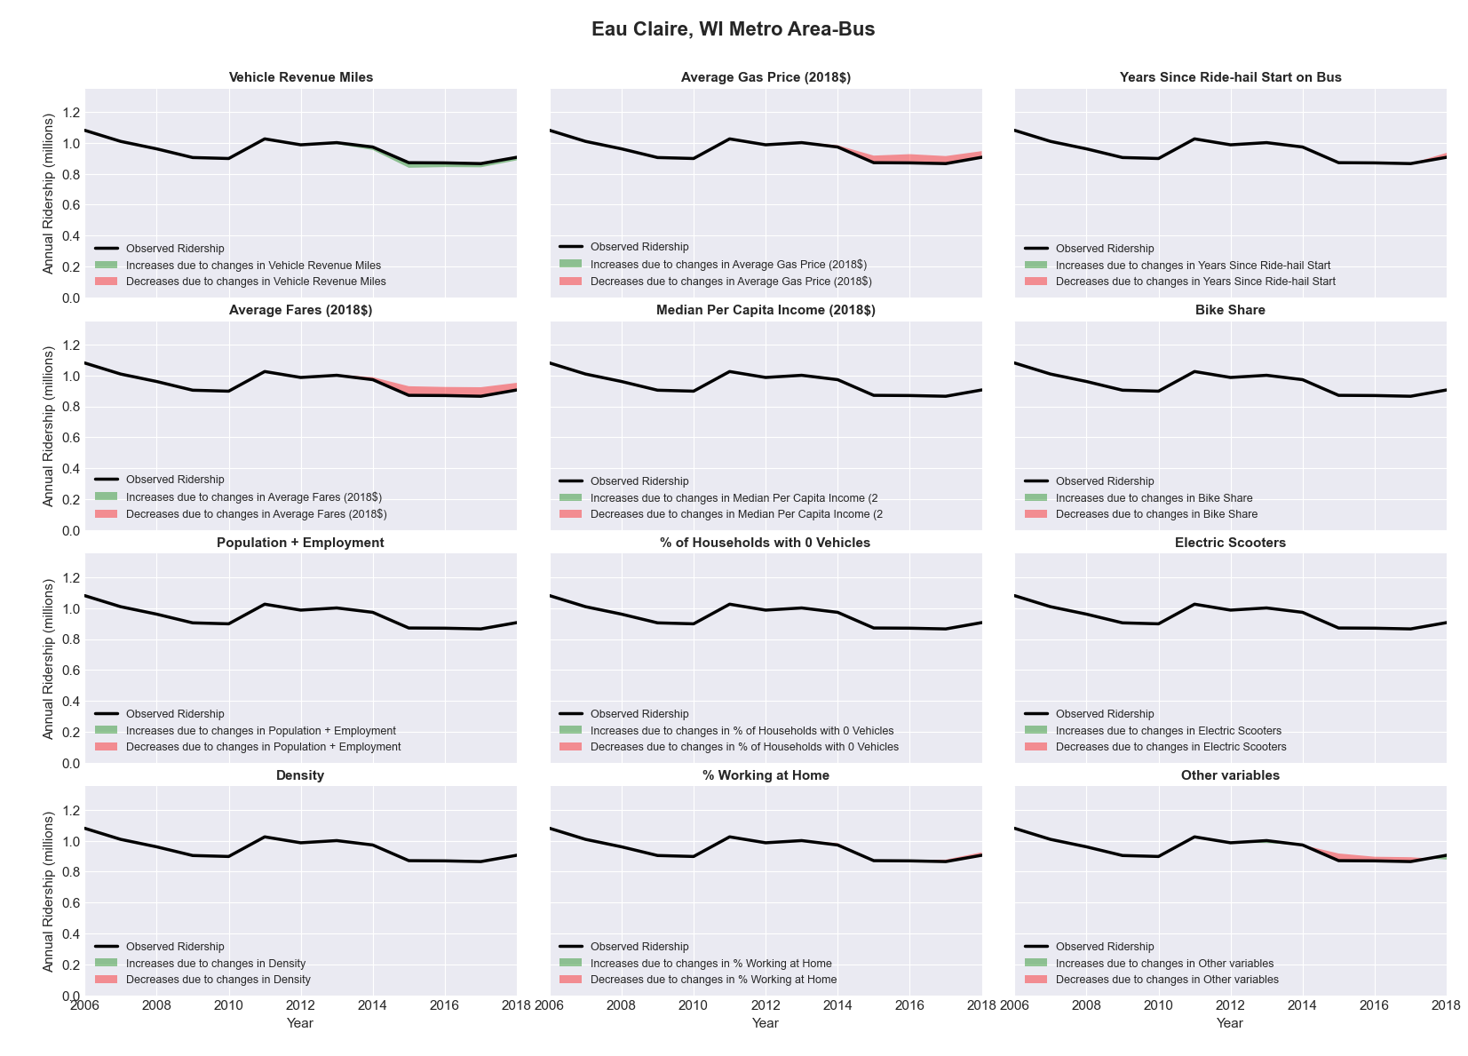

|  |  |  |  |  |  |  |
| --- | --- | --- | --- | --- | --- | --- |
| El Centro, CA Metro Area-Bus | | | | | | |
|  |  |  |  |  |  | |
|  | **Average Values** | | | **Ridership Effect** | | |
| **Description** | **2012** | **2018** | **% Diff** | **Absolute** | **% Diff** | |
|  |  |  |  |  |  | |
| **Vehicle Revenue Miles** | 663,220 | 881,300 | 32.9% | 96,000 | | **13.0%** | |
| **Average Fare (2018$)** | 0.92 | 0.77 | -16.2% | 27,830 | | **3.8%** | |
| **Network Restructure** | - | - | - | - | | **0.0%** | |
| **Major Maintenance Event** | - | - | - | - | | **0.0%** | |
| **Population + Employment** | 234,530 | 244,710 | 4.3% | 7,220 | | **1.0%** | |
| **Share of Population and Employment in Transit Supportive Density** | 0.26 | 0.26 | 1.8% | 1,660 | | **0.2%** | |
| **Average Gas Price (2018$)** | 4.35 | 3.40 | -21.8% | -23,850 | | **-3.2%** | |
| **Median Per Capita Income (2018$)** | 15,460 | 19,450 | 25.8% | -11,300 | | **-1.5%** | |
| **% of Households with 0 Vehicles** | 9 | 5 | -48.0% | -5,650 | | **-0.8%** | |
| **% Working at Home** | 4.9 | 7.3 | 49.5% | -16,280 | | **-2.2%** | |
| **Years Since Ride-hail Start** | - | 3 | 3 | -81,100 | | **-11.0%** | |
| **Bike Share** | - | - | - | - | | **0.0%** | |
| **Electric Scooters** | - | - | - | - | | **0.0%** | |
| **New Reporters** |  |  |  | - | | **0.0%** | |
| **Total Modeled Ridership** | 736,261 | 746,129 | 1.34% | 9868.57156 | | **1.3%** | |
| **Total Observed Ridership** | 625,777 | 769,635 | 22.99% | 143858 | | **23.0%** | |
| **Unexplained Change** |  |  |  |  | | **21.6%** | |

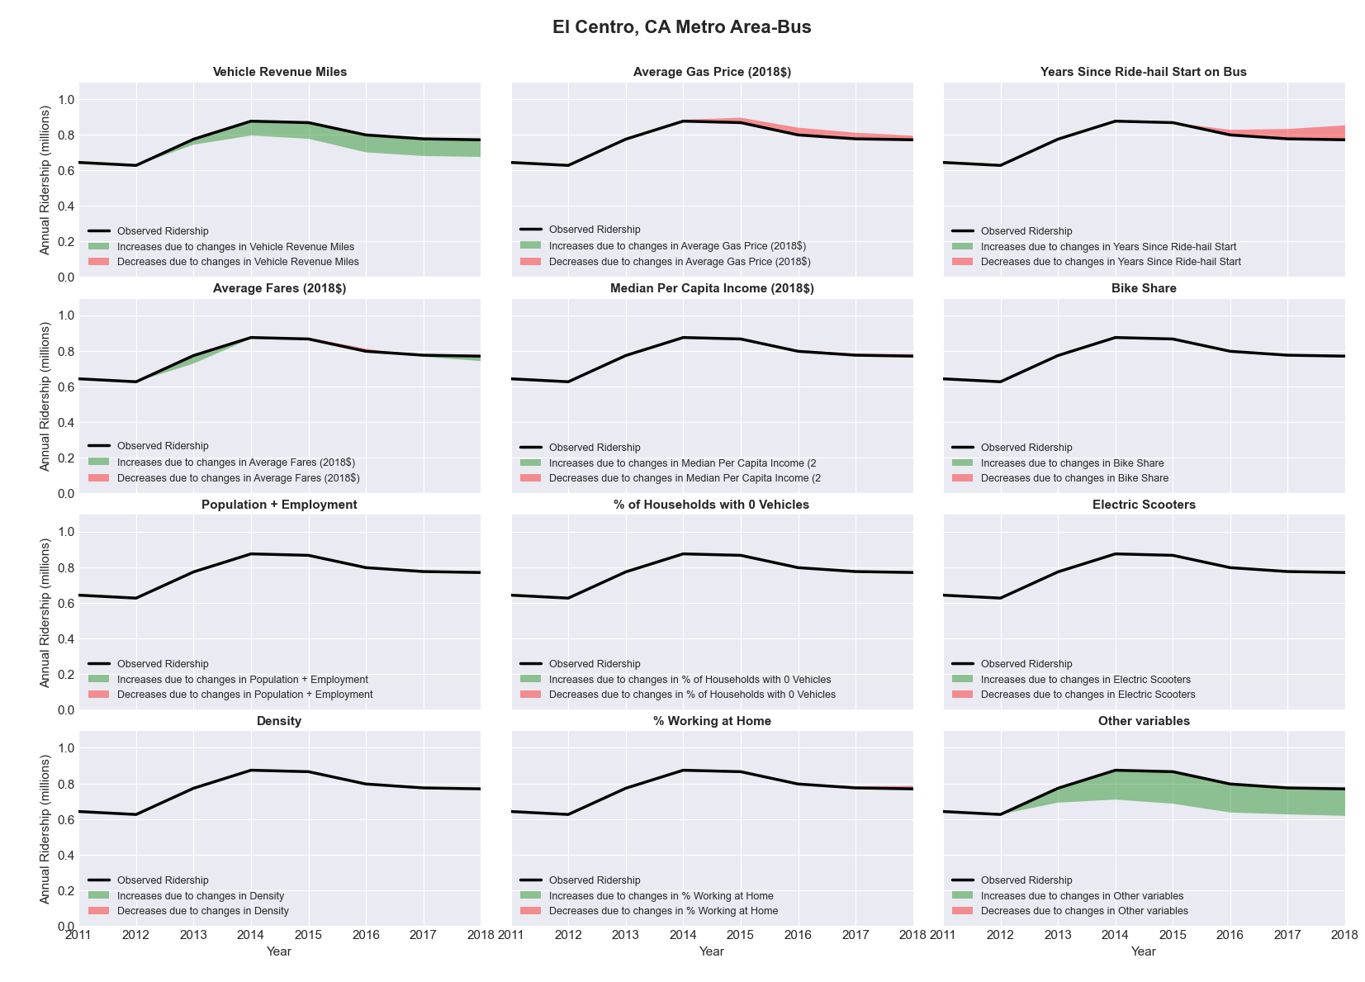

|  |  |  |  |  |  |  |
| --- | --- | --- | --- | --- | --- | --- |
| El Paso, TX Metro Area-Bus | | | | | | |
|  |  |  |  |  |  | |
|  | **Average Values** | | | **Ridership Effect** | | |
| **Description** | **2012** | **2018** | **% Diff** | **Absolute** | **% Diff** | |
|  |  |  |  |  |  | |
| **Vehicle Revenue Miles** | 6,927,890 | 6,741,400 | -2.7% | -126,190 | | **-0.9%** | |
| **Average Fare (2018$)** | 0.65 | 0.56 | -14.1% | 317,220 | | **2.3%** | |
| **Network Restructure** | - | - | - | - | | **0.0%** | |
| **Major Maintenance Event** | - | - | - | - | | **0.0%** | |
| **Population + Employment** | 1,145,230 | 1,187,180 | 3.7% | 98,810 | | **0.7%** | |
| **Share of Population and Employment in Transit Supportive Density** | 0.58 | 0.56 | -3.5% | -104,070 | | **-0.8%** | |
| **Average Gas Price (2018$)** | 3.80 | 2.58 | -32.2% | -515,160 | | **-3.7%** | |
| **Median Per Capita Income (2018$)** | 21,390 | 22,580 | 5.6% | -45,190 | | **-0.3%** | |
| **% of Households with 0 Vehicles** | 8 | 7 | -18.6% | -36,290 | | **-0.3%** | |
| **% Working at Home** | 2.8 | 4.5 | 58.9% | -164,060 | | **-1.2%** | |
| **Years Since Ride-hail Start** | - | 4 | 4 | -1,633,410 | | **-11.8%** | |
| **Bike Share** | - | 1 | 1 | - 131,900 | | **-1.0%** | |
| **Electric Scooters** | - | - | - | - | | **0.0%** | |
| **New Reporters** |  |  |  | - | | **0.0%** | |
| **Total Modeled Ridership** | 13,793,255 | 11,436,805 | -17.08% | -235649.76 | | **-17.1%** | |
| **Total Observed Ridership** | 14,575,876 | 12,134,109 | -16.75% | -2441767 | | **-16.8%** | |
| **Unexplained Change** |  |  |  |  | | **0.3%** | |

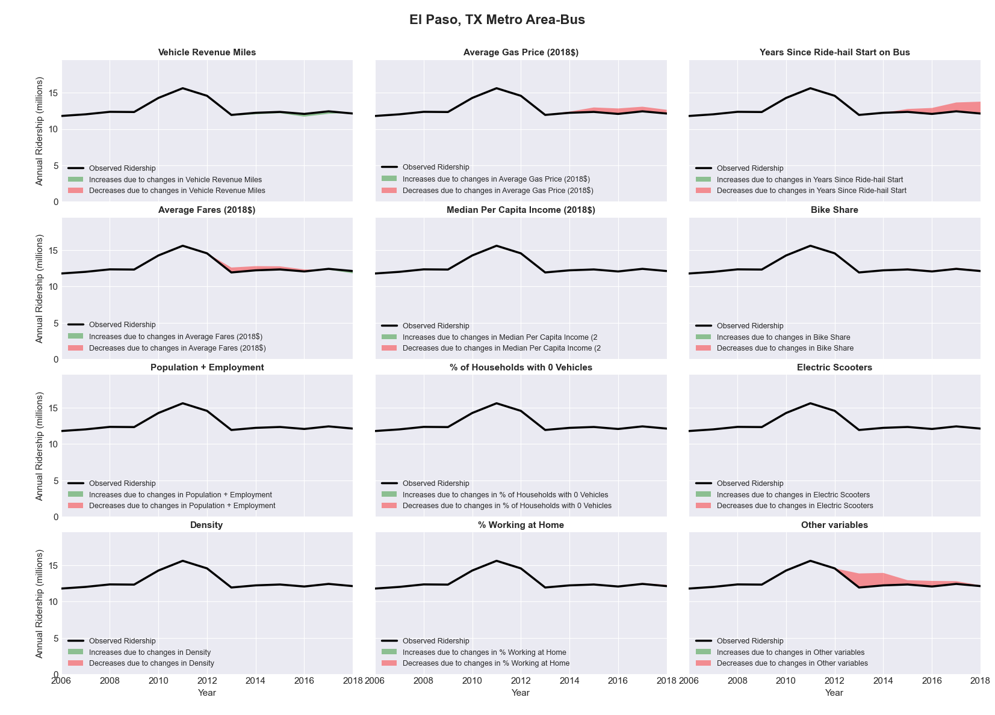

|  |  |  |  |  |  |  |
| --- | --- | --- | --- | --- | --- | --- |
| Elkhart-Goshen, IN Metro Area-Bus | | | | | | |
|  |  |  |  |  |  | |
|  | **Average Values** | | | **Ridership Effect** | | |
| **Description** | **2012** | **2018** | **% Diff** | **Absolute** | **% Diff** | |
|  |  |  |  |  |  | |
| **Vehicle Revenue Miles** | 608,560 | 592,360 | -2.7% | -4,880 | | **-1.2%** | |
| **Average Fare (2018$)** | 0.81 | 0.60 | -26.0% | 28,270 | | **6.7%** | |
| **Network Restructure** | - | - | - | - | | **0.0%** | |
| **Major Maintenance Event** | - | - | - | - | | **0.0%** | |
| **Population + Employment** | 287,810 | 320,600 | 11.4% | 9,850 | | **2.3%** | |
| **Share of Population and Employment in Transit Supportive Density** | 0.06 | 0.06 | -3.0% | -0,260 | | **-0.1%** | |
| **Average Gas Price (2018$)** | 3.93 | 2.72 | -30.9% | -18,750 | | **-4.4%** | |
| **Median Per Capita Income (2018$)** | 25,500 | 31,230 | 22.5% | -6,510 | | **-1.5%** | |
| **% of Households with 0 Vehicles** | 9 | 9 | -1.9% | -0,240 | | **-0.1%** | |
| **% Working at Home** | 2.3 | 5.2 | 125.0% | -10,030 | | **-2.4%** | |
| **Years Since Ride-hail Start** | - | 2 | 2 | -26,870 | | **-6.3%** | |
| **Bike Share** | - | 1 | 1 | - 4,180 | | **-1.0%** | |
| **Electric Scooters** | - | 1 | 1 | - 15,140 | | **-3.6%** | |
| **New Reporters** |  |  |  | - | | **0.0%** | |
| **Total Modeled Ridership** | 423,538 | 378,215 | -10.70% | -45323.428 | | **-10.7%** | |
| **Total Observed Ridership** | 355,202 | 402,493 | 13.31% | 47291 | | **13.3%** | |
| **Unexplained Change** |  |  |  |  | | **24.0%** | |

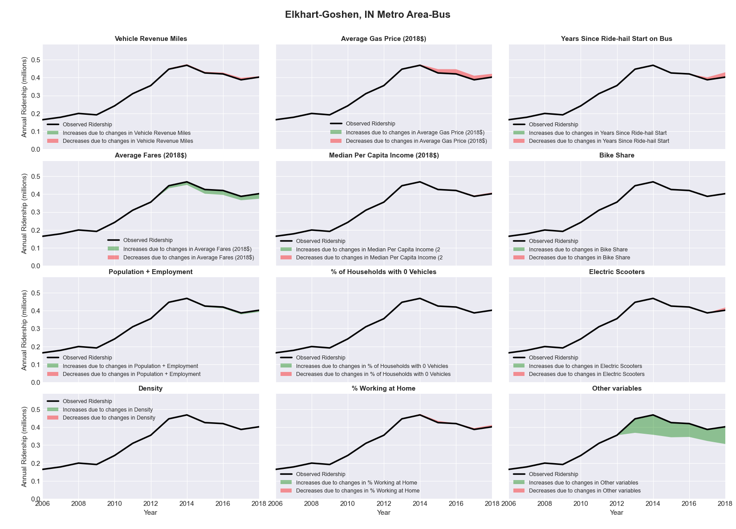

|  |  |  |  |  |  |  |
| --- | --- | --- | --- | --- | --- | --- |
| Erie, PA Metro Area-Bus | | | | | | |
|  |  |  |  |  |  | |
|  | **Average Values** | | | **Ridership Effect** | | |
| **Description** | **2012** | **2018** | **% Diff** | **Absolute** | **% Diff** | |
|  |  |  |  |  |  | |
| **Vehicle Revenue Miles** | 1,970,580 | 2,205,710 | 11.9% | 156,930 | | **4.6%** | |
| **Average Fare (2018$)** | 0.74 | 1.18 | 59.7% | -414,450 | | **-12.3%** | |
| **Network Restructure** | - | - | - | - | | **0.0%** | |
| **Major Maintenance Event** | - | - | - | - | | **0.0%** | |
| **Population + Employment** | 407,350 | 395,500 | -2.9% | -19,440 | | **-0.6%** | |
| **Share of Population and Employment in Transit Supportive Density** | 0.27 | 0.27 | 1.1% | 4,140 | | **0.1%** | |
| **Average Gas Price (2018$)** | 4.11 | 2.92 | -28.9% | -130,310 | | **-3.9%** | |
| **Median Per Capita Income (2018$)** | 24,510 | 25,090 | 2.4% | -7,110 | | **-0.2%** | |
| **% of Households with 0 Vehicles** | 10 | 12 | 20.0% | 12,600 | | **0.4%** | |
| **% Working at Home** | 3.4 | 3.3 | -2.9% | 1,180 | | **0.0%** | |
| **Years Since Ride-hail Start** | - | 3 | 3 | -287,270 | | **-8.5%** | |
| **Bike Share** | - | - | - | - | | **0.0%** | |
| **Electric Scooters** | - | - | - | - | | **0.0%** | |
| **New Reporters** |  |  |  | - | | **0.0%** | |
| **Total Modeled Ridership** | 3,378,750 | 2,706,157 | -19.91% | -672593.554 | | **-19.9%** | |
| **Total Observed Ridership** | 3,468,084 | 2,517,894 | -27.40% | -950190 | | **-27.4%** | |
| **Unexplained Change** |  |  |  |  | | **-7.5%** | |

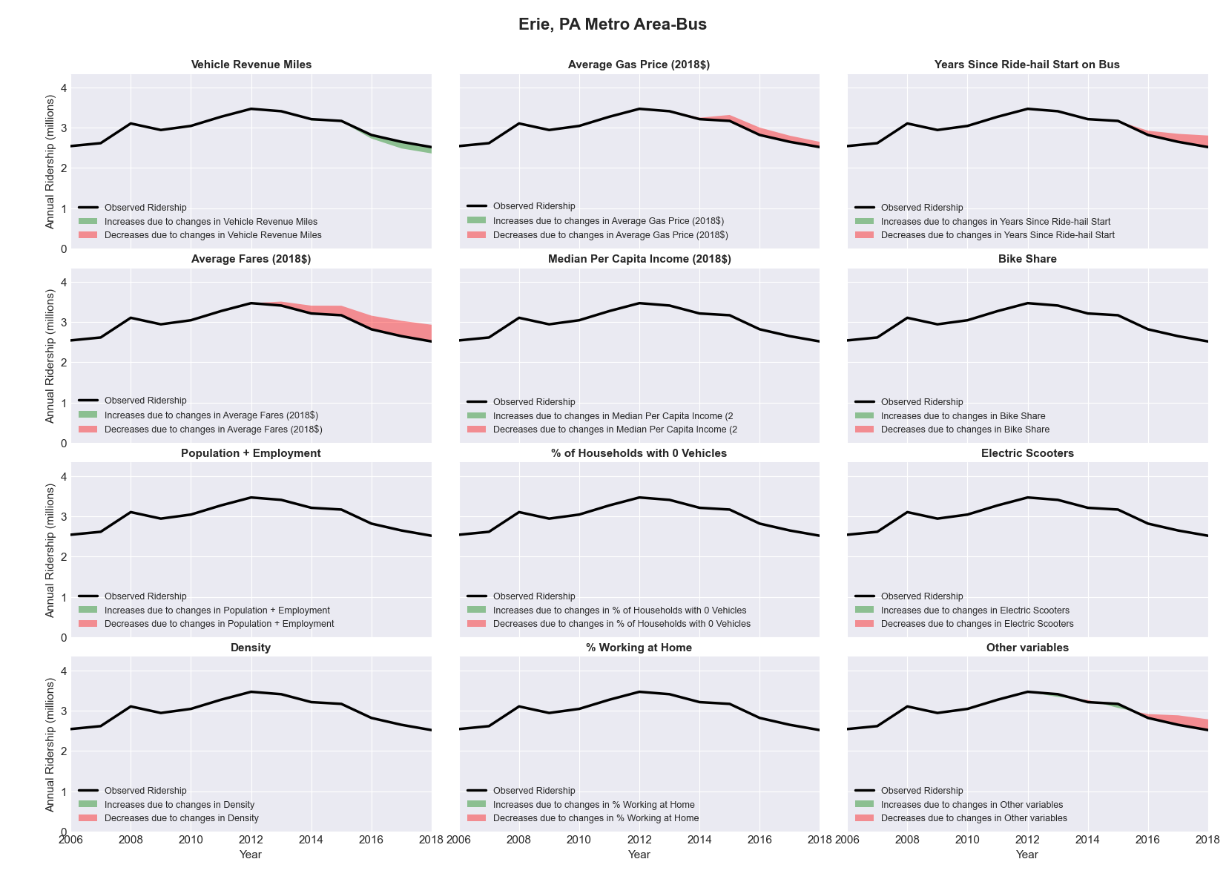

|  |  |  |  |  |  |  |
| --- | --- | --- | --- | --- | --- | --- |
| Eugene-Springfield, OR Metro Area-Bus | | | | | | |
|  |  |  |  |  |  | |
|  | **Average Values** | | | **Ridership Effect** | | |
| **Description** | **2012** | **2018** | **% Diff** | **Absolute** | **% Diff** | |
|  |  |  |  |  |  | |
| **Vehicle Revenue Miles** | 3,196,690 | 3,764,010 | 17.7% | 780,680 | | **7.3%** | |
| **Average Fare (2018$)** | 0.64 | 0.74 | 15.7% | -387,900 | | **-3.6%** | |
| **Network Restructure** | - | - | - | - | | **0.0%** | |
| **Major Maintenance Event** | - | - | - | - | | **0.0%** | |
| **Population + Employment** | 511,440 | 556,590 | 8.8% | 193,700 | | **1.8%** | |
| **Share of Population and Employment in Transit Supportive Density** | 0.28 | 0.28 | 1.4% | 17,390 | | **0.2%** | |
| **Average Gas Price (2018$)** | 4.35 | 3.40 | -21.8% | -314,000 | | **-2.9%** | |
| **Median Per Capita Income (2018$)** | 22,980 | 25,630 | 11.5% | -83,960 | | **-0.8%** | |
| **% of Households with 0 Vehicles** | 9 | 7 | -14.4% | -25,530 | | **-0.2%** | |
| **% Working at Home** | 6.7 | 7.1 | 5.2% | -10,790 | | **-0.1%** | |
| **Years Since Ride-hail Start** | - | - | - | 0,000 | | **0.0%** | |
| **Bike Share** | - | 1 | 1 | - 109,730 | | **-1.0%** | |
| **Electric Scooters** | - | - | - | - | | **0.0%** | |
| **New Reporters** |  |  |  | - | | **0.0%** | |
| **Total Modeled Ridership** | 10,752,648 | 10,830,671 | 0.73% | 78022.9939 | | **0.7%** | |
| **Total Observed Ridership** | 11,548,218 | 10,244,079 | -11.29% | -1304139 | | **-11.3%** | |
| **Unexplained Change** |  |  |  |  | | **-12.0%** | |

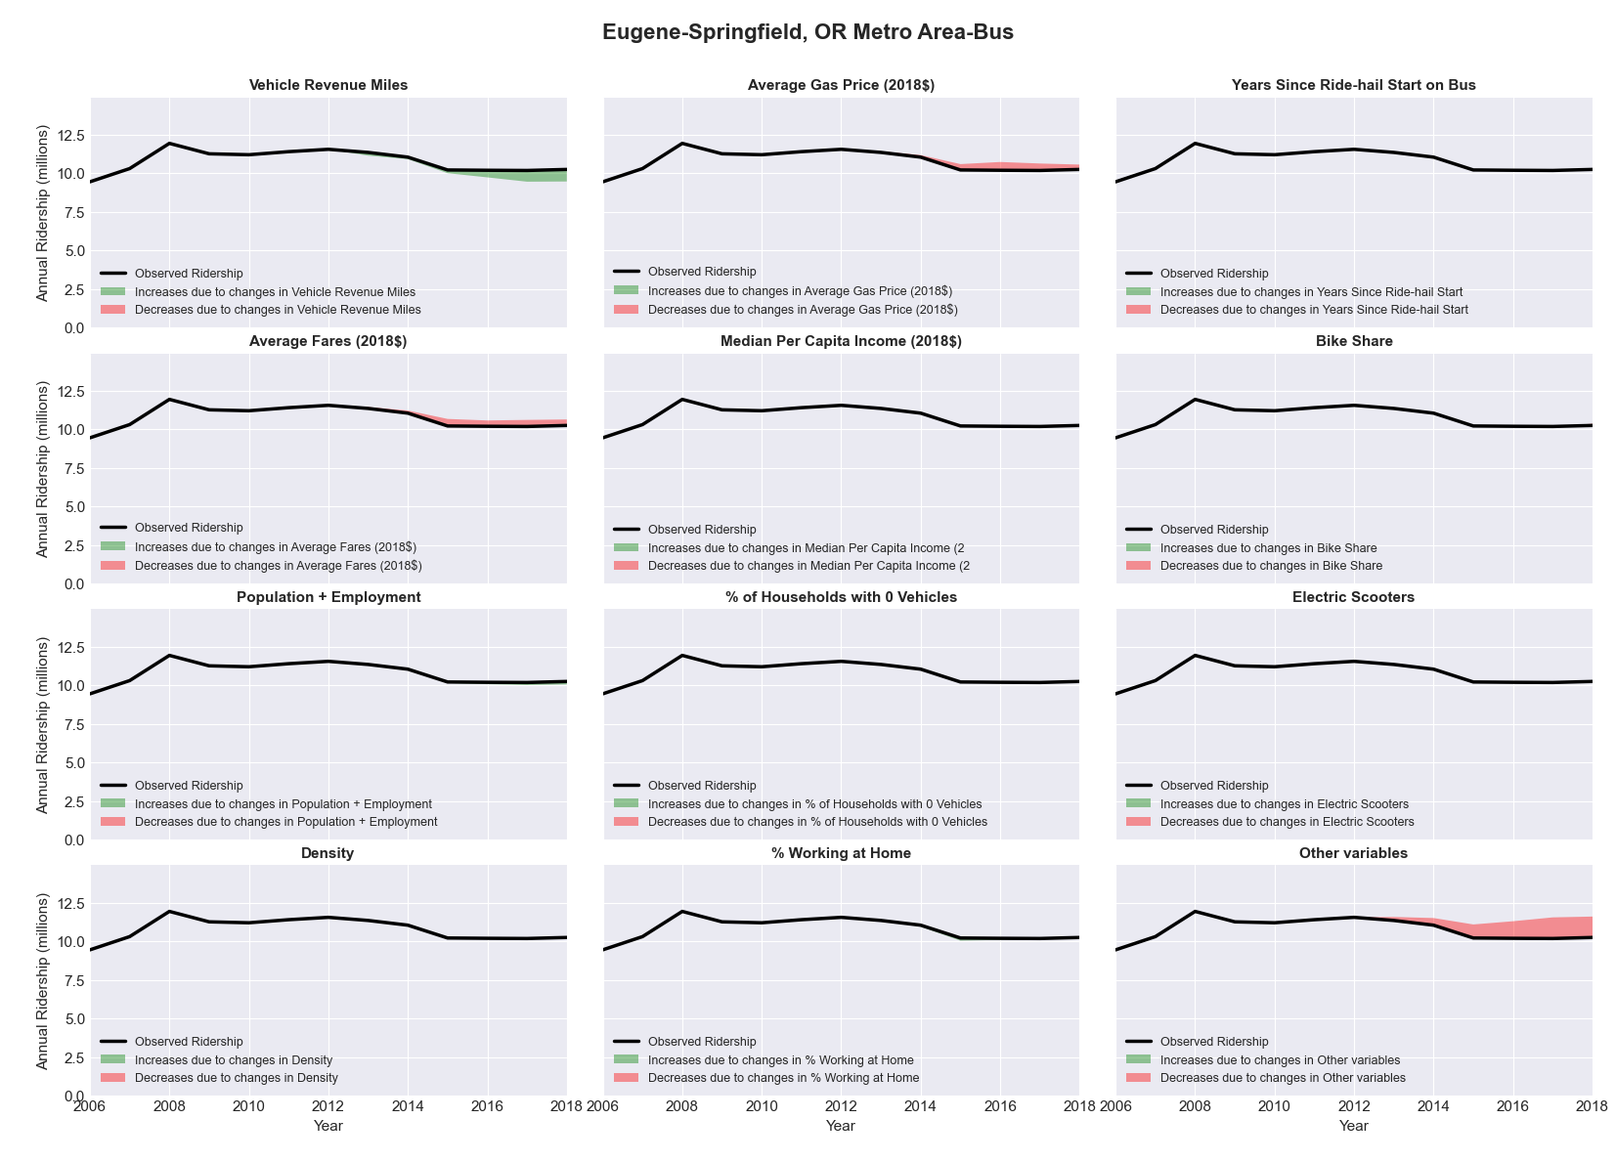

|  |  |  |  |  |  |  |
| --- | --- | --- | --- | --- | --- | --- |
| Evansville, IN-KY Metro Area-Bus | | | | | | |
|  |  |  |  |  |  | |
|  | **Average Values** | | | **Ridership Effect** | | |
| **Description** | **2012** | **2018** | **% Diff** | **Absolute** | **% Diff** | |
|  |  |  |  |  |  | |
| **Vehicle Revenue Miles** | 1,351,600 | 1,156,320 | -14.4% | -133,040 | | **-6.6%** | |
| **Average Fare (2018$)** | 0.71 | 0.91 | 27.7% | -123,520 | | **-6.1%** | |
| **Network Restructure** | - | - | - | - | | **0.0%** | |
| **Major Maintenance Event** | - | - | - | - | | **0.0%** | |
| **Population + Employment** | 527,700 | 499,190 | -5.4% | -25,930 | | **-1.3%** | |
| **Share of Population and Employment in Transit Supportive Density** | 0.20 | 0.19 | -1.3% | -1,740 | | **-0.1%** | |
| **Average Gas Price (2018$)** | 3.93 | 2.72 | -30.9% | -88,190 | | **-4.4%** | |
| **Median Per Capita Income (2018$)** | 27,190 | 29,610 | 8.9% | -10,700 | | **-0.5%** | |
| **% of Households with 0 Vehicles** | 7 | 5 | -26.8% | -5,450 | | **-0.3%** | |
| **% Working at Home** | 2.8 | 3.4 | 19.6% | -3,670 | | **-0.2%** | |
| **Years Since Ride-hail Start** | - | 1 | 1 | -49,710 | | **-2.5%** | |
| **Bike Share** | - | 1 | 1 | - 21,290 | | **-1.1%** | |
| **Electric Scooters** | - | - | - | - | | **0.0%** | |
| **New Reporters** |  |  |  | - | | **0.0%** | |
| **Total Modeled Ridership** | 2,024,068 | 1,583,246 | -21.78% | -440822.066 | | **-21.8%** | |
| **Total Observed Ridership** | 2,043,247 | 1,410,383 | -30.97% | -632864 | | **-31.0%** | |
| **Unexplained Change** |  |  |  |  | | **-9.2%** | |

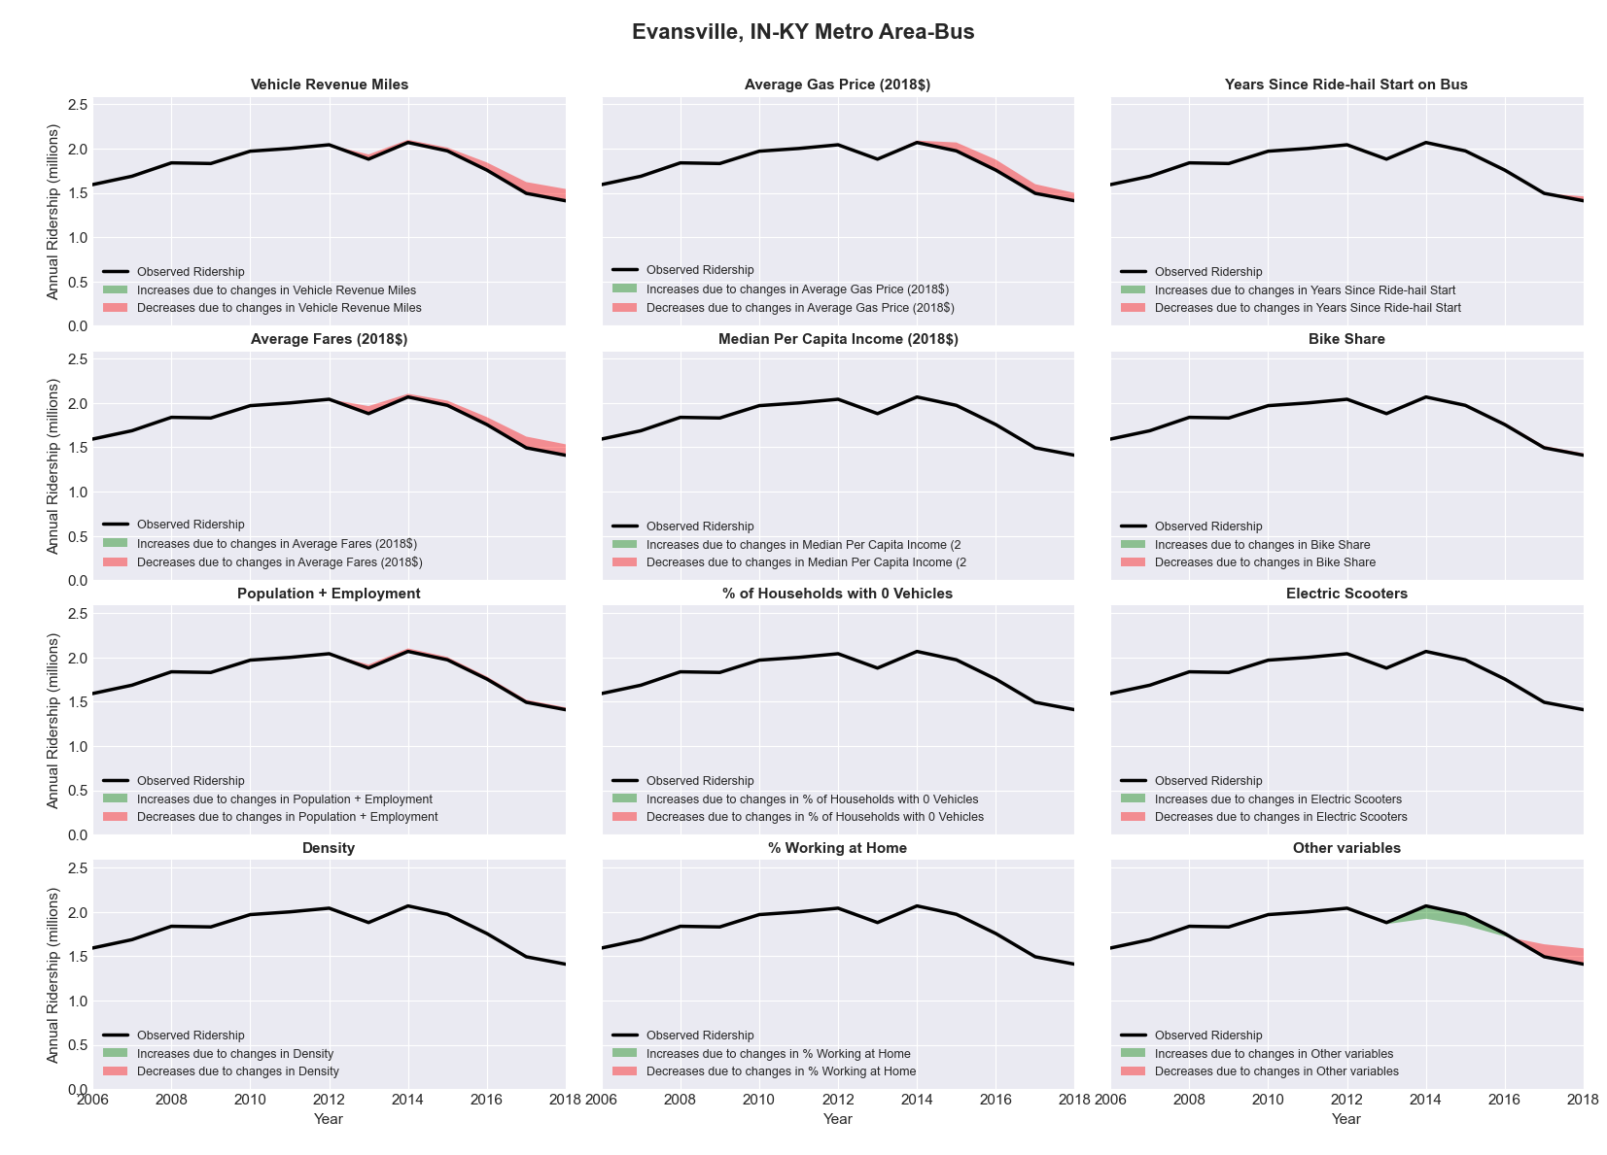

|  |  |  |  |  |  |  |
| --- | --- | --- | --- | --- | --- | --- |
| **Fargo, ND-MN** Metro Area**-Bus** | | | | | | |
|  |  |  |  |  |  | |
|  | **Average Values** | | | **Ridership Effect** | | |
| **Description** | **2012** | **2018** | **% Diff** | **Absolute** | **% Diff** | |
|  |  |  |  |  |  | |
| **Vehicle Revenue Miles** | 1,178,180 | 1,489,280 | 26.4% | 216,010 | | **10.6%** | |
| **Average Fare (2018$)** | 0.50 | 0.42 | -16.5% | 63,130 | | **3.1%** | |
| **Network Restructure** | - | - | - | - | | **0.0%** | |
| **Major Maintenance Event** | - | - | - | - | | **0.0%** | |
| **Population + Employment** | 336,620 | 379,260 | 12.7% | 54,100 | | **2.7%** | |
| **Share of Population and Employment in Transit Supportive Density** | 0.30 | 0.28 | -5.8% | -15,030 | | **-0.7%** | |
| **Average Gas Price (2018$)** | 3.93 | 2.72 | -30.9% | -90,970 | | **-4.5%** | |
| **Median Per Capita Income (2018$)** | 31,120 | 36,190 | 16.3% | -22,070 | | **-1.1%** | |
| **% of Households with 0 Vehicles** | 7 | 4 | -42.7% | -10,900 | | **-0.5%** | |
| **% Working at Home** | 3.7 | 5.6 | 52.0% | -30,400 | | **-1.5%** | |
| **Years Since Ride-hail Start** | - | 3 | 3 | -195,980 | | **-9.7%** | |
| **Bike Share** | - | 1 | 1 | - 23,020 | | **-1.1%** | |
| **Electric Scooters** | - | - | - | - | | **0.0%** | |
| **New Reporters** |  |  |  | - | | **0.0%** | |
| **Total Modeled Ridership** | 2,029,633 | 1,976,396 | -2.62% | -53233712 | | **-2.6%** | |
| **Total Observed Ridership** | 2,039,074 | 1,960,893 | -3.83% | -78181 | | **-3.8%** | |
| **Unexplained Change** |  |  |  |  | | **-1.2%** | |

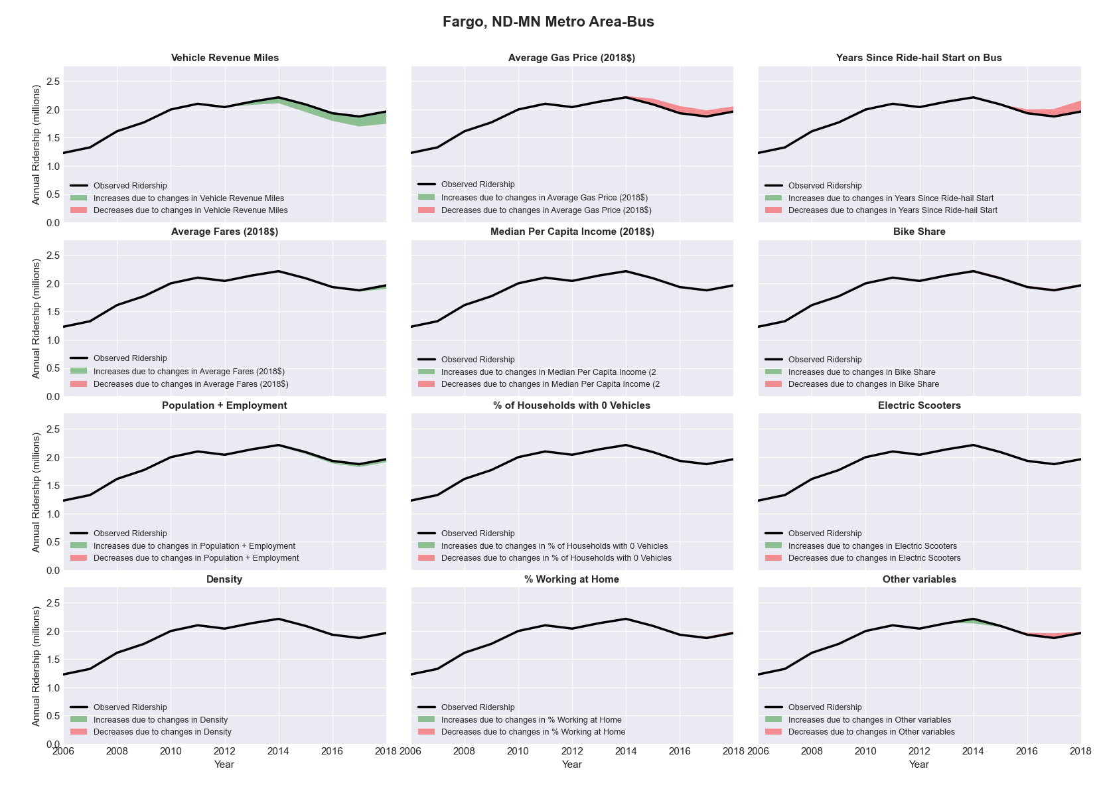

|  |  |  |  |  |  |  |
| --- | --- | --- | --- | --- | --- | --- |
| **Fayetteville, NC** Metro Area**-Bus** | | | | | | |
|  |  |  |  |  |  | |
|  | **Average Values** | | | **Ridership Effect** | | |
| **Description** | **2012** | **2018** | **% Diff** | **Absolute** | **% Diff** | |
|  |  |  |  |  |  | |
| **Vehicle Revenue Miles** | 887,750 | 1,275,840 | 43.7% | 258,210 | | **16.2%** | |
| **Average Fare (2018$)** | 0.60 | 0.83 | 37.6% | -123,350 | | **-7.7%** | |
| **Network Restructure** | - | - | - | - | | **0.0%** | |
| **Major Maintenance Event** | - | - | - | - | | **0.0%** | |
| **Population + Employment** | 510,830 | 532,710 | 4.3% | 13,360 | | **0.8%** | |
| **Share of Population and Employment in Transit Supportive Density** | 0.04 | 0.04 | 0.9% | 0,220 | | **0.0%** | |
| **Average Gas Price (2018$)** | 3.95 | 2.71 | -31.3% | -65,840 | | **-4.1%** | |
| **Median Per Capita Income (2018$)** | 27,900 | 24,590 | -11.9% | 13,610 | | **0.9%** | |
| **% of Households with 0 Vehicles** | 6 | 6 | -9.8% | -1,640 | | **-0.1%** | |
| **% Working at Home** | 1.5 | 5.1 | 241.7% | -42,480 | | **-2.7%** | |
| **Years Since Ride-hail Start** | - | 4 | 4 | -196,410 | | **-12.3%** | |
| **Bike Share** | - | 1 | 1 | - 14,780 | | **-0.9%** | |
| **Electric Scooters** | - | - | - | - | | **0.0%** | |
| **New Reporters** |  |  |  | - | | **0.0%** | |
| **Total Modeled Ridership** | 1,593,784 | 1,425,749 | -10.54% | -168034.95 | | **-10.5%** | |
| **Total Observed Ridership** | 1,671,196 | 1,357,927 | -18.75% | -313269 | | **-18.7%** | |
| **Unexplained Change** |  |  |  |  | | **-8.2%** | |

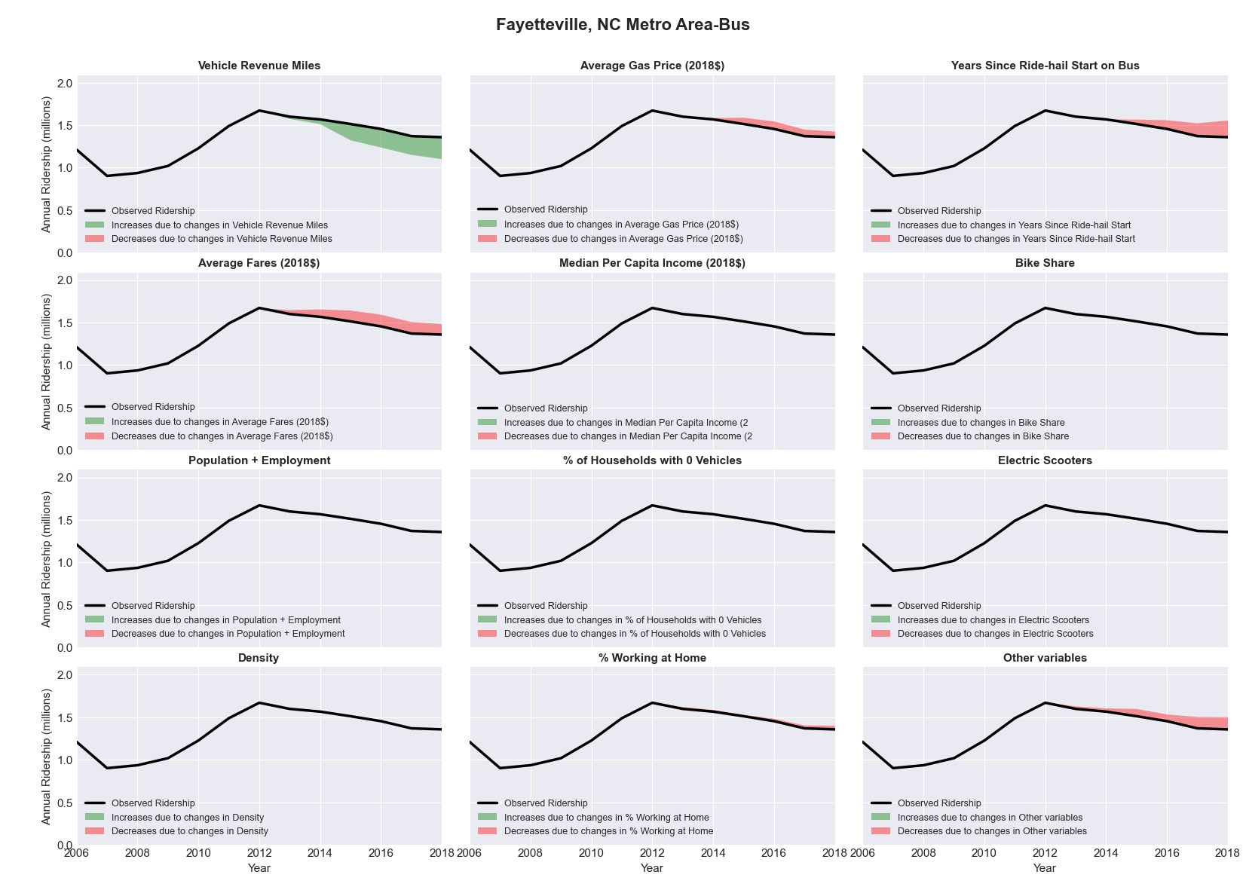

|  |  |  |  |  |  |  |
| --- | --- | --- | --- | --- | --- | --- |
| **Flagstaff, AZ** Metro Area**-Bus** | | | | | | |
|  |  |  |  |  |  | |
|  | **Average Values** | | | **Ridership Effect** | | |
| **Description** | **2012** | **2018** | **% Diff** | **Absolute** | **% Diff** | |
|  |  |  |  |  |  | |
| **Vehicle Revenue Miles** | 713,410 | 926,070 | 29.8% | 224,550 | | **11.6%** | |
| **Average Fare (2018$)** | 0.81 | 0.52 | -36.1% | 206,390 | | **10.6%** | |
| **Network Restructure** | - | - | - | - | | **0.0%** | |
| **Major Maintenance Event** | - | - | - | - | | **0.0%** | |
| **Population + Employment** | 200,930 | 213,780 | 6.4% | 26,140 | | **1.3%** | |
| **Share of Population and Employment in Transit Supportive Density** | 0.11 | 0.10 | -5.0% | -3,960 | | **-0.2%** | |
| **Average Gas Price (2018$)** | 4.35 | 3.40 | -21.8% | -45,460 | | **-2.3%** | |
| **Median Per Capita Income (2018$)** | 22,570 | 24,860 | 10.1% | -12,810 | | **-0.7%** | |
| **% of Households with 0 Vehicles** | 6 | 3 | -55.3% | -13,790 | | **-0.7%** | |
| **% Working at Home** | 7.3 | 5.2 | -29.1% | 31,420 | | **1.6%** | |
| **Years Since Ride-hail Start** | - | 4 | 4 | -265,480 | | **-13.7%** | |
| **Bike Share** | - | 1 | 1 | - 23,890 | | **-1.2%** | |
| **Electric Scooters** | - | 1 | 1 | - 86,550 | | **-4.5%** | |
| **New Reporters** |  |  |  | - | | **0.0%** | |
| **Total Modeled Ridership** | 1,938,530 | 1,976,230 | 1.94% | 37699.2686 | | **1.9%** | |
| **Total Observed Ridership** | 1,807,013 | 2,530,626 | 40.04% | 723613 | | **40.0%** | |
| **Unexplained Change** |  |  |  |  | | **38.1%** | |

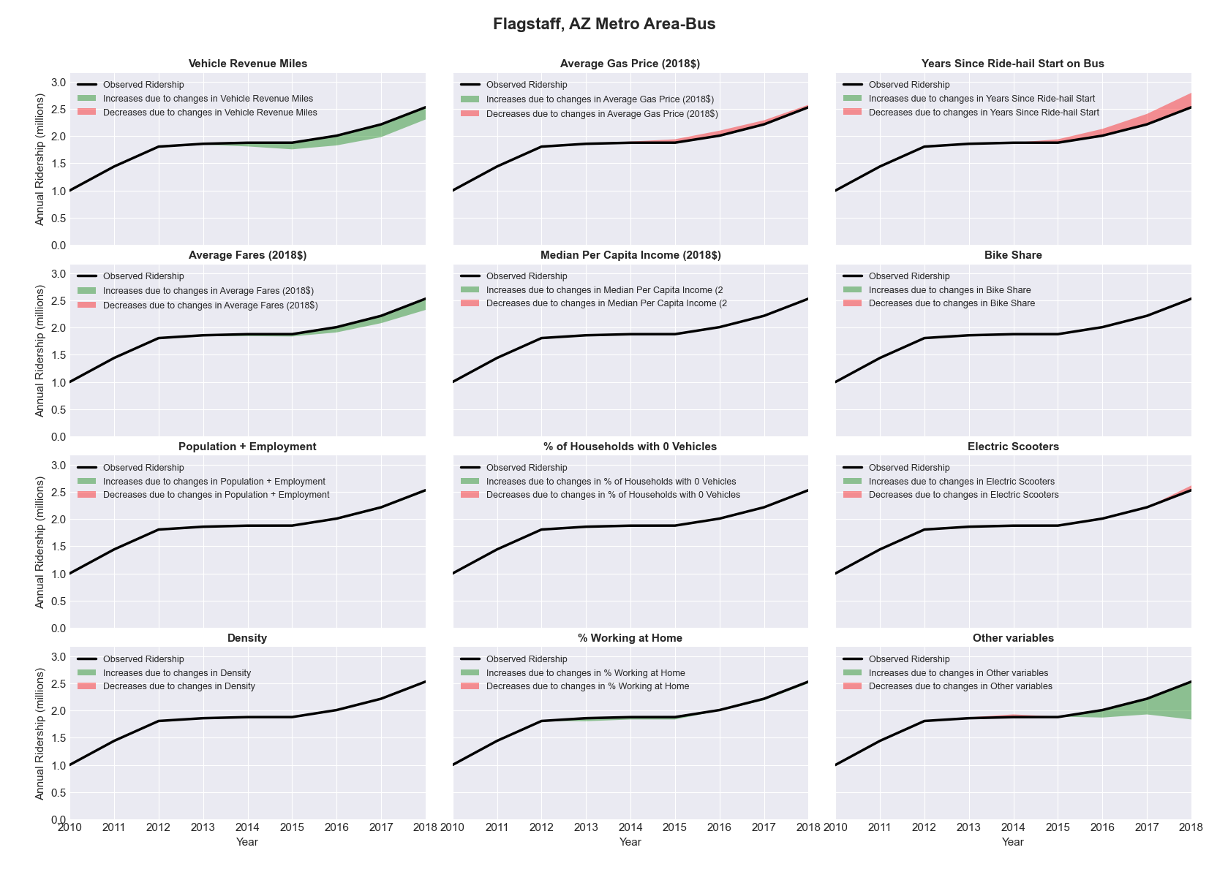

|  |  |  |  |  |  |  |
| --- | --- | --- | --- | --- | --- | --- |
| **Flint, MI** Metro Area**-Bus** | | | | | | |
|  |  |  |  |  |  | |
|  | **Average Values** | | | **Ridership Effect** | | |
| **Description** | **2012** | **2018** | **% Diff** | **Absolute** | **% Diff** | |
|  |  |  |  |  |  | |
| **Vehicle Revenue Miles** | 3,132,870 | 3,675,900 | 17.3% | 327,970 | | **6.0%** | |
| **Average Fare (2018$)** | 0.92 | 1.21 | 31.6% | -418,720 | | **-7.7%** | |
| **Network Restructure** | - | - | - | - | | **0.0%** | |
| **Major Maintenance Event** | - | - | - | - | | **0.0%** | |
| **Population + Employment** | 581,470 | 579,190 | -0.4% | -3,820 | | **-0.1%** | |
| **Share of Population and Employment in Transit Supportive Density** | 0.09 | 0.09 | -6.8% | -15,500 | | **-0.3%** | |
| **Average Gas Price (2018$)** | 3.93 | 2.72 | -30.9% | -212,570 | | **-3.9%** | |
| **Median Per Capita Income (2018$)** | 24,460 | 26,000 | 6.3% | -20,020 | | **-0.4%** | |
| **% of Households with 0 Vehicles** | 9 | 9 | 6.0% | 5,870 | | **0.1%** | |
| **% Working at Home** | 3.5 | 3.6 | 3.6% | 4,670 | | **0.1%** | |
| **Years Since Ride-hail Start** | - | 4 | 4 | -628,440 | | **-11.5%** | |
| **Bike Share** | - | 1 | 1 | - 52,560 | | **-1.0%** | |
| **Electric Scooters** | - | - | - | - | | **0.0%** | |
| **New Reporters** |  |  |  | - | | **0.0%** | |
| **Total Modeled Ridership** | 5,467,942 | 4,457,797 | -18.47% | -1010145.26 | | **-18.5%** | |
| **Total Observed Ridership** | 5,645,137 | 4,222,418 | -25.20% | -1422719 | | **-25.2%** | |
| **Unexplained Change** |  |  |  |  | | **-6.7%** | |

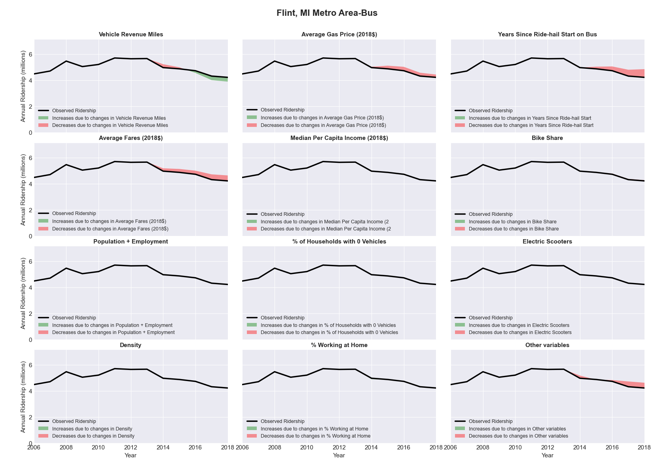

|  |  |  |  |  |  |  |
| --- | --- | --- | --- | --- | --- | --- |
| **Fort Collins-Loveland, CO** Metro Area**-Bus** | | | | | | |
|  |  |  |  |  |  | |
|  | **Average Values** | | | **Ridership Effect** | | |
| **Description** | **2012** | **2018** | **% Diff** | **Absolute** | **% Diff** | |
|  |  |  |  |  |  | |
| **Vehicle Revenue Miles** | 978,740 | 1,577,050 | 61.1% | 562,300 | | **19.1%** | |
| **Average Fare (2018$)** | 0.53 | 0.57 | 6.4% | 47,020 | | **1.6%** | |
| **Network Restructure** | - | - | - | - | | **0.0%** | |
| **Major Maintenance Event** | - | - | - | - | | **0.0%** | |
| **Population + Employment** | 471,770 | 545,300 | 15.6% | 93,500 | | **3.2%** | |
| **Share of Population and Employment in Transit Supportive Density** | 0.20 | 0.20 | 0.2% | -0,680 | | **-0.0%** | |
| **Average Gas Price (2018$)** | 3.88 | 2.89 | -25.5% | -48,470 | | **-1.6%** | |
| **Median Per Capita Income (2018$)** | 27,160 | 33,730 | 24.2% | -45,030 | | **-1.5%** | |
| **% of Households with 0 Vehicles** | 5 | 6 | 25.3% | 11,070 | | **0.4%** | |
| **% Working at Home** | 7.9 | 10.8 | 37.0% | -103,380 | | **-3.5%** | |
| **Years Since Ride-hail Start** | - | 4 | 4 | -451,830 | | **-15.3%** | |
| **Bike Share** | - | 1 | 1 | - 33,430 | | **-1.1%** | |
| **Electric Scooters** | - | - | - | - | | **0.0%** | |
| **New Reporters** |  |  |  | - | | **0.0%** | |
| **Total Modeled Ridership** | 2,947,851 | 3,005,912 | 1.97% | 58061.5089 | | **2.0%** | |
| **Total Observed Ridership** | 2,159,251 | 4,188,842 | 94.00% | 2029591 | | **94.0%** | |
| **Unexplained Change** |  |  |  |  | | **92.0%** | |

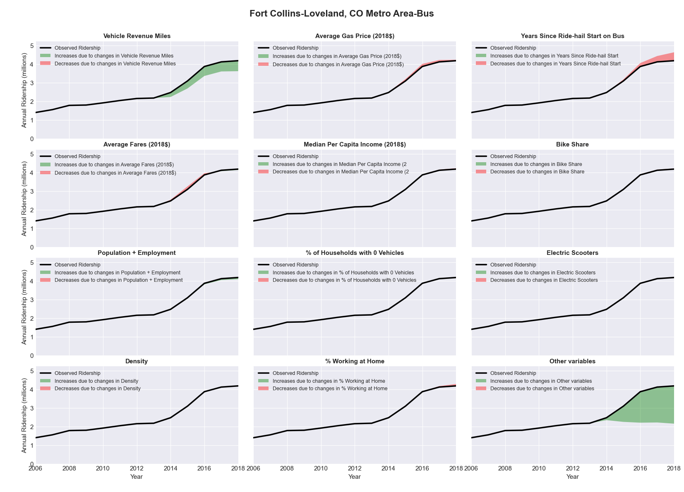

|  |  |  |  |  |  |  |
| --- | --- | --- | --- | --- | --- | --- |
| **Fort Wayne, IN** Metro Area**-Bus** | | | | | | |
|  |  |  |  |  |  | |
|  | **Average Values** | | | **Ridership Effect** | | |
| **Description** | **2012** | **2018** | **% Diff** | **Absolute** | **% Diff** | |
|  |  |  |  |  |  | |
| **Vehicle Revenue Miles** | 1,439,870 | 1,436,010 | -0.3% | -0,430 | | **-0.0%** | |
| **Average Fare (2018$)** | 0.78 | 0.88 | 12.8% | -64,530 | | **-3.2%** | |
| **Network Restructure** | - | - | - | - | | **0.0%** | |
| **Major Maintenance Event** | - | - | - | - | | **0.0%** | |
| **Population + Employment** | 608,930 | 647,880 | 6.4% | 25,720 | | **1.3%** | |
| **Share of Population and Employment in Transit Supportive Density** | 0.16 | 0.15 | -2.4% | -3,200 | | **-0.2%** | |
| **Average Gas Price (2018$)** | 3.93 | 2.72 | -30.9% | -83,080 | | **-4.1%** | |
| **Median Per Capita Income (2018$)** | 29,470 | 29,510 | 0.1% | -0,010 | | **-0.0%** | |
| **% of Households with 0 Vehicles** | 7 | 5 | -33.6% | -9,080 | | **-0.4%** | |
| **% Working at Home** | 4.4 | 3.7 | -17.0% | 10,950 | | **0.5%** | |
| **Years Since Ride-hail Start** | - | 3 | 3 | -179,510 | | **-8.8%** | |
| **Bike Share** | - | 1 | 1 | - 20,510 | | **-1.0%** | |
| **Electric Scooters** | - | - | - | - | | **0.0%** | |
| **New Reporters** |  |  |  | - | | **0.0%** | |
| **Total Modeled Ridership** | 2,029,718 | 1,707,622 | -15.87% | -322096.389 | | **-15.9%** | |
| **Total Observed Ridership** | 2,061,235 | 1,693,128 | -17.86% | -368107 | | **-17.9%** | |
| **Unexplained Change** |  |  |  |  | | **-2.0%** | |

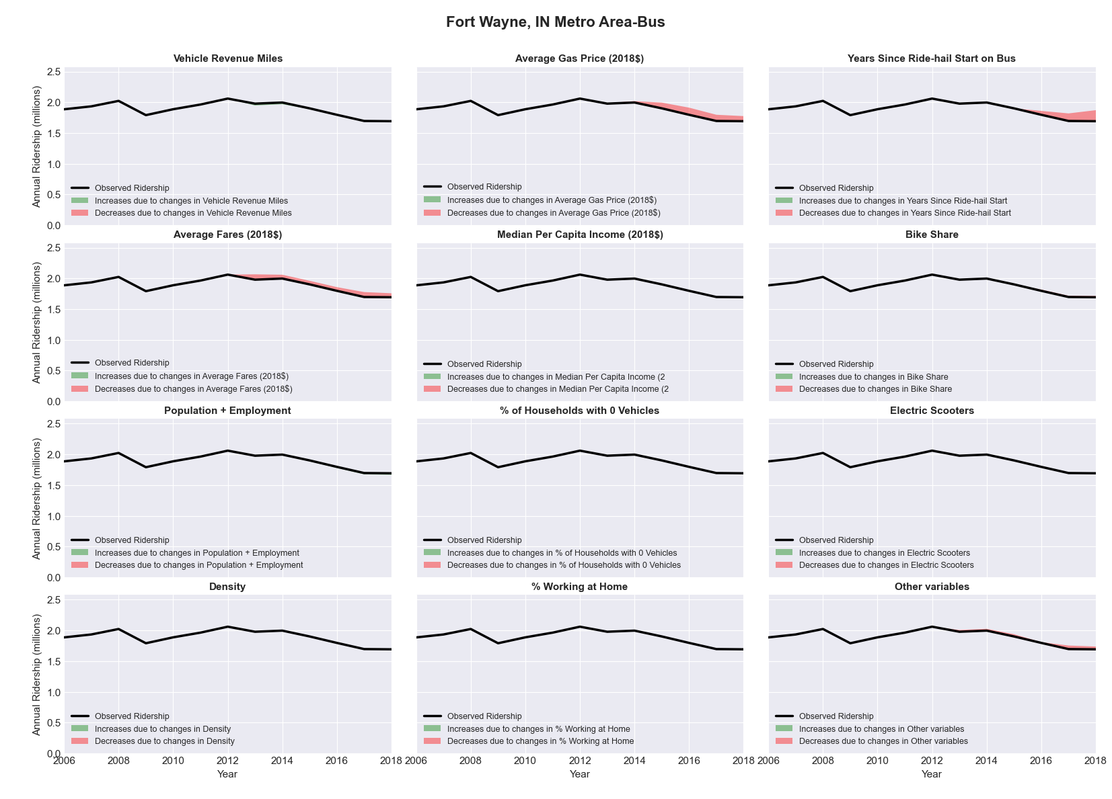

|  |  |  |  |  |  |  |
| --- | --- | --- | --- | --- | --- | --- |
| **Fresno, CA** Metro Area**-Bus** | | | | | | |
|  |  |  |  |  |  | |
|  | **Average Values** | | | **Ridership Effect** | | |
| **Description** | **2012** | **2018** | **% Diff** | **Absolute** | **% Diff** | |
|  |  |  |  |  |  | |
| **Vehicle Revenue Miles** | 3,888,610 | 4,563,170 | 17.3% | 712,610 | | **6.5%** | |
| **Average Fare (2018$)** | 0.90 | 0.71 | -21.5% | 655,170 | | **6.0%** | |
| **Network Restructure** | - | - | - | - | | **0.0%** | |
| **Major Maintenance Event** | - | - | - | - | | **0.0%** | |
| **Population + Employment** | 1,321,350 | 1,417,330 | 7.3% | 164,780 | | **1.5%** | |
| **Share of Population and Employment in Transit Supportive Density** | 0.40 | 0.41 | 1.4% | 25,540 | | **0.2%** | |
| **Average Gas Price (2018$)** | 4.35 | 3.40 | -21.8% | -335,020 | | **-3.0%** | |
| **Median Per Capita Income (2018$)** | 21,520 | 25,280 | 17.5% | -120,650 | | **-1.1%** | |
| **% of Households with 0 Vehicles** | 9 | 7 | -26.6% | -49,530 | | **-0.5%** | |
| **% Working at Home** | 4.7 | 3.7 | -21.8% | 83,080 | | **0.8%** | |
| **Years Since Ride-hail Start** | - | 4 | 4 | -1,383,480 | | **-12.6%** | |
| **Bike Share** | - | - | - | - | | **0.0%** | |
| **Electric Scooters** | - | - | - | - | | **0.0%** | |
| **New Reporters** |  |  |  | - | | **0.0%** | |
| **Total Modeled Ridership** | 10,996,528 | 10,777,360 | -1.99% | -219167.22 | | **-2.0%** | |
| **Total Observed Ridership** | 11,713,509 | 10,194,137 | -12.97% | -1519372 | | **-13.0%** | |
| **Unexplained Change** |  |  |  |  | | **-11.0%** | |

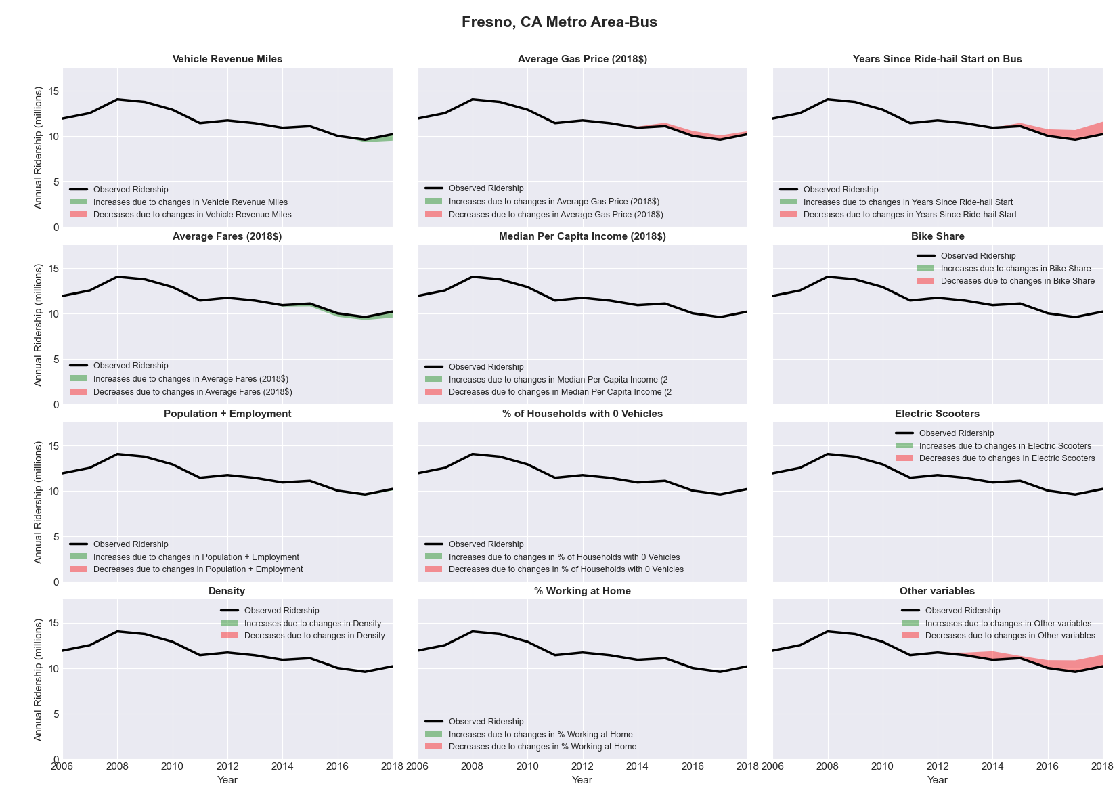

|  |  |  |  |  |  |  |
| --- | --- | --- | --- | --- | --- | --- |
| **Gainesville, FL** Metro Area**-Bus** | | | | | | |
|  |  |  |  |  |  | |
|  | **Average Values** | | | **Ridership Effect** | | |
| **Description** | **2012** | **2018** | **% Diff** | **Absolute** | **% Diff** | |
|  |  |  |  |  |  | |
| **Vehicle Revenue Miles** | 3,338,050 | 3,693,480 | 10.6% | 479,570 | | **4.4%** | |
| **Average Fare (2018$)** | 1.35 | 1.60 | 18.5% | -596,710 | | **-5.4%** | |
| **Network Restructure** | - | - | - | - | | **0.0%** | |
| **Major Maintenance Event** | - | - | - | - | | **0.0%** | |
| **Population + Employment** | 396,170 | 428,980 | 8.3% | 174,530 | | **1.6%** | |
| **Share of Population and Employment in Transit Supportive Density** | 0.28 | 0.27 | -6.6% | -79,720 | | **-0.7%** | |
| **Average Gas Price (2018$)** | 3.95 | 2.71 | -31.3% | -450,420 | | **-4.1%** | |
| **Median Per Capita Income (2018$)** | 23,490 | 24,010 | 2.2% | -18,460 | | **-0.2%** | |
| **% of Households with 0 Vehicles** | 9 | 7 | -19.4% | -34,980 | | **-0.3%** | |
| **% Working at Home** | 4.9 | 4.8 | -2.6% | 11,680 | | **0.1%** | |
| **Years Since Ride-hail Start** | - | 4 | 4 | -1,323,260 | | **-12.0%** | |
| **Bike Share** | - | 1 | 1 | - 108,560 | | **-1.0%** | |
| **Electric Scooters** | - | - | - | - | | **0.0%** | |
| **New Reporters** |  |  |  | - | | **0.0%** | |
| **Total Modeled Ridership** | 11,015,856 | 9,067,855 | -17.68% | -194800.96 | | **-17.7%** | |
| **Total Observed Ridership** | 10,760,077 | 9,276,475 | -13.79% | -1483602 | | **-13.8%** | |
| **Unexplained Change** |  |  |  |  | | **3.9%** | |

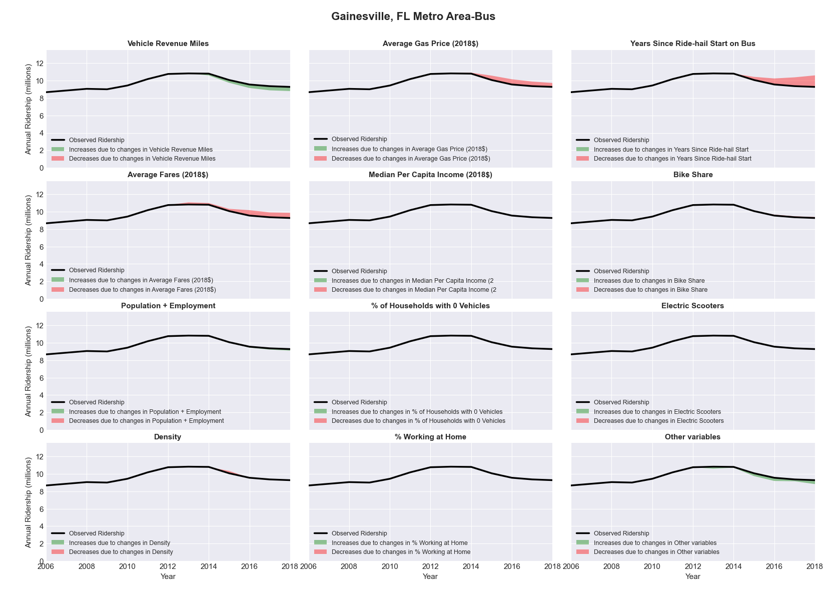

|  |  |  |  |  |  |  |
| --- | --- | --- | --- | --- | --- | --- |
| **Grand Rapids-Wyoming, MI** Metro Area**-Bus** | | | | | | |
|  |  |  |  |  |  | |
|  | **Average Values** | | | **Ridership Effect** | | |
| **Description** | **2012** | **2018** | **% Diff** | **Absolute** | **% Diff** | |
|  |  |  |  |  |  | |
| **Vehicle Revenue Miles** | 4,235,860 | 4,869,630 | 15.0% | 637,640 | | **5.9%** | |
| **Average Fare (2018$)** | 0.51 | 0.94 | 84.5% | -1,437,080 | | **-13.4%** | |
| **Network Restructure** | - | - | - | - | | **0.0%** | |
| **Major Maintenance Event** | - | - | - | - | | **0.0%** | |
| **Population + Employment** | 1,156,420 | 1,501,640 | 29.9% | 585,340 | | **5.5%** | |
| **Share of Population and Employment in Transit Supportive Density** | 0.18 | 0.18 | -2.3% | -17,460 | | **-0.2%** | |
| **Average Gas Price (2018$)** | 3.93 | 2.72 | -30.9% | -429,860 | | **-4.0%** | |
| **Median Per Capita Income (2018$)** | 27,370 | 31,610 | 15.5% | -98,300 | | **-0.9%** | |
| **% of Households with 0 Vehicles** | 7 | 5 | -30.7% | -44,160 | | **-0.4%** | |
| **% Working at Home** | 4.0 | 4.6 | 15.6% | -42,330 | | **-0.4%** | |
| **Years Since Ride-hail Start** | - | 4 | 4 | -1,285,380 | | **-12.0%** | |
| **Bike Share** | - | 1 | 1 | - 96,750 | | **-0.9%** | |
| **Electric Scooters** | - | - | - | - | | **0.0%** | |
| **New Reporters** |  |  |  | - | | **0.0%** | |
| **Total Modeled Ridership** | 10,718,273 | 8,485,709 | -20.83% | -223256.47 | | **-20.8%** | |
| **Total Observed Ridership** | 10,212,961 | 8,760,851 | -14.22% | -1452110 | | **-14.2%** | |
| **Unexplained Change** |  |  |  |  | | **6.6%** | |

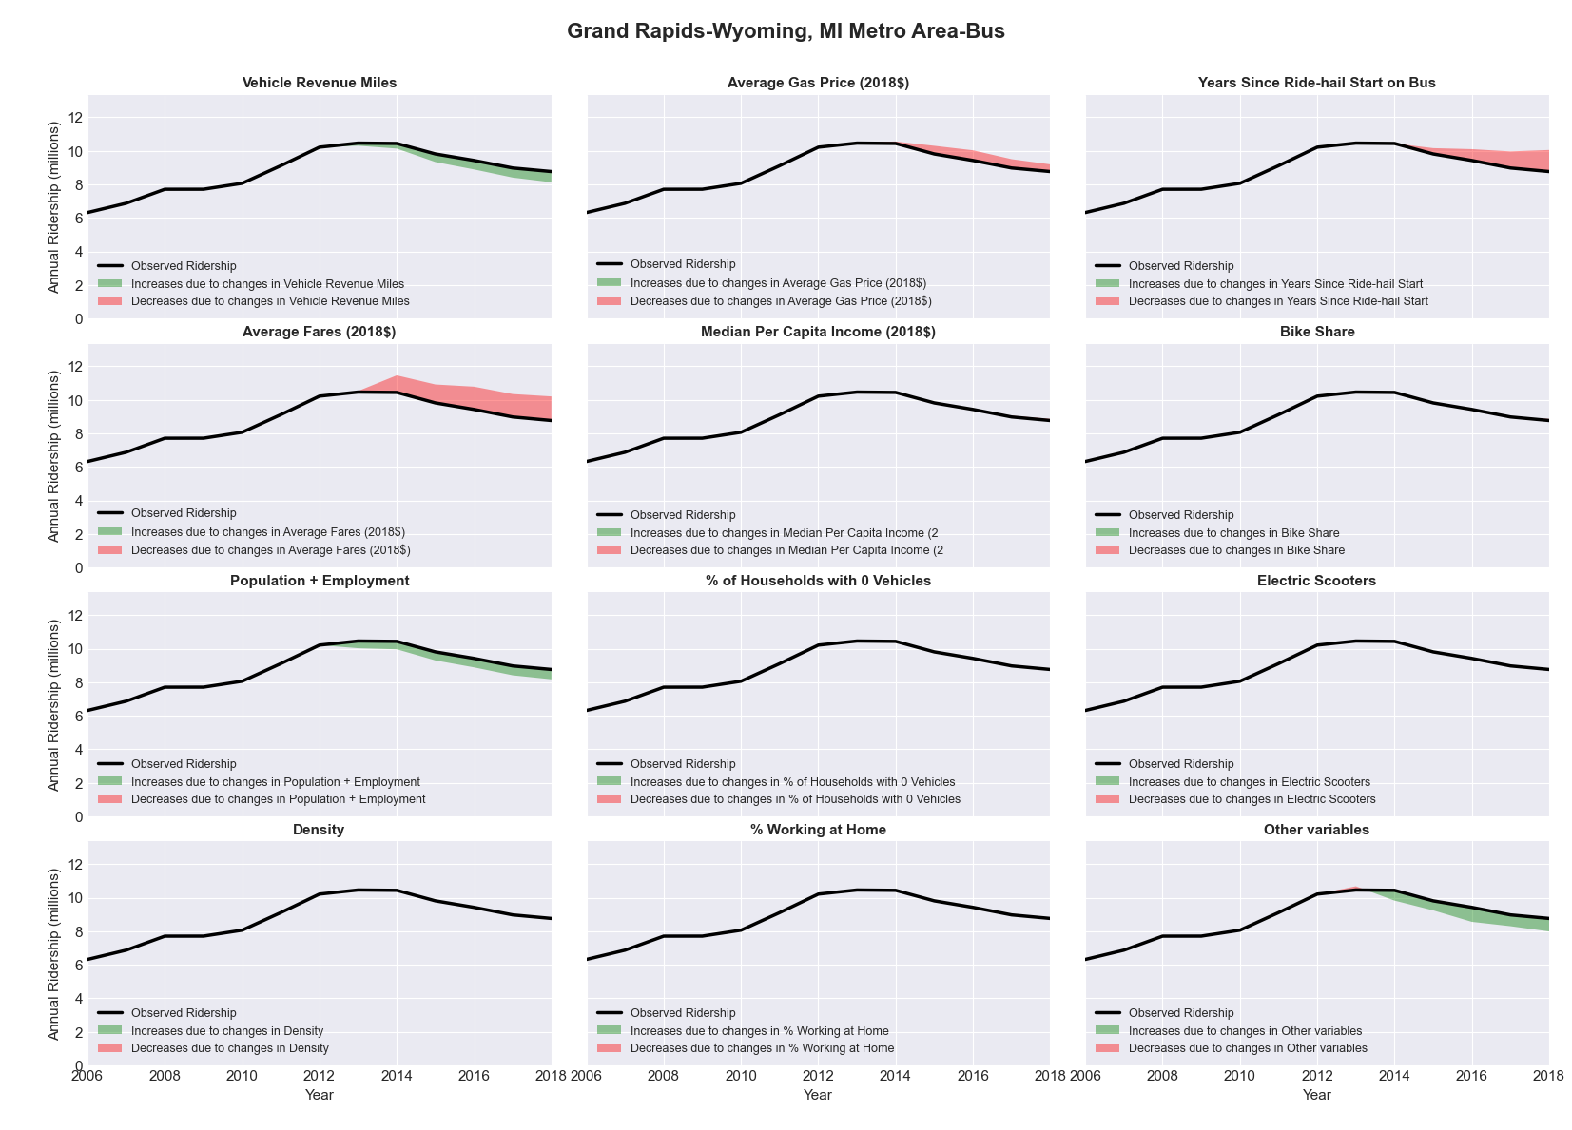

|  |  |  |  |  |  |  |
| --- | --- | --- | --- | --- | --- | --- |
| **Great Falls, MT** Metro Area**-Bus** | | | | | | |
|  |  |  |  |  |  | |
|  | **Average Values** | | | **Ridership Effect** | | |
| **Description** | **2012** | **2018** | **% Diff** | **Absolute** | **% Diff** | |
|  |  |  |  |  |  | |
| **Vehicle Revenue Miles** | 418,160 | 428,510 | 2.5% | 4,440 | | **1.0%** | |
| **Average Fare (2018$)** | 0.57 | 0.54 | -5.3% | 4,680 | | **1.1%** | |
| **Network Restructure** | - | - | - | - | | **0.0%** | |
| **Major Maintenance Event** | - | - | - | - | | **0.0%** | |
| **Population + Employment** | 117,960 | 117,750 | -0.2% | -0,160 | | **-0.0%** | |
| **Share of Population and Employment in Transit Supportive Density** | 0.23 | 0.23 | -2.4% | -0,950 | | **-0.2%** | |
| **Average Gas Price (2018$)** | 3.88 | 2.89 | -25.5% | -14,450 | | **-3.3%** | |
| **Median Per Capita Income (2018$)** | 24,730 | 28,410 | 14.9% | -4,150 | | **-0.9%** | |
| **% of Households with 0 Vehicles** | 9 | 11 | 14.1% | 1,180 | | **0.3%** | |
| **% Working at Home** | 3.2 | 7.6 | 138.3% | -13,630 | | **-3.1%** | |
| **Years Since Ride-hail Start** | - | 2 | 2 | -27,220 | | **-6.1%** | |
| **Bike Share** | - | - | - | - | | **0.0%** | |
| **Electric Scooters** | - | - | - | - | | **0.0%** | |
| **New Reporters** |  |  |  | - | | **0.0%** | |
| **Total Modeled Ridership** | 443,597 | 392,815 | -11.45% | -50781.8291 | | **-11.4%** | |
| **Total Observed Ridership** | 420,495 | 400,594 | -4.73% | -19901 | | **-4.7%** | |
| **Unexplained Change** |  |  |  |  | | **6.7%** | |

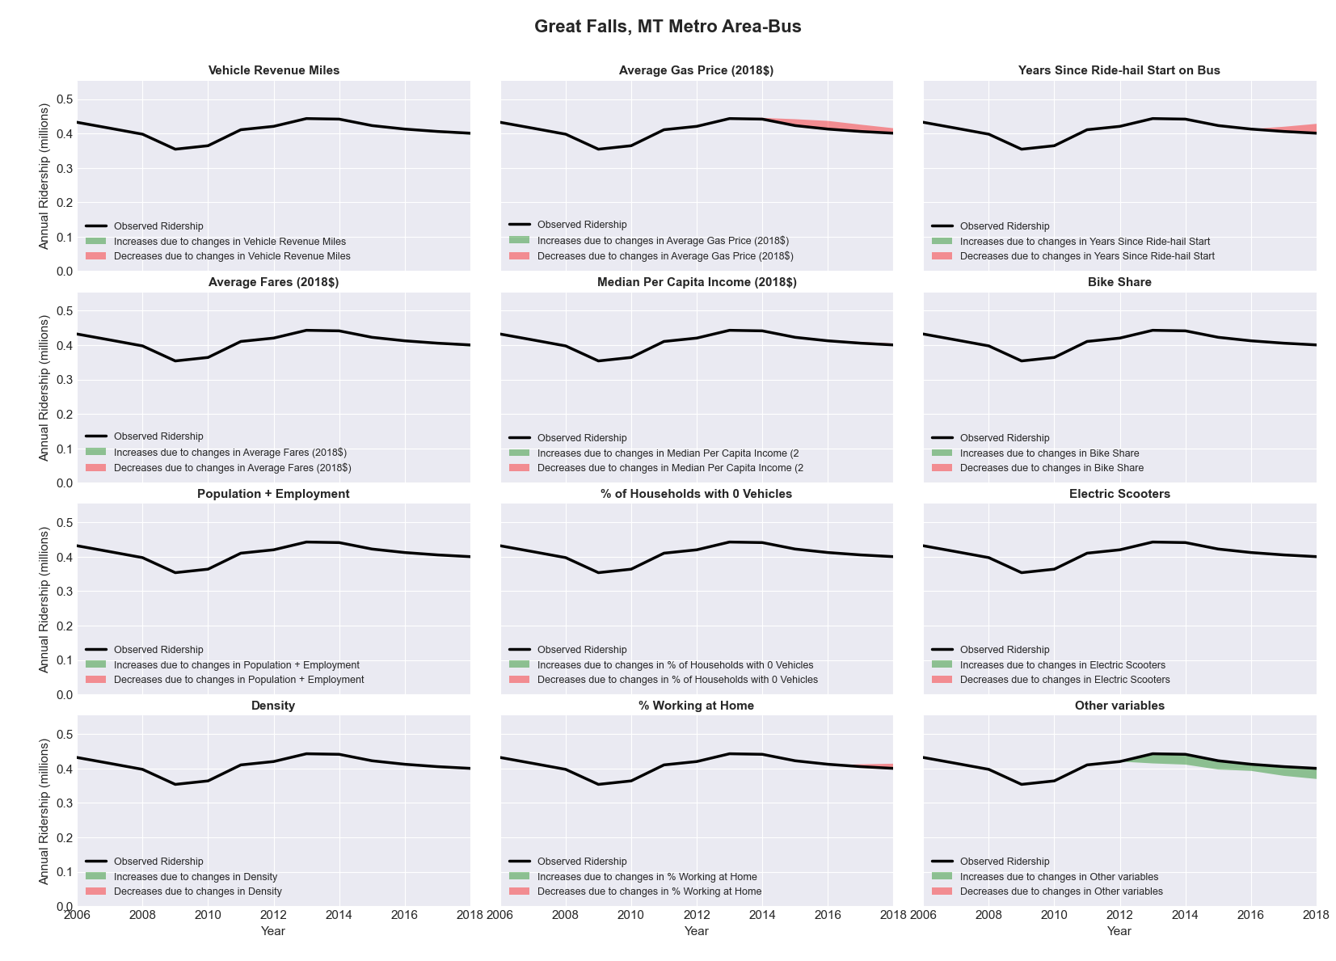

|  |  |  |  |  |  |  |
| --- | --- | --- | --- | --- | --- | --- |
| **Green Bay, WI** Metro Area**-Bus** | | | | | | |
|  |  |  |  |  |  | |
|  | **Average Values** | | | **Ridership Effect** | | |
| **Description** | **2012** | **2018** | **% Diff** | **Absolute** | **% Diff** | |
|  |  |  |  |  |  | |
| **Vehicle Revenue Miles** | 1,082,310 | 1,183,480 | 9.3% | 53,280 | | **3.6%** | |
| **Average Fare (2018$)** | 0.68 | 0.48 | -29.0% | 93,690 | | **6.4%** | |
| **Network Restructure** | - | - | - | - | | **0.0%** | |
| **Major Maintenance Event** | - | - | - | - | | **0.0%** | |
| **Population + Employment** | 468,950 | 493,650 | 5.3% | 15,590 | | **1.1%** | |
| **Share of Population and Employment in Transit Supportive Density** | 0.16 | 0.16 | 0.1% | -0,020 | | **-0.0%** | |
| **Average Gas Price (2018$)** | 3.93 | 2.72 | -30.9% | -59,920 | | **-4.1%** | |
| **Median Per Capita Income (2018$)** | 30,090 | 32,780 | 8.9% | -8,300 | | **-0.6%** | |
| **% of Households with 0 Vehicles** | 5 | 5 | -7.4% | -1,010 | | **-0.1%** | |
| **% Working at Home** | 4.4 | 5.1 | 15.9% | -6,420 | | **-0.4%** | |
| **Years Since Ride-hail Start** | - | 4 | 4 | -179,300 | | **-12.3%** | |
| **Bike Share** | - | 1 | 1 | - 13,400 | | **-0.9%** | |
| **Electric Scooters** | - | - | - | - | | **0.0%** | |
| **New Reporters** |  |  |  | - | | **0.0%** | |
| **Total Modeled Ridership** | 1,459,997 | 1,354,052 | -7.26% | -10594416 | | **-7.3%** | |
| **Total Observed Ridership** | 1,523,838 | 1,275,835 | -16.27% | -248003 | | **-16.3%** | |
| **Unexplained Change** |  |  |  |  | | **-9.0%** | |

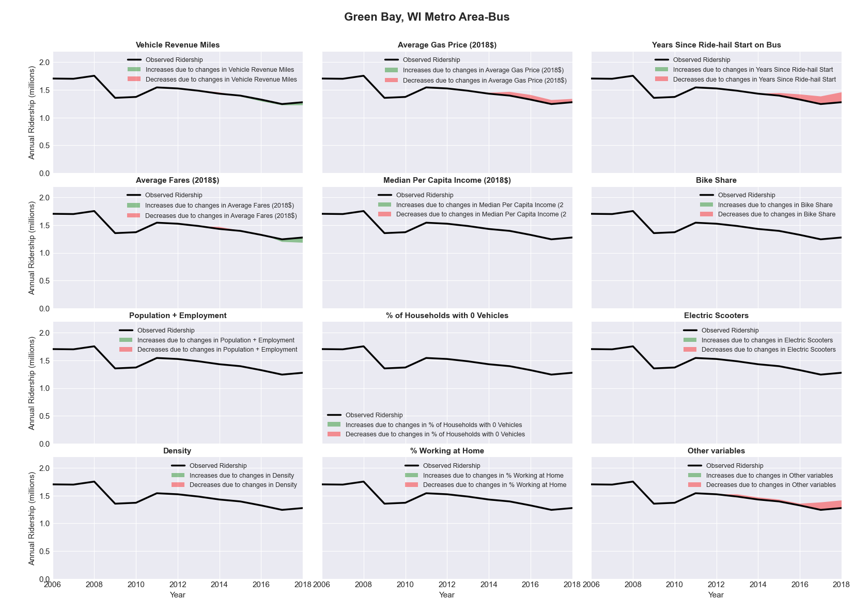

|  |  |  |  |  |  |  |
| --- | --- | --- | --- | --- | --- | --- |
| **Greensboro-High Point, NC** Metro Area**-Bus** | | | | | | |
|  |  |  |  |  |  | |
|  | **Average Values** | | | **Ridership Effect** | | |
| **Description** | **2012** | **2018** | **% Diff** | **Absolute** | **% Diff** | |
|  |  |  |  |  |  | |
| **Vehicle Revenue Miles** | 2,130,280 | 2,061,970 | -3.2% | -60,940 | | **-1.4%** | |
| **Average Fare (2018$)** | 0.78 | 0.80 | 3.5% | -49,100 | | **-1.1%** | |
| **Network Restructure** | - | - | - | - | | **0.0%** | |
| **Major Maintenance Event** | - | - | - | - | | **0.0%** | |
| **Population + Employment** | 1,066,350 | 1,121,760 | 5.2% | 46,140 | | **1.0%** | |
| **Share of Population and Employment in Transit Supportive Density** | 0.08 | 0.07 | -10.5% | -14,560 | | **-0.3%** | |
| **Average Gas Price (2018$)** | 3.95 | 2.71 | -31.3% | -187,530 | | **-4.2%** | |
| **Median Per Capita Income (2018$)** | 26,010 | 28,480 | 9.5% | -24,910 | | **-0.6%** | |
| **% of Households with 0 Vehicles** | 7 | 7 | -4.6% | -3,840 | | **-0.1%** | |
| **% Working at Home** | 3.8 | 5.5 | 44.7% | -54,910 | | **-1.2%** | |
| **Years Since Ride-hail Start** | - | 4 | 4 | -526,220 | | **-11.7%** | |
| **Bike Share** | - | 1 | 1 | - 40,670 | | **-0.9%** | |
| **Electric Scooters** | - | 1 | 1 | - 140,030 | | **-3.1%** | |
| **New Reporters** |  |  |  | - | | **0.0%** | |
| **Total Modeled Ridership** | 4,508,389 | 3,465,585 | -23.13% | -104203.94 | | **-23.1%** | |
| **Total Observed Ridership** | 4,676,281 | 3,272,336 | -30.02% | -1403945 | | **-30.0%** | |
| **Unexplained Change** |  |  |  |  | | **-6.9%** | |

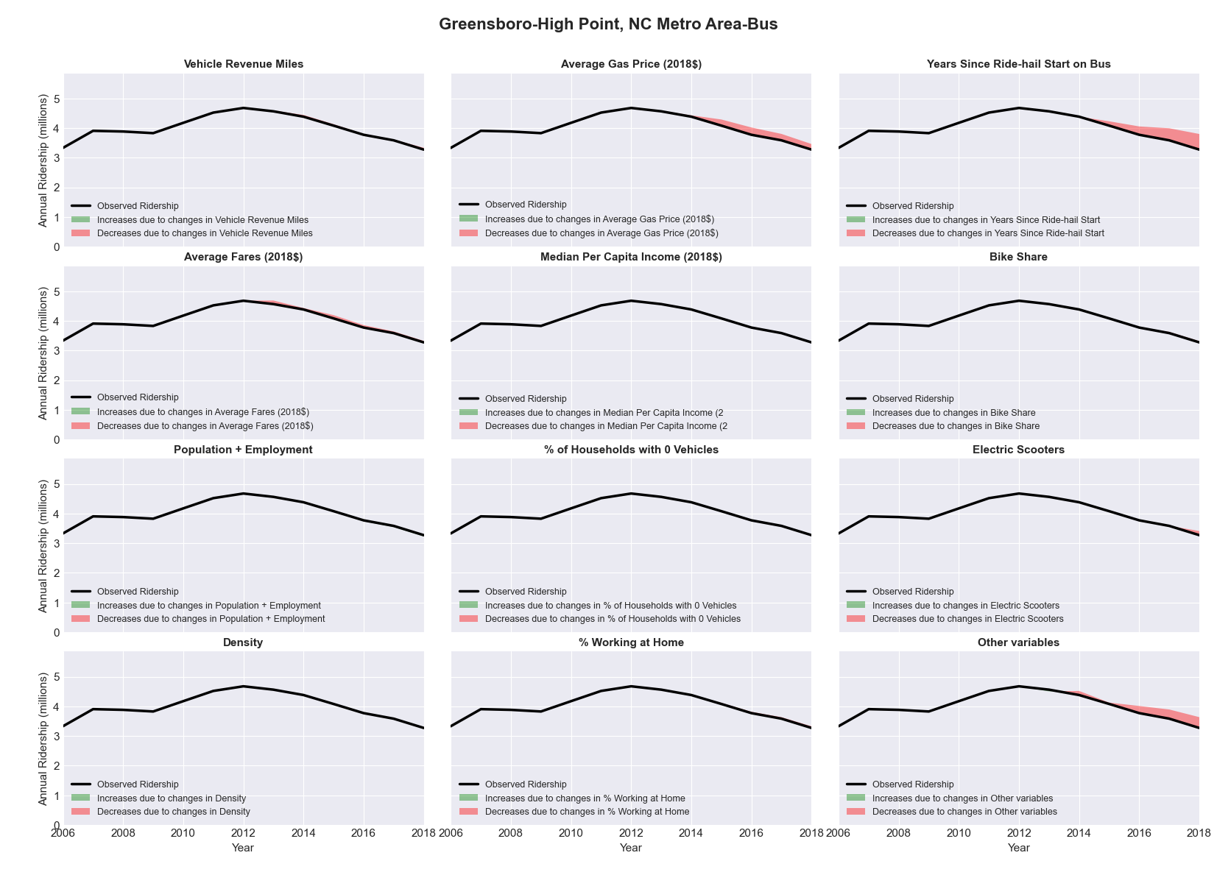

|  |  |  |  |  |  |  |
| --- | --- | --- | --- | --- | --- | --- |
| **Gulfport-Biloxi, MS** Metro Area**-Bus** | | | | | | |
|  |  |  |  |  |  | |
|  | **Average Values** | | | **Ridership Effect** | | |
| **Description** | **2012** | **2018** | **% Diff** | **Absolute** | **% Diff** | |
|  |  |  |  |  |  | |
| **Vehicle Revenue Miles** | 797,950 | 657,000 | -17.7% | -55,750 | | **-8.9%** | |
| **Average Fare (2018$)** | 0.89 | 0.90 | 1.4% | -12,100 | | **-1.9%** | |
| **Network Restructure** | - | - | - | - | | **0.0%** | |
| **Major Maintenance Event** | - | - | - | - | | **0.0%** | |
| **Population + Employment** | 362,940 | 503,770 | 38.8% | 48,760 | | **7.8%** | |
| **Share of Population and Employment in Transit Supportive Density** | 0.02 | 0.02 | 1.3% | -0,020 | | **-0.0%** | |
| **Average Gas Price (2018$)** | 3.80 | 2.58 | -32.2% | -25,330 | | **-4.0%** | |
| **Median Per Capita Income (2018$)** | 24,320 | 27,400 | 12.7% | -5,360 | | **-0.9%** | |
| **% of Households with 0 Vehicles** | 5 | 5 | 15.0% | 1,080 | | **0.2%** | |
| **% Working at Home** | 1.6 | 1.8 | 14.1% | -1,740 | | **-0.3%** | |
| **Years Since Ride-hail Start** | - | 2 | 2 | -39,000 | | **-6.2%** | |
| **Bike Share** | - | 1 | 1 | - 6,900 | | **-1.1%** | |
| **Electric Scooters** | - | - | - | - | | **0.0%** | |
| **New Reporters** |  |  |  | - | | **0.0%** | |
| **Total Modeled Ridership** | 628,148 | 541,159 | -13.85% | -86988.9485 | | **-13.8%** | |
| **Total Observed Ridership** | 671,862 | 519,389 | -22.69% | -152473 | | **-22.7%** | |
| **Unexplained Change** |  |  |  |  | | **-8.8%** | |

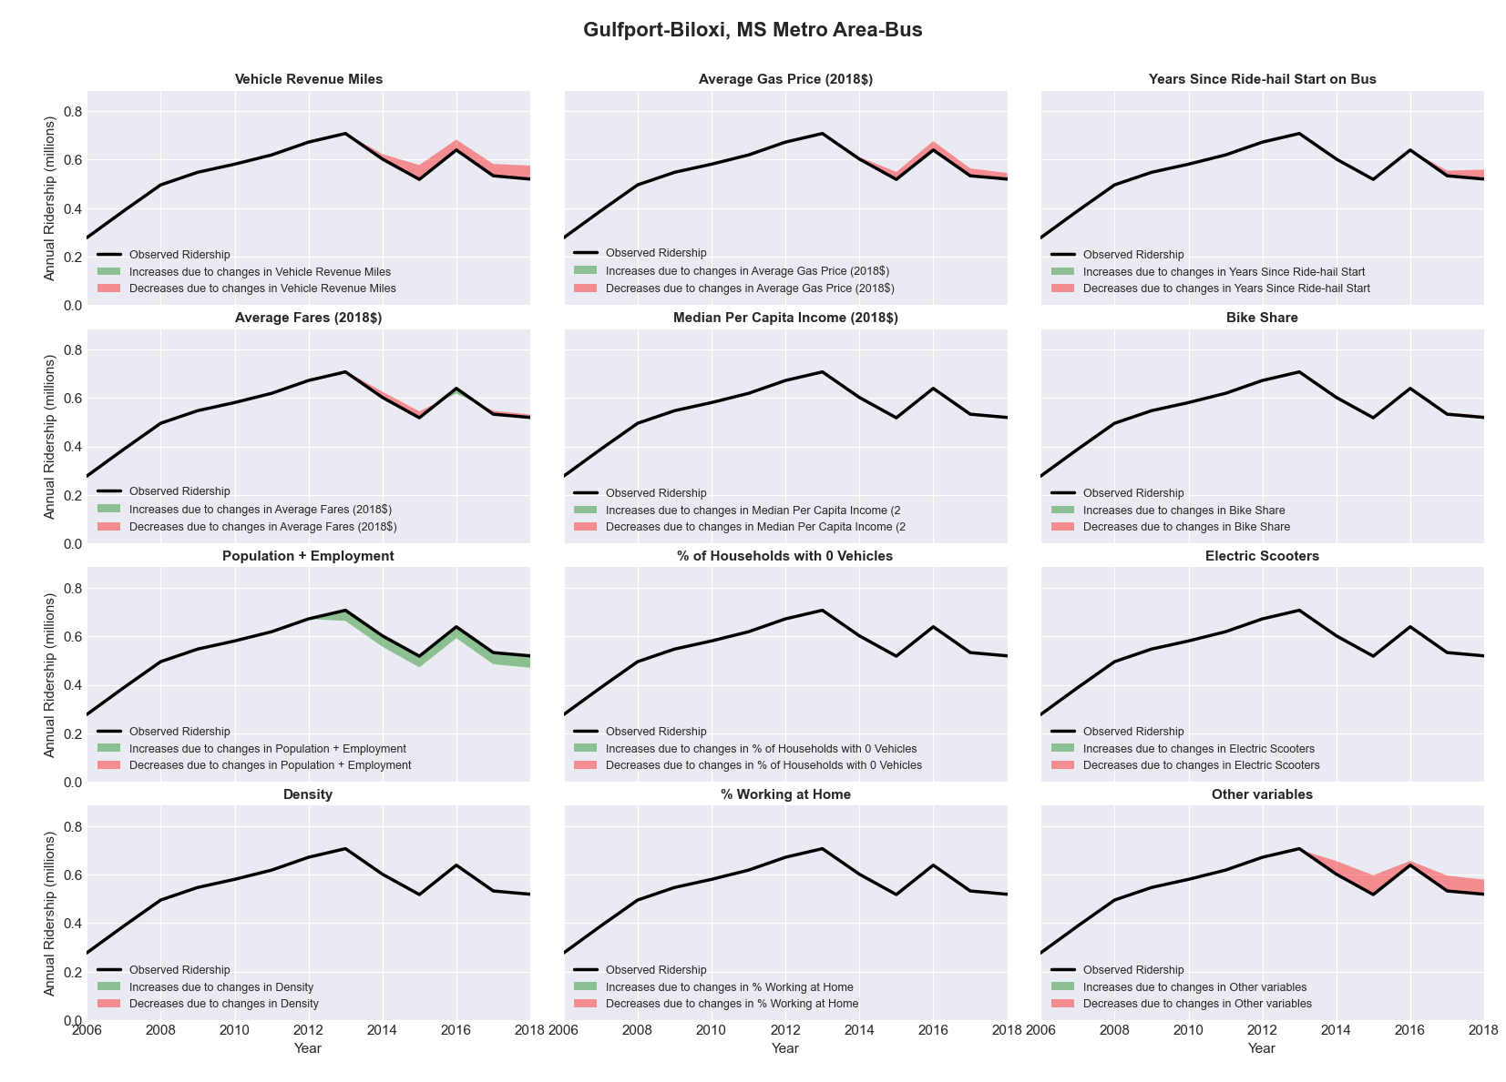

|  |  |  |  |  |  |  |
| --- | --- | --- | --- | --- | --- | --- |
| **Hanford-Corcoran, CA** Metro Area**-Bus** | | | | | | |
|  |  |  |  |  |  | |
|  | **Average Values** | | | **Ridership Effect** | | |
| **Description** | **2012** | **2018** | **% Diff** | **Absolute** | **% Diff** | |
|  |  |  |  |  |  | |
| **Vehicle Revenue Miles** | 628,360 | 772,530 | 22.9% | 69,970 | | **9.3%** | |
| **Average Fare (2018$)** | 0.85 | 0.67 | -21.1% | 42,050 | | **5.6%** | |
| **Network Restructure** | - | - | - | - | | **0.0%** | |
| **Major Maintenance Event** | - | - | - | - | | **0.0%** | |
| **Population + Employment** | 201,410 | 203,190 | 0.9% | 1,350 | | **0.2%** | |
| **Share of Population and Employment in Transit Supportive Density** | 0.17 | 0.16 | -5.1% | -2,830 | | **-0.4%** | |
| **Average Gas Price (2018$)** | 4.35 | 3.40 | -21.8% | -21,900 | | **-2.9%** | |
| **Median Per Capita Income (2018$)** | 24,280 | 25,500 | 5.0% | -2,530 | | **-0.3%** | |
| **% of Households with 0 Vehicles** | 7 | 10 | 39.8% | 4,040 | | **0.5%** | |
| **% Working at Home** | 1.1 | 9.3 | 745.5% | -45,960 | | **-6.1%** | |
| **Years Since Ride-hail Start** | - | 2 | 2 | -46,970 | | **-6.2%** | |
| **Bike Share** | - | - | - | - | | **0.0%** | |
| **Electric Scooters** | - | - | - | - | | **0.0%** | |
| **New Reporters** |  |  |  | - | | **0.0%** | |
| **Total Modeled Ridership** | 753,089 | 748,981 | -0.55% | -4108.08025 | | **-0.5%** | |
| **Total Observed Ridership** | 776,718 | 700,122 | -9.86% | -76596 | | **-9.9%** | |
| **Unexplained Change** |  |  |  |  | | **-9.3%** | |

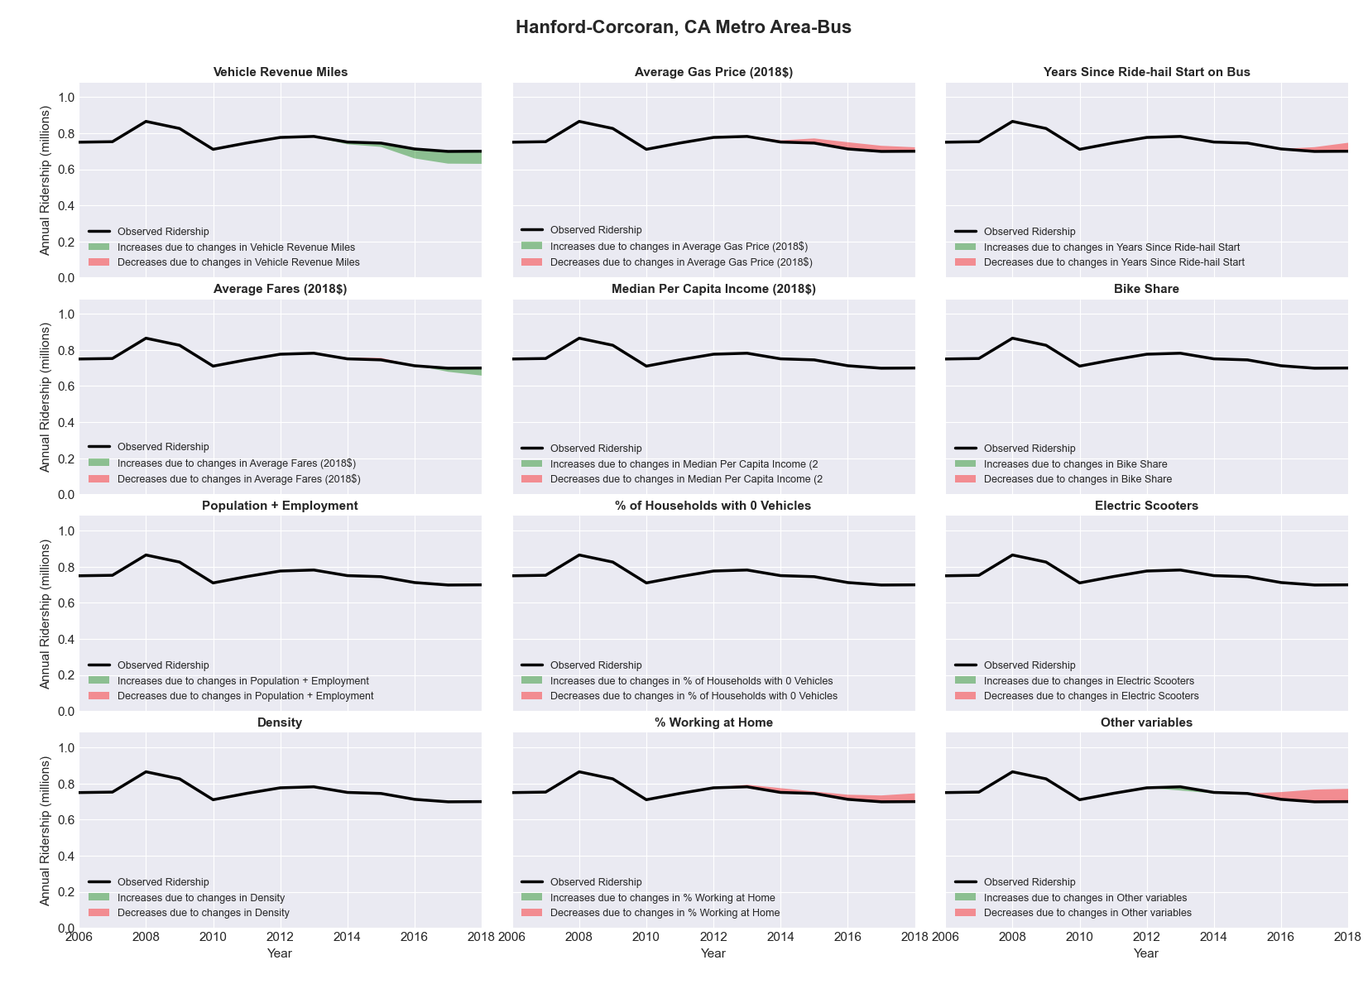

|  |  |  |  |  |  |  |
| --- | --- | --- | --- | --- | --- | --- |
| **Harrisburg-Carlisle, PA** Metro Area**-Bus** | | | | | | |
|  |  |  |  |  |  | |
|  | **Average Values** | | | **Ridership Effect** | | |
| **Description** | **2012** | **2018** | **% Diff** | **Absolute** | **% Diff** | |
|  |  |  |  |  |  | |
| **Vehicle Revenue Miles** | 1,469,200 | 1,528,750 | 4.1% | 44,690 | | **2.0%** | |
| **Average Fare (2018$)** | 1.35 | 1.32 | -2.4% | 6,500 | | **0.3%** | |
| **Network Restructure** | - | - | - | - | | **0.0%** | |
| **Major Maintenance Event** | - | - | - | - | | **0.0%** | |
| **Population + Employment** | 825,520 | 860,080 | 4.2% | 19,690 | | **0.9%** | |
| **Share of Population and Employment in Transit Supportive Density** | 0.16 | 0.16 | 0.6% | 0,930 | | **0.0%** | |
| **Average Gas Price (2018$)** | 4.11 | 2.92 | -28.9% | -93,900 | | **-4.2%** | |
| **Median Per Capita Income (2018$)** | 31,430 | 33,260 | 5.8% | -9,370 | | **-0.4%** | |
| **% of Households with 0 Vehicles** | 8 | 6 | -25.0% | -7,990 | | **-0.4%** | |
| **% Working at Home** | 3.4 | 5.5 | 62.5% | -34,120 | | **-1.5%** | |
| **Years Since Ride-hail Start** | - | 3 | 3 | -197,330 | | **-8.9%** | |
| **Bike Share** | - | 1 | 1 | - 21,130 | | **-1.0%** | |
| **Electric Scooters** | - | - | - | - | | **0.0%** | |
| **New Reporters** |  |  |  | - | | **0.0%** | |
| **Total Modeled Ridership** | 2,216,799 | 1,928,097 | -13.02% | -288702.589 | | **-13.0%** | |
| **Total Observed Ridership** | 2,316,589 | 1,754,316 | -24.27% | -562273 | | **-24.3%** | |
| **Unexplained Change** |  |  |  |  | | **-11.2%** | |

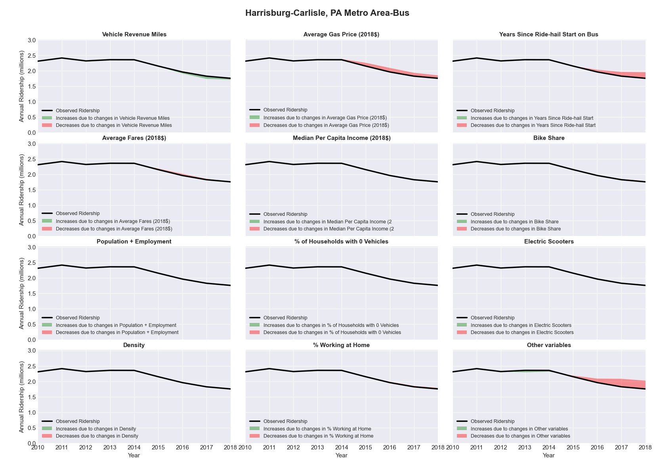

|  |  |  |  |  |  |  |
| --- | --- | --- | --- | --- | --- | --- |
| Harrisonburg, VA Metro Area-Bus | | | | | | |
|  |  |  |  |  |  | |
|  | **Average Values** | | | **Ridership Effect** | | |
| **Description** | **2012** | **2018** | **% Diff** | **Absolute** | **% Diff** | |
|  |  |  |  |  |  | |
| **Vehicle Revenue Miles** | 562,790 | 607,150 | 7.9% | 99,140 | | **3.7%** | |
| **Average Fare (2018$)** | 0.61 | 0.80 | 30.3% | -164,290 | | **-6.1%** | |
| **Network Restructure** | - | - | - | - | | **0.0%** | |
| **Major Maintenance Event** | - | - | - | - | | **0.0%** | |
| **Population + Employment** | 189,270 | 200,030 | 5.7% | 31,600 | | **1.2%** | |
| **Share of Population and Employment in Transit Supportive Density** | 0.10 | 0.11 | 6.5% | 7,520 | | **0.3%** | |
| **Average Gas Price (2018$)** | 3.95 | 2.71 | -31.3% | -117,470 | | **-4.4%** | |
| **Median Per Capita Income (2018$)** | 21,670 | 23,950 | 10.5% | -20,650 | | **-0.8%** | |
| **% of Households with 0 Vehicles** | 8 | 7 | -15.3% | -5,530 | | **-0.2%** | |
| **% Working at Home** | 6.0 | 4.8 | -20.8% | 23,010 | | **0.9%** | |
| **Years Since Ride-hail Start** | - | 3 | 3 | -256,610 | | **-9.6%** | |
| **Bike Share** | - | - | - | - | | **0.0%** | |
| **Electric Scooters** | - | 1 | 1 | - 88,750 | | **-3.3%** | |
| **New Reporters** |  |  |  | - | | **0.0%** | |
| **Total Modeled Ridership** | 2,680,007 | 2,201,164 | -17.87% | -478842.97 | | **-17.9%** | |
| **Total Observed Ridership** | 2,608,335 | 2,098,653 | -19.54% | -509682 | | **-19.5%** | |
| **Unexplained Change** |  |  |  |  | | **-1.7%** | |

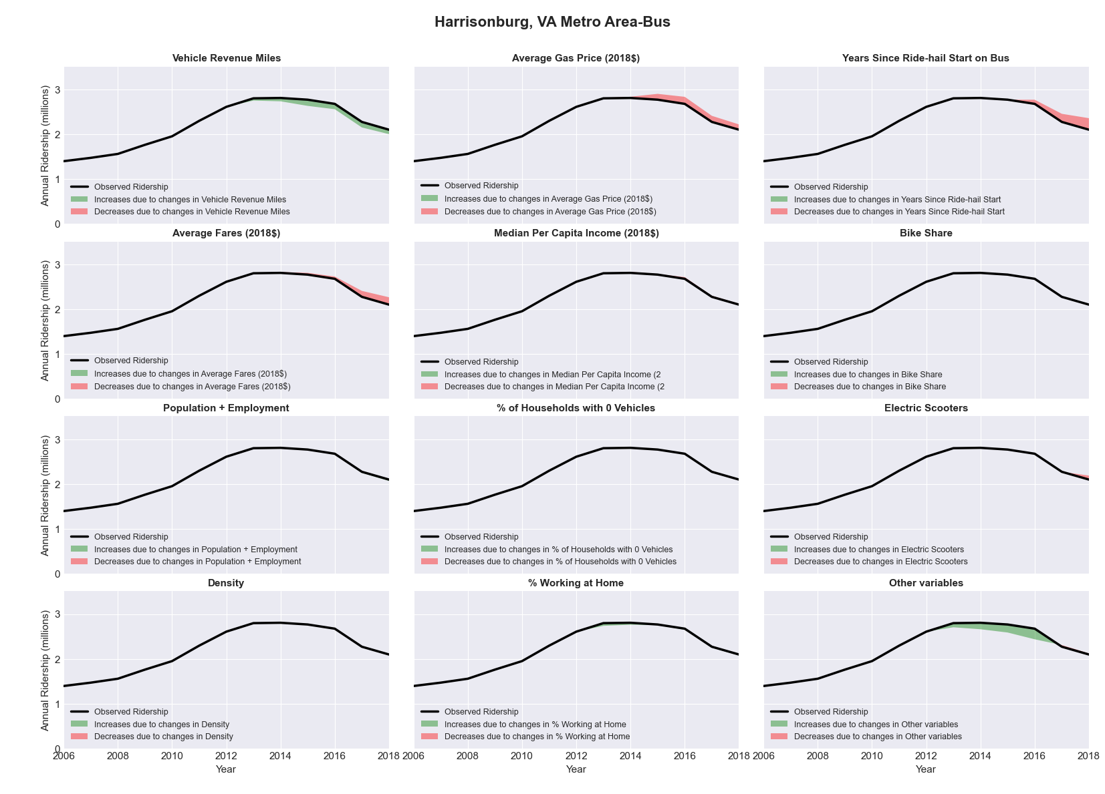

|  |  |  |  |  |  |  |
| --- | --- | --- | --- | --- | --- | --- |
| **Hartford-West Hartford-East Hartford, CT** Metro Area**-Bus** | | | | | | |
|  |  |  |  |  |  | |
|  | **Average Values** | | | **Ridership Effect** | | |
| **Description** | **2012** | **2018** | **% Diff** | **Absolute** | **% Diff** | |
|  |  |  |  |  |  | |
| **Vehicle Revenue Miles** | 7,239,350 | 10,527,780 | 45.4% | 2,916,720 | | **17.1%** | |
| **Average Fare (2018$)** | 0.98 | 1.04 | 6.3% | -294,220 | | **-1.7%** | |
| **Network Restructure** | - | - | - | - | | **0.0%** | |
| **Major Maintenance Event** | - | - | - | - | | **0.0%** | |
| **Population + Employment** | 1,808,740 | 1,843,340 | 1.9% | 69,340 | | **0.4%** | |
| **Share of Population and Employment in Transit Supportive Density** | 0.24 | 0.24 | -0.5% | -8,140 | | **-0.0%** | |
| **Average Gas Price (2018$)** | 4.13 | 2.85 | -31.0% | -646,390 | | **-3.8%** | |
| **Median Per Capita Income (2018$)** | 35,310 | 36,510 | 3.4% | -36,220 | | **-0.2%** | |
| **% of Households with 0 Vehicles** | 9 | 8 | -11.5% | -37,200 | | **-0.2%** | |
| **% Working at Home** | 3.7 | 5.2 | 40.5% | -190,600 | | **-1.1%** | |
| **Years Since Ride-hail Start** | - | 4 | 4 | -2,264,880 | | **-13.3%** | |
| **Bike Share** | - | 1 | 1 | - 185,370 | | **-1.1%** | |
| **Electric Scooters** | - | - | - | - | | **0.0%** | |
| **New Reporters** |  |  |  | - | | **0.0%** | |
| **Total Modeled Ridership** | 17,026,789 | 16,211,161 | -4.79% | -815627.533 | | **-4.8%** | |
| **Total Observed Ridership** | 16,170,563 | 17,379,737 | 7.48% | 1209174 | | **7.5%** | |
| **Unexplained Change** |  |  |  |  | | **12.3%** | |

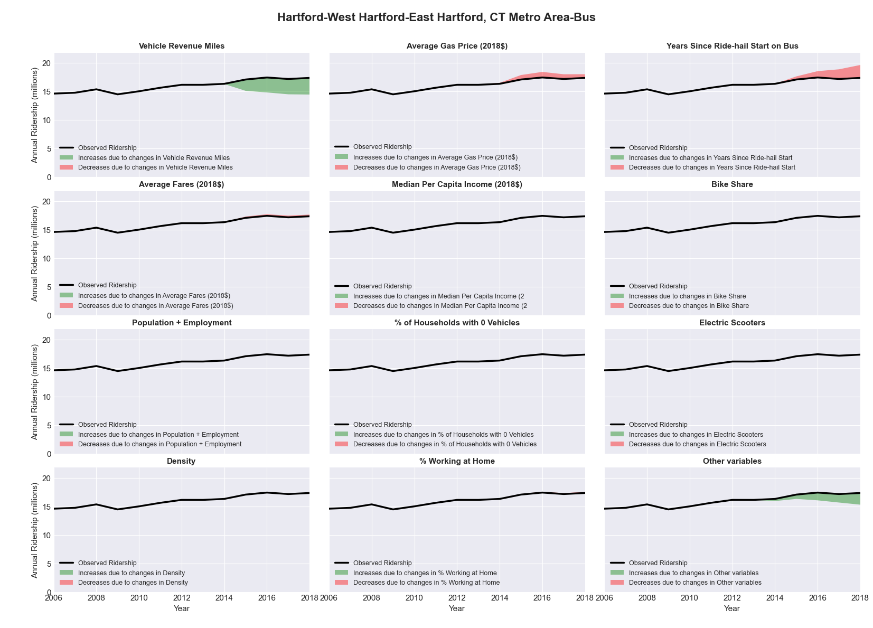

|  |  |  |  |  |  |  |
| --- | --- | --- | --- | --- | --- | --- |
| **Hartford-West Hartford-East Hartford, CT** Metro Area**-Rail** | | | | | | |
|  |  |  |  |  |  | |
|  | **Average Values** | | | **Ridership Effect** | | |
| **Description** | **2012** | **2018** | **% Diff** | **Absolute** | **% Diff** | |
|  |  |  |  |  |  | |
| **Vehicle Revenue Miles** | 1,116,200 | 1,350,390 | 21.0% | 95,080 | | **15.3%** | |
| **Average Fare (2018$)** | 3.87 | 4.09 | 5.5% | -28,140 | | **-4.5%** | |
| **Network Restructure** | - | - | - | - | | **0.0%** | |
| **Major Maintenance Event** | - | - | - | - | | **0.0%** | |
| **Population + Employment** | 1,808,740 | 1,843,340 | 1.9% | 3,600 | | **0.6%** | |
| **Share of Population and Employment in Transit Supportive Density** | 0.24 | 0.24 | -0.5% | -0,560 | | **-0.1%** | |
| **Average Gas Price (2018$)** | 4.13 | 2.85 | -31.0% | -36,870 | | **-5.9%** | |
| **Median Per Capita Income (2018$)** | 35,310 | 36,510 | 3.4% | -2,370 | | **-0.4%** | |
| **% of Households with 0 Vehicles** | 9 | 8 | -11.5% | -2,220 | | **-0.4%** | |
| **% Working at Home** | 3.7 | 5.2 | 40.5% | -10,260 | | **-1.6%** | |
| **Years Since Ride-hail Start** | - | 4 | 4 | -75,390 | | **-12.1%** | |
| **Bike Share** | - | 1 | 1 | - 8,300 | | **-1.3%** | |
| **Electric Scooters** | - | - | - | - | | **0.0%** | |
| **New Reporters** |  |  |  | - | | **0.0%** | |
| **Total Modeled Ridership** | 621,986 | 594,867 | -4.36% | -27119.1325 | | **-4.4%** | |
| **Total Observed Ridership** | 611,026 | 584,707 | -4.31% | -26319 | | **-4.3%** | |
| **Unexplained Change** |  |  |  |  | | **0.1%** | |

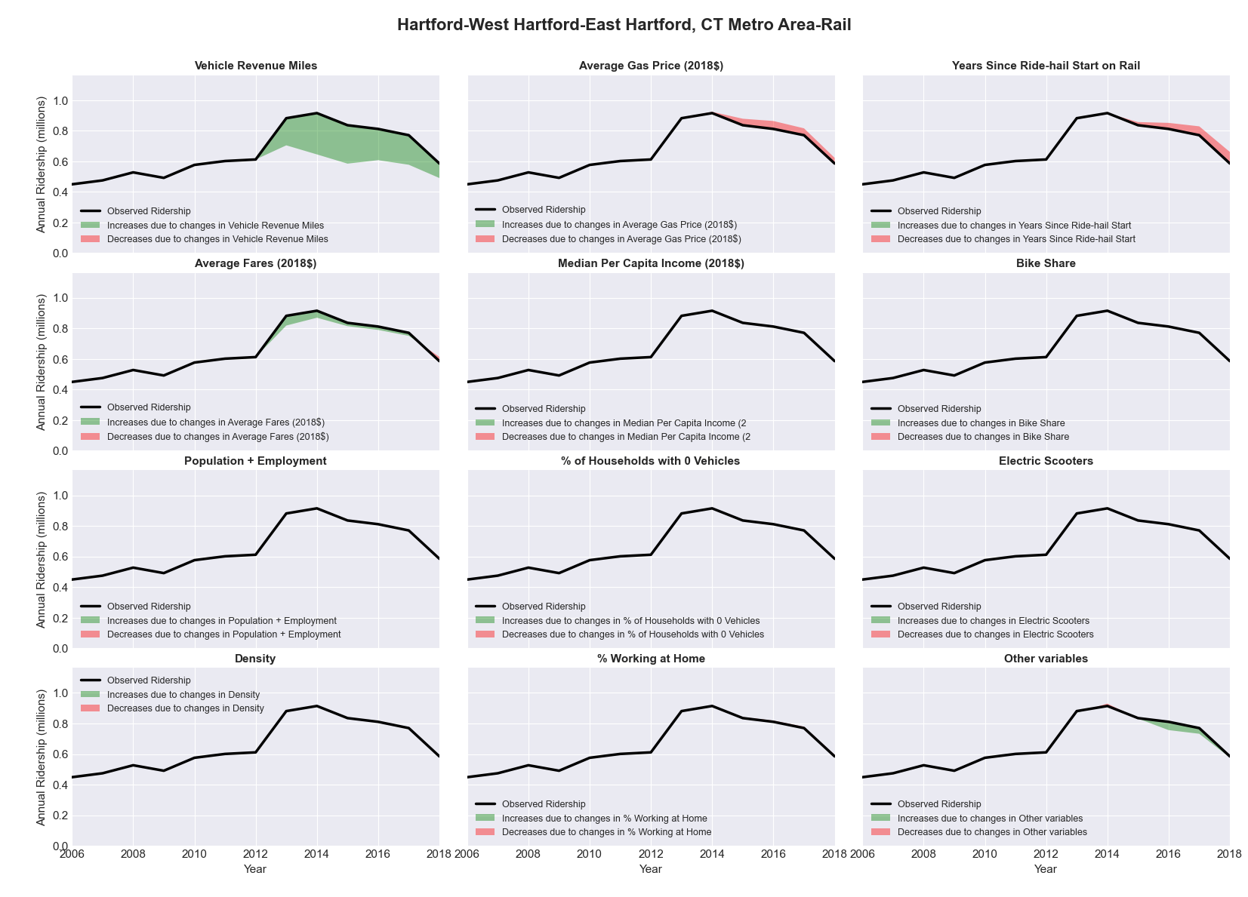

|  |  |  |  |  |  |  |
| --- | --- | --- | --- | --- | --- | --- |
| Houston-Sugar Land-Baytown, TX Metro Area-Bus | | | | | | |
|  |  |  |  |  |  | |
|  | **Average Values** | | | **Ridership Effect** | | |
| **Description** | **2012** | **2018** | **% Diff** | **Absolute** | **% Diff** | |
|  |  |  |  |  |  | |
| **Vehicle Revenue Miles** | 41,607,220 | 46,020,100 | 10.6% | 3,102,230 | | **4.6%** | |
| **Average Fare (2018$)** | 0.99 | 0.77 | -22.2% | 4,653,240 | | **6.8%** | |
| **Network Restructure** | - | - | - | 141,901.97 | | **0.2%** | |
| **Major Maintenance Event** | - | - | - | - | | **0.0%** | |
| **Population + Employment** | 9,121,500 | 10,278,730 | 12.7% | 1,768,660 | | **2.6%** | |
| **Share of Population and Employment in Transit Supportive Density** | 0.41 | 0.40 | -2.2% | -244,080 | | **-0.4%** | |
| **Average Gas Price (2018$)** | 3.80 | 2.58 | -32.2% | -2,826,660 | | **-4.2%** | |
| **Median Per Capita Income (2018$)** | 29,800 | 32,300 | 8.4% | -389,220 | | **-0.6%** | |
| **% of Households with 0 Vehicles** | 6 | 5 | -15.7% | -128,980 | | **-0.2%** | |
| **% Working at Home** | 3.5 | 5.3 | 50.0% | -899,360 | | **-1.3%** | |
| **Years Since Ride-hail Start** | - | 4 | 4 | -5,209,450 | | **-7.7%** | |
| **Bike Share** | 1.00 | 1 | - | - | | **0.0%** | |
| **Electric Scooters** | - | - | - | - | | **0.0%** | |
| **New Reporters** |  |  |  | - | | **0.0%** | |
| **Total Modeled Ridership** | 67,971,926 | 67,631,454 | -0.50% | -340472.4 | | **-0.5%** | |
| **Total Observed Ridership** | 66,496,457 | 68,081,975 | 2.38% | 1585518 | | **2.4%** | |
| **Unexplained Change** |  |  |  |  | | **2.9%** | |

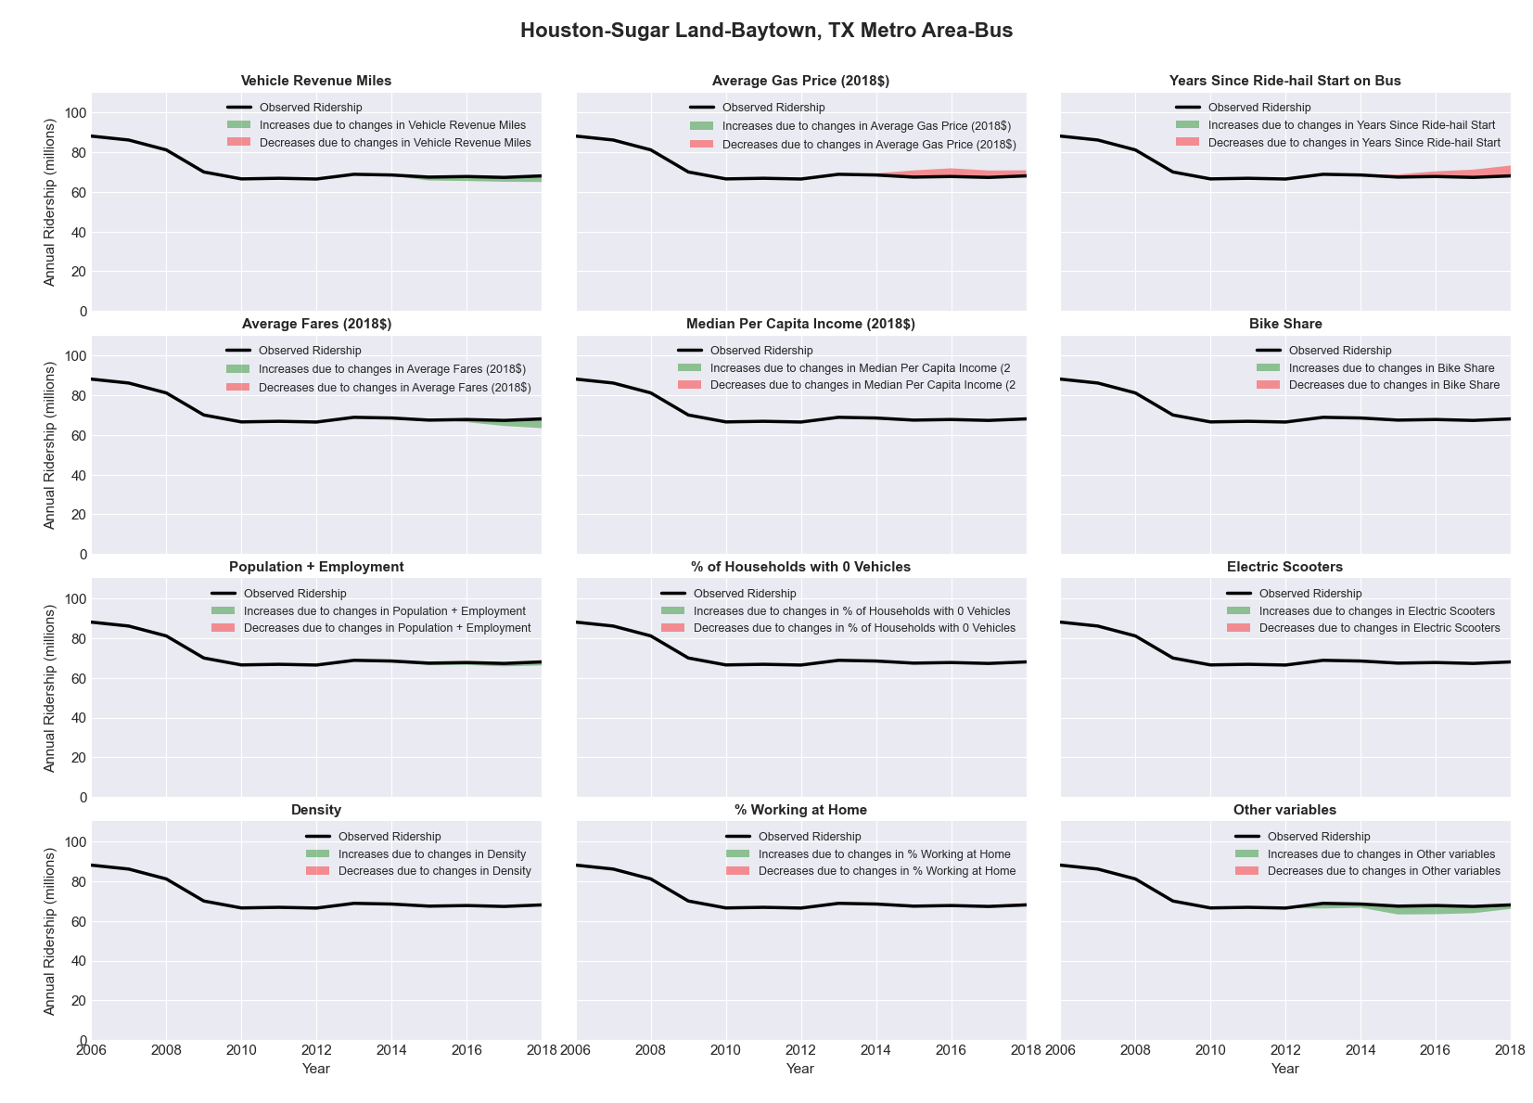

|  |  |  |  |  |  |  |
| --- | --- | --- | --- | --- | --- | --- |
| Houston-Sugar Land-Baytown, TX Metro Area-Rail | | | | | | |
|  |  |  |  |  |  | |
|  | **Average Values** | | | **Ridership Effect** | | |
| **Description** | **2012** | **2018** | **% Diff** | **Absolute** | **% Diff** | |
|  |  |  |  |  |  | |
| **Vehicle Revenue Miles** | 910,790 | 3,509,440 | 285.3% | 13,194,380 | | **149.0%** | |
| **Average Fare (2018$)** | 0.38 | 0.35 | -8.7% | 69,910 | | **0.8%** | |
| **Network Restructure** | - | - | - | - | | **0.0%** | |
| **Major Maintenance Event** | - | - | - | - | | **0.0%** | |
| **Population + Employment** | 9,121,500 | 10,278,730 | 12.7% | 377,620 | | **4.3%** | |
| **Share of Population and Employment in Transit Supportive Density** | 0.41 | 0.40 | -2.2% | -50,070 | | **-0.6%** | |
| **Average Gas Price (2018$)** | 3.80 | 2.58 | -32.2% | -459,480 | | **-5.2%** | |
| **Median Per Capita Income (2018$)** | 29,800 | 32,300 | 8.4% | -63,740 | | **-0.7%** | |
| **% of Households with 0 Vehicles** | 6 | 5 | -15.7% | -26,730 | | **-0.3%** | |
| **% Working at Home** | 3.5 | 5.3 | 50.0% | -234,760 | | **-2.7%** | |
| **Years Since Ride-hail Start** | - | 4 | 4 | 145,710 | | **1.6%** | |
| **Bike Share** | 1.00 | 1 | - | - | | **0.0%** | |
| **Electric Scooters** | - | - | - | - | | **0.0%** | |
| **New Reporters** |  |  |  | - | | **0.0%** | |
| **Total Modeled Ridership** | 8,858,139 | 21,134,904 | 138.59% | 12276765.4 | | **138.6%** | |
| **Total Observed Ridership** | 11,387,090 | 18,806,354 | 65.16% | 7419264 | | **65.2%** | |
| **Unexplained Change** |  |  |  |  | | **-73.4%** | |

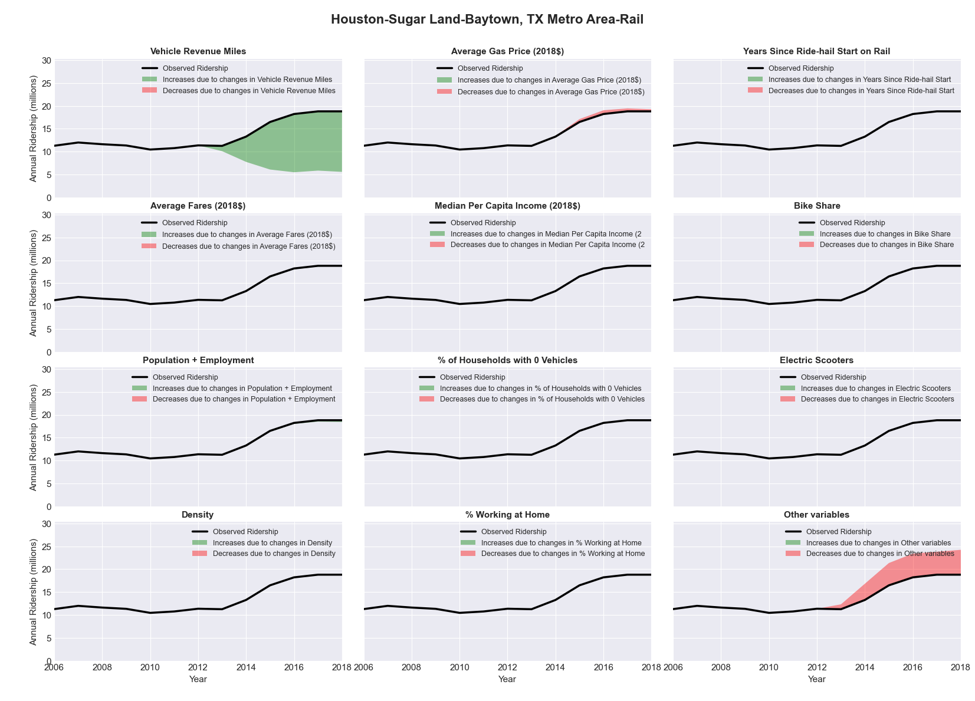

|  |  |  |  |  |  |  |
| --- | --- | --- | --- | --- | --- | --- |
| Huntsville, AL Metro Area-Bus | | | | | | |
|  |  |  |  |  |  | |
|  | **Average Values** | | | **Ridership Effect** | | |
| **Description** | **2012** | **2018** | **% Diff** | **Absolute** | **% Diff** | |
|  |  |  |  |  |  | |
| **Vehicle Revenue Miles** | 604,830 | 573,980 | -5.1% | -8,980 | | **-1.5%** | |
| **Average Fare (2018$)** | 0.59 | 0.46 | -22.5% | 26,590 | | **4.5%** | |
| **Network Restructure** | - | - | - | - | | **0.0%** | |
| **Major Maintenance Event** | - | - | - | - | | **0.0%** | |
| **Population + Employment** | 625,440 | 675,880 | 8.1% | 9,570 | | **1.6%** | |
| **Share of Population and Employment in Transit Supportive Density** | 0.07 | 0.07 | 6.3% | 0,900 | | **0.2%** | |
| **Average Gas Price (2018$)** | 3.80 | 2.58 | -32.2% | -22,350 | | **-3.8%** | |
| **Median Per Capita Income (2018$)** | 29,650 | 31,750 | 7.1% | -2,480 | | **-0.4%** | |
| **% of Households with 0 Vehicles** | 5 | 4 | -19.0% | -1,190 | | **-0.2%** | |
| **% Working at Home** | 2.4 | 3.5 | 44.8% | -3,850 | | **-0.7%** | |
| **Years Since Ride-hail Start** | - | 2 | 2 | -40,900 | | **-7.0%** | |
| **Bike Share** | - | 1 | 1 | - 6,630 | | **-1.1%** | |
| **Electric Scooters** | - | - | - | - | | **0.0%** | |
| **New Reporters** |  |  |  | - | | **0.0%** | |
| **Total Modeled Ridership** | 585,189 | 534,713 | -8.63% | -5047.1967 | | **-8.6%** | |
| **Total Observed Ridership** | 424,621 | 626,609 | 47.57% | 201988 | | **47.6%** | |
| **Unexplained Change** |  |  |  |  | | **56.2%** | |

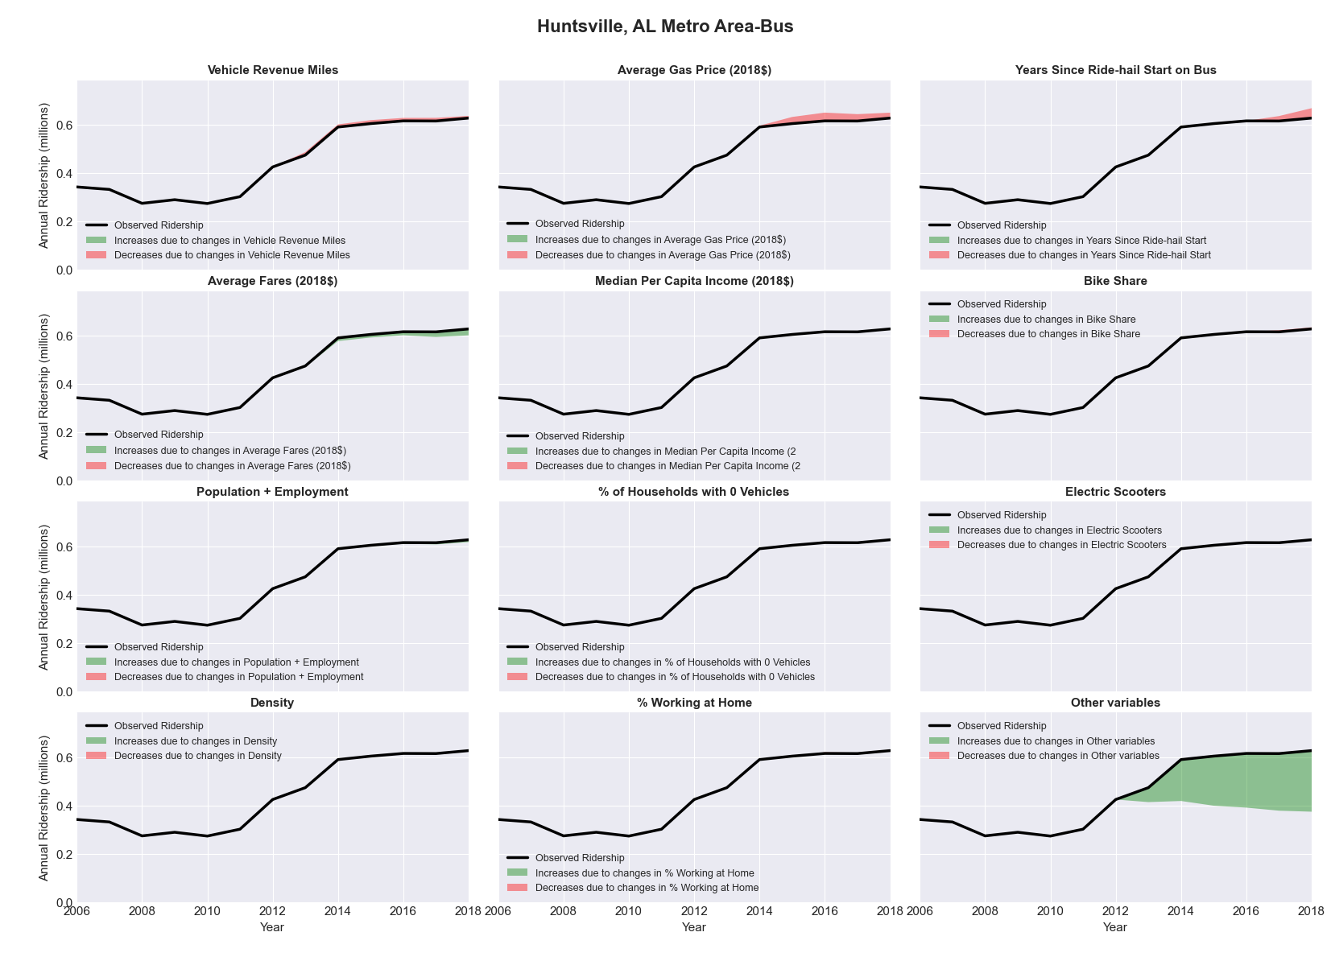

|  |  |  |  |  |  |  |
| --- | --- | --- | --- | --- | --- | --- |
| Indianapolis-Carmel, IN **Metro Area**-Bus | | | | | | |
|  |  |  |  |  |  | |
|  | **Average Values** | | | **Ridership Effect** | | |
| **Description** | **2012** | **2018** | **% Diff** | **Absolute** | **% Diff** | |
|  |  |  |  |  |  | |
| **Vehicle Revenue Miles** | 6,517,050 | 7,380,370 | 13.2% | 536,610 | | **5.3%** | |
| **Average Fare (2018$)** | 1.13 | 0.95 | -15.8% | 458,350 | | **4.5%** | |
| **Network Restructure** | - | - | - | - | | **0.0%** | |
| **Major Maintenance Event** | - | - | - | - | | **0.0%** | |
| **Population + Employment** | 2,632,660 | 3,023,080 | 14.8% | 295,570 | | **2.9%** | |
| **Share of Population and Employment in Transit Supportive Density** | 0.20 | 0.20 | 1.1% | 9,550 | | **0.1%** | |
| **Average Gas Price (2018$)** | 3.93 | 2.72 | -30.9% | -423,220 | | **-4.2%** | |
| **Median Per Capita Income (2018$)** | 30,370 | 33,120 | 9.1% | -59,950 | | **-0.6%** | |
| **% of Households with 0 Vehicles** | 7 | 6 | -6.0% | -8,550 | | **-0.1%** | |
| **% Working at Home** | 4.0 | 5.8 | 44.4% | -125,050 | | **-1.2%** | |
| **Years Since Ride-hail Start** | - | 5 | 5 | -1,596,010 | | **-15.8%** | |
| **Bike Share** | - | 1 | 1 | - 110,540 | | **-1.1%** | |
| **Electric Scooters** | - | 1 | 1 | - 340,710 | | **-3.4%** | |
| **New Reporters** |  |  |  | - | | **0.0%** | |
| **Total Modeled Ridership** | 10,095,972 | 8,747,879 | -13.35% | -1348092.69 | | **-13.4%** | |
| **Total Observed Ridership** | 9,939,873 | 8,783,370 | -11.63% | -1156503 | | **-11.6%** | |
| **Unexplained Change** |  |  |  |  | | **1.7%** | |

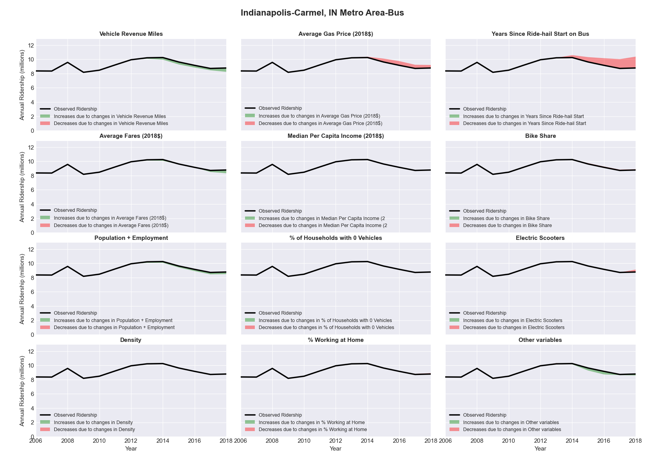

|  |  |  |  |  |  |  |
| --- | --- | --- | --- | --- | --- | --- |
| Iowa City, IA **Metro Area**-Bus | | | | | | |
|  |  |  |  |  |  | |
|  | **Average Values** | | | **Ridership Effect** | | |
| **Description** | **2012** | **2018** | **% Diff** | **Absolute** | **% Diff** | |
|  |  |  |  |  |  | |
| **Vehicle Revenue Miles** | 1,472,670 | 1,406,150 | -4.5% | -130,030 | | **-1.9%** | |
| **Average Fare (2018$)** | 0.19 | 0.56 | 201.9% | -979,540 | | **-14.1%** | |
| **Network Restructure** | - | - | - | - | | **0.0%** | |
| **Major Maintenance Event** | - | - | - | - | | **0.0%** | |
| **Population + Employment** | 247,210 | 269,880 | 9.2% | 117,860 | | **1.7%** | |
| **Share of Population and Employment in Transit Supportive Density** | 0.37 | 0.36 | -0.5% | -4,610 | | **-0.1%** | |
| **Average Gas Price (2018$)** | 3.93 | 2.72 | -30.9% | -273,800 | | **-3.9%** | |
| **Median Per Capita Income (2018$)** | 28,790 | 32,900 | 14.3% | -52,310 | | **-0.8%** | |
| **% of Households with 0 Vehicles** | 6 | 5 | -24.5% | -16,540 | | **-0.2%** | |
| **% Working at Home** | 3.9 | 4.1 | 5.1% | -10,780 | | **-0.2%** | |
| **Years Since Ride-hail Start** | - | 2 | 2 | -370,640 | | **-5.3%** | |
| **Bike Share** | - | - | - | - | | **0.0%** | |
| **Electric Scooters** | - | - | - | - | | **0.0%** | |
| **New Reporters** |  |  |  | - | | **0.0%** | |
| **Total Modeled Ridership** | 6,959,842 | 5,236,403 | -24.76% | -1723439.21 | | **-24.8%** | |
| **Total Observed Ridership** | 6,323,537 | 5,035,420 | -20.37% | -1288117 | | **-20.4%** | |
| **Unexplained Change** |  |  |  |  | | **4.4%** | |

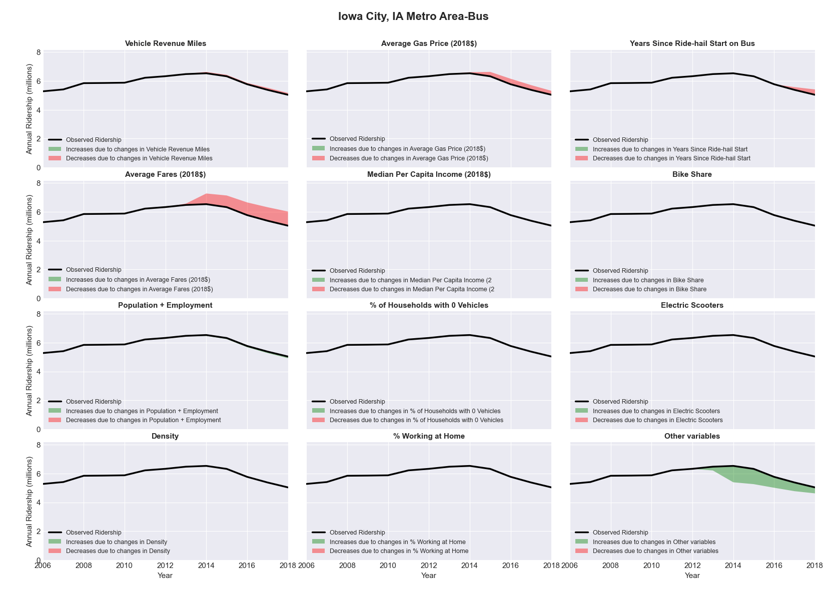

|  |  |  |  |  |  |  |
| --- | --- | --- | --- | --- | --- | --- |
| Ithaca, NY Metro Area-Bus | | | | | | |
|  |  |  |  |  |  | |
|  | **Average Values** | | | **Ridership Effect** | | |
| **Description** | **2012** | **2018** | **% Diff** | **Absolute** | **% Diff** | |
|  |  |  |  |  |  | |
| **Vehicle Revenue Miles** | 1,566,040 | 1,663,480 | 6.2% | 110,860 | | **2.6%** | |
| **Average Fare (2018$)** | 1.08 | 1.09 | 0.3% | -6,940 | | **-0.2%** | |
| **Network Restructure** | - | - | - | - | | **0.0%** | |
| **Major Maintenance Event** | - | - | - | - | | **0.0%** | |
| **Population + Employment** | 154,250 | 154,130 | -0.1% | -1,430 | | **-0.0%** | |
| **Share of Population and Employment in Transit Supportive Density** | 0.19 | 0.19 | -1.6% | -5,980 | | **-0.1%** | |
| **Average Gas Price (2018$)** | 4.11 | 2.92 | -28.9% | -163,810 | | **-3.8%** | |
| **Median Per Capita Income (2018$)** | 28,970 | 24,720 | -14.7% | 44,380 | | **1.0%** | |
| **% of Households with 0 Vehicles** | 14 | 19 | 35.5% | 40,390 | | **0.9%** | |
| **% Working at Home** | 6.2 | 12.3 | 98.4% | -182,190 | | **-4.3%** | |
| **Years Since Ride-hail Start** | - | 1 | 1 | -132,610 | | **-3.1%** | |
| **Bike Share** | - | 1 | 1 | - 42,980 | | **-1.0%** | |
| **Electric Scooters** | - | - | - | - | | **0.0%** | |
| **New Reporters** |  |  |  | - | | **0.0%** | |
| **Total Modeled Ridership** | 4,266,342 | 3,925,289 | -7.99% | -341053.174 | | **-8.0%** | |
| **Total Observed Ridership** | 4,128,242 | 4,169,977 | 1.01% | 41735 | | **1.0%** | |
| **Unexplained Change** |  |  |  |  | | **9.0%** | |

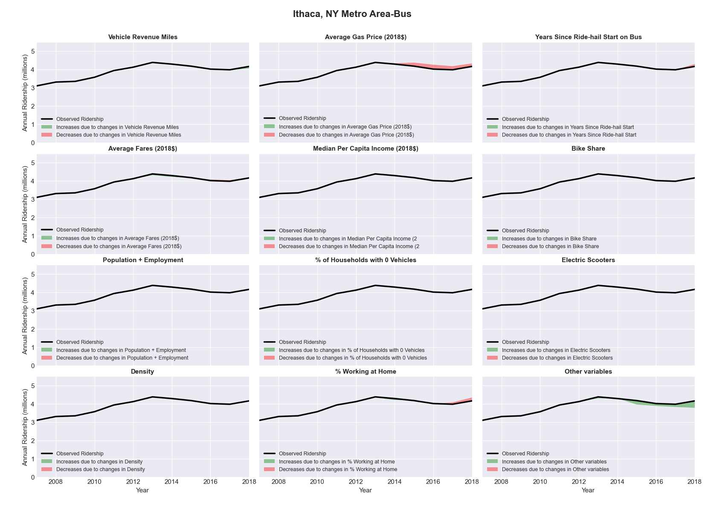

|  |  |  |  |  |  |  |
| --- | --- | --- | --- | --- | --- | --- |
| Jackson, MI Metro Area-Bus | | | | | | |
|  |  |  |  |  |  | |
|  | **Average Values** | | | **Ridership Effect** | | |
| **Description** | **2012** | **2018** | **% Diff** | **Absolute** | **% Diff** | |
|  |  |  |  |  |  | |
| **Vehicle Revenue Miles** | 373,360 | 346,230 | -7.3% | -18,960 | | **-3.3%** | |
| **Average Fare (2018$)** | 0.75 | 0.67 | -10.9% | 12,230 | | **2.2%** | |
| **Network Restructure** | - | - | - | - | | **0.0%** | |
| **Major Maintenance Event** | - | - | - | - | | **0.0%** | |
| **Population + Employment** | 225,760 | 229,610 | 1.7% | 1,970 | | **0.3%** | |
| **Share of Population and Employment in Transit Supportive Density** | 0.25 | 0.24 | -3.5% | -2,090 | | **-0.4%** | |
| **Average Gas Price (2018$)** | 3.93 | 2.72 | -30.9% | -23,190 | | **-4.1%** | |
| **Median Per Capita Income (2018$)** | 23,700 | 28,360 | 19.7% | -6,690 | | **-1.2%** | |
| **% of Households with 0 Vehicles** | 7 | 4 | -40.6% | -2,820 | | **-0.5%** | |
| **% Working at Home** | 3.1 | 4.2 | 33.9% | -3,360 | | **-0.6%** | |
| **Years Since Ride-hail Start** | - | 4 | 4 | -69,170 | | **-12.2%** | |
| **Bike Share** | - | - | - | - | | **0.0%** | |
| **Electric Scooters** | - | - | - | - | | **0.0%** | |
| **New Reporters** |  |  |  | - | | **0.0%** | |
| **Total Modeled Ridership** | 567,650 | 460,732 | -18.84% | -106917.24 | | **-18.8%** | |
| **Total Observed Ridership** | 543,284 | 483,288 | -11.04% | -59996 | | **-11.0%** | |
| **Unexplained Change** |  |  |  |  | | **7.8%** | |

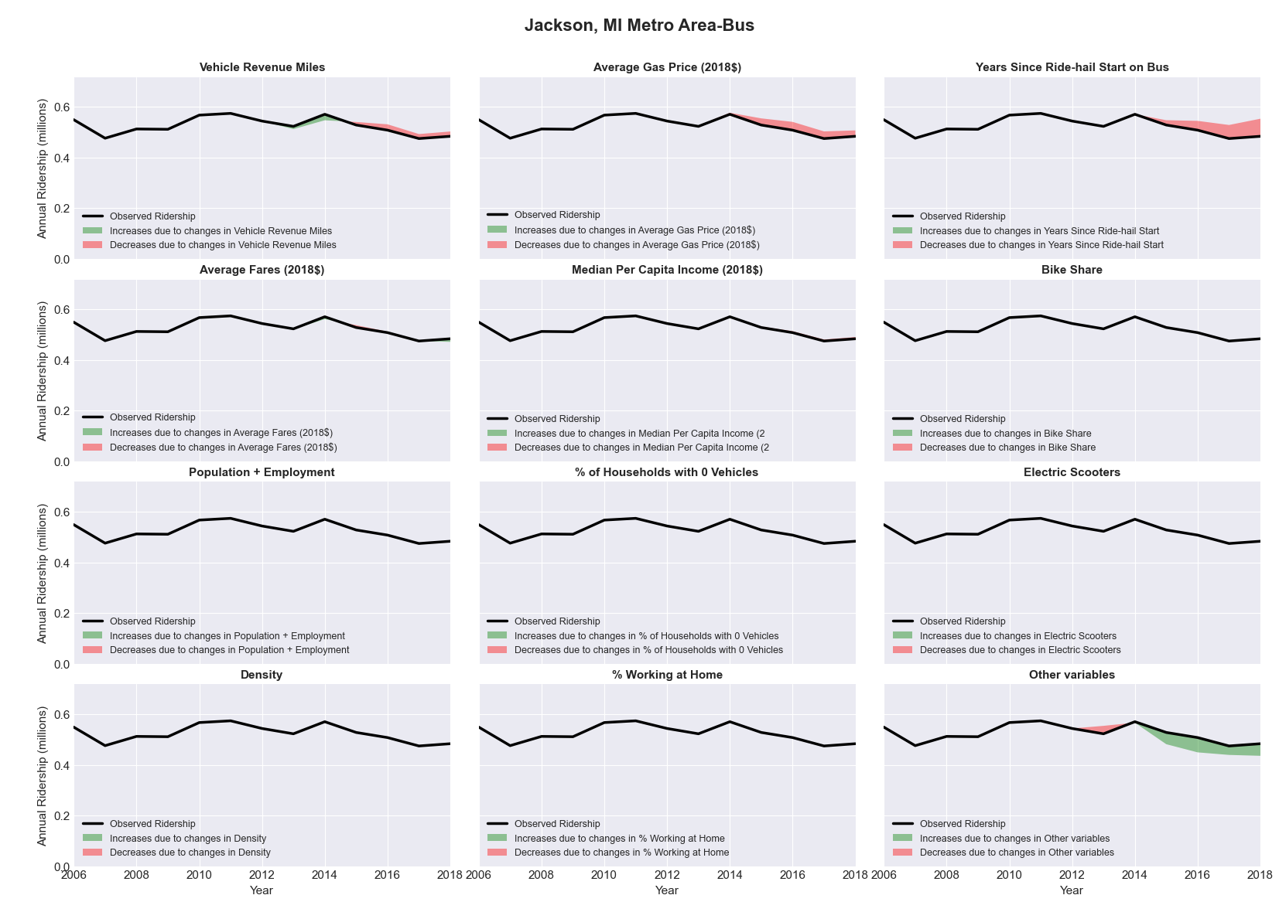

|  |  |  |  |  |  |  |
| --- | --- | --- | --- | --- | --- | --- |
| Jackson, MS Metro Area-Bus | | | | | | |
|  |  |  |  |  |  | |
|  | **Average Values** | | | **Ridership Effect** | | |
| **Description** | **2012** | **2018** | **% Diff** | **Absolute** | **% Diff** | |
|  |  |  |  |  |  | |
| **Vehicle Revenue Miles** | 719,010 | 778,970 | 8.3% | 20,850 | | **3.4%** | |
| **Average Fare (2018$)** | 0.75 | 0.53 | -28.7% | 30,380 | | **5.0%** | |
| **Network Restructure** | - | - | - | - | | **0.0%** | |
| **Major Maintenance Event** | - | - | - | - | | **0.0%** | |
| **Population + Employment** | 791,270 | 832,080 | 5.2% | 6,820 | | **1.1%** | |
| **Share of Population and Employment in Transit Supportive Density** | 0.14 | 0.12 | -8.5% | -2,810 | | **-0.5%** | |
| **Average Gas Price (2018$)** | 3.80 | 2.58 | -32.2% | -28,370 | | **-4.6%** | |
| **Median Per Capita Income (2018$)** | 25,030 | 29,970 | 19.7% | -7,350 | | **-1.2%** | |
| **% of Households with 0 Vehicles** | 6 | 4 | -32.8% | -1,870 | | **-0.3%** | |
| **% Working at Home** | 2.3 | 2.2 | -4.3% | 0,720 | | **0.1%** | |
| **Years Since Ride-hail Start** | - | 4 | 4 | -70,010 | | **-11.4%** | |
| **Bike Share** | - | 1 | 1 | - 4,830 | | **-0.8%** | |
| **Electric Scooters** | - | - | - | - | | **0.0%** | |
| **New Reporters** |  |  |  | - | | **0.0%** | |
| **Total Modeled Ridership** | 611,651 | 561,357 | -8.22% | -50293.8125 | | **-8.2%** | |
| **Total Observed Ridership** | 675,472 | 506,573 | -25.00% | -168899 | | **-25.0%** | |
| **Unexplained Change** |  |  |  |  | | **-16.8%** | |

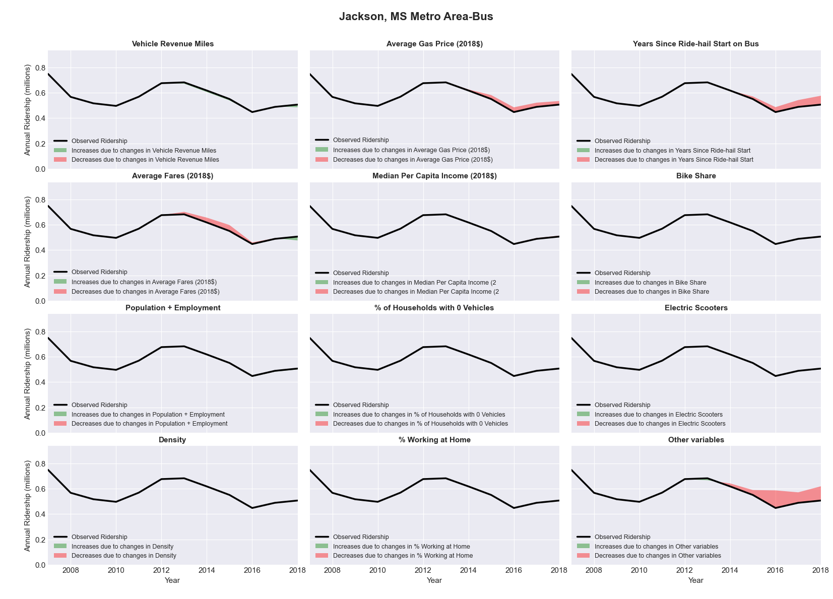

|  |  |  |  |  |  |  |
| --- | --- | --- | --- | --- | --- | --- |
| Jacksonville, FL Metro Area-Bus | | | | | | |
|  |  |  |  |  |  | |
|  | **Average Values** | | | **Ridership Effect** | | |
| **Description** | **2012** | **2018** | **% Diff** | **Absolute** | **% Diff** | |
|  |  |  |  |  |  | |
| **Vehicle Revenue Miles** | 8,821,510 | 9,100,360 | 3.2% | 159,430 | | **1.4%** | |
| **Average Fare (2018$)** | 1.13 | 0.99 | -12.3% | 436,000 | | **3.8%** | |
| **Network Restructure** | - | 1.000 | - | 534,945.44 | | **4.8%** | |
| **Major Maintenance Event** | - | - | - | - | | **0.0%** | |
| **Population + Employment** | 2,024,210 | 2,284,610 | 12.9% | 296,790 | | **2.6%** | |
| **Share of Population and Employment in Transit Supportive Density** | 0.18 | 0.18 | -1.7% | -14,380 | | **-0.1%** | |
| **Average Gas Price (2018$)** | 3.95 | 2.71 | -31.3% | -459,400 | | **-4.0%** | |
| **Median Per Capita Income (2018$)** | 27,710 | 30,570 | 10.3% | -80,010 | | **-0.7%** | |
| **% of Households with 0 Vehicles** | 7 | 6 | -17.4% | -27,660 | | **-0.2%** | |
| **% Working at Home** | 4.7 | 6.8 | 43.6% | -178,440 | | **-1.6%** | |
| **Years Since Ride-hail Start** | - | 4 | 4 | -1,494,560 | | **-13.1%** | |
| **Bike Share** | - | 1 | 1 | - 121,190 | | **-1.1%** | |
| **Electric Scooters** | - | - | - | - | | **0.0%** | |
| **New Reporters** |  |  |  | - | | **0.0%** | |
| **Total Modeled Ridership** | 11,412,397 | 10,454,725 | -8.39% | -95762.128 | | **-8.4%** | |
| **Total Observed Ridership** | 11,217,218 | 10,262,121 | -8.51% | -955097 | | **-8.5%** | |
| **Unexplained Change** |  |  |  |  | | **-0.1%** | |

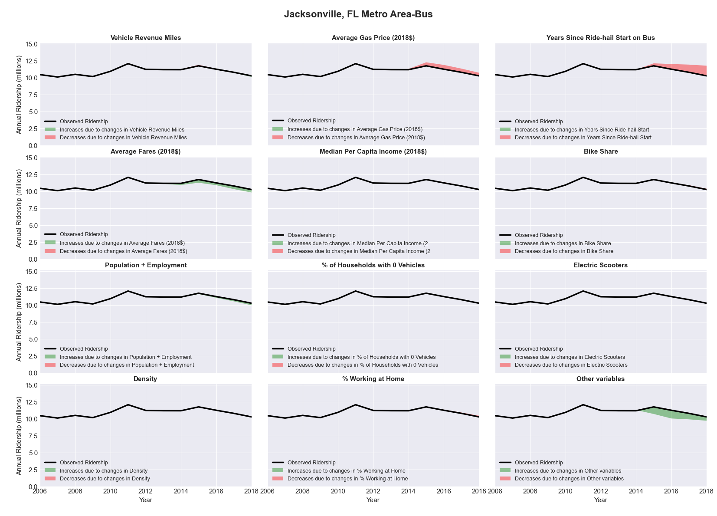

|  |  |  |  |  |  |  |
| --- | --- | --- | --- | --- | --- | --- |
| Johnstown, PA Metro Area-Bus | | | | | | |
|  |  |  |  |  |  | |
|  | **Average Values** | | | **Ridership Effect** | | |
| **Description** | **2012** | **2018** | **% Diff** | **Absolute** | **% Diff** | |
|  |  |  |  |  |  | |
| **Vehicle Revenue Miles** | 938,230 | 929,600 | -0.9% | -3,840 | | **-0.4%** | |
| **Average Fare (2018$)** | 0.70 | 0.76 | 7.3% | -18,460 | | **-1.7%** | |
| **Network Restructure** | - | - | - | - | | **0.0%** | |
| **Major Maintenance Event** | - | - | - | - | | **0.0%** | |
| **Population + Employment** | 201,760 | 187,460 | -7.1% | -16,180 | | **-1.5%** | |
| **Share of Population and Employment in Transit Supportive Density** | 0.13 | 0.12 | -12.0% | -6,730 | | **-0.6%** | |
| **Average Gas Price (2018$)** | 4.11 | 2.92 | -28.9% | -39,560 | | **-3.6%** | |
| **Median Per Capita Income (2018$)** | 23,630 | 26,010 | 10.1% | -6,960 | | **-0.6%** | |
| **% of Households with 0 Vehicles** | 10 | 8 | -19.4% | -3,760 | | **-0.3%** | |
| **% Working at Home** | 2.2 | 4.6 | 106.8% | -17,260 | | **-1.6%** | |
| **Years Since Ride-hail Start** | - | 2 | 2 | -63,200 | | **-5.8%** | |
| **Bike Share** | - | - | - | - | | **0.0%** | |
| **Electric Scooters** | - | - | - | - | | **0.0%** | |
| **New Reporters** |  |  |  | - | | **0.0%** | |
| **Total Modeled Ridership** | 1,084,420 | 907,547 | -16.31% | -176873.116 | | **-16.3%** | |
| **Total Observed Ridership** | 1,062,894 | 950,143 | -10.61% | -112751 | | **-10.6%** | |
| **Unexplained Change** |  |  |  |  | | **5.7%** | |

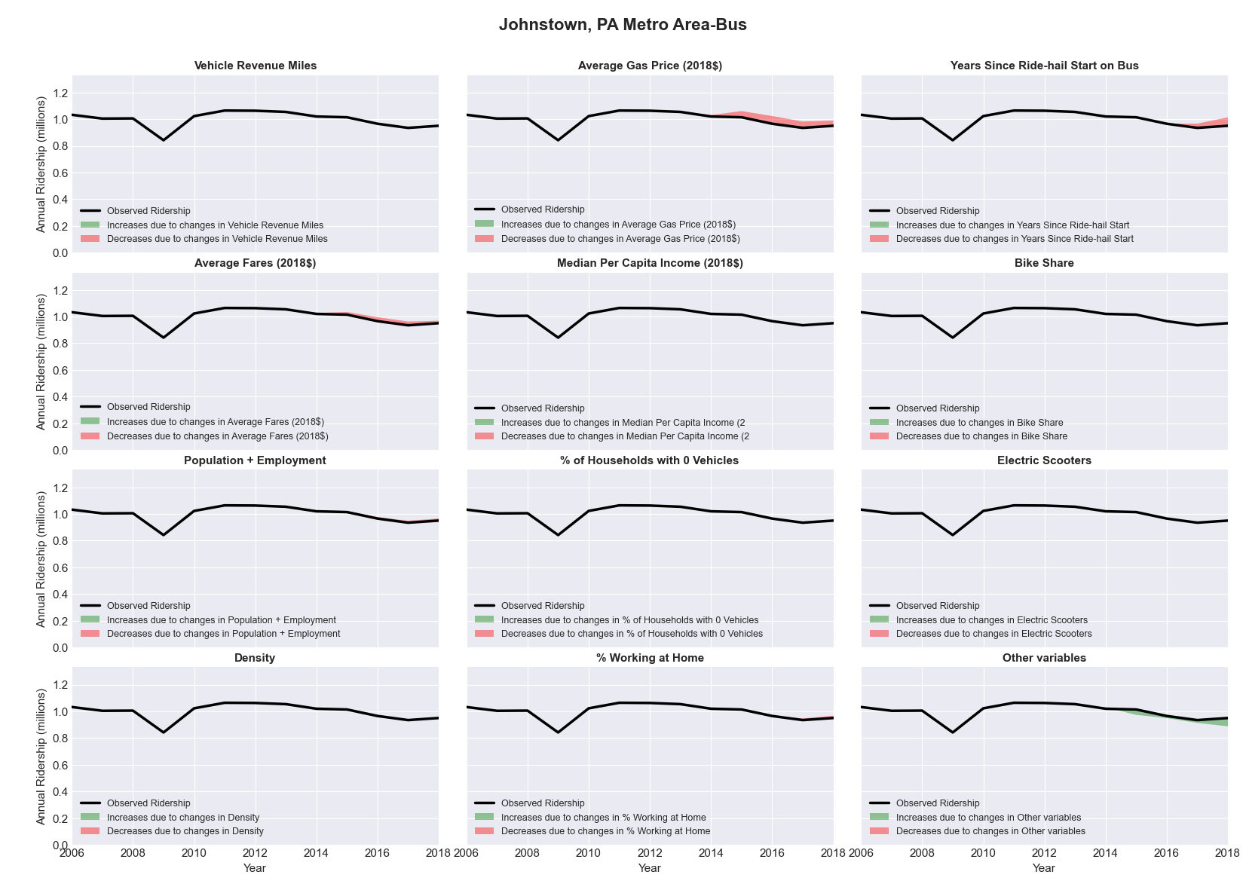

|  |  |  |  |  |  |  |
| --- | --- | --- | --- | --- | --- | --- |
| Kalamazoo-Portage, MI Metro Area-Bus | | | | | | |
|  |  |  |  |  |  | |
|  | **Average Values** | | | **Ridership Effect** | | |
| **Description** | **2012** | **2018** | **% Diff** | **Absolute** | **% Diff** | |
|  |  |  |  |  |  | |
| **Vehicle Revenue Miles** | 1,501,930 | 1,739,310 | 15.8% | 181,140 | | **6.0%** | |
| **Average Fare (2018$)** | 0.92 | 1.03 | 12.6% | -77,720 | | **-2.6%** | |
| **Network Restructure** | - | - | - | - | | **0.0%** | |
| **Major Maintenance Event** | - | - | - | - | | **0.0%** | |
| **Population + Employment** | 477,090 | 501,580 | 5.1% | 31,480 | | **1.0%** | |
| **Share of Population and Employment in Transit Supportive Density** | 0.16 | 0.14 | -9.6% | -16,810 | | **-0.6%** | |
| **Average Gas Price (2018$)** | 3.93 | 2.72 | -30.9% | -122,870 | | **-4.1%** | |
| **Median Per Capita Income (2018$)** | 23,460 | 30,650 | 30.6% | -53,650 | | **-1.8%** | |
| **% of Households with 0 Vehicles** | 8 | 6 | -21.2% | -8,450 | | **-0.3%** | |
| **% Working at Home** | 3.3 | 4.7 | 41.7% | -26,700 | | **-0.9%** | |
| **Years Since Ride-hail Start** | - | 4 | 4 | -371,690 | | **-12.4%** | |
| **Bike Share** | - | - | - | - | | **0.0%** | |
| **Electric Scooters** | - | - | - | - | | **0.0%** | |
| **New Reporters** |  |  |  | - | | **0.0%** | |
| **Total Modeled Ridership** | 3,008,362 | 2,534,015 | -15.77% | -47434.596 | | **-15.8%** | |
| **Total Observed Ridership** | 2,891,508 | 2,648,426 | -8.41% | -243082 | | **-8.4%** | |
| **Unexplained Change** |  |  |  |  | | **7.4%** | |

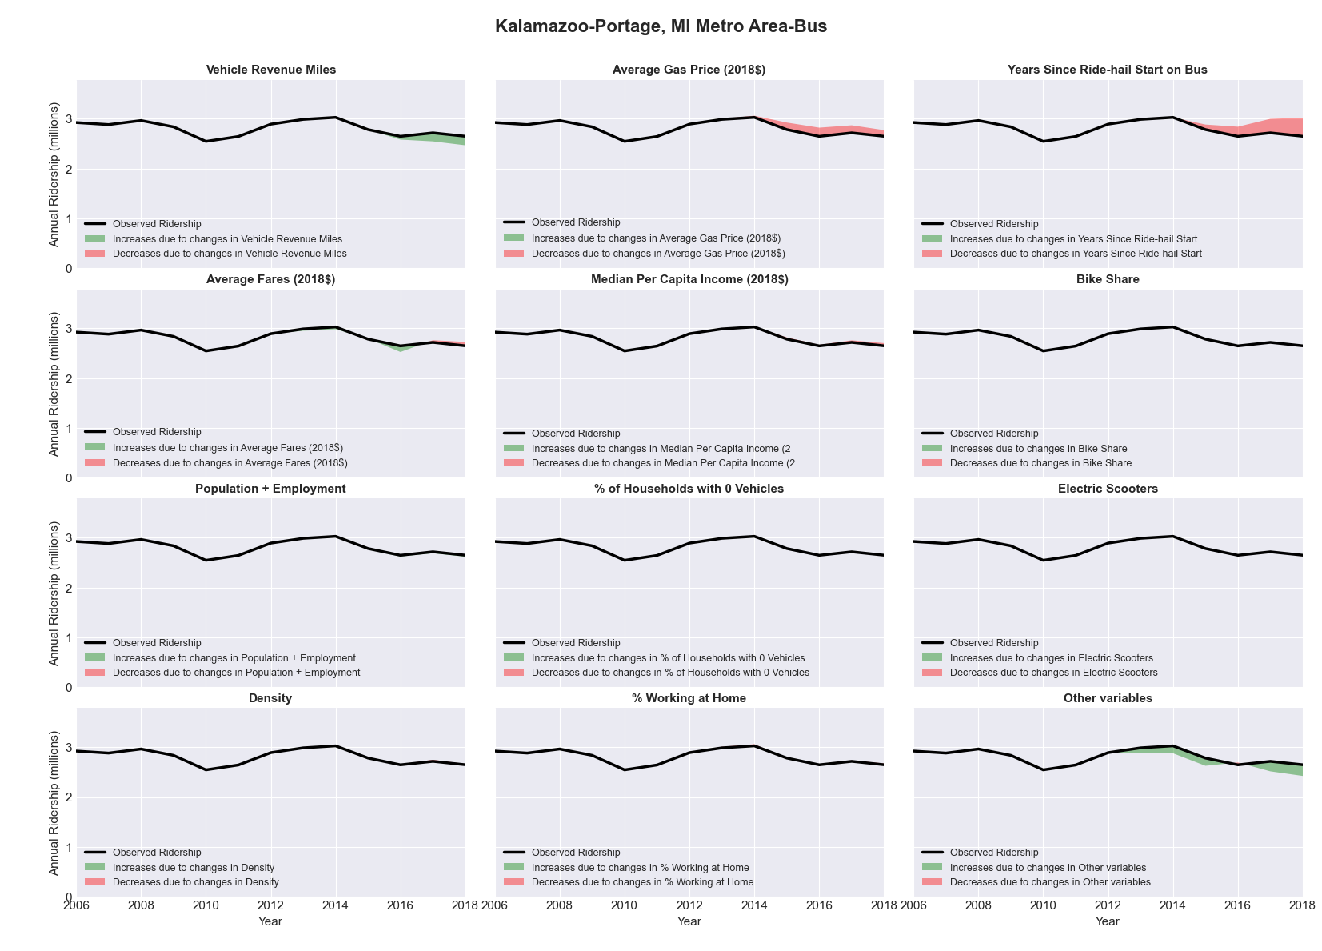

|  |  |  |  |  |  |  |
| --- | --- | --- | --- | --- | --- | --- |
| Kankakee-Bradley, IL Metro Area-Bus | | | | | | |
|  |  |  |  |  |  | |
|  | **Average Values** | | | **Ridership Effect** | | |
| **Description** | **2012** | **2018** | **% Diff** | **Absolute** | **% Diff** | |
|  |  |  |  |  |  | |
| **Vehicle Revenue Miles** | 908,400 | 1,287,700 | 41.8% | 152,570 | | **18.9%** | |
| **Average Fare (2018$)** | 0.45 | 0.45 | 0.8% | -4,350 | | **-0.5%** | |
| **Network Restructure** | - | - | - | - | | **0.0%** | |
| **Major Maintenance Event** | - | - | - | - | | **0.0%** | |
| **Population + Employment** | 163,820 | 164,680 | 0.5% | 0,350 | | **0.0%** | |
| **Share of Population and Employment in Transit Supportive Density** | 0.13 | 0.14 | 4.0% | 1,700 | | **0.2%** | |
| **Average Gas Price (2018$)** | 3.93 | 2.72 | -30.9% | -41,360 | | **-5.1%** | |
| **Median Per Capita Income (2018$)** | 27,750 | 30,380 | 9.5% | -4,810 | | **-0.6%** | |
| **% of Households with 0 Vehicles** | 6 | 11 | 77.4% | 7,790 | | **1.0%** | |
| **% Working at Home** | 3.0 | 2.8 | -8.3% | 0,950 | | **0.1%** | |
| **Years Since Ride-hail Start** | - | 3 | 3 | -83,420 | | **-10.3%** | |
| **Bike Share** | - | 1 | 1 | - 7,420 | | **-0.9%** | |
| **Electric Scooters** | - | - | - | - | | **0.0%** | |
| **New Reporters** |  |  |  | - | | **0.0%** | |
| **Total Modeled Ridership** | 808,316 | 817,122 | 1.09% | 8805.91463 | | **1.1%** | |
| **Total Observed Ridership** | 914,259 | 671,130 | -26.59% | -243129 | | **-26.6%** | |
| **Unexplained Change** |  |  |  |  | | **-27.7%** | |

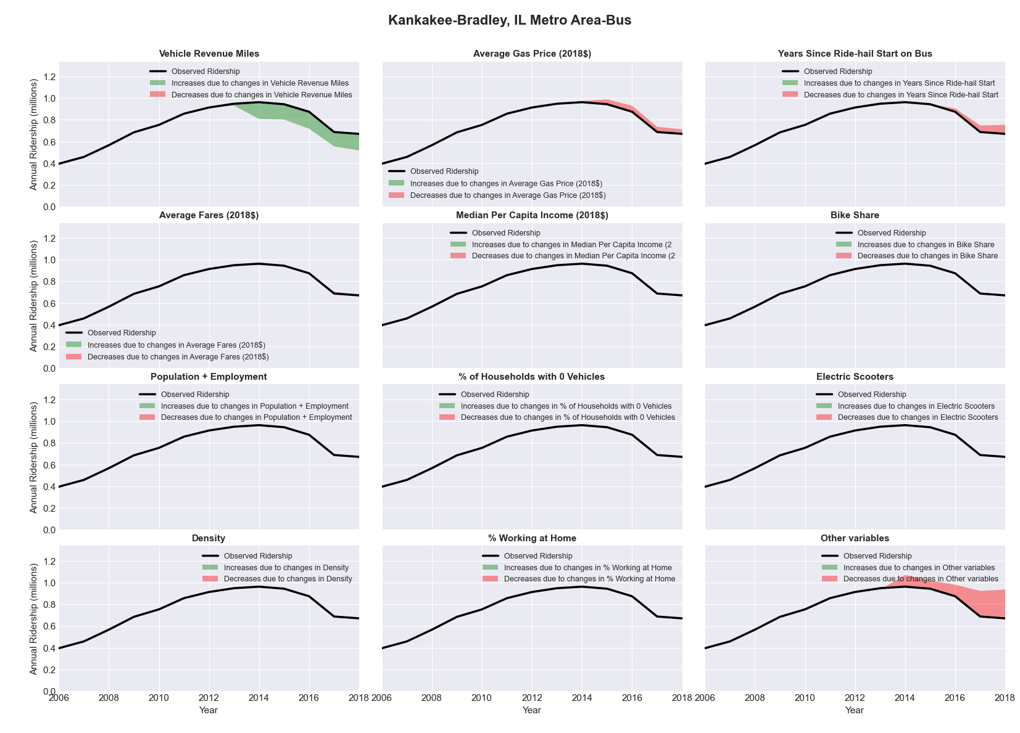

|  |  |  |  |  |  |  |
| --- | --- | --- | --- | --- | --- | --- |
| Kansas City, MO-KS Metro Area-Bus | | | | | | |
|  |  |  |  |  |  | |
|  | **Average Values** | | | **Ridership Effect** | | |
| **Description** | **2012** | **2018** | **% Diff** | **Absolute** | **% Diff** | |
|  |  |  |  |  |  | |
| **Vehicle Revenue Miles** | 9,105,260 | 9,370,100 | 2.9% | 210,740 | | **1.3%** | |
| **Average Fare (2018$)** | 0.82 | 0.62 | -24.7% | 996,440 | | **6.3%** | |
| **Network Restructure** | - | - | - | - | | **0.0%** | |
| **Major Maintenance Event** | - | - | - | - | | **0.0%** | |
| **Population + Employment** | 3,087,270 | 3,262,940 | 5.7% | 183,480 | | **1.2%** | |
| **Share of Population and Employment in Transit Supportive Density** | 0.21 | 0.21 | -1.9% | -25,430 | | **-0.2%** | |
| **Average Gas Price (2018$)** | 3.93 | 2.72 | -30.9% | -685,630 | | **-4.3%** | |
| **Median Per Capita Income (2018$)** | 31,930 | 34,570 | 8.3% | -87,460 | | **-0.5%** | |
| **% of Households with 0 Vehicles** | 7 | 5 | -21.6% | -42,510 | | **-0.3%** | |
| **% Working at Home** | 4.2 | 5.4 | 28.6% | -144,740 | | **-0.9%** | |
| **Years Since Ride-hail Start** | - | 4 | 4 | -1,982,570 | | **-12.4%** | |
| **Bike Share** | 1.00 | 1 | - | - | | **0.0%** | |
| **Electric Scooters** | - | 1 | 1 | - 530,360 | | **-3.3%** | |
| **New Reporters** |  |  |  | - | | **0.0%** | |
| **Total Modeled Ridership** | 15,926,149 | 13,821,599 | -13.21% | -210450.07 | | **-13.2%** | |
| **Total Observed Ridership** | 16,550,779 | 12,968,764 | -21.64% | -3582015 | | **-21.6%** | |
| **Unexplained Change** |  |  |  |  | | **-8.4%** | |

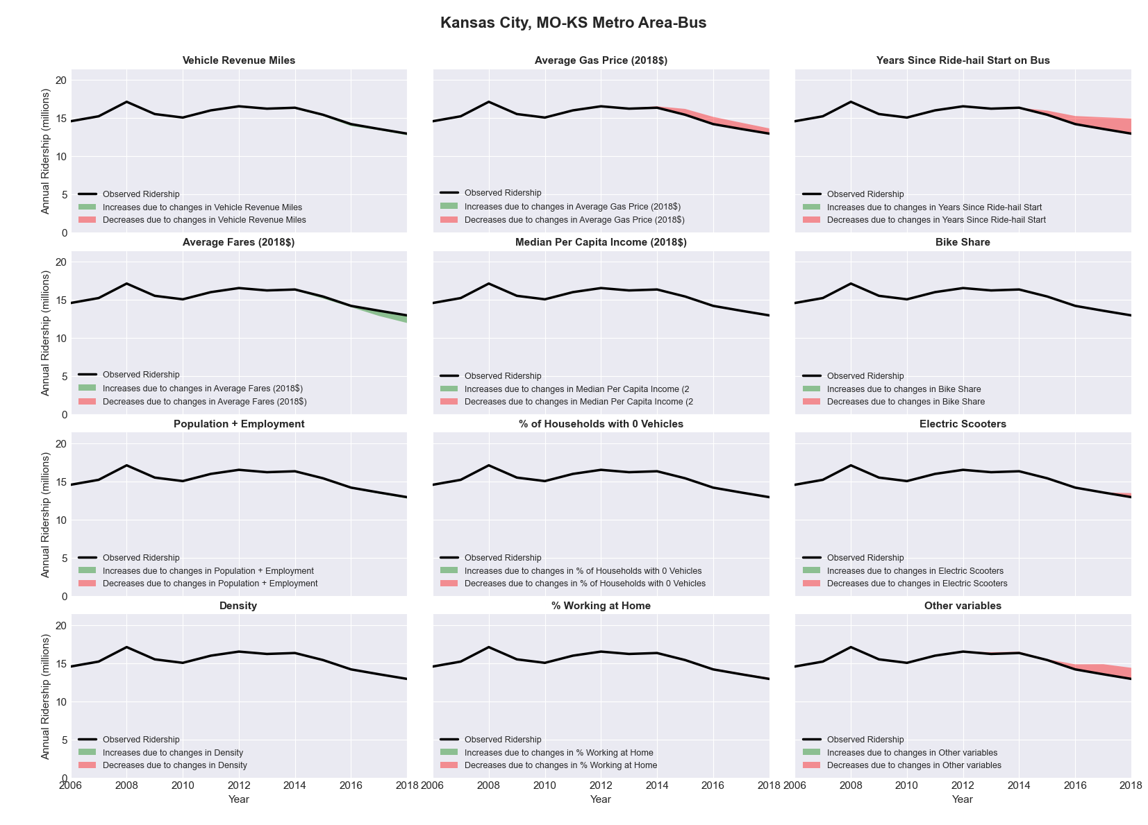

|  |  |  |  |  |  |  |
| --- | --- | --- | --- | --- | --- | --- |
| Kennewick-Pasco-Richland, WA Metro Area-Bus | | | | | | |
|  |  |  |  |  |  | |
|  | **Average Values** | | | **Ridership Effect** | | |
| **Description** | **2012** | **2018** | **% Diff** | **Absolute** | **% Diff** | |
|  |  |  |  |  |  | |
| **Vehicle Revenue Miles** | 2,072,250 | 2,537,440 | 22.4% | 215,860 | | **8.2%** | |
| **Average Fare (2018$)** | 0.50 | 0.78 | 56.8% | -235,530 | | **-9.0%** | |
| **Network Restructure** | - | - | - | - | | **0.0%** | |
| **Major Maintenance Event** | - | - | - | - | | **0.0%** | |
| **Population + Employment** | 387,070 | 428,320 | 10.7% | 56,250 | | **2.1%** | |
| **Share of Population and Employment in Transit Supportive Density** | 0.25 | 0.26 | 2.2% | 7,160 | | **0.3%** | |
| **Average Gas Price (2018$)** | 4.35 | 3.40 | -21.8% | -87,140 | | **-3.3%** | |
| **Median Per Capita Income (2018$)** | 30,210 | 31,050 | 2.8% | -4,470 | | **-0.2%** | |
| **% of Households with 0 Vehicles** | 6 | 5 | -25.2% | -9,490 | | **-0.4%** | |
| **% Working at Home** | 4.4 | 7.5 | 70.5% | -48,350 | | **-1.8%** | |
| **Years Since Ride-hail Start** | - | 2 | 2 | -151,890 | | **-5.8%** | |
| **Bike Share** | - | - | - | - | | **0.0%** | |
| **Electric Scooters** | - | - | - | - | | **0.0%** | |
| **New Reporters** |  |  |  | - | | **0.0%** | |
| **Total Modeled Ridership** | 2,620,885 | 2,350,114 | -10.33% | -270770.17 | | **-10.3%** | |
| **Total Observed Ridership** | 2,995,267 | 2,016,104 | -32.69% | -979163 | | **-32.7%** | |
| **Unexplained Change** |  |  |  |  | | **-22.4%** | |

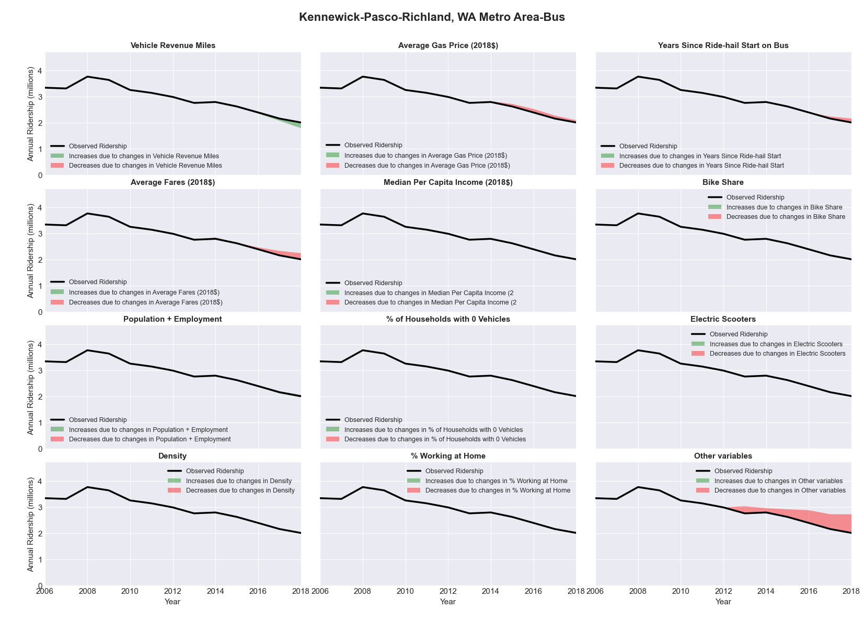

|  |  |  |  |  |  |  |
| --- | --- | --- | --- | --- | --- | --- |
| Killeen-Temple-Fort Hood, TX Metro Area-Bus | | | | | | |
|  |  |  |  |  |  | |
|  | **Average Values** | | | **Ridership Effect** | | |
| **Description** | **2012** | **2018** | **% Diff** | **Absolute** | **% Diff** | |
|  |  |  |  |  |  | |
| **Vehicle Revenue Miles** | 635,060 | 476,520 | -25.0% | -65,760 | | **-10.5%** | |
| **Average Fare (2018$)** | 0.61 | 0.84 | 36.9% | -37,770 | | **-6.0%** | |
| **Network Restructure** | - | - | - | - | | **0.0%** | |
| **Major Maintenance Event** | - | - | - | - | | **0.0%** | |
| **Population + Employment** | 576,290 | 619,910 | 7.6% | 9,770 | | **1.6%** | |
| **Share of Population and Employment in Transit Supportive Density** | 0.10 | 0.09 | -8.0% | -2,180 | | **-0.3%** | |
| **Average Gas Price (2018$)** | 3.80 | 2.58 | -32.2% | -28,210 | | **-4.5%** | |
| **Median Per Capita Income (2018$)** | 29,250 | 27,790 | -5.0% | 2,290 | | **0.4%** | |
| **% of Households with 0 Vehicles** | 5 | 5 | 8.8% | 0,520 | | **0.1%** | |
| **% Working at Home** | 2.6 | 4.0 | 52.9% | -6,880 | | **-1.1%** | |
| **Years Since Ride-hail Start** | - | 3 | 3 | -59,420 | | **-9.5%** | |
| **Bike Share** | - | - | - | - | | **0.0%** | |
| **Electric Scooters** | - | - | - | - | | **0.0%** | |
| **New Reporters** |  |  |  | - | | **0.0%** | |
| **Total Modeled Ridership** | 625,413 | 444,174 | -28.98% | -181238.858 | | **-29.0%** | |
| **Total Observed Ridership** | 624,855 | 442,325 | -29.21% | -182530 | | **-29.2%** | |
| **Unexplained Change** |  |  |  |  | | **-0.2%** | |

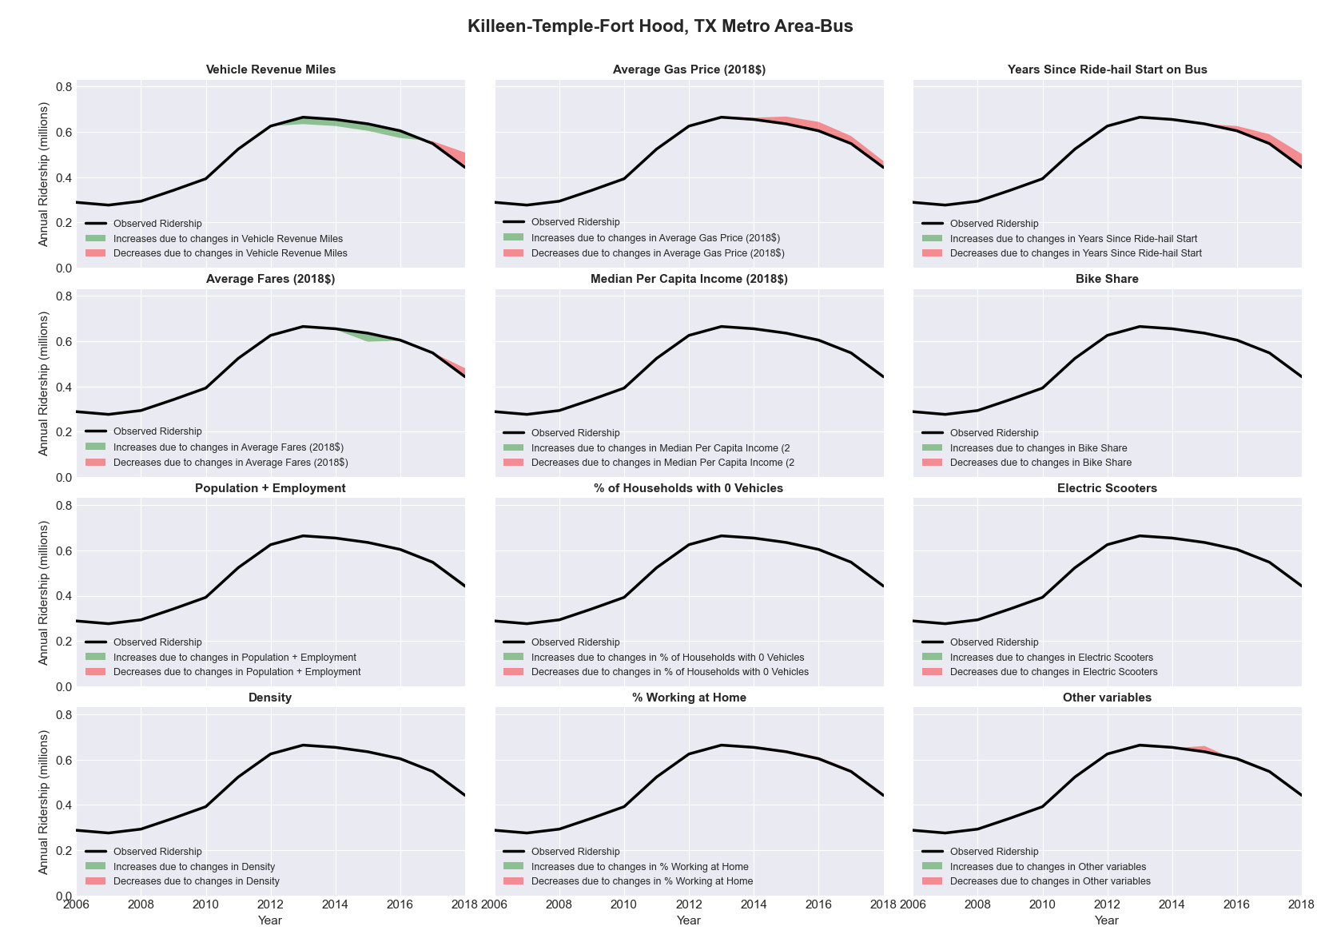

|  |  |  |  |  |  |  |
| --- | --- | --- | --- | --- | --- | --- |
| Knoxville, TN Metro Area-Bus | | | | | | |
|  |  |  |  |  |  | |
|  | **Average Values** | | | **Ridership Effect** | | |
| **Description** | **2012** | **2018** | **% Diff** | **Absolute** | **% Diff** | |
|  |  |  |  |  |  | |
| **Vehicle Revenue Miles** | 2,364,860 | 2,615,960 | 10.6% | 129,540 | | **4.3%** | |
| **Average Fare (2018$)** | 0.50 | 0.62 | 24.2% | -149,060 | | **-4.9%** | |
| **Network Restructure** | - | - | - | - | | **0.0%** | |
| **Major Maintenance Event** | - | - | - | - | | **0.0%** | |
| **Population + Employment** | 1,041,780 | 1,240,740 | 19.1% | 117,920 | | **3.9%** | |
| **Share of Population and Employment in Transit Supportive Density** | 0.10 | 0.09 | -5.0% | -5,640 | | **-0.2%** | |
| **Average Gas Price (2018$)** | 3.93 | 2.72 | -30.9% | -116,550 | | **-3.8%** | |
| **Median Per Capita Income (2018$)** | 26,360 | 28,170 | 6.9% | -9,850 | | **-0.3%** | |
| **% of Households with 0 Vehicles** | 6 | 5 | -15.3% | -3,750 | | **-0.1%** | |
| **% Working at Home** | 4.4 | 5.9 | 33.5% | -28,410 | | **-0.9%** | |
| **Years Since Ride-hail Start** | - | 4 | 4 | -354,550 | | **-11.7%** | |
| **Bike Share** | - | 1 | 1 | - 27,300 | | **-0.9%** | |
| **Electric Scooters** | - | - | - | - | | **0.0%** | |
| **New Reporters** |  |  |  | - | | **0.0%** | |
| **Total Modeled Ridership** | 3,029,719 | 2,562,243 | -15.43% | -46746.023 | | **-15.4%** | |
| **Total Observed Ridership** | 3,218,087 | 2,594,981 | -19.36% | -623106 | | **-19.4%** | |
| **Unexplained Change** |  |  |  |  | | **-3.9%** | |

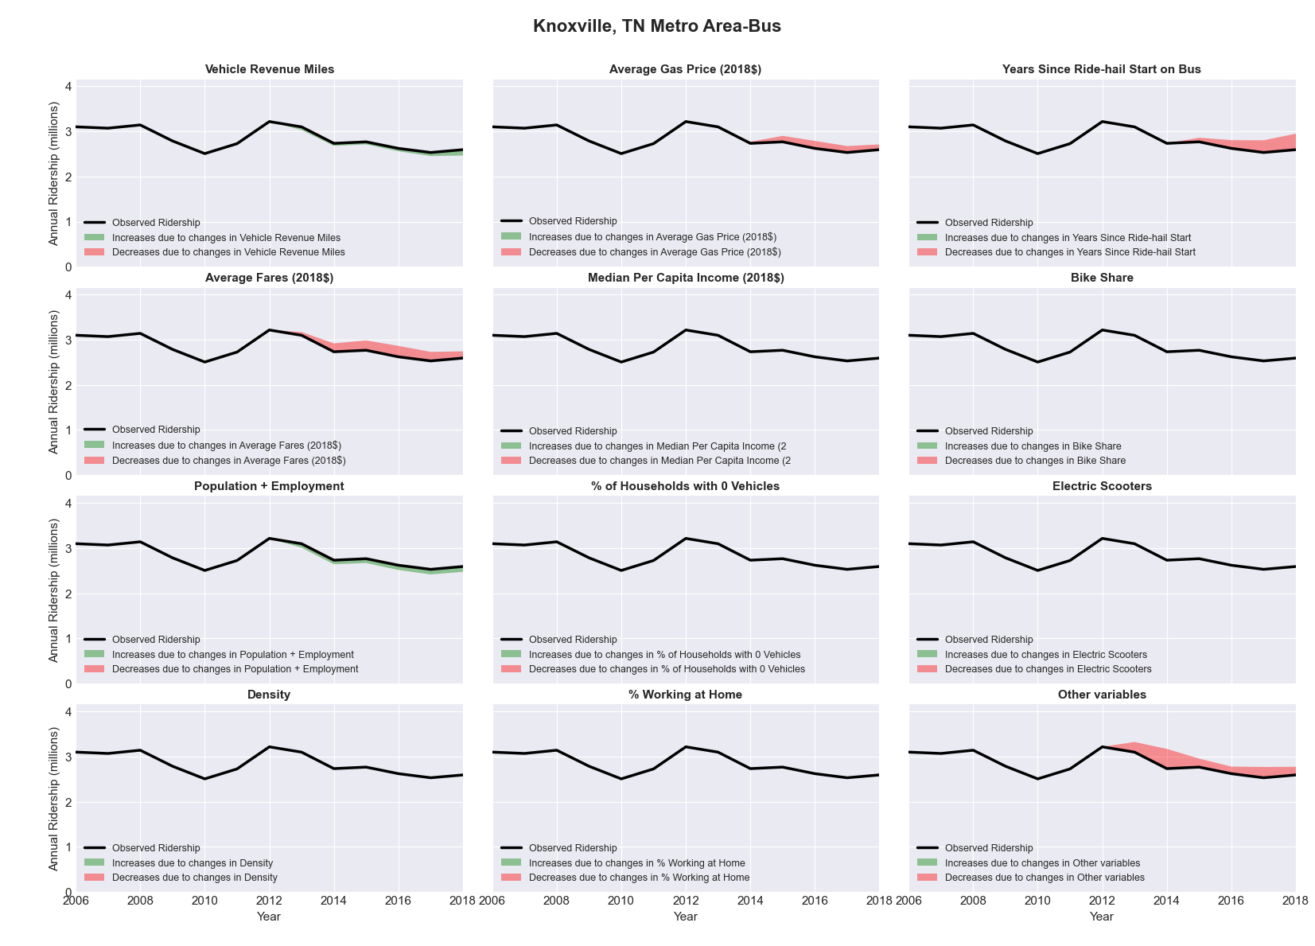

|  |  |  |  |  |  |  |
| --- | --- | --- | --- | --- | --- | --- |
| La Crosse, WI-MN Metro Area-Bus | | | | | | |
|  |  |  |  |  |  | |
|  | **Average Values** | | | **Ridership Effect** | | |
| **Description** | **2012** | **2018** | **% Diff** | **Absolute** | **% Diff** | |
|  |  |  |  |  |  | |
| **Vehicle Revenue Miles** | 768,080 | 843,910 | 9.9% | 47,890 | | **4.3%** | |
| **Average Fare (2018$)** | 0.61 | 0.63 | 3.4% | -8,810 | | **-0.8%** | |
| **Network Restructure** | - | - | - | - | | **0.0%** | |
| **Major Maintenance Event** | - | - | - | - | | **0.0%** | |
| **Population + Employment** | 208,050 | 214,220 | 3.0% | 7,090 | | **0.6%** | |
| **Share of Population and Employment in Transit Supportive Density** | 0.12 | 0.12 | 0.6% | 0,320 | | **0.0%** | |
| **Average Gas Price (2018$)** | 3.93 | 2.72 | -30.9% | -49,270 | | **-4.5%** | |
| **Median Per Capita Income (2018$)** | 26,310 | 32,780 | 24.6% | -16,380 | | **-1.5%** | |
| **% of Households with 0 Vehicles** | 6 | 7 | 23.5% | 3,010 | | **0.3%** | |
| **% Working at Home** | 4.2 | 3.7 | -12.5% | 4,490 | | **0.4%** | |
| **Years Since Ride-hail Start** | - | 1 | 1 | -33,210 | | **-3.0%** | |
| **Bike Share** | - | - | - | - | | **0.0%** | |
| **Electric Scooters** | - | - | - | - | | **0.0%** | |
| **New Reporters** |  |  |  | - | | **0.0%** | |
| **Total Modeled Ridership** | 1,102,856 | 1,057,978 | -4.07% | -44878.0884 | | **-4.1%** | |
| **Total Observed Ridership** | 1,152,038 | 957,918 | -16.85% | -194120 | | **-16.9%** | |
| **Unexplained Change** |  |  |  |  | | **-12.8%** | |

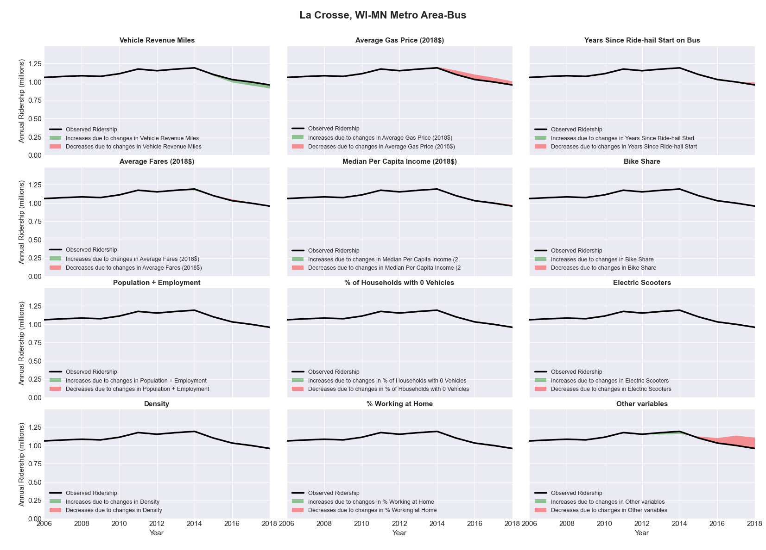

|  |  |  |  |  |  |  |
| --- | --- | --- | --- | --- | --- | --- |
| Lafayette, IN Metro Area-Bus | | | | | | |
|  |  |  |  |  |  | |
|  | **Average Values** | | | **Ridership Effect** | | |
| **Description** | **2012** | **2018** | **% Diff** | **Absolute** | **% Diff** | |
|  |  |  |  |  |  | |
| **Vehicle Revenue Miles** | 1,690,560 | 1,804,300 | 6.7% | 137,150 | | **2.5%** | |
| **Average Fare (2018$)** | 0.54 | 0.65 | 21.0% | -208,810 | | **-3.8%** | |
| **Network Restructure** | - | - | - | - | | **0.0%** | |
| **Major Maintenance Event** | - | - | - | - | | **0.0%** | |
| **Population + Employment** | 301,670 | 329,280 | 9.2% | 97,130 | | **1.8%** | |
| **Share of Population and Employment in Transit Supportive Density** | 0.25 | 0.24 | -2.5% | -12,700 | | **-0.2%** | |
| **Average Gas Price (2018$)** | 3.93 | 2.72 | -30.9% | -217,460 | | **-4.0%** | |
| **Median Per Capita Income (2018$)** | 23,140 | 25,070 | 8.3% | -27,950 | | **-0.5%** | |
| **% of Households with 0 Vehicles** | 8 | 9 | 18.6% | 12,310 | | **0.2%** | |
| **% Working at Home** | 2.8 | 4.7 | 66.1% | -64,060 | | **-1.2%** | |
| **Years Since Ride-hail Start** | - | 4 | 4 | -649,370 | | **-11.8%** | |
| **Bike Share** | - | 1 | 1 | - 51,380 | | **-0.9%** | |
| **Electric Scooters** | - | - | - | - | | **0.0%** | |
| **New Reporters** |  |  |  | - | | **0.0%** | |
| **Total Modeled Ridership** | 5,494,457 | 4,503,177 | -18.04% | -991280.13 | | **-18.0%** | |
| **Total Observed Ridership** | 5,258,842 | 4,713,280 | -10.37% | -545562 | | **-10.4%** | |
| **Unexplained Change** |  |  |  |  | | **7.7%** | |

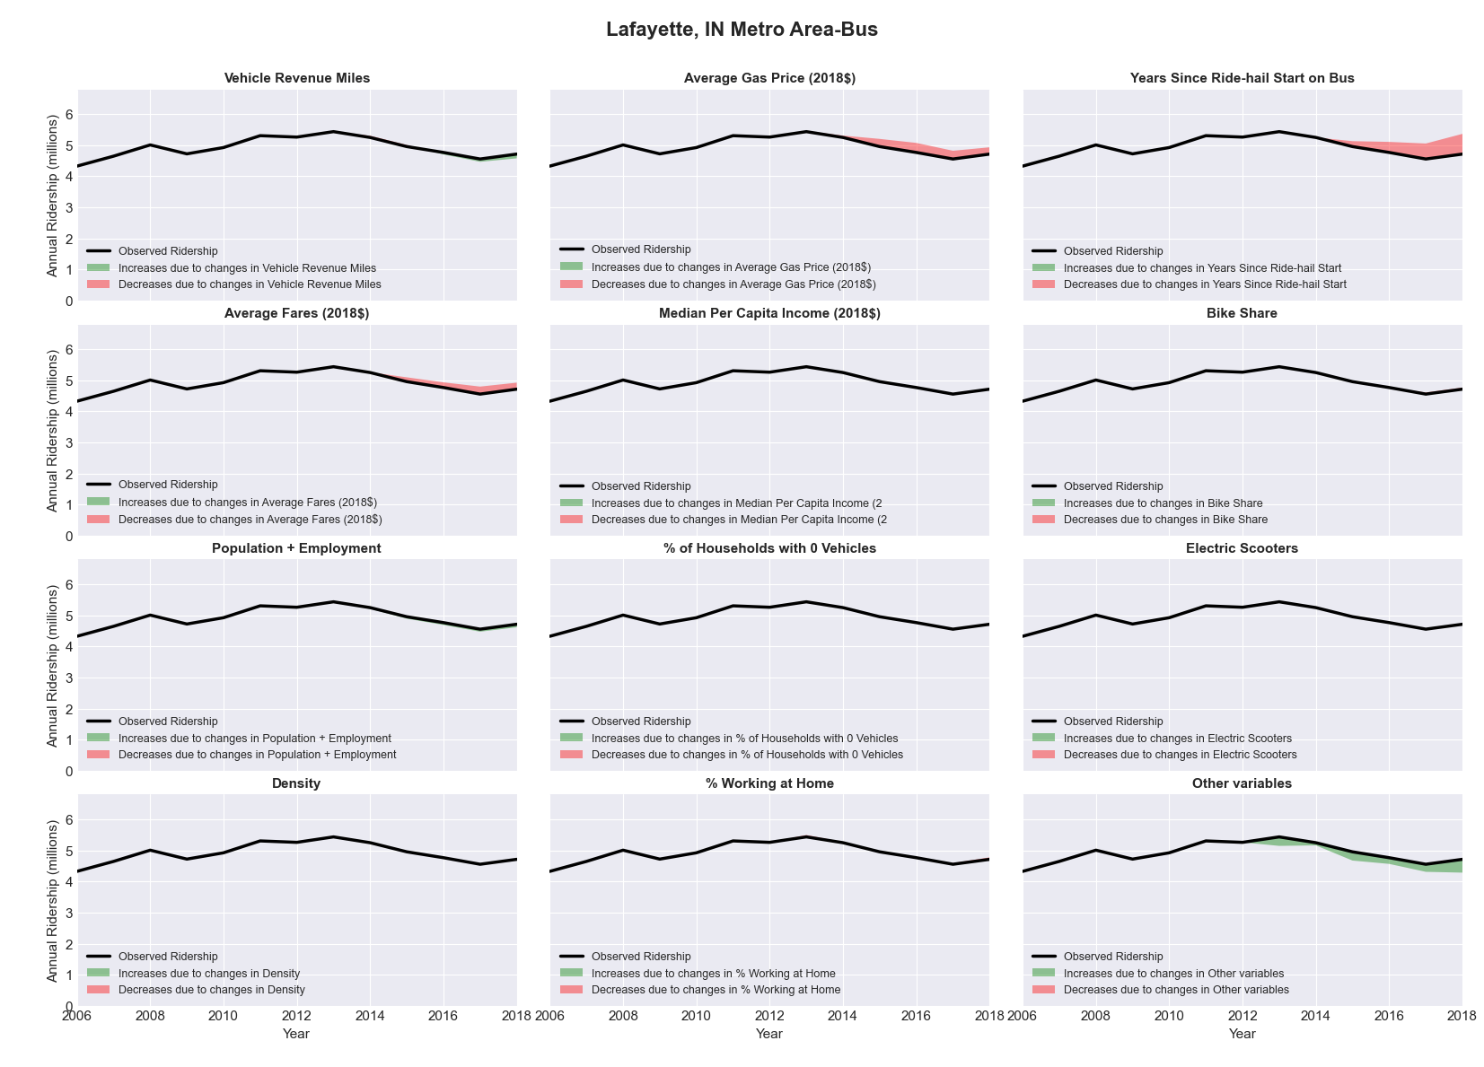

|  |  |  |  |  |  |  |
| --- | --- | --- | --- | --- | --- | --- |
| Lafayette, LA Metro Area-Bus | | | | | | |
|  |  |  |  |  |  | |
|  | **Average Values** | | | **Ridership Effect** | | |
| **Description** | **2012** | **2018** | **% Diff** | **Absolute** | **% Diff** | |
|  |  |  |  |  |  | |
| **Vehicle Revenue Miles** | 627,550 | 670,000 | 6.8% | 42,510 | | **3.7%** | |
| **Average Fare (2018$)** | 0.39 | 0.29 | -26.0% | 46,760 | | **4.1%** | |
| **Network Restructure** | - | - | - | - | | **0.0%** | |
| **Major Maintenance Event** | - | - | - | - | | **0.0%** | |
| **Population + Employment** | 413,220 | 620,990 | 50.3% | 108,340 | | **9.5%** | |
| **Share of Population and Employment in Transit Supportive Density** | 0.11 | 0.11 | 4.2% | 2,000 | | **0.2%** | |
| **Average Gas Price (2018$)** | 3.80 | 2.58 | -32.2% | -42,340 | | **-3.7%** | |
| **Median Per Capita Income (2018$)** | 25,570 | 25,430 | -0.5% | 0,760 | | **0.1%** | |
| **% of Households with 0 Vehicles** | 7 | 10 | 35.7% | 6,140 | | **0.5%** | |
| **% Working at Home** | 2.6 | 4.5 | 71.2% | -18,000 | | **-1.6%** | |
| **Years Since Ride-hail Start** | - | 3 | 3 | -122,000 | | **-10.7%** | |
| **Bike Share** | - | 1 | 1 | - 12,560 | | **-1.1%** | |
| **Electric Scooters** | - | - | - | - | | **0.0%** | |
| **New Reporters** |  |  |  | - | | **0.0%** | |
| **Total Modeled Ridership** | 1,140,695 | 1,141,545 | 0.07% | 850.413293 | | **0.1%** | |
| **Total Observed Ridership** | 1,170,818 | 1,203,001 | 2.75% | 32183 | | **2.7%** | |
| **Unexplained Change** |  |  |  |  | | **2.7%** | |

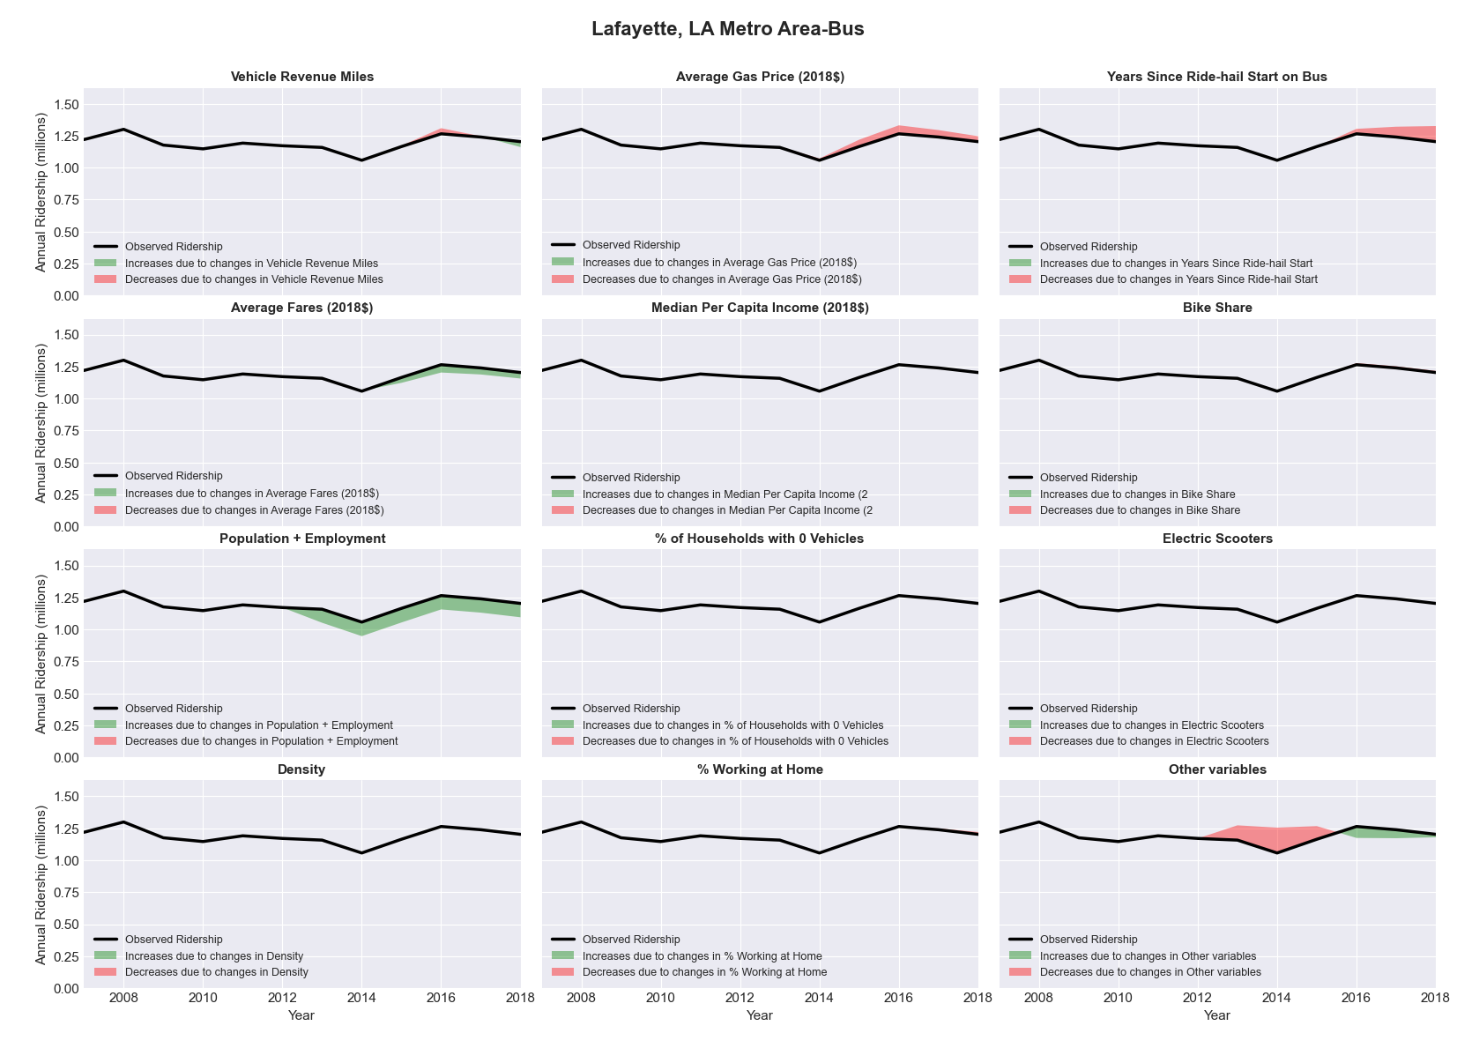

|  |  |  |  |  |  |  |
| --- | --- | --- | --- | --- | --- | --- |
| Lakeland-Winter Haven, FL Metro Area-Bus | | | | | | |
|  |  |  |  |  |  | |
|  | **Average Values** | | | **Ridership Effect** | | |
| **Description** | **2012** | **2018** | **% Diff** | **Absolute** | **% Diff** | |
|  |  |  |  |  |  | |
| **Vehicle Revenue Miles** | 951,750 | 1,462,180 | 53.6% | 246,430 | | **19.1%** | |
| **Average Fare (2018$)** | 1.15 | 2.46 | 114.6% | -322,630 | | **-25.0%** | |
| **Network Restructure** | - | - | - | - | | **0.0%** | |
| **Major Maintenance Event** | - | - | - | - | | **0.0%** | |
| **Population + Employment** | 866,610 | 993,540 | 14.6% | 38,830 | | **3.0%** | |
| **Share of Population and Employment in Transit Supportive Density** | 0.11 | 0.10 | -11.4% | -6,750 | | **-0.5%** | |
| **Average Gas Price (2018$)** | 3.95 | 2.71 | -31.3% | -61,020 | | **-4.7%** | |
| **Median Per Capita Income (2018$)** | 24,340 | 25,650 | 5.4% | -5,130 | | **-0.4%** | |
| **% of Households with 0 Vehicles** | 7 | 6 | -17.8% | -3,890 | | **-0.3%** | |
| **% Working at Home** | 3.2 | 4.5 | 41.4% | -12,130 | | **-0.9%** | |
| **Years Since Ride-hail Start** | - | 2 | 2 | -83,310 | | **-6.5%** | |
| **Bike Share** | - | - | - | - 2,930 | | **-0.2%** | |
| **Electric Scooters** | - | - | - | - | | **0.0%** | |
| **New Reporters** |  |  |  | - | | **0.0%** | |
| **Total Modeled Ridership** | 1,291,367 | 1,074,042 | -16.83% | -217324.37 | | **-16.8%** | |
| **Total Observed Ridership** | 1,152,561 | 1,144,920 | -0.66% | -7641 | | **-0.7%** | |
| **Unexplained Change** |  |  |  |  | | **16.2%** | |

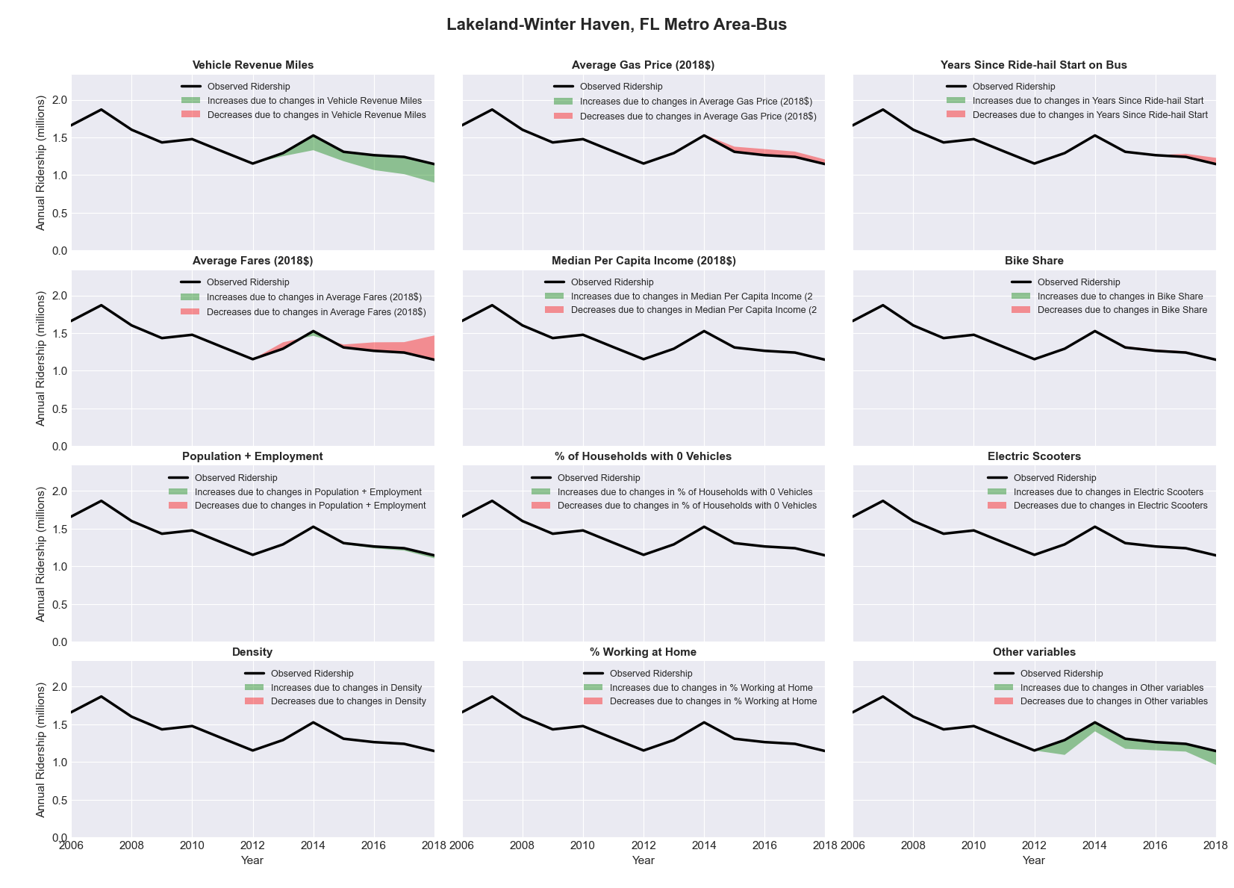

|  |  |  |  |  |  |  |
| --- | --- | --- | --- | --- | --- | --- |
| Lansing-East Lansing, MI Metro Area-Bus | | | | | | |
|  |  |  |  |  |  | |
|  | **Average Values** | | | **Ridership Effect** | | |
| **Description** | **2012** | **2018** | **% Diff** | **Absolute** | **% Diff** | |
|  |  |  |  |  |  | |
| **Vehicle Revenue Miles** | 3,157,560 | 3,392,320 | 7.4% | 341,790 | | **3.0%** | |
| **Average Fare (2018$)** | 0.67 | 0.53 | -21.0% | 519,350 | | **4.6%** | |
| **Network Restructure** | - | - | - | - | | **0.0%** | |
| **Major Maintenance Event** | - | - | - | - | | **0.0%** | |
| **Population + Employment** | 684,910 | 721,650 | 5.4% | 121,820 | | **1.1%** | |
| **Share of Population and Employment in Transit Supportive Density** | 0.25 | 0.21 | -14.8% | -160,240 | | **-1.4%** | |
| **Average Gas Price (2018$)** | 3.93 | 2.72 | -30.9% | -456,650 | | **-4.0%** | |
| **Median Per Capita Income (2018$)** | 25,040 | 29,430 | 17.5% | -123,190 | | **-1.1%** | |
| **% of Households with 0 Vehicles** | 6 | 7 | 15.1% | 21,620 | | **0.2%** | |
| **% Working at Home** | 4.5 | 4.0 | -12.2% | 50,230 | | **0.4%** | |
| **Years Since Ride-hail Start** | - | 4 | 4 | -1,380,340 | | **-12.1%** | |
| **Bike Share** | - | 1 | 1 | - 121,660 | | **-1.1%** | |
| **Electric Scooters** | - | 1 | 1 | - 379,700 | | **-3.3%** | |
| **New Reporters** |  |  |  | - | | **0.0%** | |
| **Total Modeled Ridership** | 11,408,528 | 9,800,272 | -14.10% | -1608256.01 | | **-14.1%** | |
| **Total Observed Ridership** | 11,284,550 | 10,114,311 | -10.37% | -1170239 | | **-10.4%** | |
| **Unexplained Change** |  |  |  |  | | **3.7%** | |

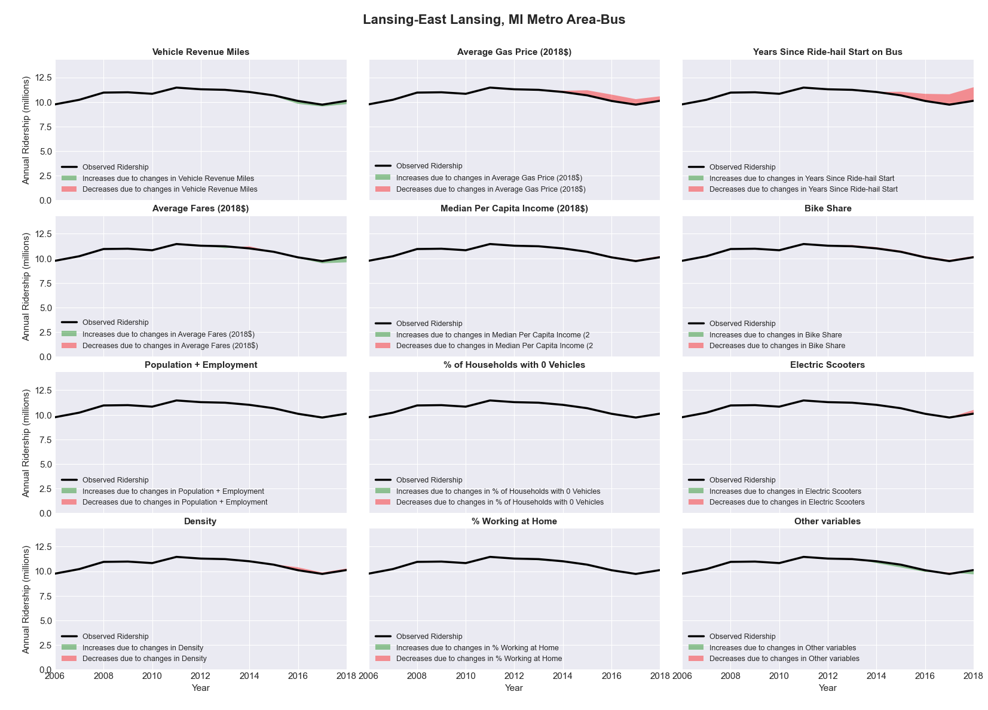

|  |  |  |  |  |  |  |
| --- | --- | --- | --- | --- | --- | --- |
| Laredo, TX Metro Area-Bus | | | | | | |
|  |  |  |  |  |  | |
|  | **Average Values** | | | **Ridership Effect** | | |
| **Description** | **2012** | **2018** | **% Diff** | **Absolute** | **% Diff** | |
|  |  |  |  |  |  | |
| **Vehicle Revenue Miles** | 1,674,330 | 1,695,130 | 1.2% | 18,140 | | **0.6%** | |
| **Average Fare (2018$)** | 1.12 | 1.16 | 3.7% | -31,890 | | **-1.0%** | |
| **Network Restructure** | - | - | - | - | | **0.0%** | |
| **Major Maintenance Event** | - | - | - | - | | **0.0%** | |
| **Population + Employment** | 361,240 | 388,870 | 7.6% | 50,120 | | **1.6%** | |
| **Share of Population and Employment in Transit Supportive Density** | 0.44 | 0.42 | -5.3% | -29,470 | | **-0.9%** | |
| **Average Gas Price (2018$)** | 3.80 | 2.58 | -32.2% | -134,790 | | **-4.3%** | |
| **Median Per Capita Income (2018$)** | 19,020 | 22,640 | 19.0% | -38,040 | | **-1.2%** | |
| **% of Households with 0 Vehicles** | 9 | 6 | -28.8% | -16,140 | | **-0.5%** | |
| **% Working at Home** | 3.4 | 2.7 | -20.6% | 18,180 | | **0.6%** | |
| **Years Since Ride-hail Start** | - | 1 | 1 | -99,090 | | **-3.2%** | |
| **Bike Share** | - | - | - | - | | **0.0%** | |
| **Electric Scooters** | - | - | - | - | | **0.0%** | |
| **New Reporters** |  |  |  | - | | **0.0%** | |
| **Total Modeled Ridership** | 3,143,819 | 2,881,597 | -8.34% | -262221.938 | | **-8.3%** | |
| **Total Observed Ridership** | 3,219,490 | 2,639,258 | -18.02% | -580232 | | **-18.0%** | |
| **Unexplained Change** |  |  |  |  | | **-9.7%** | |

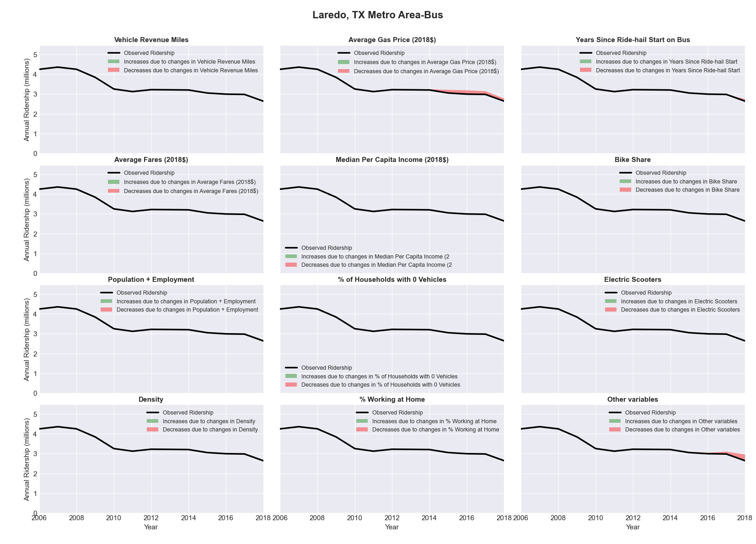

|  |  |  |  |  |  |  |
| --- | --- | --- | --- | --- | --- | --- |
| Las Vegas-Paradise, NV Metro Area-Bus | | | | | | |
|  |  |  |  |  |  | |
|  | **Average Values** | | | **Ridership Effect** | | |
| **Description** | **2012** | **2018** | **% Diff** | **Absolute** | **% Diff** | |
|  |  |  |  |  |  | |
| **Vehicle Revenue Miles** | 15,185,730 | 18,877,330 | 24.3% | 6,358,420 | | **10.1%** | |
| **Average Fare (2018$)** | 1.19 | 1.00 | -15.9% | 3,334,690 | | **5.3%** | |
| **Network Restructure** | - | - | - | - | | **0.0%** | |
| **Major Maintenance Event** | - | - | - | - | | **0.0%** | |
| **Population + Employment** | 2,887,730 | 3,301,380 | 14.3% | 1,844,140 | | **2.9%** | |
| **Share of Population and Employment in Transit Supportive Density** | 0.66 | 0.65 | -1.7% | -273,710 | | **-0.4%** | |
| **Average Gas Price (2018$)** | 4.35 | 3.40 | -21.8% | -1,732,440 | | **-2.8%** | |
| **Median Per Capita Income (2018$)** | 29,010 | 31,800 | 9.6% | -421,770 | | **-0.7%** | |
| **% of Households with 0 Vehicles** | 9 | 8 | -11.0% | -122,560 | | **-0.2%** | |
| **% Working at Home** | 2.9 | 4.6 | 59.5% | -844,540 | | **-1.3%** | |
| **Years Since Ride-hail Start** | - | 3 | 3 | -6,498,090 | | **-10.3%** | |
| **Bike Share** | - | 1 | 1 | - 721,920 | | **-1.1%** | |
| **Electric Scooters** | - | - | - | - | | **0.0%** | |
| **New Reporters** |  |  |  | - | | **0.0%** | |
| **Total Modeled Ridership** | 62,981,835 | 63,811,693 | 1.32% | 829858.594 | | **1.3%** | |
| **Total Observed Ridership** | 60,397,551 | 64,861,790 | 7.39% | 4464239 | | **7.4%** | |
| **Unexplained Change** |  |  |  |  | | **6.1%** | |

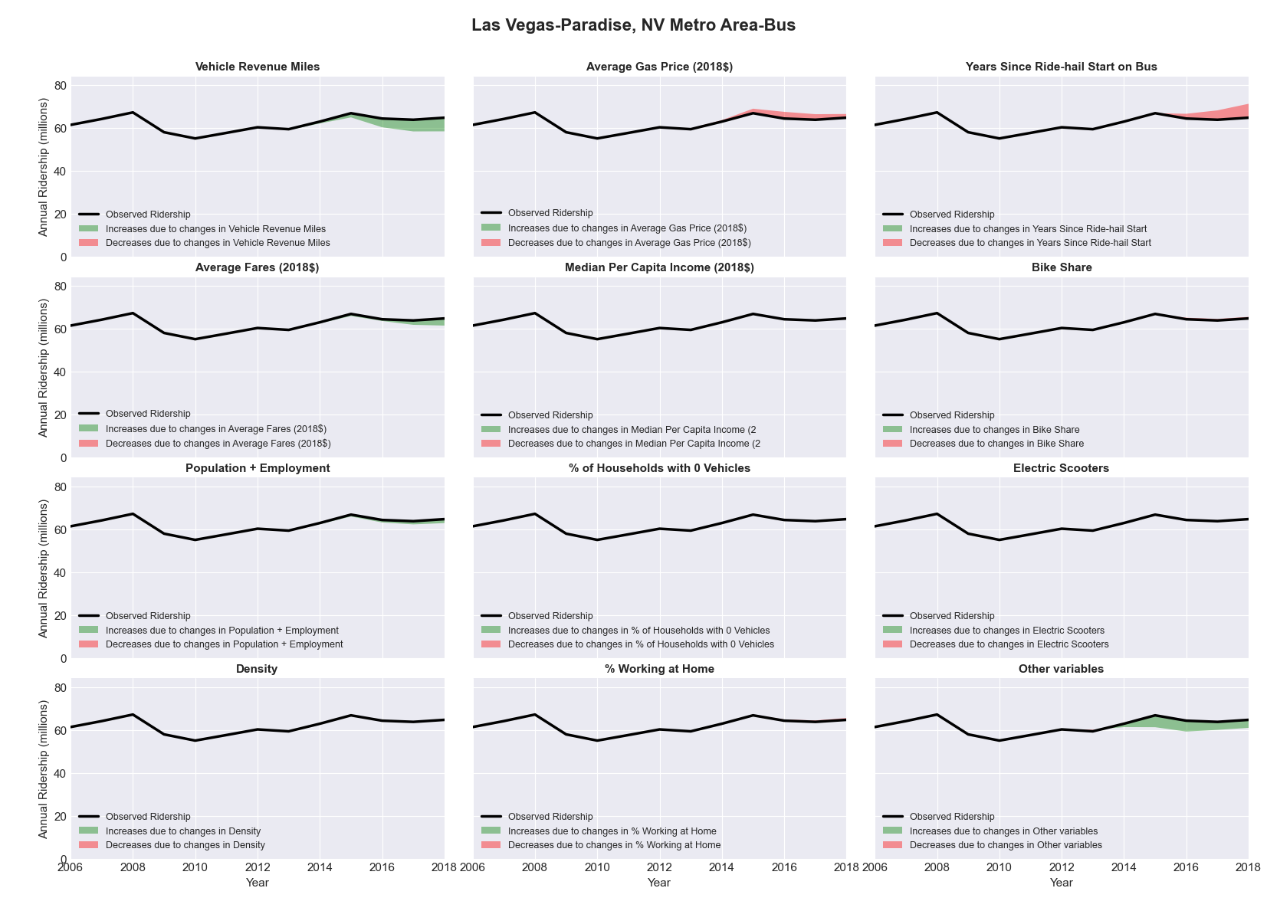

|  |  |  |  |  |  |  |
| --- | --- | --- | --- | --- | --- | --- |
| Lebanon, PA Metro Area-Bus | | | | | | |
|  |  |  |  |  |  | |
|  | **Average Values** | | | **Ridership Effect** | | |
| **Description** | **2012** | **2018** | **% Diff** | **Absolute** | **% Diff** | |
|  |  |  |  |  |  | |
| **Vehicle Revenue Miles** | 493,140 | 505,840 | 2.6% | 3,350 | | **1.0%** | |
| **Average Fare (2018$)** | 1.34 | 1.17 | -12.7% | 12,730 | | **4.0%** | |
| **Network Restructure** | - | - | - | - | | **0.0%** | |
| **Major Maintenance Event** | - | - | - | - | | **0.0%** | |
| **Population + Employment** | 201,420 | 208,430 | 3.5% | 2,370 | | **0.7%** | |
| **Share of Population and Employment in Transit Supportive Density** | 0.20 | 0.17 | -16.2% | -3,700 | | **-1.2%** | |
| **Average Gas Price (2018$)** | 4.11 | 2.92 | -28.9% | -11,930 | | **-3.7%** | |
| **Median Per Capita Income (2018$)** | 28,590 | 32,000 | 11.9% | -2,380 | | **-0.7%** | |
| **% of Households with 0 Vehicles** | 8 | 5 | -37.5% | -1,940 | | **-0.6%** | |
| **% Working at Home** | 4.1 | 5.8 | 40.9% | -3,940 | | **-1.2%** | |
| **Years Since Ride-hail Start** | - | 2 | 2 | -20,940 | | **-6.5%** | |
| **Bike Share** | - | - | - | - | | **0.0%** | |
| **Electric Scooters** | - | - | - | - | | **0.0%** | |
| **New Reporters** |  |  |  | - | | **0.0%** | |
| **Total Modeled Ridership** | 321,635 | 296,043 | -7.96% | -25591.4822 | | **-8.0%** | |
| **Total Observed Ridership** | 290,317 | 312,840 | 7.76% | 22523 | | **7.8%** | |
| **Unexplained Change** |  |  |  |  | | **15.7%** | |

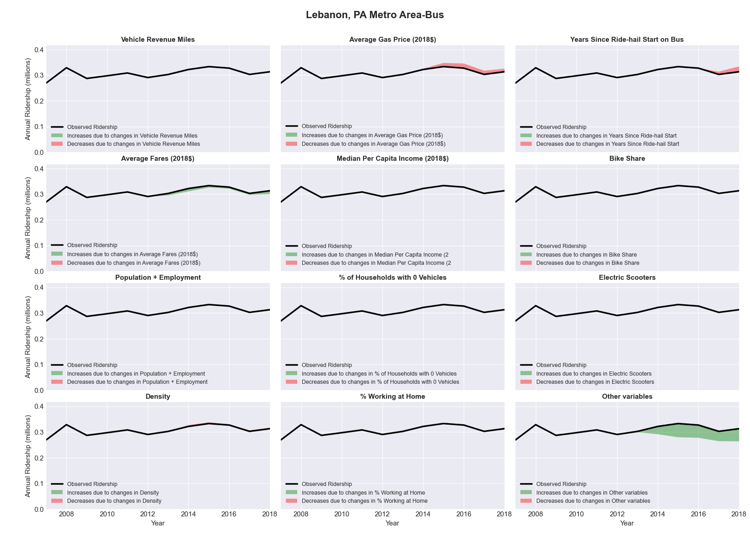

|  |  |  |  |  |  |  |
| --- | --- | --- | --- | --- | --- | --- |
| Lexington-Fayette, KY Metro Area-Bus | | | | | | |
|  |  |  |  |  |  | |
|  | **Average Values** | | | **Ridership Effect** | | |
| **Description** | **2012** | **2018** | **% Diff** | **Absolute** | **% Diff** | |
|  |  |  |  |  |  | |
| **Vehicle Revenue Miles** | 2,271,520 | 1,829,370 | -19.5% | -454,260 | | **-8.6%** | |
| **Average Fare (2018$)** | 0.56 | 0.91 | 63.3% | -495,590 | | **-9.3%** | |
| **Network Restructure** | - | - | - | - | | **0.0%** | |
| **Major Maintenance Event** | - | - | - | - | | **0.0%** | |
| **Population + Employment** | 727,370 | 782,510 | 7.6% | 67,620 | | **1.3%** | |
| **Share of Population and Employment in Transit Supportive Density** | 0.29 | 0.27 | -7.1% | -30,810 | | **-0.6%** | |
| **Average Gas Price (2018$)** | 3.93 | 2.72 | -30.9% | -176,600 | | **-3.3%** | |
| **Median Per Capita Income (2018$)** | 27,760 | 30,760 | 10.8% | -28,240 | | **-0.5%** | |
| **% of Households with 0 Vehicles** | 7 | 8 | 0.5% | -0,460 | | **-0.0%** | |
| **% Working at Home** | 3.8 | 4.9 | 28.3% | -33,320 | | **-0.6%** | |
| **Years Since Ride-hail Start** | - | 4 | 4 | -537,310 | | **-10.1%** | |
| **Bike Share** | - | 1 | 1 | - 44,820 | | **-0.8%** | |
| **Electric Scooters** | - | - | - | - | | **0.0%** | |
| **New Reporters** |  |  |  | - | | **0.0%** | |
| **Total Modeled Ridership** | 5,307,147 | 3,522,621 | -33.62% | -1784526.83 | | **-33.6%** | |
| **Total Observed Ridership** | 5,019,458 | 4,090,381 | -18.51% | -929077 | | **-18.5%** | |
| **Unexplained Change** |  |  |  |  | | **15.1%** | |

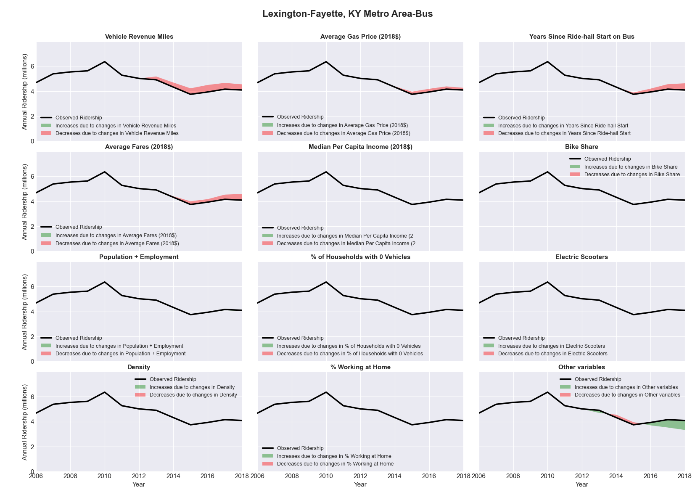

|  |  |  |  |  |  |  |
| --- | --- | --- | --- | --- | --- | --- |
| Lincoln, NE Metro Area-Bus | | | | | | |
|  |  |  |  |  |  | |
|  | **Average Values** | | | **Ridership Effect** | | |
| **Description** | **2012** | **2018** | **% Diff** | **Absolute** | **% Diff** | |
|  |  |  |  |  |  | |
| **Vehicle Revenue Miles** | 1,362,610 | 1,778,950 | 30.6% | 264,780 | | **10.5%** | |
| **Average Fare (2018$)** | 0.67 | 1.14 | 69.2% | -320,570 | | **-12.7%** | |
| **Network Restructure** | - | - | - | - | | **0.0%** | |
| **Major Maintenance Event** | - | - | - | - | | **0.0%** | |
| **Population + Employment** | 479,580 | 511,610 | 6.7% | 31,380 | | **1.2%** | |
| **Share of Population and Employment in Transit Supportive Density** | 0.37 | 0.37 | -0.1% | 0,050 | | **0.0%** | |
| **Average Gas Price (2018$)** | 3.93 | 2.72 | -30.9% | -95,540 | | **-3.8%** | |
| **Median Per Capita Income (2018$)** | 28,350 | 33,320 | 17.5% | -25,670 | | **-1.0%** | |
| **% of Households with 0 Vehicles** | 7 | 5 | -24.6% | -8,260 | | **-0.3%** | |
| **% Working at Home** | 4.0 | 4.4 | 10.6% | -8,300 | | **-0.3%** | |
| **Years Since Ride-hail Start** | - | 4 | 4 | -308,220 | | **-12.2%** | |
| **Bike Share** | - | 1 | 1 | - 25,110 | | **-1.0%** | |
| **Electric Scooters** | - | - | - | - | | **0.0%** | |
| **New Reporters** |  |  |  | - | | **0.0%** | |
| **Total Modeled Ridership** | 2,522,529 | 2,037,252 | -19.24% | -485277.019 | | **-19.2%** | |
| **Total Observed Ridership** | 2,002,943 | 2,387,496 | 19.20% | 384553 | | **19.2%** | |
| **Unexplained Change** |  |  |  |  | | **38.4%** | |

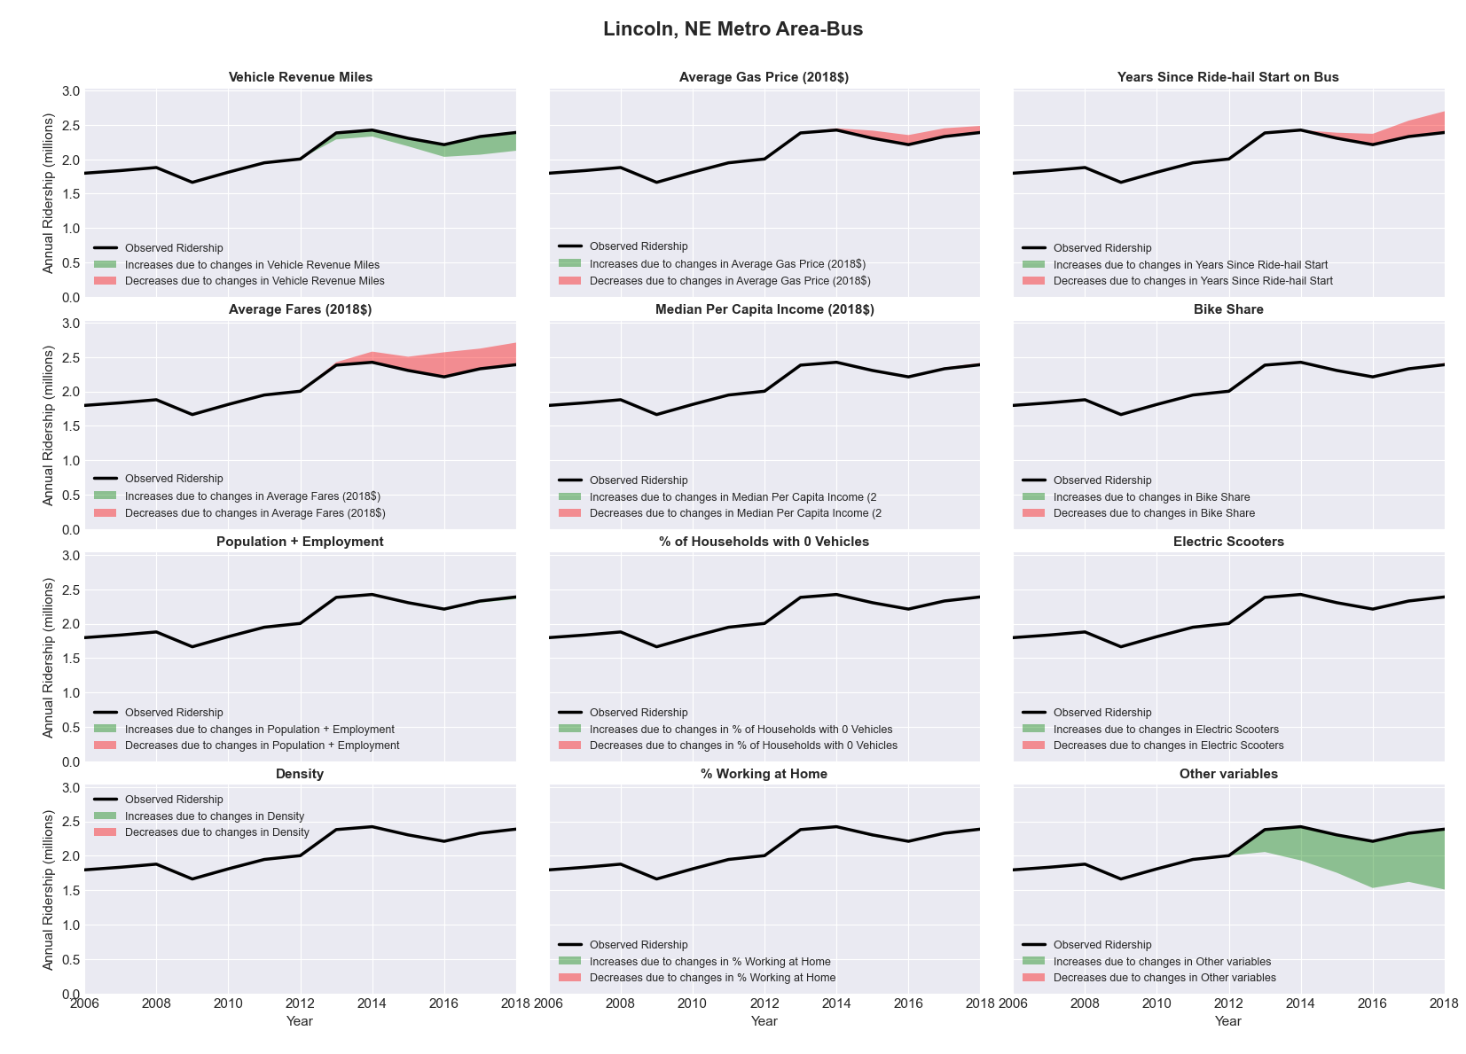

|  |  |  |  |  |  |  |
| --- | --- | --- | --- | --- | --- | --- |
| Little Rock-North Little Rock-Conway, AR Metro Area-Bus | | | | | | |
|  |  |  |  |  |  | |
|  | **Average Values** | | | **Ridership Effect** | | |
| **Description** | **2012** | **2018** | **% Diff** | **Absolute** | **% Diff** | |
|  |  |  |  |  |  | |
| **Vehicle Revenue Miles** | 2,307,900 | 2,431,010 | 5.3% | 66,950 | | **2.4%** | |
| **Average Fare (2018$)** | 0.77 | 0.77 | -0.9% | 5,460 | | **0.2%** | |
| **Network Restructure** | - | - | - | - | | **0.0%** | |
| **Major Maintenance Event** | - | - | - | - | | **0.0%** | |
| **Population + Employment** | 1,040,440 | 1,085,910 | 4.4% | 24,610 | | **0.9%** | |
| **Share of Population and Employment in Transit Supportive Density** | 0.17 | 0.16 | -2.8% | -5,080 | | **-0.2%** | |
| **Average Gas Price (2018$)** | 3.80 | 2.58 | -32.2% | -117,850 | | **-4.3%** | |
| **Median Per Capita Income (2018$)** | 28,580 | 30,190 | 5.6% | -9,070 | | **-0.3%** | |
| **% of Households with 0 Vehicles** | 7 | 5 | -19.3% | -6,660 | | **-0.2%** | |
| **% Working at Home** | 2.7 | 4.8 | 78.7% | -40,130 | | **-1.5%** | |
| **Years Since Ride-hail Start** | - | 4 | 4 | -338,500 | | **-12.4%** | |
| **Bike Share** | - | - | - | - | | **0.0%** | |
| **Electric Scooters** | - | 1 | 1 | - 92,130 | | **-3.4%** | |
| **New Reporters** |  |  |  | - | | **0.0%** | |
| **Total Modeled Ridership** | 2,739,823 | 2,227,585 | -18.70% | -512237.92 | | **-18.7%** | |
| **Total Observed Ridership** | 2,823,616 | 2,215,044 | -21.55% | -608572 | | **-21.6%** | |
| **Unexplained Change** |  |  |  |  | | **-2.9%** | |

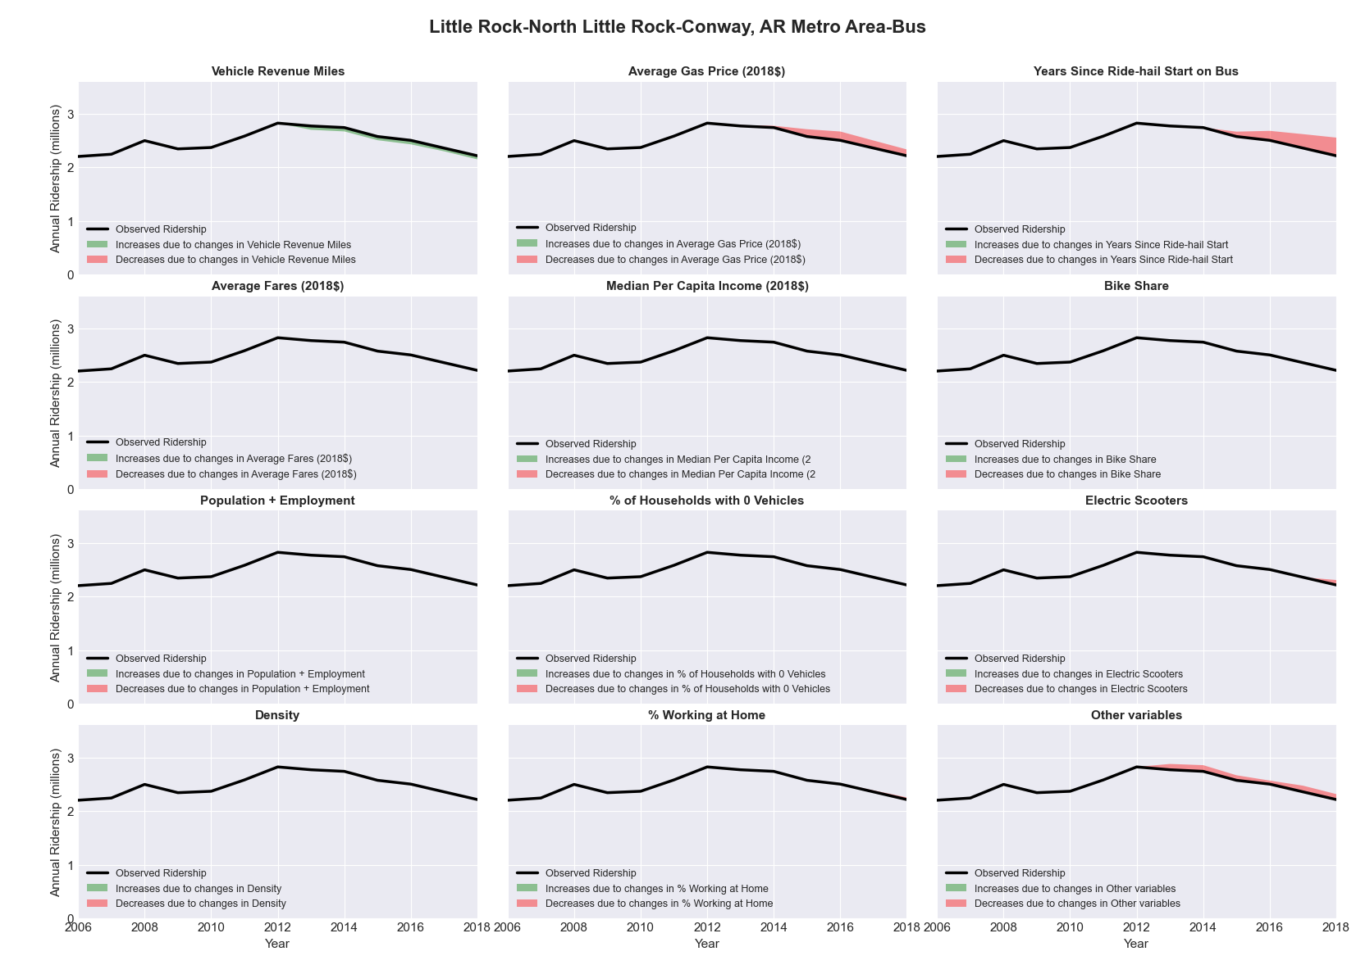

|  |  |  |  |  |  |  |
| --- | --- | --- | --- | --- | --- | --- |
| Logan, UT-ID Metro Area-Bus | | | | | | |
|  |  |  |  |  |  | |
|  | **Average Values** | | | **Ridership Effect** | | |
| **Description** | **2012** | **2018** | **% Diff** | **Absolute** | **% Diff** | |
|  |  |  |  |  |  | |
| **Vehicle Revenue Miles** | 812,880 | 819,150 | 0.8% | 4,510 | | **0.2%** | |
| **Average Fare (2018$)** | - | - | - | 0,000 | | **0.0%** | |
| **Network Restructure** | - | - | - | - | | **0.0%** | |
| **Major Maintenance Event** | - | - | - | - | | **0.0%** | |
| **Population + Employment** | 188,810 | 209,350 | 10.9% | 41,490 | | **2.2%** | |
| **Share of Population and Employment in Transit Supportive Density** | 0.20 | 0.20 | -3.2% | -5,420 | | **-0.3%** | |
| **Average Gas Price (2018$)** | 3.88 | 2.89 | -25.5% | -68,670 | | **-3.7%** | |
| **Median Per Capita Income (2018$)** | 21,220 | 22,360 | 5.4% | -8,610 | | **-0.5%** | |
| **% of Households with 0 Vehicles** | 4 | 2 | -31.6% | -3,360 | | **-0.2%** | |
| **% Working at Home** | 4.4 | 2.7 | -38.6% | 17,960 | | **1.0%** | |
| **Years Since Ride-hail Start** | - | 1 | 1 | -52,050 | | **-2.8%** | |
| **Bike Share** | - | - | - | - | | **0.0%** | |
| **Electric Scooters** | - | - | - | - | | **0.0%** | |
| **New Reporters** |  |  |  | - | | **0.0%** | |
| **Total Modeled Ridership** | 1,845,069 | 1,779,816 | -3.54% | -65252.8672 | | **-3.5%** | |
| **Total Observed Ridership** | 2,101,697 | 1,507,093 | -28.29% | -594604 | | **-28.3%** | |
| **Unexplained Change** |  |  |  |  | | **-24.8%** | |

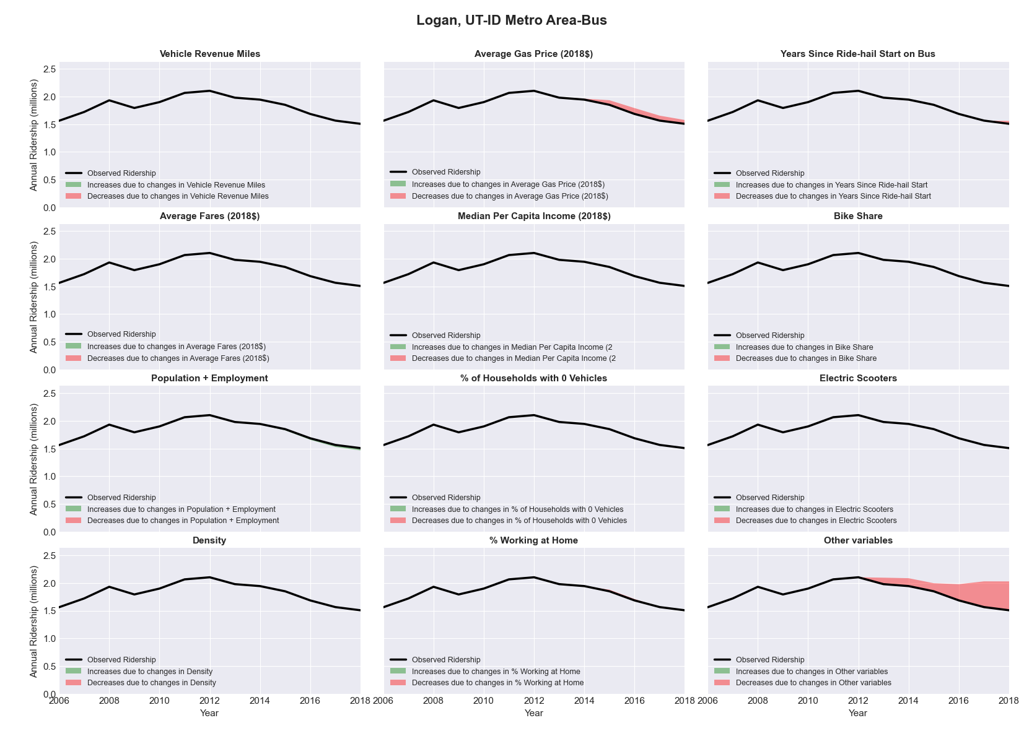

|  |  |  |  |  |  |  |
| --- | --- | --- | --- | --- | --- | --- |
| Los Angeles-Long Beach-Santa Ana, CA Metro Area-Bus | | | | | | |
|  |  |  |  |  |  | |
|  | **Average Values** | | | **Ridership Effect** | | |
| **Description** | **2012** | **2018** | **% Diff** | **Absolute** | **% Diff** | |
|  |  |  |  |  |  | |
| **Vehicle Revenue Miles** | 127,409,770 | 128,129,790 | 0.6% | 1,835,070 | | **0.4%** | |
| **Average Fare (2018$)** | 0.84 | 0.79 | -5.7% | 5,080,920 | | **1.1%** | |
| **Network Restructure** | - | - | - | - | | **0.0%** | |
| **Major Maintenance Event** | - | - | - | - | | **0.0%** | |
| **Population + Employment** | 18,870,580 | 19,865,660 | 5.3% | 5,229,020 | | **1.1%** | |
| **Share of Population and Employment in Transit Supportive Density** | 0.86 | 0.86 | 0.1% | 238,560 | | **0.0%** | |
| **Average Gas Price (2018$)** | 4.35 | 3.40 | -21.8% | -14,703,070 | | **-3.1%** | |
| **Median Per Capita Income (2018$)** | 27,390 | 32,190 | 17.5% | -4,926,660 | | **-1.0%** | |
| **% of Households with 0 Vehicles** | 9 | 8 | -12.7% | -1,043,430 | | **-0.2%** | |
| **% Working at Home** | 5.1 | 5.9 | 15.2% | -2,596,810 | | **-0.5%** | |
| **Years Since Ride-hail Start** | - | 6 | 6 | -52,275,020 | | **-10.9%** | |
| **Bike Share** | - | 1 | 1 | - 4,890,260 | | **-1.0%** | |
| **Electric Scooters** | - | - | - | - | | **0.0%** | |
| **New Reporters** |  |  |  | - | | **0.0%** | |
| **Total Modeled Ridership** | 478,143,128 | 413,412,973 | -13.54% | -6473014.5 | | **-13.5%** | |
| **Total Observed Ridership** | 492,655,252 | 375,175,754 | -23.85% | -11747998 | | **-23.8%** | |
| **Unexplained Change** |  |  |  |  | | **-10.3%** | |

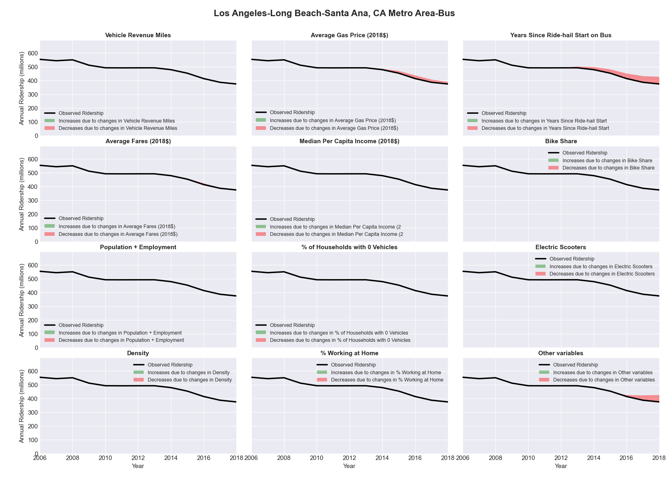

|  |  |  |  |  |  |  |
| --- | --- | --- | --- | --- | --- | --- |
| Los Angeles-Long Beach-Santa Ana, CA Metro Area-Rail | | | | | | |
|  |  |  |  |  |  | |
|  | **Average Values** | | | **Ridership Effect** | | |
| **Description** | **2012** | **2018** | **% Diff** | **Absolute** | **% Diff** | |
|  |  |  |  |  |  | |
| **Vehicle Revenue Miles** | 29,946,800 | 37,083,330 | 23.8% | 17,024,750 | | **14.9%** | |
| **Average Fare (2018$)** | 1.34 | 1.44 | 7.5% | -1,757,930 | | **-1.5%** | |
| **Network Restructure** | - | - | - | - | | **0.0%** | |
| **Major Maintenance Event** | - | - | - | - | | **0.0%** | |
| **Population + Employment** | 18,870,580 | 19,865,660 | 5.3% | 1,335,660 | | **1.2%** | |
| **Share of Population and Employment in Transit Supportive Density** | 0.86 | 0.86 | 0.1% | 56,570 | | **0.0%** | |
| **Average Gas Price (2018$)** | 4.35 | 3.40 | -21.8% | -3,213,290 | | **-2.8%** | |
| **Median Per Capita Income (2018$)** | 27,390 | 32,190 | 17.5% | -1,365,980 | | **-1.2%** | |
| **% of Households with 0 Vehicles** | 9 | 8 | -12.7% | -266,320 | | **-0.2%** | |
| **% Working at Home** | 5.1 | 5.9 | 15.2% | -706,670 | | **-0.6%** | |
| **Years Since Ride-hail Start** | - | 6 | 6 | 1,555,730 | | **1.4%** | |
| **Bike Share** | - | 1 | 1 | - 1,239,100 | | **-1.1%** | |
| **Electric Scooters** | - | - | - | - | | **0.0%** | |
| **New Reporters** |  |  |  | - | | **0.0%** | |
| **Total Modeled Ridership** | 114,063,665 | 125,218,949 | 9.78% | 11155283.4 | | **9.8%** | |
| **Total Observed Ridership** | 116,962,928 | 114,537,927 | -2.07% | -2425001 | | **-2.1%** | |
| **Unexplained Change** |  |  |  |  | | **-11.9%** | |

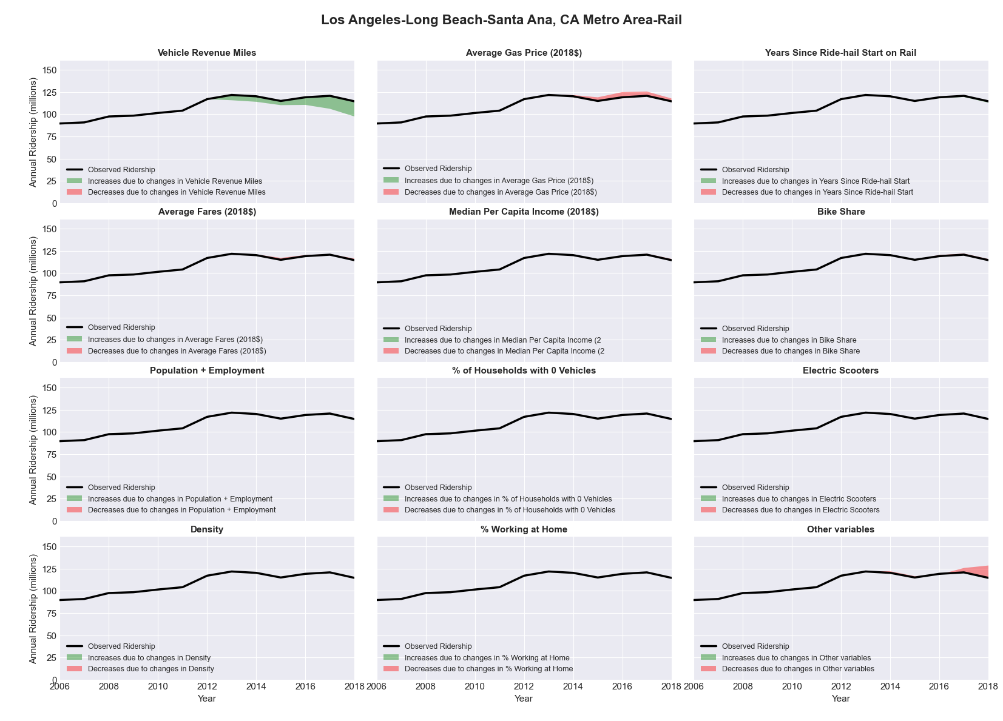

|  |  |  |  |  |  |  |
| --- | --- | --- | --- | --- | --- | --- |
| Louisville/Jefferson County, KY-IN Metro Area-Bus | | | | | | |
|  |  |  |  |  |  | |
|  | **Average Values** | | | **Ridership Effect** | | |
| **Description** | **2012** | **2018** | **% Diff** | **Absolute** | **% Diff** | |
|  |  |  |  |  |  | |
| **Vehicle Revenue Miles** | 7,140,180 | 7,079,300 | -0.9% | -87,070 | | **-0.5%** | |
| **Average Fare (2018$)** | 0.67 | 0.91 | 36.0% | -1,200,340 | | **-7.5%** | |
| **Network Restructure** | - | - | - | - | | **0.0%** | |
| **Major Maintenance Event** | - | - | - | - | | **0.0%** | |
| **Population + Employment** | 1,905,800 | 1,967,840 | 3.3% | 83,070 | | **0.5%** | |
| **Share of Population and Employment in Transit Supportive Density** | 0.26 | 0.26 | -1.8% | -26,690 | | **-0.2%** | |
| **Average Gas Price (2018$)** | 3.93 | 2.72 | -30.9% | -616,480 | | **-3.8%** | |
| **Median Per Capita Income (2018$)** | 27,930 | 32,190 | 15.3% | -141,100 | | **-0.9%** | |
| **% of Households with 0 Vehicles** | 8 | 8 | 1.0% | -0,250 | | **-0.0%** | |
| **% Working at Home** | 3.2 | 5.5 | 70.3% | -224,680 | | **-1.4%** | |
| **Years Since Ride-hail Start** | - | 4 | 4 | -1,770,470 | | **-11.0%** | |
| **Bike Share** | - | 1 | 1 | - 138,490 | | **-0.9%** | |
| **Electric Scooters** | - | 1 | 1 | - 471,830 | | **-2.9%** | |
| **New Reporters** |  |  |  | - | | **0.0%** | |
| **Total Modeled Ridership** | 16,039,998 | 11,522,865 | -28.16% | -4517132.76 | | **-28.2%** | |
| **Total Observed Ridership** | 16,469,664 | 11,553,148 | -29.85% | -4916516 | | **-29.9%** | |
| **Unexplained Change** |  |  |  |  | | **-1.7%** | |

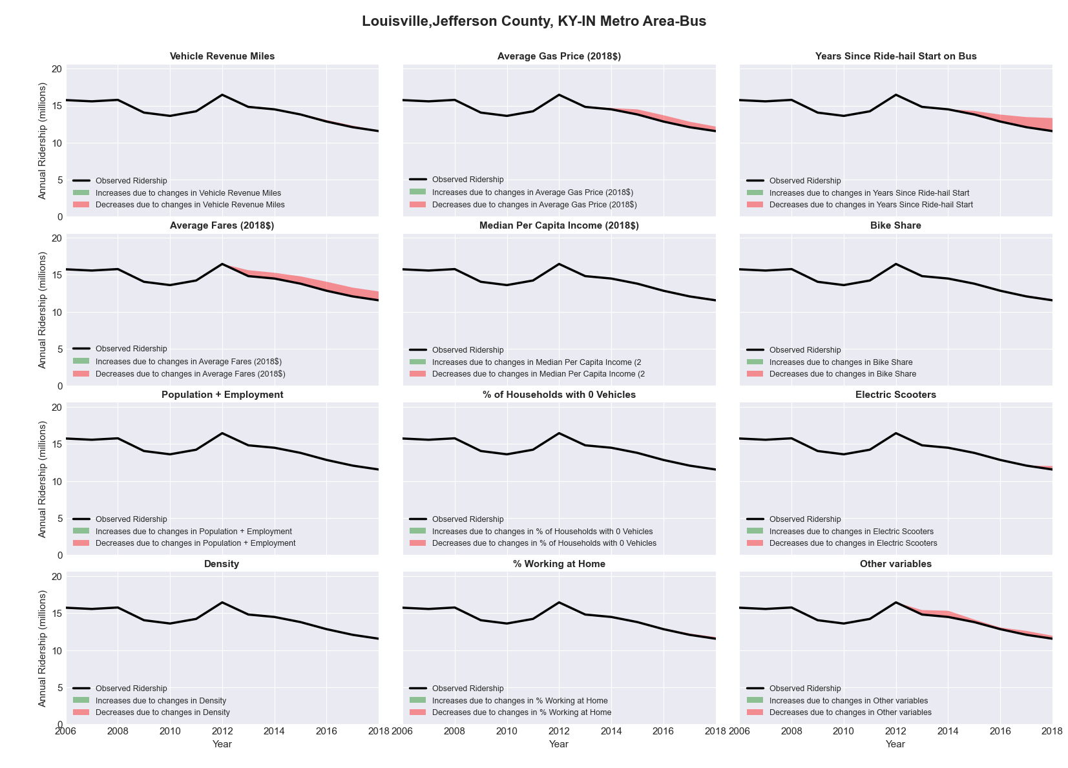

|  |  |  |  |  |  |  |
| --- | --- | --- | --- | --- | --- | --- |
| Lubbock, TX Metro Area-Bus | | | | | | |
|  |  |  |  |  |  | |
|  | **Average Values** | | | **Ridership Effect** | | |
| **Description** | **2012** | **2018** | **% Diff** | **Absolute** | **% Diff** | |
|  |  |  |  |  |  | |
| **Vehicle Revenue Miles** | 1,747,930 | 1,889,720 | 8.1% | 130,850 | | **3.2%** | |
| **Average Fare (2018$)** | 1.13 | 1.17 | 3.2% | -39,810 | | **-1.0%** | |
| **Network Restructure** | - | - | - | - | | **0.0%** | |
| **Major Maintenance Event** | - | - | - | - | | **0.0%** | |
| **Population + Employment** | 432,090 | 478,280 | 10.7% | 83,300 | | **2.1%** | |
| **Share of Population and Employment in Transit Supportive Density** | 0.37 | 0.35 | -5.2% | -29,790 | | **-0.7%** | |
| **Average Gas Price (2018$)** | 3.80 | 2.58 | -32.2% | -165,340 | | **-4.1%** | |
| **Median Per Capita Income (2018$)** | 22,630 | 24,230 | 7.1% | -18,440 | | **-0.5%** | |
| **% of Households with 0 Vehicles** | 6 | 6 | -5.5% | -2,390 | | **-0.1%** | |
| **% Working at Home** | 3.0 | 3.3 | 8.3% | -5,860 | | **-0.1%** | |
| **Years Since Ride-hail Start** | - | 4 | 4 | -497,630 | | **-12.3%** | |
| **Bike Share** | - | - | - | - | | **0.0%** | |
| **Electric Scooters** | - | 1 | 1 | - 137,930 | | **-3.4%** | |
| **New Reporters** |  |  |  | - | | **0.0%** | |
| **Total Modeled Ridership** | 4,050,936 | 3,367,194 | -16.88% | -683742.274 | | **-16.9%** | |
| **Total Observed Ridership** | 3,744,006 | 3,675,939 | -1.82% | -68067 | | **-1.8%** | |
| **Unexplained Change** |  |  |  |  | | **15.1%** | |

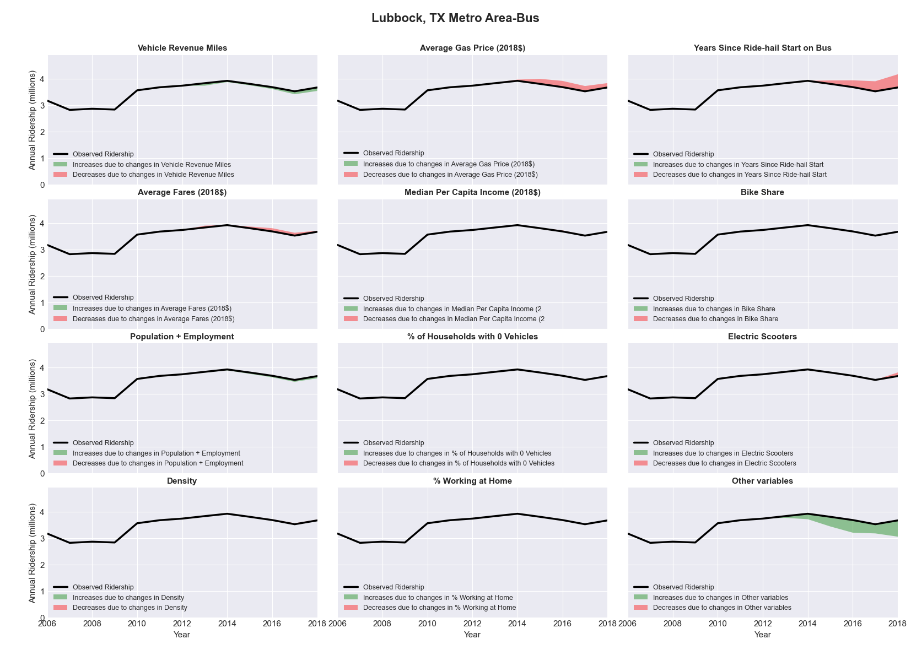

|  |  |  |  |  |  |  |
| --- | --- | --- | --- | --- | --- | --- |
| Lynchburg, VA Metro Area-Bus | | | | | | |
|  |  |  |  |  |  | |
|  | **Average Values** | | | **Ridership Effect** | | |
| **Description** | **2012** | **2018** | **% Diff** | **Absolute** | **% Diff** | |
|  |  |  |  |  |  | |
| **Vehicle Revenue Miles** | 1,036,550 | 1,008,590 | -2.7% | 1,830 | | **0.1%** | |
| **Average Fare (2018$)** | 0.48 | 1.89 | 295.3% | -819,550 | | **-28.8%** | |
| **Network Restructure** | - | - | - | - | | **0.0%** | |
| **Major Maintenance Event** | - | - | - | - | | **0.0%** | |
| **Population + Employment** | 372,920 | 379,020 | 1.6% | 8,710 | | **0.3%** | |
| **Share of Population and Employment in Transit Supportive Density** | 0.04 | 0.04 | -3.2% | -0,910 | | **-0.0%** | |
| **Average Gas Price (2018$)** | 3.95 | 2.71 | -31.3% | -113,200 | | **-4.0%** | |
| **Median Per Capita Income (2018$)** | 25,130 | 27,000 | 7.4% | -12,770 | | **-0.4%** | |
| **% of Households with 0 Vehicles** | 8 | 5 | -38.2% | -13,520 | | **-0.5%** | |
| **% Working at Home** | 3.3 | 5.4 | 62.9% | -36,760 | | **-1.3%** | |
| **Years Since Ride-hail Start** | - | 3 | 3 | -225,370 | | **-7.9%** | |
| **Bike Share** | - | - | - | - | | **0.0%** | |
| **Electric Scooters** | - | - | - | - | | **0.0%** | |
| **New Reporters** |  |  |  | - | | **0.0%** | |
| **Total Modeled Ridership** | 2,846,756 | 1,614,065 | -43.30% | -1232690.67 | | **-43.3%** | |
| **Total Observed Ridership** | 2,330,451 | 2,151,558 | -7.68% | -178893 | | **-7.7%** | |
| **Unexplained Change** |  |  |  |  | | **35.6%** | |

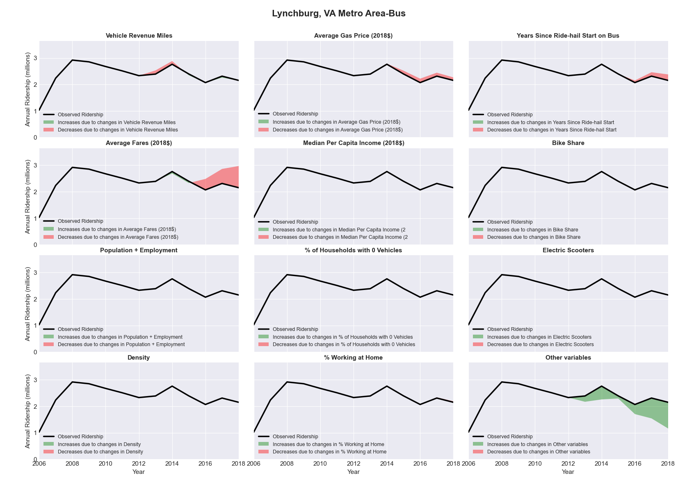

|  |  |  |  |  |  |  |
| --- | --- | --- | --- | --- | --- | --- |
| Madison, WI Metro Area-Bus | | | | | | |
|  |  |  |  |  |  | |
|  | **Average Values** | | | **Ridership Effect** | | |
| **Description** | **2012** | **2018** | **% Diff** | **Absolute** | **% Diff** | |
|  |  |  |  |  |  | |
| **Vehicle Revenue Miles** | 4,822,860 | 5,032,180 | 4.3% | 288,330 | | **1.9%** | |
| **Average Fare (2018$)** | 0.91 | 0.97 | 6.2% | -268,570 | | **-1.8%** | |
| **Network Restructure** | - | - | - | - | | **0.0%** | |
| **Major Maintenance Event** | - | - | - | - | | **0.0%** | |
| **Population + Employment** | 908,510 | 1,023,550 | 12.7% | 375,120 | | **2.5%** | |
| **Share of Population and Employment in Transit Supportive Density** | 0.25 | 0.25 | -2.5% | -36,750 | | **-0.2%** | |
| **Average Gas Price (2018$)** | 3.93 | 2.72 | -30.9% | -629,310 | | **-4.2%** | |
| **Median Per Capita Income (2018$)** | 33,390 | 38,810 | 16.2% | -149,210 | | **-1.0%** | |
| **% of Households with 0 Vehicles** | 8 | 7 | -4.1% | -10,770 | | **-0.1%** | |
| **% Working at Home** | 4.0 | 5.5 | 37.5% | -163,030 | | **-1.1%** | |
| **Years Since Ride-hail Start** | - | 4 | 4 | -1,852,950 | | **-12.3%** | |
| **Bike Share** | 1.00 | 1 | - | - | | **0.0%** | |
| **Electric Scooters** | - | - | - | - | | **0.0%** | |
| **New Reporters** |  |  |  | - | | **0.0%** | |
| **Total Modeled Ridership** | 15,065,906 | 12,673,360 | -15.88% | -2392545.68 | | **-15.9%** | |
| **Total Observed Ridership** | 14,594,687 | 13,230,698 | -9.35% | -1363989 | | **-9.3%** | |
| **Unexplained Change** |  |  |  |  | | **6.5%** | |

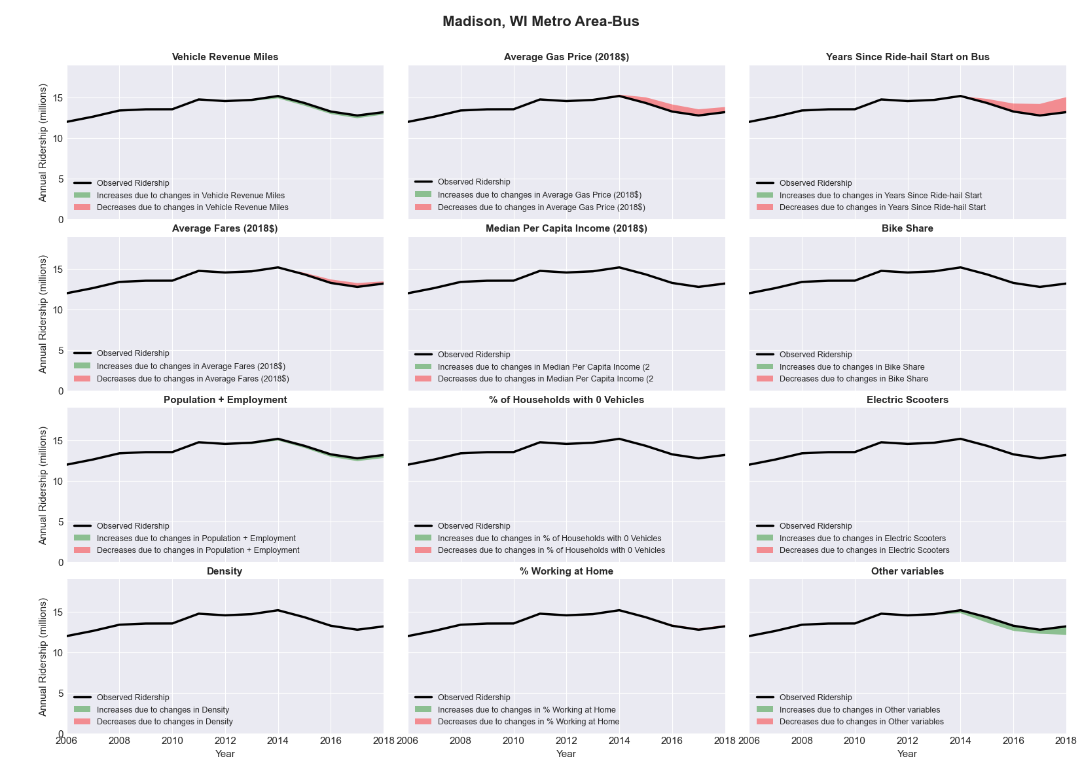

|  |  |  |  |  |  |  |
| --- | --- | --- | --- | --- | --- | --- |
| Medford, OR Metro Area-Bus | | | | | | |
|  |  |  |  |  |  | |
|  | **Average Values** | | | **Ridership Effect** | | |
| **Description** | **2012** | **2018** | **% Diff** | **Absolute** | **% Diff** | |
|  |  |  |  |  |  | |
| **Vehicle Revenue Miles** | 782,390 | 974,460 | 24.5% | 99,170 | | **7.4%** | |
| **Average Fare (2018$)** | 0.84 | 0.87 | 3.5% | -20,870 | | **-1.6%** | |
| **Network Restructure** | - | - | - | - | | **0.0%** | |
| **Major Maintenance Event** | - | - | - | - | | **0.0%** | |
| **Population + Employment** | 293,870 | 319,750 | 8.8% | 22,730 | | **1.7%** | |
| **Share of Population and Employment in Transit Supportive Density** | 0.29 | 0.28 | -1.1% | -1,450 | | **-0.1%** | |
| **Average Gas Price (2018$)** | 4.35 | 3.40 | -21.8% | -40,540 | | **-3.0%** | |
| **Median Per Capita Income (2018$)** | 23,270 | 29,110 | 25.1% | -19,240 | | **-1.4%** | |
| **% of Households with 0 Vehicles** | 6 | 6 | 8.0% | 2,270 | | **0.2%** | |
| **% Working at Home** | 7.4 | 11.0 | 48.3% | -32,980 | | **-2.5%** | |
| **Years Since Ride-hail Start** | - | 1 | 1 | -38,060 | | **-2.8%** | |
| **Bike Share** | - | 1 | 1 | - 15,150 | | **-1.1%** | |
| **Electric Scooters** | - | - | - | - | | **0.0%** | |
| **New Reporters** |  |  |  | - | | **0.0%** | |
| **Total Modeled Ridership** | 1,337,943 | 1,326,893 | -0.83% | -11049.7463 | | **-0.8%** | |
| **Total Observed Ridership** | 1,356,160 | 1,173,842 | -13.44% | -182318 | | **-13.4%** | |
| **Unexplained Change** |  |  |  |  | | **-12.6%** | |

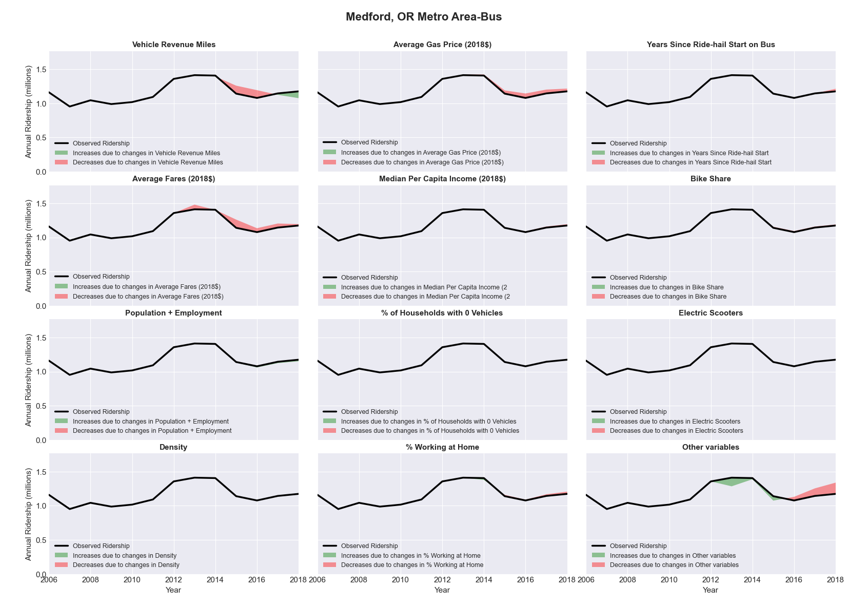

|  |  |  |  |  |  |  |
| --- | --- | --- | --- | --- | --- | --- |
| Memphis, TN-MS-AR Metro Area-Bus | | | | | | |
|  |  |  |  |  |  | |
|  | **Average Values** | | | **Ridership Effect** | | |
| **Description** | **2012** | **2018** | **% Diff** | **Absolute** | **% Diff** | |
|  |  |  |  |  |  | |
| **Vehicle Revenue Miles** | 5,657,310 | 5,103,640 | -9.8% | -369,190 | | **-4.5%** | |
| **Average Fare (2018$)** | 1.14 | 0.99 | -13.1% | 329,060 | | **4.0%** | |
| **Network Restructure** | - | - | - | - | | **0.0%** | |
| **Major Maintenance Event** | - | - | - | - | | **0.0%** | |
| **Population + Employment** | 1,910,730 | 1,958,710 | 2.5% | 39,500 | | **0.5%** | |
| **Share of Population and Employment in Transit Supportive Density** | 0.21 | 0.19 | -6.6% | -44,180 | | **-0.5%** | |
| **Average Gas Price (2018$)** | 3.80 | 2.58 | -32.2% | -349,630 | | **-4.2%** | |
| **Median Per Capita Income (2018$)** | 26,860 | 28,350 | 5.5% | -28,150 | | **-0.3%** | |
| **% of Households with 0 Vehicles** | 8 | 7 | -22.5% | -27,330 | | **-0.3%** | |
| **% Working at Home** | 3.0 | 3.9 | 30.0% | -49,310 | | **-0.6%** | |
| **Years Since Ride-hail Start** | - | 4 | 4 | -983,730 | | **-11.9%** | |
| **Bike Share** | - | 1 | 1 | - 72,060 | | **-0.9%** | |
| **Electric Scooters** | - | 1 | 1 | - 261,080 | | **-3.1%** | |
| **New Reporters** |  |  |  | - | | **0.0%** | |
| **Total Modeled Ridership** | 8,290,073 | 6,475,392 | -21.89% | -1814681.34 | | **-21.9%** | |
| **Total Observed Ridership** | 8,523,158 | 6,051,607 | -29.00% | -2471551 | | **-29.0%** | |
| **Unexplained Change** |  |  |  |  | | **-7.1%** | |

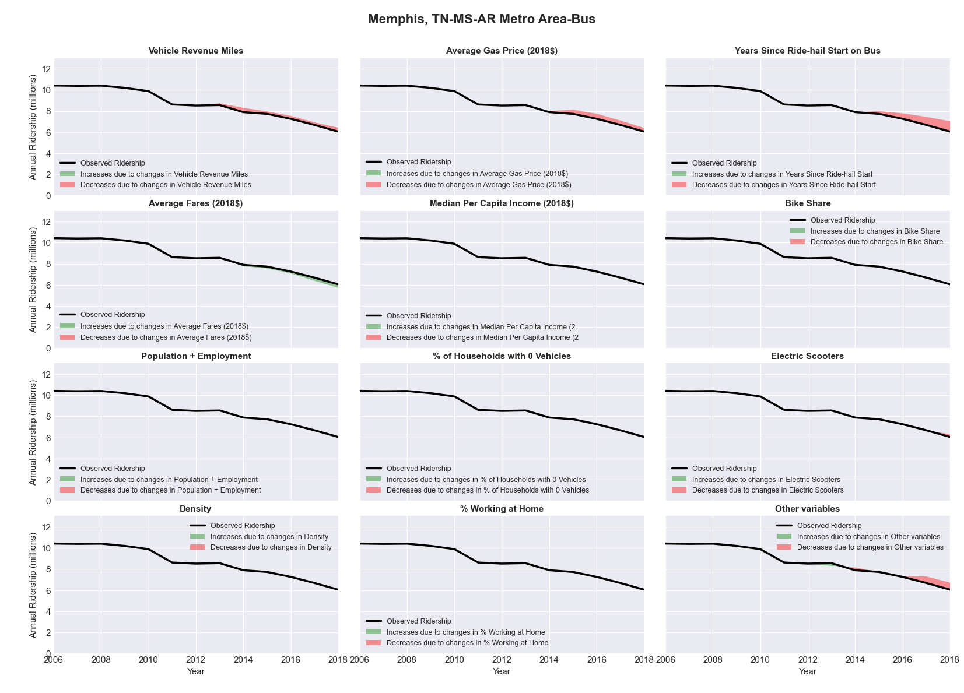

|  |  |  |  |  |  |  |
| --- | --- | --- | --- | --- | --- | --- |
| Merced, CA Metro Area-Bus | | | | | | |
|  |  |  |  |  |  | |
|  | **Average Values** | | | **Ridership Effect** | | |
| **Description** | **2012** | **2018** | **% Diff** | **Absolute** | **% Diff** | |
|  |  |  |  |  |  | |
| **Vehicle Revenue Miles** | 1,304,200 | 1,806,510 | 38.5% | 130,640 | | **16.4%** | |
| **Average Fare (2018$)** | 1.40 | 1.55 | 10.3% | -18,200 | | **-2.3%** | |
| **Network Restructure** | - | - | - | - | | **0.0%** | |
| **Major Maintenance Event** | - | - | - | - | | **0.0%** | |
| **Population + Employment** | 358,540 | 383,510 | 7.0% | 12,510 | | **1.6%** | |
| **Share of Population and Employment in Transit Supportive Density** | 0.19 | 0.17 | -8.2% | -5,150 | | **-0.6%** | |
| **Average Gas Price (2018$)** | 4.35 | 3.40 | -21.8% | -24,760 | | **-3.1%** | |
| **Median Per Capita Income (2018$)** | 22,650 | 24,450 | 7.9% | -4,560 | | **-0.6%** | |
| **% of Households with 0 Vehicles** | 7 | 5 | -29.1% | -3,560 | | **-0.4%** | |
| **% Working at Home** | 3.8 | 4.2 | 10.5% | -2,600 | | **-0.3%** | |
| **Years Since Ride-hail Start** | - | 2 | 2 | -56,380 | | **-7.1%** | |
| **Bike Share** | - | - | - | - | | **0.0%** | |
| **Electric Scooters** | - | - | - | - | | **0.0%** | |
| **New Reporters** |  |  |  | - | | **0.0%** | |
| **Total Modeled Ridership** | 794,699 | 805,027 | 1.30% | 10327.8082 | | **1.3%** | |
| **Total Observed Ridership** | 854,831 | 931,889 | 9.01% | 77058 | | **9.0%** | |
| **Unexplained Change** |  |  |  |  | | **7.7%** | |

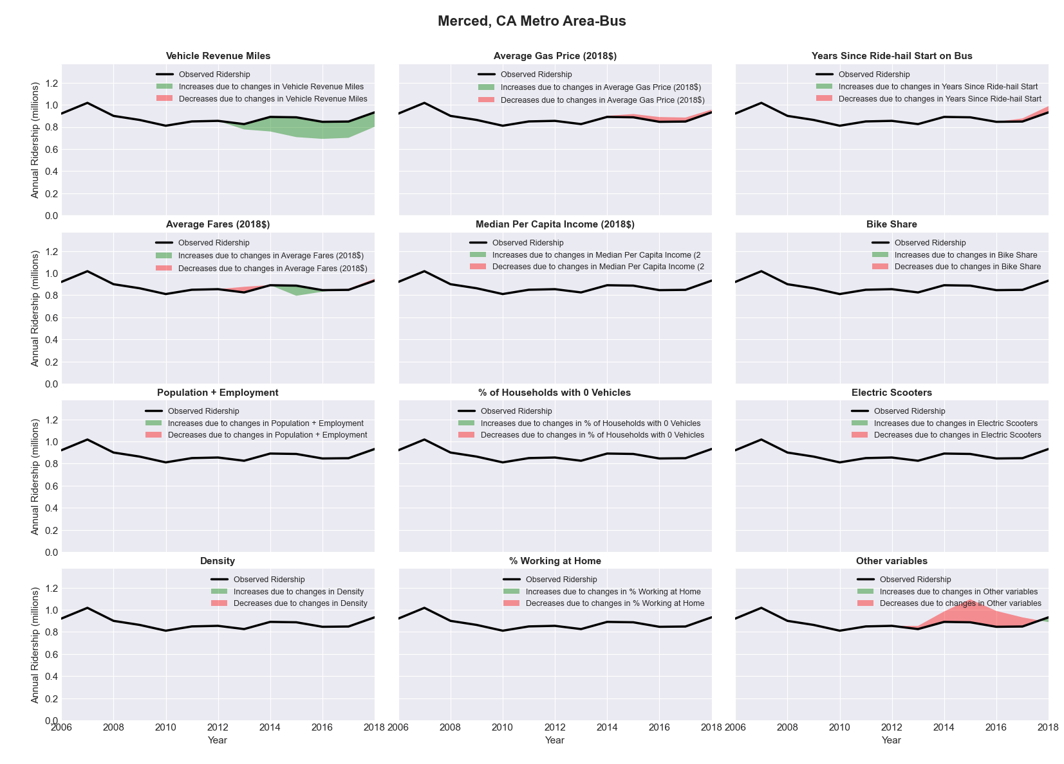

|  |  |  |  |  |  |  |
| --- | --- | --- | --- | --- | --- | --- |
| Miami-Fort Lauderdale-Pompano Beach, FL Metro Area-Bus | | | | | | |
|  |  |  |  |  |  | |
|  | **Average Values** | | | **Ridership Effect** | | |
| **Description** | **2012** | **2018** | **% Diff** | **Absolute** | **% Diff** | |
|  |  |  |  |  |  | |
| **Vehicle Revenue Miles** | 49,778,410 | 48,777,740 | -2.0% | -364,590 | | **-0.3%** | |
| **Average Fare (2018$)** | 1.07 | 1.16 | 8.0% | -3,578,430 | | **-2.9%** | |
| **Network Restructure** | - | - | - | - | | **0.0%** | |
| **Major Maintenance Event** | - | - | - | - | | **0.0%** | |
| **Population + Employment** | 8,430,430 | 9,275,700 | 10.0% | 2,430,460 | | **2.0%** | |
| **Share of Population and Employment in Transit Supportive Density** | 0.64 | 0.63 | -1.4% | -446,570 | | **-0.4%** | |
| **Average Gas Price (2018$)** | 3.95 | 2.71 | -31.3% | -5,442,930 | | **-4.5%** | |
| **Median Per Capita Income (2018$)** | 25,020 | 26,980 | 7.8% | -650,140 | | **-0.5%** | |
| **% of Households with 0 Vehicles** | 9 | 8 | -15.7% | -334,830 | | **-0.3%** | |
| **% Working at Home** | 5.0 | 6.3 | 25.0% | -1,038,400 | | **-0.9%** | |
| **Years Since Ride-hail Start** | - | 4 | 4 | -8,490,510 | | **-7.0%** | |
| **Bike Share** | - | 1 | 1 | - 1,383,490 | | **-1.1%** | |
| **Electric Scooters** | - | 1 | 1 | - 3,677,830 | | **-3.0%** | |
| **New Reporters** |  |  |  | - | | **0.0%** | |
| **Total Modeled Ridership** | 121,437,593 | 99,168,229 | -18.34% | -22269363.8 | | **-18.3%** | |
| **Total Observed Ridership** | 128,204,683 | 87,496,634 | -31.75% | -40708049 | | **-31.8%** | |
| **Unexplained Change** |  |  |  |  | | **-13.4%** | |

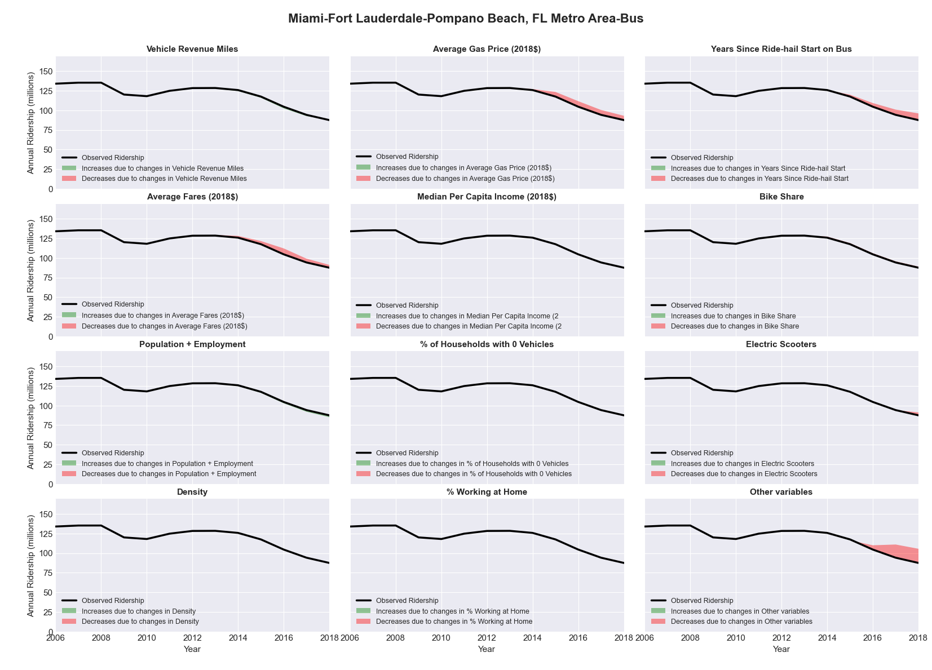

|  |  |  |  |  |  |  |
| --- | --- | --- | --- | --- | --- | --- |
| Miami-Fort Lauderdale-Pompano Beach, FL Metro Area-Rail | | | | | | |
|  |  |  |  |  |  | |
|  | **Average Values** | | | **Ridership Effect** | | |
| **Description** | **2012** | **2018** | **% Diff** | **Absolute** | **% Diff** | |
|  |  |  |  |  |  | |
| **Vehicle Revenue Miles** | 11,155,830 | 12,513,960 | 12.2% | 2,564,960 | | **7.8%** | |
| **Average Fare (2018$)** | 1.11 | 0.72 | -34.6% | 2,440,070 | | **7.5%** | |
| **Network Restructure** | - | - | - | - | | **0.0%** | |
| **Major Maintenance Event** | - | - | - | - | | **0.0%** | |
| **Population + Employment** | 8,430,430 | 9,275,700 | 10.0% | 726,330 | | **2.2%** | |
| **Share of Population and Employment in Transit Supportive Density** | 0.64 | 0.63 | -1.4% | -122,870 | | **-0.4%** | |
| **Average Gas Price (2018$)** | 3.95 | 2.71 | -31.3% | -1,465,500 | | **-4.5%** | |
| **Median Per Capita Income (2018$)** | 25,020 | 26,980 | 7.8% | -188,800 | | **-0.6%** | |
| **% of Households with 0 Vehicles** | 9 | 8 | -15.7% | -102,570 | | **-0.3%** | |
| **% Working at Home** | 5.0 | 6.3 | 25.0% | -338,860 | | **-1.0%** | |
| **Years Since Ride-hail Start** | - | 4 | 4 | 306,950 | | **0.9%** | |
| **Bike Share** | - | 1 | 1 | - 380,250 | | **-1.2%** | |
| **Electric Scooters** | - | 1 | 1 | - 1,293,540 | | **-4.0%** | |
| **New Reporters** |  |  |  | - | | **0.0%** | |
| **Total Modeled Ridership** | 32,746,541 | 34,839,946 | 6.39% | 2093404.97 | | **6.4%** | |
| **Total Observed Ridership** | 32,540,324 | 32,532,866 | -0.02% | -7458 | | **-0.0%** | |
| **Unexplained Change** |  |  |  |  | | **-6.4%** | |

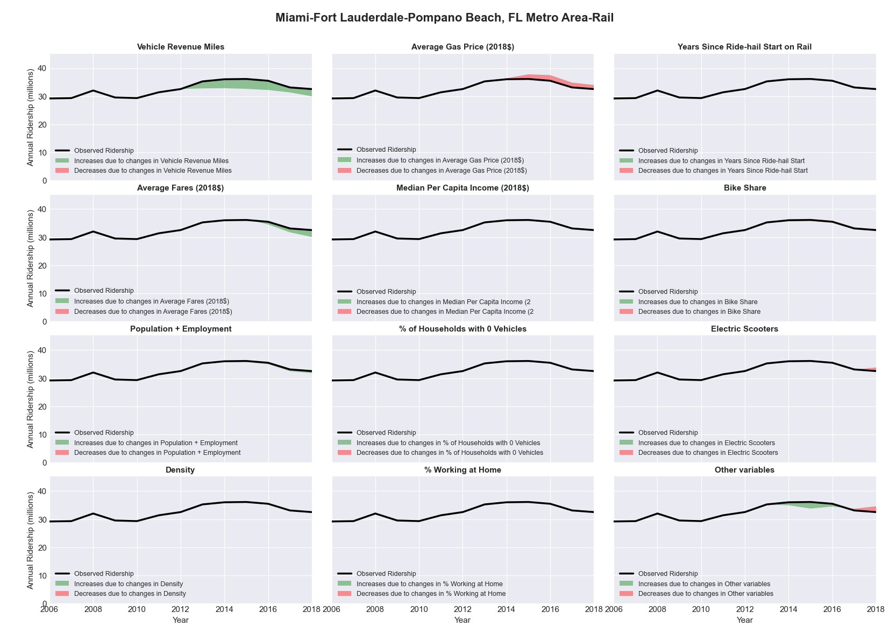

|  |  |  |  |  |  |  |
| --- | --- | --- | --- | --- | --- | --- |
| Milwaukee-Waukesha-West Allis, WI Metro Area-Bus | | | | | | |
|  |  |  |  |  |  | |
|  | **Average Values** | | | **Ridership Effect** | | |
| **Description** | **2012** | **2018** | **% Diff** | **Absolute** | **% Diff** | |
|  |  |  |  |  |  | |
| **Vehicle Revenue Miles** | 15,509,680 | 16,381,050 | 5.6% | 991,470 | | **2.4%** | |
| **Average Fare (2018$)** | 1.01 | 1.14 | 12.7% | -1,248,770 | | **-3.0%** | |
| **Network Restructure** | - | - | - | - | | **0.0%** | |
| **Major Maintenance Event** | - | - | - | - | | **0.0%** | |
| **Population + Employment** | 2,322,720 | 2,385,420 | 2.7% | 237,240 | | **0.6%** | |
| **Share of Population and Employment in Transit Supportive Density** | 0.36 | 0.37 | 3.4% | 200,590 | | **0.5%** | |
| **Average Gas Price (2018$)** | 3.93 | 2.72 | -30.9% | -1,705,060 | | **-4.1%** | |
| **Median Per Capita Income (2018$)** | 30,680 | 32,910 | 7.3% | -198,200 | | **-0.5%** | |
| **% of Households with 0 Vehicles** | 11 | 9 | -15.5% | -142,010 | | **-0.3%** | |
| **% Working at Home** | 3.2 | 5.2 | 62.5% | -599,340 | | **-1.4%** | |
| **Years Since Ride-hail Start** | - | 4 | 4 | -5,162,200 | | **-12.3%** | |
| **Bike Share** | - | 1 | 1 | - 454,270 | | **-1.1%** | |
| **Electric Scooters** | - | - | - | - | | **0.0%** | |
| **New Reporters** |  |  |  | - | | **0.0%** | |
| **Total Modeled Ridership** | 41,970,806 | 33,991,249 | -19.01% | -7979556.79 | | **-19.0%** | |
| **Total Observed Ridership** | 45,217,284 | 30,429,789 | -32.70% | -14787495 | | **-32.7%** | |
| **Unexplained Change** |  |  |  |  | | **-13.7%** | |

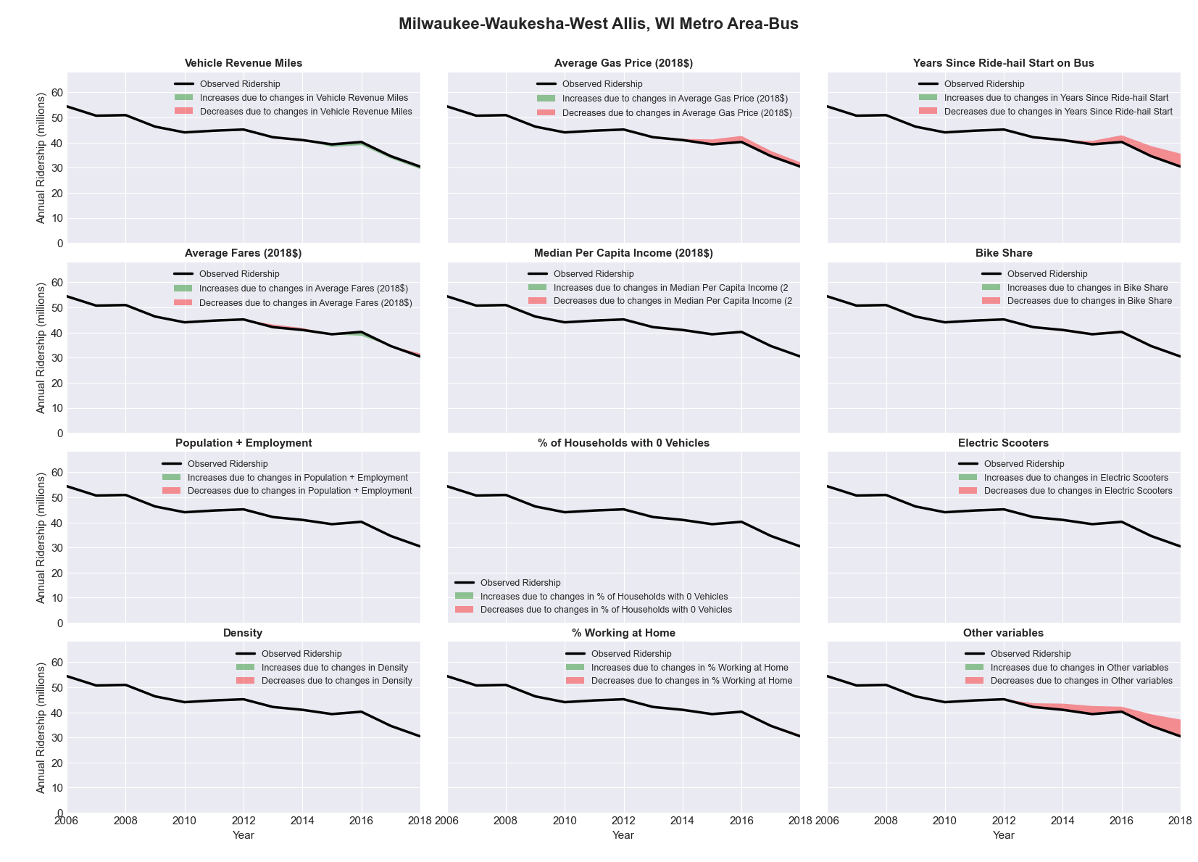

|  |  |  |  |  |  |  |
| --- | --- | --- | --- | --- | --- | --- |
| Minneapolis-St. Paul-Bloomington, MN-WI Metro Area-Bus | | | | | | |
|  |  |  |  |  |  | |
|  | **Average Values** | | | **Ridership Effect** | | |
| **Description** | **2012** | **2018** | **% Diff** | **Absolute** | **% Diff** | |
|  |  |  |  |  |  | |
| **Vehicle Revenue Miles** | 30,117,860 | 33,304,840 | 10.6% | 3,670,540 | | **4.7%** | |
| **Average Fare (2018$)** | 1.19 | 1.17 | -1.4% | 292,950 | | **0.4%** | |
| **Network Restructure** | - | - | - | - | | **0.0%** | |
| **Major Maintenance Event** | - | - | - | - | | **0.0%** | |
| **Population + Employment** | 5,102,110 | 5,571,480 | 9.2% | 1,459,580 | | **1.9%** | |
| **Share of Population and Employment in Transit Supportive Density** | 0.34 | 0.34 | -0.8% | -81,010 | | **-0.1%** | |
| **Average Gas Price (2018$)** | 3.93 | 2.72 | -30.9% | -3,307,810 | | **-4.2%** | |
| **Median Per Capita Income (2018$)** | 35,980 | 39,580 | 10.0% | -504,550 | | **-0.6%** | |
| **% of Households with 0 Vehicles** | 7 | 7 | -6.5% | -67,770 | | **-0.1%** | |
| **% Working at Home** | 5.0 | 5.8 | 15.5% | -447,730 | | **-0.6%** | |
| **Years Since Ride-hail Start** | - | 6 | 6 | -8,707,900 | | **-11.2%** | |
| **Bike Share** | 1.00 | 1 | - | - | | **0.0%** | |
| **Electric Scooters** | - | 1 | 1 | - 2,655,530 | | **-3.4%** | |
| **New Reporters** |  |  |  | - | | **0.0%** | |
| **Total Modeled Ridership** | 78,097,743 | 67,703,627 | -13.31% | -10394115.5 | | **-13.3%** | |
| **Total Observed Ridership** | 81,212,694 | 65,554,150 | -19.28% | -15658544 | | **-19.3%** | |
| **Unexplained Change** |  |  |  |  | | **-6.0%** | |

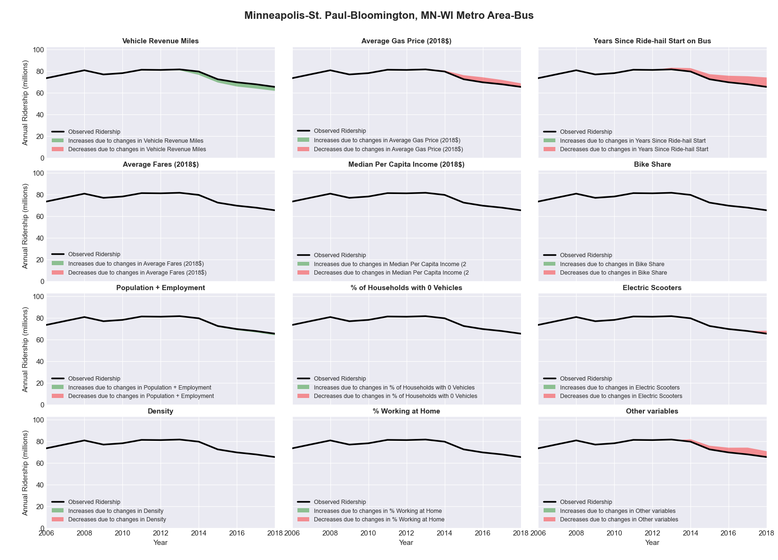

|  |  |  |  |  |  |  |
| --- | --- | --- | --- | --- | --- | --- |
| Minneapolis-St. Paul-Bloomington, MN-WI Metro Area-Rail | | | | | | |
|  |  |  |  |  |  | |
|  | **Average Values** | | | **Ridership Effect** | | |
| **Description** | **2012** | **2018** | **% Diff** | **Absolute** | **% Diff** | |
|  |  |  |  |  |  | |
| **Vehicle Revenue Miles** | 2,584,240 | 5,866,990 | 127.0% | 7,908,030 | | **61.3%** | |
| **Average Fare (2018$)** | 1.25 | 1.07 | -14.6% | 426,060 | | **3.3%** | |
| **Network Restructure** | - | - | - | - | | **0.0%** | |
| **Major Maintenance Event** | - | - | - | - | | **0.0%** | |
| **Population + Employment** | 5,102,110 | 5,571,480 | 9.2% | 337,690 | | **2.6%** | |
| **Share of Population and Employment in Transit Supportive Density** | 0.34 | 0.34 | -0.8% | -24,080 | | **-0.2%** | |
| **Average Gas Price (2018$)** | 3.93 | 2.72 | -30.9% | -540,750 | | **-4.2%** | |
| **Median Per Capita Income (2018$)** | 35,980 | 39,580 | 10.0% | -137,250 | | **-1.1%** | |
| **% of Households with 0 Vehicles** | 7 | 7 | -6.5% | -28,060 | | **-0.2%** | |
| **% Working at Home** | 5.0 | 5.8 | 15.5% | -123,750 | | **-1.0%** | |
| **Years Since Ride-hail Start** | - | 6 | 6 | 241,760 | | **1.9%** | |
| **Bike Share** | 1.00 | 1 | - | - | | **0.0%** | |
| **Electric Scooters** | - | 1 | 1 | - 961,080 | | **-7.5%** | |
| **New Reporters** |  |  |  | - | | **0.0%** | |
| **Total Modeled Ridership** | 12,892,888 | 21,454,659 | 66.41% | 8561770.34 | | **66.4%** | |
| **Total Observed Ridership** | 11,198,514 | 25,742,944 | 129.88% | 14544430 | | **129.9%** | |
| **Unexplained Change** |  |  |  |  | | **63.5%** | |

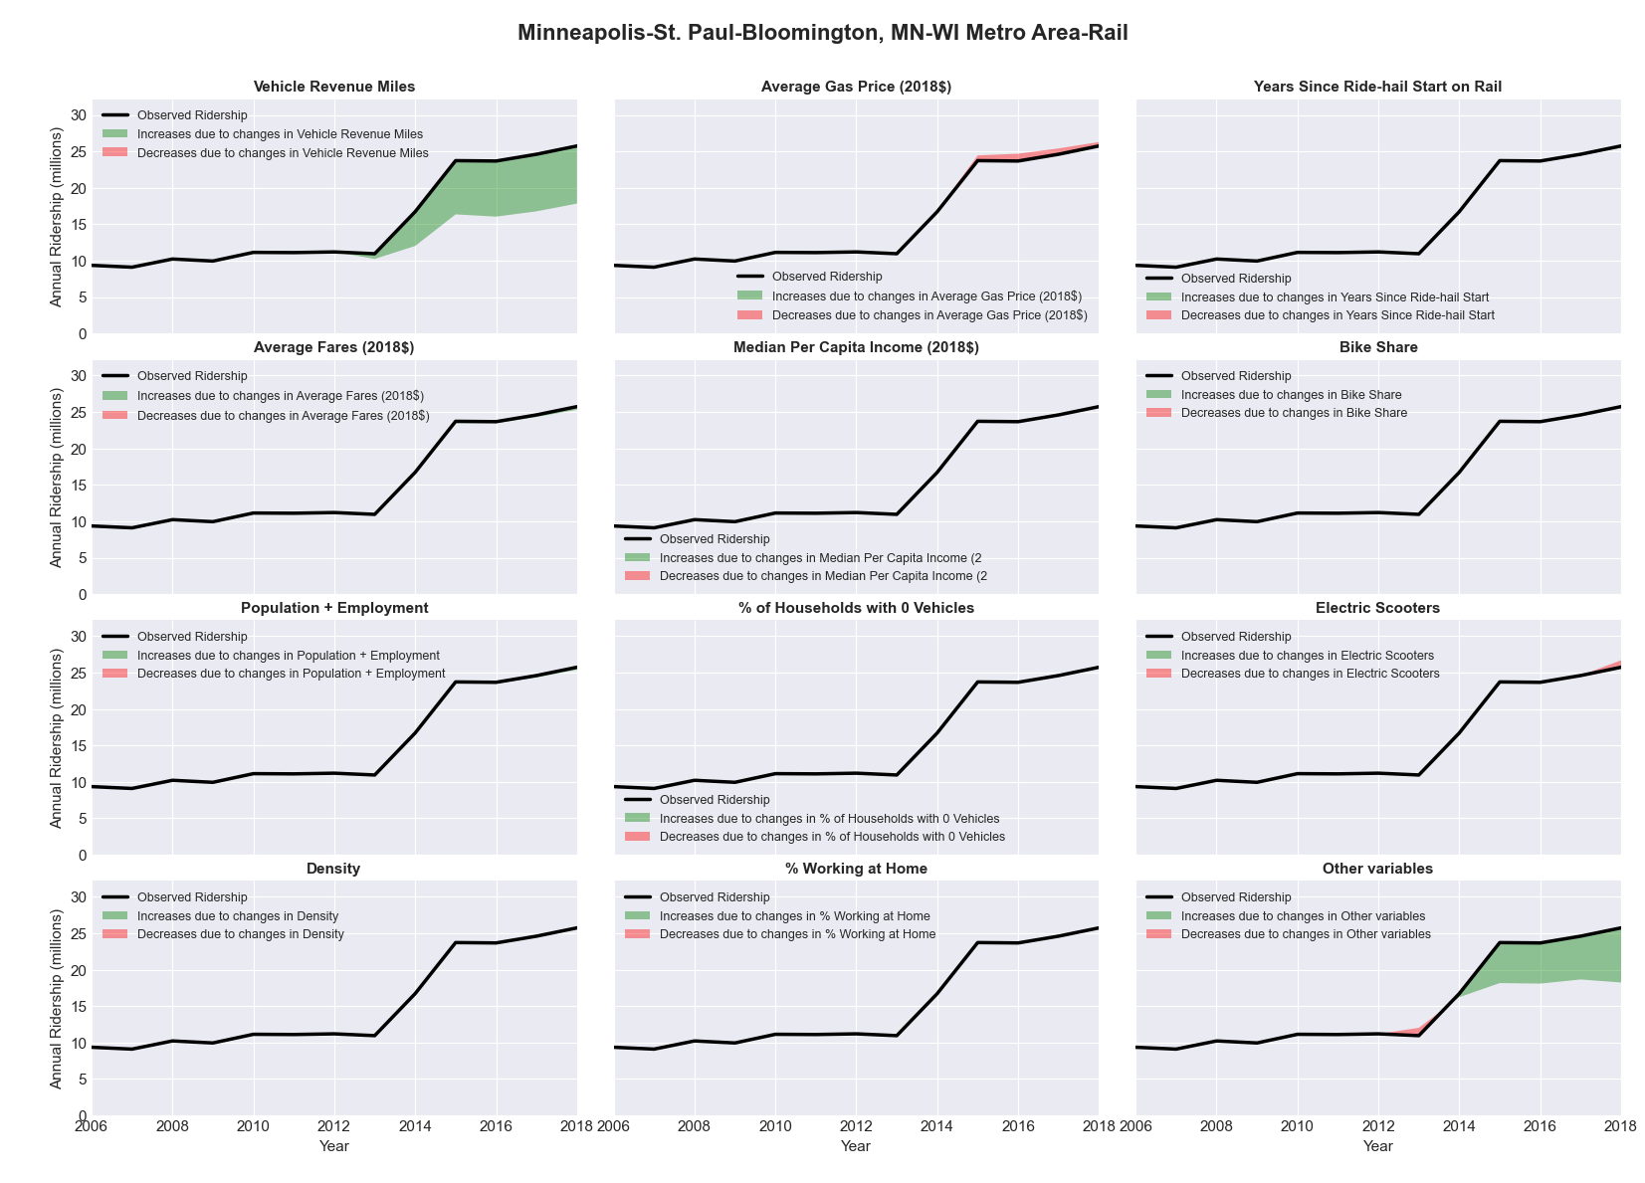

|  |  |  |  |  |  |  |
| --- | --- | --- | --- | --- | --- | --- |
| Missoula, MT Metro Area-Bus | | | | | | |
|  |  |  |  |  |  | |
|  | **Average Values** | | | **Ridership Effect** | | |
| **Description** | **2012** | **2018** | **% Diff** | **Absolute** | **% Diff** | |
|  |  |  |  |  |  | |
| **Vehicle Revenue Miles** | 616,310 | 686,920 | 11.5% | 39,280 | | **3.5%** | |
| **Average Fare (2018$)** | 0.34 | (0.08) | -122.5% | 279,050 | | **25.0%** | |
| **Network Restructure** | - | - | - | - | | **0.0%** | |
| **Major Maintenance Event** | - | - | - | - | | **0.0%** | |
| **Population + Employment** | 166,640 | 179,050 | 7.4% | 19,050 | | **1.7%** | |
| **Share of Population and Employment in Transit Supportive Density** | 0.31 | 0.31 | 1.4% | 0,960 | | **0.1%** | |
| **Average Gas Price (2018$)** | 3.88 | 2.89 | -25.5% | -19,850 | | **-1.8%** | |
| **Median Per Capita Income (2018$)** | 25,400 | 27,840 | 9.6% | -11,430 | | **-1.0%** | |
| **% of Households with 0 Vehicles** | 6 | 6 | 9.0% | 1,490 | | **0.1%** | |
| **% Working at Home** | 6.1 | 5.7 | -6.1% | 2,370 | | **0.2%** | |
| **Years Since Ride-hail Start** | - | 2 | 2 | -103,670 | | **-9.3%** | |
| **Bike Share** | - | - | - | - | | **0.0%** | |
| **Electric Scooters** | - | - | - | - | | **0.0%** | |
| **New Reporters** |  |  |  | - | | **0.0%** | |
| **Total Modeled Ridership** | 1,116,535 | 1,331,945 | 19.29% | 215410.112 | | **19.3%** | |
| **Total Observed Ridership** | 897,888 | 1,573,615 | 75.26% | 675727 | | **75.3%** | |
| **Unexplained Change** |  |  |  |  | | **56.0%** | |

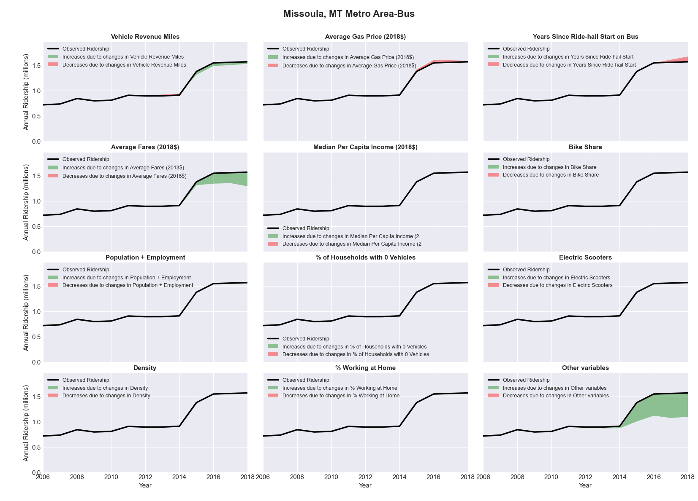

|  |  |  |  |  |  |  |
| --- | --- | --- | --- | --- | --- | --- |
| Mobile, AL Metro Area-Bus | | | | | | |
|  |  |  |  |  |  | |
|  | **Average Values** | | | **Ridership Effect** | | |
| **Description** | **2012** | **2018** | **% Diff** | **Absolute** | **% Diff** | |
|  |  |  |  |  |  | |
| **Vehicle Revenue Miles** | 1,281,660 | 1,032,900 | -19.4% | -87,740 | | **-7.9%** | |
| **Average Fare (2018$)** | 0.83 | 0.68 | -18.9% | 58,000 | | **5.2%** | |
| **Network Restructure** | - | - | - | - | | **0.0%** | |
| **Major Maintenance Event** | - | - | - | - | | **0.0%** | |
| **Population + Employment** | 585,240 | 592,210 | 1.2% | 2,820 | | **0.3%** | |
| **Share of Population and Employment in Transit Supportive Density** | 0.16 | 0.16 | 0.7% | 0,330 | | **0.0%** | |
| **Average Gas Price (2018$)** | 3.80 | 2.58 | -32.2% | -53,650 | | **-4.8%** | |
| **Median Per Capita Income (2018$)** | 23,610 | 25,970 | 10.0% | -7,890 | | **-0.7%** | |
| **% of Households with 0 Vehicles** | 8 | 8 | -3.1% | -1,150 | | **-0.1%** | |
| **% Working at Home** | 3.0 | 4.5 | 48.3% | -13,860 | | **-1.2%** | |
| **Years Since Ride-hail Start** | - | 3 | 3 | -97,680 | | **-8.8%** | |
| **Bike Share** | - | 1 | 1 | - 9,150 | | **-0.8%** | |
| **Electric Scooters** | - | - | - | - | | **0.0%** | |
| **New Reporters** |  |  |  | - | | **0.0%** | |
| **Total Modeled Ridership** | 1,113,368 | 898,033 | -19.34% | -215334.548 | | **-19.3%** | |
| **Total Observed Ridership** | 1,137,564 | 844,255 | -25.78% | -293309 | | **-25.8%** | |
| **Unexplained Change** |  |  |  |  | | **-6.4%** | |

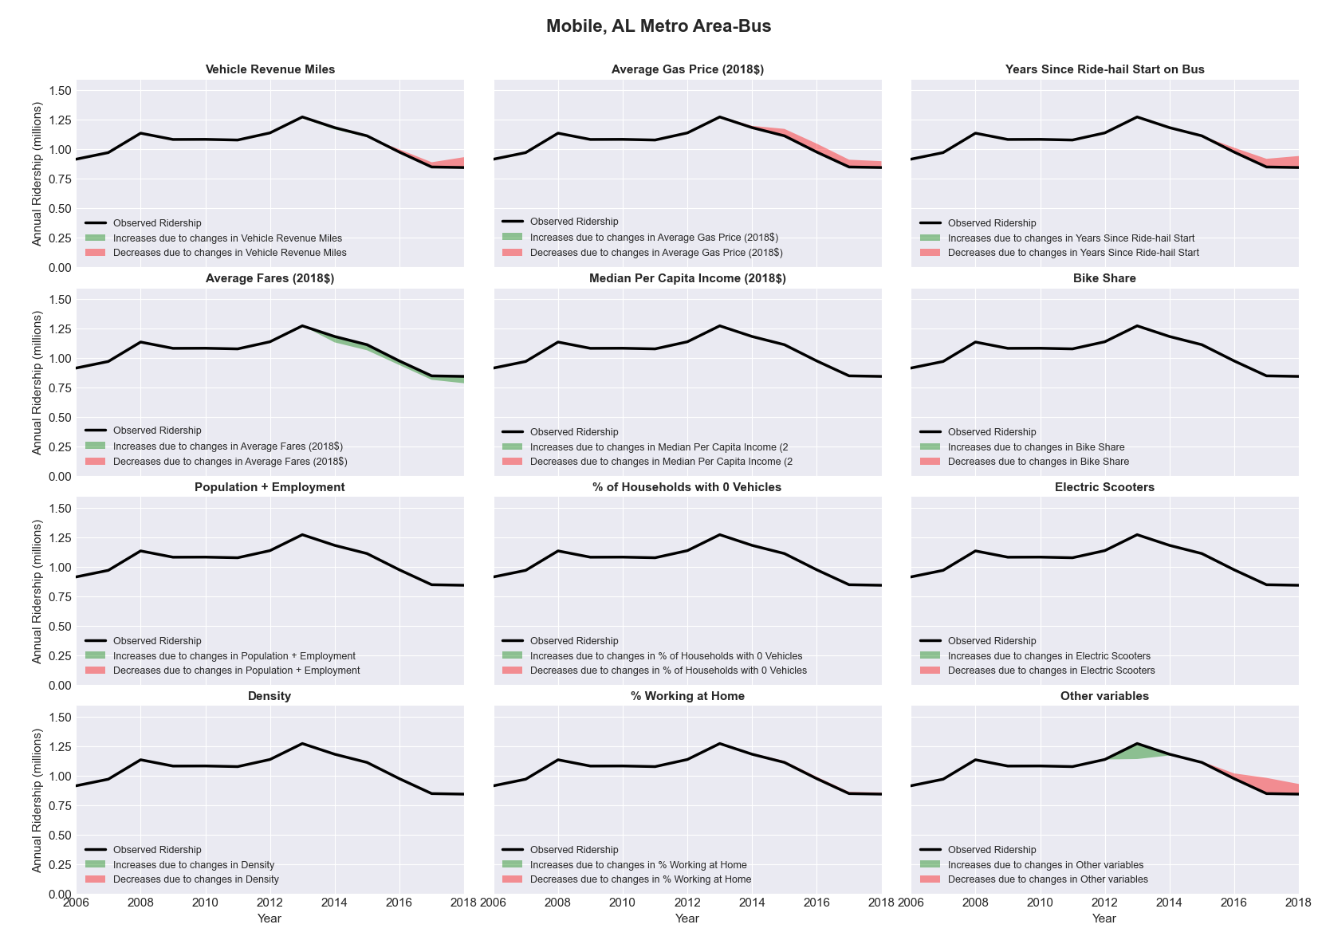

|  |  |  |  |  |  |  |
| --- | --- | --- | --- | --- | --- | --- |
| Modesto, CA Metro Area-Bus | | | | | | |
|  |  |  |  |  |  | |
|  | **Average Values** | | | **Ridership Effect** | | |
| **Description** | **2012** | **2018** | **% Diff** | **Absolute** | **% Diff** | |
|  |  |  |  |  |  | |
| **Vehicle Revenue Miles** | 1,826,610 | 1,856,920 | 1.7% | 51,550 | | **1.5%** | |
| **Average Fare (2018$)** | 0.75 | 0.88 | 17.6% | -160,920 | | **-4.7%** | |
| **Network Restructure** | - | - | - | - | | **0.0%** | |
| **Major Maintenance Event** | - | - | - | - | | **0.0%** | |
| **Population + Employment** | 727,660 | 781,420 | 7.4% | 51,900 | | **1.5%** | |
| **Share of Population and Employment in Transit Supportive Density** | 0.43 | 0.43 | -0.6% | -3,560 | | **-0.1%** | |
| **Average Gas Price (2018$)** | 4.35 | 3.40 | -21.8% | -115,000 | | **-3.3%** | |
| **Median Per Capita Income (2018$)** | 23,340 | 28,230 | 21.0% | -44,070 | | **-1.3%** | |
| **% of Households with 0 Vehicles** | 6 | 4 | -33.0% | -11,060 | | **-0.3%** | |
| **% Working at Home** | 4.5 | 6.0 | 32.8% | -35,500 | | **-1.0%** | |
| **Years Since Ride-hail Start** | - | 4 | 4 | -421,420 | | **-12.2%** | |
| **Bike Share** | - | - | - | - | | **0.0%** | |
| **Electric Scooters** | - | - | - | - | | **0.0%** | |
| **New Reporters** |  |  |  | - | | **0.0%** | |
| **Total Modeled Ridership** | 3,451,875 | 2,790,607 | -19.16% | -66126.667 | | **-19.2%** | |
| **Total Observed Ridership** | 3,486,871 | 2,618,596 | -24.90% | -868275 | | **-24.9%** | |
| **Unexplained Change** |  |  |  |  | | **-5.7%** | |

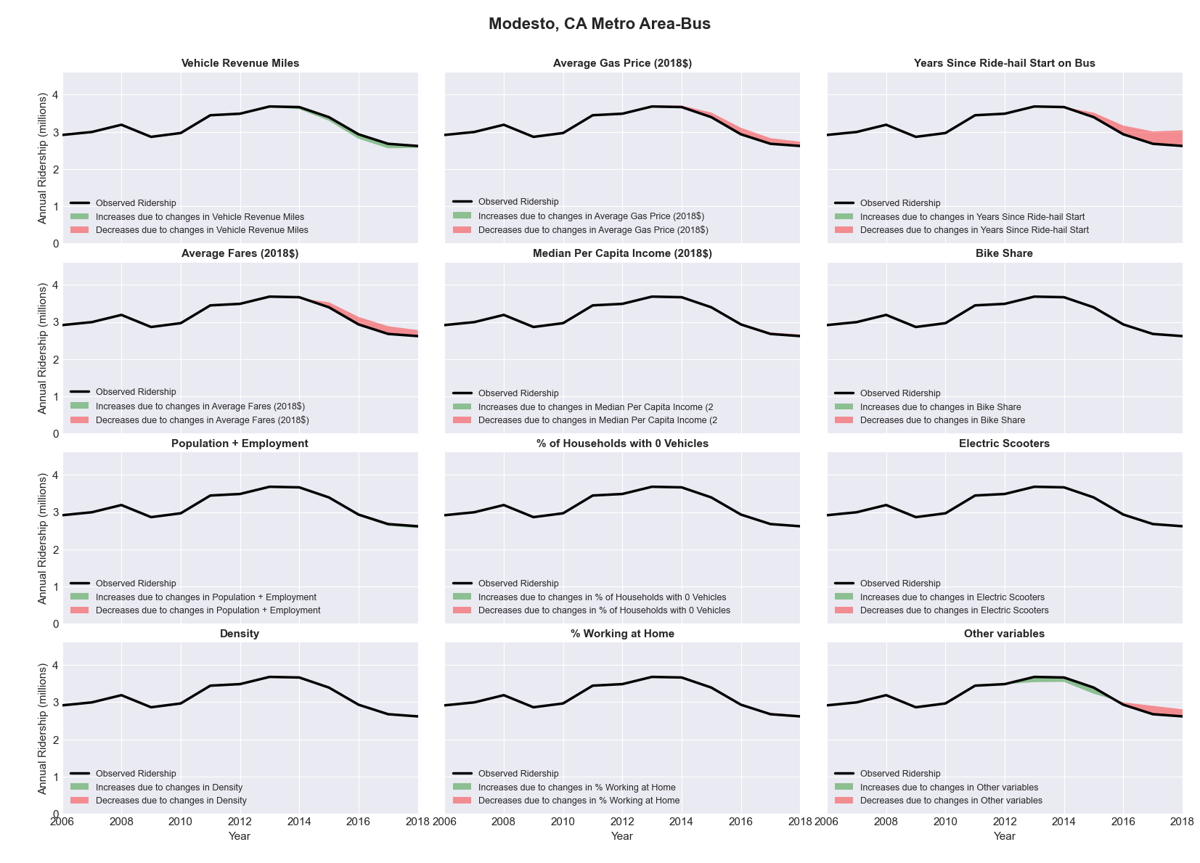

|  |  |  |  |  |  |  |
| --- | --- | --- | --- | --- | --- | --- |
| Montgomery, AL Metro Area-Bus | | | | | | |
|  |  |  |  |  |  | |
|  | **Average Values** | | | **Ridership Effect** | | |
| **Description** | **2012** | **2018** | **% Diff** | **Absolute** | **% Diff** | |
|  |  |  |  |  |  | |
| **Vehicle Revenue Miles** | 1,102,730 | 1,179,300 | 6.9% | 20,240 | | **2.4%** | |
| **Average Fare (2018$)** | 0.89 | 1.00 | 12.5% | -24,380 | | **-2.9%** | |
| **Network Restructure** | - | - | - | - | | **0.0%** | |
| **Major Maintenance Event** | - | - | - | - | | **0.0%** | |
| **Population + Employment** | 538,000 | 539,270 | 0.2% | 0,320 | | **0.0%** | |
| **Share of Population and Employment in Transit Supportive Density** | 0.11 | 0.10 | -3.7% | -1,490 | | **-0.2%** | |
| **Average Gas Price (2018$)** | 3.80 | 2.58 | -32.2% | -40,740 | | **-4.8%** | |
| **Median Per Capita Income (2018$)** | 24,730 | 23,620 | -4.5% | 1,040 | | **0.1%** | |
| **% of Households with 0 Vehicles** | 7 | 8 | 9.1% | 1,110 | | **0.1%** | |
| **% Working at Home** | 2.4 | 3.6 | 49.0% | -7,290 | | **-0.9%** | |
| **Years Since Ride-hail Start** | - | 2 | 2 | -45,510 | | **-5.4%** | |
| **Bike Share** | - | - | - | - | | **0.0%** | |
| **Electric Scooters** | - | - | - | - | | **0.0%** | |
| **New Reporters** |  |  |  | - | | **0.0%** | |
| **Total Modeled Ridership** | 844,109 | 750,016 | -11.15% | -9492.9801 | | **-11.1%** | |
| **Total Observed Ridership** | 936,718 | 593,910 | -36.60% | -342808 | | **-36.6%** | |
| **Unexplained Change** |  |  |  |  | | **-25.4%** | |

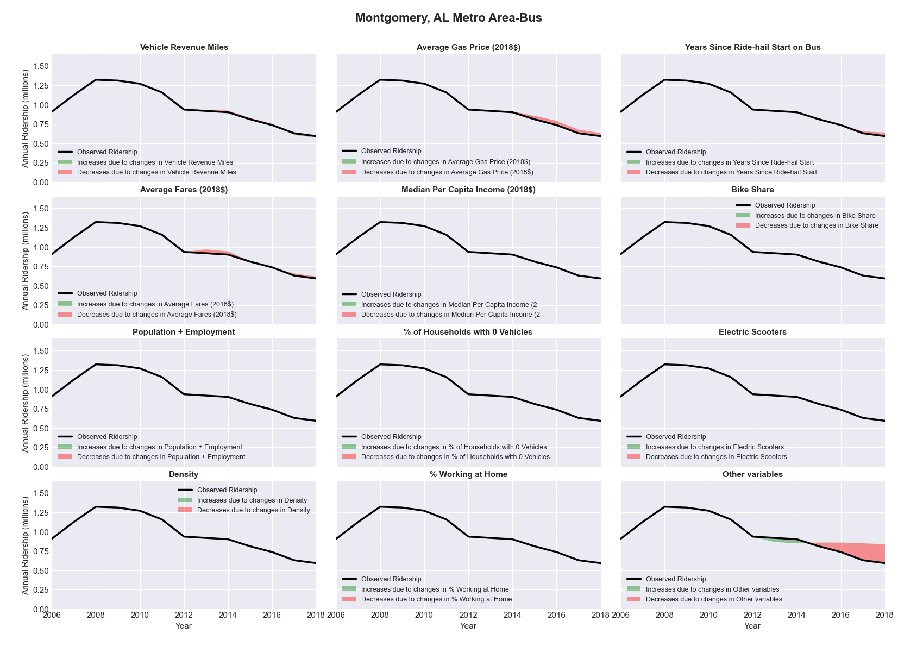

|  |  |  |  |  |  |  |
| --- | --- | --- | --- | --- | --- | --- |
| Mount Vernon-Anacortes, WA Metro Area-Bus | | | | | | |
|  |  |  |  |  |  | |
|  | **Average Values** | | | **Ridership Effect** | | |
| **Description** | **2012** | **2018** | **% Diff** | **Absolute** | **% Diff** | |
|  |  |  |  |  |  | |
| **Vehicle Revenue Miles** | 918,500 | 1,338,790 | 45.8% | 122,760 | | **18.4%** | |
| **Average Fare (2018$)** | 0.73 | 0.52 | -28.0% | 52,050 | | **7.8%** | |
| **Network Restructure** | - | - | - | - | | **0.0%** | |
| **Major Maintenance Event** | - | - | - | - | | **0.0%** | |
| **Population + Employment** | 169,820 | 183,860 | 8.3% | 12,940 | | **1.9%** | |
| **Share of Population and Employment in Transit Supportive Density** | 0.11 | 0.12 | 2.6% | 0,840 | | **0.1%** | |
| **Average Gas Price (2018$)** | 4.35 | 3.40 | -21.8% | -24,750 | | **-3.7%** | |
| **Median Per Capita Income (2018$)** | 28,790 | 33,030 | 14.7% | -8,020 | | **-1.2%** | |
| **% of Households with 0 Vehicles** | 5 | 6 | 18.5% | 0,980 | | **0.1%** | |
| **% Working at Home** | 4.8 | 7.9 | 64.1% | -16,410 | | **-2.5%** | |
| **Years Since Ride-hail Start** | - | 2 | 2 | -45,310 | | **-6.8%** | |
| **Bike Share** | - | - | - | - | | **0.0%** | |
| **Electric Scooters** | - | - | - | - | | **0.0%** | |
| **New Reporters** |  |  |  | - | | **0.0%** | |
| **Total Modeled Ridership** | 667,219 | 762,738 | 14.32% | 95519.2488 | | **14.3%** | |
| **Total Observed Ridership** | 697,473 | 730,270 | 4.70% | 32797 | | **4.7%** | |
| **Unexplained Change** |  |  |  |  | | **-9.6%** | |

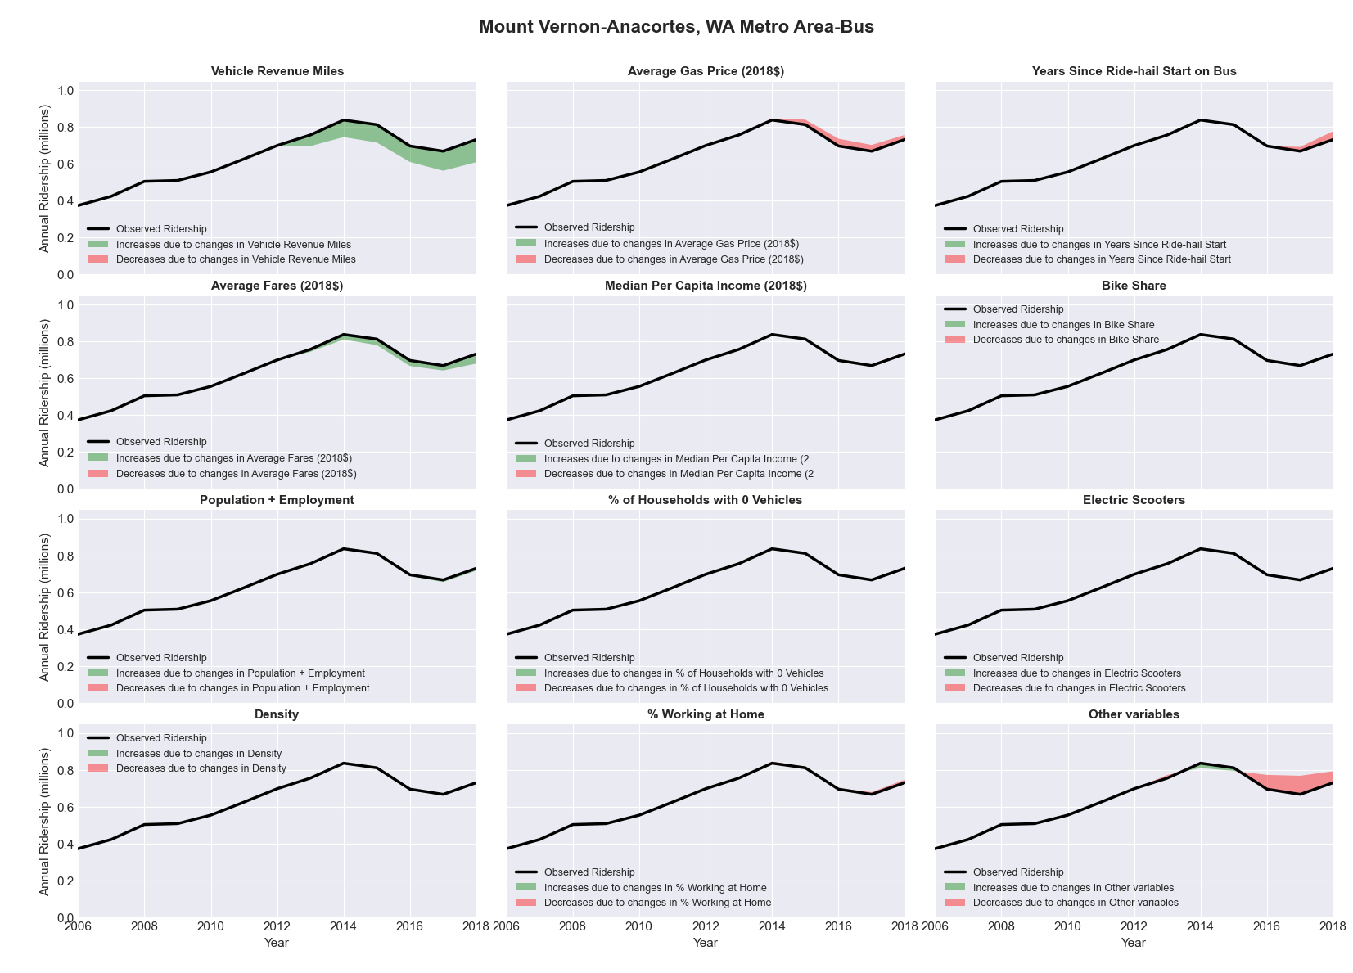

|  |  |  |  |  |  |  |
| --- | --- | --- | --- | --- | --- | --- |
| Muncie, IN Metro Area-Bus | | | | | | |
|  |  |  |  |  |  | |
|  | **Average Values** | | | **Ridership Effect** | | |
| **Description** | **2012** | **2018** | **% Diff** | **Absolute** | **% Diff** | |
|  |  |  |  |  |  | |
| **Vehicle Revenue Miles** | 783,720 | 738,400 | -5.8% | -36,830 | | **-2.1%** | |
| **Average Fare (2018$)** | 0.10 | 0.13 | 33.0% | -31,650 | | **-1.8%** | |
| **Network Restructure** | - | - | - | - | | **0.0%** | |
| **Major Maintenance Event** | - | - | - | - | | **0.0%** | |
| **Population + Employment** | 167,110 | 167,900 | 0.5% | 1,870 | | **0.1%** | |
| **Share of Population and Employment in Transit Supportive Density** | 0.18 | 0.18 | 5.0% | 6,420 | | **0.4%** | |
| **Average Gas Price (2018$)** | 3.93 | 2.72 | -30.9% | -79,020 | | **-4.5%** | |
| **Median Per Capita Income (2018$)** | 20,180 | 23,780 | 17.8% | -19,520 | | **-1.1%** | |
| **% of Households with 0 Vehicles** | 8 | 9 | 16.2% | 3,130 | | **0.2%** | |
| **% Working at Home** | 3.6 | 8.5 | 136.8% | -50,650 | | **-2.9%** | |
| **Years Since Ride-hail Start** | - | 3 | 3 | -154,070 | | **-8.8%** | |
| **Bike Share** | - | - | - | - | | **0.0%** | |
| **Electric Scooters** | - | - | - | - | | **0.0%** | |
| **New Reporters** |  |  |  | - | | **0.0%** | |
| **Total Modeled Ridership** | 1,754,787 | 1,397,287 | -20.37% | -357500.084 | | **-20.4%** | |
| **Total Observed Ridership** | 1,836,874 | 1,316,717 | -28.32% | -520157 | | **-28.3%** | |
| **Unexplained Change** |  |  |  |  | | **-7.9%** | |

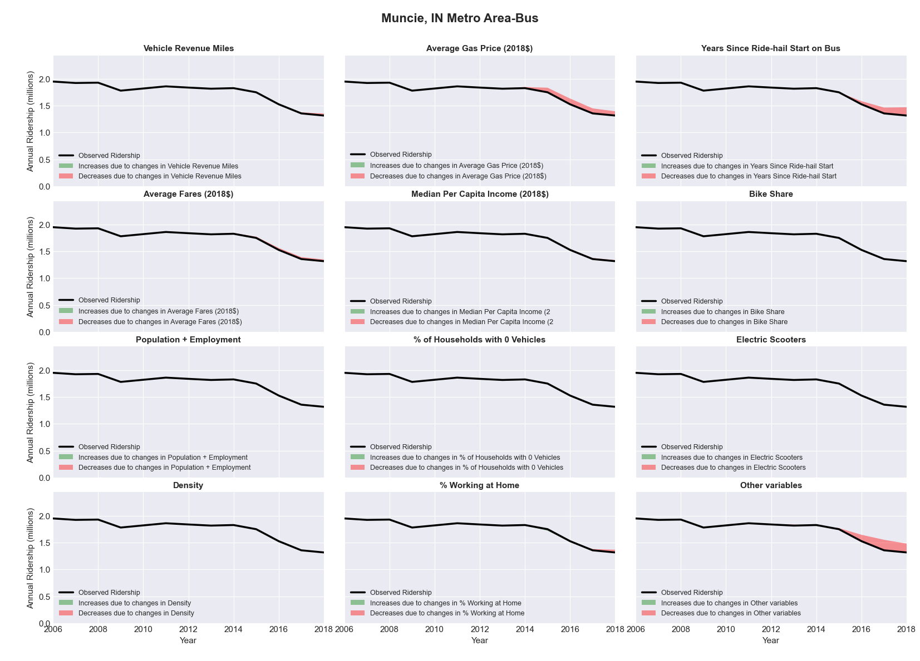

|  |  |  |  |  |  |  |
| --- | --- | --- | --- | --- | --- | --- |
| Napa, CA Metro Area-Bus | | | | | | |
|  |  |  |  |  |  | |
|  | **Average Values** | | | **Ridership Effect** | | |
| **Description** | **2012** | **2018** | **% Diff** | **Absolute** | **% Diff** | |
|  |  |  |  |  |  | |
| **Vehicle Revenue Miles** | 1,112,450 | 1,629,940 | 46.5% | 119,200 | | **15.0%** | |
| **Average Fare (2018$)** | 2.11 | 1.08 | -48.7% | 207,810 | | **26.2%** | |
| **Network Restructure** | - | - | - | - | | **0.0%** | |
| **Major Maintenance Event** | - | - | - | - | | **0.0%** | |
| **Population + Employment** | 204,800 | 211,440 | 3.2% | 4,930 | | **0.6%** | |
| **Share of Population and Employment in Transit Supportive Density** | 0.33 | 0.33 | -1.6% | -1,920 | | **-0.2%** | |
| **Average Gas Price (2018$)** | 4.35 | 3.40 | -21.8% | -21,860 | | **-2.8%** | |
| **Median Per Capita Income (2018$)** | 32,590 | 40,860 | 25.4% | -18,850 | | **-2.4%** | |
| **% of Households with 0 Vehicles** | 4 | 3 | -18.5% | -3,660 | | **-0.5%** | |
| **% Working at Home** | 4.8 | 2.1 | -57.3% | 30,070 | | **3.8%** | |
| **Years Since Ride-hail Start** | - | 4 | 4 | -152,520 | | **-19.2%** | |
| **Bike Share** | - | - | - | - | | **0.0%** | |
| **Electric Scooters** | - | - | - | - | | **0.0%** | |
| **New Reporters** |  |  |  | - | | **0.0%** | |
| **Total Modeled Ridership** | 792,860 | 1,017,590 | 28.34% | 224730.199 | | **28.3%** | |
| **Total Observed Ridership** | 655,166 | 1,136,553 | 73.48% | 481387 | | **73.5%** | |
| **Unexplained Change** |  |  |  |  | | **45.1%** | |

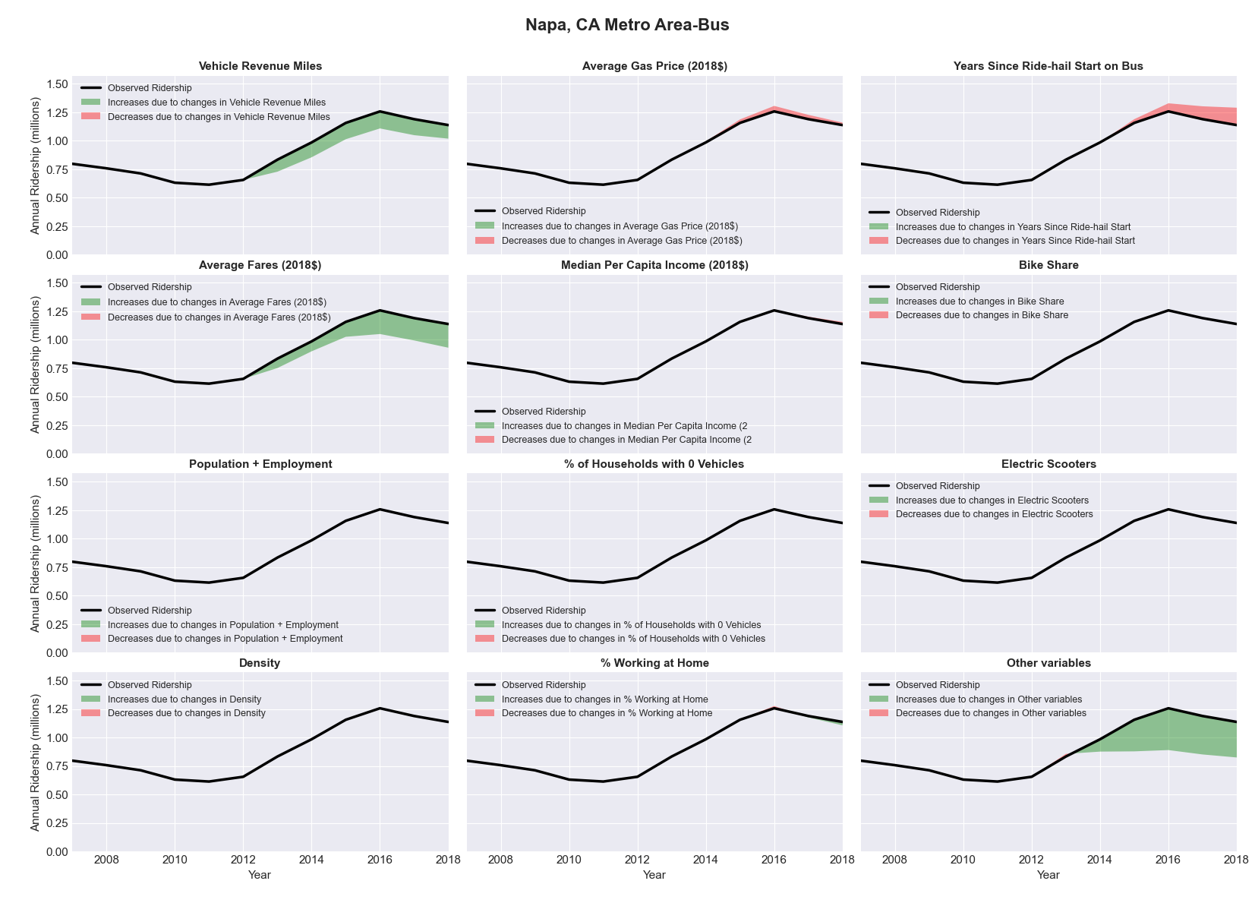

|  |  |  |  |  |  |  |
| --- | --- | --- | --- | --- | --- | --- |
| Nashville-Davidson--Murfreesboro--Franklin, TN Metro Area-Bus | | | | | | |
|  |  |  |  |  |  | |
|  | **Average Values** | | | **Ridership Effect** | | |
| **Description** | **2012** | **2018** | **% Diff** | **Absolute** | **% Diff** | |
|  |  |  |  |  |  | |
| **Vehicle Revenue Miles** | 4,872,490 | 6,382,170 | 31.0% | 1,170,570 | | **12.0%** | |
| **Average Fare (2018$)** | 1.11 | 0.94 | -14.8% | 443,920 | | **4.6%** | |
| **Network Restructure** | - | - | - | - | | **0.0%** | |
| **Major Maintenance Event** | - | - | - | - | | **0.0%** | |
| **Population + Employment** | 2,451,350 | 2,901,540 | 18.4% | 346,800 | | **3.6%** | |
| **Share of Population and Employment in Transit Supportive Density** | 0.21 | 0.19 | -5.7% | -44,610 | | **-0.5%** | |
| **Average Gas Price (2018$)** | 3.93 | 2.72 | -30.9% | -384,090 | | **-3.9%** | |
| **Median Per Capita Income (2018$)** | 29,370 | 32,350 | 10.1% | -65,290 | | **-0.7%** | |
| **% of Households with 0 Vehicles** | 6 | 4 | -26.5% | -28,140 | | **-0.3%** | |
| **% Working at Home** | 4.7 | 7.0 | 47.9% | -161,620 | | **-1.7%** | |
| **Years Since Ride-hail Start** | - | 5 | 5 | -1,561,230 | | **-16.0%** | |
| **Bike Share** | - | 1 | 1 | - 101,870 | | **-1.0%** | |
| **Electric Scooters** | - | 1 | 1 | - 356,710 | | **-3.7%** | |
| **New Reporters** |  |  |  | - | | **0.0%** | |
| **Total Modeled Ridership** | 9,750,588 | 8,937,111 | -8.34% | -813476.919 | | **-8.3%** | |
| **Total Observed Ridership** | 9,449,084 | 9,372,763 | -0.81% | -76321 | | **-0.8%** | |
| **Unexplained Change** |  |  |  |  | | **7.5%** | |

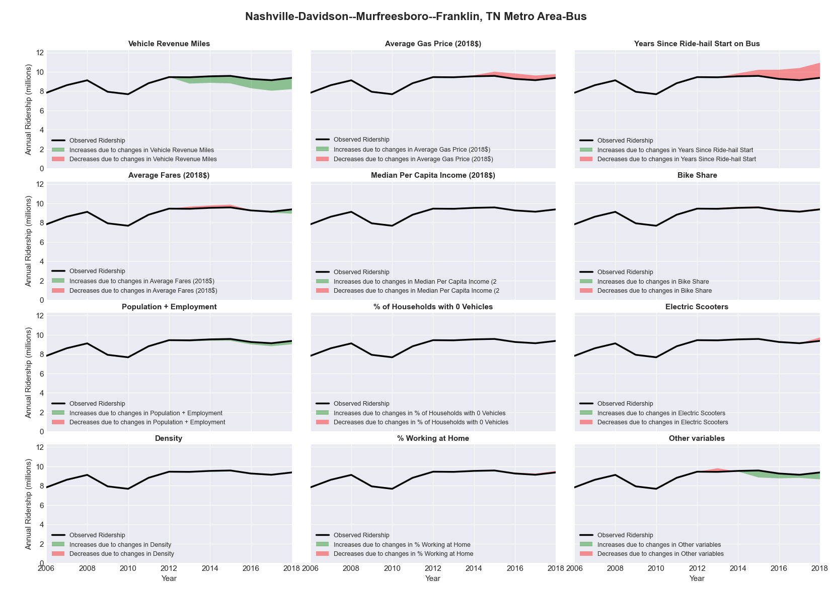

|  |  |  |  |  |  |  |
| --- | --- | --- | --- | --- | --- | --- |
| New Haven-Milford, CT Metro Area-Bus | | | | | | |
|  |  |  |  |  |  | |
|  | **Average Values** | | | **Ridership Effect** | | |
| **Description** | **2012** | **2018** | **% Diff** | **Absolute** | **% Diff** | |
|  |  |  |  |  |  | |
| **Vehicle Revenue Miles** | 4,339,510 | 4,564,350 | 5.2% | 235,660 | | **2.1%** | |
| **Average Fare (2018$)** | 0.94 | 0.91 | -3.2% | 80,060 | | **0.7%** | |
| **Network Restructure** | - | - | - | - | | **0.0%** | |
| **Major Maintenance Event** | - | - | - | - | | **0.0%** | |
| **Population + Employment** | 1,278,000 | 1,299,030 | 1.6% | 37,880 | | **0.3%** | |
| **Share of Population and Employment in Transit Supportive Density** | 0.29 | 0.29 | 0.3% | 3,970 | | **0.0%** | |
| **Average Gas Price (2018$)** | 4.13 | 2.85 | -31.0% | -482,820 | | **-4.4%** | |
| **Median Per Capita Income (2018$)** | 32,520 | 36,070 | 10.9% | -78,400 | | **-0.7%** | |
| **% of Households with 0 Vehicles** | 11 | 10 | -8.2% | -16,220 | | **-0.1%** | |
| **% Working at Home** | 3.4 | 4.3 | 25.7% | -78,820 | | **-0.7%** | |
| **Years Since Ride-hail Start** | - | 4 | 4 | -1,364,610 | | **-12.3%** | |
| **Bike Share** | - | 1 | 1 | - 97,880 | | **-0.9%** | |
| **Electric Scooters** | - | - | - | - | | **0.0%** | |
| **New Reporters** |  |  |  | - | | **0.0%** | |
| **Total Modeled Ridership** | 11,083,371 | 9,373,626 | -15.43% | -1709744.4 | | **-15.4%** | |
| **Total Observed Ridership** | 11,165,565 | 8,845,413 | -20.78% | -2320152 | | **-20.8%** | |
| **Unexplained Change** |  |  |  |  | | **-5.4%** | |

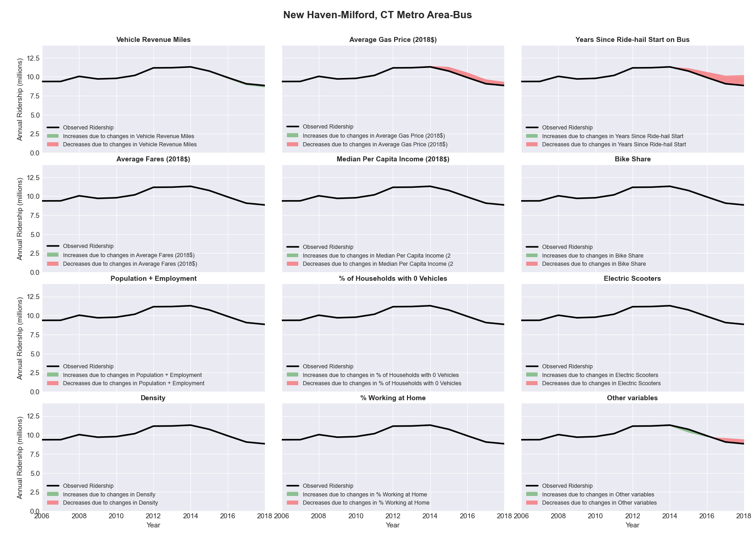

|  |  |  |  |  |  |  |
| --- | --- | --- | --- | --- | --- | --- |
| New Orleans-Metairie-Kenner, LA Metro Area-Bus | | | | | | |
|  |  |  |  |  |  | |
|  | **Average Values** | | | **Ridership Effect** | | |
| **Description** | **2012** | **2018** | **% Diff** | **Absolute** | **% Diff** | |
|  |  |  |  |  |  | |
| **Vehicle Revenue Miles** | 5,481,140 | 6,992,210 | 27.6% | 1,554,890 | | **10.5%** | |
| **Average Fare (2018$)** | 0.82 | 1.15 | 40.7% | -1,555,590 | | **-10.5%** | |
| **Network Restructure** | - | - | - | - | | **0.0%** | |
| **Major Maintenance Event** | - | - | - | - | | **0.0%** | |
| **Population + Employment** | 1,728,670 | 1,849,330 | 7.0% | 224,090 | | **1.5%** | |
| **Share of Population and Employment in Transit Supportive Density** | 0.47 | 0.48 | 0.7% | 21,740 | | **0.1%** | |
| **Average Gas Price (2018$)** | 3.80 | 2.58 | -32.2% | -603,160 | | **-4.1%** | |
| **Median Per Capita Income (2018$)** | 26,250 | 27,590 | 5.1% | -60,600 | | **-0.4%** | |
| **% of Households with 0 Vehicles** | 10 | 10 | -4.1% | -2,690 | | **-0.0%** | |
| **% Working at Home** | 2.6 | 5.1 | 95.2% | -253,210 | | **-1.7%** | |
| **Years Since Ride-hail Start** | - | 3 | 3 | -1,267,080 | | **-8.6%** | |
| **Bike Share** | - | 1 | 1 | - 133,630 | | **-0.9%** | |
| **Electric Scooters** | - | - | - | - | | **0.0%** | |
| **New Reporters** |  |  |  | - | | **0.0%** | |
| **Total Modeled Ridership** | 14,785,036 | 12,732,529 | -13.88% | -2052506.92 | | **-13.9%** | |
| **Total Observed Ridership** | 17,505,416 | 11,867,629 | -32.21% | -5637787 | | **-32.2%** | |
| **Unexplained Change** |  |  |  |  | | **-18.3%** | |

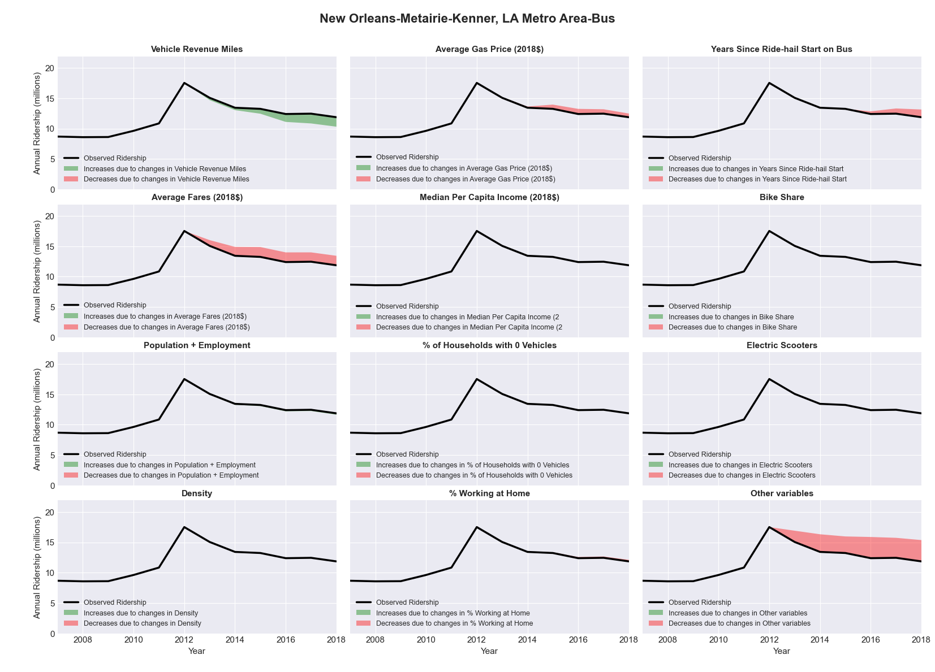

|  |  |  |  |  |  |  |
| --- | --- | --- | --- | --- | --- | --- |
| New Orleans-Metairie-Kenner, LA Metro Area-Rail | | | | | | |
|  |  |  |  |  |  | |
|  | **Average Values** | | | **Ridership Effect** | | |
| **Description** | **2012** | **2018** | **% Diff** | **Absolute** | **% Diff** | |
|  |  |  |  |  |  | |
| **Vehicle Revenue Miles** | 821,840 | 1,218,960 | 48.3% | 2,194,480 | | **30.9%** | |
| **Average Fare (2018$)** | 0.88 | 0.88 | -0.3% | -11,860 | | **-0.2%** | |
| **Network Restructure** | - | - | - | - | | **0.0%** | |
| **Major Maintenance Event** | - | - | - | - | | **0.0%** | |
| **Population + Employment** | 1,728,670 | 1,849,330 | 7.0% | 114,110 | | **1.6%** | |
| **Share of Population and Employment in Transit Supportive Density** | 0.47 | 0.48 | 0.7% | 10,720 | | **0.2%** | |
| **Average Gas Price (2018$)** | 3.80 | 2.58 | -32.2% | -300,900 | | **-4.2%** | |
| **Median Per Capita Income (2018$)** | 26,250 | 27,590 | 5.1% | -26,360 | | **-0.4%** | |
| **% of Households with 0 Vehicles** | 10 | 10 | -4.1% | -9,490 | | **-0.1%** | |
| **% Working at Home** | 2.6 | 5.1 | 95.2% | -144,920 | | **-2.0%** | |
| **Years Since Ride-hail Start** | - | 3 | 3 | -530,840 | | **-7.5%** | |
| **Bike Share** | - | 1 | 1 | - 87,040 | | **-1.2%** | |
| **Electric Scooters** | - | - | - | - | | **0.0%** | |
| **New Reporters** |  |  |  | - | | **0.0%** | |
| **Total Modeled Ridership** | 7,097,654 | 8,104,258 | 14.18% | 1006604.45 | | **14.2%** | |
| **Total Observed Ridership** | 7,227,552 | 7,745,942 | 7.17% | 518390 | | **7.2%** | |
| **Unexplained Change** |  |  |  |  | | **-7.0%** | |

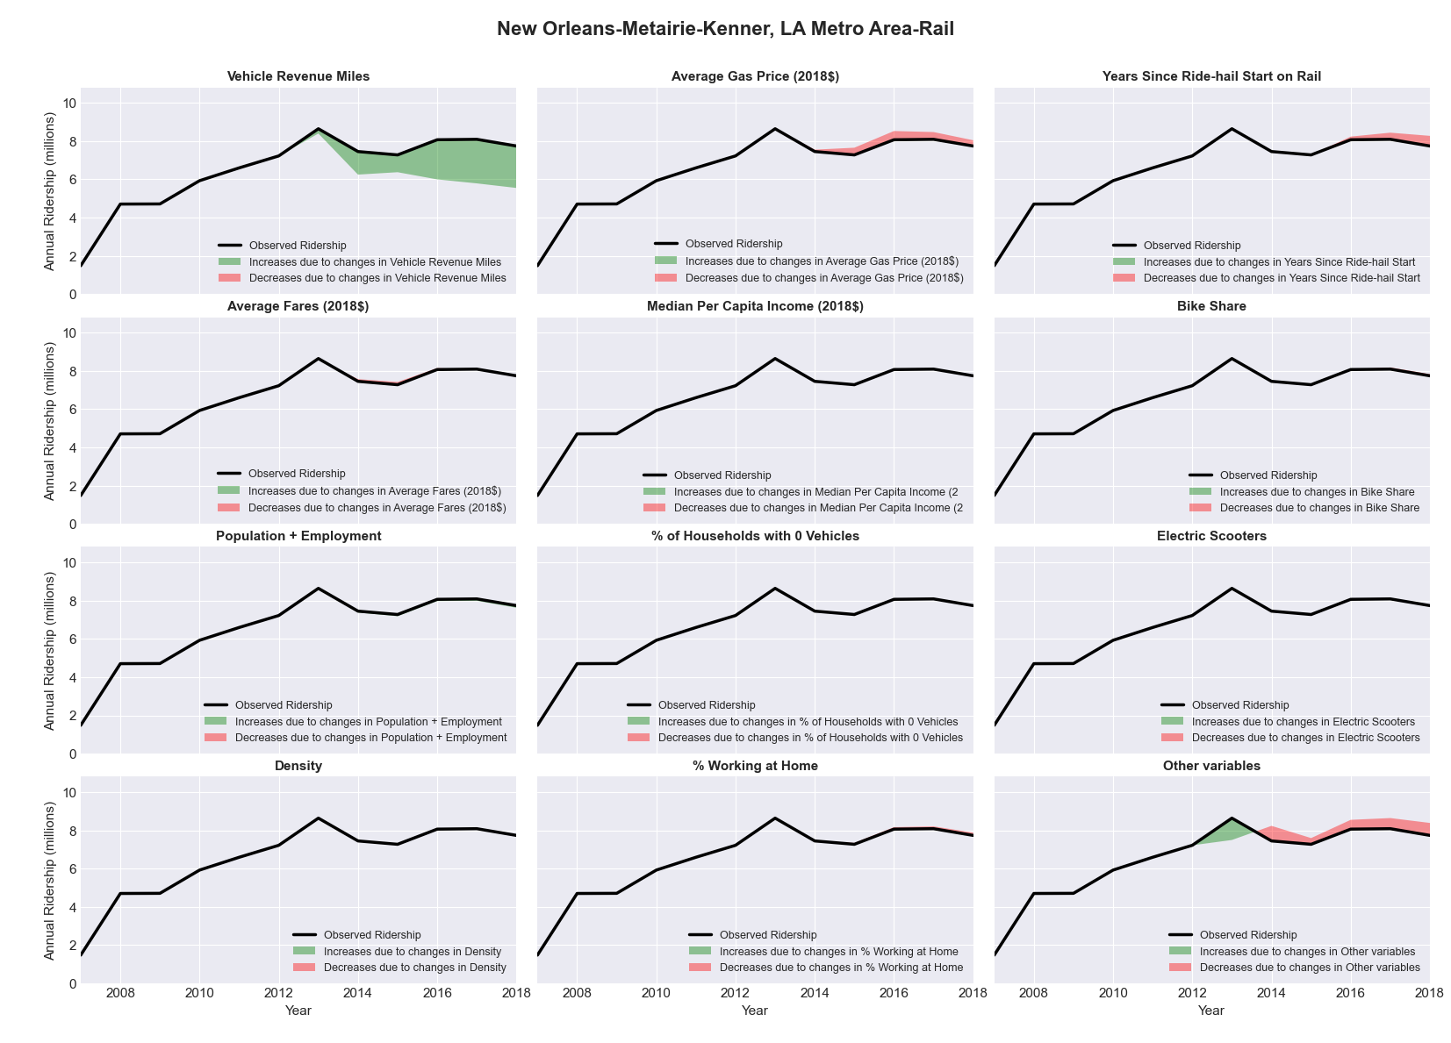

|  |  |  |  |  |  |  |
| --- | --- | --- | --- | --- | --- | --- |
| Ocala, FL Metro Area-Bus | | | | | | |
|  |  |  |  |  |  | |
|  | **Average Values** | | | **Ridership Effect** | | |
| **Description** | **2012** | **2018** | **% Diff** | **Absolute** | **% Diff** | |
|  |  |  |  |  |  | |
| **Vehicle Revenue Miles** | 436,900 | 480,450 | 10.0% | 18,780 | | **4.3%** | |
| **Average Fare (2018$)** | 0.85 | 0.71 | -16.6% | 19,120 | | **4.4%** | |
| **Network Restructure** | - | - | - | - | | **0.0%** | |
| **Major Maintenance Event** | - | - | - | - | | **0.0%** | |
| **Population + Employment** | 452,260 | 489,580 | 8.3% | 7,230 | | **1.7%** | |
| **Share of Population and Employment in Transit Supportive Density** | 0.10 | 0.10 | 5.3% | 0,870 | | **0.2%** | |
| **Average Gas Price (2018$)** | 3.95 | 2.71 | -31.3% | -17,570 | | **-4.0%** | |
| **Median Per Capita Income (2018$)** | 22,400 | 25,970 | 15.9% | -4,420 | | **-1.0%** | |
| **% of Households with 0 Vehicles** | 6 | 4 | -31.3% | -1,530 | | **-0.4%** | |
| **% Working at Home** | 4.8 | 5.5 | 14.1% | -2,090 | | **-0.5%** | |
| **Years Since Ride-hail Start** | - | 4 | 4 | -55,730 | | **-12.8%** | |
| **Bike Share** | - | - | - | - | | **0.0%** | |
| **Electric Scooters** | - | - | - | - | | **0.0%** | |
| **New Reporters** |  |  |  | - | | **0.0%** | |
| **Total Modeled Ridership** | 434,205 | 397,656 | -8.42% | -36548.7638 | | **-8.4%** | |
| **Total Observed Ridership** | 425,402 | 405,660 | -4.64% | -19742 | | **-4.6%** | |
| **Unexplained Change** |  |  |  |  | | **3.8%** | |

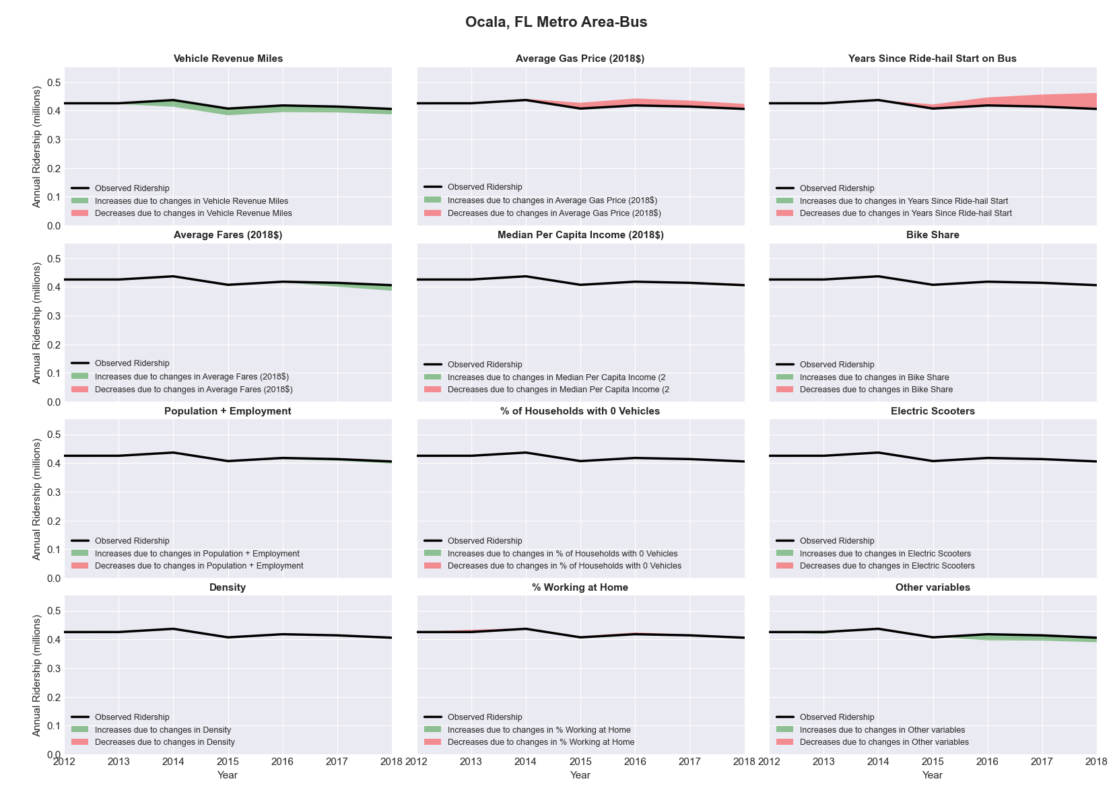

|  |  |  |  |  |  |  |
| --- | --- | --- | --- | --- | --- | --- |
| Oklahoma City, OK Metro Area-Bus | | | | | | |
|  |  |  |  |  |  | |
|  | **Average Values** | | | **Ridership Effect** | | |
| **Description** | **2012** | **2018** | **% Diff** | **Absolute** | **% Diff** | |
|  |  |  |  |  |  | |
| **Vehicle Revenue Miles** | 2,551,350 | 2,853,800 | 11.9% | 148,840 | | **4.7%** | |
| **Average Fare (2018$)** | 0.92 | 0.82 | -10.1% | 86,460 | | **2.7%** | |
| **Network Restructure** | - | - | - | - | | **0.0%** | |
| **Major Maintenance Event** | - | - | - | - | | **0.0%** | |
| **Population + Employment** | 1,912,470 | 2,057,180 | 7.6% | 47,540 | | **1.5%** | |
| **Share of Population and Employment in Transit Supportive Density** | 0.25 | 0.24 | -5.9% | -18,450 | | **-0.6%** | |
| **Average Gas Price (2018$)** | 3.93 | 2.72 | -30.9% | -116,450 | | **-3.7%** | |
| **Median Per Capita Income (2018$)** | 28,020 | 30,380 | 8.4% | -17,370 | | **-0.5%** | |
| **% of Households with 0 Vehicles** | 6 | 5 | -14.8% | -5,310 | | **-0.2%** | |
| **% Working at Home** | 3.3 | 4.3 | 28.8% | -22,050 | | **-0.7%** | |
| **Years Since Ride-hail Start** | - | 5 | 5 | -504,440 | | **-15.9%** | |
| **Bike Share** | 1.00 | 1 | - | - | | **0.0%** | |
| **Electric Scooters** | - | 1 | 1 | - 119,250 | | **-3.7%** | |
| **New Reporters** |  |  |  | - | | **0.0%** | |
| **Total Modeled Ridership** | 3,181,292 | 2,669,951 | -16.07% | -511340.895 | | **-16.1%** | |
| **Total Observed Ridership** | 2,878,429 | 2,911,904 | 1.16% | 33475 | | **1.2%** | |
| **Unexplained Change** |  |  |  |  | | **17.2%** | |

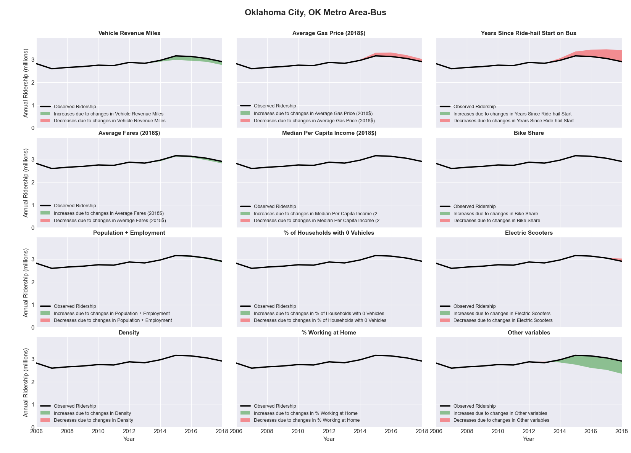

|  |  |  |  |  |  |  |
| --- | --- | --- | --- | --- | --- | --- |
| Olympia, WA Metro Area-Bus | | | | | | |
|  |  |  |  |  |  | |
|  | **Average Values** | | | **Ridership Effect** | | |
| **Description** | **2012** | **2018** | **% Diff** | **Absolute** | **% Diff** | |
|  |  |  |  |  |  | |
| **Vehicle Revenue Miles** | 2,726,030 | 2,876,820 | 5.5% | 108,390 | | **2.5%** | |
| **Average Fare (2018$)** | 0.61 | 0.65 | 7.3% | -78,370 | | **-1.8%** | |
| **Network Restructure** | - | - | - | - | | **0.0%** | |
| **Major Maintenance Event** | - | - | - | - | | **0.0%** | |
| **Population + Employment** | 371,140 | 415,740 | 12.0% | 105,730 | | **2.4%** | |
| **Share of Population and Employment in Transit Supportive Density** | 0.22 | 0.23 | 4.1% | 16,390 | | **0.4%** | |
| **Average Gas Price (2018$)** | 4.35 | 3.40 | -21.8% | -130,620 | | **-3.0%** | |
| **Median Per Capita Income (2018$)** | 34,320 | 37,980 | 10.7% | -29,210 | | **-0.7%** | |
| **% of Households with 0 Vehicles** | 5 | 4 | -26.9% | -11,070 | | **-0.3%** | |
| **% Working at Home** | 4.4 | 4.4 | 0.0% | -1,760 | | **-0.0%** | |
| **Years Since Ride-hail Start** | - | 2 | 2 | -267,380 | | **-6.1%** | |
| **Bike Share** | - | - | - | - | | **0.0%** | |
| **Electric Scooters** | - | - | - | - | | **0.0%** | |
| **New Reporters** |  |  |  | - | | **0.0%** | |
| **Total Modeled Ridership** | 4,373,726 | 4,083,310 | -6.64% | -290415.364 | | **-6.6%** | |
| **Total Observed Ridership** | 4,567,371 | 3,763,430 | -17.60% | -803941 | | **-17.6%** | |
| **Unexplained Change** |  |  |  |  | | **-11.0%** | |

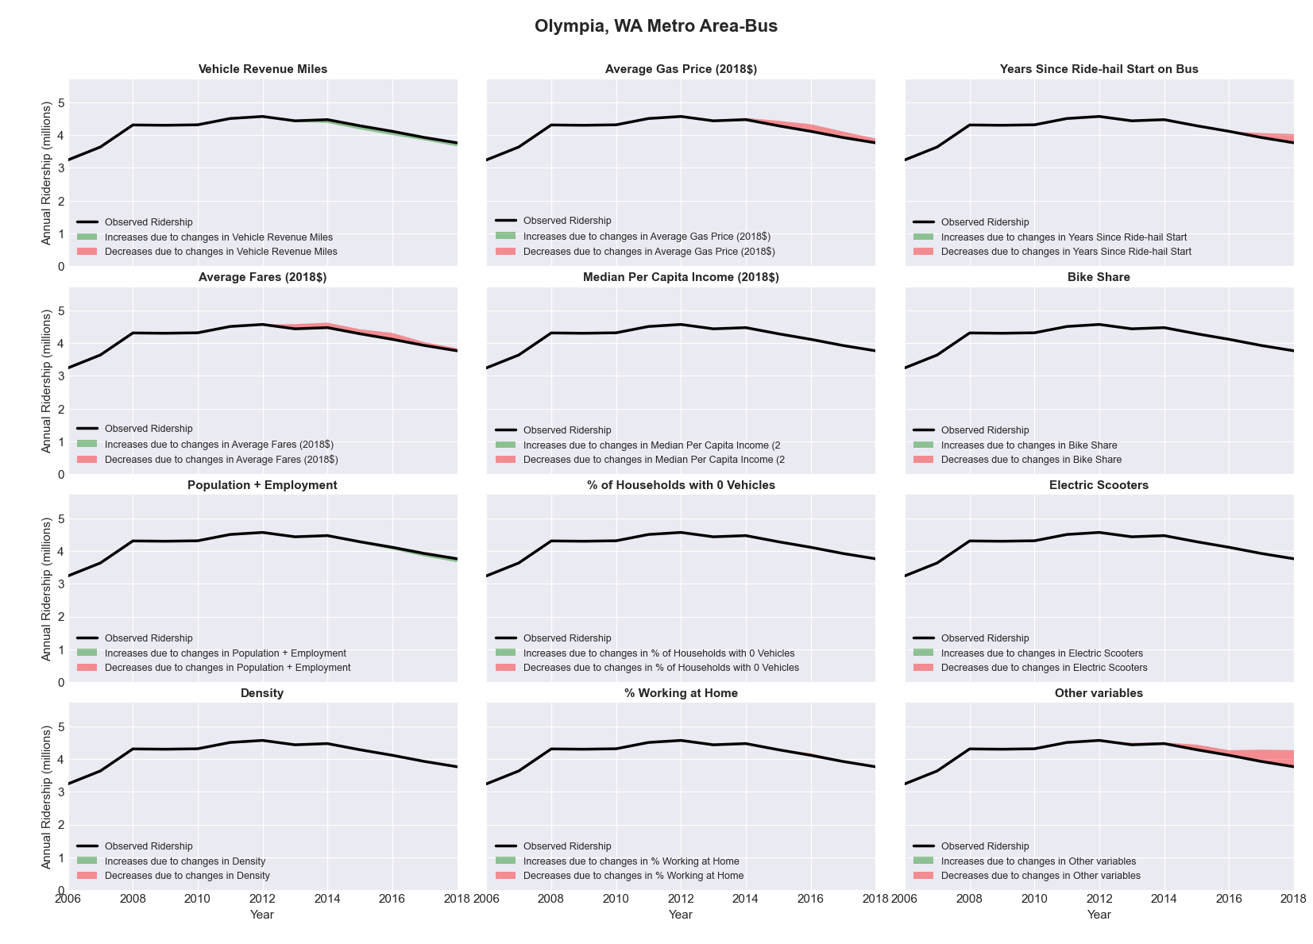

|  |  |  |  |  |  |  |
| --- | --- | --- | --- | --- | --- | --- |
| Omaha-Council Bluffs, NE-IA Metro Area-Bus | | | | | | |
|  |  |  |  |  |  | |
|  | **Average Values** | | | **Ridership Effect** | | |
| **Description** | **2012** | **2018** | **% Diff** | **Absolute** | **% Diff** | |
|  |  |  |  |  |  | |
| **Vehicle Revenue Miles** | 3,931,080 | 4,025,440 | 2.4% | 41,820 | | **1.0%** | |
| **Average Fare (2018$)** | 1.20 | 1.19 | -0.5% | 10,550 | | **0.3%** | |
| **Network Restructure** | - | - | - | - | | **0.0%** | |
| **Major Maintenance Event** | - | - | - | - | | **0.0%** | |
| **Population + Employment** | 1,338,240 | 1,415,700 | 5.8% | 47,840 | | **1.2%** | |
| **Share of Population and Employment in Transit Supportive Density** | 0.31 | 0.31 | -1.6% | -8,610 | | **-0.2%** | |
| **Average Gas Price (2018$)** | 3.93 | 2.72 | -30.9% | -167,300 | | **-4.0%** | |
| **Median Per Capita Income (2018$)** | 31,780 | 36,390 | 14.5% | -36,850 | | **-0.9%** | |
| **% of Households with 0 Vehicles** | 7 | 6 | -8.9% | -4,710 | | **-0.1%** | |
| **% Working at Home** | 3.4 | 4.6 | 34.6% | -32,860 | | **-0.8%** | |
| **Years Since Ride-hail Start** | - | 4 | 4 | -500,280 | | **-12.1%** | |
| **Bike Share** | - | 1 | 1 | - 45,050 | | **-1.1%** | |
| **Electric Scooters** | - | - | - | - | | **0.0%** | |
| **New Reporters** |  |  |  | - | | **0.0%** | |
| **Total Modeled Ridership** | 4,143,822 | 3,447,840 | -16.80% | -695981.792 | | **-16.8%** | |
| **Total Observed Ridership** | 4,225,033 | 3,409,221 | -19.31% | -815812 | | **-19.3%** | |
| **Unexplained Change** |  |  |  |  | | **-2.5%** | |

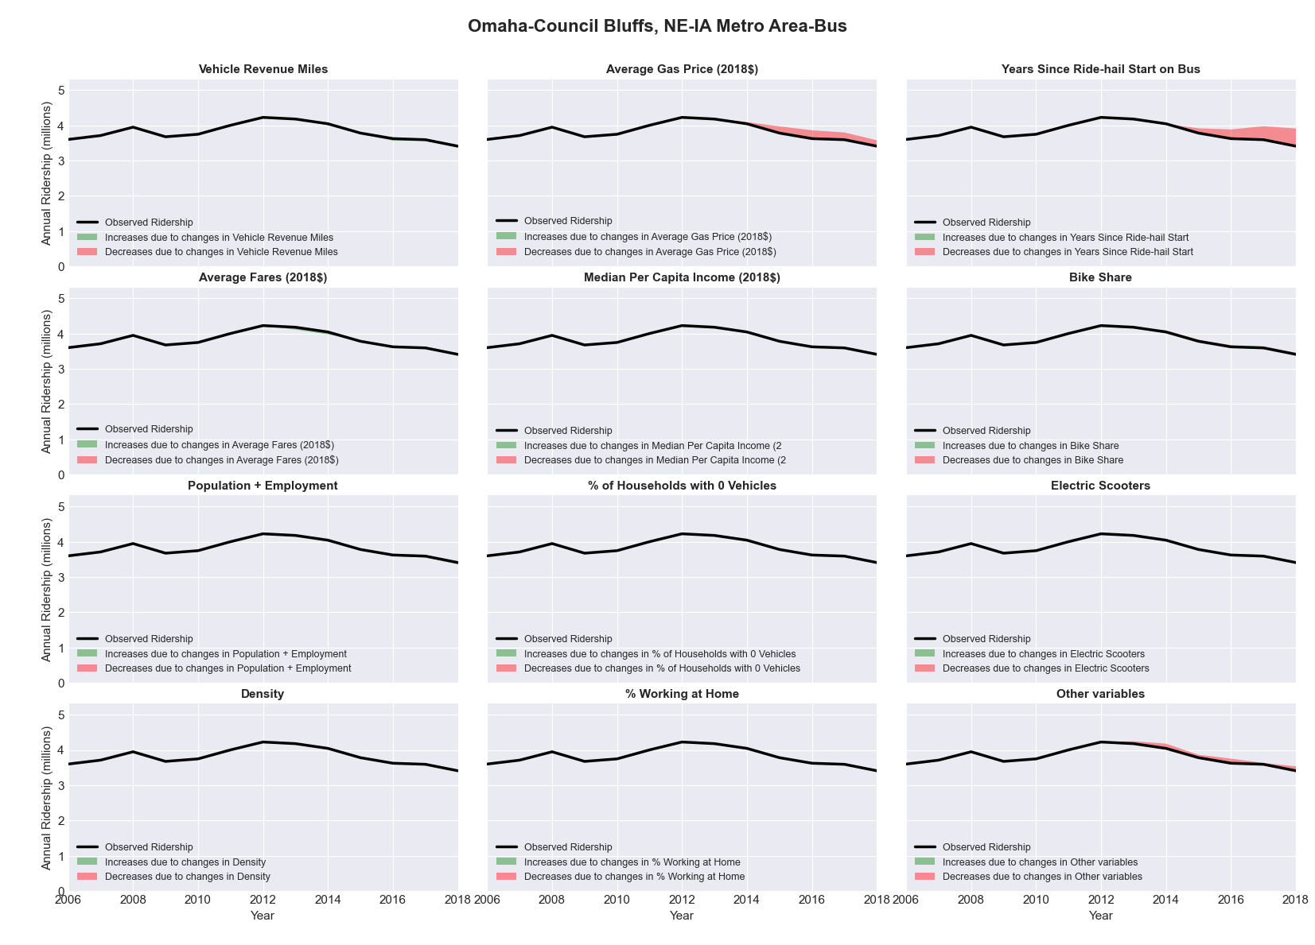

|  |  |  |  |  |  |  |
| --- | --- | --- | --- | --- | --- | --- |
| Orlando-Kissimmee-Sanford, FL Metro Area-Bus | | | | | | |
|  |  |  |  |  |  | |
|  | **Average Values** | | | **Ridership Effect** | | |
| **Description** | **2012** | **2018** | **% Diff** | **Absolute** | **% Diff** | |
|  |  |  |  |  |  | |
| **Vehicle Revenue Miles** | 15,866,260 | 16,599,940 | 4.6% | 577,550 | | **2.0%** | |
| **Average Fare (2018$)** | 1.03 | 0.89 | -13.1% | 1,067,920 | | **3.7%** | |
| **Network Restructure** | - | - | - | - | | **0.0%** | |
| **Major Maintenance Event** | - | - | - | - | | **0.0%** | |
| **Population + Employment** | 3,288,560 | 3,876,460 | 17.9% | 997,140 | | **3.4%** | |
| **Share of Population and Employment in Transit Supportive Density** | 0.22 | 0.22 | -0.6% | -13,270 | | **-0.0%** | |
| **Average Gas Price (2018$)** | 3.95 | 2.71 | -31.3% | -1,229,050 | | **-4.2%** | |
| **Median Per Capita Income (2018$)** | 25,430 | 27,260 | 7.2% | -146,840 | | **-0.5%** | |
| **% of Households with 0 Vehicles** | 6 | 5 | -17.1% | -52,000 | | **-0.2%** | |
| **% Working at Home** | 4.6 | 5.9 | 28.3% | -282,220 | | **-1.0%** | |
| **Years Since Ride-hail Start** | - | 4 | 4 | -3,632,190 | | **-12.5%** | |
| **Bike Share** | - | 1 | 1 | - 316,590 | | **-1.1%** | |
| **Electric Scooters** | - | - | - | - | | **0.0%** | |
| **New Reporters** |  |  |  | - | | **0.0%** | |
| **Total Modeled Ridership** | 29,004,468 | 26,016,284 | -10.30% | -2988184.47 | | **-10.3%** | |
| **Total Observed Ridership** | 28,789,748 | 24,281,359 | -15.66% | -4508389 | | **-15.7%** | |
| **Unexplained Change** |  |  |  |  | | **-5.4%** | |

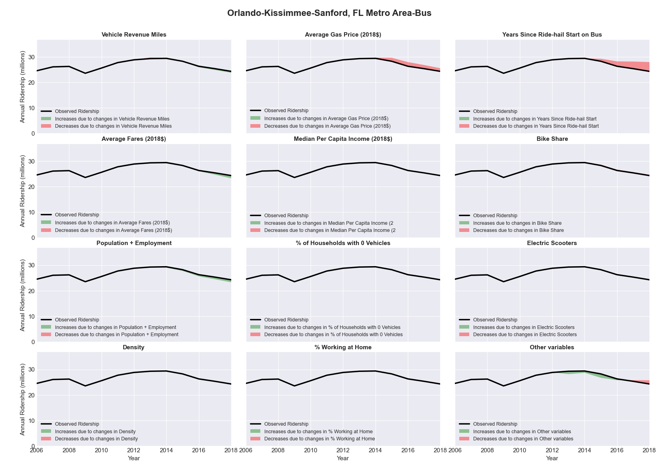

|  |  |  |  |  |  |  |
| --- | --- | --- | --- | --- | --- | --- |
| Oshkosh-Neenah, WI Metro Area-Bus | | | | | | |
|  |  |  |  |  |  | |
|  | **Average Values** | | | **Ridership Effect** | | |
| **Description** | **2012** | **2018** | **% Diff** | **Absolute** | **% Diff** | |
|  |  |  |  |  |  | |
| **Vehicle Revenue Miles** | 543,630 | 544,800 | 0.2% | 0,980 | | **0.1%** | |
| **Average Fare (2018$)** | 0.82 | 0.56 | -32.4% | 87,520 | | **9.7%** | |
| **Network Restructure** | - | - | - | - | | **0.0%** | |
| **Major Maintenance Event** | - | - | - | - | | **0.0%** | |
| **Population + Employment** | 255,140 | 262,760 | 3.0% | 5,820 | | **0.6%** | |
| **Share of Population and Employment in Transit Supportive Density** | 0.21 | 0.22 | 3.9% | 3,200 | | **0.4%** | |
| **Average Gas Price (2018$)** | 3.93 | 2.72 | -30.9% | -36,240 | | **-4.0%** | |
| **Median Per Capita Income (2018$)** | 28,580 | 30,570 | 7.0% | -4,310 | | **-0.5%** | |
| **% of Households with 0 Vehicles** | 6 | 6 | 3.1% | 0,440 | | **0.0%** | |
| **% Working at Home** | 3.1 | 2.1 | -31.5% | 7,110 | | **0.8%** | |
| **Years Since Ride-hail Start** | - | 3 | 3 | -90,300 | | **-10.0%** | |
| **Bike Share** | - | - | - | - | | **0.0%** | |
| **Electric Scooters** | - | - | - | - | | **0.0%** | |
| **New Reporters** |  |  |  | - | | **0.0%** | |
| **Total Modeled Ridership** | 900,226 | 867,849 | -3.60% | -32377.0446 | | **-3.6%** | |
| **Total Observed Ridership** | 987,349 | 867,598 | -12.13% | -119751 | | **-12.1%** | |
| **Unexplained Change** |  |  |  |  | | **-8.5%** | |

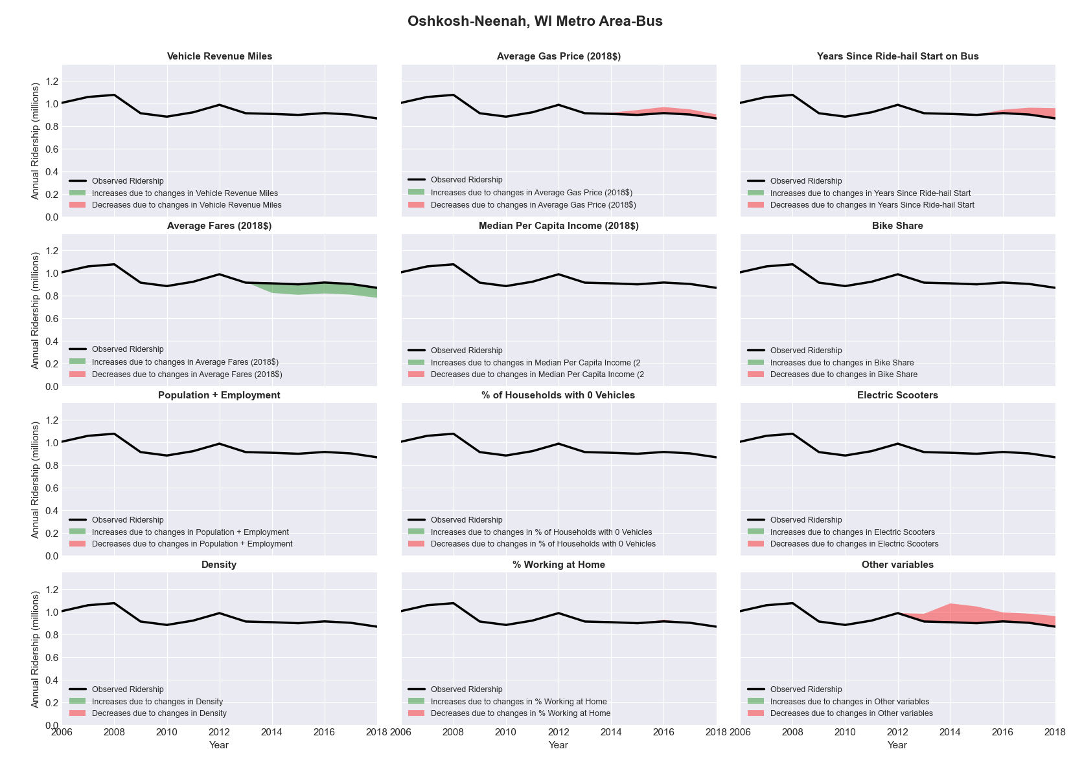

|  |  |  |  |  |  |  |
| --- | --- | --- | --- | --- | --- | --- |
| Oxnard-Thousand Oaks-Ventura, CA Metro Area-Bus | | | | | | |
|  |  |  |  |  |  | |
|  | **Average Values** | | | **Ridership Effect** | | |
| **Description** | **2012** | **2018** | **% Diff** | **Absolute** | **% Diff** | |
|  |  |  |  |  |  | |
| **Vehicle Revenue Miles** | 3,329,150 | 3,807,060 | 14.4% | 282,660 | | **6.2%** | |
| **Average Fare (2018$)** | 1.01 | 0.95 | -5.6% | 67,750 | | **1.5%** | |
| **Network Restructure** | - | - | - | - | | **0.0%** | |
| **Major Maintenance Event** | - | - | - | - | | **0.0%** | |
| **Population + Employment** | 1,231,130 | 1,267,890 | 3.0% | 28,710 | | **0.6%** | |
| **Share of Population and Employment in Transit Supportive Density** | 0.45 | 0.46 | 1.3% | 11,280 | | **0.2%** | |
| **Average Gas Price (2018$)** | 4.35 | 3.40 | -21.8% | -133,900 | | **-2.9%** | |
| **Median Per Capita Income (2018$)** | 30,570 | 33,220 | 8.7% | -26,350 | | **-0.6%** | |
| **% of Households with 0 Vehicles** | 4 | 4 | -4.3% | -1,800 | | **-0.0%** | |
| **% Working at Home** | 5.3 | 7.8 | 47.2% | -83,340 | | **-1.8%** | |
| **Years Since Ride-hail Start** | - | 4 | 4 | -606,400 | | **-13.3%** | |
| **Bike Share** | - | - | - | - | | **0.0%** | |
| **Electric Scooters** | - | - | - | - | | **0.0%** | |
| **New Reporters** |  |  |  | - | | **0.0%** | |
| **Total Modeled Ridership** | 4,568,017 | 4,121,039 | -9.78% | -446978.097 | | **-9.8%** | |
| **Total Observed Ridership** | 4,400,815 | 4,236,638 | -3.73% | -164177 | | **-3.7%** | |
| **Unexplained Change** |  |  |  |  | | **6.1%** | |

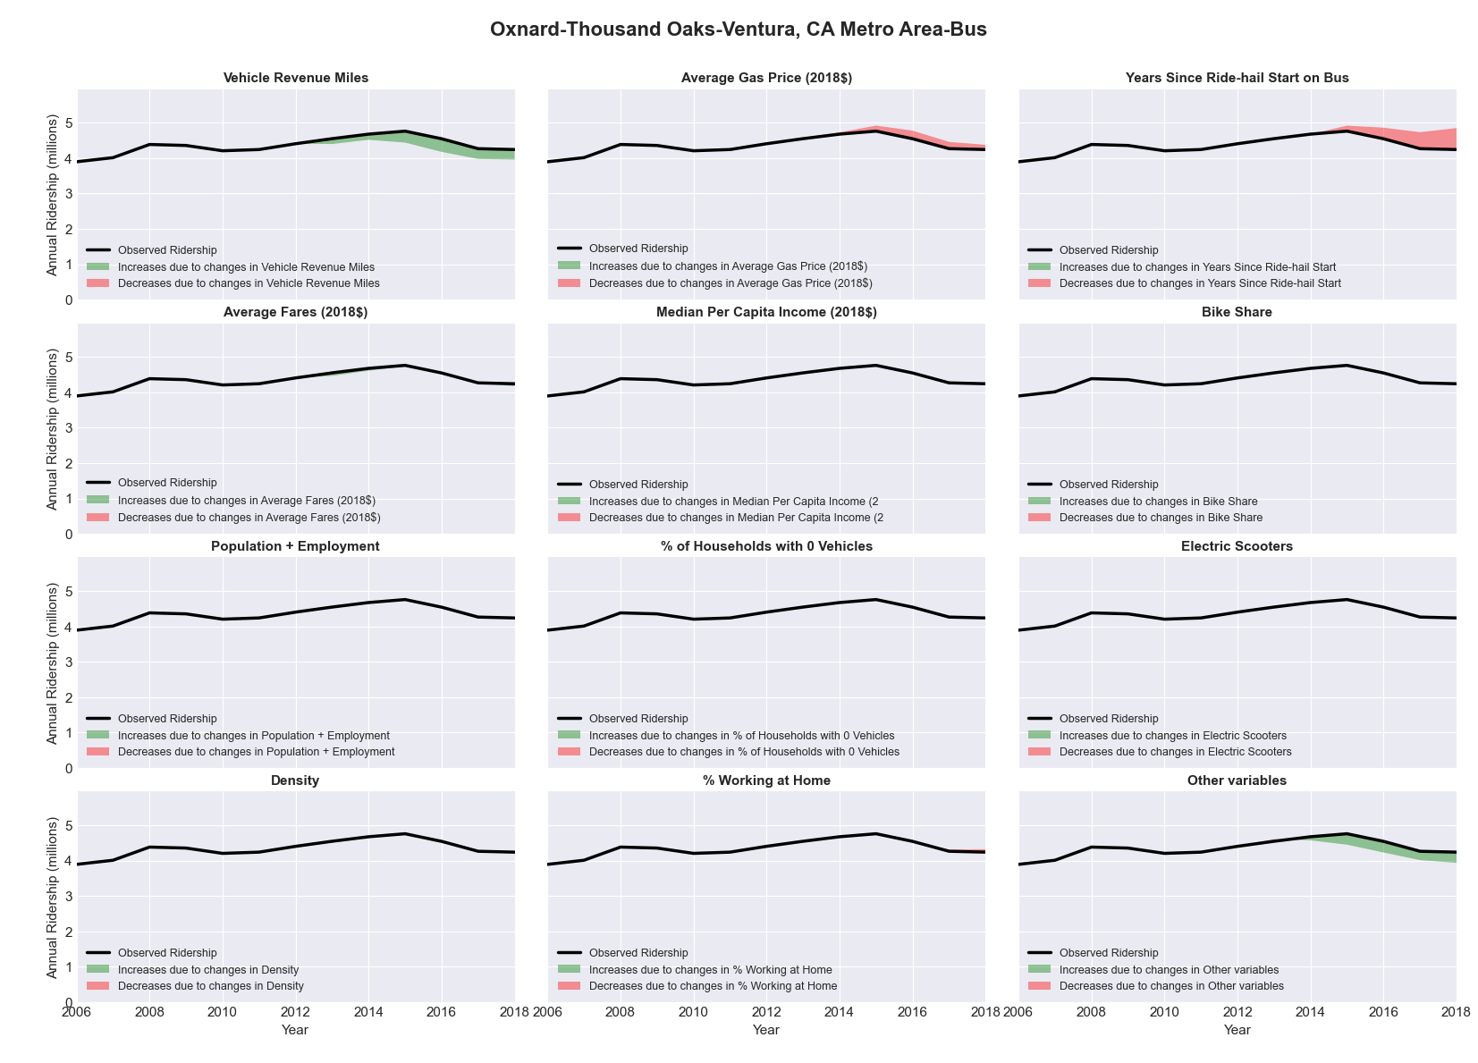

|  |  |  |  |  |  |  |
| --- | --- | --- | --- | --- | --- | --- |
| Palm Bay-Melbourne-Titusville, FL Metro Area-Bus | | | | | | |
|  |  |  |  |  |  | |
|  | **Average Values** | | | **Ridership Effect** | | |
| **Description** | **2012** | **2018** | **% Diff** | **Absolute** | **% Diff** | |
|  |  |  |  |  |  | |
| **Vehicle Revenue Miles** | 1,512,360 | 1,862,790 | 23.2% | 218,770 | | **9.6%** | |
| **Average Fare (2018$)** | 0.46 | 0.30 | -34.7% | 160,920 | | **7.0%** | |
| **Network Restructure** | - | - | - | - | | **0.0%** | |
| **Major Maintenance Event** | - | - | - | - | | **0.0%** | |
| **Population + Employment** | 785,270 | 861,350 | 9.7% | 45,700 | | **2.0%** | |
| **Share of Population and Employment in Transit Supportive Density** | 0.04 | 0.03 | -22.4% | -8,950 | | **-0.4%** | |
| **Average Gas Price (2018$)** | 3.95 | 2.71 | -31.3% | -97,040 | | **-4.2%** | |
| **Median Per Capita Income (2018$)** | 26,040 | 27,600 | 6.0% | -8,900 | | **-0.4%** | |
| **% of Households with 0 Vehicles** | 5 | 5 | -12.7% | -3,570 | | **-0.2%** | |
| **% Working at Home** | 4.6 | 8.0 | 72.8% | -56,110 | | **-2.5%** | |
| **Years Since Ride-hail Start** | - | 4 | 4 | -301,060 | | **-13.2%** | |
| **Bike Share** | - | - | - | - | | **0.0%** | |
| **Electric Scooters** | - | - | - | - | | **0.0%** | |
| **New Reporters** |  |  |  | - | | **0.0%** | |
| **Total Modeled Ridership** | 2,288,949 | 2,219,755 | -3.02% | -69193.5778 | | **-3.0%** | |
| **Total Observed Ridership** | 2,122,677 | 2,109,362 | -0.63% | -13315 | | **-0.6%** | |
| **Unexplained Change** |  |  |  |  | | **2.4%** | |

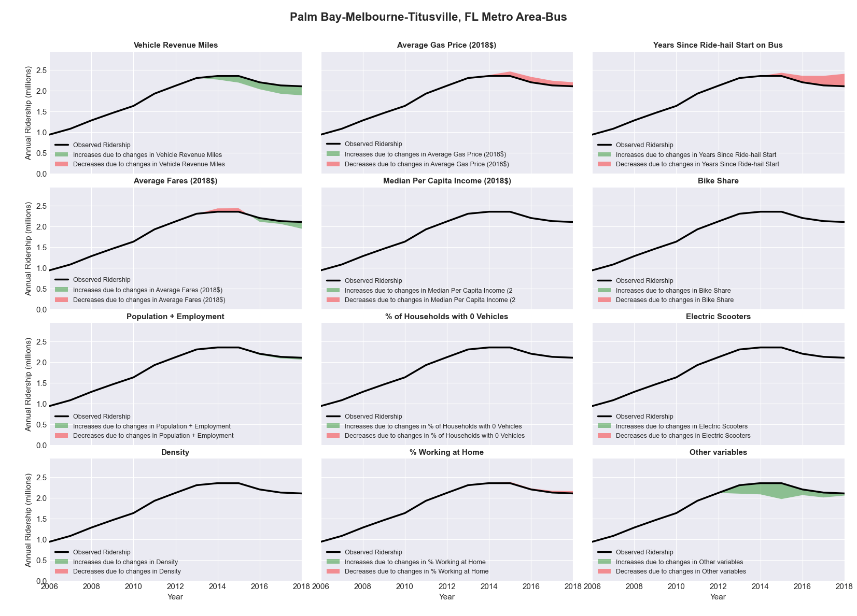

|  |  |  |  |  |  |  |
| --- | --- | --- | --- | --- | --- | --- |
| Pensacola-Ferry Pass-Brent, FL Metro Area-Bus | | | | | | |
|  |  |  |  |  |  | |
|  | **Average Values** | | | **Ridership Effect** | | |
| **Description** | **2012** | **2018** | **% Diff** | **Absolute** | **% Diff** | |
|  |  |  |  |  |  | |
| **Vehicle Revenue Miles** | 1,487,490 | 1,570,110 | 5.6% | 34,480 | | **2.4%** | |
| **Average Fare (2018$)** | 1.24 | 0.71 | -42.7% | 246,830 | | **17.2%** | |
| **Network Restructure** | - | - | - | - | | **0.0%** | |
| **Major Maintenance Event** | - | - | - | - | | **0.0%** | |
| **Population + Employment** | 656,360 | 709,360 | 8.1% | 24,780 | | **1.7%** | |
| **Share of Population and Employment in Transit Supportive Density** | 0.16 | 0.15 | -3.4% | -3,210 | | **-0.2%** | |
| **Average Gas Price (2018$)** | 3.95 | 2.71 | -31.3% | -60,010 | | **-4.2%** | |
| **Median Per Capita Income (2018$)** | 27,630 | 27,690 | 0.2% | -0,120 | | **-0.0%** | |
| **% of Households with 0 Vehicles** | 5 | 5 | 0.2% | 0,030 | | **0.0%** | |
| **% Working at Home** | 6.9 | 5.1 | -26.1% | 19,440 | | **1.4%** | |
| **Years Since Ride-hail Start** | - | 4 | 4 | -192,220 | | **-13.4%** | |
| **Bike Share** | - | - | - | - | | **0.0%** | |
| **Electric Scooters** | - | - | - | - | | **0.0%** | |
| **New Reporters** |  |  |  | - | | **0.0%** | |
| **Total Modeled Ridership** | 1,436,429 | 1,483,604 | 3.28% | 47174.4865 | | **3.3%** | |
| **Total Observed Ridership** | 1,501,900 | 1,385,976 | -7.72% | -115924 | | **-7.7%** | |
| **Unexplained Change** |  |  |  |  | | **-11.0%** | |

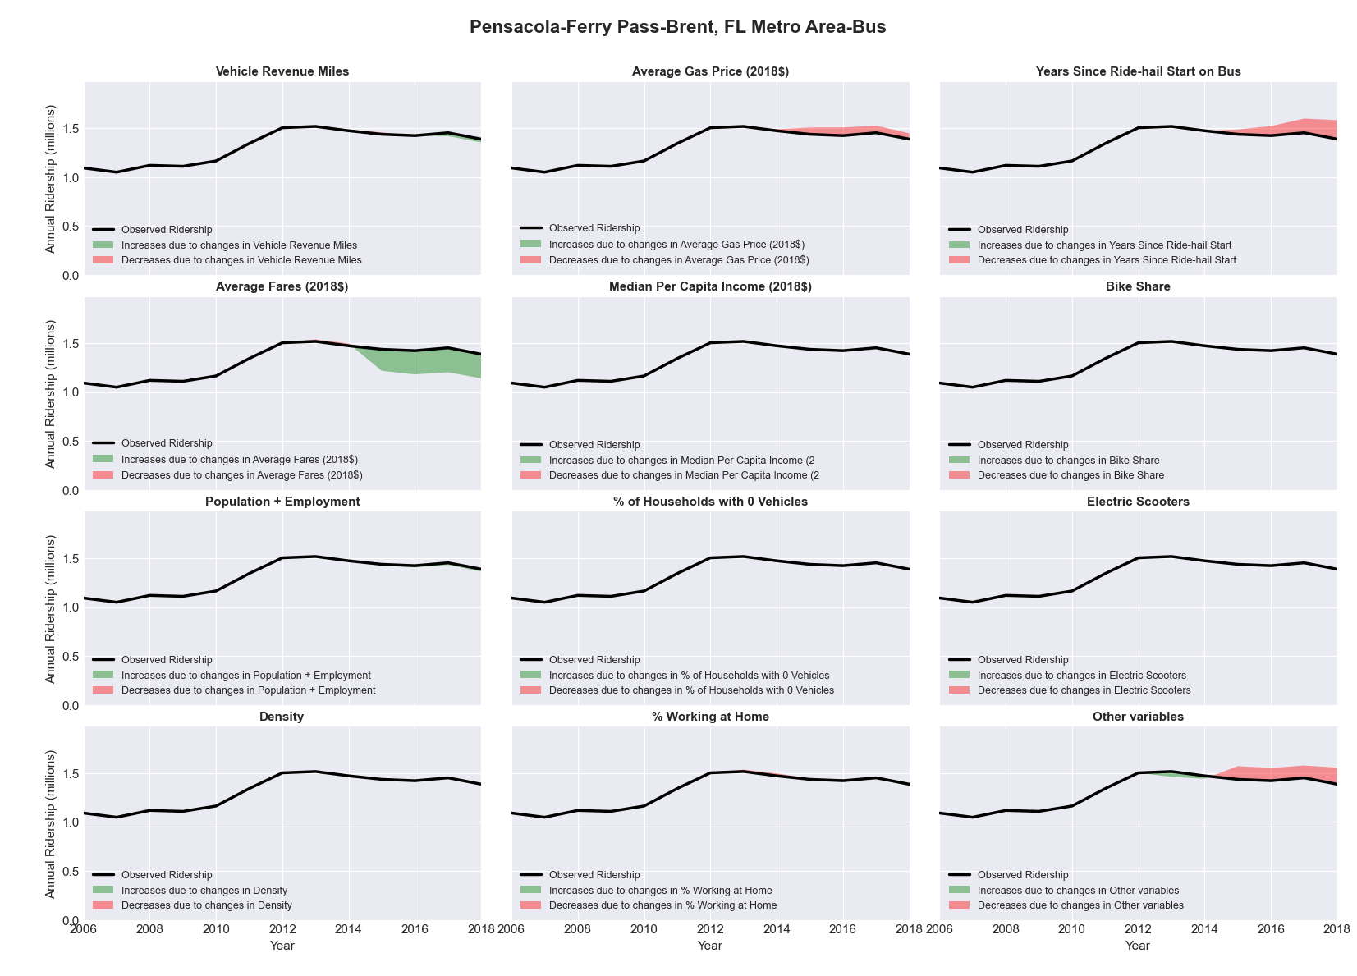

|  |  |  |  |  |  |  |
| --- | --- | --- | --- | --- | --- | --- |
| Peoria, IL Metro Area-Bus | | | | | | |
|  |  |  |  |  |  | |
|  | **Average Values** | | | **Ridership Effect** | | |
| **Description** | **2012** | **2018** | **% Diff** | **Absolute** | **% Diff** | |
|  |  |  |  |  |  | |
| **Vehicle Revenue Miles** | 1,854,440 | 2,008,590 | 8.3% | 123,160 | | **4.1%** | |
| **Average Fare (2018$)** | 0.80 | 0.58 | -26.9% | 248,560 | | **8.3%** | |
| **Network Restructure** | - | - | - | - | | **0.0%** | |
| **Major Maintenance Event** | - | - | - | - | | **0.0%** | |
| **Population + Employment** | 562,770 | 541,370 | -3.8% | -27,210 | | **-0.9%** | |
| **Share of Population and Employment in Transit Supportive Density** | 0.14 | 0.14 | -0.0% | -0,440 | | **-0.0%** | |
| **Average Gas Price (2018$)** | 3.93 | 2.72 | -30.9% | -145,420 | | **-4.8%** | |
| **Median Per Capita Income (2018$)** | 29,700 | 31,500 | 6.1% | -15,000 | | **-0.5%** | |
| **% of Households with 0 Vehicles** | 7 | 7 | 1.7% | 1,900 | | **0.1%** | |
| **% Working at Home** | 3.3 | 3.2 | -4.5% | 2,550 | | **0.1%** | |
| **Years Since Ride-hail Start** | - | 3 | 3 | -289,970 | | **-9.6%** | |
| **Bike Share** | - | 1 | 1 | - 30,240 | | **-1.0%** | |
| **Electric Scooters** | - | - | - | - | | **0.0%** | |
| **New Reporters** |  |  |  | - | | **0.0%** | |
| **Total Modeled Ridership** | 3,007,164 | 2,847,895 | -5.30% | -159269.351 | | **-5.3%** | |
| **Total Observed Ridership** | 3,349,766 | 2,681,837 | -19.94% | -667929 | | **-19.9%** | |
| **Unexplained Change** |  |  |  |  | | **-14.6%** | |

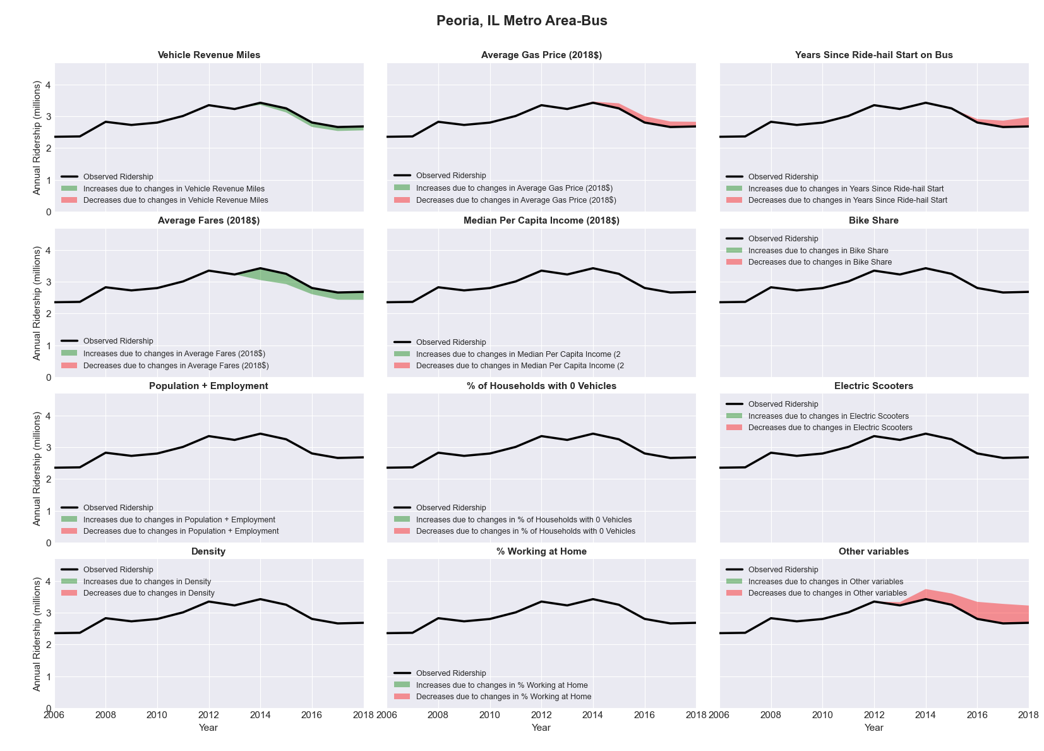

|  |  |  |  |  |  |  |
| --- | --- | --- | --- | --- | --- | --- |
| Philadelphia-Camden-Wilmington, PA-NJ-DE-MD Metro Area-Bus | | | | | | |
|  |  |  |  |  |  | |
|  | **Average Values** | | | **Ridership Effect** | | |
| **Description** | **2012** | **2018** | **% Diff** | **Absolute** | **% Diff** | |
|  |  |  |  |  |  | |
| **Vehicle Revenue Miles** | 48,015,420 | 50,123,460 | 4.4% | 3,452,900 | | **1.7%** | |
| **Average Fare (2018$)** | 1.08 | 1.11 | 2.7% | -1,413,110 | | **-0.7%** | |
| **Network Restructure** | - | - | - | - | | **0.0%** | |
| **Major Maintenance Event** | - | - | - | - | | **0.0%** | |
| **Population + Employment** | 8,811,530 | 9,078,790 | 3.0% | 1,235,370 | | **0.6%** | |
| **Share of Population and Employment in Transit Supportive Density** | 0.39 | 0.40 | 2.2% | 674,340 | | **0.3%** | |
| **Average Gas Price (2018$)** | 4.11 | 2.92 | -28.9% | -7,318,470 | | **-3.6%** | |
| **Median Per Capita Income (2018$)** | 32,350 | 35,850 | 10.8% | -1,340,970 | | **-0.7%** | |
| **% of Households with 0 Vehicles** | 14 | 14 | 1.9% | 68,940 | | **0.0%** | |
| **% Working at Home** | 4.2 | 5.7 | 34.5% | -2,091,710 | | **-1.0%** | |
| **Years Since Ride-hail Start** | - | 6 | 6 | -21,820,620 | | **-10.8%** | |
| **Bike Share** | - | 1 | 1 | - 2,045,690 | | **-1.0%** | |
| **Electric Scooters** | - | - | - | - | | **0.0%** | |
| **New Reporters** |  |  |  | - | | **0.0%** | |
| **Total Modeled Ridership** | 201,856,519 | 171,712,798 | -14.93% | -30143721.2 | | **-14.9%** | |
| **Total Observed Ridership** | 192,220,056 | 161,912,862 | -15.77% | -30307194 | | **-15.8%** | |
| **Unexplained Change** |  |  |  |  | | **-0.8%** | |

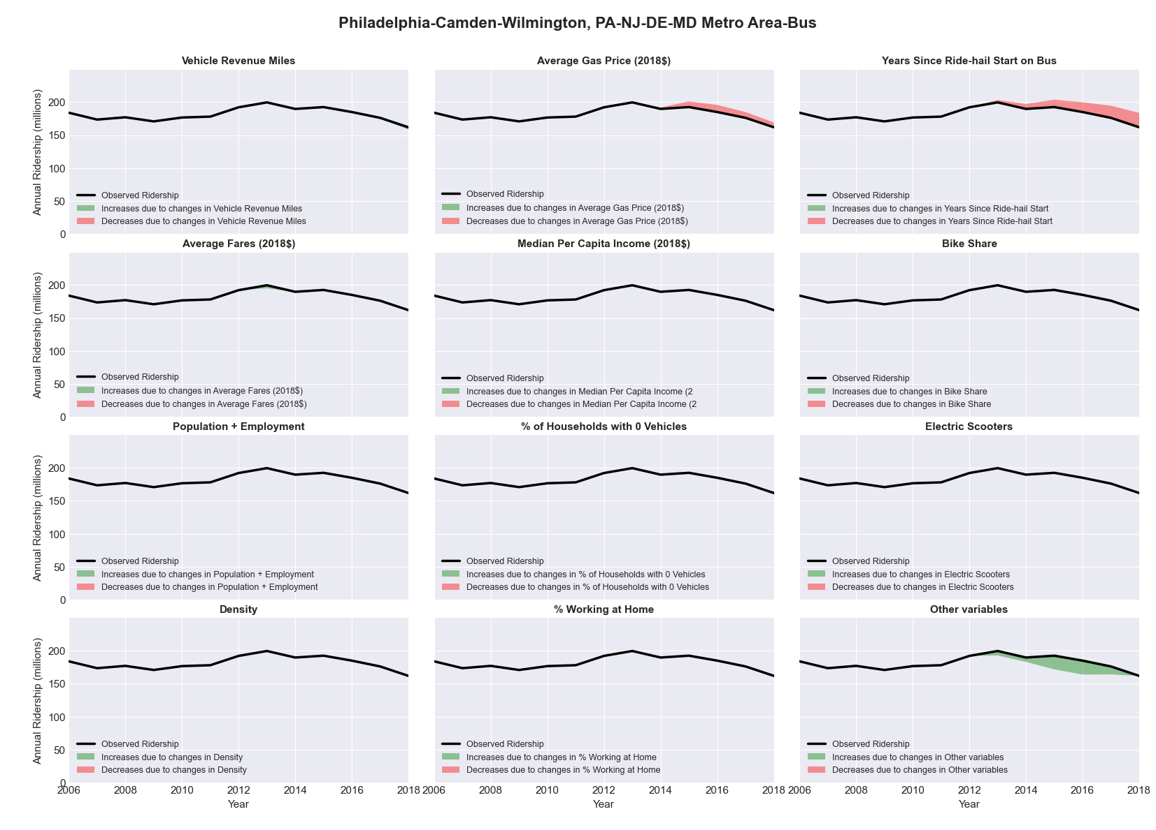

|  |  |  |  |  |  |  |
| --- | --- | --- | --- | --- | --- | --- |
| Philadelphia-Camden-Wilmington, PA-NJ-DE-MD Metro Area-Rail | | | | | | |
|  |  |  |  |  |  | |
|  | **Average Values** | | | **Ridership Effect** | | |
| **Description** | **2012** | **2018** | **% Diff** | **Absolute** | **% Diff** | |
|  |  |  |  |  |  | |
| **Vehicle Revenue Miles** | 45,208,620 | 49,151,650 | 8.7% | 9,660,080 | | **5.5%** | |
| **Average Fare (2018$)** | 1.84 | 1.99 | 8.1% | -3,249,010 | | **-1.9%** | |
| **Network Restructure** | - | - | - | - | | **0.0%** | |
| **Major Maintenance Event** | - | - | - | - | | **0.0%** | |
| **Population + Employment** | 8,811,530 | 9,078,790 | 3.0% | 1,124,840 | | **0.6%** | |
| **Share of Population and Employment in Transit Supportive Density** | 0.39 | 0.40 | 2.2% | 612,270 | | **0.4%** | |
| **Average Gas Price (2018$)** | 4.11 | 2.92 | -28.9% | -6,658,450 | | **-3.8%** | |
| **Median Per Capita Income (2018$)** | 32,350 | 35,850 | 10.8% | -1,233,850 | | **-0.7%** | |
| **% of Households with 0 Vehicles** | 14 | 14 | 1.9% | 67,460 | | **0.0%** | |
| **% Working at Home** | 4.2 | 5.7 | 34.5% | -1,906,600 | | **-1.1%** | |
| **Years Since Ride-hail Start** | - | 6 | 6 | 2,256,580 | | **1.3%** | |
| **Bike Share** | - | 1 | 1 | - 1,875,370 | | **-1.1%** | |
| **Electric Scooters** | - | - | - | - | | **0.0%** | |
| **New Reporters** |  |  |  | - | | **0.0%** | |
| **Total Modeled Ridership** | 174,061,709 | 173,023,914 | -0.60% | -1037794.2 | | **-0.6%** | |
| **Total Observed Ridership** | 175,720,920 | 163,836,049 | -6.76% | -11884871 | | **-6.8%** | |
| **Unexplained Change** |  |  |  |  | | **-6.2%** | |

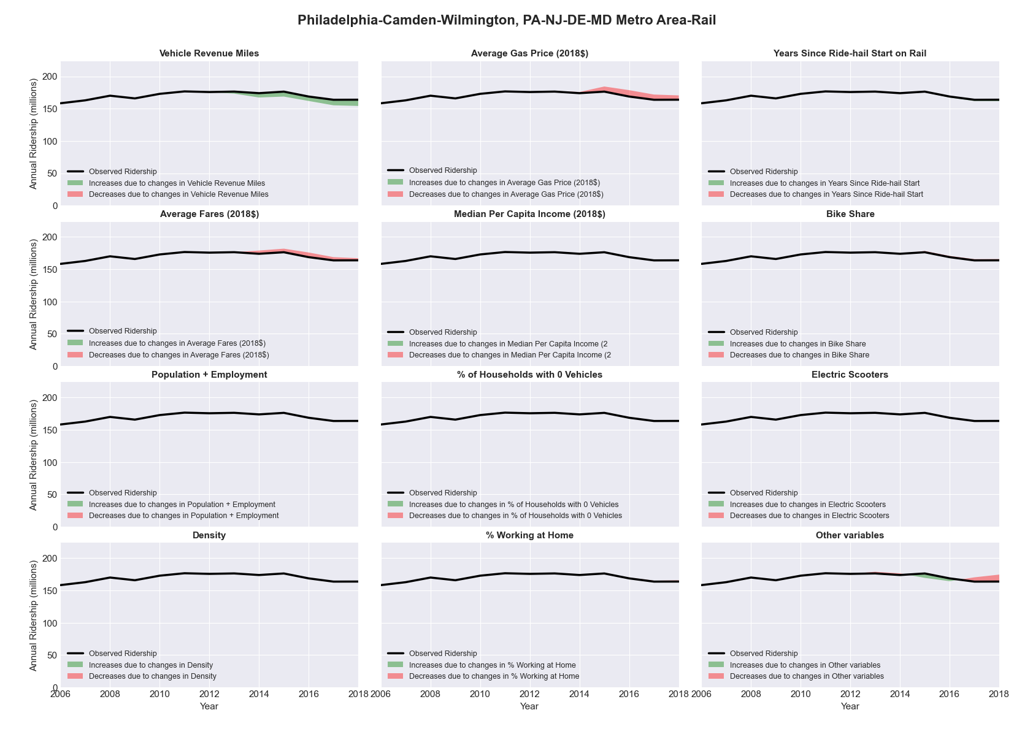

|  |  |  |  |  |  |  |
| --- | --- | --- | --- | --- | --- | --- |
| Phoenix-Mesa-Glendale, AZ Metro Area-Bus | | | | | | |
|  |  |  |  |  |  | |
|  | **Average Values** | | | **Ridership Effect** | | |
| **Description** | **2012** | **2018** | **% Diff** | **Absolute** | **% Diff** | |
|  |  |  |  |  |  | |
| **Vehicle Revenue Miles** | 27,603,180 | 34,792,530 | 26.0% | 5,561,120 | | **9.5%** | |
| **Average Fare (2018$)** | 0.76 | 0.66 | -13.4% | 1,593,100 | | **2.7%** | |
| **Network Restructure** | - | - | - | - | | **0.0%** | |
| **Major Maintenance Event** | - | - | - | - | | **0.0%** | |
| **Population + Employment** | 6,223,120 | 7,090,130 | 13.9% | 1,573,040 | | **2.7%** | |
| **Share of Population and Employment in Transit Supportive Density** | 0.45 | 0.44 | -1.8% | -177,780 | | **-0.3%** | |
| **Average Gas Price (2018$)** | 4.35 | 3.40 | -21.8% | -1,652,940 | | **-2.8%** | |
| **Median Per Capita Income (2018$)** | 29,870 | 32,320 | 8.2% | -306,230 | | **-0.5%** | |
| **% of Households with 0 Vehicles** | 7 | 5 | -27.1% | -186,720 | | **-0.3%** | |
| **% Working at Home** | 5.6 | 7.0 | 25.4% | -596,260 | | **-1.0%** | |
| **Years Since Ride-hail Start** | - | 6 | 6 | -6,376,850 | | **-10.9%** | |
| **Bike Share** | - | 1 | 1 | - 630,170 | | **-1.1%** | |
| **Electric Scooters** | - | 1 | 1 | - 2,080,100 | | **-3.6%** | |
| **New Reporters** |  |  |  | - | | **0.0%** | |
| **Total Modeled Ridership** | 58,567,948 | 55,644,731 | -4.99% | -2923216.92 | | **-5.0%** | |
| **Total Observed Ridership** | 58,355,581 | 50,872,279 | -12.82% | -7483302 | | **-12.8%** | |
| **Unexplained Change** |  |  |  |  | | **-7.8%** | |

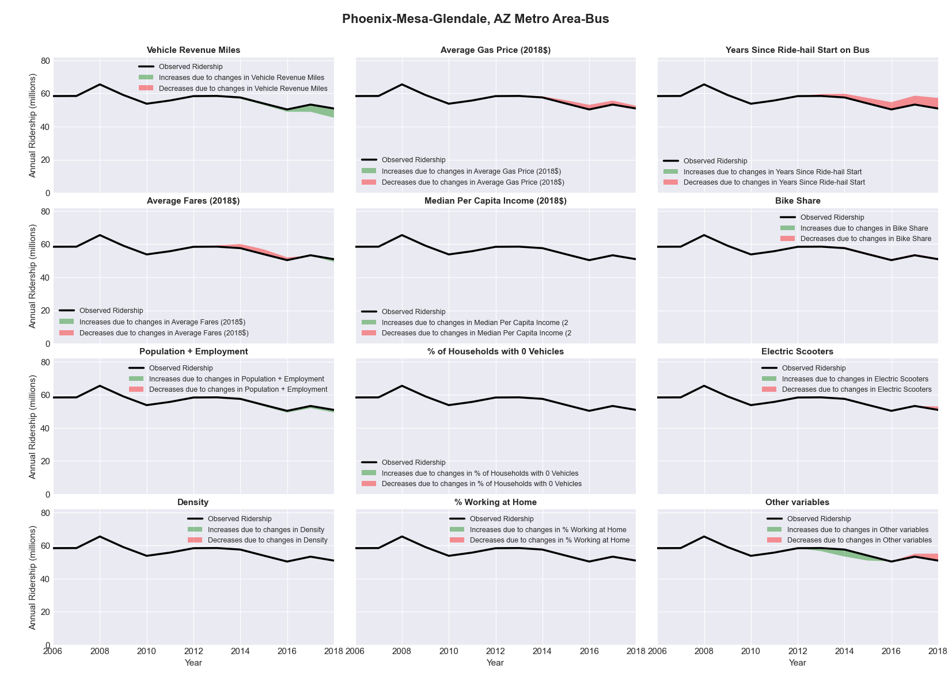

|  |  |  |  |  |  |  |
| --- | --- | --- | --- | --- | --- | --- |
| Phoenix-Mesa-Glendale, AZ Metro Area-Rail | | | | | | |
|  |  |  |  |  |  | |
|  | **Average Values** | | | **Ridership Effect** | | |
| **Description** | **2012** | **2018** | **% Diff** | **Absolute** | **% Diff** | |
|  |  |  |  |  |  | |
| **Vehicle Revenue Miles** | 2,442,460 | 3,286,320 | 34.5% | 3,062,900 | | **21.8%** | |
| **Average Fare (2018$)** | 0.92 | 0.88 | -4.2% | 102,150 | | **0.7%** | |
| **Network Restructure** | - | - | - | - | | **0.0%** | |
| **Major Maintenance Event** | - | - | - | - | | **0.0%** | |
| **Population + Employment** | 6,223,120 | 7,090,130 | 13.9% | 426,900 | | **3.0%** | |
| **Share of Population and Employment in Transit Supportive Density** | 0.45 | 0.44 | -1.8% | -46,510 | | **-0.3%** | |
| **Average Gas Price (2018$)** | 4.35 | 3.40 | -21.8% | -353,900 | | **-2.5%** | |
| **Median Per Capita Income (2018$)** | 29,870 | 32,320 | 8.2% | -85,050 | | **-0.6%** | |
| **% of Households with 0 Vehicles** | 7 | 5 | -27.1% | -56,440 | | **-0.4%** | |
| **% Working at Home** | 5.6 | 7.0 | 25.4% | -161,320 | | **-1.1%** | |
| **Years Since Ride-hail Start** | - | 6 | 6 | 195,940 | | **1.4%** | |
| **Bike Share** | - | 1 | 1 | - 153,380 | | **-1.1%** | |
| **Electric Scooters** | - | 1 | 1 | - 635,480 | | **-4.5%** | |
| **New Reporters** |  |  |  | - | | **0.0%** | |
| **Total Modeled Ridership** | 14,060,821 | 16,221,544 | 15.37% | 2160722.61 | | **15.4%** | |
| **Total Observed Ridership** | 14,042,008 | 15,406,410 | 9.72% | 1364402 | | **9.7%** | |
| **Unexplained Change** |  |  |  |  | | **-5.7%** | |

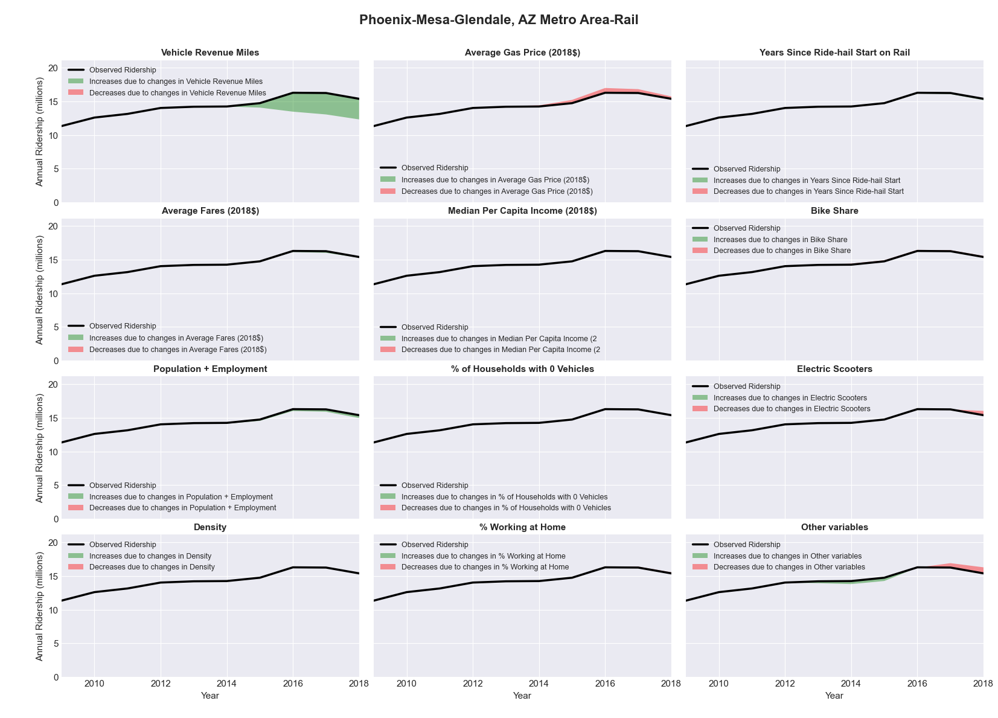

|  |  |  |  |  |  |  |
| --- | --- | --- | --- | --- | --- | --- |
| Pittsburgh, PA Metro Area-Bus | | | | | | |
|  |  |  |  |  |  | |
|  | **Average Values** | | | **Ridership Effect** | | |
| **Description** | **2012** | **2018** | **% Diff** | **Absolute** | **% Diff** | |
|  |  |  |  |  |  | |
| **Vehicle Revenue Miles** | 21,046,970 | 23,599,770 | 12.1% | 2,844,080 | | **4.9%** | |
| **Average Fare (2018$)** | 1.54 | 1.45 | -5.5% | 1,060,450 | | **1.8%** | |
| **Network Restructure** | - | - | - | - | | **0.0%** | |
| **Major Maintenance Event** | - | - | - | - | | **0.0%** | |
| **Population + Employment** | 3,499,540 | 3,472,700 | -0.8% | -91,300 | | **-0.2%** | |
| **Share of Population and Employment in Transit Supportive Density** | 0.29 | 0.28 | -1.0% | -62,280 | | **-0.1%** | |
| **Average Gas Price (2018$)** | 4.11 | 2.92 | -28.9% | -2,073,600 | | **-3.6%** | |
| **Median Per Capita Income (2018$)** | 28,830 | 32,200 | 11.7% | -428,390 | | **-0.7%** | |
| **% of Households with 0 Vehicles** | 11 | 9 | -13.7% | -164,910 | | **-0.3%** | |
| **% Working at Home** | 3.6 | 5.1 | 40.3% | -607,910 | | **-1.1%** | |
| **Years Since Ride-hail Start** | - | 4 | 4 | -4,210,390 | | **-7.3%** | |
| **Bike Share** | - | 1 | 1 | - 599,000 | | **-1.0%** | |
| **Electric Scooters** | - | - | - | - | | **0.0%** | |
| **New Reporters** |  |  |  | - | | **0.0%** | |
| **Total Modeled Ridership** | 57,597,878 | 53,164,077 | -7.70% | -4433800.97 | | **-7.7%** | |
| **Total Observed Ridership** | 55,828,155 | 55,709,140 | -0.21% | -119015 | | **-0.2%** | |
| **Unexplained Change** |  |  |  |  | | **7.5%** | |

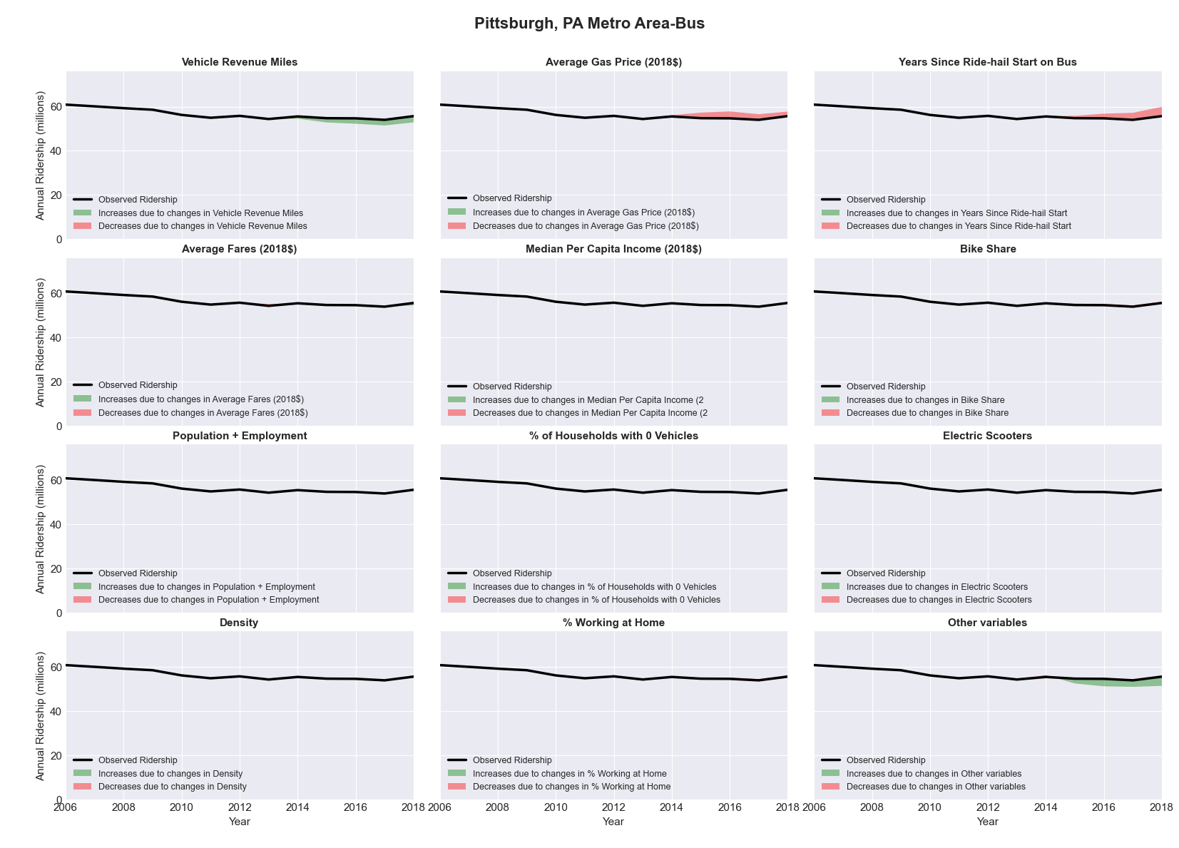

|  |  |  |  |  |  |  |
| --- | --- | --- | --- | --- | --- | --- |
| Pittsburgh, PA Metro Area-Rail | | | | | | |
|  |  |  |  |  |  | |
|  | **Average Values** | | | **Ridership Effect** | | |
| **Description** | **2012** | **2018** | **% Diff** | **Absolute** | **% Diff** | |
|  |  |  |  |  |  | |
| **Vehicle Revenue Miles** | 1,983,660 | 2,202,450 | 11.0% | 618,050 | | **7.1%** | |
| **Average Fare (2018$)** | 1.27 | 1.10 | -13.7% | 226,920 | | **2.6%** | |
| **Network Restructure** | - | - | - | - | | **0.0%** | |
| **Major Maintenance Event** | - | - | - | - | | **0.0%** | |
| **Population + Employment** | 3,499,540 | 3,472,700 | -0.8% | -14,290 | | **-0.2%** | |
| **Share of Population and Employment in Transit Supportive Density** | 0.29 | 0.28 | -1.0% | -10,250 | | **-0.1%** | |
| **Average Gas Price (2018$)** | 4.11 | 2.92 | -28.9% | -334,950 | | **-3.9%** | |
| **Median Per Capita Income (2018$)** | 28,830 | 32,200 | 11.7% | -67,810 | | **-0.8%** | |
| **% of Households with 0 Vehicles** | 11 | 9 | -13.7% | -25,220 | | **-0.3%** | |
| **% Working at Home** | 3.6 | 5.1 | 40.3% | -96,680 | | **-1.1%** | |
| **Years Since Ride-hail Start** | - | 4 | 4 | 74,580 | | **0.9%** | |
| **Bike Share** | - | 1 | 1 | - 94,610 | | **-1.1%** | |
| **Electric Scooters** | - | - | - | - | | **0.0%** | |
| **New Reporters** |  |  |  | - | | **0.0%** | |
| **Total Modeled Ridership** | 8,651,301 | 8,933,164 | 3.26% | 281863.297 | | **3.3%** | |
| **Total Observed Ridership** | 8,992,620 | 7,920,730 | -11.92% | -1071890 | | **-11.9%** | |
| **Unexplained Change** |  |  |  |  | | **-15.2%** | |

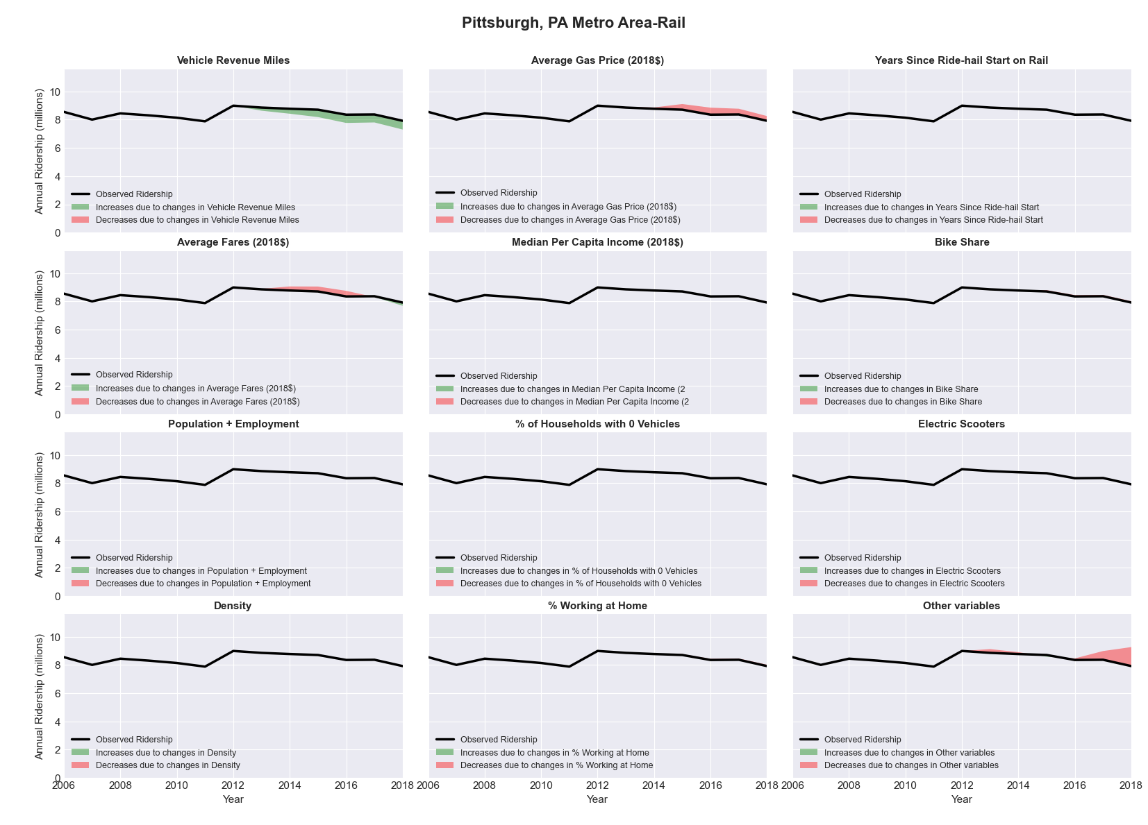

|  |  |  |  |  |  |  |
| --- | --- | --- | --- | --- | --- | --- |
| Portland-South Portland-Biddeford, ME Metro Area-Bus | | | | | | |
|  |  |  |  |  |  | |
|  | **Average Values** | | | **Ridership Effect** | | |
| **Description** | **2012** | **2018** | **% Diff** | **Absolute** | **% Diff** | |
|  |  |  |  |  |  | |
| **Vehicle Revenue Miles** | 829,840 | 1,149,490 | 38.5% | 264,180 | | **15.8%** | |
| **Average Fare (2018$)** | 1.32 | 1.05 | -20.7% | 116,780 | | **7.0%** | |
| **Network Restructure** | - | - | - | - | | **0.0%** | |
| **Major Maintenance Event** | - | - | - | - | | **0.0%** | |
| **Population + Employment** | 789,450 | 828,630 | 5.0% | 17,320 | | **1.0%** | |
| **Share of Population and Employment in Transit Supportive Density** | 0.14 | 0.14 | 0.4% | 0,150 | | **0.0%** | |
| **Average Gas Price (2018$)** | 4.13 | 2.85 | -31.0% | -53,980 | | **-3.2%** | |
| **Median Per Capita Income (2018$)** | 29,800 | 35,000 | 17.4% | -18,570 | | **-1.1%** | |
| **% of Households with 0 Vehicles** | 6 | 4 | -30.4% | -7,540 | | **-0.5%** | |
| **% Working at Home** | 5.6 | 7.1 | 26.8% | -19,310 | | **-1.2%** | |
| **Years Since Ride-hail Start** | - | 4 | 4 | -223,500 | | **-13.4%** | |
| **Bike Share** | - | - | - | - | | **0.0%** | |
| **Electric Scooters** | - | - | - | - | | **0.0%** | |
| **New Reporters** |  |  |  | - | | **0.0%** | |
| **Total Modeled Ridership** | 1,669,684 | 1,715,580 | 2.75% | 45895.8471 | | **2.7%** | |
| **Total Observed Ridership** | 1,464,676 | 1,947,038 | 32.93% | 482362 | | **32.9%** | |
| **Unexplained Change** |  |  |  |  | | **30.2%** | |

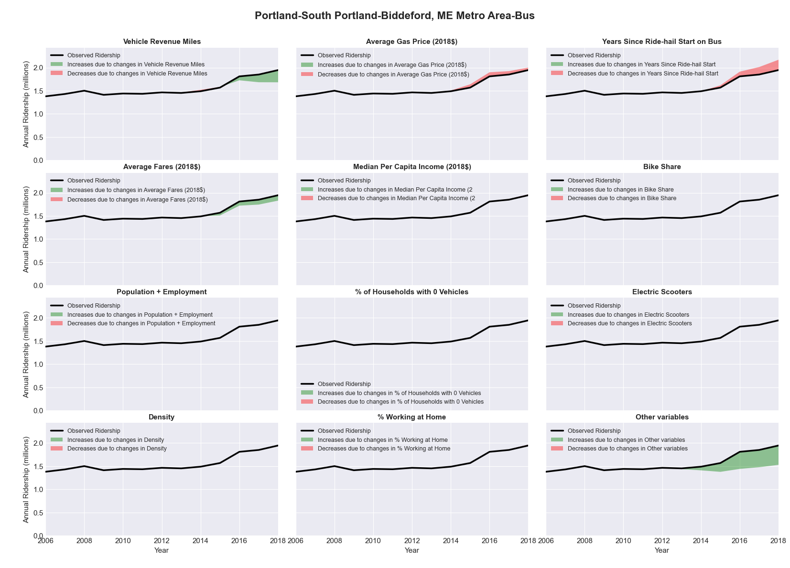

|  |  |  |  |  |  |  |
| --- | --- | --- | --- | --- | --- | --- |
| Portland-South Portland-Biddeford, ME Metro Area-Rail | | | | | | |
|  |  |  |  |  |  | |
|  | **Average Values** | | | **Ridership Effect** | | |
| **Description** | **2012** | **2018** | **% Diff** | **Absolute** | **% Diff** | |
|  |  |  |  |  |  | |
| **Vehicle Revenue Miles** | 1,962,440 | 2,143,060 | 9.2% | 28,230 | | **5.0%** | |
| **Average Fare (2018$)** | 14.56 | 17.59 | 20.8% | -36,970 | | **-6.6%** | |
| **Network Restructure** | - | - | - | - | | **0.0%** | |
| **Major Maintenance Event** | - | - | - | - | | **0.0%** | |
| **Population + Employment** | 789,450 | 828,630 | 5.0% | 5,240 | | **0.9%** | |
| **Share of Population and Employment in Transit Supportive Density** | 0.14 | 0.14 | 0.4% | -0,080 | | **-0.0%** | |
| **Average Gas Price (2018$)** | 4.13 | 2.85 | -31.0% | -19,360 | | **-3.5%** | |
| **Median Per Capita Income (2018$)** | 29,800 | 35,000 | 17.4% | -5,910 | | **-1.1%** | |
| **% of Households with 0 Vehicles** | 6 | 4 | -30.4% | -1,770 | | **-0.3%** | |
| **% Working at Home** | 5.6 | 7.1 | 26.8% | -6,060 | | **-1.1%** | |
| **Years Since Ride-hail Start** | - | 4 | 4 | -44,440 | | **-7.9%** | |
| **Bike Share** | - | - | - | - | | **0.0%** | |
| **Electric Scooters** | - | - | - | - | | **0.0%** | |
| **New Reporters** |  |  |  | - | | **0.0%** | |
| **Total Modeled Ridership** | 560,838 | 481,815 | -14.09% | -79022.8355 | | **-14.1%** | |
| **Total Observed Ridership** | 555,196 | 534,058 | -3.81% | -21138 | | **-3.8%** | |
| **Unexplained Change** |  |  |  |  | | **10.3%** | |

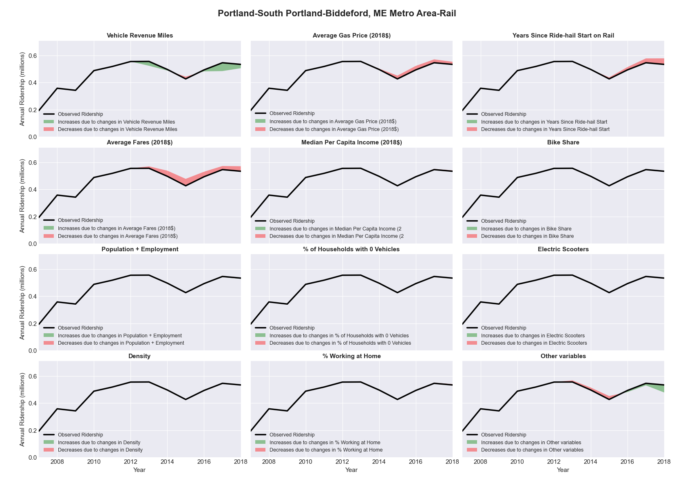

|  |  |  |  |  |  |  |
| --- | --- | --- | --- | --- | --- | --- |
| Portland-Vancouver-Hillsboro, OR-WA Metro Area-Bus | | | | | | |
|  |  |  |  |  |  | |
|  | **Average Values** | | | **Ridership Effect** | | |
| **Description** | **2012** | **2018** | **% Diff** | **Absolute** | **% Diff** | |
|  |  |  |  |  |  | |
| **Vehicle Revenue Miles** | 23,136,150 | 25,598,540 | 10.6% | 2,989,940 | | **4.3%** | |
| **Average Fare (2018$)** | 1.03 | 1.11 | 7.7% | -1,545,820 | | **-2.2%** | |
| **Network Restructure** | - | - | - | - | | **0.0%** | |
| **Major Maintenance Event** | - | - | - | - | | **0.0%** | |
| **Population + Employment** | 3,392,830 | 3,749,980 | 10.5% | 1,442,680 | | **2.1%** | |
| **Share of Population and Employment in Transit Supportive Density** | 0.49 | 0.49 | -0.3% | -34,690 | | **-0.0%** | |
| **Average Gas Price (2018$)** | 4.35 | 3.40 | -21.8% | -1,940,320 | | **-2.8%** | |
| **Median Per Capita Income (2018$)** | 30,810 | 36,970 | 20.0% | -848,870 | | **-1.2%** | |
| **% of Households with 0 Vehicles** | 9 | 7 | -16.0% | -184,330 | | **-0.3%** | |
| **% Working at Home** | 6.4 | 8.3 | 30.1% | -953,140 | | **-1.4%** | |
| **Years Since Ride-hail Start** | - | 4 | 4 | -5,047,730 | | **-7.2%** | |
| **Bike Share** | - | 1 | 1 | - 725,790 | | **-1.0%** | |
| **Electric Scooters** | - | 1 | 1 | - 2,466,000 | | **-3.5%** | |
| **New Reporters** |  |  |  | - | | **0.0%** | |
| **Total Modeled Ridership** | 70,324,118 | 61,002,082 | -13.26% | -9322036.34 | | **-13.3%** | |
| **Total Observed Ridership** | 66,991,124 | 62,639,730 | -6.50% | -4351394 | | **-6.5%** | |
| **Unexplained Change** |  |  |  |  | | **6.8%** | |

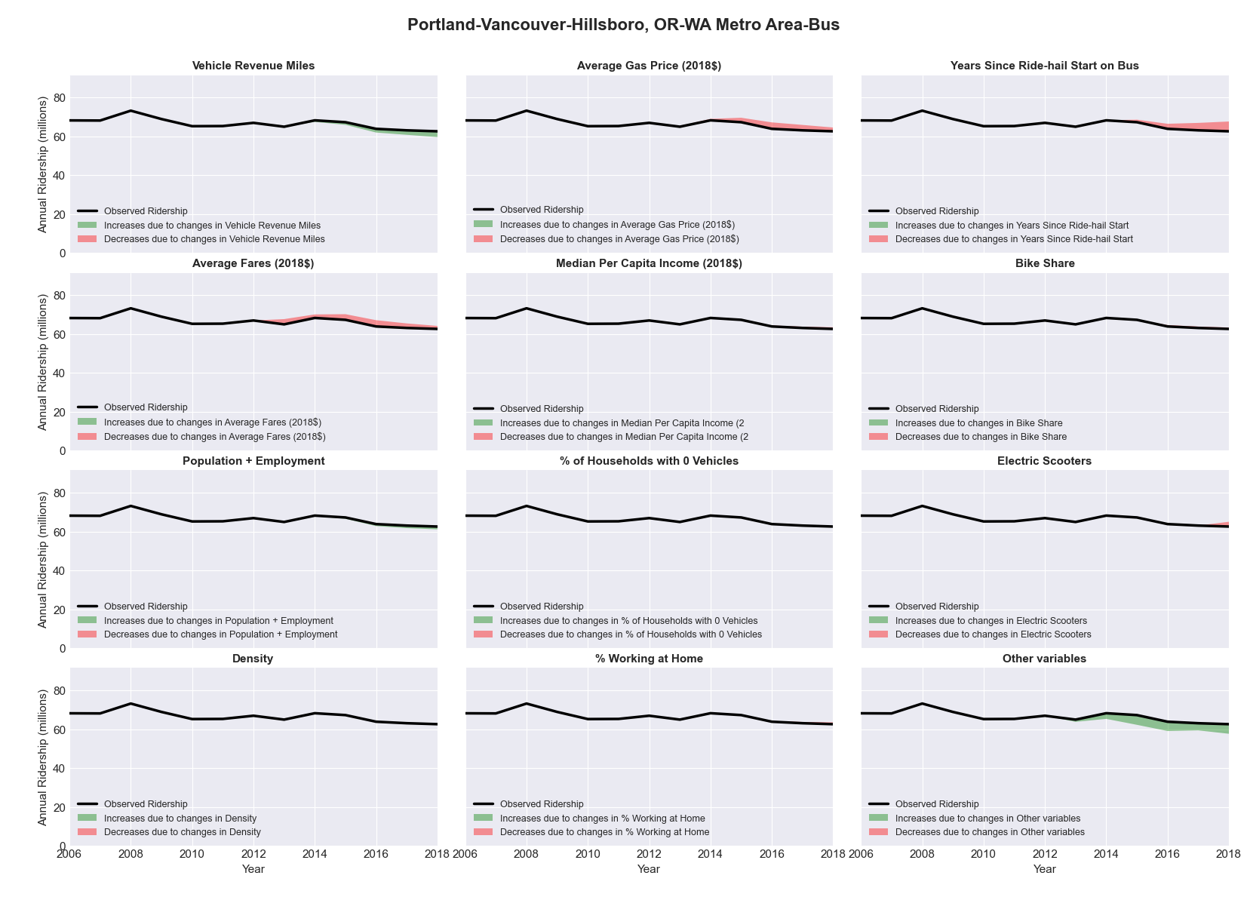

|  |  |  |  |  |  |  |
| --- | --- | --- | --- | --- | --- | --- |
| Portland-Vancouver-Hillsboro, OR-WA Metro Area-Rail | | | | | | |
|  |  |  |  |  |  | |
|  | **Average Values** | | | **Ridership Effect** | | |
| **Description** | **2012** | **2018** | **% Diff** | **Absolute** | **% Diff** | |
|  |  |  |  |  |  | |
| **Vehicle Revenue Miles** | 8,180,790 | 9,568,050 | 17.0% | 4,580,580 | | **10.4%** | |
| **Average Fare (2018$)** | 1.05 | 1.21 | 14.9% | -1,138,690 | | **-2.6%** | |
| **Network Restructure** | - | - | - | - | | **0.0%** | |
| **Major Maintenance Event** | - | - | - | - | | **0.0%** | |
| **Population + Employment** | 3,392,830 | 3,749,980 | 10.5% | 958,380 | | **2.2%** | |
| **Share of Population and Employment in Transit Supportive Density** | 0.49 | 0.49 | -0.3% | -25,450 | | **-0.1%** | |
| **Average Gas Price (2018$)** | 4.35 | 3.40 | -21.8% | -1,162,220 | | **-2.6%** | |
| **Median Per Capita Income (2018$)** | 30,810 | 36,970 | 20.0% | -568,290 | | **-1.3%** | |
| **% of Households with 0 Vehicles** | 9 | 7 | -16.0% | -123,780 | | **-0.3%** | |
| **% Working at Home** | 6.4 | 8.3 | 30.1% | -650,380 | | **-1.5%** | |
| **Years Since Ride-hail Start** | - | 4 | 4 | 384,390 | | **0.9%** | |
| **Bike Share** | - | 1 | 1 | - 465,030 | | **-1.1%** | |
| **Electric Scooters** | - | 1 | 1 | - 1,730,590 | | **-3.9%** | |
| **New Reporters** |  |  |  | - | | **0.0%** | |
| **Total Modeled Ridership** | 44,044,911 | 44,001,563 | -0.10% | -43348.3879 | | **-0.1%** | |
| **Total Observed Ridership** | 45,040,066 | 44,133,779 | -2.01% | -906287 | | **-2.0%** | |
| **Unexplained Change** |  |  |  |  | | **-1.9%** | |

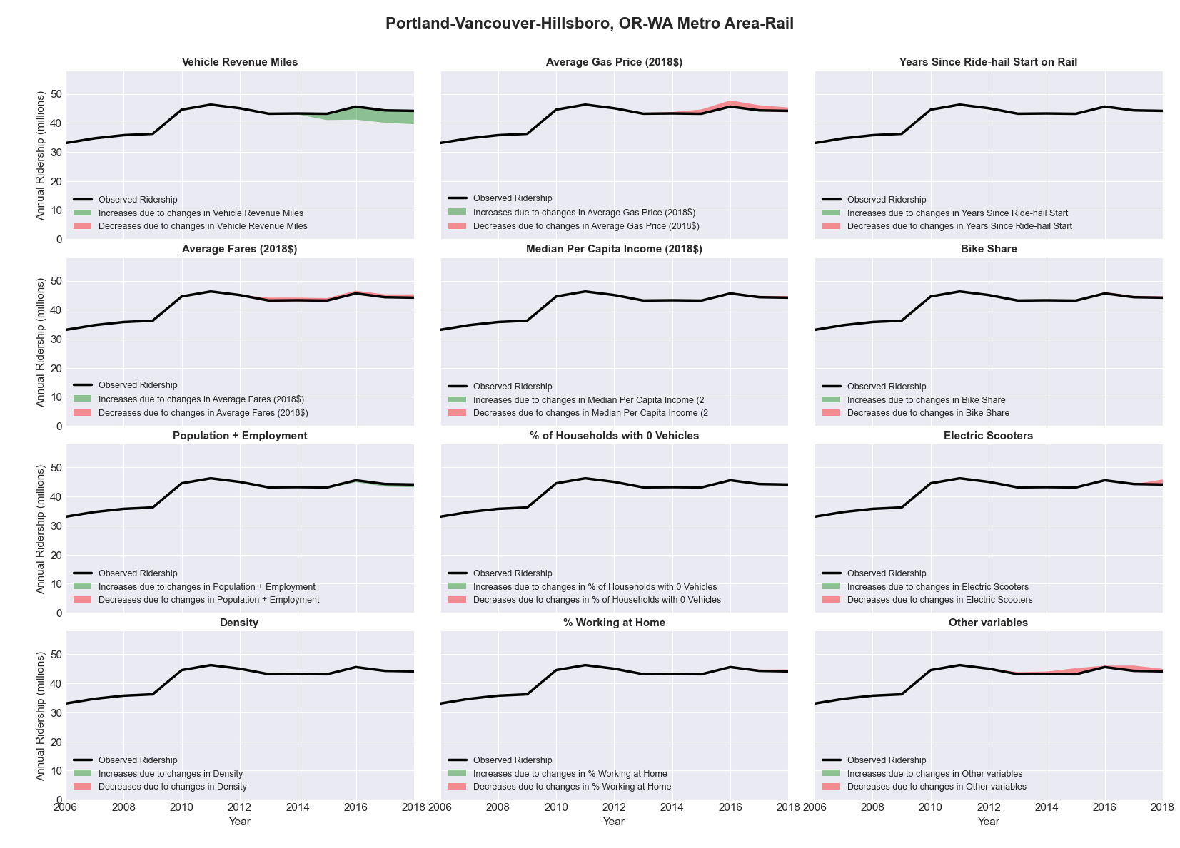

|  |  |  |  |  |  |  |
| --- | --- | --- | --- | --- | --- | --- |
| Providence-New Bedford-Fall River, RI-MA Metro Area-Bus | | | | | | |
|  |  |  |  |  |  | |
|  | **Average Values** | | | **Ridership Effect** | | |
| **Description** | **2012** | **2018** | **% Diff** | **Absolute** | **% Diff** | |
|  |  |  |  |  |  | |
| **Vehicle Revenue Miles** | 11,149,640 | 11,714,550 | 5.1% | 462,180 | | **2.2%** | |
| **Average Fare (2018$)** | 1.20 | 1.14 | -5.2% | 377,950 | | **1.8%** | |
| **Network Restructure** | - | - | - | - | | **0.0%** | |
| **Major Maintenance Event** | - | - | - | - | | **0.0%** | |
| **Population + Employment** | 2,362,200 | 2,452,410 | 3.8% | 169,460 | | **0.8%** | |
| **Share of Population and Employment in Transit Supportive Density** | 0.39 | 0.40 | 0.7% | 24,540 | | **0.1%** | |
| **Average Gas Price (2018$)** | 4.13 | 2.85 | -31.0% | -923,540 | | **-4.4%** | |
| **Median Per Capita Income (2018$)** | 28,990 | 31,600 | 9.0% | -135,150 | | **-0.6%** | |
| **% of Households with 0 Vehicles** | 11 | 9 | -17.6% | -73,250 | | **-0.3%** | |
| **% Working at Home** | 3.2 | 4.9 | 53.9% | -263,140 | | **-1.2%** | |
| **Years Since Ride-hail Start** | - | 1 | 1 | -626,920 | | **-3.0%** | |
| **Bike Share** | - | - | - | - | | **0.0%** | |
| **Electric Scooters** | - | 1 | 1 | - 736,170 | | **-3.5%** | |
| **New Reporters** |  |  |  | - | | **0.0%** | |
| **Total Modeled Ridership** | 21,083,297 | 19,271,982 | -8.59% | -1811315.07 | | **-8.6%** | |
| **Total Observed Ridership** | 21,659,939 | 19,080,462 | -11.91% | -2579477 | | **-11.9%** | |
| **Unexplained Change** |  |  |  |  | | **-3.3%** | |

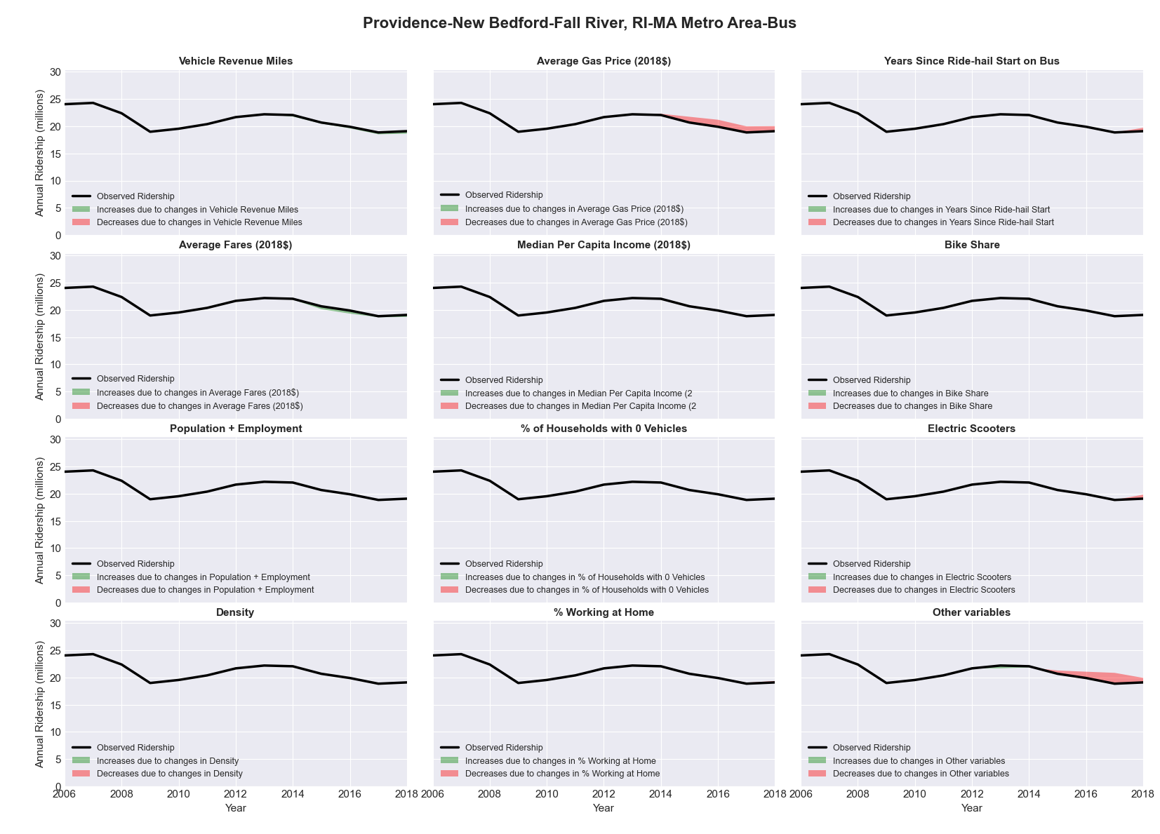

|  |  |  |  |  |  |  |
| --- | --- | --- | --- | --- | --- | --- |
| Pueblo, CO Metro Area-Bus | | | | | | |
|  |  |  |  |  |  | |
|  | **Average Values** | | | **Ridership Effect** | | |
| **Description** | **2012** | **2018** | **% Diff** | **Absolute** | **% Diff** | |
|  |  |  |  |  |  | |
| **Vehicle Revenue Miles** | 554,300 | 546,630 | -1.4% | -6,840 | | **-0.7%** | |
| **Average Fare (2018$)** | 0.50 | 0.93 | 85.5% | -121,610 | | **-12.0%** | |
| **Network Restructure** | - | - | - | - | | **0.0%** | |
| **Major Maintenance Event** | - | - | - | - | | **0.0%** | |
| **Population + Employment** | 227,370 | 239,890 | 5.5% | 10,730 | | **1.1%** | |
| **Share of Population and Employment in Transit Supportive Density** | 0.22 | 0.21 | -4.1% | -3,590 | | **-0.4%** | |
| **Average Gas Price (2018$)** | 3.88 | 2.89 | -25.5% | -35,370 | | **-3.5%** | |
| **Median Per Capita Income (2018$)** | 23,710 | 23,960 | 1.1% | -0,460 | | **-0.0%** | |
| **% of Households with 0 Vehicles** | 8 | 8 | -3.7% | -0,410 | | **-0.0%** | |
| **% Working at Home** | 3.1 | 3.2 | 1.6% | -0,150 | | **-0.0%** | |
| **Years Since Ride-hail Start** | - | 2 | 2 | -55,430 | | **-5.5%** | |
| **Bike Share** | - | - | - | - | | **0.0%** | |
| **Electric Scooters** | - | - | - | - | | **0.0%** | |
| **New Reporters** |  |  |  | - | | **0.0%** | |
| **Total Modeled Ridership** | 1,013,439 | 792,715 | -21.78% | -220723.773 | | **-21.8%** | |
| **Total Observed Ridership** | 1,076,700 | 806,352 | -25.11% | -270348 | | **-25.1%** | |
| **Unexplained Change** |  |  |  |  | | **-3.3%** | |

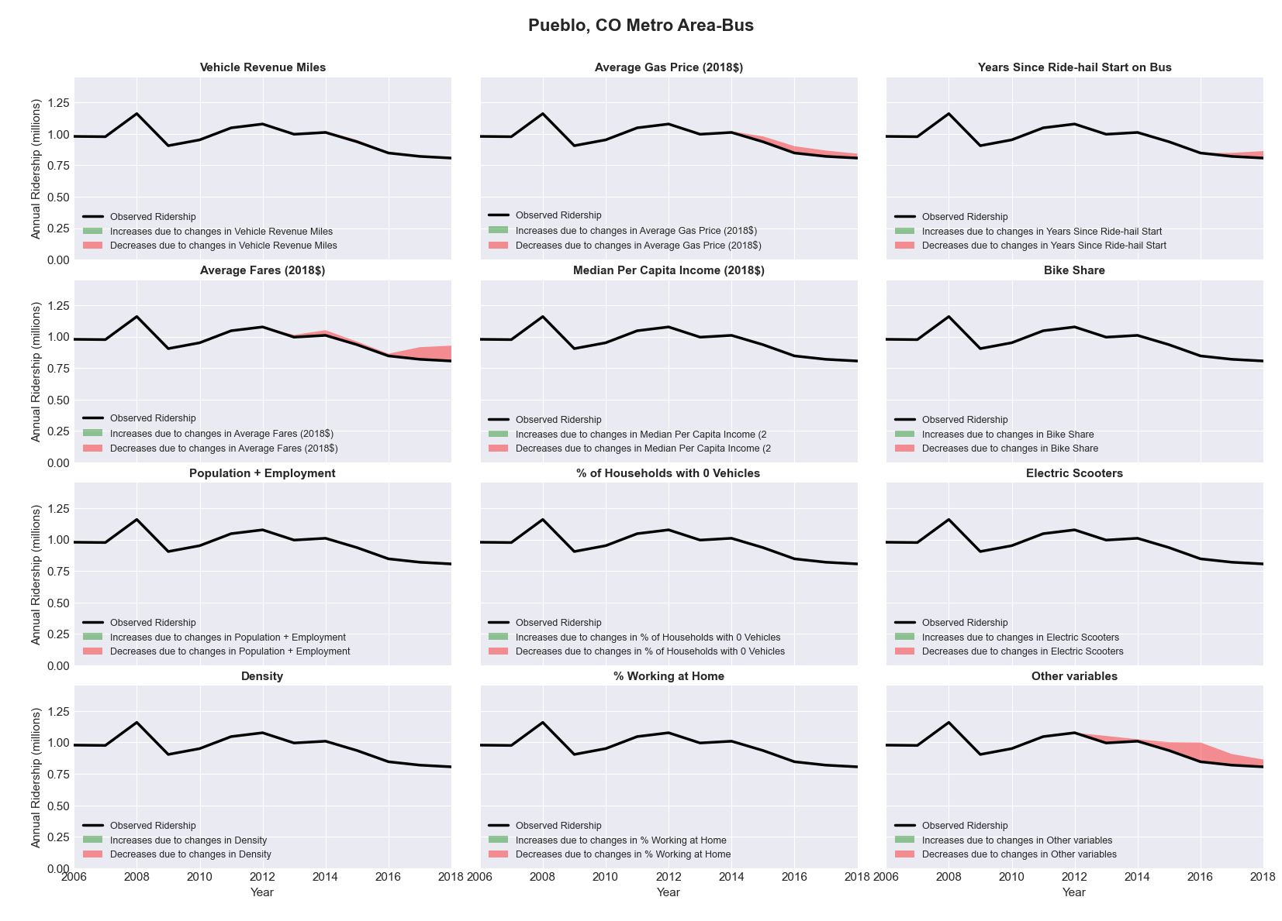

|  |  |  |  |  |  |  |
| --- | --- | --- | --- | --- | --- | --- |
| Racine, WI Metro Area-Bus | | | | | | |
|  |  |  |  |  |  | |
|  | **Average Values** | | | **Ridership Effect** | | |
| **Description** | **2012** | **2018** | **% Diff** | **Absolute** | **% Diff** | |
|  |  |  |  |  |  | |
| **Vehicle Revenue Miles** | 1,335,510 | 1,141,520 | -14.5% | -94,080 | | **-6.6%** | |
| **Average Fare (2018$)** | 1.10 | 0.98 | -10.7% | 40,450 | | **2.8%** | |
| **Network Restructure** | - | - | - | - | | **0.0%** | |
| **Major Maintenance Event** | - | - | - | - | | **0.0%** | |
| **Population + Employment** | 286,830 | 292,980 | 2.1% | 5,960 | | **0.4%** | |
| **Share of Population and Employment in Transit Supportive Density** | 0.22 | 0.23 | 2.5% | 3,230 | | **0.2%** | |
| **Average Gas Price (2018$)** | 3.93 | 2.72 | -30.9% | -59,630 | | **-4.2%** | |
| **Median Per Capita Income (2018$)** | 29,660 | 33,290 | 12.2% | -10,280 | | **-0.7%** | |
| **% of Households with 0 Vehicles** | 7 | 5 | -27.4% | -4,550 | | **-0.3%** | |
| **% Working at Home** | 2.7 | 4.1 | 51.9% | -13,050 | | **-0.9%** | |
| **Years Since Ride-hail Start** | - | 3 | 3 | -123,930 | | **-8.7%** | |
| **Bike Share** | - | - | - | - | | **0.0%** | |
| **Electric Scooters** | - | - | - | - | | **0.0%** | |
| **New Reporters** |  |  |  | - | | **0.0%** | |
| **Total Modeled Ridership** | 1,427,530 | 1,174,094 | -17.75% | -253435.749 | | **-17.8%** | |
| **Total Observed Ridership** | 1,409,660 | 1,118,365 | -20.66% | -291295 | | **-20.7%** | |
| **Unexplained Change** |  |  |  |  | | **-2.9%** | |

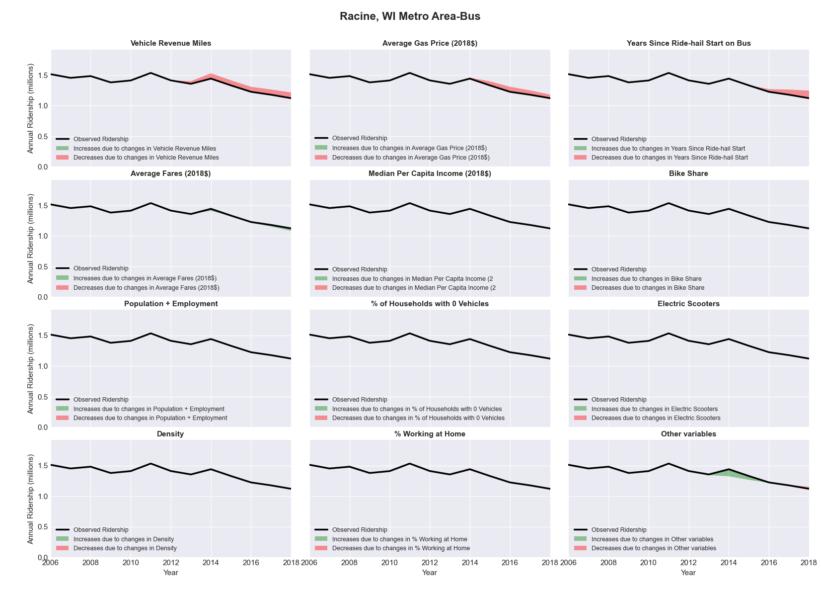

|  |  |  |  |  |  |  |
| --- | --- | --- | --- | --- | --- | --- |
| Raleigh-Cary, NC Metro Area-Bus | | | | | | |
|  |  |  |  |  |  | |
|  | **Average Values** | | | **Ridership Effect** | | |
| **Description** | **2012** | **2018** | **% Diff** | **Absolute** | **% Diff** | |
|  |  |  |  |  |  | |
| **Vehicle Revenue Miles** | 2,738,290 | 3,171,880 | 15.8% | 371,650 | | **6.1%** | |
| **Average Fare (2018$)** | 0.50 | 0.67 | 32.5% | -360,820 | | **-5.9%** | |
| **Network Restructure** | - | - | - | - | | **0.0%** | |
| **Major Maintenance Event** | - | - | - | - | | **0.0%** | |
| **Population + Employment** | 1,757,100 | 2,055,330 | 17.0% | 192,370 | | **3.2%** | |
| **Share of Population and Employment in Transit Supportive Density** | 0.21 | 0.18 | -14.5% | -77,190 | | **-1.3%** | |
| **Average Gas Price (2018$)** | 3.95 | 2.71 | -31.3% | -256,140 | | **-4.2%** | |
| **Median Per Capita Income (2018$)** | 34,440 | 37,590 | 9.1% | -30,470 | | **-0.5%** | |
| **% of Households with 0 Vehicles** | 5 | 3 | -28.1% | -13,880 | | **-0.2%** | |
| **% Working at Home** | 6.2 | 9.9 | 59.3% | -156,260 | | **-2.6%** | |
| **Years Since Ride-hail Start** | - | 4 | 4 | -700,760 | | **-11.5%** | |
| **Bike Share** | - | - | - | - | | **0.0%** | |
| **Electric Scooters** | - | 1 | 1 | - 184,070 | | **-3.0%** | |
| **New Reporters** |  |  |  | - | | **0.0%** | |
| **Total Modeled Ridership** | 6,098,209 | 4,867,329 | -20.18% | -1230880.12 | | **-20.2%** | |
| **Total Observed Ridership** | 6,425,635 | 5,039,467 | -21.57% | -1386168 | | **-21.6%** | |
| **Unexplained Change** |  |  |  |  | | **-1.4%** | |

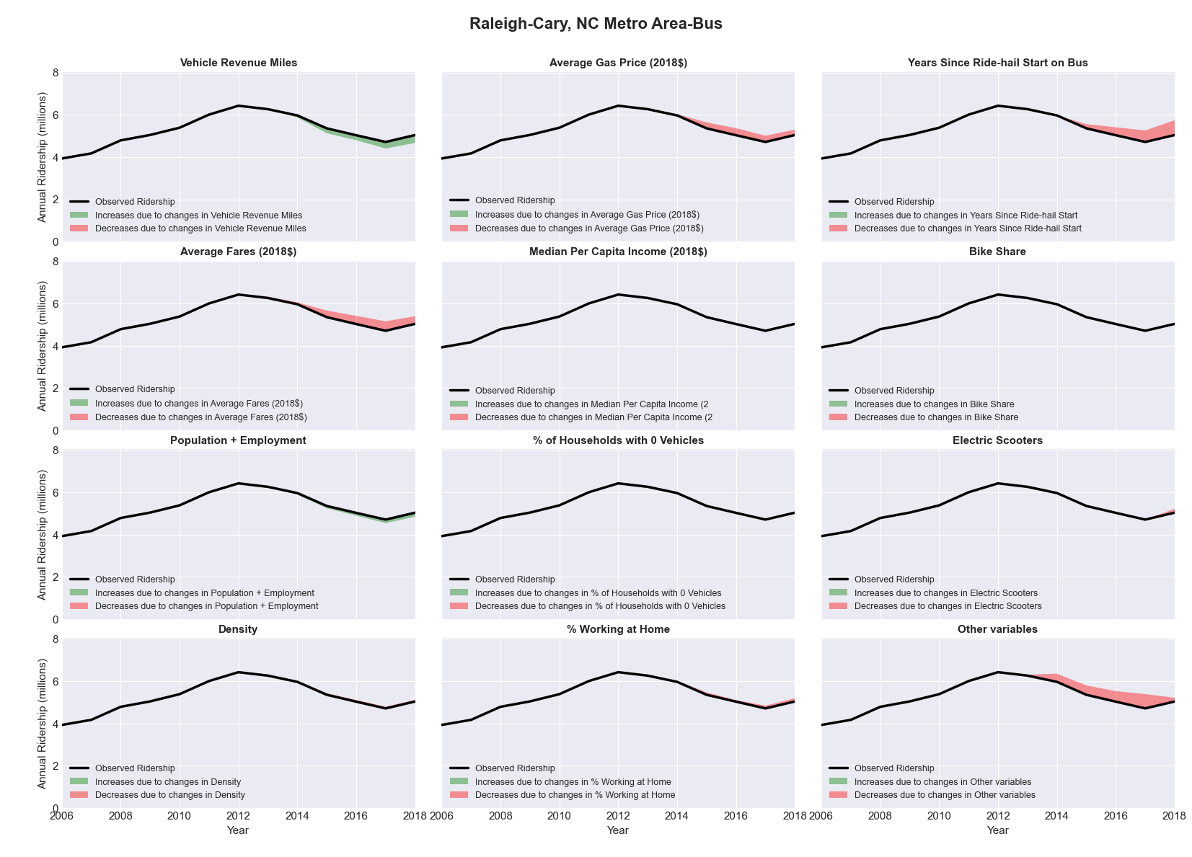

|  |  |  |  |  |  |  |
| --- | --- | --- | --- | --- | --- | --- |
| Redding, CA Metro Area-Bus | | | | | | |
|  |  |  |  |  |  | |
|  | **Average Values** | | | **Ridership Effect** | | |
| **Description** | **2012** | **2018** | **% Diff** | **Absolute** | **% Diff** | |
|  |  |  |  |  |  | |
| **Vehicle Revenue Miles** | 637,320 | 719,870 | 13.0% | 41,080 | | **5.4%** | |
| **Average Fare (2018$)** | 0.97 | 1.09 | 13.0% | -29,180 | | **-3.9%** | |
| **Network Restructure** | - | - | - | - | | **0.0%** | |
| **Major Maintenance Event** | - | - | - | - | | **0.0%** | |
| **Population + Employment** | 243,810 | 251,240 | 3.0% | 4,950 | | **0.7%** | |
| **Share of Population and Employment in Transit Supportive Density** | 0.05 | 0.05 | -8.3% | -1,320 | | **-0.2%** | |
| **Average Gas Price (2018$)** | 4.35 | 3.40 | -21.8% | -23,250 | | **-3.1%** | |
| **Median Per Capita Income (2018$)** | 23,610 | 28,540 | 20.9% | -9,880 | | **-1.3%** | |
| **% of Households with 0 Vehicles** | 6 | 10 | 54.0% | 4,970 | | **0.7%** | |
| **% Working at Home** | 3.7 | 9.0 | 143.9% | -28,270 | | **-3.7%** | |
| **Years Since Ride-hail Start** | - | 2 | 2 | -45,060 | | **-6.0%** | |
| **Bike Share** | - | - | - | - | | **0.0%** | |
| **Electric Scooters** | - | - | - | - | | **0.0%** | |
| **New Reporters** |  |  |  | - | | **0.0%** | |
| **Total Modeled Ridership** | 755,957 | 670,968 | -11.24% | -84989.3383 | | **-11.2%** | |
| **Total Observed Ridership** | 785,519 | 625,370 | -20.39% | -160149 | | **-20.4%** | |
| **Unexplained Change** |  |  |  |  | | **-9.1%** | |

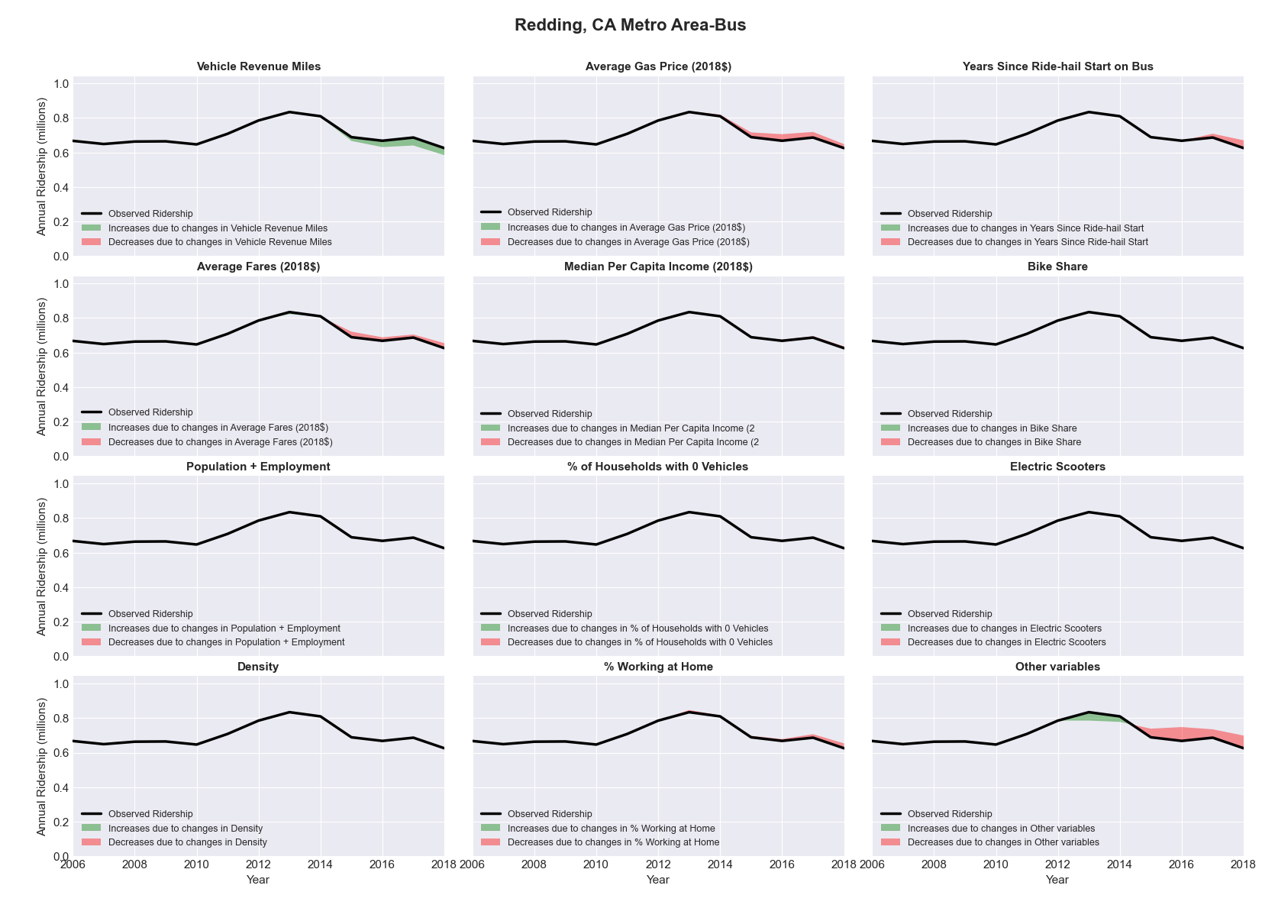

|  |  |  |  |  |  |  |
| --- | --- | --- | --- | --- | --- | --- |
| Reno-Sparks, NV Metro Area-Bus | | | | | | |
|  |  |  |  |  |  | |
|  | **Average Values** | | | **Ridership Effect** | | |
| **Description** | **2012** | **2018** | **% Diff** | **Absolute** | **% Diff** | |
|  |  |  |  |  |  | |
| **Vehicle Revenue Miles** | 2,787,450 | 2,800,500 | 0.5% | 26,740 | | **0.3%** | |
| **Average Fare (2018$)** | 0.80 | 0.77 | -4.1% | 76,830 | | **0.9%** | |
| **Network Restructure** | - | - | - | - | | **0.0%** | |
| **Major Maintenance Event** | - | - | - | - | | **0.0%** | |
| **Population + Employment** | 632,040 | 713,450 | 12.9% | 206,810 | | **2.5%** | |
| **Share of Population and Employment in Transit Supportive Density** | 0.37 | 0.37 | -1.9% | -22,580 | | **-0.3%** | |
| **Average Gas Price (2018$)** | 4.35 | 3.40 | -21.8% | -237,920 | | **-2.9%** | |
| **Median Per Capita Income (2018$)** | 27,580 | 33,850 | 22.7% | -113,920 | | **-1.4%** | |
| **% of Households with 0 Vehicles** | 9 | 4 | -55.4% | -77,710 | | **-0.9%** | |
| **% Working at Home** | 3.8 | 4.7 | 23.7% | -54,570 | | **-0.7%** | |
| **Years Since Ride-hail Start** | - | 4 | 4 | -1,034,700 | | **-12.4%** | |
| **Bike Share** | - | 1 | 1 | - 80,060 | | **-1.0%** | |
| **Electric Scooters** | - | - | - | - | | **0.0%** | |
| **New Reporters** |  |  |  | - | | **0.0%** | |
| **Total Modeled Ridership** | 8,328,265 | 7,030,028 | -15.59% | -1298237.45 | | **-15.6%** | |
| **Total Observed Ridership** | 8,025,068 | 7,250,019 | -9.66% | -775049 | | **-9.7%** | |
| **Unexplained Change** |  |  |  |  | | **5.9%** | |

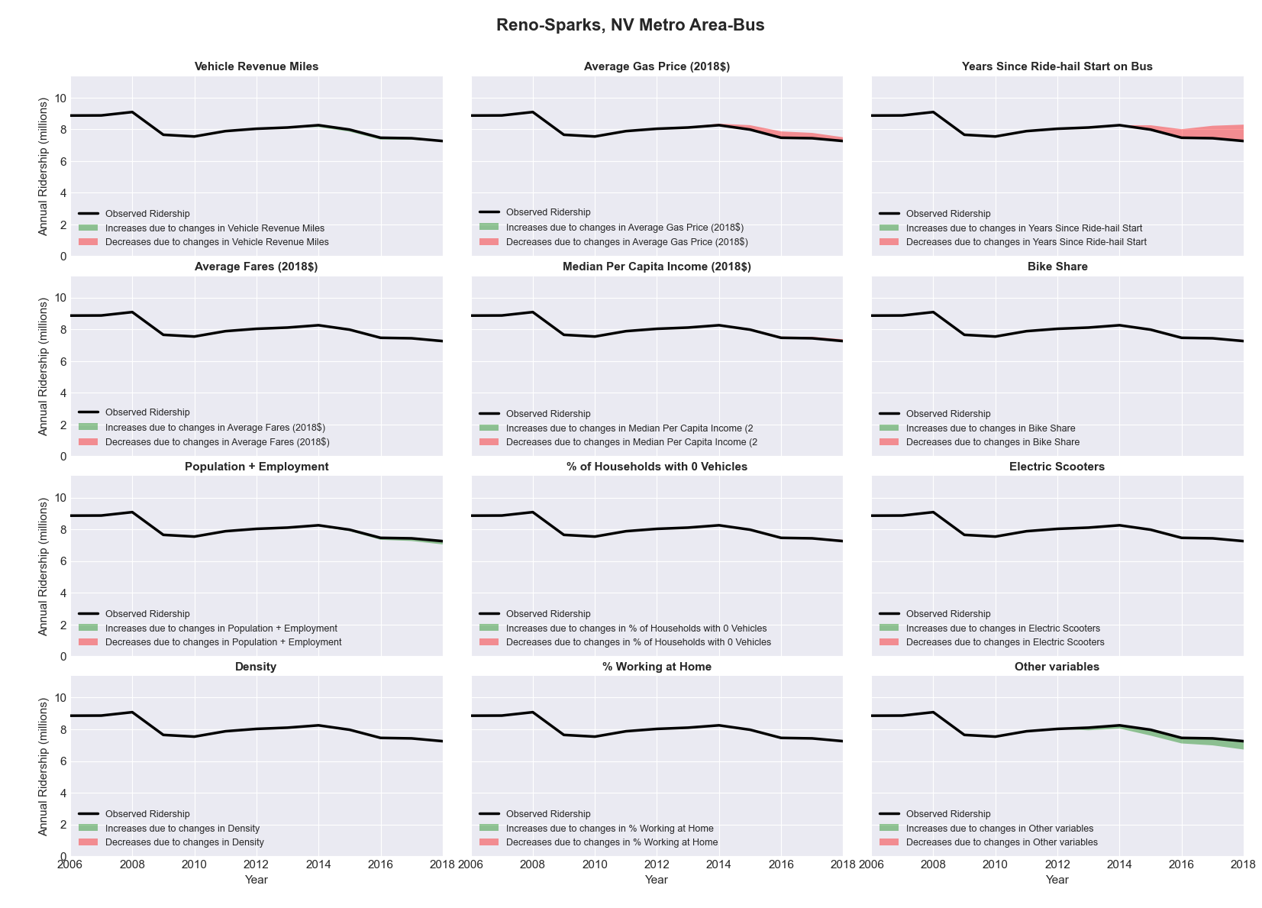

|  |  |  |  |  |  |  |
| --- | --- | --- | --- | --- | --- | --- |
| Richmond, VA Metro Area-Bus | | | | | | |
|  |  |  |  |  |  | |
|  | **Average Values** | | | **Ridership Effect** | | |
| **Description** | **2012** | **2018** | **% Diff** | **Absolute** | **% Diff** | |
|  |  |  |  |  |  | |
| **Vehicle Revenue Miles** | 4,606,840 | 4,583,660 | -0.5% | -50,490 | | **-0.6%** | |
| **Average Fare (2018$)** | 1.27 | 0.91 | -29.0% | 848,180 | | **9.7%** | |
| **Network Restructure** | - | - | - | - | | **0.0%** | |
| **Major Maintenance Event** | - | - | - | - | | **0.0%** | |
| **Population + Employment** | 1,905,200 | 2,007,520 | 5.4% | 92,050 | | **1.1%** | |
| **Share of Population and Employment in Transit Supportive Density** | 0.23 | 0.23 | -2.3% | -18,630 | | **-0.2%** | |
| **Average Gas Price (2018$)** | 3.95 | 2.71 | -31.3% | -350,230 | | **-4.0%** | |
| **Median Per Capita Income (2018$)** | 31,770 | 34,840 | 9.7% | -52,870 | | **-0.6%** | |
| **% of Households with 0 Vehicles** | 7 | 6 | -5.7% | -5,480 | | **-0.1%** | |
| **% Working at Home** | 4.7 | 6.6 | 39.9% | -113,960 | | **-1.3%** | |
| **Years Since Ride-hail Start** | - | 4 | 4 | -1,093,420 | | **-12.5%** | |
| **Bike Share** | - | 1 | 1 | - 90,030 | | **-1.0%** | |
| **Electric Scooters** | - | - | - | - | | **0.0%** | |
| **New Reporters** |  |  |  | - | | **0.0%** | |
| **Total Modeled Ridership** | 8,751,823 | 7,922,593 | -9.47% | -829230.655 | | **-9.5%** | |
| **Total Observed Ridership** | 8,767,432 | 7,780,704 | -11.25% | -986728 | | **-11.3%** | |
| **Unexplained Change** |  |  |  |  | | **-1.8%** | |

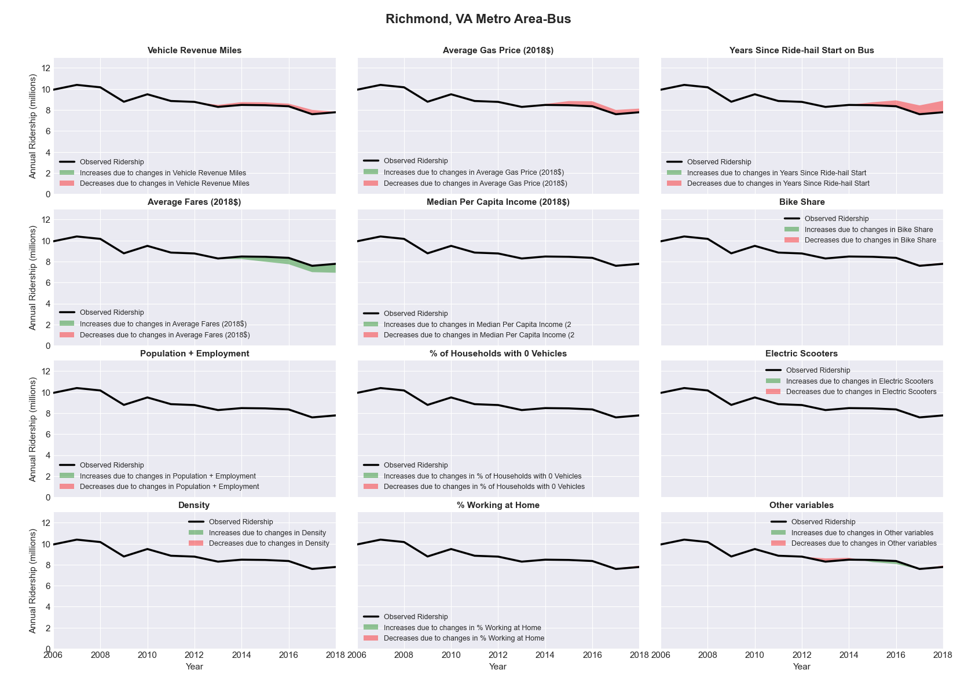

|  |  |  |  |  |  |  |
| --- | --- | --- | --- | --- | --- | --- |
| Riverside-San Bernardino-Ontario, CA Metro Area-Bus | | | | | | |
|  |  |  |  |  |  | |
|  | **Average Values** | | | **Ridership Effect** | | |
| **Description** | **2012** | **2018** | **% Diff** | **Absolute** | **% Diff** | |
|  |  |  |  |  |  | |
| **Vehicle Revenue Miles** | 19,720,570 | 26,187,530 | 32.8% | 3,759,680 | | **13.2%** | |
| **Average Fare (2018$)** | 0.94 | 0.97 | 2.9% | -372,550 | | **-1.3%** | |
| **Network Restructure** | - | - | - | - | | **0.0%** | |
| **Major Maintenance Event** | - | - | - | - | | **0.0%** | |
| **Population + Employment** | 6,012,760 | 6,591,110 | 9.6% | 577,270 | | **2.0%** | |
| **Share of Population and Employment in Transit Supportive Density** | 0.39 | 0.39 | -1.8% | -88,130 | | **-0.3%** | |
| **Average Gas Price (2018$)** | 4.35 | 3.40 | -21.8% | -932,440 | | **-3.3%** | |
| **Median Per Capita Income (2018$)** | 25,180 | 27,190 | 8.0% | -160,900 | | **-0.6%** | |
| **% of Households with 0 Vehicles** | 5 | 5 | -17.9% | -57,330 | | **-0.2%** | |
| **% Working at Home** | 4.4 | 5.1 | 16.5% | -174,780 | | **-0.6%** | |
| **Years Since Ride-hail Start** | - | 4 | 4 | -3,680,500 | | **-12.9%** | |
| **Bike Share** | - | - | - | - | | **0.0%** | |
| **Electric Scooters** | - | - | - | - | | **0.0%** | |
| **New Reporters** |  |  |  | - | | **0.0%** | |
| **Total Modeled Ridership** | 28,567,838 | 27,456,206 | -3.89% | -1111631.94 | | **-3.9%** | |
| **Total Observed Ridership** | 30,801,998 | 24,263,296 | -21.23% | -6538702 | | **-21.2%** | |
| **Unexplained Change** |  |  |  |  | | **-17.3%** | |

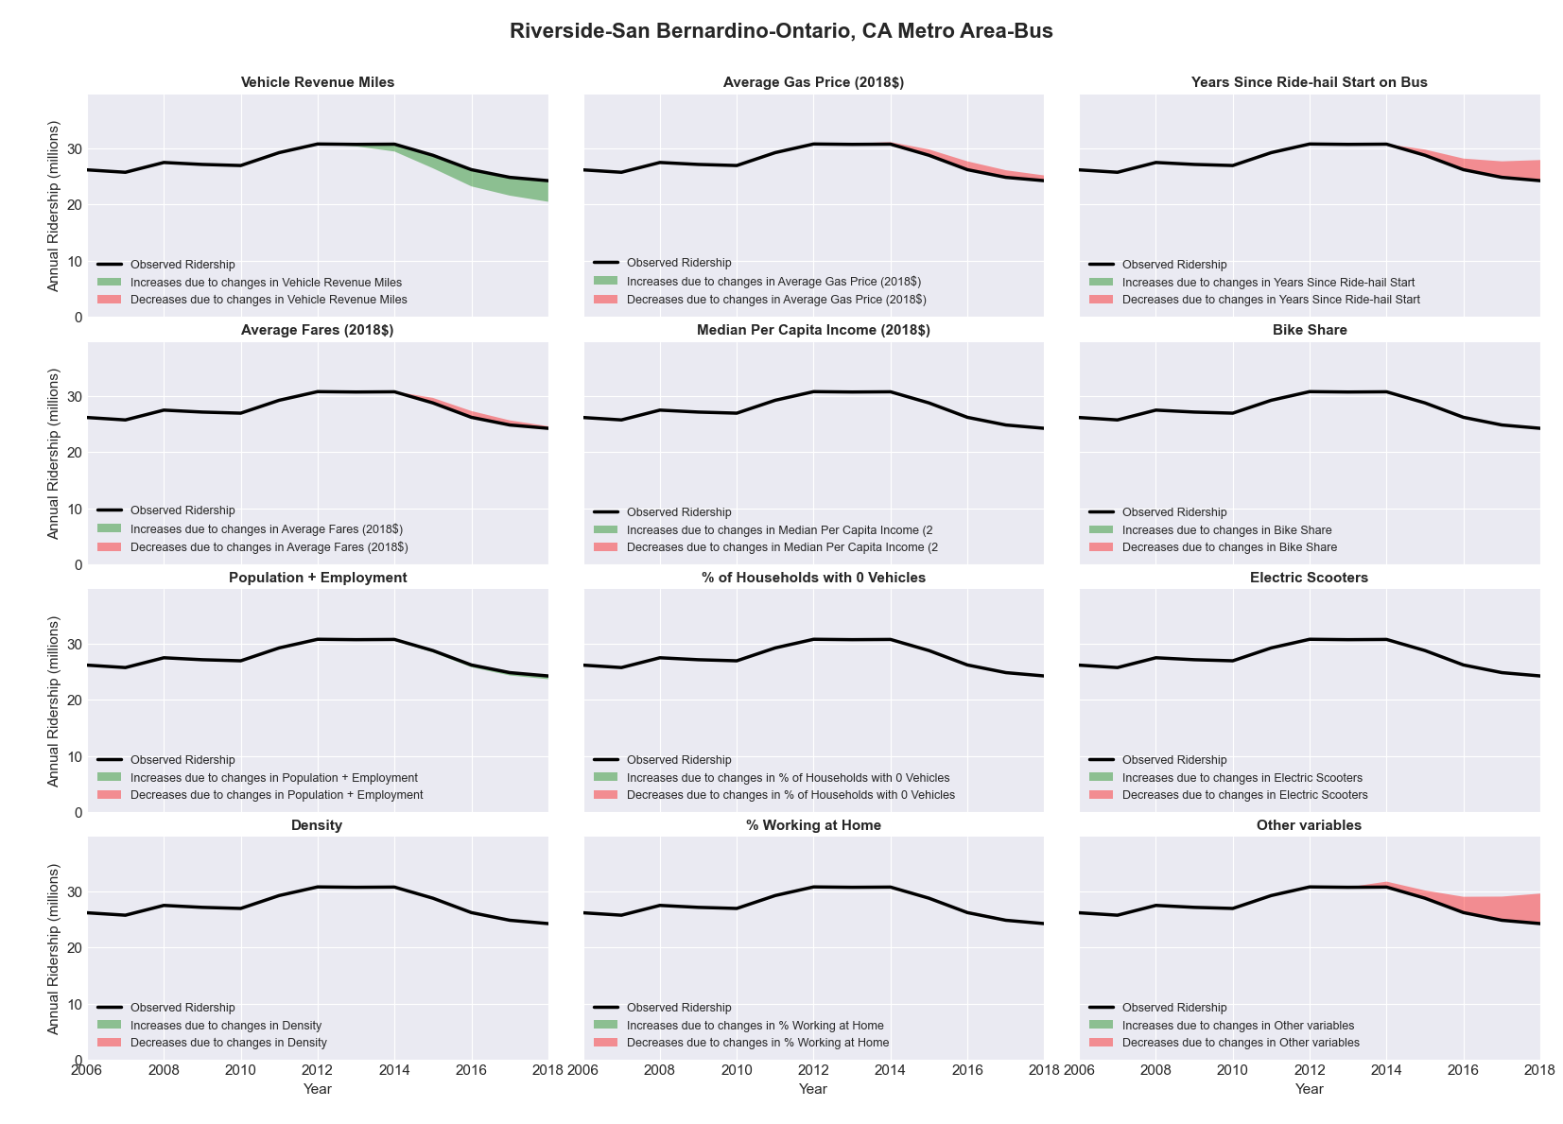

|  |  |  |  |  |  |  |
| --- | --- | --- | --- | --- | --- | --- |
| Roanoke, VA Metro Area-Bus | | | | | | |
|  |  |  |  |  |  | |
|  | **Average Values** | | | **Ridership Effect** | | |
| **Description** | **2012** | **2018** | **% Diff** | **Absolute** | **% Diff** | |
|  |  |  |  |  |  | |
| **Vehicle Revenue Miles** | 1,653,460 | 1,693,830 | 2.4% | 25,970 | | **1.1%** | |
| **Average Fare (2018$)** | 0.89 | 0.91 | 2.5% | -18,610 | | **-0.8%** | |
| **Network Restructure** | - | - | - | - | | **0.0%** | |
| **Major Maintenance Event** | - | - | - | - | | **0.0%** | |
| **Population + Employment** | 459,270 | 466,120 | 1.5% | 7,260 | | **0.3%** | |
| **Share of Population and Employment in Transit Supportive Density** | 0.06 | 0.08 | 50.6% | 26,460 | | **1.1%** | |
| **Average Gas Price (2018$)** | 3.95 | 2.71 | -31.3% | -97,730 | | **-4.1%** | |
| **Median Per Capita Income (2018$)** | 26,960 | 29,580 | 9.7% | -15,240 | | **-0.6%** | |
| **% of Households with 0 Vehicles** | 8 | 10 | 33.4% | 10,700 | | **0.4%** | |
| **% Working at Home** | 3.7 | 7.9 | 113.5% | -68,240 | | **-2.8%** | |
| **Years Since Ride-hail Start** | - | 4 | 4 | -293,640 | | **-12.2%** | |
| **Bike Share** | - | 1 | 1 | - 23,390 | | **-1.0%** | |
| **Electric Scooters** | - | - | - | - | | **0.0%** | |
| **New Reporters** |  |  |  | - | | **0.0%** | |
| **Total Modeled Ridership** | 2,412,750 | 1,970,956 | -18.31% | -441794.018 | | **-18.3%** | |
| **Total Observed Ridership** | 2,409,033 | 1,891,295 | -21.49% | -517738 | | **-21.5%** | |
| **Unexplained Change** |  |  |  |  | | **-3.2%** | |

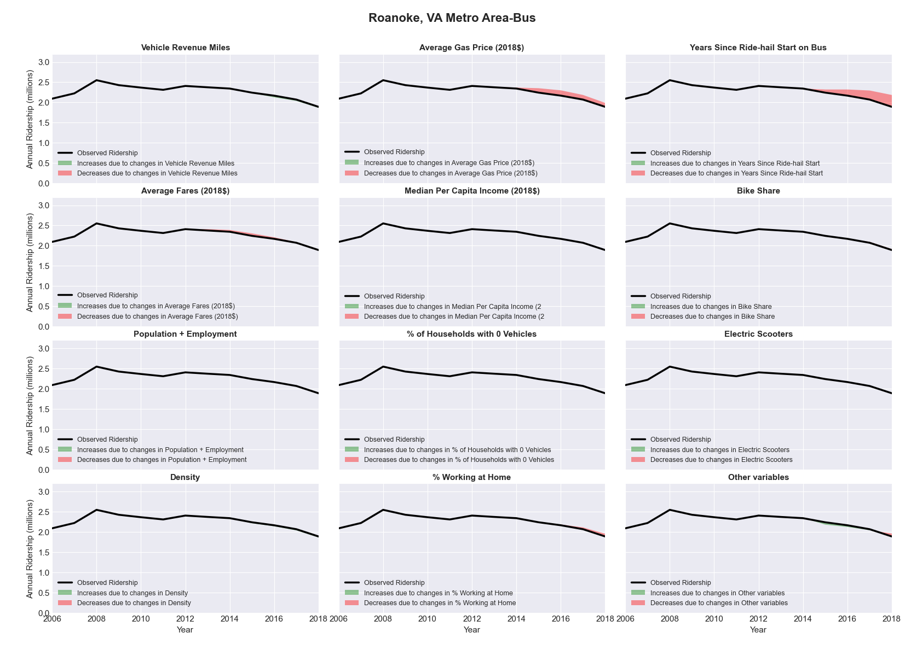

|  |  |  |  |  |  |  |
| --- | --- | --- | --- | --- | --- | --- |
| Rochester, MN Metro Area-Bus | | | | | | |
|  |  |  |  |  |  | |
|  | **Average Values** | | | **Ridership Effect** | | |
| **Description** | **2012** | **2018** | **% Diff** | **Absolute** | **% Diff** | |
|  |  |  |  |  |  | |
| **Vehicle Revenue Miles** | 965,350 | 1,432,600 | 48.4% | 322,890 | | **18.6%** | |
| **Average Fare (2018$)** | 1.24 | 1.34 | 8.3% | -40,360 | | **-2.3%** | |
| **Network Restructure** | - | - | - | - | | **0.0%** | |
| **Major Maintenance Event** | - | - | - | - | | **0.0%** | |
| **Population + Employment** | 289,770 | 328,060 | 13.2% | 47,150 | | **2.7%** | |
| **Share of Population and Employment in Transit Supportive Density** | 0.22 | 0.23 | 3.6% | 5,350 | | **0.3%** | |
| **Average Gas Price (2018$)** | 3.93 | 2.72 | -30.9% | -65,040 | | **-3.7%** | |
| **Median Per Capita Income (2018$)** | 34,950 | 39,130 | 12.0% | -13,860 | | **-0.8%** | |
| **% of Households with 0 Vehicles** | 6 | 4 | -26.7% | -5,560 | | **-0.3%** | |
| **% Working at Home** | 4.0 | 6.8 | 68.8% | -36,590 | | **-2.1%** | |
| **Years Since Ride-hail Start** | - | 1 | 1 | -61,140 | | **-3.5%** | |
| **Bike Share** | - | - | - | - | | **0.0%** | |
| **Electric Scooters** | - | - | - | - | | **0.0%** | |
| **New Reporters** |  |  |  | - | | **0.0%** | |
| **Total Modeled Ridership** | 1,736,844 | 1,872,434 | 7.81% | 135590.096 | | **7.8%** | |
| **Total Observed Ridership** | 1,739,071 | 2,010,145 | 15.59% | 271074 | | **15.6%** | |
| **Unexplained Change** |  |  |  |  | | **7.8%** | |

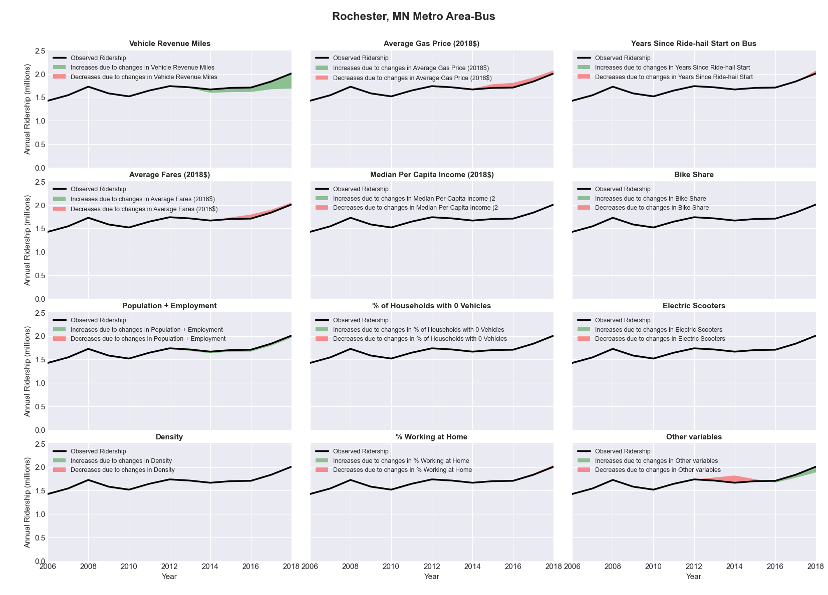

|  |  |  |  |  |  |  |
| --- | --- | --- | --- | --- | --- | --- |
| Rochester, NY Metro Area-Bus | | | | | | |
|  |  |  |  |  |  | |
|  | **Average Values** | | | **Ridership Effect** | | |
| **Description** | **2012** | **2018** | **% Diff** | **Absolute** | **% Diff** | |
|  |  |  |  |  |  | |
| **Vehicle Revenue Miles** | 5,029,450 | 5,094,270 | 1.3% | 134,780 | | **0.6%** | |
| **Average Fare (2018$)** | 0.64 | 1.51 | 136.5% | -4,618,190 | | **-20.6%** | |
| **Network Restructure** | - | - | - | - | | **0.0%** | |
| **Major Maintenance Event** | - | - | - | - | | **0.0%** | |
| **Population + Employment** | 1,544,750 | 1,567,260 | 1.5% | 68,610 | | **0.3%** | |
| **Share of Population and Employment in Transit Supportive Density** | 0.22 | 0.23 | 2.7% | 40,340 | | **0.2%** | |
| **Average Gas Price (2018$)** | 4.11 | 2.92 | -28.9% | -685,370 | | **-3.1%** | |
| **Median Per Capita Income (2018$)** | 29,040 | 30,520 | 5.1% | -55,990 | | **-0.2%** | |
| **% of Households with 0 Vehicles** | 11 | 10 | -9.8% | -34,300 | | **-0.2%** | |
| **% Working at Home** | 3.2 | 4.7 | 45.3% | -190,960 | | **-0.9%** | |
| **Years Since Ride-hail Start** | - | 4 | 4 | -2,155,180 | | **-9.6%** | |
| **Bike Share** | - | 1 | 1 | - 170,220 | | **-0.8%** | |
| **Electric Scooters** | - | - | - | - | | **0.0%** | |
| **New Reporters** |  |  |  | - | | **0.0%** | |
| **Total Modeled Ridership** | 22,458,983 | 14,515,934 | -35.37% | -7943049.48 | | **-35.4%** | |
| **Total Observed Ridership** | 20,874,982 | 14,626,707 | -29.93% | -6248275 | | **-29.9%** | |
| **Unexplained Change** |  |  |  |  | | **5.4%** | |

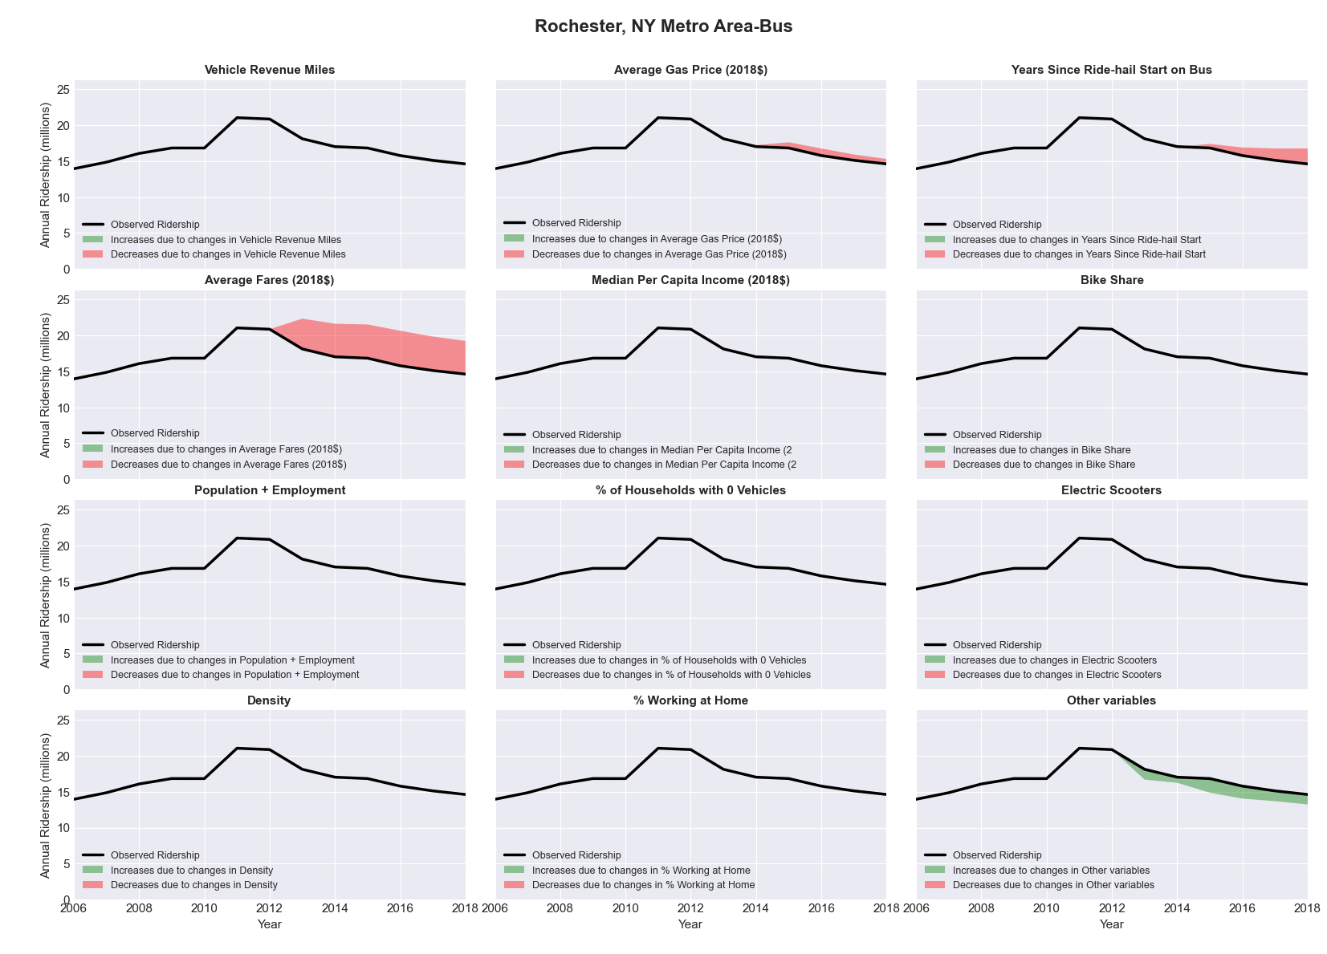

|  |  |  |  |  |  |  |
| --- | --- | --- | --- | --- | --- | --- |
| Rockford, IL Metro Area-Bus | | | | | | |
|  |  |  |  |  |  | |
|  | **Average Values** | | | **Ridership Effect** | | |
| **Description** | **2012** | **2018** | **% Diff** | **Absolute** | **% Diff** | |
|  |  |  |  |  |  | |
| **Vehicle Revenue Miles** | 1,350,790 | 1,215,130 | -10.0% | -82,970 | | **-4.5%** | |
| **Average Fare (2018$)** | 0.73 | 0.63 | -14.1% | 57,800 | | **3.1%** | |
| **Network Restructure** | - | - | - | - | | **0.0%** | |
| **Major Maintenance Event** | - | - | - | - | | **0.0%** | |
| **Population + Employment** | 500,980 | 495,310 | -1.1% | -4,490 | | **-0.2%** | |
| **Share of Population and Employment in Transit Supportive Density** | 0.14 | 0.13 | -6.6% | -6,390 | | **-0.3%** | |
| **Average Gas Price (2018$)** | 3.93 | 2.72 | -30.9% | -73,000 | | **-4.0%** | |
| **Median Per Capita Income (2018$)** | 28,040 | 30,400 | 8.4% | -8,640 | | **-0.5%** | |
| **% of Households with 0 Vehicles** | 8 | 8 | 4.6% | 1,240 | | **0.1%** | |
| **% Working at Home** | 3.5 | 4.5 | 27.1% | -12,100 | | **-0.7%** | |
| **Years Since Ride-hail Start** | - | 3 | 3 | -163,060 | | **-8.8%** | |
| **Bike Share** | 1.00 | 1 | - | - | | **0.0%** | |
| **Electric Scooters** | - | - | - | - | | **0.0%** | |
| **New Reporters** |  |  |  | - | | **0.0%** | |
| **Total Modeled Ridership** | 1,844,701 | 1,552,600 | -15.83% | -292101.421 | | **-15.8%** | |
| **Total Observed Ridership** | 1,817,660 | 1,561,371 | -14.10% | -256289 | | **-14.1%** | |
| **Unexplained Change** |  |  |  |  | | **1.7%** | |

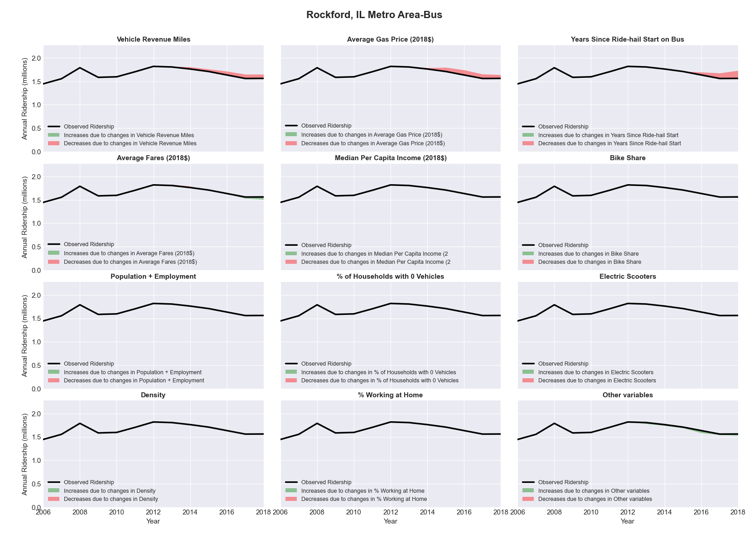

|  |  |  |  |  |  |  |
| --- | --- | --- | --- | --- | --- | --- |
| Sacramento--Arden-Arcade--Roseville, CA Metro Area-Bus | | | | | | |
|  |  |  |  |  |  | |
|  | **Average Values** | | | **Ridership Effect** | | |
| **Description** | **2012** | **2018** | **% Diff** | **Absolute** | **% Diff** | |
|  |  |  |  |  |  | |
| **Vehicle Revenue Miles** | 9,474,330 | 9,865,230 | 4.1% | 375,840 | | **1.8%** | |
| **Average Fare (2018$)** | 1.02 | 1.42 | 39.9% | -1,987,580 | | **-9.4%** | |
| **Network Restructure** | - | - | - | - | | **0.0%** | |
| **Major Maintenance Event** | - | - | - | - | | **0.0%** | |
| **Population + Employment** | 3,136,360 | 3,397,060 | 8.3% | 332,170 | | **1.6%** | |
| **Share of Population and Employment in Transit Supportive Density** | 0.49 | 0.48 | -3.0% | -119,020 | | **-0.6%** | |
| **Average Gas Price (2018$)** | 4.35 | 3.40 | -21.8% | -627,000 | | **-2.9%** | |
| **Median Per Capita Income (2018$)** | 29,290 | 32,550 | 11.1% | -153,280 | | **-0.7%** | |
| **% of Households with 0 Vehicles** | 7 | 6 | -14.1% | -35,810 | | **-0.2%** | |
| **% Working at Home** | 6.0 | 7.8 | 29.6% | -250,750 | | **-1.2%** | |
| **Years Since Ride-hail Start** | - | 5 | 5 | -3,129,800 | | **-14.7%** | |
| **Bike Share** | - | - | - | - | | **0.0%** | |
| **Electric Scooters** | - | - | - | - | | **0.0%** | |
| **New Reporters** |  |  |  | - | | **0.0%** | |
| **Total Modeled Ridership** | 21,255,988 | 15,799,177 | -25.67% | -5456810.86 | | **-25.7%** | |
| **Total Observed Ridership** | 19,858,162 | 15,927,467 | -19.79% | -3930695 | | **-19.8%** | |
| **Unexplained Change** |  |  |  |  | | **5.9%** | |

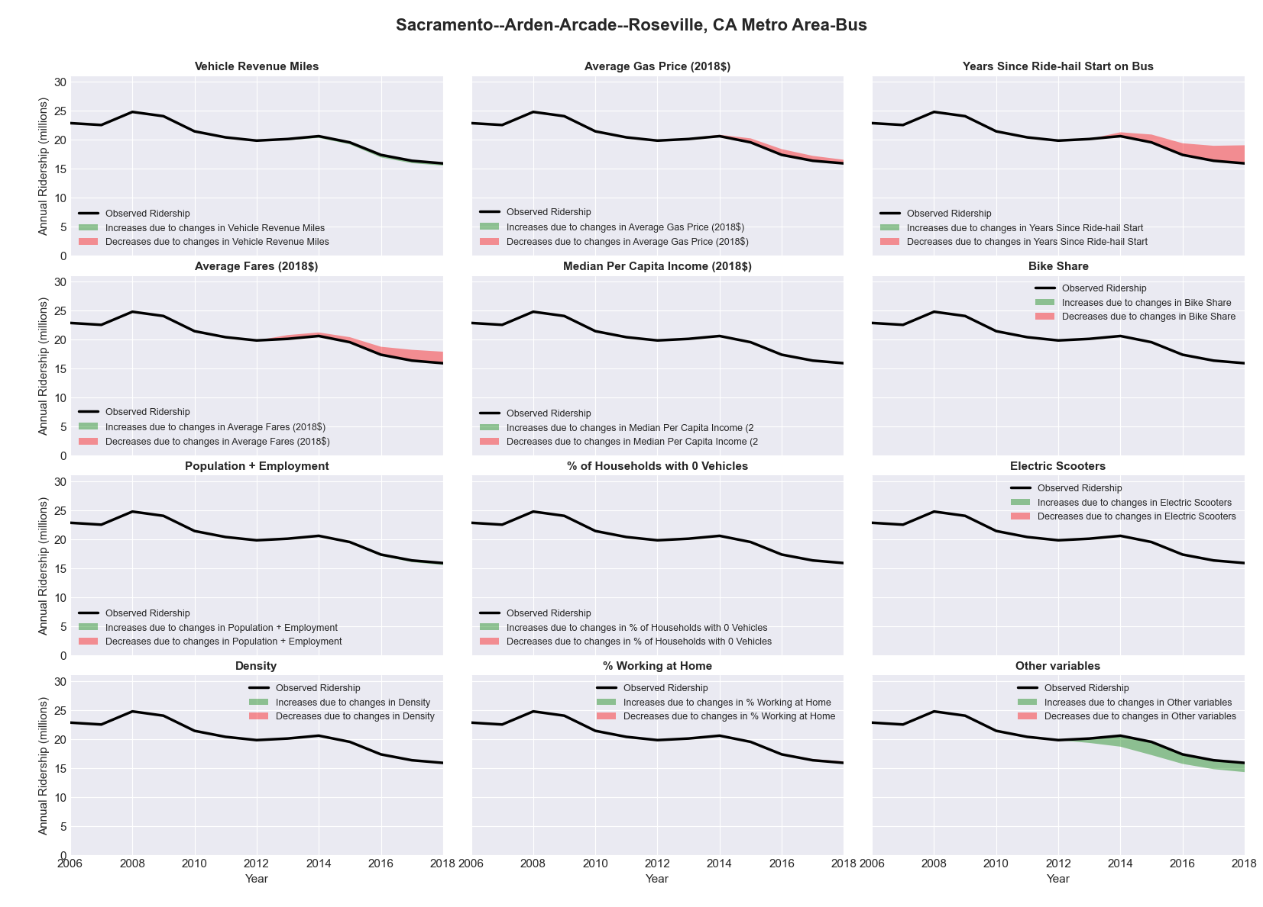

|  |  |  |  |  |  |  |
| --- | --- | --- | --- | --- | --- | --- |
| Sacramento--Arden-Arcade--Roseville, CA Metro Area-Rail | | | | | | |
|  |  |  |  |  |  | |
|  | **Average Values** | | | **Ridership Effect** | | |
| **Description** | **2012** | **2018** | **% Diff** | **Absolute** | **% Diff** | |
|  |  |  |  |  |  | |
| **Vehicle Revenue Miles** | 3,886,330 | 4,497,350 | 15.7% | 1,203,510 | | **9.6%** | |
| **Average Fare (2018$)** | 1.16 | 1.59 | 36.9% | -712,400 | | **-5.7%** | |
| **Network Restructure** | - | - | - | - | | **0.0%** | |
| **Major Maintenance Event** | - | - | - | - | | **0.0%** | |
| **Population + Employment** | 3,136,360 | 3,397,060 | 8.3% | 216,670 | | **1.7%** | |
| **Share of Population and Employment in Transit Supportive Density** | 0.49 | 0.48 | -3.0% | -76,380 | | **-0.6%** | |
| **Average Gas Price (2018$)** | 4.35 | 3.40 | -21.8% | -374,770 | | **-3.0%** | |
| **Median Per Capita Income (2018$)** | 29,290 | 32,550 | 11.1% | -95,020 | | **-0.8%** | |
| **% of Households with 0 Vehicles** | 7 | 6 | -14.1% | -22,400 | | **-0.2%** | |
| **% Working at Home** | 6.0 | 7.8 | 29.6% | -155,190 | | **-1.2%** | |
| **Years Since Ride-hail Start** | - | 5 | 5 | -1,380,320 | | **-11.0%** | |
| **Bike Share** | - | - | - | - | | **0.0%** | |
| **Electric Scooters** | - | - | - | - | | **0.0%** | |
| **New Reporters** |  |  |  | - | | **0.0%** | |
| **Total Modeled Ridership** | 12,540,321 | 11,122,798 | -11.30% | -1417523.6 | | **-11.3%** | |
| **Total Observed Ridership** | 13,586,505 | 9,762,892 | -28.14% | -3823613 | | **-28.1%** | |
| **Unexplained Change** |  |  |  |  | | **-16.8%** | |

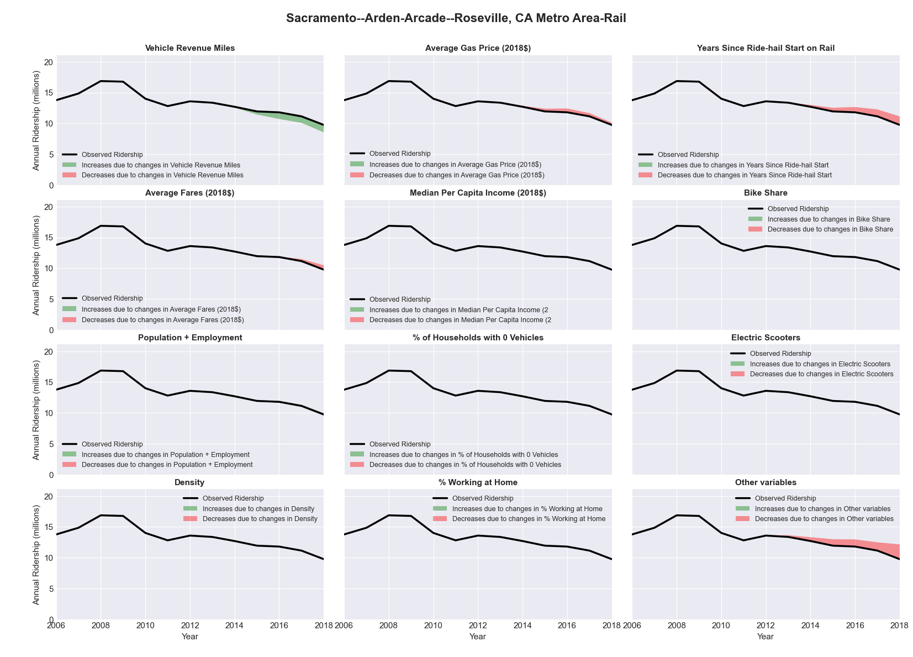

|  |  |  |  |  |  |  |
| --- | --- | --- | --- | --- | --- | --- |
| Saginaw-Saginaw Township North, MI Metro Area-Bus | | | | | | |
|  |  |  |  |  |  | |
|  | **Average Values** | | | **Ridership Effect** | | |
| **Description** | **2012** | **2018** | **% Diff** | **Absolute** | **% Diff** | |
|  |  |  |  |  |  | |
| **Vehicle Revenue Miles** | 681,620 | 953,800 | 39.9% | 72,780 | | **9.2%** | |
| **Average Fare (2018$)** | 0.87 | 1.06 | 21.9% | -25,180 | | **-3.2%** | |
| **Network Restructure** | - | - | - | - | | **0.0%** | |
| **Major Maintenance Event** | - | - | - | - | | **0.0%** | |
| **Population + Employment** | 278,930 | 274,470 | -1.6% | -2,960 | | **-0.4%** | |
| **Share of Population and Employment in Transit Supportive Density** | 0.04 | 0.04 | -6.7% | -0,850 | | **-0.1%** | |
| **Average Gas Price (2018$)** | 3.93 | 2.72 | -30.9% | -46,740 | | **-5.9%** | |
| **Median Per Capita Income (2018$)** | 24,140 | 25,980 | 7.6% | -3,280 | | **-0.4%** | |
| **% of Households with 0 Vehicles** | 8 | 9 | 13.8% | 1,520 | | **0.2%** | |
| **% Working at Home** | 3.0 | 5.1 | 70.8% | -7,540 | | **-1.0%** | |
| **Years Since Ride-hail Start** | - | 1 | 1 | -17,260 | | **-2.2%** | |
| **Bike Share** | - | - | - | - | | **0.0%** | |
| **Electric Scooters** | - | - | - | - | | **0.0%** | |
| **New Reporters** |  |  |  | - | | **0.0%** | |
| **Total Modeled Ridership** | 790,691 | 788,205 | -0.31% | -2486.56533 | | **-0.3%** | |
| **Total Observed Ridership** | 975,907 | 559,182 | -42.70% | -416725 | | **-42.7%** | |
| **Unexplained Change** |  |  |  |  | | **-42.4%** | |

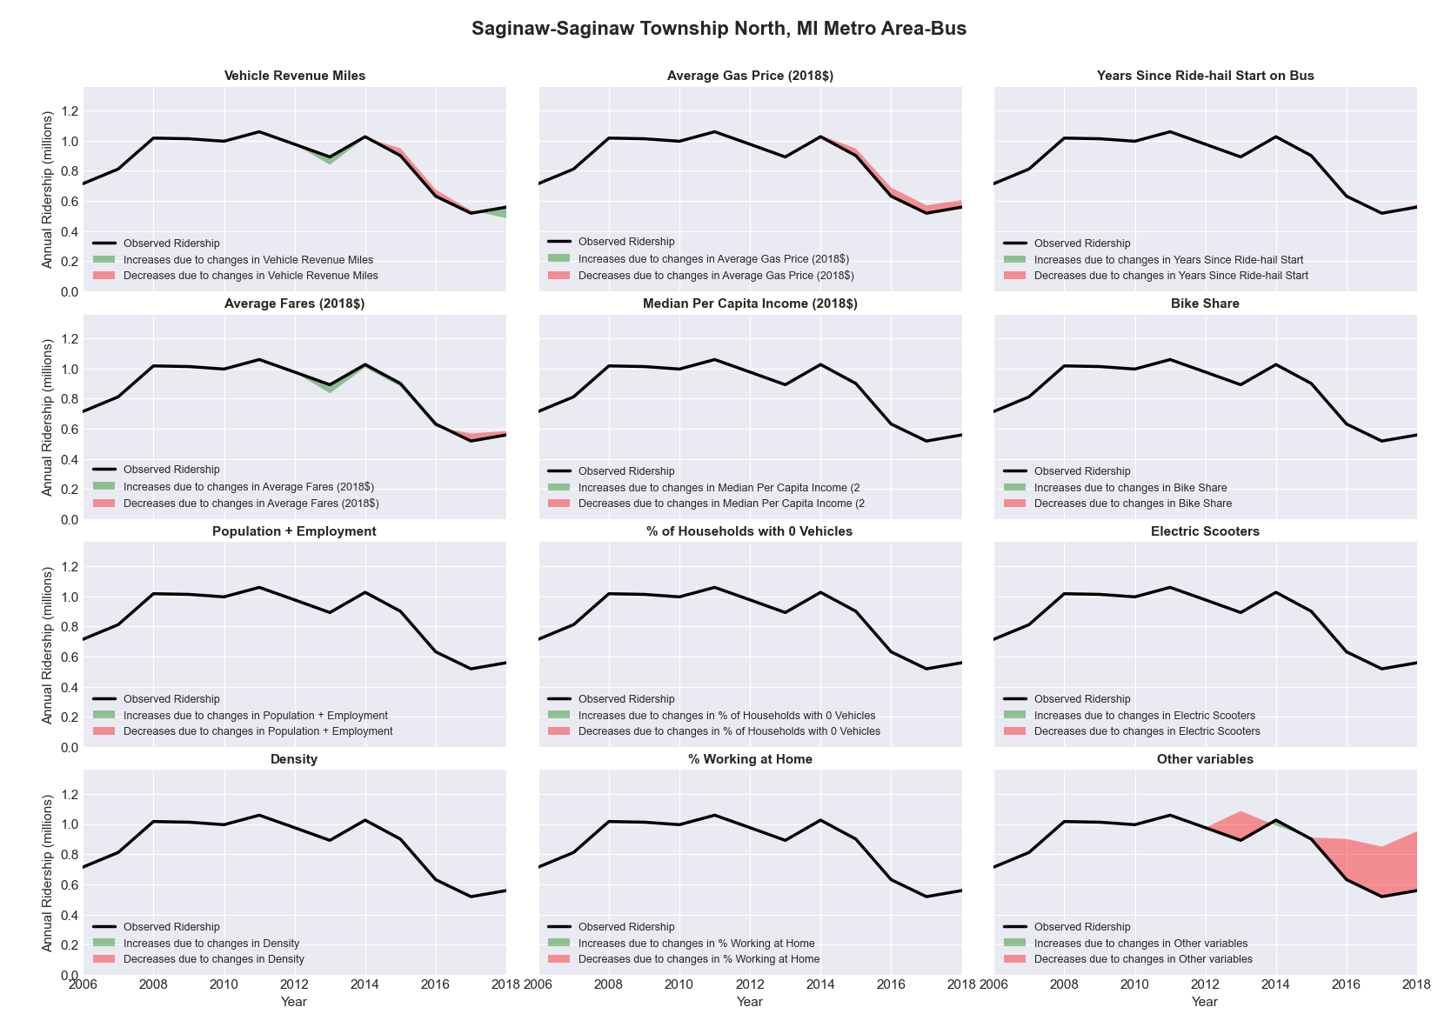

|  |  |  |  |  |  |  |
| --- | --- | --- | --- | --- | --- | --- |
| Salem, OR Metro Area-Bus | | | | | | |
|  |  |  |  |  |  | |
|  | **Average Values** | | | **Ridership Effect** | | |
| **Description** | **2012** | **2018** | **% Diff** | **Absolute** | **% Diff** | |
|  |  |  |  |  |  | |
| **Vehicle Revenue Miles** | 1,972,320 | 2,115,120 | 7.2% | 110,940 | | **3.4%** | |
| **Average Fare (2018$)** | 0.79 | 0.84 | 6.3% | -51,300 | | **-1.6%** | |
| **Network Restructure** | - | - | - | - | | **0.0%** | |
| **Major Maintenance Event** | - | - | - | - | | **0.0%** | |
| **Population + Employment** | 563,970 | 625,470 | 10.9% | 71,990 | | **2.2%** | |
| **Share of Population and Employment in Transit Supportive Density** | 0.28 | 0.27 | -2.7% | -9,990 | | **-0.3%** | |
| **Average Gas Price (2018$)** | 4.35 | 3.40 | -21.8% | -99,250 | | **-3.1%** | |
| **Median Per Capita Income (2018$)** | 24,540 | 27,630 | 12.6% | -27,750 | | **-0.9%** | |
| **% of Households with 0 Vehicles** | 8 | 6 | -30.7% | -17,200 | | **-0.5%** | |
| **% Working at Home** | 4.6 | 6.8 | 47.8% | -49,000 | | **-1.5%** | |
| **Years Since Ride-hail Start** | - | 1 | 1 | -100,270 | | **-3.1%** | |
| **Bike Share** | - | - | - | - | | **0.0%** | |
| **Electric Scooters** | - | - | - | - | | **0.0%** | |
| **New Reporters** |  |  |  | - | | **0.0%** | |
| **Total Modeled Ridership** | 3,234,049 | 3,055,074 | -5.53% | -178974.846 | | **-5.5%** | |
| **Total Observed Ridership** | 3,424,964 | 2,990,859 | -12.67% | -434105 | | **-12.7%** | |
| **Unexplained Change** |  |  |  |  | | **-7.1%** | |

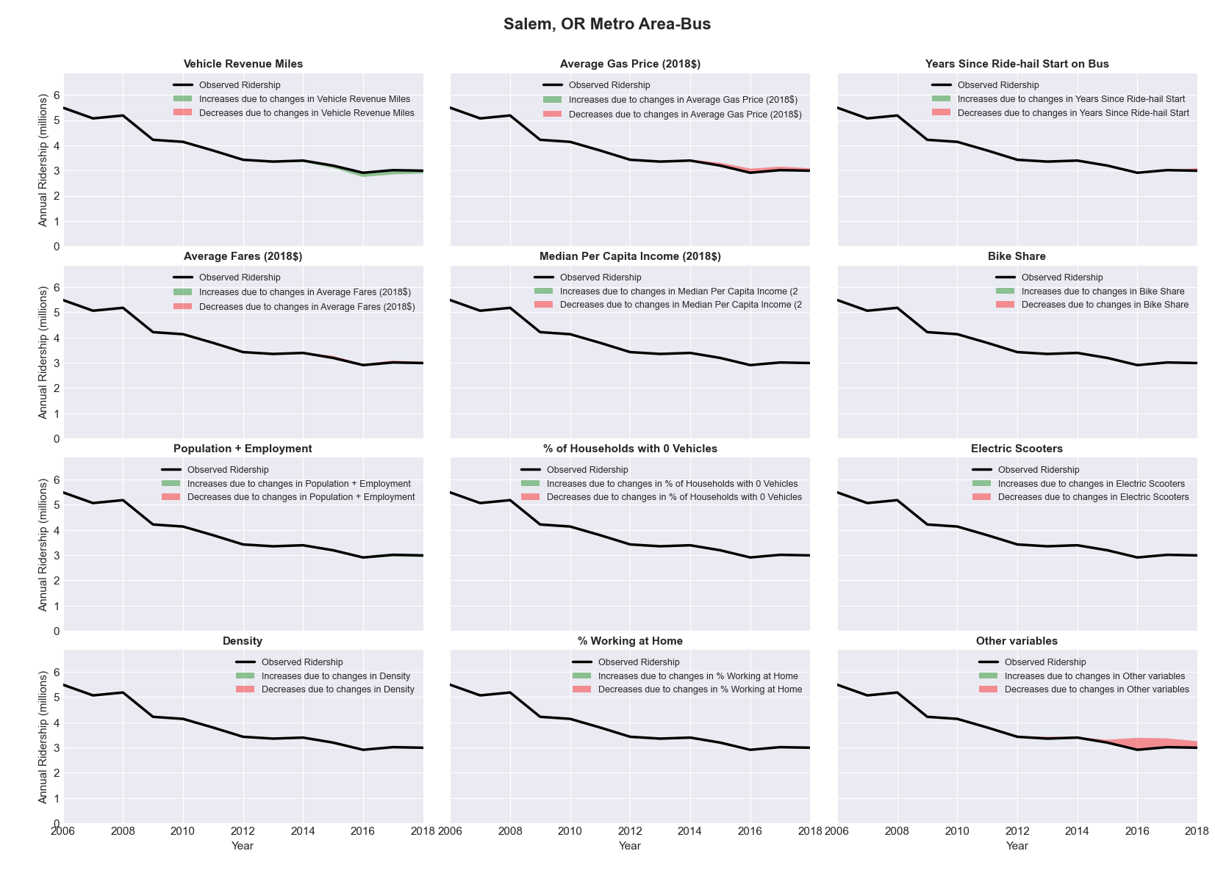

|  |  |  |  |  |  |  |
| --- | --- | --- | --- | --- | --- | --- |
| Salinas, CA Metro Area-Bus | | | | | | |
|  |  |  |  |  |  | |
|  | **Average Values** | | | **Ridership Effect** | | |
| **Description** | **2012** | **2018** | **% Diff** | **Absolute** | **% Diff** | |
|  |  |  |  |  |  | |
| **Vehicle Revenue Miles** | 4,260,180 | 4,550,170 | 6.8% | 130,980 | | **2.8%** | |
| **Average Fare (2018$)** | 2.01 | 2.61 | 29.9% | -436,370 | | **-9.5%** | |
| **Network Restructure** | - | - | - | - | | **0.0%** | |
| **Major Maintenance Event** | - | - | - | - | | **0.0%** | |
| **Population + Employment** | 619,360 | 649,300 | 4.8% | 42,810 | | **0.9%** | |
| **Share of Population and Employment in Transit Supportive Density** | 0.37 | 0.38 | 1.7% | 10,280 | | **0.2%** | |
| **Average Gas Price (2018$)** | 4.35 | 3.40 | -21.8% | -109,590 | | **-2.4%** | |
| **Median Per Capita Income (2018$)** | 24,250 | 28,420 | 17.2% | -47,460 | | **-1.0%** | |
| **% of Households with 0 Vehicles** | 5 | 3 | -41.2% | -17,900 | | **-0.4%** | |
| **% Working at Home** | 4.0 | 5.6 | 40.0% | -53,660 | | **-1.2%** | |
| **Years Since Ride-hail Start** | - | 4 | 4 | -560,150 | | **-12.2%** | |
| **Bike Share** | - | - | - | - | | **0.0%** | |
| **Electric Scooters** | - | - | - | - | | **0.0%** | |
| **New Reporters** |  |  |  | - | | **0.0%** | |
| **Total Modeled Ridership** | 4,600,813 | 3,568,634 | -22.43% | -1032179.07 | | **-22.4%** | |
| **Total Observed Ridership** | 4,165,308 | 4,269,542 | 2.50% | 104234 | | **2.5%** | |
| **Unexplained Change** |  |  |  |  | | **24.9%** | |

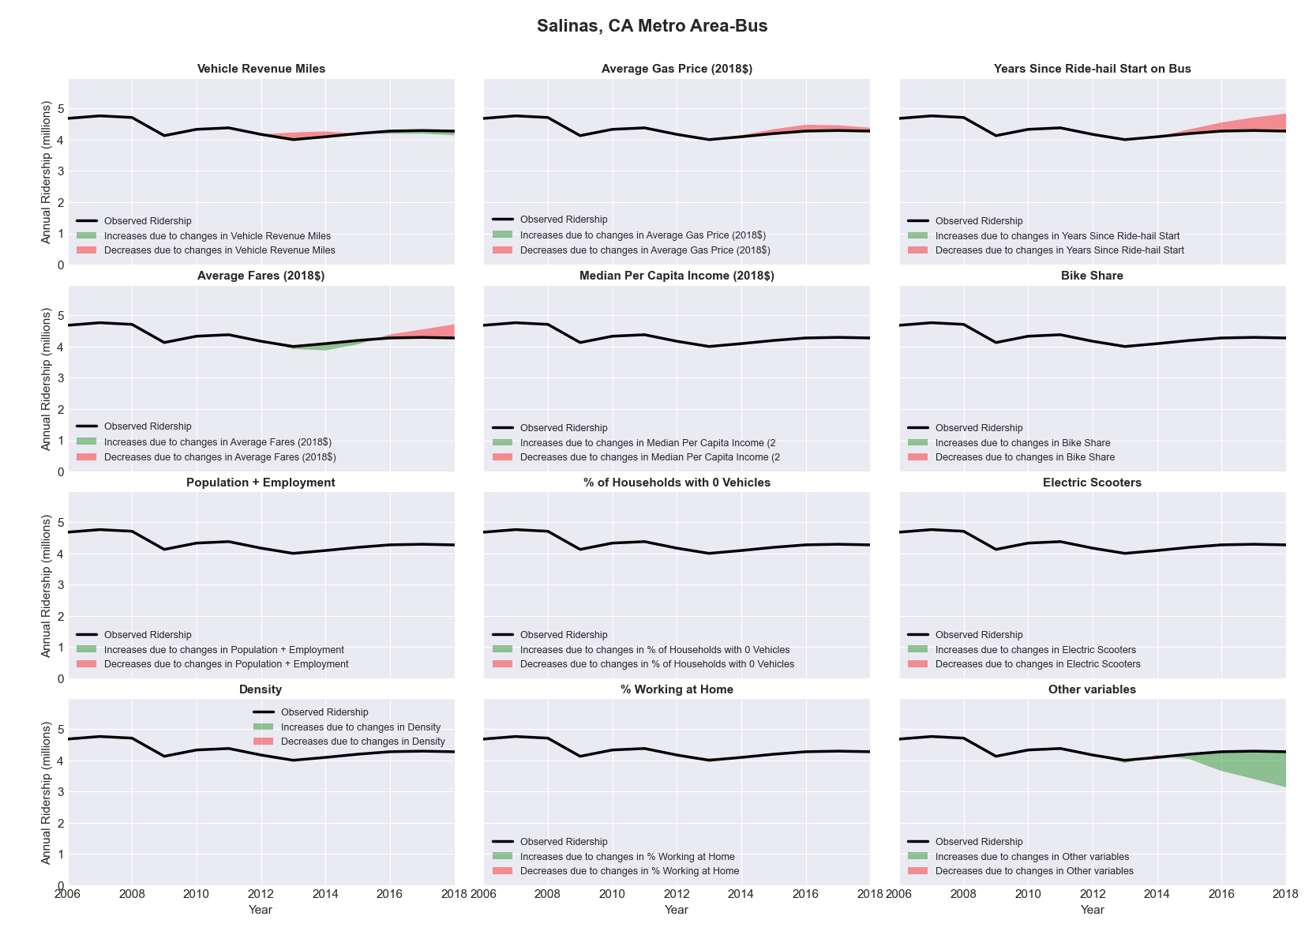

|  |  |  |  |  |  |  |
| --- | --- | --- | --- | --- | --- | --- |
| Salt Lake City, UT Metro Area-Bus | | | | | | |
|  |  |  |  |  |  | |
|  | **Average Values** | | | **Ridership Effect** | | |
| **Description** | **2012** | **2018** | **% Diff** | **Absolute** | **% Diff** | |
|  |  |  |  |  |  | |
| **Vehicle Revenue Miles** | 15,931,530 | 17,895,280 | 12.3% | 1,069,730 | | **4.9%** | |
| **Average Fare (2018$)** | 1.11 | 1.22 | 9.3% | -526,620 | | **-2.4%** | |
| **Network Restructure** | - | - | - | - | | **0.0%** | |
| **Major Maintenance Event** | - | - | - | - | | **0.0%** | |
| **Population + Employment** | 1,735,510 | 1,886,360 | 8.7% | 364,710 | | **1.7%** | |
| **Share of Population and Employment in Transit Supportive Density** | 0.51 | 0.49 | -2.9% | -121,220 | | **-0.6%** | |
| **Average Gas Price (2018$)** | 3.88 | 2.89 | -25.5% | -651,260 | | **-3.0%** | |
| **Median Per Capita Income (2018$)** | 29,280 | 32,700 | 11.7% | -158,080 | | **-0.7%** | |
| **% of Households with 0 Vehicles** | 6 | 5 | -27.2% | -69,630 | | **-0.3%** | |
| **% Working at Home** | 4.7 | 7.4 | 56.4% | -407,950 | | **-1.9%** | |
| **Years Since Ride-hail Start** | - | 4 | 4 | -2,675,610 | | **-12.3%** | |
| **Bike Share** | - | 1 | 1 | - 226,860 | | **-1.0%** | |
| **Electric Scooters** | - | 1 | 1 | - 770,750 | | **-3.5%** | |
| **New Reporters** |  |  |  | - | | **0.0%** | |
| **Total Modeled Ridership** | 21,761,109 | 17,584,047 | -19.20% | -4177062.85 | | **-19.2%** | |
| **Total Observed Ridership** | 21,042,239 | 19,607,273 | -6.82% | -1434966 | | **-6.8%** | |
| **Unexplained Change** |  |  |  |  | | **12.4%** | |

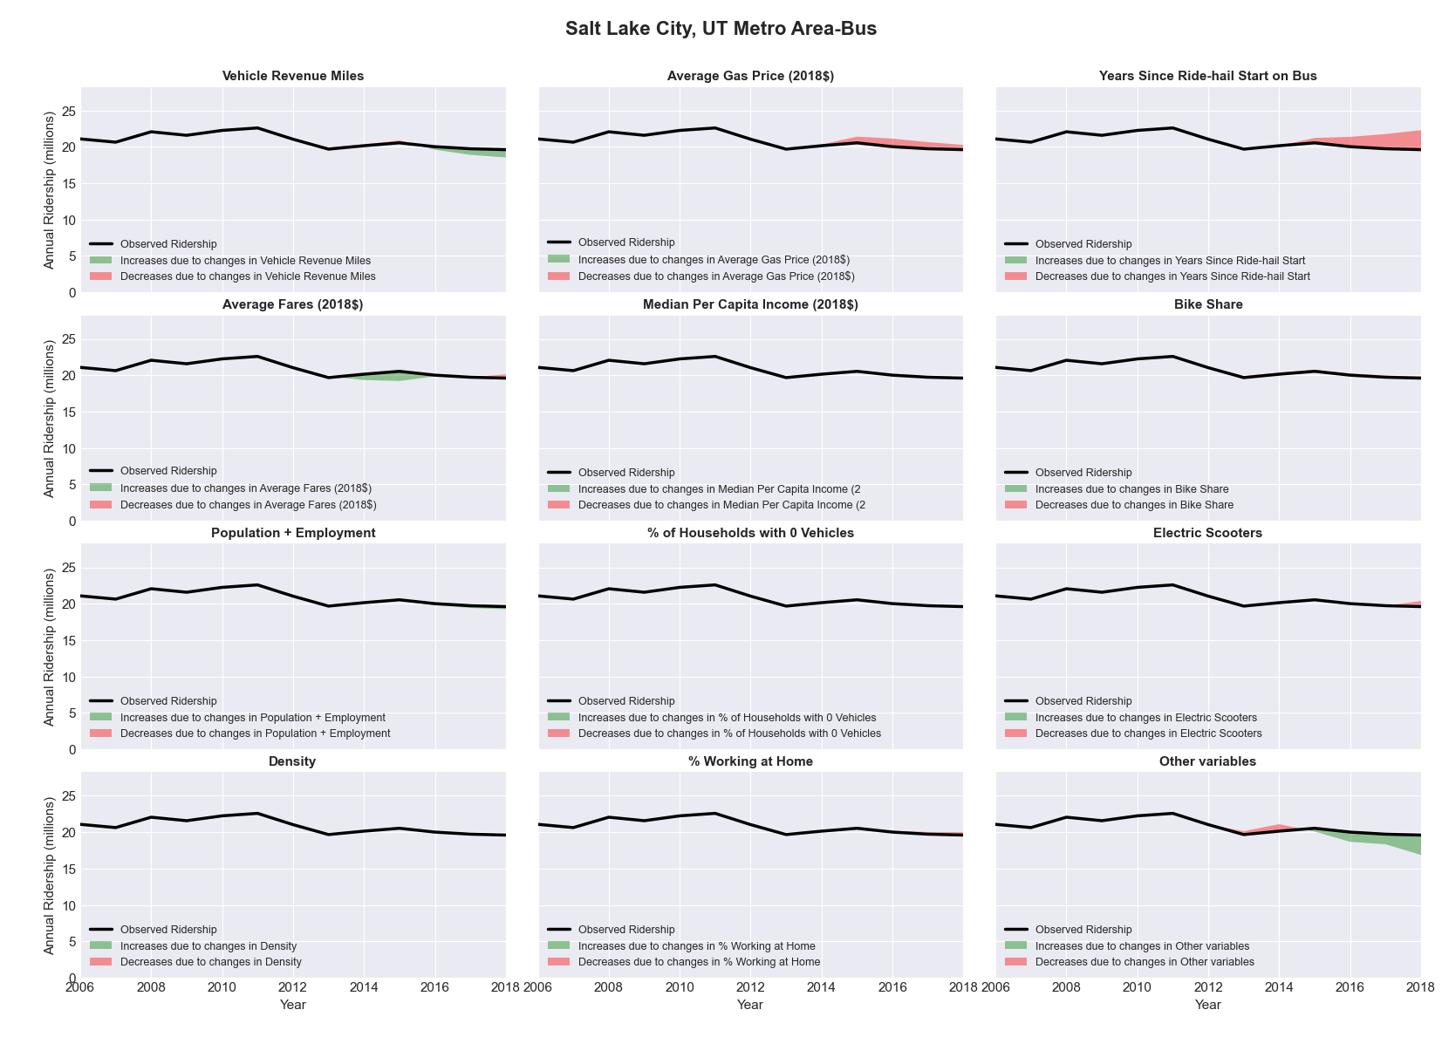

|  |  |  |  |  |  |  |
| --- | --- | --- | --- | --- | --- | --- |
| Salt Lake City, UT Metro Area-Rail | | | | | | |
|  |  |  |  |  |  | |
|  | **Average Values** | | | **Ridership Effect** | | |
| **Description** | **2012** | **2018** | **% Diff** | **Absolute** | **% Diff** | |
|  |  |  |  |  |  | |
| **Vehicle Revenue Miles** | 7,738,850 | 12,073,890 | 56.0% | 6,608,310 | | **33.7%** | |
| **Average Fare (2018$)** | 1.09 | 1.05 | -4.0% | 251,810 | | **1.3%** | |
| **Network Restructure** | - | - | - | - | | **0.0%** | |
| **Major Maintenance Event** | - | - | - | - | | **0.0%** | |
| **Population + Employment** | 1,735,510 | 1,886,360 | 8.7% | 434,730 | | **2.2%** | |
| **Share of Population and Employment in Transit Supportive Density** | 0.51 | 0.49 | -2.9% | -130,870 | | **-0.7%** | |
| **Average Gas Price (2018$)** | 3.88 | 2.89 | -25.5% | -760,100 | | **-3.9%** | |
| **Median Per Capita Income (2018$)** | 29,280 | 32,700 | 11.7% | -185,350 | | **-0.9%** | |
| **% of Households with 0 Vehicles** | 6 | 5 | -27.2% | -70,910 | | **-0.4%** | |
| **% Working at Home** | 4.7 | 7.4 | 56.4% | -467,020 | | **-2.4%** | |
| **Years Since Ride-hail Start** | - | 4 | 4 | -2,174,190 | | **-11.1%** | |
| **Bike Share** | - | 1 | 1 | - 209,200 | | **-1.1%** | |
| **Electric Scooters** | - | 1 | 1 | - 924,030 | | **-4.7%** | |
| **New Reporters** |  |  |  | - | | **0.0%** | |
| **Total Modeled Ridership** | 19,634,662 | 21,868,424 | 11.38% | 2233762.38 | | **11.4%** | |
| **Total Observed Ridership** | 19,404,129 | 22,961,200 | 18.33% | 3557071 | | **18.3%** | |
| **Unexplained Change** |  |  |  |  | | **7.0%** | |

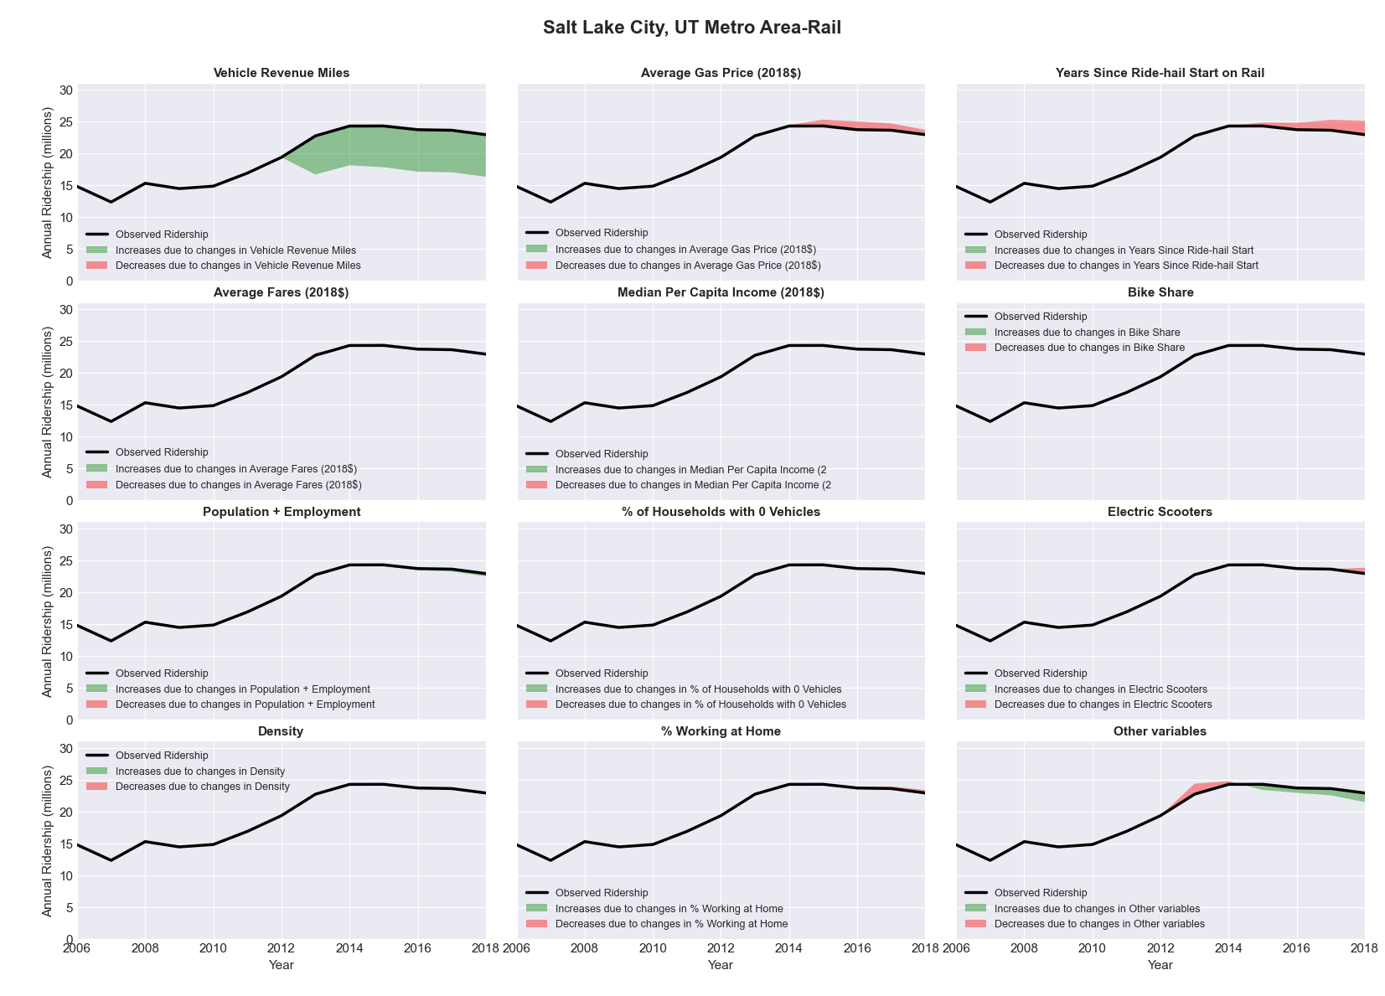

|  |  |  |  |  |  |  |
| --- | --- | --- | --- | --- | --- | --- |
| San Antonio-New Braunfels, TX Metro Area-Bus | | | | | | |
|  |  |  |  |  |  | |
|  | **Average Values** | | | **Ridership Effect** | | |
| **Description** | **2012** | **2018** | **% Diff** | **Absolute** | **% Diff** | |
|  |  |  |  |  |  | |
| **Vehicle Revenue Miles** | 20,316,120 | 23,189,050 | 14.1% | 2,364,690 | | **5.5%** | |
| **Average Fare (2018$)** | 0.53 | 0.49 | -8.9% | 514,620 | | **1.2%** | |
| **Network Restructure** | - | - | - | - | | **0.0%** | |
| **Major Maintenance Event** | - | - | - | - | | **0.0%** | |
| **Population + Employment** | 3,221,370 | 3,662,240 | 13.7% | 1,137,320 | | **2.7%** | |
| **Share of Population and Employment in Transit Supportive Density** | 0.37 | 0.36 | -4.0% | -257,300 | | **-0.6%** | |
| **Average Gas Price (2018$)** | 3.80 | 2.58 | -32.2% | -1,810,250 | | **-4.2%** | |
| **Median Per Capita Income (2018$)** | 26,790 | 28,260 | 5.5% | -152,430 | | **-0.4%** | |
| **% of Households with 0 Vehicles** | 7 | 7 | 9.6% | 47,500 | | **0.1%** | |
| **% Working at Home** | 4.1 | 4.9 | 18.9% | -241,800 | | **-0.6%** | |
| **Years Since Ride-hail Start** | - | 4 | 4 | -5,085,870 | | **-11.9%** | |
| **Bike Share** | - | 1 | 1 | - 448,680 | | **-1.1%** | |
| **Electric Scooters** | - | 1 | 1 | - 1,414,820 | | **-3.3%** | |
| **New Reporters** |  |  |  | - | | **0.0%** | |
| **Total Modeled Ridership** | 42,731,146 | 37,264,873 | -12.79% | -5466273.28 | | **-12.8%** | |
| **Total Observed Ridership** | 46,032,779 | 37,284,986 | -19.00% | -8747793 | | **-19.0%** | |
| **Unexplained Change** |  |  |  |  | | **-6.2%** | |

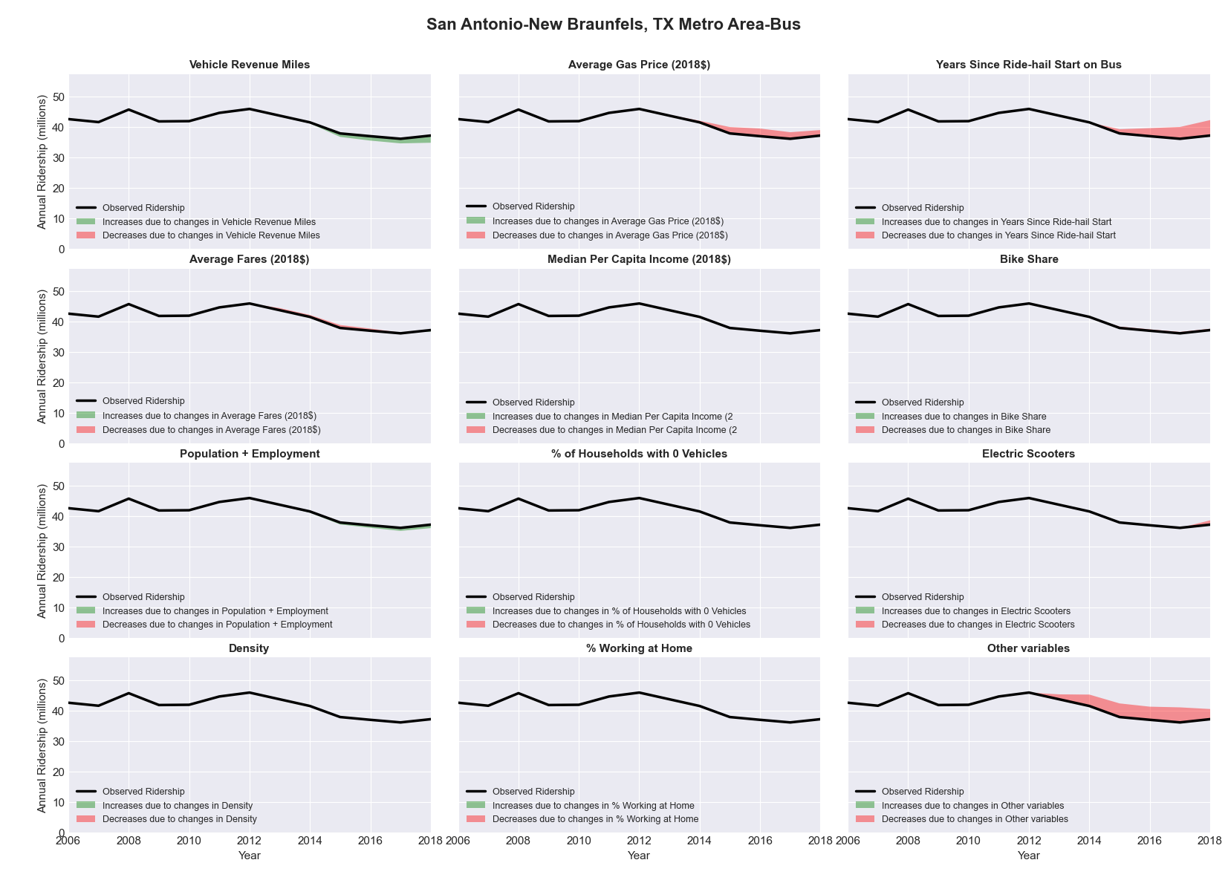

|  |  |  |  |  |  |  |
| --- | --- | --- | --- | --- | --- | --- |
| San Diego-Carlsbad-San Marcos, CA Metro Area-Bus | | | | | | |
|  |  |  |  |  |  | |
|  | **Average Values** | | | **Ridership Effect** | | |
| **Description** | **2012** | **2018** | **% Diff** | **Absolute** | **% Diff** | |
|  |  |  |  |  |  | |
| **Vehicle Revenue Miles** | 23,175,910 | 25,702,230 | 10.9% | 2,970,450 | | **4.6%** | |
| **Average Fare (2018$)** | 1.05 | 1.01 | -4.0% | 576,660 | | **0.9%** | |
| **Network Restructure** | - | - | - | - | | **0.0%** | |
| **Major Maintenance Event** | - | - | - | - | | **0.0%** | |
| **Population + Employment** | 4,576,940 | 4,896,460 | 7.0% | 906,900 | | **1.4%** | |
| **Share of Population and Employment in Transit Supportive Density** | 0.63 | 0.61 | -1.7% | -274,320 | | **-0.4%** | |
| **Average Gas Price (2018$)** | 4.35 | 3.40 | -21.8% | -1,893,270 | | **-3.0%** | |
| **Median Per Capita Income (2018$)** | 30,970 | 33,990 | 9.8% | -398,400 | | **-0.6%** | |
| **% of Households with 0 Vehicles** | 6 | 5 | -18.1% | -138,840 | | **-0.2%** | |
| **% Working at Home** | 6.6 | 6.8 | 3.0% | -94,830 | | **-0.1%** | |
| **Years Since Ride-hail Start** | - | 6 | 6 | -7,032,120 | | **-11.0%** | |
| **Bike Share** | - | 1 | 1 | - 692,670 | | **-1.1%** | |
| **Electric Scooters** | - | 1 | 1 | - 2,158,350 | | **-3.4%** | |
| **New Reporters** |  |  |  | - | | **0.0%** | |
| **Total Modeled Ridership** | 64,156,140 | 55,968,638 | -12.76% | -8187502.16 | | **-12.8%** | |
| **Total Observed Ridership** | 63,917,496 | 54,188,618 | -15.22% | -9728878 | | **-15.2%** | |
| **Unexplained Change** |  |  |  |  | | **-2.5%** | |

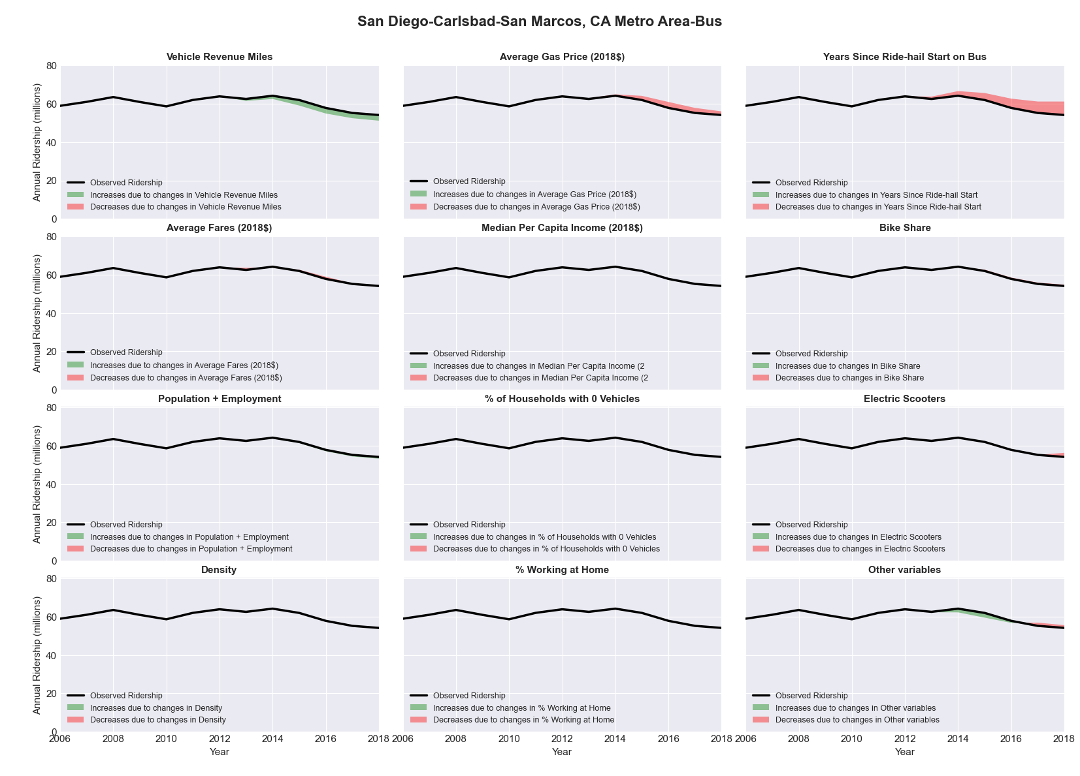

|  |  |  |  |  |  |  |
| --- | --- | --- | --- | --- | --- | --- |
| San Diego-Carlsbad-San Marcos, CA Metro Area-Rail | | | | | | |
|  |  |  |  |  |  | |
|  | **Average Values** | | | **Ridership Effect** | | |
| **Description** | **2012** | **2018** | **% Diff** | **Absolute** | **% Diff** | |
|  |  |  |  |  |  | |
| **Vehicle Revenue Miles** | 9,627,040 | 10,756,920 | 11.7% | 2,793,950 | | **7.2%** | |
| **Average Fare (2018$)** | 1.38 | 1.11 | -19.7% | 1,612,810 | | **4.1%** | |
| **Network Restructure** | - | - | - | - | | **0.0%** | |
| **Major Maintenance Event** | - | - | - | - | | **0.0%** | |
| **Population + Employment** | 4,576,940 | 4,896,460 | 7.0% | 597,510 | | **1.5%** | |
| **Share of Population and Employment in Transit Supportive Density** | 0.63 | 0.61 | -1.7% | -169,560 | | **-0.4%** | |
| **Average Gas Price (2018$)** | 4.35 | 3.40 | -21.8% | -1,192,690 | | **-3.1%** | |
| **Median Per Capita Income (2018$)** | 30,970 | 33,990 | 9.8% | -270,010 | | **-0.7%** | |
| **% of Households with 0 Vehicles** | 6 | 5 | -18.1% | -92,960 | | **-0.2%** | |
| **% Working at Home** | 6.6 | 6.8 | 3.0% | -35,290 | | **-0.1%** | |
| **Years Since Ride-hail Start** | - | 6 | 6 | 536,370 | | **1.4%** | |
| **Bike Share** | - | 1 | 1 | - 474,750 | | **-1.2%** | |
| **Electric Scooters** | - | 1 | 1 | - 1,610,460 | | **-4.1%** | |
| **New Reporters** |  |  |  | - | | **0.0%** | |
| **Total Modeled Ridership** | 38,968,839 | 40,965,274 | 5.12% | 1996434.98 | | **5.1%** | |
| **Total Observed Ridership** | 35,279,118 | 40,977,876 | 16.15% | 5698758 | | **16.2%** | |
| **Unexplained Change** |  |  |  |  | | **11.0%** | |

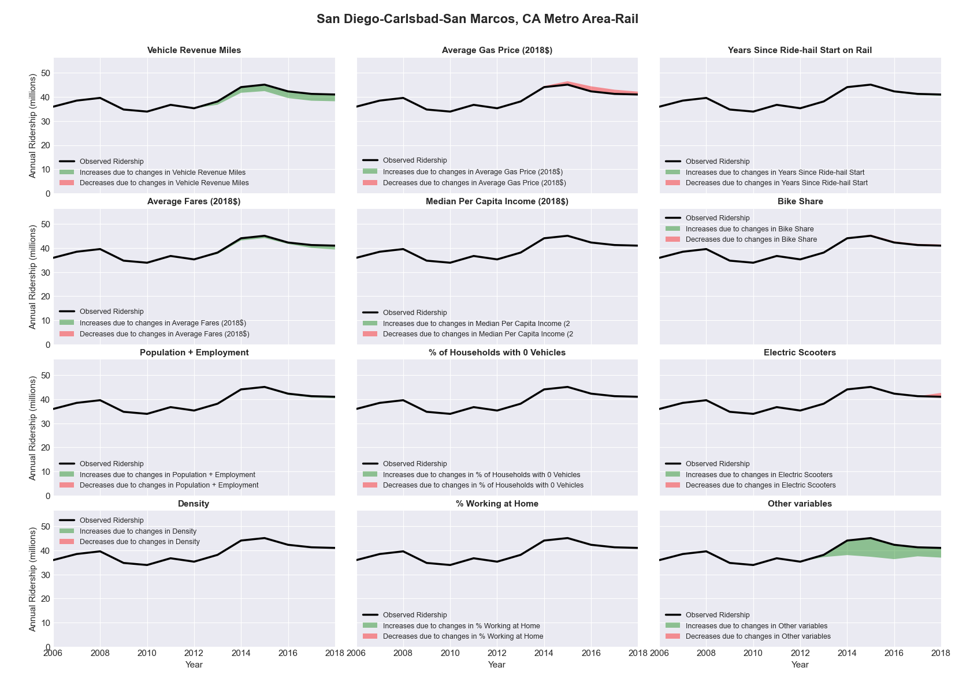

|  |  |  |  |  |  |  |
| --- | --- | --- | --- | --- | --- | --- |
| San Francisco-Oakland-Fremont, CA Metro Area-Bus | | | | | | |
|  |  |  |  |  |  | |
|  | **Average Values** | | | **Ridership Effect** | | |
| **Description** | **2012** | **2018** | **% Diff** | **Absolute** | **% Diff** | |
|  |  |  |  |  |  | |
| **Vehicle Revenue Miles** | 56,186,380 | 61,778,690 | 10.0% | 10,559,370 | | **4.0%** | |
| **Average Fare (2018$)** | 1.03 | 1.03 | -0.4% | 380,700 | | **0.1%** | |
| **Network Restructure** | - | - | - | - | | **0.0%** | |
| **Major Maintenance Event** | - | - | - | - | | **0.0%** | |
| **Population + Employment** | 6,661,390 | 7,287,030 | 9.4% | 4,798,440 | | **1.8%** | |
| **Share of Population and Employment in Transit Supportive Density** | 0.71 | 0.71 | -0.1% | -37,990 | | **-0.0%** | |
| **Average Gas Price (2018$)** | 4.35 | 3.40 | -21.8% | -6,843,860 | | **-2.6%** | |
| **Median Per Capita Income (2018$)** | 38,660 | 44,200 | 14.3% | -2,327,980 | | **-0.9%** | |
| **% of Households with 0 Vehicles** | 13 | 12 | -8.0% | -499,150 | | **-0.2%** | |
| **% Working at Home** | 6.1 | 7.0 | 15.2% | -1,714,900 | | **-0.7%** | |
| **Years Since Ride-hail Start** | 2.0 | 8 | 6 | -28,190,460 | | **-10.7%** | |
| **Bike Share** | - | 1 | 1 | - 2,663,690 | | **-1.0%** | |
| **Electric Scooters** | - | 1 | 1 | - 9,330,560 | | **-3.6%** | |
| **New Reporters** |  |  |  | - | | **0.0%** | |
| **Total Modeled Ridership** | 262,377,608 | 225,697,320 | -13.98% | -36680287.7 | | **-14.0%** | |
| **Total Observed Ridership** | 245,339,548 | 239,567,962 | -2.35% | -5771586 | | **-2.4%** | |
| **Unexplained Change** |  |  |  |  | | **11.6%** | |

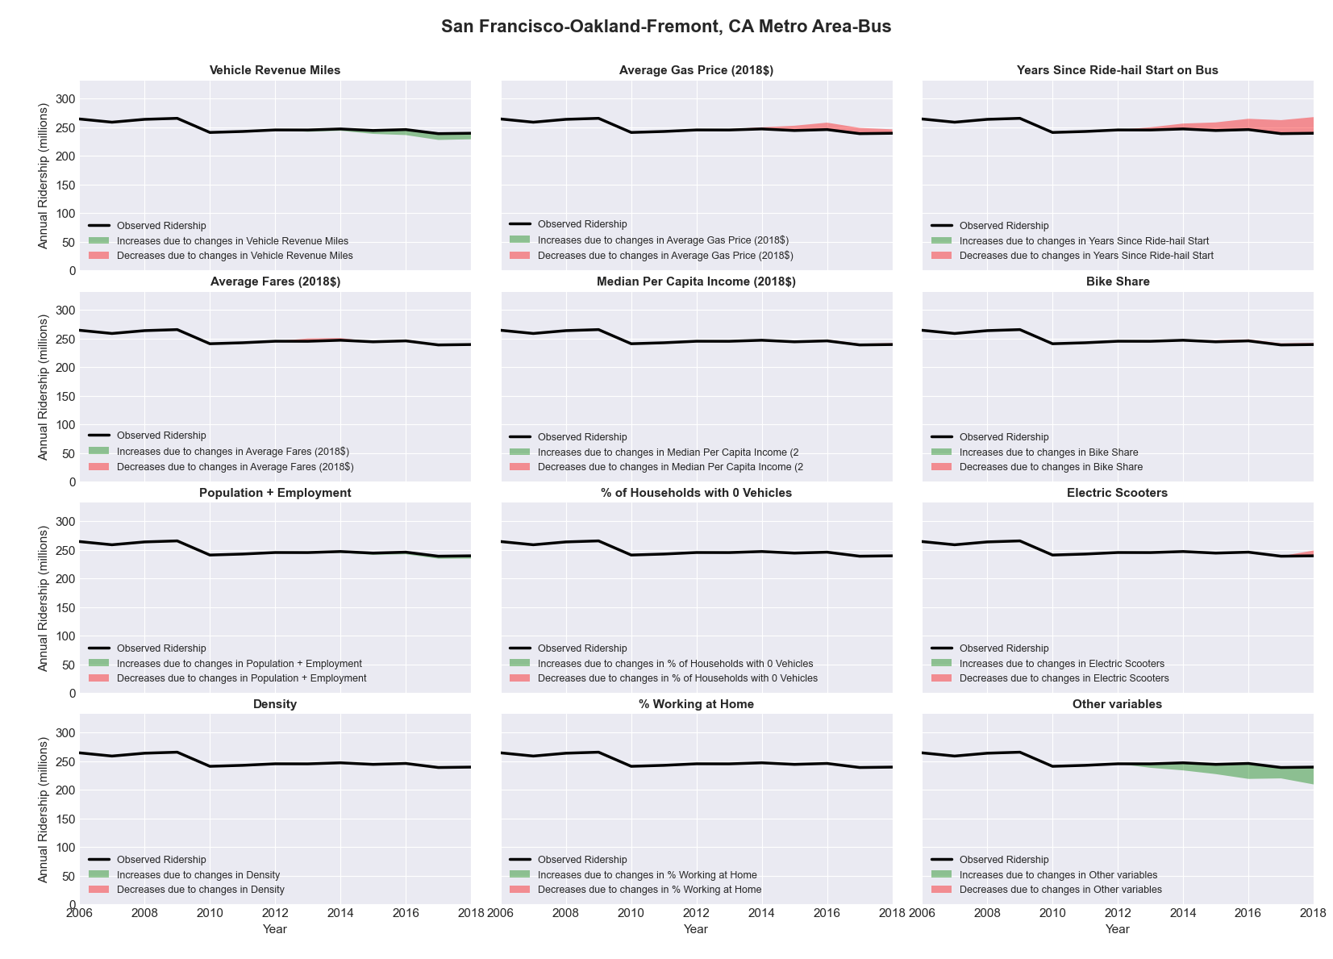

|  |  |  |  |  |  |  |
| --- | --- | --- | --- | --- | --- | --- |
| San Francisco-Oakland-Fremont, CA Metro Area-Rail | | | | | | |
|  |  |  |  |  |  | |
|  | **Average Values** | | | **Ridership Effect** | | |
| **Description** | **2012** | **2018** | **% Diff** | **Absolute** | **% Diff** | |
|  |  |  |  |  |  | |
| **Vehicle Revenue Miles** | 77,061,460 | 93,622,590 | 21.5% | 28,012,610 | | **13.4%** | |
| **Average Fare (2018$)** | 2.74 | 3.14 | 14.4% | -7,420,200 | | **-3.6%** | |
| **Network Restructure** | - | - | - | - | | **0.0%** | |
| **Major Maintenance Event** | - | - | - | - | | **0.0%** | |
| **Population + Employment** | 6,661,390 | 7,287,030 | 9.4% | 4,092,400 | | **2.0%** | |
| **Share of Population and Employment in Transit Supportive Density** | 0.71 | 0.71 | -0.1% | -35,970 | | **-0.0%** | |
| **Average Gas Price (2018$)** | 4.35 | 3.40 | -21.8% | -5,862,780 | | **-2.8%** | |
| **Median Per Capita Income (2018$)** | 38,660 | 44,200 | 14.3% | -2,047,090 | | **-1.0%** | |
| **% of Households with 0 Vehicles** | 13 | 12 | -8.0% | -434,090 | | **-0.2%** | |
| **% Working at Home** | 6.1 | 7.0 | 15.2% | -1,516,180 | | **-0.7%** | |
| **Years Since Ride-hail Start** | 2.0 | 8 | 6 | 2,748,660 | | **1.3%** | |
| **Bike Share** | - | 1 | 1 | - 2,362,860 | | **-1.1%** | |
| **Electric Scooters** | - | 1 | 1 | - 8,263,430 | | **-4.0%** | |
| **New Reporters** |  |  |  | - | | **0.0%** | |
| **Total Modeled Ridership** | 208,572,422 | 214,786,255 | 2.98% | 6213832.84 | | **3.0%** | |
| **Total Observed Ridership** | 195,606,009 | 210,924,190 | 7.83% | 15318181 | | **7.8%** | |
| **Unexplained Change** |  |  |  |  | | **4.9%** | |

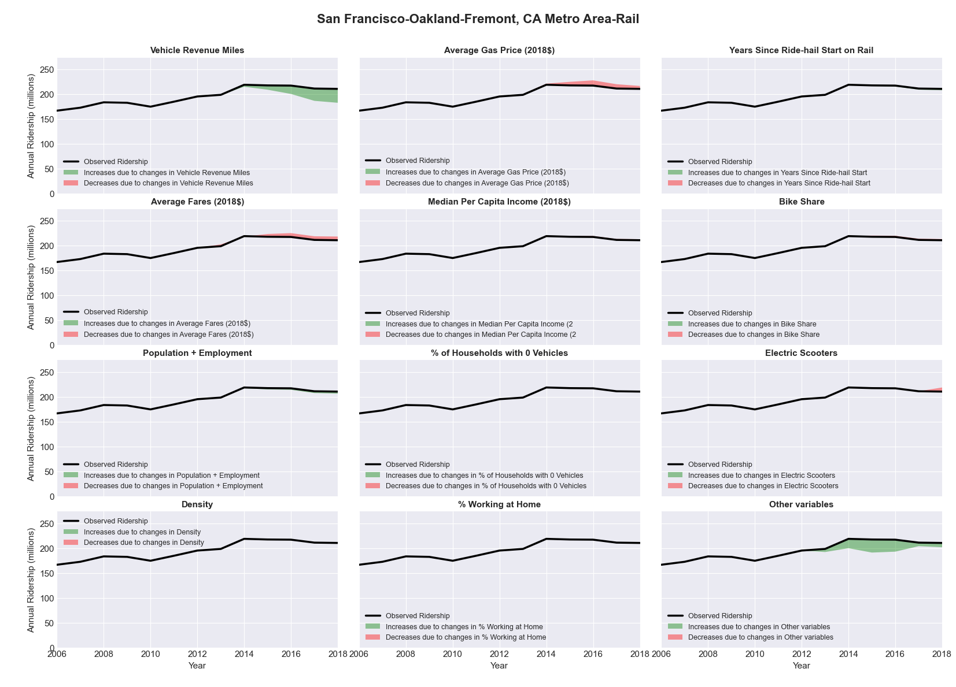

|  |  |  |  |  |  |  |
| --- | --- | --- | --- | --- | --- | --- |
| San Jose-Sunnyvale-Santa Clara, CA Metro Area-Bus | | | | | | |
|  |  |  |  |  |  | |
|  | **Average Values** | | | **Ridership Effect** | | |
| **Description** | **2012** | **2018** | **% Diff** | **Absolute** | **% Diff** | |
|  |  |  |  |  |  | |
| **Vehicle Revenue Miles** | 14,683,630 | 16,138,260 | 9.9% | 1,375,610 | | **4.2%** | |
| **Average Fare (2018$)** | 0.96 | 0.86 | -10.6% | 910,640 | | **2.8%** | |
| **Network Restructure** | - | - | - | - | | **0.0%** | |
| **Major Maintenance Event** | - | - | - | - | | **0.0%** | |
| **Population + Employment** | 2,802,300 | 3,073,170 | 9.7% | 643,210 | | **1.9%** | |
| **Share of Population and Employment in Transit Supportive Density** | 0.83 | 0.83 | -0.3% | -37,300 | | **-0.1%** | |
| **Average Gas Price (2018$)** | 4.35 | 3.40 | -21.8% | -981,540 | | **-3.0%** | |
| **Median Per Capita Income (2018$)** | 39,610 | 46,660 | 17.8% | -367,700 | | **-1.1%** | |
| **% of Households with 0 Vehicles** | 5 | 5 | -0.4% | -4,270 | | **-0.0%** | |
| **% Working at Home** | 4.6 | 5.3 | 14.7% | -172,790 | | **-0.5%** | |
| **Years Since Ride-hail Start** | 2.0 | 8 | 6 | -3,677,760 | | **-11.1%** | |
| **Bike Share** | - | 1 | 1 | - 310,700 | | **-0.9%** | |
| **Electric Scooters** | - | 1 | 1 | - 1,125,700 | | **-3.4%** | |
| **New Reporters** |  |  |  | - | | **0.0%** | |
| **Total Modeled Ridership** | 33,054,902 | 29,327,646 | -11.28% | -3727256.42 | | **-11.3%** | |
| **Total Observed Ridership** | 32,487,791 | 27,999,054 | -13.82% | -4488737 | | **-13.8%** | |
| **Unexplained Change** |  |  |  |  | | **-2.5%** | |

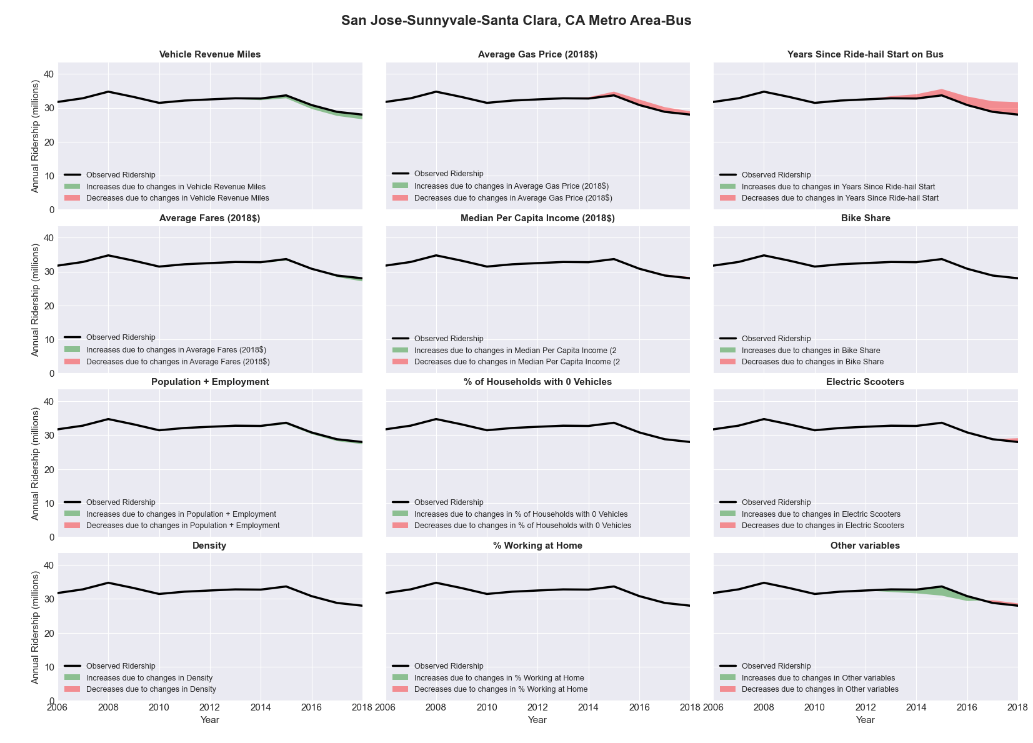

|  |  |  |  |  |  |  |
| --- | --- | --- | --- | --- | --- | --- |
| San Jose-Sunnyvale-Santa Clara, CA Metro Area-Rail | | | | | | |
|  |  |  |  |  |  | |
|  | **Average Values** | | | **Ridership Effect** | | |
| **Description** | **2012** | **2018** | **% Diff** | **Absolute** | **% Diff** | |
|  |  |  |  |  |  | |
| **Vehicle Revenue Miles** | 3,104,680 | 3,491,750 | 12.5% | 789,730 | | **8.1%** | |
| **Average Fare (2018$)** | 0.96 | 0.83 | -13.7% | 200,530 | | **2.1%** | |
| **Network Restructure** | - | - | - | - | | **0.0%** | |
| **Major Maintenance Event** | - | - | - | - | | **0.0%** | |
| **Population + Employment** | 2,802,300 | 3,073,170 | 9.7% | 210,280 | | **2.2%** | |
| **Share of Population and Employment in Transit Supportive Density** | 0.83 | 0.83 | -0.3% | -9,500 | | **-0.1%** | |
| **Average Gas Price (2018$)** | 4.35 | 3.40 | -21.8% | -347,310 | | **-3.6%** | |
| **Median Per Capita Income (2018$)** | 39,610 | 46,660 | 17.8% | -120,770 | | **-1.2%** | |
| **% of Households with 0 Vehicles** | 5 | 5 | -0.4% | -1,440 | | **-0.0%** | |
| **% Working at Home** | 4.6 | 5.3 | 14.7% | -57,000 | | **-0.6%** | |
| **Years Since Ride-hail Start** | 2.0 | 8 | 6 | 135,850 | | **1.4%** | |
| **Bike Share** | - | 1 | 1 | - 93,330 | | **-1.0%** | |
| **Electric Scooters** | - | 1 | 1 | - 338,130 | | **-3.5%** | |
| **New Reporters** |  |  |  | - | | **0.0%** | |
| **Total Modeled Ridership** | 9,724,812 | 10,105,714 | 3.92% | 380901.775 | | **3.9%** | |
| **Total Observed Ridership** | 10,479,267 | 8,530,540 | -18.60% | -1948727 | | **-18.6%** | |
| **Unexplained Change** |  |  |  |  | | **-22.5%** | |

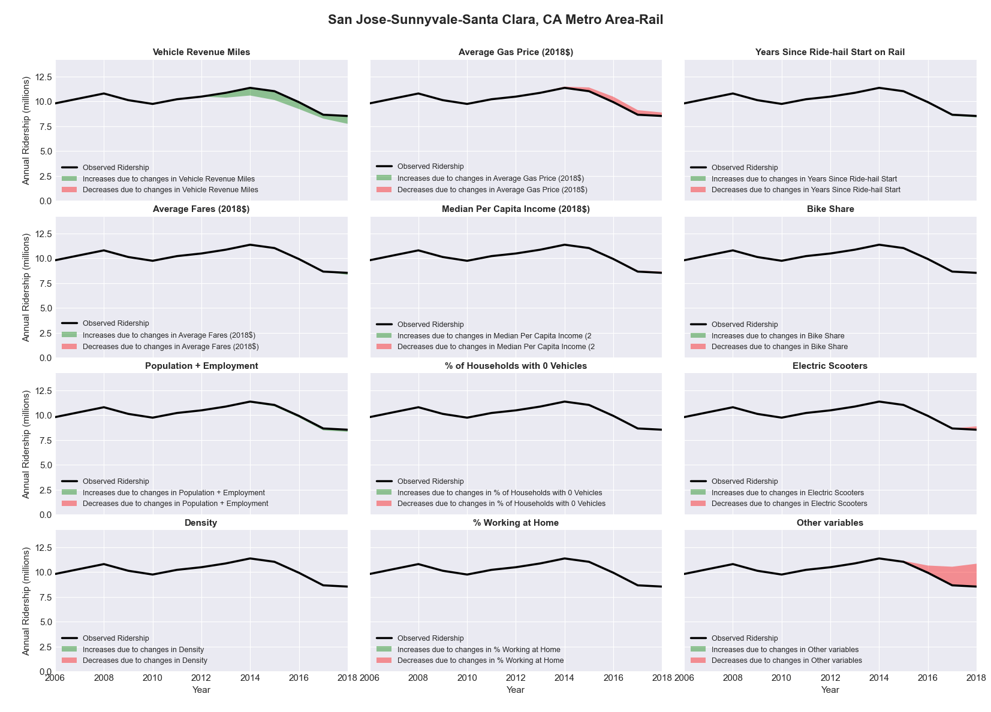

|  |  |  |  |  |  |  |
| --- | --- | --- | --- | --- | --- | --- |
| Santa Cruz-Watsonville, CA Metro Area-Bus | | | | | | |
|  |  |  |  |  |  | |
|  | **Average Values** | | | **Ridership Effect** | | |
| **Description** | **2012** | **2018** | **% Diff** | **Absolute** | **% Diff** | |
|  |  |  |  |  |  | |
| **Vehicle Revenue Miles** | 3,026,360 | 2,907,740 | -3.9% | -97,200 | | **-1.7%** | |
| **Average Fare (2018$)** | 1.71 | 1.77 | 3.8% | -82,490 | | **-1.5%** | |
| **Network Restructure** | - | - | - | - | | **0.0%** | |
| **Major Maintenance Event** | - | - | - | - | | **0.0%** | |
| **Population + Employment** | 392,030 | 415,230 | 5.9% | 67,500 | | **1.2%** | |
| **Share of Population and Employment in Transit Supportive Density** | 0.47 | 0.47 | -0.3% | -3,550 | | **-0.1%** | |
| **Average Gas Price (2018$)** | 4.35 | 3.40 | -21.8% | -161,490 | | **-2.9%** | |
| **Median Per Capita Income (2018$)** | 31,130 | 31,620 | 1.6% | -6,610 | | **-0.1%** | |
| **% of Households with 0 Vehicles** | 5 | 6 | 28.9% | 14,010 | | **0.2%** | |
| **% Working at Home** | 7.4 | 7.9 | 6.8% | -20,900 | | **-0.4%** | |
| **Years Since Ride-hail Start** | - | 4 | 4 | -717,950 | | **-12.7%** | |
| **Bike Share** | - | - | - | - | | **0.0%** | |
| **Electric Scooters** | - | - | - | - | | **0.0%** | |
| **New Reporters** |  |  |  | - | | **0.0%** | |
| **Total Modeled Ridership** | 5,633,290 | 4,680,709 | -16.91% | -952580.994 | | **-16.9%** | |
| **Total Observed Ridership** | 5,259,019 | 5,028,444 | -4.38% | -230575 | | **-4.4%** | |
| **Unexplained Change** |  |  |  |  | | **12.5%** | |

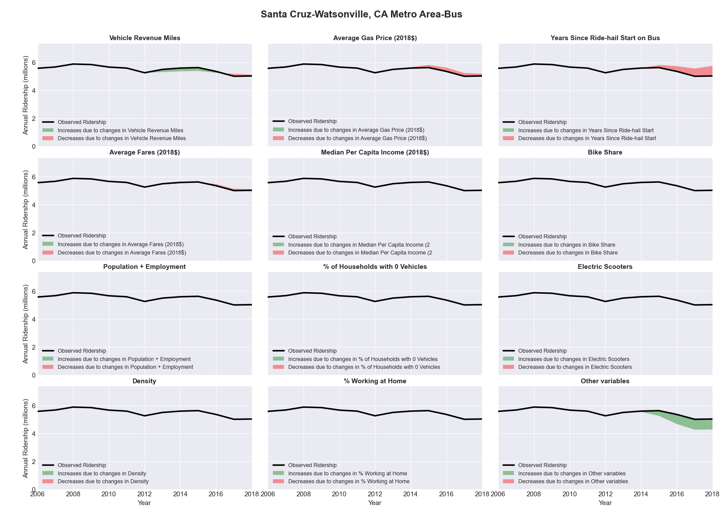

|  |  |  |  |  |  |  |
| --- | --- | --- | --- | --- | --- | --- |
| Santa Fe, NM Metro Area-Bus | | | | | | |
|  |  |  |  |  |  | |
|  | **Average Values** | | | **Ridership Effect** | | |
| **Description** | **2012** | **2018** | **% Diff** | **Absolute** | **% Diff** | |
|  |  |  |  |  |  | |
| **Vehicle Revenue Miles** | 859,490 | 864,910 | 0.6% | 3,650 | | **0.3%** | |
| **Average Fare (2018$)** | 0.36 | 0.32 | -9.5% | 15,830 | | **1.4%** | |
| **Network Restructure** | - | - | - | - | | **0.0%** | |
| **Major Maintenance Event** | - | - | - | - | | **0.0%** | |
| **Population + Employment** | 215,770 | 220,010 | 2.0% | 4,240 | | **0.4%** | |
| **Share of Population and Employment in Transit Supportive Density** | 0.23 | 0.22 | -6.2% | -6,130 | | **-0.6%** | |
| **Average Gas Price (2018$)** | 3.80 | 2.58 | -32.2% | -46,660 | | **-4.3%** | |
| **Median Per Capita Income (2018$)** | 29,810 | 31,380 | 5.3% | -4,440 | | **-0.4%** | |
| **% of Households with 0 Vehicles** | 4 | 4 | -7.0% | -0,620 | | **-0.1%** | |
| **% Working at Home** | 6.8 | 5.7 | -16.9% | 7,560 | | **0.7%** | |
| **Years Since Ride-hail Start** | - | 4 | 4 | -135,990 | | **-12.4%** | |
| **Bike Share** | - | - | - | - | | **0.0%** | |
| **Electric Scooters** | - | - | - | - | | **0.0%** | |
| **New Reporters** |  |  |  | - | | **0.0%** | |
| **Total Modeled Ridership** | 1,094,965 | 936,027 | -14.52% | -158937.775 | | **-14.5%** | |
| **Total Observed Ridership** | 1,036,495 | 903,831 | -12.80% | -132664 | | **-12.8%** | |
| **Unexplained Change** |  |  |  |  | | **1.7%** | |

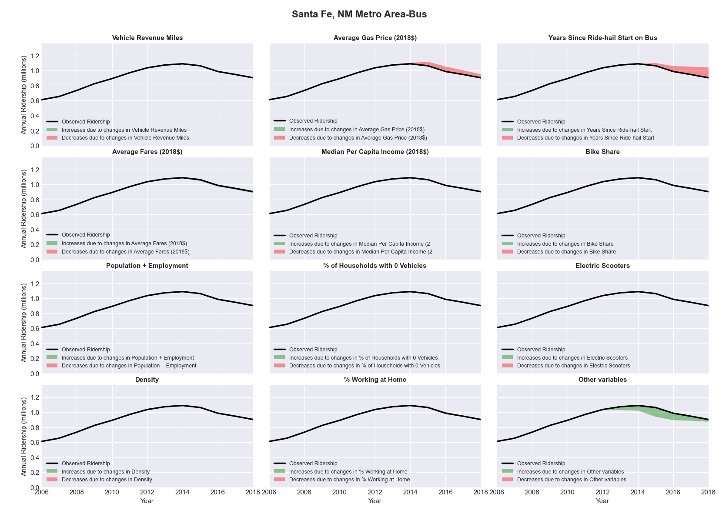

|  |  |  |  |  |  |  |
| --- | --- | --- | --- | --- | --- | --- |
| Santa Rosa-Petaluma, CA Metro Area-Bus | | | | | | |
|  |  |  |  |  |  | |
|  | **Average Values** | | | **Ridership Effect** | | |
| **Description** | **2012** | **2018** | **% Diff** | **Absolute** | **% Diff** | |
|  |  |  |  |  |  | |
| **Vehicle Revenue Miles** | 2,763,360 | 2,816,870 | 1.9% | 7,420 | | **0.2%** | |
| **Average Fare (2018$)** | 0.97 | 1.02 | 6.0% | -110,190 | | **-2.6%** | |
| **Network Restructure** | - | - | - | - | | **0.0%** | |
| **Major Maintenance Event** | - | - | - | - | | **0.0%** | |
| **Population + Employment** | 716,290 | 763,250 | 6.6% | 55,880 | | **1.3%** | |
| **Share of Population and Employment in Transit Supportive Density** | 0.29 | 0.30 | 2.6% | 11,920 | | **0.3%** | |
| **Average Gas Price (2018$)** | 4.35 | 3.40 | -21.8% | -121,950 | | **-2.9%** | |
| **Median Per Capita Income (2018$)** | 30,620 | 38,470 | 25.6% | -60,600 | | **-1.4%** | |
| **% of Households with 0 Vehicles** | 5 | 5 | 0.2% | -0,270 | | **-0.0%** | |
| **% Working at Home** | 6.0 | 8.0 | 33.3% | -59,240 | | **-1.4%** | |
| **Years Since Ride-hail Start** | - | 4 | 4 | -474,980 | | **-11.4%** | |
| **Bike Share** | - | - | - | - | | **0.0%** | |
| **Electric Scooters** | - | - | - | - | | **0.0%** | |
| **New Reporters** |  |  |  | - | | **0.0%** | |
| **Total Modeled Ridership** | 4,181,713 | 3,471,161 | -16.99% | -710552.364 | | **-17.0%** | |
| **Total Observed Ridership** | 4,565,664 | 3,068,326 | -32.80% | -1497338 | | **-32.8%** | |
| **Unexplained Change** |  |  |  |  | | **-15.8%** | |

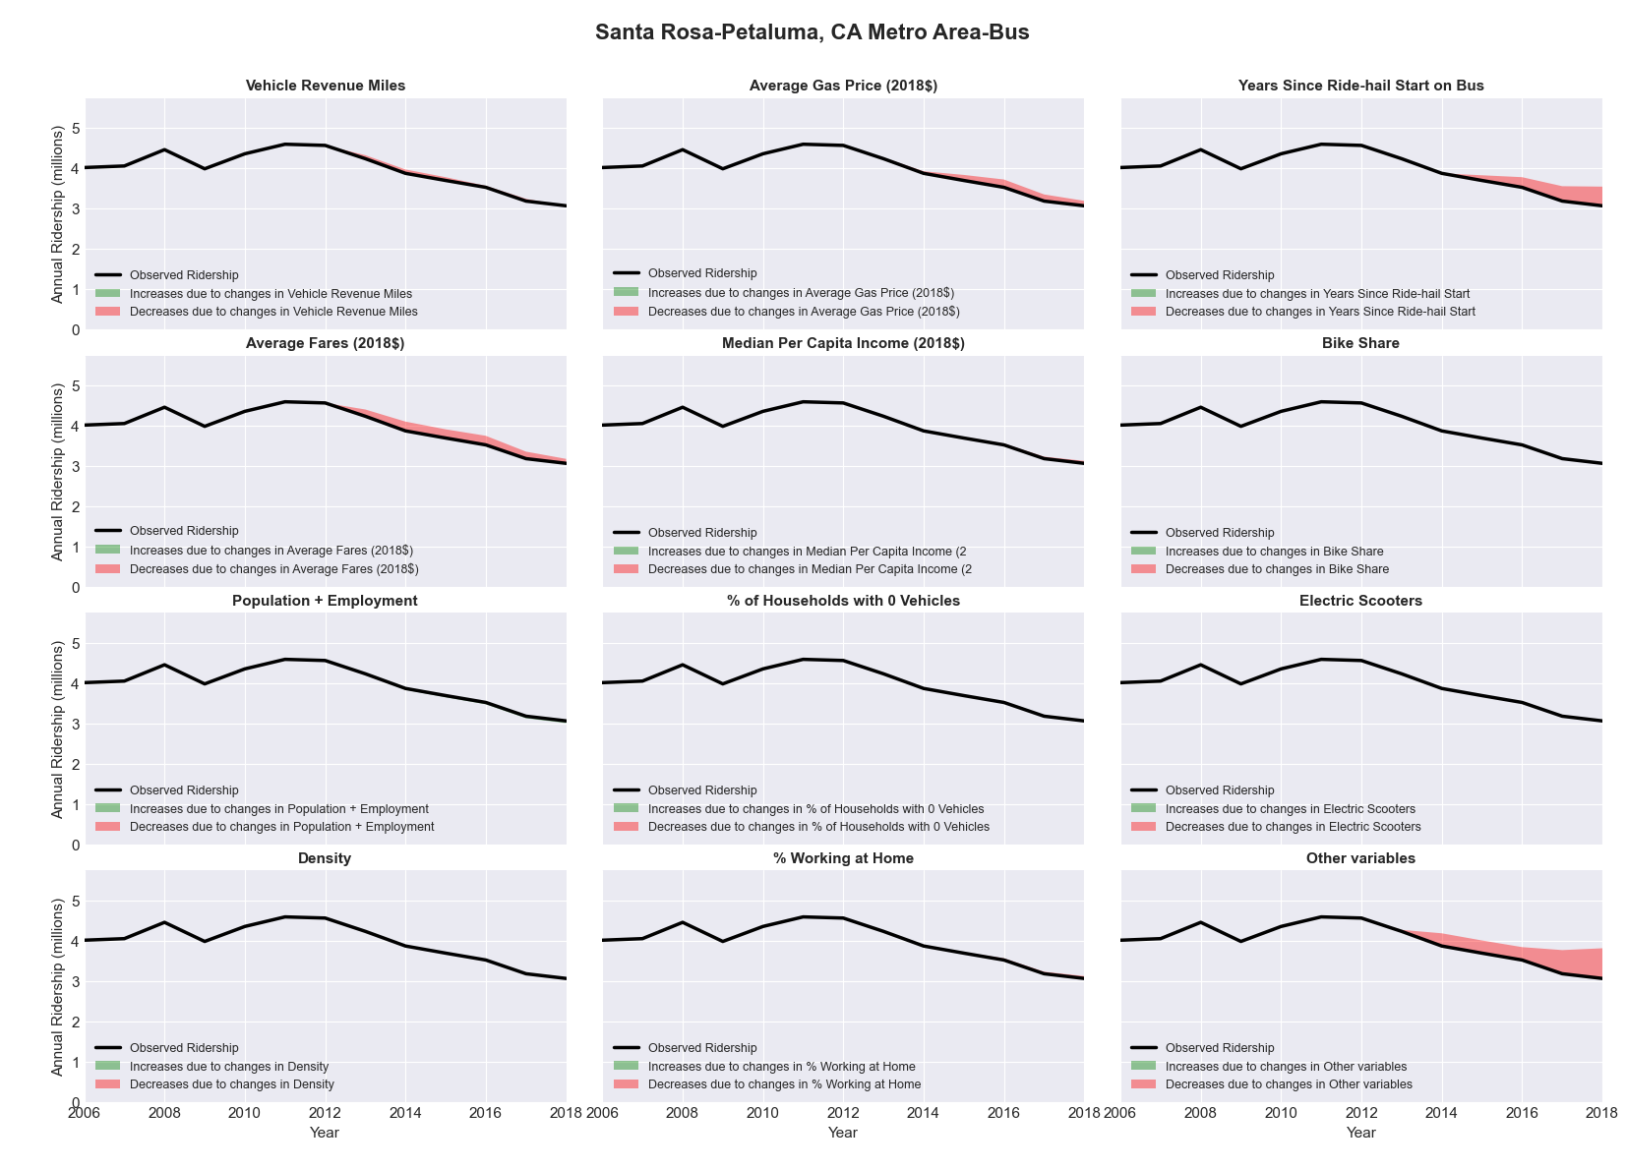

|  |  |  |  |  |  |  |
| --- | --- | --- | --- | --- | --- | --- |
| Savannah, GA Metro Area-Bus | | | | | | |
|  |  |  |  |  |  | |
|  | **Average Values** | | | **Ridership Effect** | | |
| **Description** | **2012** | **2018** | **% Diff** | **Absolute** | **% Diff** | |
|  |  |  |  |  |  | |
| **Vehicle Revenue Miles** | 2,479,860 | 2,216,640 | -10.6% | -167,500 | | **-4.5%** | |
| **Average Fare (2018$)** | 0.96 | 1.22 | 27.7% | -204,140 | | **-5.5%** | |
| **Network Restructure** | - | - | - | - | | **0.0%** | |
| **Major Maintenance Event** | - | - | - | - | | **0.0%** | |
| **Population + Employment** | 519,420 | 571,350 | 10.0% | 73,040 | | **2.0%** | |
| **Share of Population and Employment in Transit Supportive Density** | 0.22 | 0.21 | -2.7% | -7,690 | | **-0.2%** | |
| **Average Gas Price (2018$)** | 3.95 | 2.71 | -31.3% | -155,100 | | **-4.2%** | |
| **Median Per Capita Income (2018$)** | 26,320 | 27,980 | 6.3% | -18,240 | | **-0.5%** | |
| **% of Households with 0 Vehicles** | 7 | 7 | -9.8% | -4,650 | | **-0.1%** | |
| **% Working at Home** | 3.5 | 3.7 | 5.0% | -6,700 | | **-0.2%** | |
| **Years Since Ride-hail Start** | - | 3 | 3 | -329,530 | | **-8.9%** | |
| **Bike Share** | - | - | - | - 6,400 | | **-0.2%** | |
| **Electric Scooters** | - | - | - | - | | **0.0%** | |
| **New Reporters** |  |  |  | - | | **0.0%** | |
| **Total Modeled Ridership** | 3,712,740 | 2,875,362 | -22.55% | -837378.616 | | **-22.6%** | |
| **Total Observed Ridership** | 3,780,025 | 3,046,095 | -19.42% | -733930 | | **-19.4%** | |
| **Unexplained Change** |  |  |  |  | | **3.1%** | |

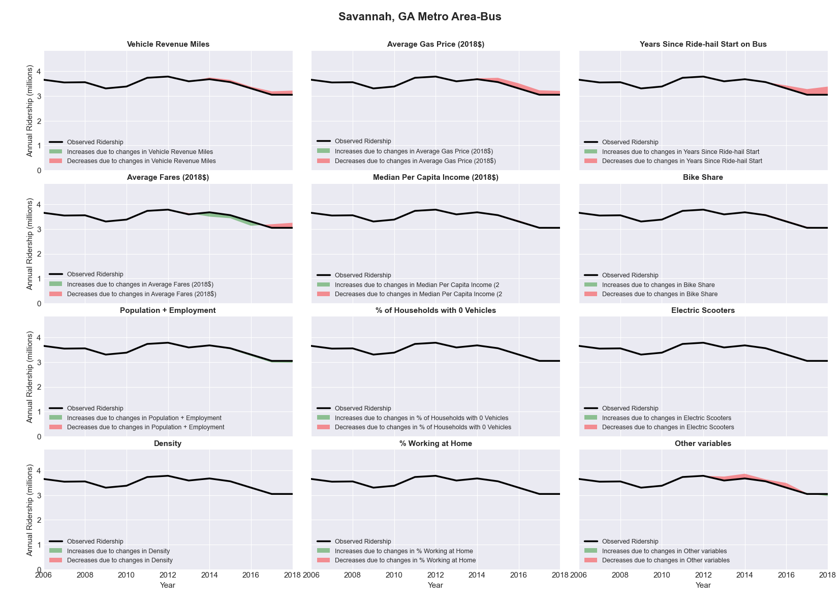

|  |  |  |  |  |  |  |
| --- | --- | --- | --- | --- | --- | --- |
| Scranton--Wilkes-Barre, PA Metro Area-Bus | | | | | | |
|  |  |  |  |  |  | |
|  | **Average Values** | | | **Ridership Effect** | | |
| **Description** | **2012** | **2018** | **% Diff** | **Absolute** | **% Diff** | |
|  |  |  |  |  |  | |
| **Vehicle Revenue Miles** | 2,142,600 | 2,140,880 | -0.1% | 2,610 | | **0.1%** | |
| **Average Fare (2018$)** | 0.82 | 1.13 | 38.0% | -237,440 | | **-8.9%** | |
| **Network Restructure** | - | - | - | - | | **0.0%** | |
| **Major Maintenance Event** | - | - | - | - | | **0.0%** | |
| **Population + Employment** | 819,950 | 819,840 | -0.0% | -0,180 | | **-0.0%** | |
| **Share of Population and Employment in Transit Supportive Density** | 0.26 | 0.25 | -4.4% | -10,530 | | **-0.4%** | |
| **Average Gas Price (2018$)** | 4.11 | 2.92 | -28.9% | -91,470 | | **-3.4%** | |
| **Median Per Capita Income (2018$)** | 24,730 | 27,140 | 9.7% | -16,400 | | **-0.6%** | |
| **% of Households with 0 Vehicles** | 10 | 11 | 9.9% | 4,520 | | **0.2%** | |
| **% Working at Home** | 2.9 | 4.3 | 46.6% | -23,740 | | **-0.9%** | |
| **Years Since Ride-hail Start** | - | 3 | 3 | -221,680 | | **-8.4%** | |
| **Bike Share** | - | - | - | - | | **0.0%** | |
| **Electric Scooters** | - | - | - | - | | **0.0%** | |
| **New Reporters** |  |  |  | - | | **0.0%** | |
| **Total Modeled Ridership** | 2,653,729 | 2,064,910 | -22.19% | -588818.664 | | **-22.2%** | |
| **Total Observed Ridership** | 2,825,911 | 2,123,536 | -24.85% | -702375 | | **-24.9%** | |
| **Unexplained Change** |  |  |  |  | | **-2.7%** | |

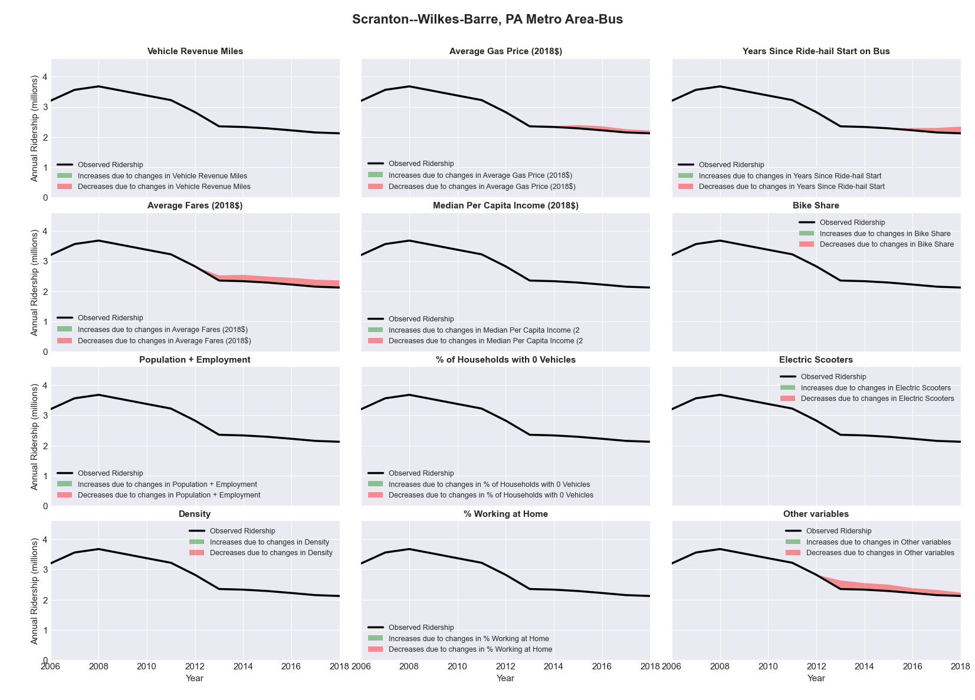

|  |  |  |  |  |  |  |
| --- | --- | --- | --- | --- | --- | --- |
| Seattle-Tacoma-Bellevue, WA Metro Area-Bus | | | | | | |
|  |  |  |  |  |  | |
|  | **Average Values** | | | **Ridership Effect** | | |
| **Description** | **2012** | **2018** | **% Diff** | **Absolute** | **% Diff** | |
|  |  |  |  |  |  | |
| **Vehicle Revenue Miles** | 59,368,010 | 64,570,520 | 8.8% | 6,087,810 | | **3.5%** | |
| **Average Fare (2018$)** | 1.64 | 1.69 | 2.8% | -1,530,680 | | **-0.9%** | |
| **Network Restructure** | - | - | - | - | | **0.0%** | |
| **Major Maintenance Event** | - | - | - | - | | **0.0%** | |
| **Population + Employment** | 5,311,660 | 5,964,580 | 12.3% | 3,976,440 | | **2.3%** | |
| **Share of Population and Employment in Transit Supportive Density** | 0.50 | 0.50 | 0.2% | 79,030 | | **0.0%** | |
| **Average Gas Price (2018$)** | 4.35 | 3.40 | -21.8% | -4,285,950 | | **-2.5%** | |
| **Median Per Capita Income (2018$)** | 35,990 | 42,280 | 17.5% | -1,803,430 | | **-1.0%** | |
| **% of Households with 0 Vehicles** | 8 | 7 | -2.7% | -74,050 | | **-0.0%** | |
| **% Working at Home** | 5.5 | 6.5 | 18.6% | -1,241,760 | | **-0.7%** | |
| **Years Since Ride-hail Start** | 1.0 | 7 | 6 | -18,102,080 | | **-10.5%** | |
| **Bike Share** | - | 1 | 1 | - 1,666,070 | | **-1.0%** | |
| **Electric Scooters** | - | 1 | 1 | - 6,224,890 | | **-3.6%** | |
| **New Reporters** |  |  |  | - | | **0.0%** | |
| **Total Modeled Ridership** | 172,608,969 | 146,892,042 | -14.90% | -25716926.7 | | **-14.9%** | |
| **Total Observed Ridership** | 151,189,331 | 160,322,023 | 6.04% | 9132692 | | **6.0%** | |
| **Unexplained Change** |  |  |  |  | | **20.9%** | |

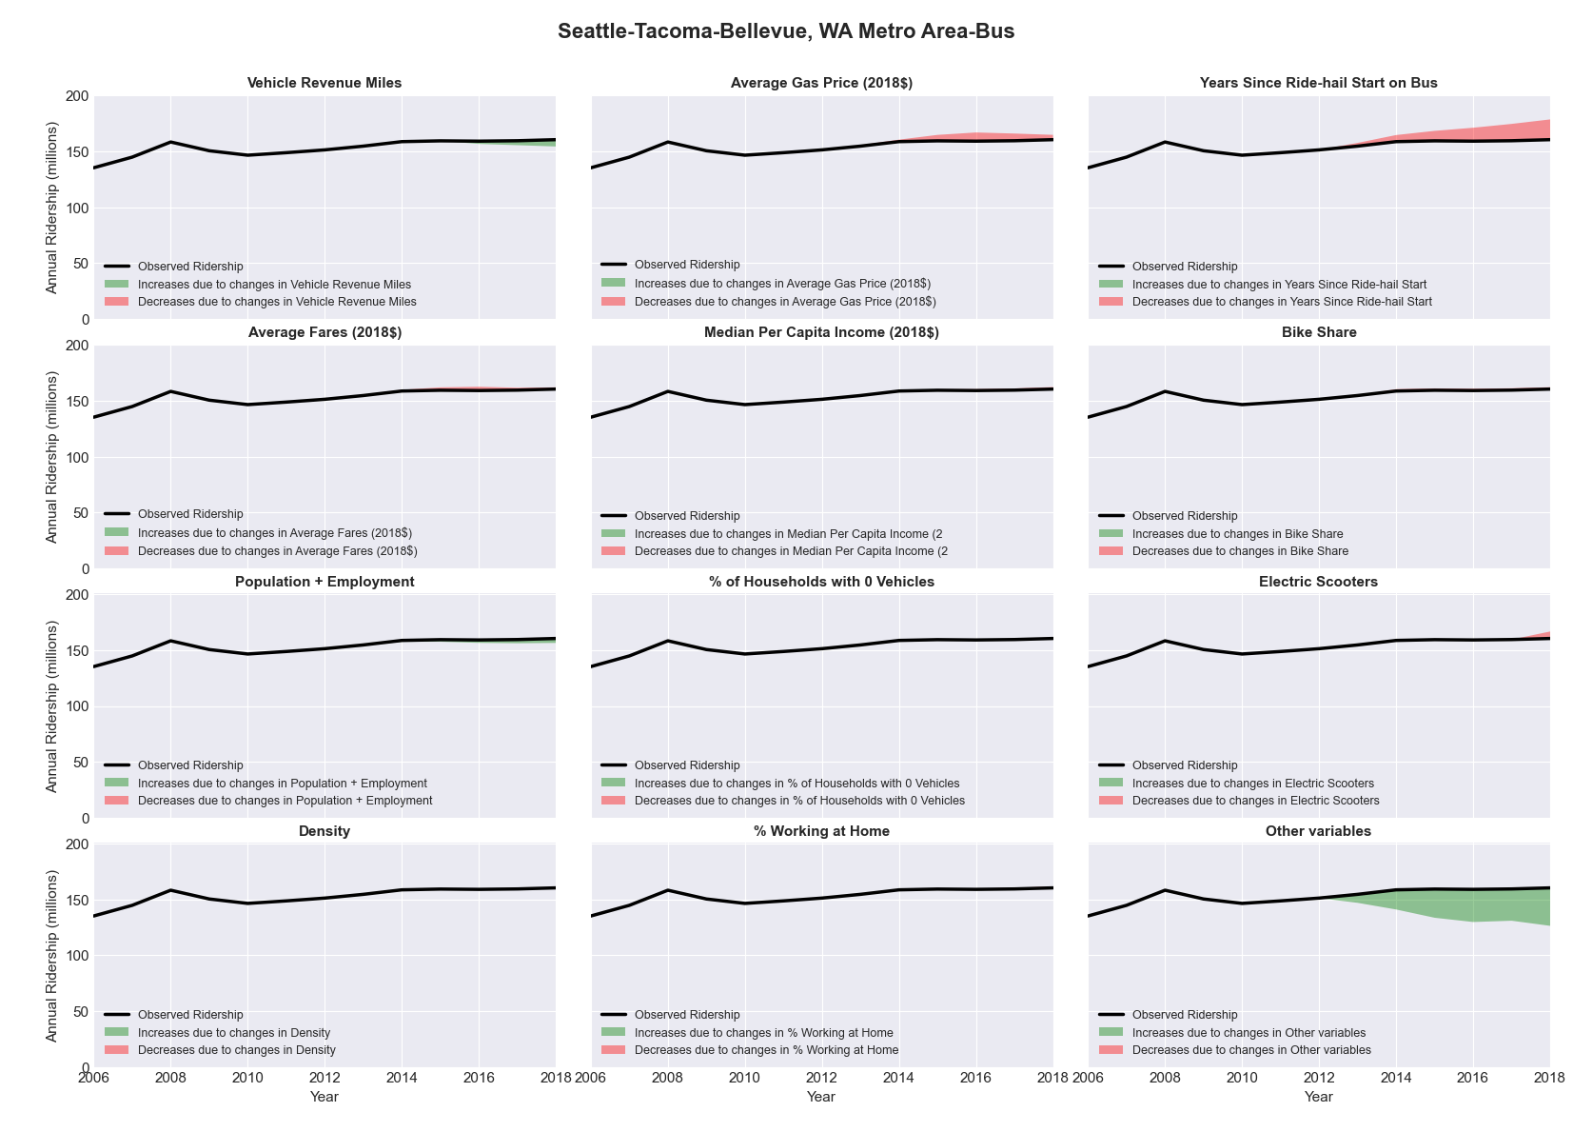

|  |  |  |  |  |  |  |
| --- | --- | --- | --- | --- | --- | --- |
| Seattle-Tacoma-Bellevue, WA Metro Area-Rail | | | | | | |
|  |  |  |  |  |  | |
|  | **Average Values** | | | **Ridership Effect** | | |
| **Description** | **2012** | **2018** | **% Diff** | **Absolute** | **% Diff** | |
|  |  |  |  |  |  | |
| **Vehicle Revenue Miles** | 4,414,860 | 8,150,160 | 84.6% | 9,796,860 | | **51.2%** | |
| **Average Fare (2018$)** | 2.98 | 2.76 | -7.5% | 464,620 | | **2.4%** | |
| **Network Restructure** | - | - | - | - | | **0.0%** | |
| **Major Maintenance Event** | - | - | - | - | | **0.0%** | |
| **Population + Employment** | 5,311,660 | 5,964,580 | 12.3% | 548,760 | | **2.9%** | |
| **Share of Population and Employment in Transit Supportive Density** | 0.50 | 0.50 | 0.2% | 9,600 | | **0.1%** | |
| **Average Gas Price (2018$)** | 4.35 | 3.40 | -21.8% | -223,060 | | **-1.2%** | |
| **Median Per Capita Income (2018$)** | 35,990 | 42,280 | 17.5% | -246,900 | | **-1.3%** | |
| **% of Households with 0 Vehicles** | 8 | 7 | -2.7% | -24,610 | | **-0.1%** | |
| **% Working at Home** | 5.5 | 6.5 | 18.6% | -181,540 | | **-0.9%** | |
| **Years Since Ride-hail Start** | 1.0 | 7 | 6 | 281,420 | | **1.5%** | |
| **Bike Share** | - | 1 | 1 | - 177,910 | | **-0.9%** | |
| **Electric Scooters** | - | 1 | 1 | - 1,247,810 | | **-6.5%** | |
| **New Reporters** |  |  |  | - | | **0.0%** | |
| **Total Modeled Ridership** | 19,152,965 | 27,625,258 | 44.23% | 8472293.1 | | **44.2%** | |
| **Total Observed Ridership** | 15,382,724 | 33,683,284 | 118.97% | 18300560 | | **119.0%** | |
| **Unexplained Change** |  |  |  |  | | **74.7%** | |

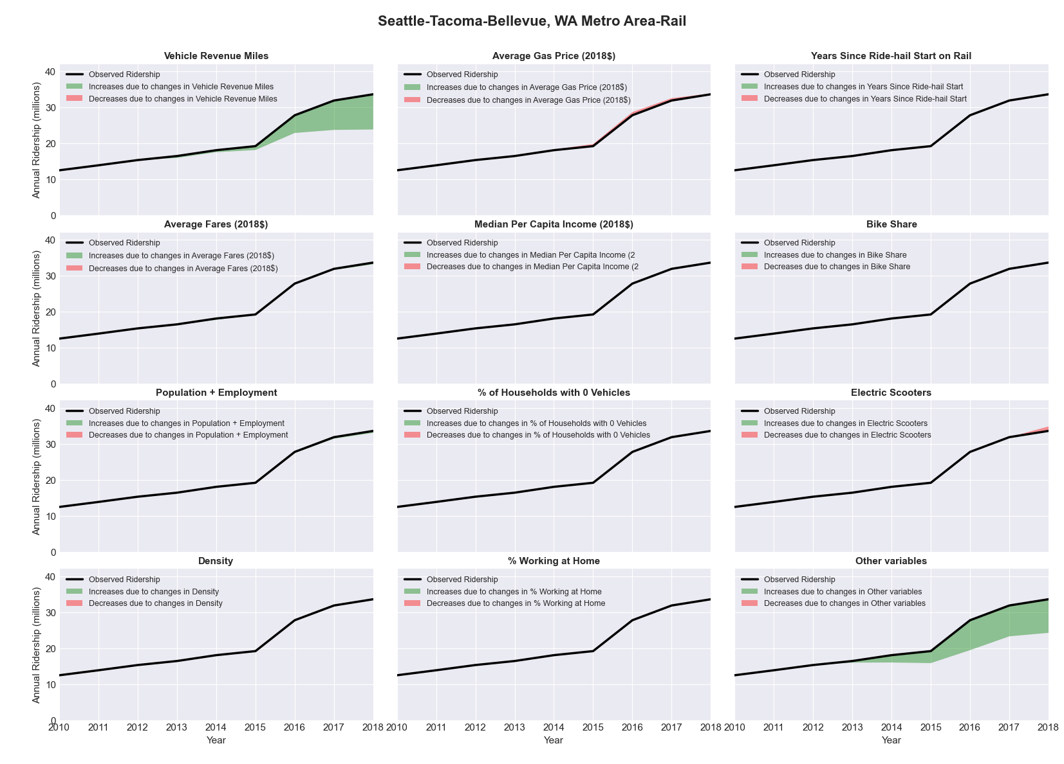

|  |  |  |  |  |  |  |
| --- | --- | --- | --- | --- | --- | --- |
| Shreveport-Bossier City, LA Metro Area-Bus | | | | | | |
|  |  |  |  |  |  | |
|  | **Average Values** | | | **Ridership Effect** | | |
| **Description** | **2012** | **2018** | **% Diff** | **Absolute** | **% Diff** | |
|  |  |  |  |  |  | |
| **Vehicle Revenue Miles** | 2,274,520 | 2,277,250 | 0.1% | -4,580 | | **-0.2%** | |
| **Average Fare (2018$)** | 0.84 | 0.69 | -16.9% | 120,370 | | **4.1%** | |
| **Network Restructure** | - | - | - | - | | **0.0%** | |
| **Major Maintenance Event** | - | - | - | - | | **0.0%** | |
| **Population + Employment** | 575,230 | 604,480 | 5.1% | 38,450 | | **1.3%** | |
| **Share of Population and Employment in Transit Supportive Density** | 0.14 | 0.14 | -0.6% | -1,010 | | **-0.0%** | |
| **Average Gas Price (2018$)** | 3.80 | 2.58 | -32.2% | -140,300 | | **-4.8%** | |
| **Median Per Capita Income (2018$)** | 26,260 | 21,680 | -17.4% | 38,740 | | **1.3%** | |
| **% of Households with 0 Vehicles** | 10 | 8 | -15.5% | -9,480 | | **-0.3%** | |
| **% Working at Home** | 2.2 | 3.9 | 77.3% | -33,730 | | **-1.2%** | |
| **Years Since Ride-hail Start** | - | - | - | 0,000 | | **0.0%** | |
| **Bike Share** | - | - | - | - | | **0.0%** | |
| **Electric Scooters** | - | - | - | - | | **0.0%** | |
| **New Reporters** |  |  |  | - | | **0.0%** | |
| **Total Modeled Ridership** | 2,909,522 | 2,947,519 | 1.31% | 37996.3957 | | **1.3%** | |
| **Total Observed Ridership** | 3,373,943 | 2,523,868 | -25.20% | -850075 | | **-25.2%** | |
| **Unexplained Change** |  |  |  |  | | **-26.5%** | |

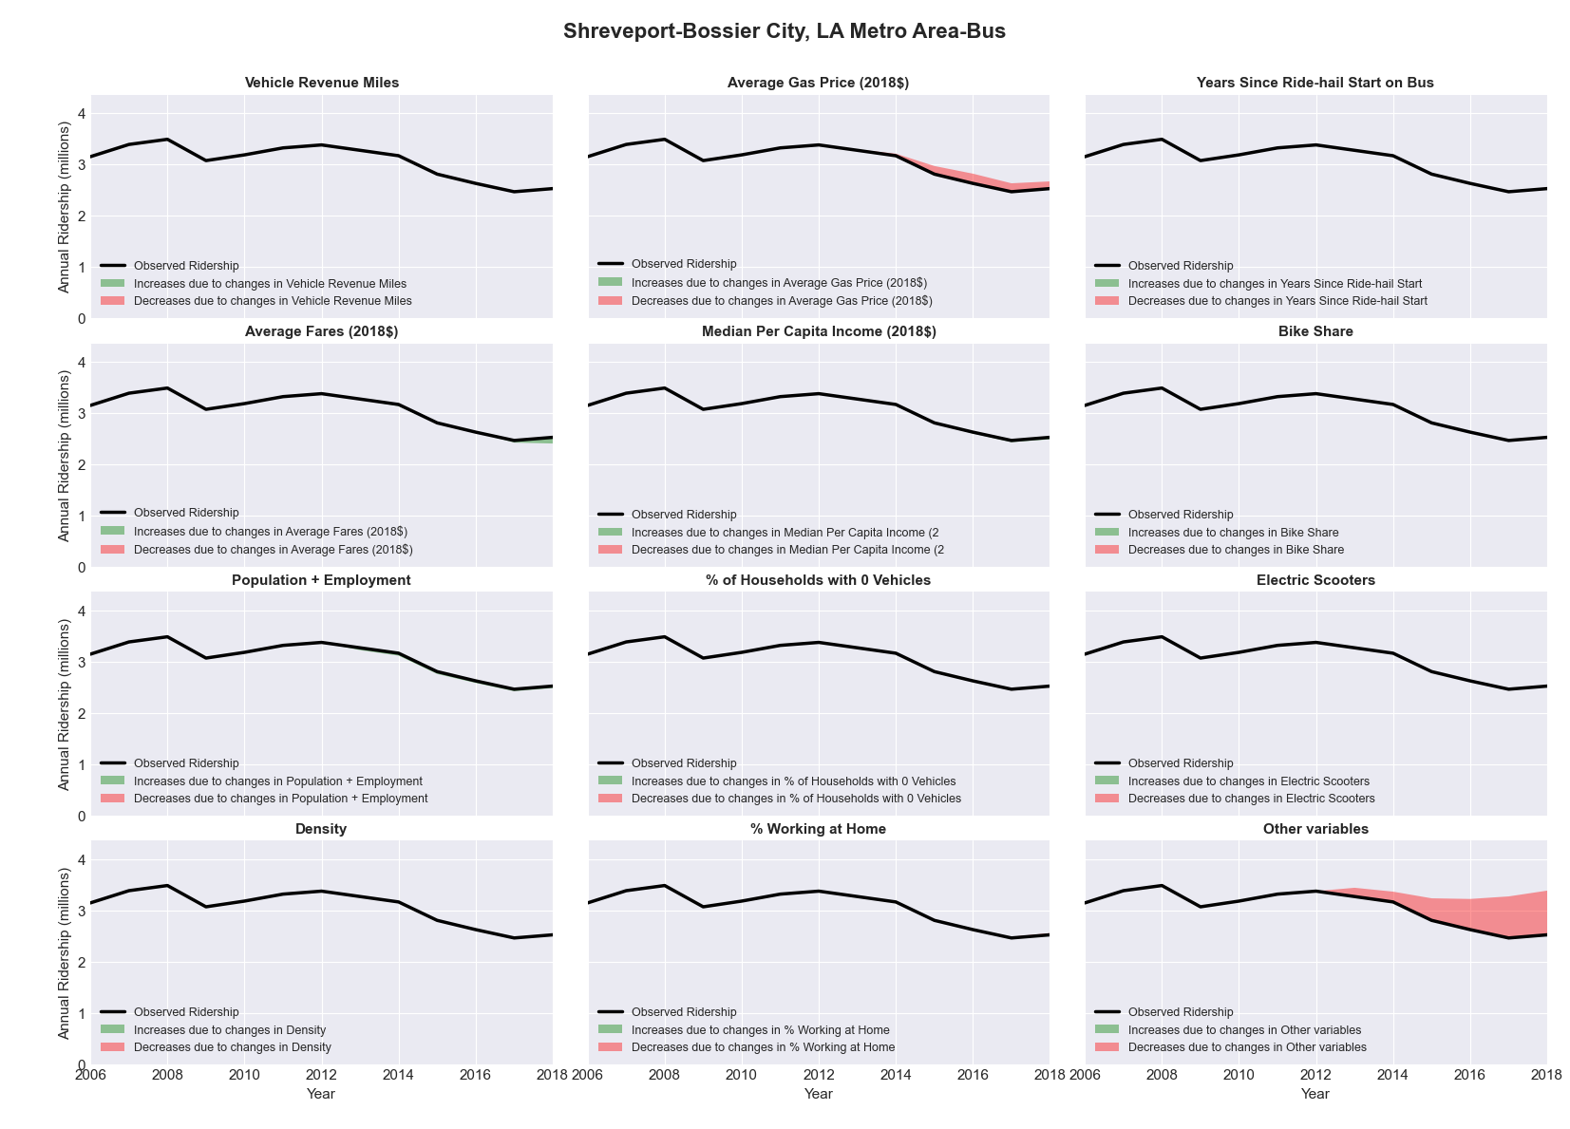

|  |  |  |  |  |  |  |
| --- | --- | --- | --- | --- | --- | --- |
| Sioux City, IA-NE-SD Metro Area-Bus | | | | | | |
|  |  |  |  |  |  | |
|  | **Average Values** | | | **Ridership Effect** | | |
| **Description** | **2012** | **2018** | **% Diff** | **Absolute** | **% Diff** | |
|  |  |  |  |  |  | |
| **Vehicle Revenue Miles** | 621,900 | 591,630 | -4.9% | -21,860 | | **-2.1%** | |
| **Average Fare (2018$)** | 0.73 | 0.81 | 11.0% | -31,110 | | **-2.9%** | |
| **Network Restructure** | - | - | - | - | | **0.0%** | |
| **Major Maintenance Event** | - | - | - | - | | **0.0%** | |
| **Population + Employment** | 216,680 | 244,810 | 13.0% | 28,840 | | **2.7%** | |
| **Share of Population and Employment in Transit Supportive Density** | 0.16 | 0.15 | -6.0% | -4,210 | | **-0.4%** | |
| **Average Gas Price (2018$)** | 3.93 | 2.72 | -30.9% | -47,010 | | **-4.5%** | |
| **Median Per Capita Income (2018$)** | 25,830 | 32,260 | 24.9% | -16,820 | | **-1.6%** | |
| **% of Households with 0 Vehicles** | 5 | 9 | 64.4% | 6,380 | | **0.6%** | |
| **% Working at Home** | 3.1 | 4.3 | 37.9% | -9,870 | | **-0.9%** | |
| **Years Since Ride-hail Start** | - | 1 | 1 | -28,610 | | **-2.7%** | |
| **Bike Share** | - | - | - | - | | **0.0%** | |
| **Electric Scooters** | - | - | - | - | | **0.0%** | |
| **New Reporters** |  |  |  | - | | **0.0%** | |
| **Total Modeled Ridership** | 1,055,249 | 937,386 | -11.17% | -117863.08 | | **-11.2%** | |
| **Total Observed Ridership** | 1,092,130 | 851,828 | -22.00% | -240302 | | **-22.0%** | |
| **Unexplained Change** |  |  |  |  | | **-10.8%** | |

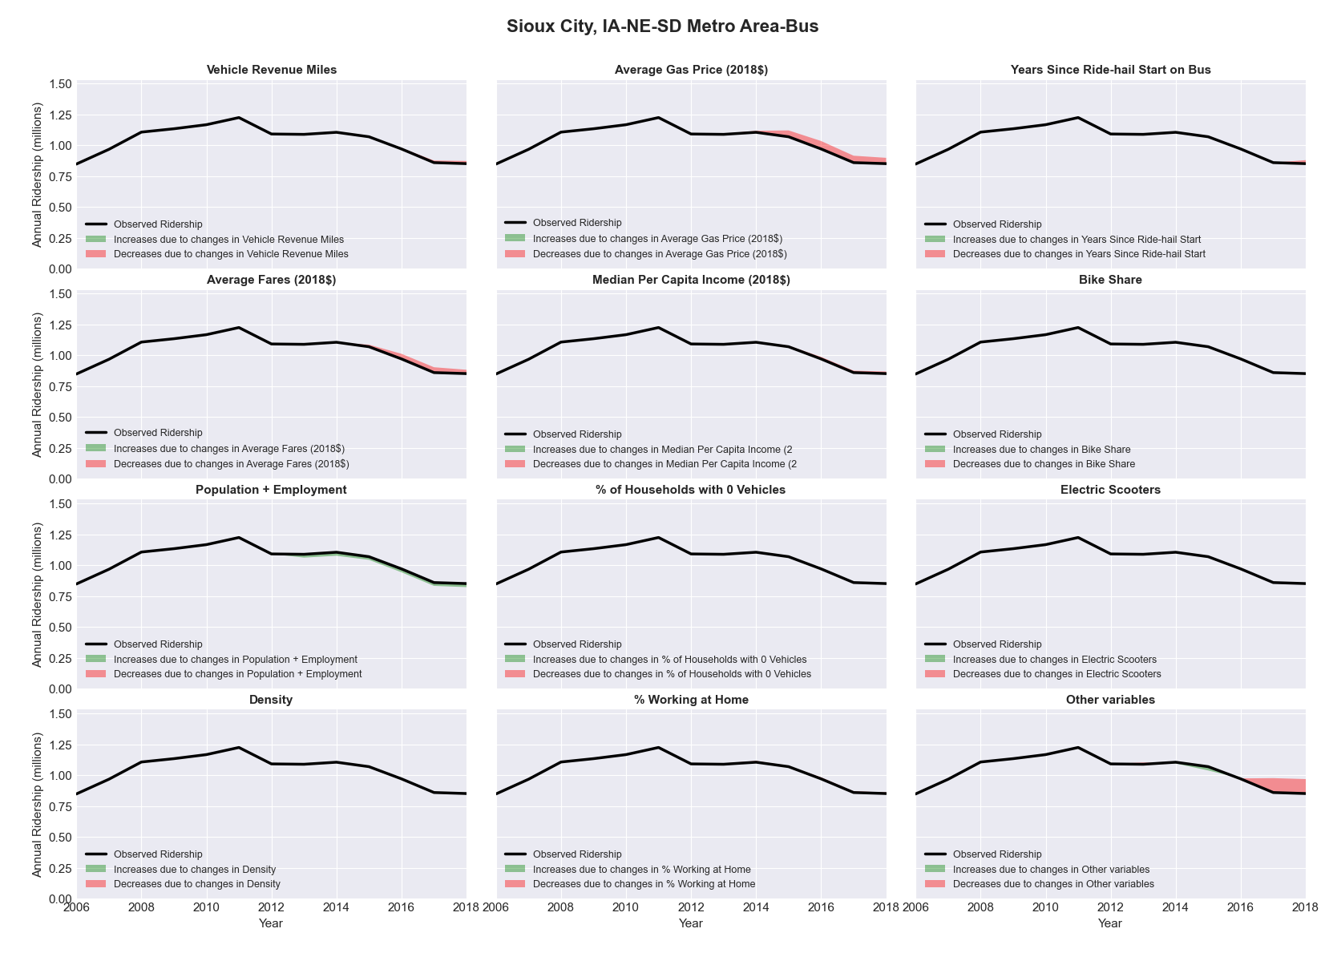

|  |  |  |  |  |  |  |
| --- | --- | --- | --- | --- | --- | --- |
| Sioux Falls, SD Metro Area-Bus | | | | | | |
|  |  |  |  |  |  | |
|  | **Average Values** | | | **Ridership Effect** | | |
| **Description** | **2012** | **2018** | **% Diff** | **Absolute** | **% Diff** | |
|  |  |  |  |  |  | |
| **Vehicle Revenue Miles** | 735,270 | 735,940 | 0.1% | 3,550 | | **0.4%** | |
| **Average Fare (2018$)** | 0.60 | 0.50 | -17.7% | 31,250 | | **3.4%** | |
| **Network Restructure** | - | - | - | - | | **0.0%** | |
| **Major Maintenance Event** | - | - | - | - | | **0.0%** | |
| **Population + Employment** | 369,020 | 410,590 | 11.3% | 21,830 | | **2.4%** | |
| **Share of Population and Employment in Transit Supportive Density** | 0.31 | 0.34 | 8.1% | 0,790 | | **0.1%** | |
| **Average Gas Price (2018$)** | 3.93 | 2.72 | -30.9% | -40,530 | | **-4.4%** | |
| **Median Per Capita Income (2018$)** | 32,010 | 33,220 | 3.8% | -2,710 | | **-0.3%** | |
| **% of Households with 0 Vehicles** | 4 | 3 | -14.3% | -0,180 | | **-0.0%** | |
| **% Working at Home** | 4.0 | 5.5 | 36.3% | -8,680 | | **-0.9%** | |
| **Years Since Ride-hail Start** | - | - | - | 0,000 | | **0.0%** | |
| **Bike Share** | - | - | - | - | | **0.0%** | |
| **Electric Scooters** | - | - | - | - | | **0.0%** | |
| **New Reporters** |  |  |  | - | | **0.0%** | |
| **Total Modeled Ridership** | 917,982 | 935,105 | 1.87% | 17123.2568 | | **1.9%** | |
| **Total Observed Ridership** | 1,026,715 | 782,129 | -23.82% | -244586 | | **-23.8%** | |
| **Unexplained Change** |  |  |  |  | | **-25.7%** | |

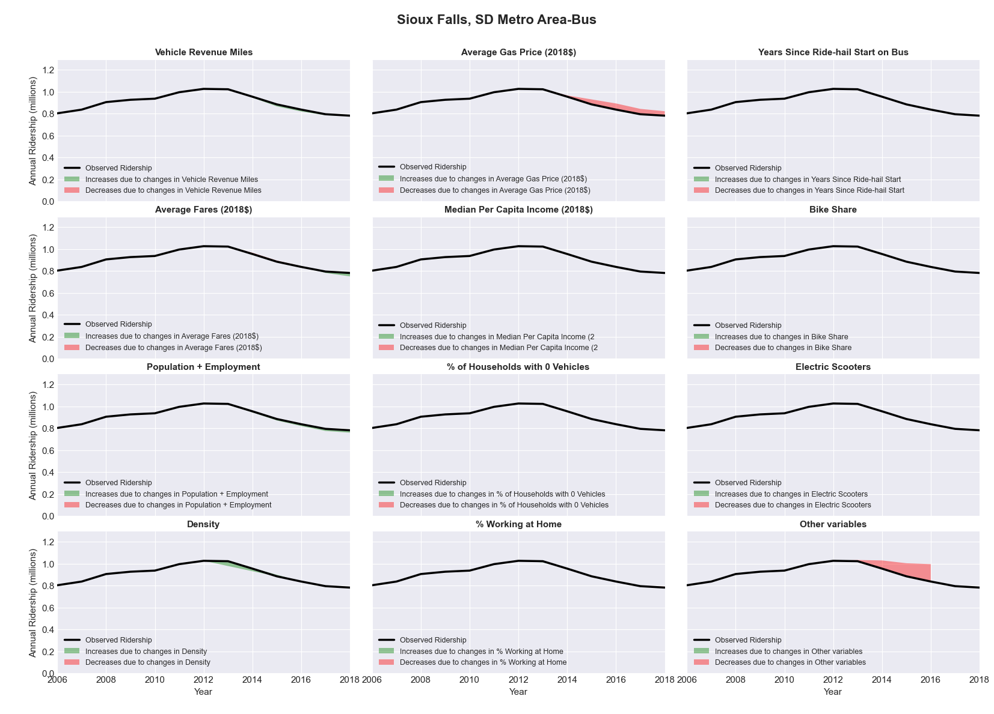

|  |  |  |  |  |  |  |
| --- | --- | --- | --- | --- | --- | --- |
| Spokane, WA Metro Area-Bus | | | | | | |
|  |  |  |  |  |  | |
|  | **Average Values** | | | **Ridership Effect** | | |
| **Description** | **2012** | **2018** | **% Diff** | **Absolute** | **% Diff** | |
|  |  |  |  |  |  | |
| **Vehicle Revenue Miles** | 5,313,520 | 5,850,420 | 10.1% | 459,570 | | **4.2%** | |
| **Average Fare (2018$)** | 0.88 | 0.84 | -4.5% | 162,270 | | **1.5%** | |
| **Network Restructure** | - | - | - | - | | **0.0%** | |
| **Major Maintenance Event** | - | - | - | - | | **0.0%** | |
| **Population + Employment** | 685,240 | 798,060 | 16.5% | 363,560 | | **3.3%** | |
| **Share of Population and Employment in Transit Supportive Density** | 0.29 | 0.28 | -3.5% | -42,750 | | **-0.4%** | |
| **Average Gas Price (2018$)** | 4.35 | 3.40 | -21.8% | -323,380 | | **-2.9%** | |
| **Median Per Capita Income (2018$)** | 27,410 | 30,870 | 12.6% | -87,780 | | **-0.8%** | |
| **% of Households with 0 Vehicles** | 8 | 7 | -12.8% | -22,870 | | **-0.2%** | |
| **% Working at Home** | 5.8 | 7.2 | 23.3% | -104,180 | | **-0.9%** | |
| **Years Since Ride-hail Start** | - | 4 | 4 | -1,419,270 | | **-12.9%** | |
| **Bike Share** | - | - | - | - | | **0.0%** | |
| **Electric Scooters** | - | 1 | 1 | - 400,960 | | **-3.6%** | |
| **New Reporters** |  |  |  | - | | **0.0%** | |
| **Total Modeled Ridership** | 10,991,655 | 9,565,075 | -12.98% | -1426579.97 | | **-13.0%** | |
| **Total Observed Ridership** | 11,030,806 | 10,069,599 | -8.71% | -961207 | | **-8.7%** | |
| **Unexplained Change** |  |  |  |  | | **4.3%** | |

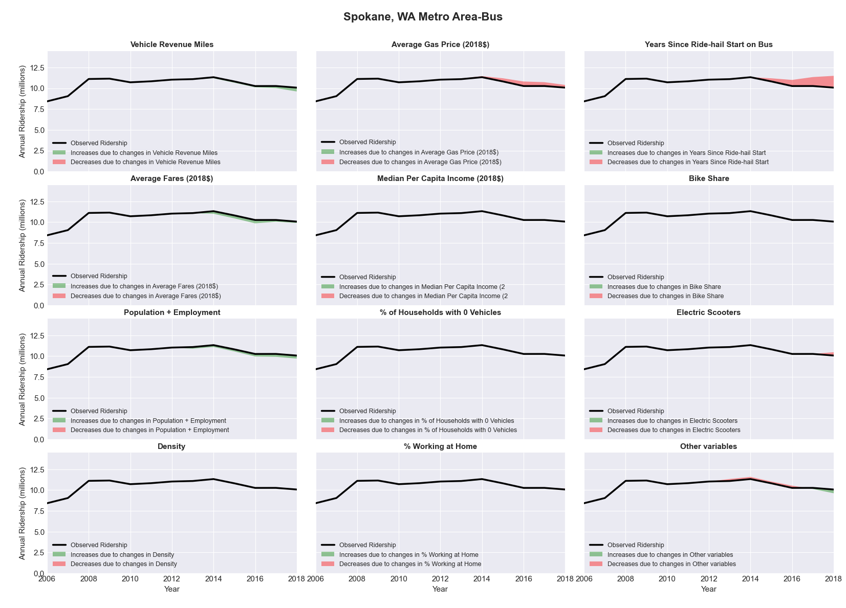

|  |  |  |  |  |  |  |
| --- | --- | --- | --- | --- | --- | --- |
| Springfield, IL Metro Area-Bus | | | | | | |
|  |  |  |  |  |  | |
|  | **Average Values** | | | **Ridership Effect** | | |
| **Description** | **2012** | **2018** | **% Diff** | **Absolute** | **% Diff** | |
|  |  |  |  |  |  | |
| **Vehicle Revenue Miles** | 1,423,550 | 1,438,250 | 1.0% | 2,890 | | **0.2%** | |
| **Average Fare (2018$)** | 0.56 | 0.54 | -3.0% | 5,170 | | **0.3%** | |
| **Network Restructure** | - | - | - | - | | **0.0%** | |
| **Major Maintenance Event** | - | - | - | - | | **0.0%** | |
| **Population + Employment** | 317,790 | 311,890 | -1.9% | -6,920 | | **-0.4%** | |
| **Share of Population and Employment in Transit Supportive Density** | 0.29 | 0.28 | -3.1% | -7,050 | | **-0.4%** | |
| **Average Gas Price (2018$)** | 3.93 | 2.72 | -30.9% | -78,590 | | **-4.2%** | |
| **Median Per Capita Income (2018$)** | 33,510 | 36,370 | 8.5% | -9,650 | | **-0.5%** | |
| **% of Households with 0 Vehicles** | 7 | 7 | 4.9% | 1,380 | | **0.1%** | |
| **% Working at Home** | 3.1 | 4.2 | 34.7% | -14,890 | | **-0.8%** | |
| **Years Since Ride-hail Start** | - | 3 | 3 | -170,320 | | **-9.0%** | |
| **Bike Share** | - | - | - | - | | **0.0%** | |
| **Electric Scooters** | - | - | - | - | | **0.0%** | |
| **New Reporters** |  |  |  | - | | **0.0%** | |
| **Total Modeled Ridership** | 1,885,674 | 1,619,643 | -14.11% | -266031.317 | | **-14.1%** | |
| **Total Observed Ridership** | 1,836,455 | 1,527,980 | -16.80% | -308475 | | **-16.8%** | |
| **Unexplained Change** |  |  |  |  | | **-2.7%** | |

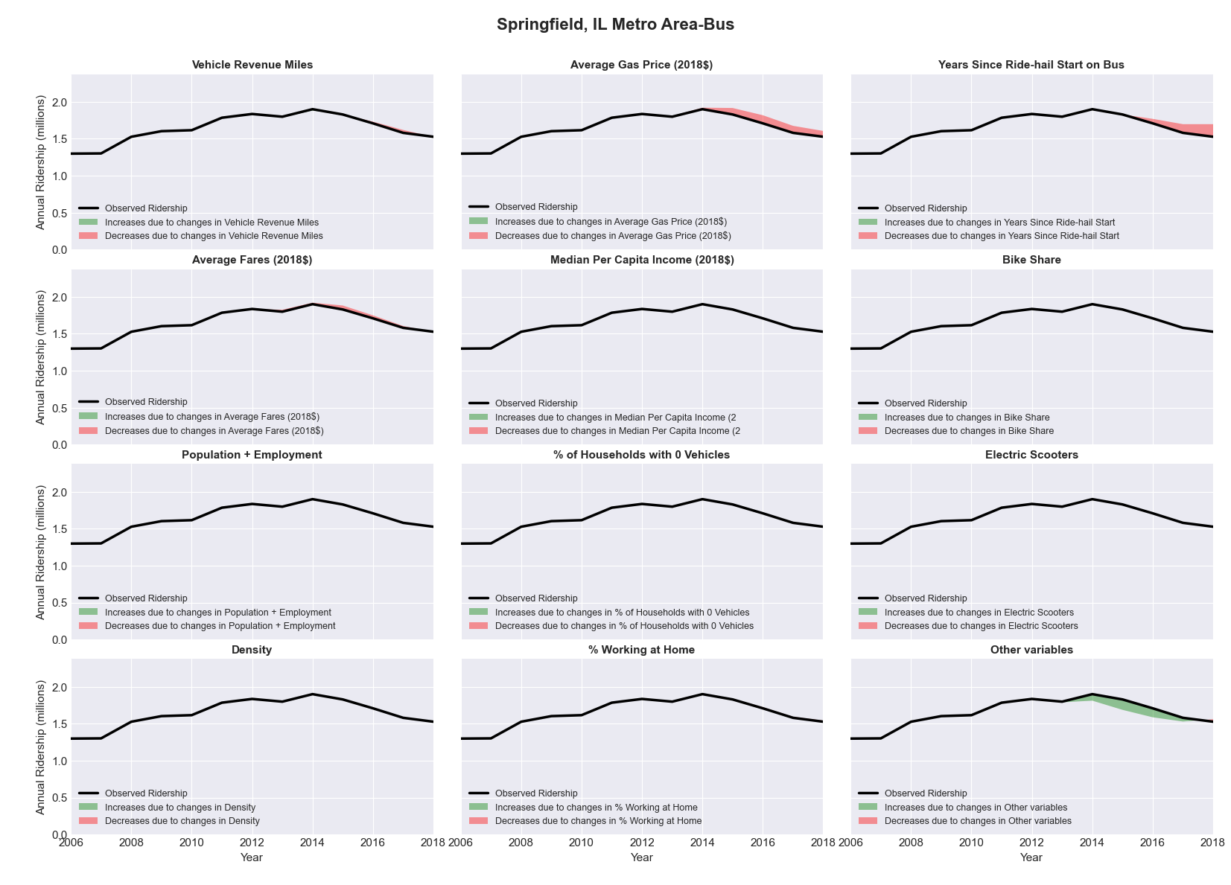

|  |  |  |  |  |  |  |
| --- | --- | --- | --- | --- | --- | --- |
| Springfield, MO Metro Area-Bus | | | | | | |
|  |  |  |  |  |  | |
|  | **Average Values** | | | **Ridership Effect** | | |
| **Description** | **2012** | **2018** | **% Diff** | **Absolute** | **% Diff** | |
|  |  |  |  |  |  | |
| **Vehicle Revenue Miles** | 1,096,190 | 1,073,390 | -2.1% | -11,110 | | **-0.7%** | |
| **Average Fare (2018$)** | 0.68 | 0.67 | -0.9% | -7,420 | | **-0.5%** | |
| **Network Restructure** | - | - | - | - | | **0.0%** | |
| **Major Maintenance Event** | - | - | - | - | | **0.0%** | |
| **Population + Employment** | 652,620 | 689,250 | 5.6% | 18,200 | | **1.2%** | |
| **Share of Population and Employment in Transit Supportive Density** | 0.17 | 0.17 | -4.5% | -5,620 | | **-0.4%** | |
| **Average Gas Price (2018$)** | 3.93 | 2.72 | -30.9% | -71,450 | | **-4.6%** | |
| **Median Per Capita Income (2018$)** | 23,840 | 26,620 | 11.7% | -12,280 | | **-0.8%** | |
| **% of Households with 0 Vehicles** | 6 | 6 | -3.1% | -0,310 | | **-0.0%** | |
| **% Working at Home** | 4.1 | 3.4 | -17.7% | 5,560 | | **0.4%** | |
| **Years Since Ride-hail Start** | - | 2 | 2 | -89,590 | | **-5.8%** | |
| **Bike Share** | - | - | - | - | | **0.0%** | |
| **Electric Scooters** | - | - | - | - | | **0.0%** | |
| **New Reporters** |  |  |  | - | | **0.0%** | |
| **Total Modeled Ridership** | 1,539,857 | 1,380,167 | -10.37% | -159690.108 | | **-10.4%** | |
| **Total Observed Ridership** | 1,583,297 | 1,280,717 | -19.11% | -302580 | | **-19.1%** | |
| **Unexplained Change** |  |  |  |  | | **-8.7%** | |

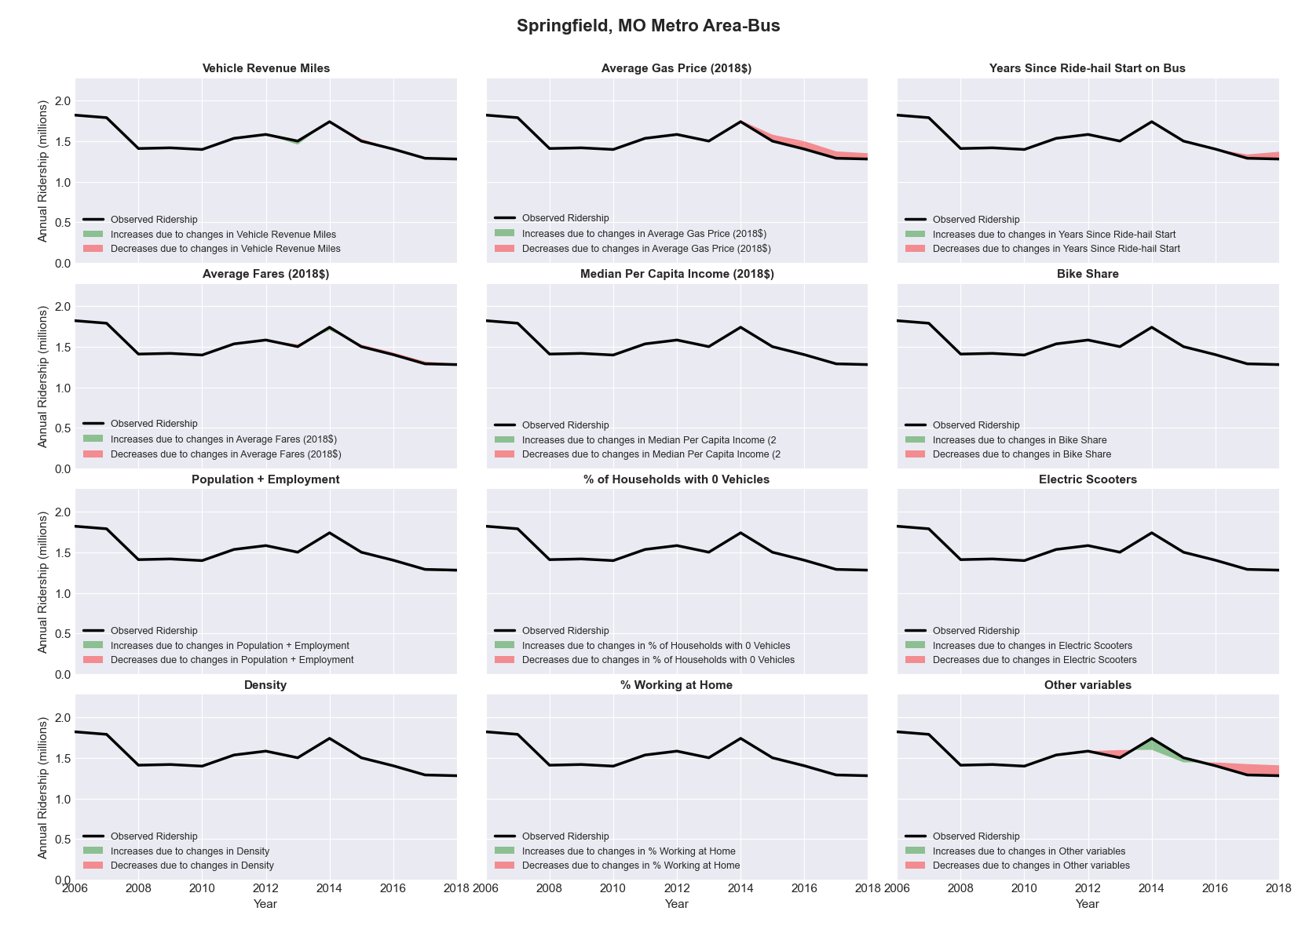

|  |  |  |  |  |  |  |
| --- | --- | --- | --- | --- | --- | --- |
| St. Cloud, MN Metro Area-Bus | | | | | | |
|  |  |  |  |  |  | |
|  | **Average Values** | | | **Ridership Effect** | | |
| **Description** | **2012** | **2018** | **% Diff** | **Absolute** | **% Diff** | |
|  |  |  |  |  |  | |
| **Vehicle Revenue Miles** | 1,249,240 | 1,370,810 | 9.7% | 83,990 | | **4.4%** | |
| **Average Fare (2018$)** | 0.67 | 0.64 | -4.4% | 12,870 | | **0.7%** | |
| **Network Restructure** | - | - | - | - | | **0.0%** | |
| **Major Maintenance Event** | - | - | - | - | | **0.0%** | |
| **Population + Employment** | 291,920 | 309,730 | 6.1% | 24,870 | | **1.3%** | |
| **Share of Population and Employment in Transit Supportive Density** | 0.15 | 0.15 | 0.0% | -0,070 | | **-0.0%** | |
| **Average Gas Price (2018$)** | 3.93 | 2.72 | -30.9% | -86,550 | | **-4.5%** | |
| **Median Per Capita Income (2018$)** | 28,100 | 31,840 | 13.3% | -16,820 | | **-0.9%** | |
| **% of Households with 0 Vehicles** | 5 | 5 | -1.3% | 0,130 | | **0.0%** | |
| **% Working at Home** | 5.4 | 4.4 | -18.5% | 12,880 | | **0.7%** | |
| **Years Since Ride-hail Start** | - | 1 | 1 | -55,180 | | **-2.9%** | |
| **Bike Share** | - | - | - | - | | **0.0%** | |
| **Electric Scooters** | - | - | - | - | | **0.0%** | |
| **New Reporters** |  |  |  | - | | **0.0%** | |
| **Total Modeled Ridership** | 1,907,610 | 1,887,196 | -1.07% | -20413.9371 | | **-1.1%** | |
| **Total Observed Ridership** | 2,112,140 | 1,552,740 | -26.48% | -559400 | | **-26.5%** | |
| **Unexplained Change** |  |  |  |  | | **-25.4%** | |

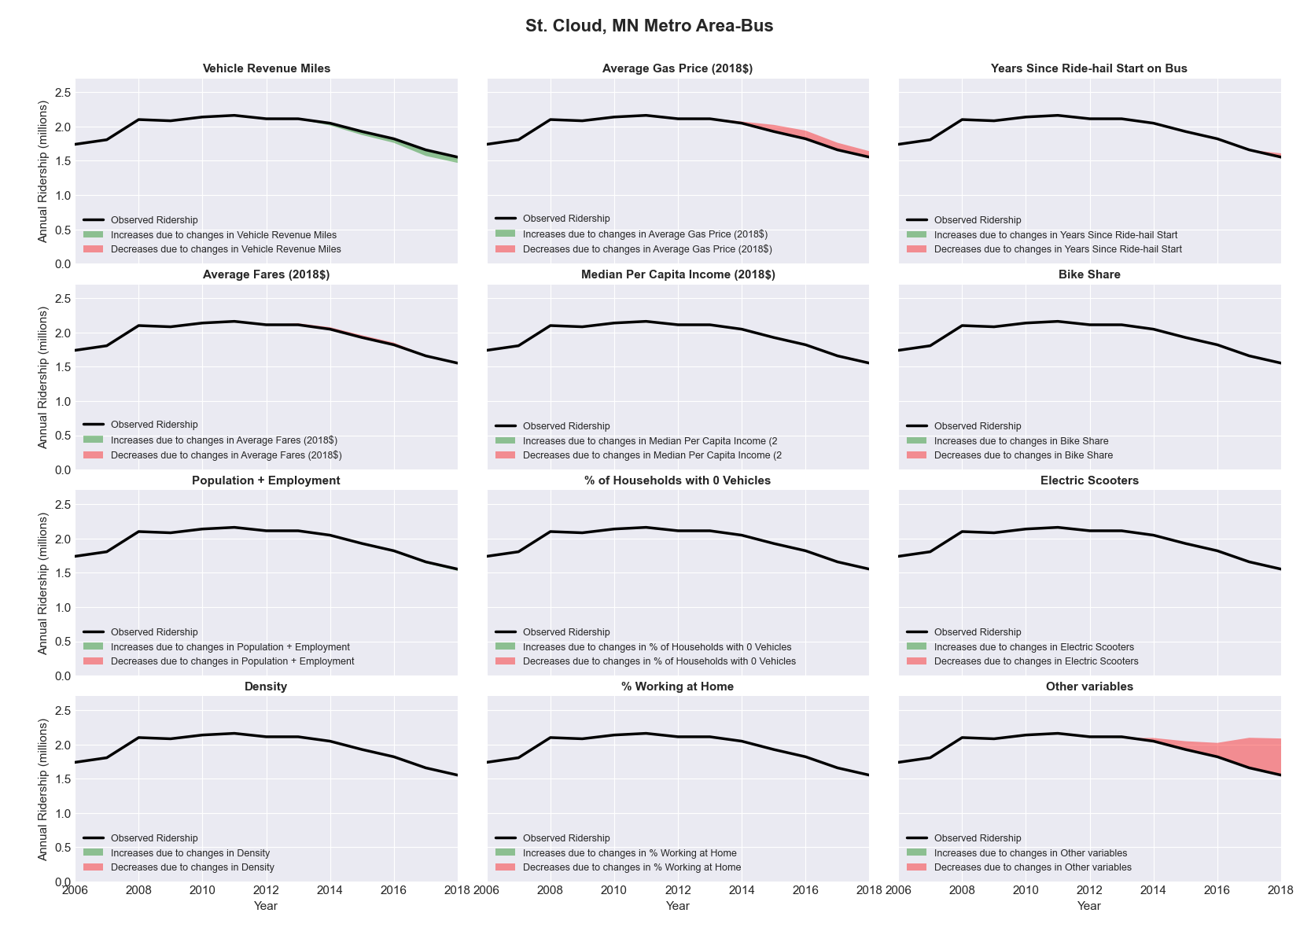

|  |  |  |  |  |  |  |
| --- | --- | --- | --- | --- | --- | --- |
| St. Louis, MO-IL Metro Area-Bus | | | | | | |
|  |  |  |  |  |  | |
|  | **Average Values** | | | **Ridership Effect** | | |
| **Description** | **2012** | **2018** | **% Diff** | **Absolute** | **% Diff** | |
|  |  |  |  |  |  | |
| **Vehicle Revenue Miles** | 21,805,500 | 22,382,820 | 2.6% | 371,490 | | **1.1%** | |
| **Average Fare (2018$)** | 1.10 | 1.05 | -4.1% | 261,830 | | **0.8%** | |
| **Network Restructure** | - | - | - | - | | **0.0%** | |
| **Major Maintenance Event** | - | - | - | - | | **0.0%** | |
| **Population + Employment** | 4,187,460 | 4,242,470 | 1.3% | 89,440 | | **0.3%** | |
| **Share of Population and Employment in Transit Supportive Density** | 0.24 | 0.23 | -2.6% | -81,480 | | **-0.2%** | |
| **Average Gas Price (2018$)** | 3.93 | 2.72 | -30.9% | -1,375,860 | | **-4.2%** | |
| **Median Per Capita Income (2018$)** | 29,340 | 32,370 | 10.3% | -228,110 | | **-0.7%** | |
| **% of Households with 0 Vehicles** | 9 | 8 | -11.9% | -70,040 | | **-0.2%** | |
| **% Working at Home** | 4.2 | 5.2 | 23.2% | -227,650 | | **-0.7%** | |
| **Years Since Ride-hail Start** | - | 4 | 4 | -3,970,250 | | **-12.1%** | |
| **Bike Share** | 1.00 | 1 | - | - | | **0.0%** | |
| **Electric Scooters** | - | 1 | 1 | - 1,042,770 | | **-3.2%** | |
| **New Reporters** |  |  |  | - | | **0.0%** | |
| **Total Modeled Ridership** | 32,719,966 | 26,592,176 | -18.73% | -6127789.53 | | **-18.7%** | |
| **Total Observed Ridership** | 32,221,882 | 25,271,634 | -21.57% | -6950248 | | **-21.6%** | |
| **Unexplained Change** |  |  |  |  | | **-2.8%** | |

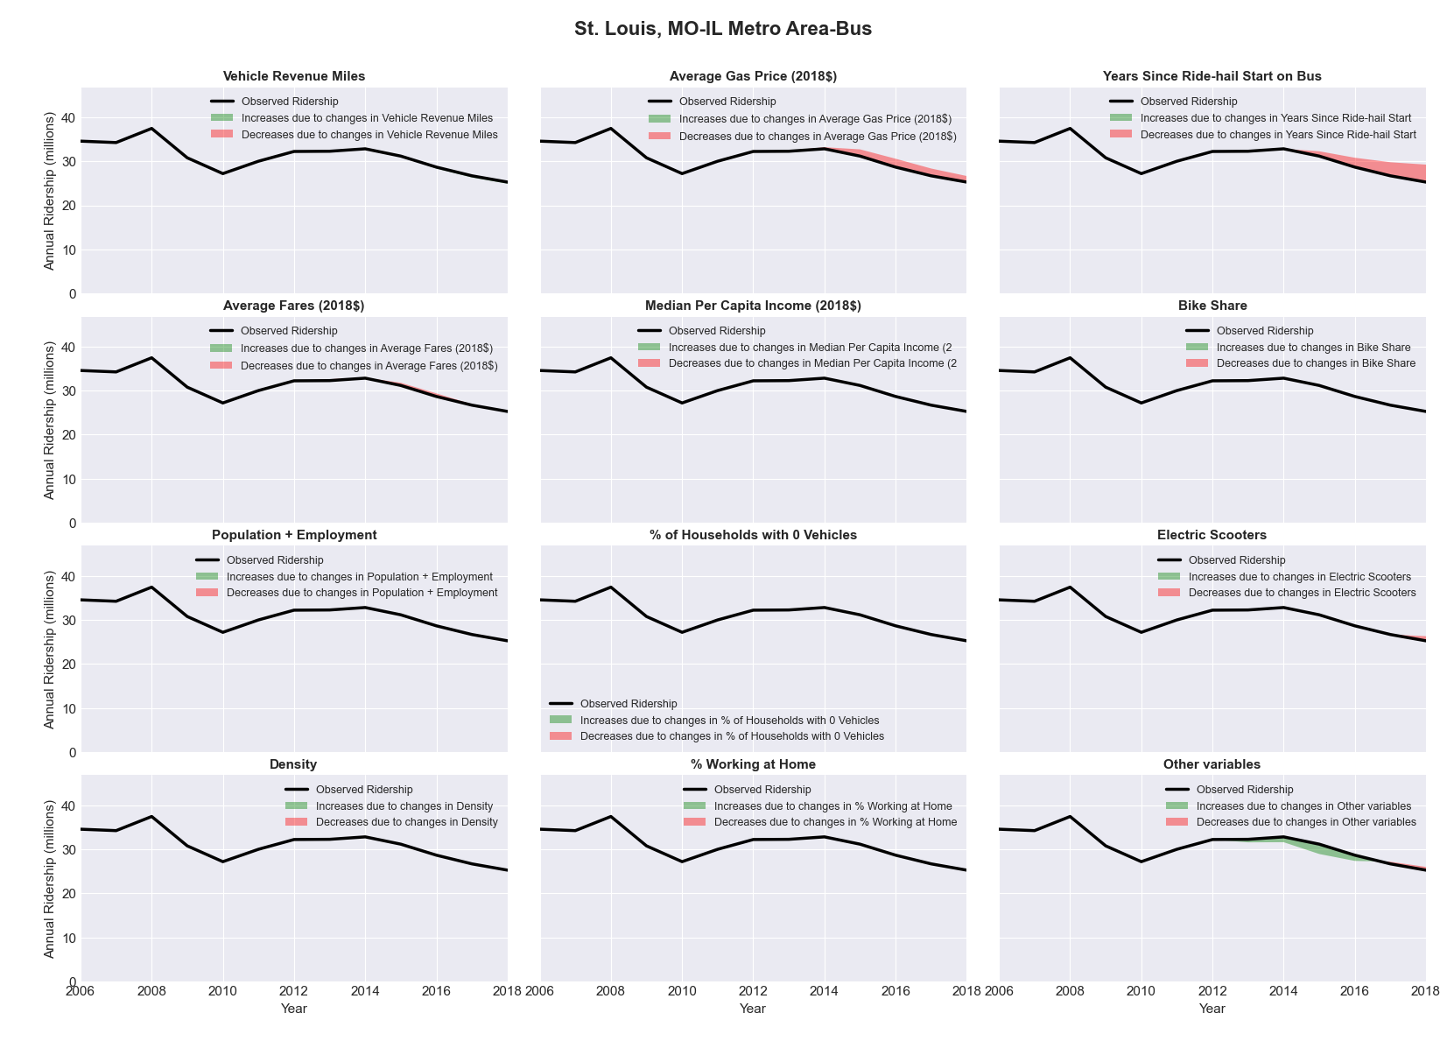

|  |  |  |  |  |  |  |
| --- | --- | --- | --- | --- | --- | --- |
| St. Louis, MO-IL Metro Area-Rail | | | | | | |
|  |  |  |  |  |  | |
|  | **Average Values** | | | **Ridership Effect** | | |
| **Description** | **2012** | **2018** | **% Diff** | **Absolute** | **% Diff** | |
|  |  |  |  |  |  | |
| **Vehicle Revenue Miles** | 6,297,940 | 6,124,330 | -2.8% | -279,820 | | **-1.6%** | |
| **Average Fare (2018$)** | 1.12 | 1.06 | -5.5% | 132,520 | | **0.8%** | |
| **Network Restructure** | - | - | - | - | | **0.0%** | |
| **Major Maintenance Event** | - | - | - | - | | **0.0%** | |
| **Population + Employment** | 4,187,460 | 4,242,470 | 1.3% | 47,210 | | **0.3%** | |
| **Share of Population and Employment in Transit Supportive Density** | 0.24 | 0.23 | -2.6% | -43,410 | | **-0.3%** | |
| **Average Gas Price (2018$)** | 3.93 | 2.72 | -30.9% | -717,770 | | **-4.2%** | |
| **Median Per Capita Income (2018$)** | 29,340 | 32,370 | 10.3% | -119,590 | | **-0.7%** | |
| **% of Households with 0 Vehicles** | 9 | 8 | -11.9% | -36,120 | | **-0.2%** | |
| **% Working at Home** | 4.2 | 5.2 | 23.2% | -117,910 | | **-0.7%** | |
| **Years Since Ride-hail Start** | - | 4 | 4 | -1,419,890 | | **-8.3%** | |
| **Bike Share** | 1.00 | 1 | - | - | | **0.0%** | |
| **Electric Scooters** | - | 1 | 1 | - 551,360 | | **-3.2%** | |
| **New Reporters** |  |  |  | - | | **0.0%** | |
| **Total Modeled Ridership** | 17,145,288 | 14,086,715 | -17.84% | -3058572.41 | | **-17.8%** | |
| **Total Observed Ridership** | 17,128,317 | 13,220,212 | -22.82% | -3908105 | | **-22.8%** | |
| **Unexplained Change** |  |  |  |  | | **-5.0%** | |

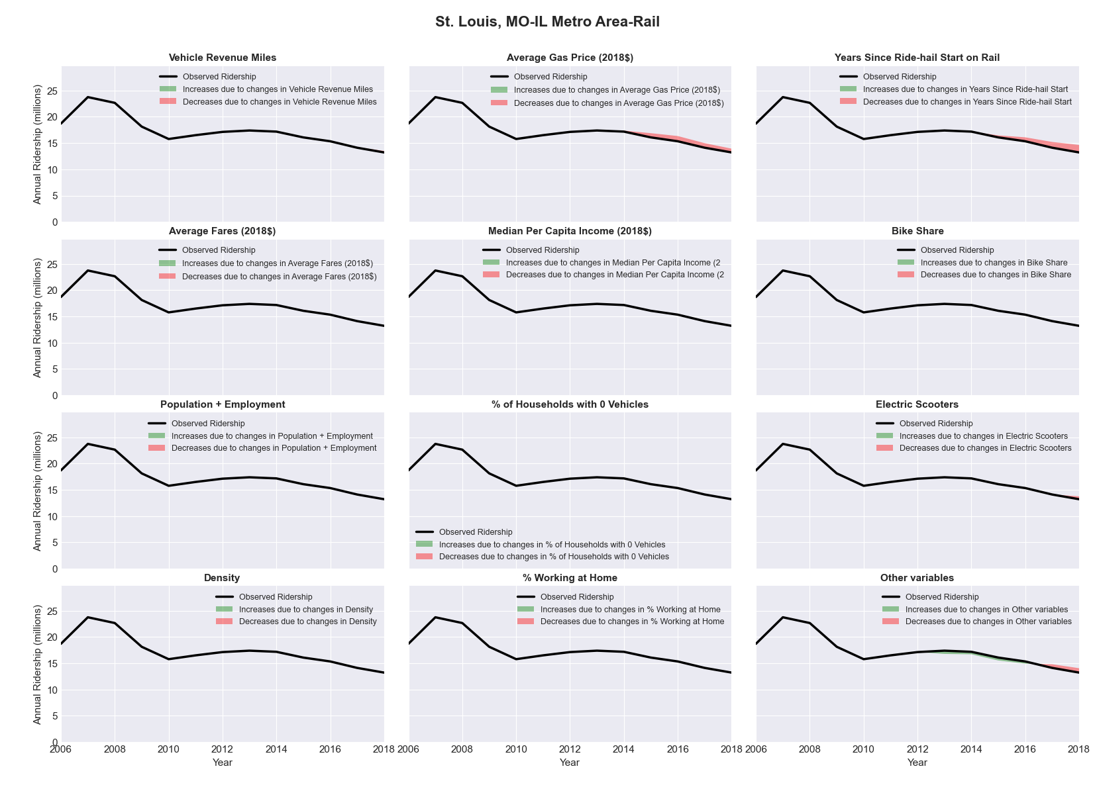

|  |  |  |  |  |  |  |
| --- | --- | --- | --- | --- | --- | --- |
| State College, PA Metro Area-Bus | | | | | | |
|  |  |  |  |  |  | |
|  | **Average Values** | | | **Ridership Effect** | | |
| **Description** | **2012** | **2018** | **% Diff** | **Absolute** | **% Diff** | |
|  |  |  |  |  |  | |
| **Vehicle Revenue Miles** | 1,510,820 | 1,792,270 | 18.6% | 569,060 | | **8.0%** | |
| **Average Fare (2018$)** | 0.90 | 1.06 | 17.9% | -340,790 | | **-4.8%** | |
| **Network Restructure** | - | - | - | - | | **0.0%** | |
| **Major Maintenance Event** | - | - | - | - | | **0.0%** | |
| **Population + Employment** | 228,480 | 239,200 | 4.7% | 71,600 | | **1.0%** | |
| **Share of Population and Employment in Transit Supportive Density** | 0.15 | 0.22 | 43.5% | 211,350 | | **3.0%** | |
| **Average Gas Price (2018$)** | 4.11 | 2.92 | -28.9% | -277,510 | | **-3.9%** | |
| **Median Per Capita Income (2018$)** | 23,870 | 25,670 | 7.5% | -37,490 | | **-0.5%** | |
| **% of Households with 0 Vehicles** | 9 | 9 | 3.7% | 4,850 | | **0.1%** | |
| **% Working at Home** | 4.4 | 3.4 | -23.3% | 51,760 | | **0.7%** | |
| **Years Since Ride-hail Start** | - | 3 | 3 | -692,050 | | **-9.8%** | |
| **Bike Share** | - | 1 | 1 | - 75,550 | | **-1.1%** | |
| **Electric Scooters** | - | - | - | - | | **0.0%** | |
| **New Reporters** |  |  |  | - | | **0.0%** | |
| **Total Modeled Ridership** | 7,092,366 | 6,542,052 | -7.76% | -550313.392 | | **-7.8%** | |
| **Total Observed Ridership** | 6,997,392 | 6,508,742 | -6.98% | -488650 | | **-7.0%** | |
| **Unexplained Change** |  |  |  |  | | **0.8%** | |

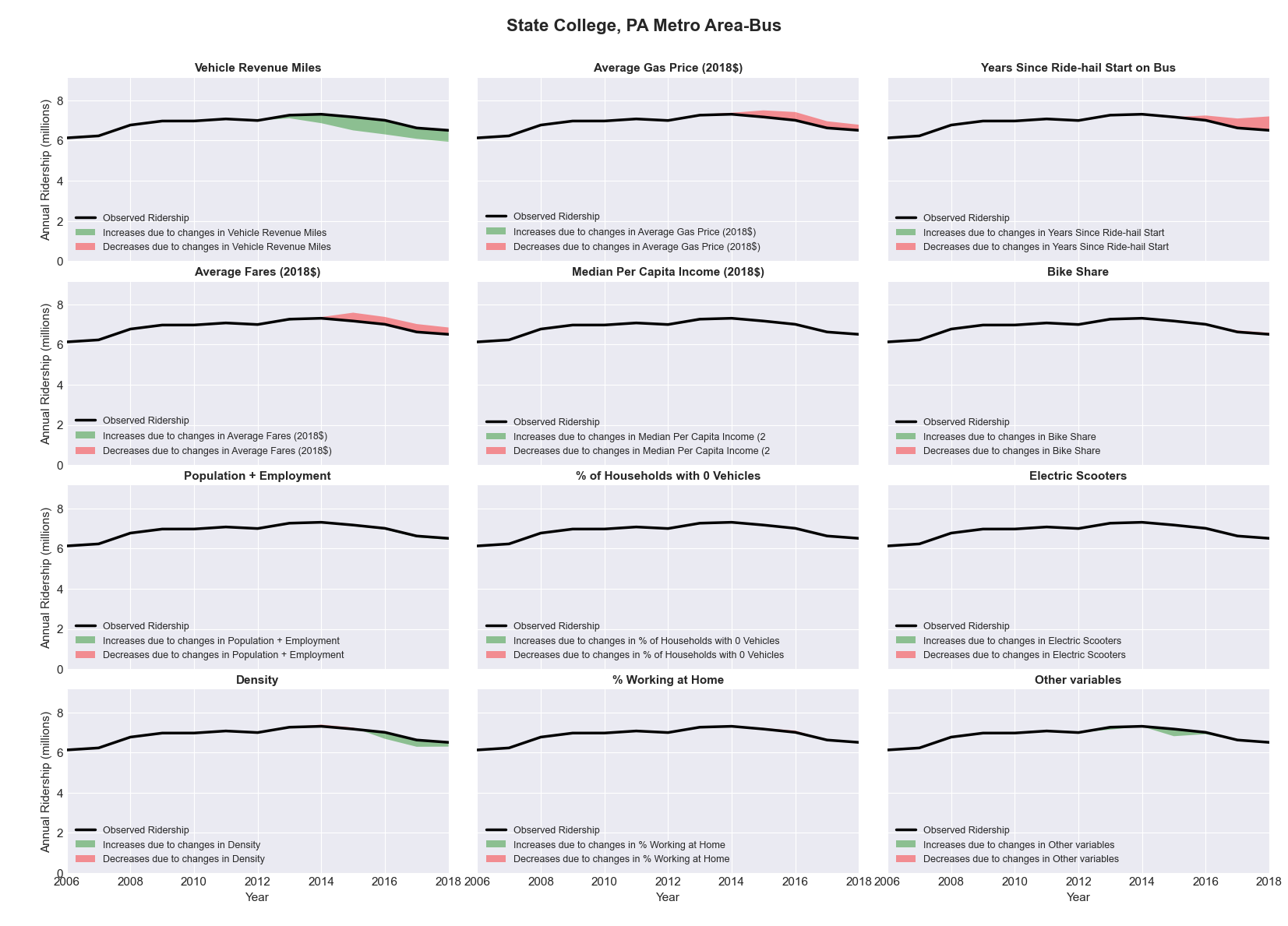

|  |  |  |  |  |  |  |
| --- | --- | --- | --- | --- | --- | --- |
| Stockton, CA Metro Area-Bus | | | | | | |
|  |  |  |  |  |  | |
|  | **Average Values** | | | **Ridership Effect** | | |
| **Description** | **2012** | **2018** | **% Diff** | **Absolute** | **% Diff** | |
|  |  |  |  |  |  | |
| **Vehicle Revenue Miles** | 2,605,580 | 2,471,910 | -5.1% | -82,310 | | **-2.0%** | |
| **Average Fare (2018$)** | 1.22 | 0.89 | -26.8% | 351,000 | | **8.6%** | |
| **Network Restructure** | - | - | - | - | | **0.0%** | |
| **Major Maintenance Event** | - | - | - | - | | **0.0%** | |
| **Population + Employment** | 969,670 | 1,064,700 | 9.8% | 82,080 | | **2.0%** | |
| **Share of Population and Employment in Transit Supportive Density** | 0.47 | 0.46 | -2.3% | -18,990 | | **-0.5%** | |
| **Average Gas Price (2018$)** | 4.35 | 3.40 | -21.8% | -135,560 | | **-3.3%** | |
| **Median Per Capita Income (2018$)** | 24,910 | 30,780 | 23.6% | -60,790 | | **-1.5%** | |
| **% of Households with 0 Vehicles** | 7 | 4 | -51.2% | -26,880 | | **-0.7%** | |
| **% Working at Home** | 3.5 | 3.4 | -2.9% | -1,680 | | **-0.0%** | |
| **Years Since Ride-hail Start** | - | 4 | 4 | -525,950 | | **-12.9%** | |
| **Bike Share** | - | - | - | - | | **0.0%** | |
| **Electric Scooters** | - | - | - | - | | **0.0%** | |
| **New Reporters** |  |  |  | - | | **0.0%** | |
| **Total Modeled Ridership** | 4,074,017 | 3,685,924 | -9.53% | -388093.051 | | **-9.5%** | |
| **Total Observed Ridership** | 4,081,350 | 3,510,022 | -14.00% | -571328 | | **-14.0%** | |
| **Unexplained Change** |  |  |  |  | | **-4.5%** | |

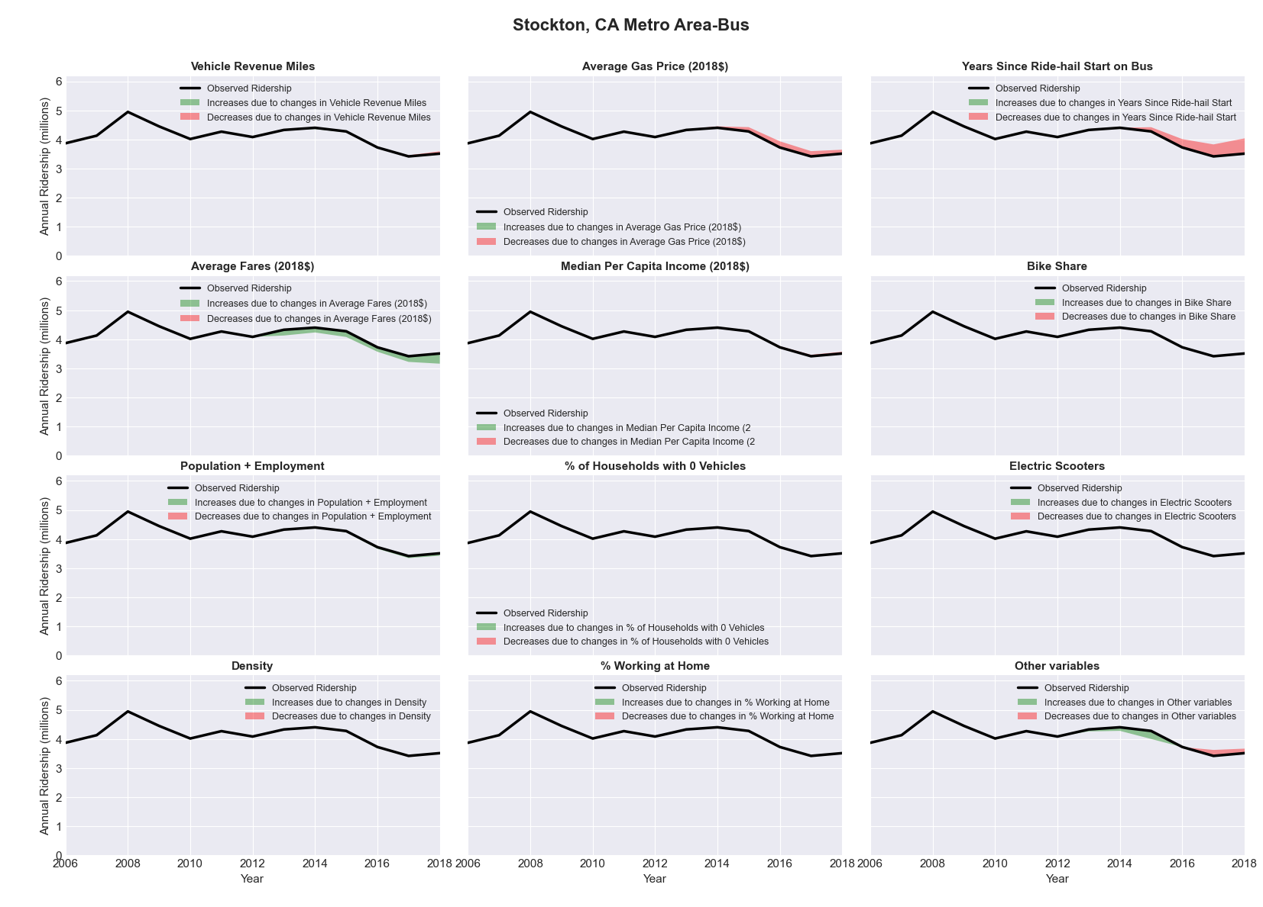

|  |  |  |  |  |  |  |
| --- | --- | --- | --- | --- | --- | --- |
| Syracuse, NY Metro Area-Bus | | | | | | |
|  |  |  |  |  |  | |
|  | **Average Values** | | | **Ridership Effect** | | |
| **Description** | **2012** | **2018** | **% Diff** | **Absolute** | **% Diff** | |
|  |  |  |  |  |  | |
| **Vehicle Revenue Miles** | 3,016,920 | 4,900,810 | 62.4% | 2,279,270 | | **24.3%** | |
| **Average Fare (2018$)** | 1.37 | 1.48 | 8.3% | -281,710 | | **-3.0%** | |
| **Network Restructure** | - | - | - | - | | **0.0%** | |
| **Major Maintenance Event** | - | - | - | - | | **0.0%** | |
| **Population + Employment** | 958,810 | 945,850 | -1.4% | -30,000 | | **-0.3%** | |
| **Share of Population and Employment in Transit Supportive Density** | 0.23 | 0.23 | 2.3% | 18,880 | | **0.2%** | |
| **Average Gas Price (2018$)** | 4.11 | 2.92 | -28.9% | -343,810 | | **-3.7%** | |
| **Median Per Capita Income (2018$)** | 29,030 | 31,680 | 9.1% | -61,600 | | **-0.7%** | |
| **% of Households with 0 Vehicles** | 12 | 11 | -10.7% | -22,700 | | **-0.2%** | |
| **% Working at Home** | 3.3 | 6.1 | 85.6% | -224,010 | | **-2.4%** | |
| **Years Since Ride-hail Start** | - | 1 | 1 | -345,250 | | **-3.7%** | |
| **Bike Share** | - | - | - | - | | **0.0%** | |
| **Electric Scooters** | - | - | - | - | | **0.0%** | |
| **New Reporters** |  |  |  | - | | **0.0%** | |
| **Total Modeled Ridership** | 9,387,312 | 10,252,133 | 9.21% | 864821.267 | | **9.2%** | |
| **Total Observed Ridership** | 9,557,604 | 10,168,272 | 6.39% | 610668 | | **6.4%** | |
| **Unexplained Change** |  |  |  |  | | **-2.8%** | |

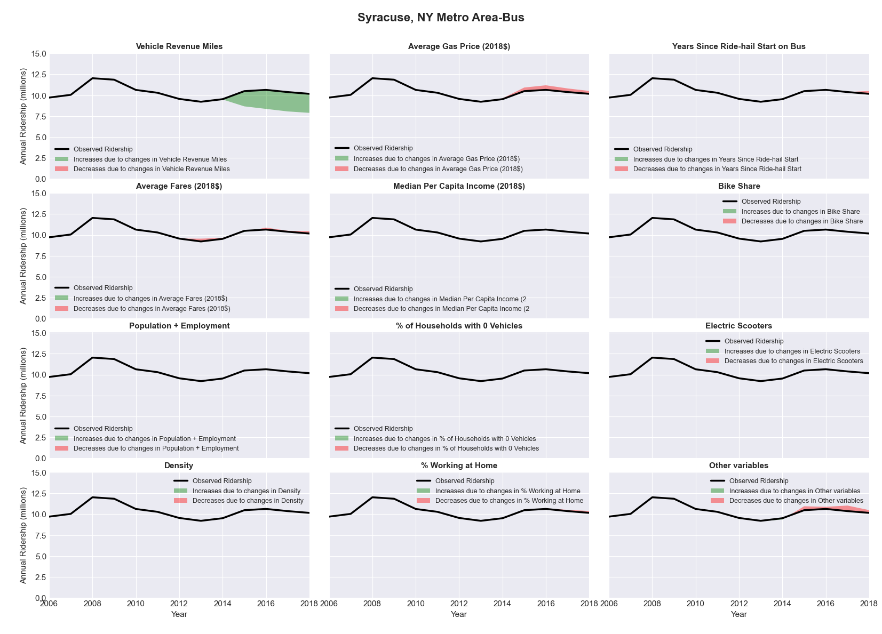

|  |  |  |  |  |  |  |
| --- | --- | --- | --- | --- | --- | --- |
| Tallahassee, FL Metro Area-Bus | | | | | | |
|  |  |  |  |  |  | |
|  | **Average Values** | | | **Ridership Effect** | | |
| **Description** | **2012** | **2018** | **% Diff** | **Absolute** | **% Diff** | |
|  |  |  |  |  |  | |
| **Vehicle Revenue Miles** | 2,125,840 | 1,979,780 | -6.9% | -116,300 | | **-2.5%** | |
| **Average Fare (2018$)** | 0.95 | 1.38 | 45.0% | -494,440 | | **-10.8%** | |
| **Network Restructure** | 1 | 1.000 | 0.0% | - | | **0.0%** | |
| **Major Maintenance Event** | - | - | - | - | | **0.0%** | |
| **Population + Employment** | 550,270 | 576,900 | 4.8% | 37,470 | | **0.8%** | |
| **Share of Population and Employment in Transit Supportive Density** | 0.29 | 0.29 | 0.4% | 1,870 | | **0.0%** | |
| **Average Gas Price (2018$)** | 3.95 | 2.71 | -31.3% | -178,640 | | **-3.9%** | |
| **Median Per Capita Income (2018$)** | 24,310 | 27,770 | 14.2% | -38,920 | | **-0.9%** | |
| **% of Households with 0 Vehicles** | 8 | 5 | -34.0% | -20,480 | | **-0.4%** | |
| **% Working at Home** | 2.8 | 3.9 | 37.5% | -37,280 | | **-0.8%** | |
| **Years Since Ride-hail Start** | - | 4 | 4 | -495,250 | | **-10.8%** | |
| **Bike Share** | - | 1 | 1 | - 35,920 | | **-0.8%** | |
| **Electric Scooters** | - | - | - | - | | **0.0%** | |
| **New Reporters** |  |  |  | - | | **0.0%** | |
| **Total Modeled Ridership** | 4,573,632 | 3,235,011 | -29.27% | -1338621.19 | | **-29.3%** | |
| **Total Observed Ridership** | 4,705,192 | 2,976,152 | -36.75% | -1729040 | | **-36.7%** | |
| **Unexplained Change** |  |  |  |  | | **-7.5%** | |

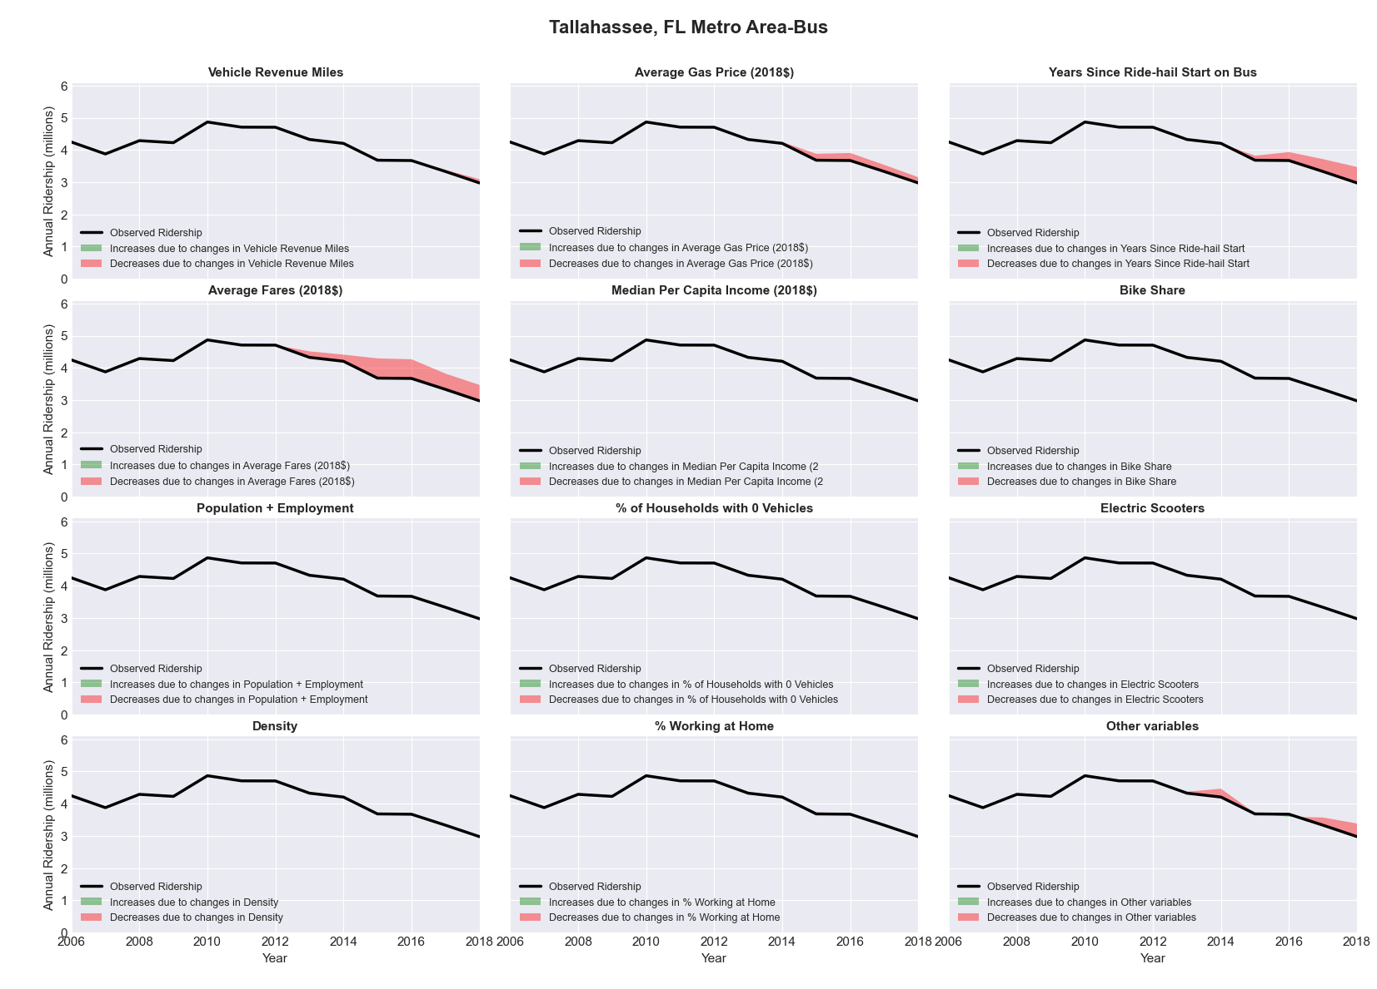

|  |  |  |  |  |  |  |
| --- | --- | --- | --- | --- | --- | --- |
| Tampa-St. Petersburg-Clearwater, FL Metro Area-Bus | | | | | | |
|  |  |  |  |  |  | |
|  | **Average Values** | | | **Ridership Effect** | | |
| **Description** | **2012** | **2018** | **% Diff** | **Absolute** | **% Diff** | |
|  |  |  |  |  |  | |
| **Vehicle Revenue Miles** | 17,578,140 | 18,547,270 | 5.5% | 749,940 | | **2.6%** | |
| **Average Fare (2018$)** | 1.06 | 0.89 | -16.3% | 1,367,280 | | **4.7%** | |
| **Network Restructure** | - | - | - | - | | **0.0%** | |
| **Major Maintenance Event** | - | - | - | - | | **0.0%** | |
| **Population + Employment** | 4,137,580 | 4,635,160 | 12.0% | 704,690 | | **2.4%** | |
| **Share of Population and Employment in Transit Supportive Density** | 0.31 | 0.31 | 0.3% | 12,150 | | **0.0%** | |
| **Average Gas Price (2018$)** | 3.95 | 2.71 | -31.3% | -1,292,400 | | **-4.4%** | |
| **Median Per Capita Income (2018$)** | 27,300 | 28,300 | 3.7% | -73,070 | | **-0.3%** | |
| **% of Households with 0 Vehicles** | 8 | 6 | -17.3% | -75,270 | | **-0.3%** | |
| **% Working at Home** | 5.4 | 7.6 | 40.3% | -493,540 | | **-1.7%** | |
| **Years Since Ride-hail Start** | - | 4 | 4 | -3,724,200 | | **-12.7%** | |
| **Bike Share** | - | 1 | 1 | - 322,760 | | **-1.1%** | |
| **Electric Scooters** | - | - | - | - | | **0.0%** | |
| **New Reporters** |  |  |  | - | | **0.0%** | |
| **Total Modeled Ridership** | 29,220,537 | 26,196,984 | -10.35% | -3023553.32 | | **-10.3%** | |
| **Total Observed Ridership** | 29,467,656 | 23,972,682 | -18.65% | -5494974 | | **-18.6%** | |
| **Unexplained Change** |  |  |  |  | | **-8.3%** | |

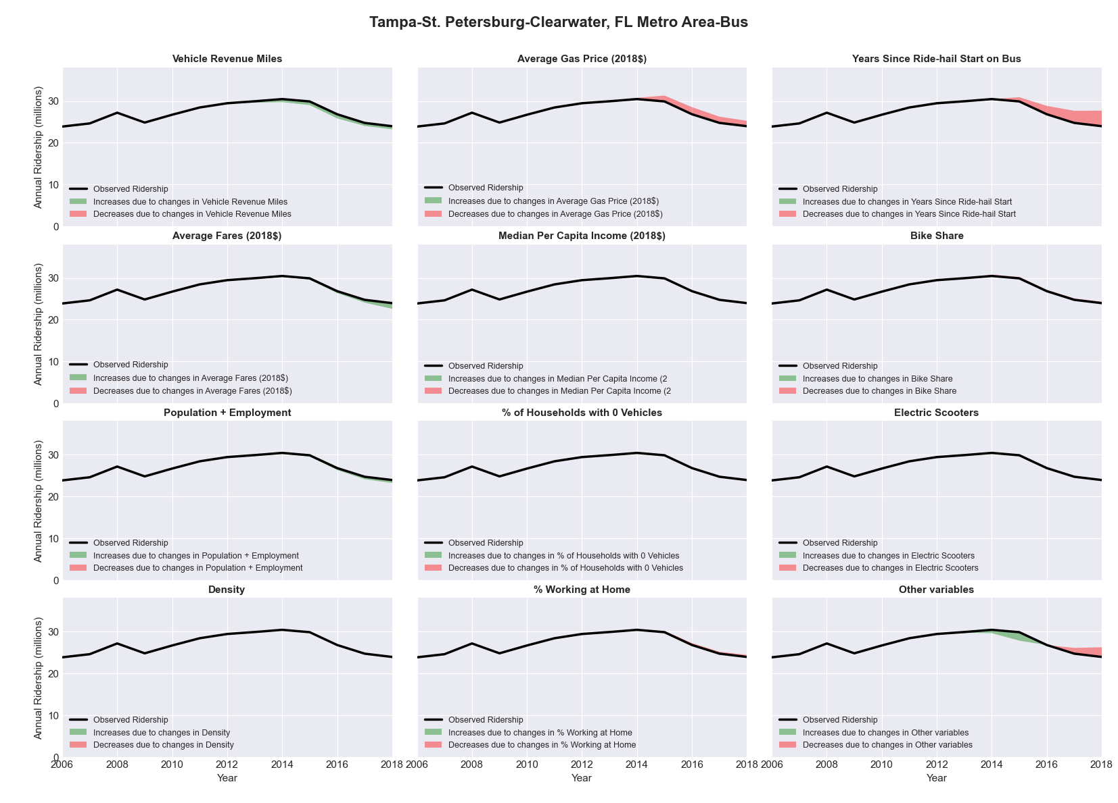

|  |  |  |  |  |  |  |
| --- | --- | --- | --- | --- | --- | --- |
| Tampa-St. Petersburg-Clearwater, FL Metro Area-Rail | | | | | | |
|  |  |  |  |  |  | |
|  | **Average Values** | | | **Ridership Effect** | | |
| **Description** | **2012** | **2018** | **% Diff** | **Absolute** | **% Diff** | |
|  |  |  |  |  |  | |
| **Vehicle Revenue Miles** | 67,500 | 75,120 | 11.3% | 20,450 | | **6.5%** | |
| **Average Fare (2018$)** | 2.06 | 1.24 | -39.7% | 33,090 | | **10.5%** | |
| **Network Restructure** | - | - | - | - | | **0.0%** | |
| **Major Maintenance Event** | - | - | - | - | | **0.0%** | |
| **Population + Employment** | 4,137,580 | 4,635,160 | 12.0% | 7,160 | | **2.3%** | |
| **Share of Population and Employment in Transit Supportive Density** | 0.31 | 0.31 | 0.3% | 0,100 | | **0.0%** | |
| **Average Gas Price (2018$)** | 3.95 | 2.71 | -31.3% | -11,260 | | **-3.6%** | |
| **Median Per Capita Income (2018$)** | 27,300 | 28,300 | 3.7% | -0,720 | | **-0.2%** | |
| **% of Households with 0 Vehicles** | 8 | 6 | -17.3% | -0,790 | | **-0.3%** | |
| **% Working at Home** | 5.4 | 7.6 | 40.3% | -4,710 | | **-1.5%** | |
| **Years Since Ride-hail Start** | - | 4 | 4 | -25,800 | | **-8.2%** | |
| **Bike Share** | - | 1 | 1 | - 3,200 | | **-1.0%** | |
| **Electric Scooters** | - | - | - | - | | **0.0%** | |
| **New Reporters** |  |  |  | - | | **0.0%** | |
| **Total Modeled Ridership** | 314,951 | 327,175 | 3.88% | 12224.6643 | | **3.9%** | |
| **Total Observed Ridership** | 301,516 | 423,123 | 40.33% | 121607 | | **40.3%** | |
| **Unexplained Change** |  |  |  |  | | **36.5%** | |

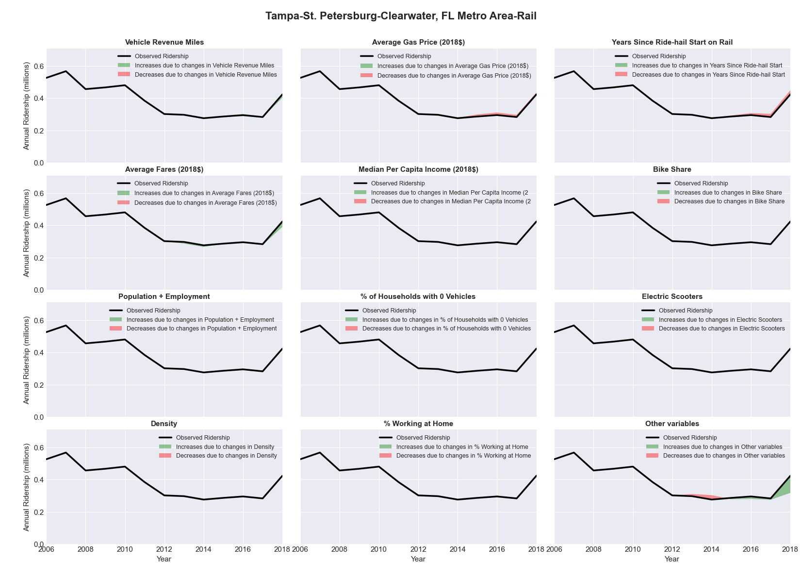

|  |  |  |  |  |  |  |
| --- | --- | --- | --- | --- | --- | --- |
| Terre Haute, IN Metro Area-Bus | | | | | | |
|  |  |  |  |  |  | |
|  | **Average Values** | | | **Ridership Effect** | | |
| **Description** | **2012** | **2018** | **% Diff** | **Absolute** | **% Diff** | |
|  |  |  |  |  |  | |
| **Vehicle Revenue Miles** | 360,290 | 426,230 | 18.3% | 29,530 | | **9.0%** | |
| **Average Fare (2018$)** | 0.44 | 0.43 | -3.4% | -1,820 | | **-0.6%** | |
| **Network Restructure** | - | - | - | - | | **0.0%** | |
| **Major Maintenance Event** | - | - | - | - | | **0.0%** | |
| **Population + Employment** | 245,000 | 236,300 | -3.6% | -2,300 | | **-0.7%** | |
| **Share of Population and Employment in Transit Supportive Density** | 0.10 | 0.10 | 5.4% | 0,800 | | **0.2%** | |
| **Average Gas Price (2018$)** | 3.93 | 2.72 | -30.9% | -17,900 | | **-5.5%** | |
| **Median Per Capita Income (2018$)** | 22,310 | 22,940 | 2.8% | -1,290 | | **-0.4%** | |
| **% of Households with 0 Vehicles** | 8 | 9 | 16.9% | 0,500 | | **0.2%** | |
| **% Working at Home** | 1.2 | 2.1 | 72.9% | -2,890 | | **-0.9%** | |
| **Years Since Ride-hail Start** | - | 1 | 1 | -8,620 | | **-2.6%** | |
| **Bike Share** | - | - | - | - | | **0.0%** | |
| **Electric Scooters** | - | - | - | - | | **0.0%** | |
| **New Reporters** |  |  |  | - | | **0.0%** | |
| **Total Modeled Ridership** | 327,376 | 325,974 | -0.43% | -1401.66804 | | **-0.4%** | |
| **Total Observed Ridership** | 362,702 | 241,250 | -33.49% | -121452 | | **-33.5%** | |
| **Unexplained Change** |  |  |  |  | | **-33.1%** | |

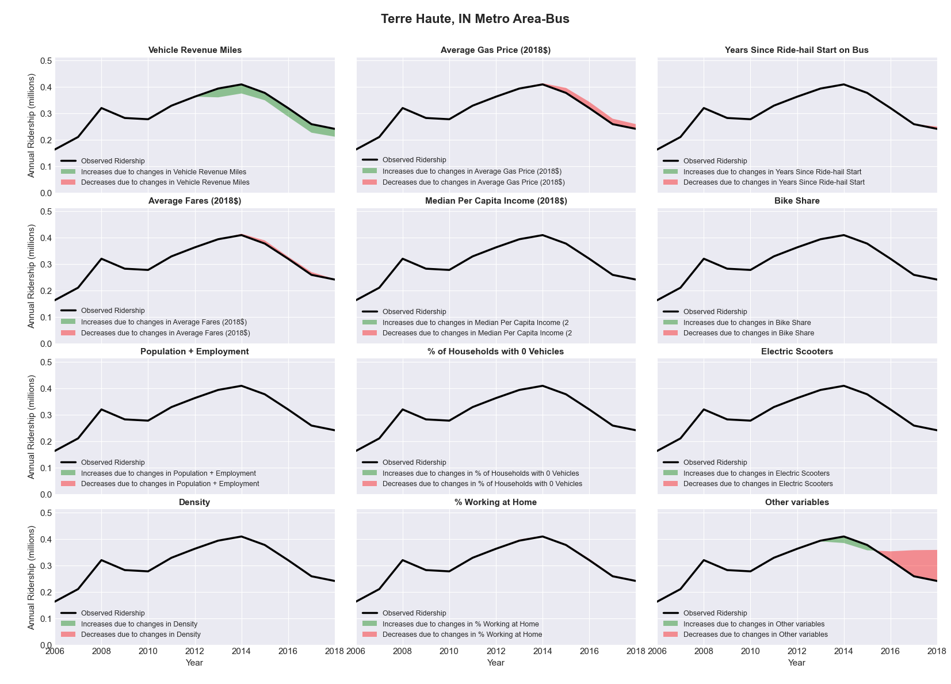

|  |  |  |  |  |  |  |
| --- | --- | --- | --- | --- | --- | --- |
| Toledo, OH Metro Area-Bus | | | | | | |
|  |  |  |  |  |  | |
|  | **Average Values** | | | **Ridership Effect** | | |
| **Description** | **2012** | **2018** | **% Diff** | **Absolute** | **% Diff** | |
|  |  |  |  |  |  | |
| **Vehicle Revenue Miles** | 2,685,850 | 2,771,330 | 3.2% | 51,660 | | **1.7%** | |
| **Average Fare (2018$)** | 1.29 | 1.96 | 52.5% | -370,570 | | **-12.2%** | |
| **Network Restructure** | - | - | - | - | | **0.0%** | |
| **Major Maintenance Event** | - | - | - | - | | **0.0%** | |
| **Population + Employment** | 947,410 | 909,840 | -4.0% | -25,640 | | **-0.8%** | |
| **Share of Population and Employment in Transit Supportive Density** | 0.17 | 0.17 | -2.1% | -3,940 | | **-0.1%** | |
| **Average Gas Price (2018$)** | 3.93 | 2.72 | -30.9% | -113,940 | | **-3.7%** | |
| **Median Per Capita Income (2018$)** | 25,750 | 26,770 | 4.0% | -7,680 | | **-0.3%** | |
| **% of Households with 0 Vehicles** | 10 | 9 | -3.7% | -2,640 | | **-0.1%** | |
| **% Working at Home** | 3.1 | 4.1 | 31.5% | -17,060 | | **-0.6%** | |
| **Years Since Ride-hail Start** | - | 4 | 4 | -343,870 | | **-11.3%** | |
| **Bike Share** | - | 1 | 1 | - 25,800 | | **-0.8%** | |
| **Electric Scooters** | - | - | - | - | | **0.0%** | |
| **New Reporters** |  |  |  | - | | **0.0%** | |
| **Total Modeled Ridership** | 3,043,187 | 2,157,913 | -29.09% | -885273.868 | | **-29.1%** | |
| **Total Observed Ridership** | 2,939,815 | 2,131,046 | -27.51% | -808769 | | **-27.5%** | |
| **Unexplained Change** |  |  |  |  | | **1.6%** | |

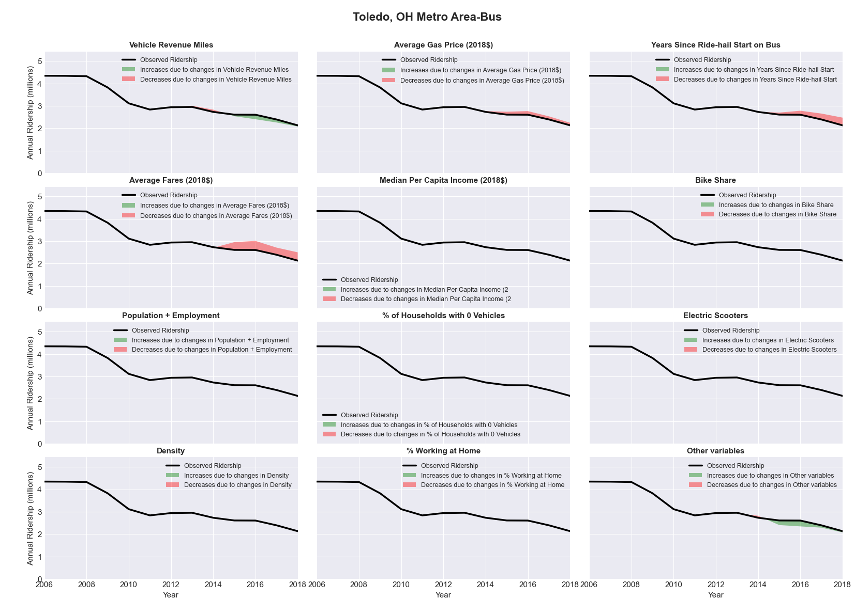

|  |  |  |  |  |  |  |
| --- | --- | --- | --- | --- | --- | --- |
| Topeka, KS Metro Area-Bus | | | | | | |
|  |  |  |  |  |  | |
|  | **Average Values** | | | **Ridership Effect** | | |
| **Description** | **2012** | **2018** | **% Diff** | **Absolute** | **% Diff** | |
|  |  |  |  |  |  | |
| **Vehicle Revenue Miles** | 807,440 | 903,510 | 11.9% | 60,970 | | **4.9%** | |
| **Average Fare (2018$)** | 0.97 | 0.71 | -27.3% | 113,380 | | **9.1%** | |
| **Network Restructure** | - | - | - | - | | **0.0%** | |
| **Major Maintenance Event** | - | - | - | - | | **0.0%** | |
| **Population + Employment** | 348,720 | 347,950 | -0.2% | -0,590 | | **-0.0%** | |
| **Share of Population and Employment in Transit Supportive Density** | 0.20 | 0.21 | 3.4% | 3,180 | | **0.3%** | |
| **Average Gas Price (2018$)** | 3.93 | 2.72 | -30.9% | -47,310 | | **-3.8%** | |
| **Median Per Capita Income (2018$)** | 28,740 | 33,330 | 16.0% | -12,280 | | **-1.0%** | |
| **% of Households with 0 Vehicles** | 7 | 6 | -19.7% | -3,440 | | **-0.3%** | |
| **% Working at Home** | 3.4 | 3.8 | 11.8% | -3,720 | | **-0.3%** | |
| **Years Since Ride-hail Start** | - | 3 | 3 | -118,490 | | **-9.5%** | |
| **Bike Share** | - | 1 | 1 | - 13,090 | | **-1.1%** | |
| **Electric Scooters** | - | - | - | - | | **0.0%** | |
| **New Reporters** |  |  |  | - | | **0.0%** | |
| **Total Modeled Ridership** | 1,241,543 | 1,201,471 | -3.23% | -40071.3393 | | **-3.2%** | |
| **Total Observed Ridership** | 1,108,509 | 1,229,955 | 10.96% | 121446 | | **11.0%** | |
| **Unexplained Change** |  |  |  |  | | **14.2%** | |

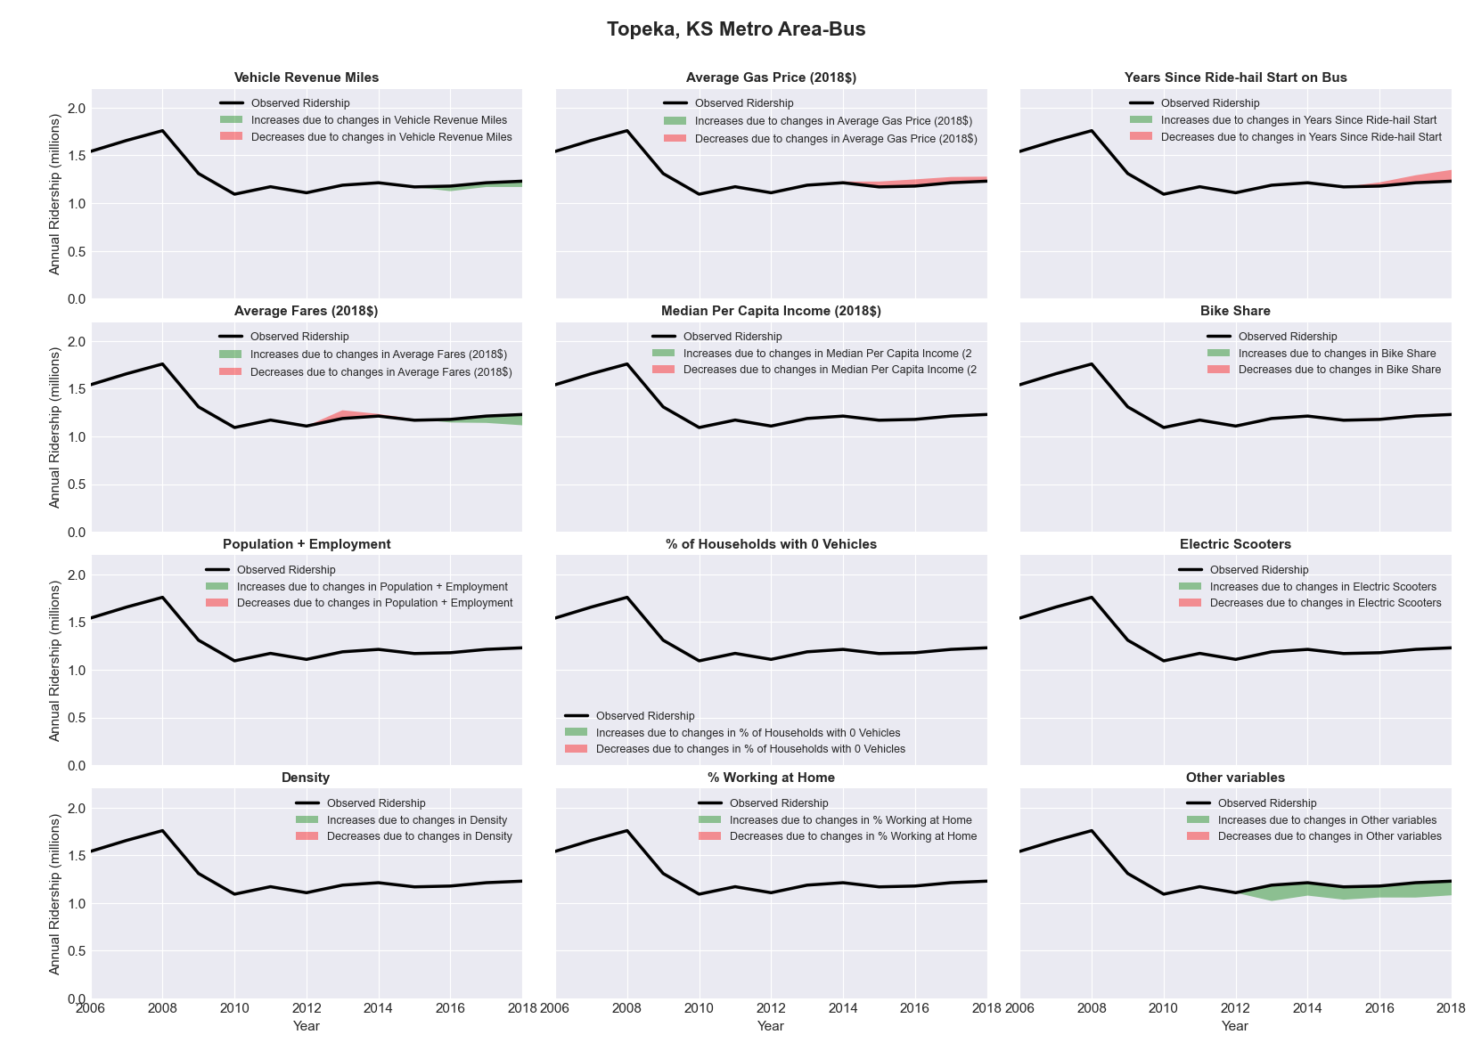

|  |  |  |  |  |  |  |
| --- | --- | --- | --- | --- | --- | --- |
| Tucson, AZ Metro Area-Bus | | | | | | |
|  |  |  |  |  |  | |
|  | **Average Values** | | | **Ridership Effect** | | |
| **Description** | **2012** | **2018** | **% Diff** | **Absolute** | **% Diff** | |
|  |  |  |  |  |  | |
| **Vehicle Revenue Miles** | 7,902,170 | 8,283,420 | 4.8% | 294,610 | | **1.6%** | |
| **Average Fare (2018$)** | 0.71 | 0.67 | -6.0% | 249,440 | | **1.3%** | |
| **Network Restructure** | - | - | - | - | | **0.0%** | |
| **Major Maintenance Event** | - | - | - | - | | **0.0%** | |
| **Population + Employment** | 1,421,190 | 1,491,840 | 5.0% | 186,850 | | **1.0%** | |
| **Share of Population and Employment in Transit Supportive Density** | 0.34 | 0.34 | -1.3% | -26,220 | | **-0.1%** | |
| **Average Gas Price (2018$)** | 4.35 | 3.40 | -21.8% | -571,290 | | **-3.0%** | |
| **Median Per Capita Income (2018$)** | 25,520 | 28,450 | 11.5% | -128,310 | | **-0.7%** | |
| **% of Households with 0 Vehicles** | 9 | 8 | -14.3% | -42,010 | | **-0.2%** | |
| **% Working at Home** | 4.9 | 5.5 | 11.2% | -56,580 | | **-0.3%** | |
| **Years Since Ride-hail Start** | - | 5 | 5 | -2,941,030 | | **-15.5%** | |
| **Bike Share** | - | 1 | 1 | - 182,630 | | **-1.0%** | |
| **Electric Scooters** | - | - | - | - | | **0.0%** | |
| **New Reporters** |  |  |  | - | | **0.0%** | |
| **Total Modeled Ridership** | 18,929,116 | 15,843,323 | -16.30% | -3085793.1 | | **-16.3%** | |
| **Total Observed Ridership** | 20,017,125 | 14,612,074 | -27.00% | -5405051 | | **-27.0%** | |
| **Unexplained Change** |  |  |  |  | | **-10.7%** | |

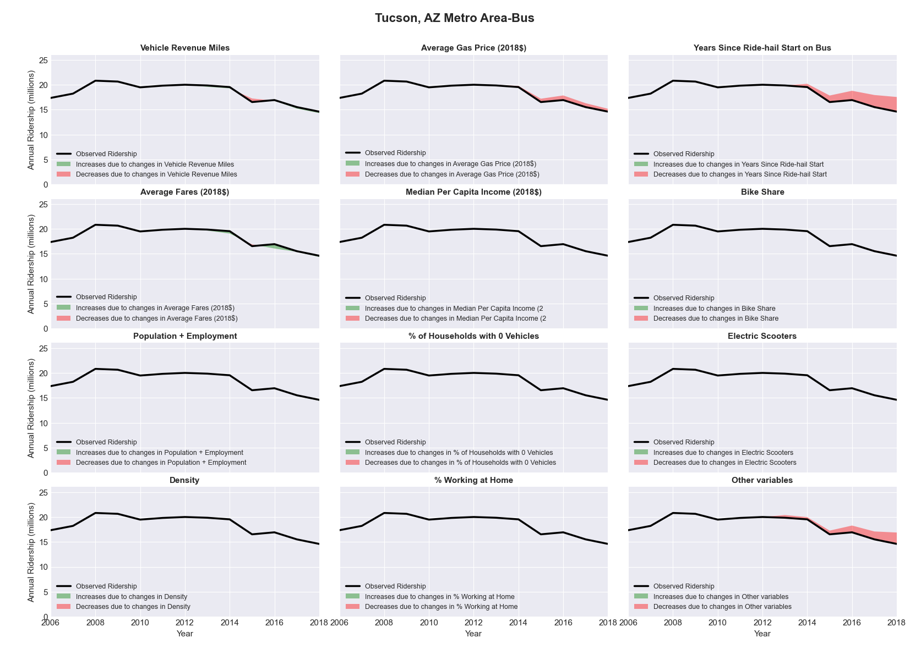

|  |  |  |  |  |  |  |
| --- | --- | --- | --- | --- | --- | --- |
| Tulsa, OK Metro Area-Bus | | | | | | |
|  |  |  |  |  |  | |
|  | **Average Values** | | | **Ridership Effect** | | |
| **Description** | **2012** | **2018** | **% Diff** | **Absolute** | **% Diff** | |
|  |  |  |  |  |  | |
| **Vehicle Revenue Miles** | 2,590,060 | 2,879,510 | 11.2% | 141,030 | | **4.4%** | |
| **Average Fare (2018$)** | 0.80 | 0.89 | 11.2% | -88,050 | | **-2.7%** | |
| **Network Restructure** | - | - | - | - | | **0.0%** | |
| **Major Maintenance Event** | - | - | - | - | | **0.0%** | |
| **Population + Employment** | 1,393,410 | 1,463,670 | 5.0% | 31,700 | | **1.0%** | |
| **Share of Population and Employment in Transit Supportive Density** | 0.22 | 0.21 | -4.9% | -13,060 | | **-0.4%** | |
| **Average Gas Price (2018$)** | 3.93 | 2.72 | -30.9% | -125,440 | | **-3.9%** | |
| **Median Per Capita Income (2018$)** | 27,950 | 29,000 | 3.8% | -8,280 | | **-0.3%** | |
| **% of Households with 0 Vehicles** | 6 | 5 | -12.3% | -4,110 | | **-0.1%** | |
| **% Working at Home** | 3.3 | 4.2 | 28.0% | -21,160 | | **-0.7%** | |
| **Years Since Ride-hail Start** | - | 4 | 4 | -387,830 | | **-12.1%** | |
| **Bike Share** | - | 1 | 1 | - 33,270 | | **-1.0%** | |
| **Electric Scooters** | - | 1 | 1 | - 109,080 | | **-3.4%** | |
| **New Reporters** |  |  |  | - | | **0.0%** | |
| **Total Modeled Ridership** | 3,210,214 | 2,597,501 | -19.09% | -612712.892 | | **-19.1%** | |
| **Total Observed Ridership** | 2,921,255 | 2,720,550 | -6.87% | -200705 | | **-6.9%** | |
| **Unexplained Change** |  |  |  |  | | **12.2%** | |

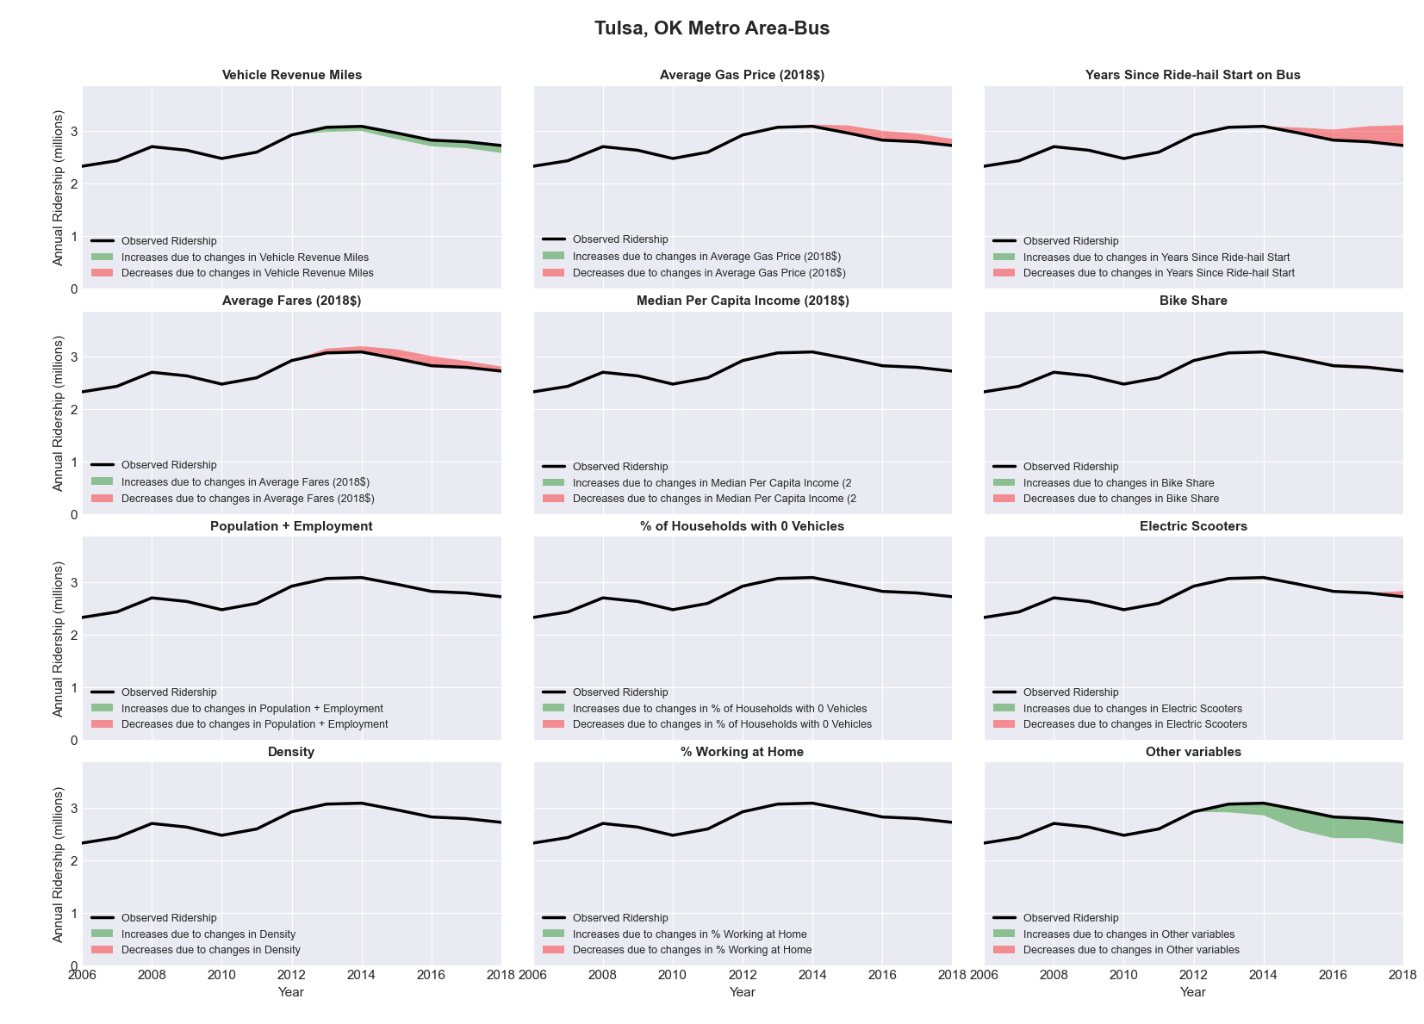

|  |  |  |  |  |  |  |
| --- | --- | --- | --- | --- | --- | --- |
| Vallejo-Fairfield, CA Metro Area-Bus | | | | | | |
|  |  |  |  |  |  | |
|  | **Average Values** | | | **Ridership Effect** | | |
| **Description** | **2012** | **2018** | **% Diff** | **Absolute** | **% Diff** | |
|  |  |  |  |  |  | |
| **Vehicle Revenue Miles** | 1,594,170 | 1,787,210 | 12.1% | 53,050 | | **5.3%** | |
| **Average Fare (2018$)** | 2.46 | 2.39 | -2.9% | 13,240 | | **1.3%** | |
| **Network Restructure** | - | - | - | - | | **0.0%** | |
| **Major Maintenance Event** | - | - | - | - | | **0.0%** | |
| **Population + Employment** | 601,740 | 651,210 | 8.2% | 17,840 | | **1.8%** | |
| **Share of Population and Employment in Transit Supportive Density** | 0.43 | 0.41 | -5.0% | -9,220 | | **-0.9%** | |
| **Average Gas Price (2018$)** | 4.35 | 3.40 | -21.8% | -30,550 | | **-3.1%** | |
| **Median Per Capita Income (2018$)** | 31,950 | 38,190 | 19.5% | -12,670 | | **-1.3%** | |
| **% of Households with 0 Vehicles** | 6 | 5 | -13.0% | -1,650 | | **-0.2%** | |
| **% Working at Home** | 3.8 | 5.5 | 44.1% | -13,020 | | **-1.3%** | |
| **Years Since Ride-hail Start** | - | 2 | 2 | -66,020 | | **-6.6%** | |
| **Bike Share** | - | - | - | - | | **0.0%** | |
| **Electric Scooters** | - | - | - | - | | **0.0%** | |
| **New Reporters** |  |  |  | - | | **0.0%** | |
| **Total Modeled Ridership** | 997,142 | 948,038 | -4.92% | -49104.3593 | | **-4.9%** | |
| **Total Observed Ridership** | 999,482 | 921,265 | -7.83% | -78217 | | **-7.8%** | |
| **Unexplained Change** |  |  |  |  | | **-2.9%** | |

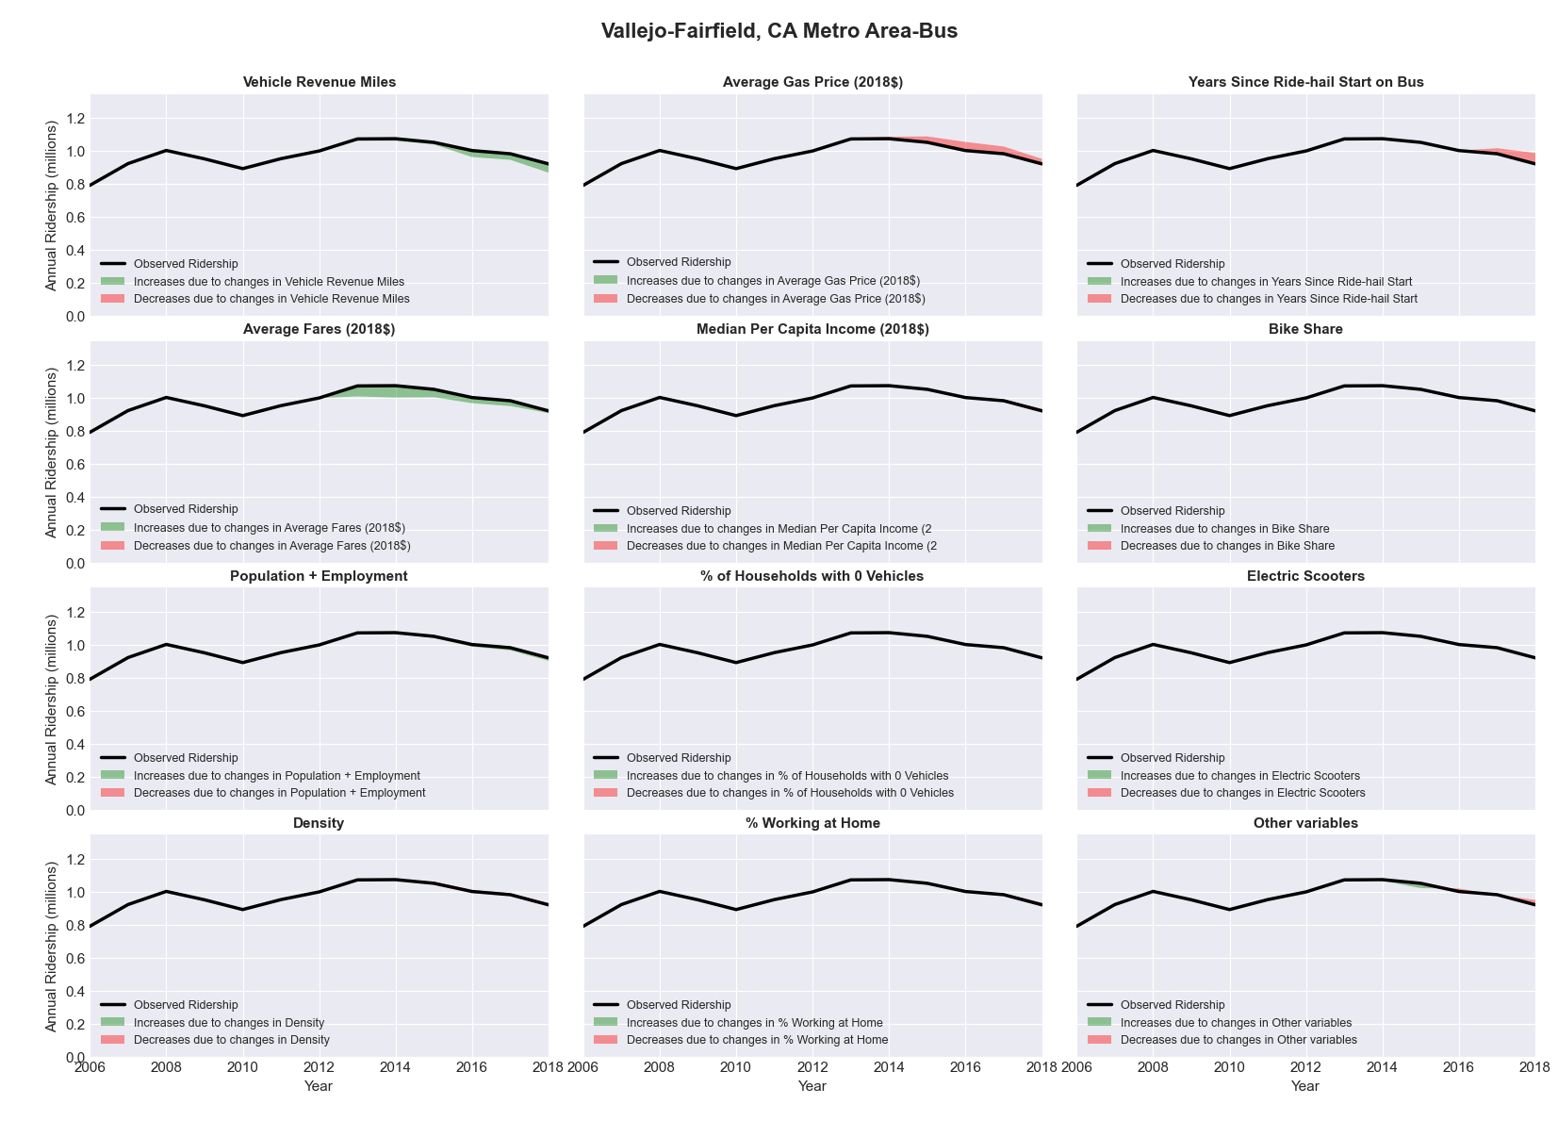

|  |  |  |  |  |  |  |
| --- | --- | --- | --- | --- | --- | --- |
| Virginia Beach-Norfolk-Newport News, VA-NC Metro Area-Bus | | | | | | |
|  |  |  |  |  |  | |
|  | **Average Values** | | | **Ridership Effect** | | |
| **Description** | **2012** | **2018** | **% Diff** | **Absolute** | **% Diff** | |
|  |  |  |  |  |  | |
| **Vehicle Revenue Miles** | 11,378,290 | 11,583,310 | 1.8% | 150,240 | | **0.9%** | |
| **Average Fare (2018$)** | 0.88 | 0.99 | 12.2% | -530,760 | | **-3.0%** | |
| **Network Restructure** | - | - | - | - | | **0.0%** | |
| **Major Maintenance Event** | - | - | - | - | | **0.0%** | |
| **Population + Employment** | 2,473,770 | 2,546,900 | 3.0% | 108,760 | | **0.6%** | |
| **Share of Population and Employment in Transit Supportive Density** | 0.38 | 0.37 | -1.4% | -39,540 | | **-0.2%** | |
| **Average Gas Price (2018$)** | 3.95 | 2.71 | -31.3% | -735,670 | | **-4.2%** | |
| **Median Per Capita Income (2018$)** | 30,710 | 31,530 | 2.7% | -37,370 | | **-0.2%** | |
| **% of Households with 0 Vehicles** | 6 | 7 | 4.4% | 11,910 | | **0.1%** | |
| **% Working at Home** | 4.3 | 3.3 | -23.3% | 142,060 | | **0.8%** | |
| **Years Since Ride-hail Start** | - | 4 | 4 | -2,100,240 | | **-11.9%** | |
| **Bike Share** | - | 1 | 1 | - 155,610 | | **-0.9%** | |
| **Electric Scooters** | - | 1 | 1 | - 563,790 | | **-3.2%** | |
| **New Reporters** |  |  |  | - | | **0.0%** | |
| **Total Modeled Ridership** | 17,637,198 | 13,860,871 | -21.41% | -3776326.73 | | **-21.4%** | |
| **Total Observed Ridership** | 18,896,387 | 13,357,352 | -29.31% | -5539035 | | **-29.3%** | |
| **Unexplained Change** |  |  |  |  | | **-7.9%** | |

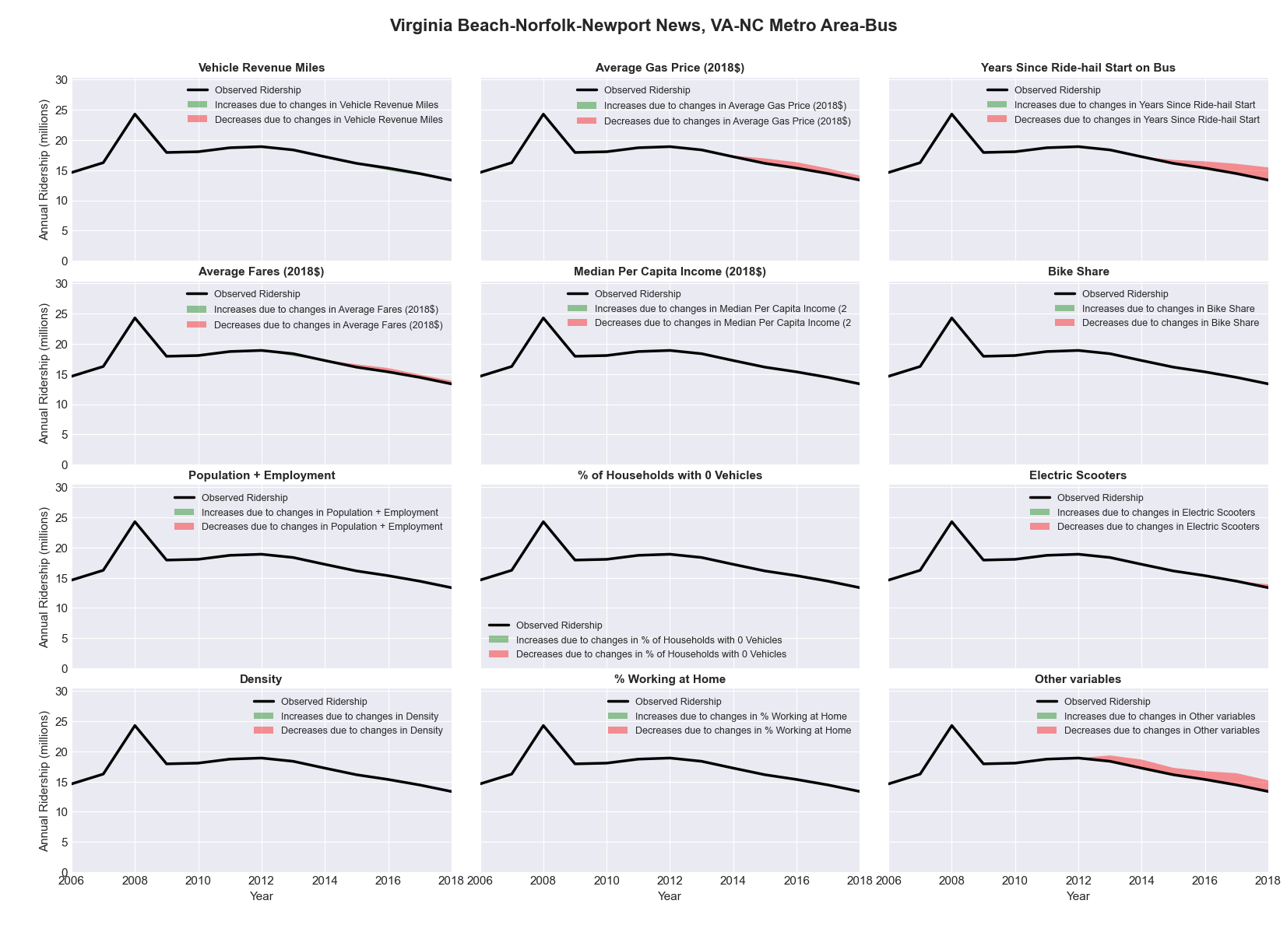

|  |  |  |  |  |  |  |
| --- | --- | --- | --- | --- | --- | --- |
| Virginia Beach-Norfolk-Newport News, VA-NC Metro Area-Rail | | | | | | |
|  |  |  |  |  |  | |
|  | **Average Values** | | | **Ridership Effect** | | |
| **Description** | **2012** | **2018** | **% Diff** | **Absolute** | **% Diff** | |
|  |  |  |  |  |  | |
| **Vehicle Revenue Miles** | 375,060 | 383,470 | 2.2% | 28,070 | | **1.6%** | |
| **Average Fare (2018$)** | 0.45 | 0.83 | 84.4% | -133,920 | | **-7.8%** | |
| **Network Restructure** | - | - | - | - | | **0.0%** | |
| **Major Maintenance Event** | - | - | - | - | | **0.0%** | |
| **Population + Employment** | 2,473,770 | 2,546,900 | 3.0% | 9,810 | | **0.6%** | |
| **Share of Population and Employment in Transit Supportive Density** | 0.38 | 0.37 | -1.4% | -3,410 | | **-0.2%** | |
| **Average Gas Price (2018$)** | 3.95 | 2.71 | -31.3% | -67,160 | | **-3.9%** | |
| **Median Per Capita Income (2018$)** | 30,710 | 31,530 | 2.7% | -3,460 | | **-0.2%** | |
| **% of Households with 0 Vehicles** | 6 | 7 | 4.4% | 0,930 | | **0.1%** | |
| **% Working at Home** | 4.3 | 3.3 | -23.3% | 12,330 | | **0.7%** | |
| **Years Since Ride-hail Start** | - | 4 | 4 | -132,510 | | **-7.7%** | |
| **Bike Share** | - | 1 | 1 | - 15,120 | | **-0.9%** | |
| **Electric Scooters** | - | 1 | 1 | - 54,780 | | **-3.2%** | |
| **New Reporters** |  |  |  | - | | **0.0%** | |
| **Total Modeled Ridership** | 1,718,768 | 1,353,830 | -21.23% | -364937.939 | | **-21.2%** | |
| **Total Observed Ridership** | 1,651,310 | 1,461,451 | -11.50% | -189859 | | **-11.5%** | |
| **Unexplained Change** |  |  |  |  | | **9.7%** | |

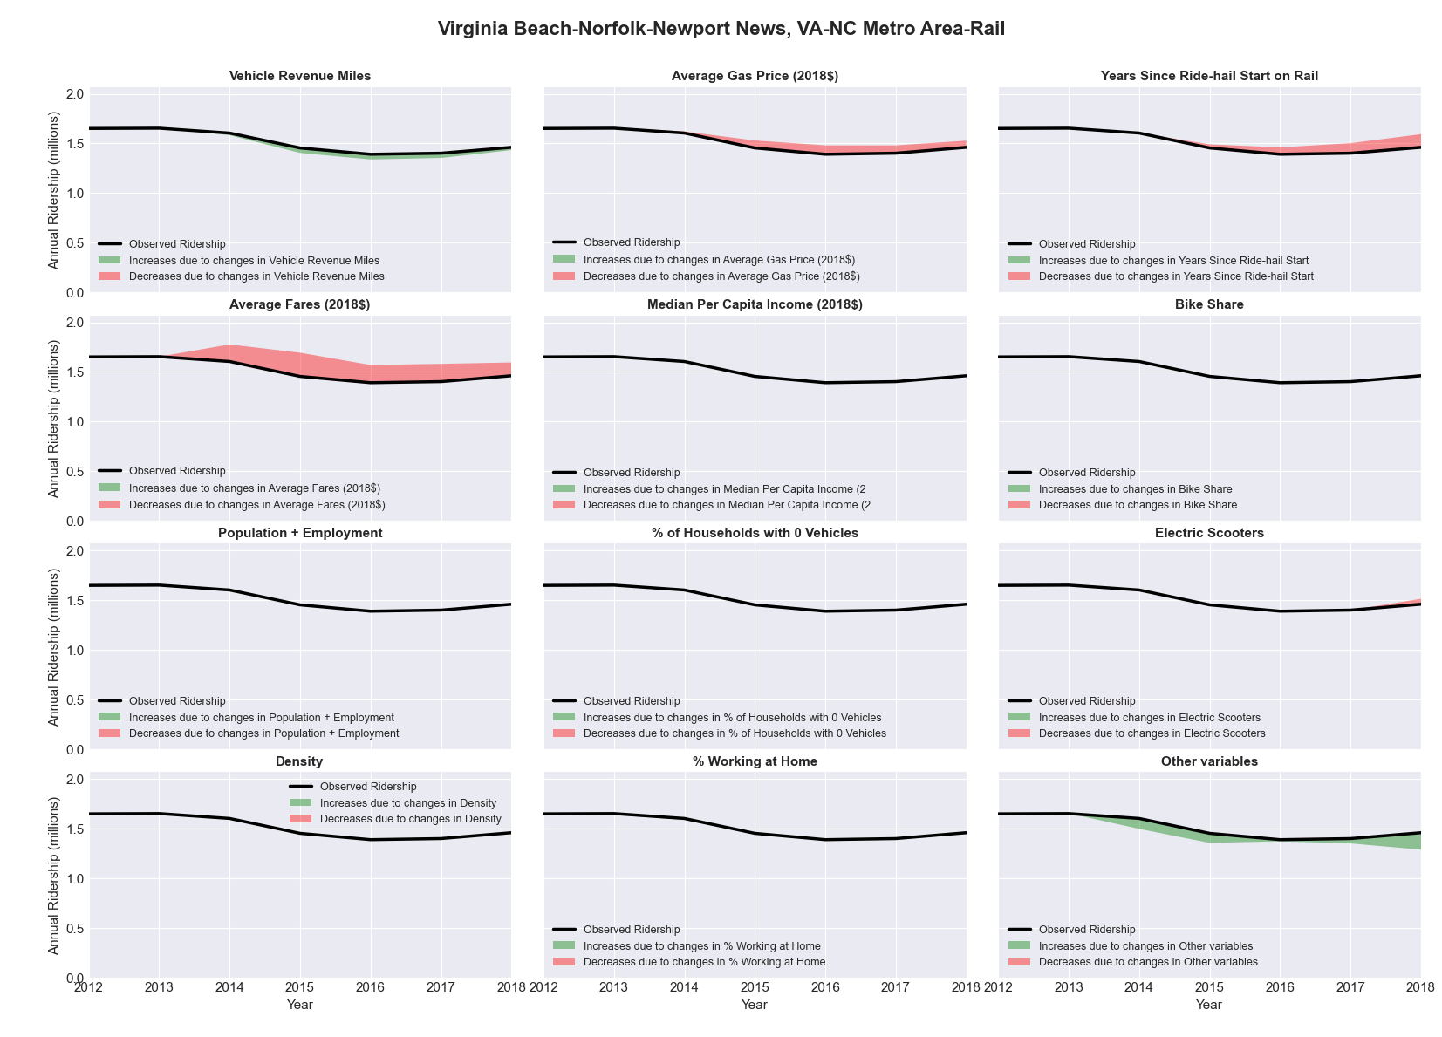

|  |  |  |  |  |  |  |
| --- | --- | --- | --- | --- | --- | --- |
| Visalia-Porterville, CA Metro Area-Bus | | | | | | |
|  |  |  |  |  |  | |
|  | **Average Values** | | | **Ridership Effect** | | |
| **Description** | **2012** | **2018** | **% Diff** | **Absolute** | **% Diff** | |
|  |  |  |  |  |  | |
| **Vehicle Revenue Miles** | 1,572,880 | 2,005,190 | 27.5% | 185,070 | | **11.3%** | |
| **Average Fare (2018$)** | 0.72 | 0.99 | 37.6% | -141,730 | | **-8.6%** | |
| **Network Restructure** | - | - | - | - | | **0.0%** | |
| **Major Maintenance Event** | - | - | - | - | | **0.0%** | |
| **Population + Employment** | 620,740 | 655,540 | 5.6% | 19,370 | | **1.2%** | |
| **Share of Population and Employment in Transit Supportive Density** | 0.29 | 0.30 | 1.9% | 3,760 | | **0.2%** | |
| **Average Gas Price (2018$)** | 4.35 | 3.40 | -21.8% | -52,000 | | **-3.2%** | |
| **Median Per Capita Income (2018$)** | 20,090 | 21,960 | 9.3% | -11,060 | | **-0.7%** | |
| **% of Households with 0 Vehicles** | 6 | 4 | -34.5% | -5,880 | | **-0.4%** | |
| **% Working at Home** | 2.9 | 6.0 | 106.0% | -33,780 | | **-2.1%** | |
| **Years Since Ride-hail Start** | - | 2 | 2 | -97,090 | | **-5.9%** | |
| **Bike Share** | - | - | - | - | | **0.0%** | |
| **Electric Scooters** | - | - | - | - | | **0.0%** | |
| **New Reporters** |  |  |  | - | | **0.0%** | |
| **Total Modeled Ridership** | 1,644,739 | 1,501,130 | -8.73% | -143608.949 | | **-8.7%** | |
| **Total Observed Ridership** | 1,785,496 | 1,360,152 | -23.82% | -425344 | | **-23.8%** | |
| **Unexplained Change** |  |  |  |  | | **-15.1%** | |

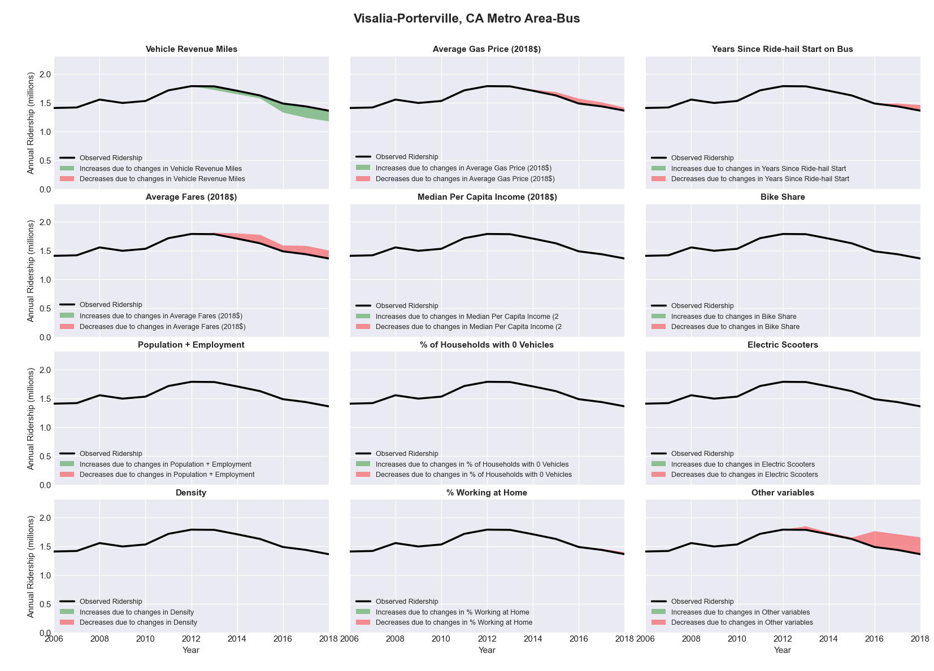

|  |  |  |  |  |  |  |
| --- | --- | --- | --- | --- | --- | --- |
| Waco, TX Metro Area-Bus | | | | | | |
|  |  |  |  |  |  | |
|  | **Average Values** | | | **Ridership Effect** | | |
| **Description** | **2012** | **2018** | **% Diff** | **Absolute** | **% Diff** | |
|  |  |  |  |  |  | |
| **Vehicle Revenue Miles** | 777,200 | 793,720 | 2.1% | 11,550 | | **0.9%** | |
| **Average Fare (2018$)** | 0.61 | 0.96 | 57.6% | -84,000 | | **-6.4%** | |
| **Network Restructure** | - | - | - | - | | **0.0%** | |
| **Major Maintenance Event** | - | - | - | - | | **0.0%** | |
| **Population + Employment** | 343,610 | 384,870 | 12.0% | 24,650 | | **1.9%** | |
| **Share of Population and Employment in Transit Supportive Density** | 0.18 | 0.18 | -1.4% | -0,860 | | **-0.1%** | |
| **Average Gas Price (2018$)** | 3.80 | 2.58 | -32.2% | -42,980 | | **-3.3%** | |
| **Median Per Capita Income (2018$)** | 23,450 | 24,890 | 6.1% | -4,540 | | **-0.3%** | |
| **% of Households with 0 Vehicles** | 8 | 10 | 18.7% | 3,870 | | **0.3%** | |
| **% Working at Home** | 2.1 | 3.8 | 79.8% | -12,220 | | **-0.9%** | |
| **Years Since Ride-hail Start** | - | 4 | 4 | -143,630 | | **-11.0%** | |
| **Bike Share** | - | 1 | 1 | - 12,070 | | **-0.9%** | |
| **Electric Scooters** | - | - | - | - | | **0.0%** | |
| **New Reporters** |  |  |  | - | | **0.0%** | |
| **Total Modeled Ridership** | 1,304,411 | 982,283 | -24.70% | -322127.523 | | **-24.7%** | |
| **Total Observed Ridership** | 934,740 | 1,250,485 | 33.78% | 315745 | | **33.8%** | |
| **Unexplained Change** |  |  |  |  | | **58.5%** | |

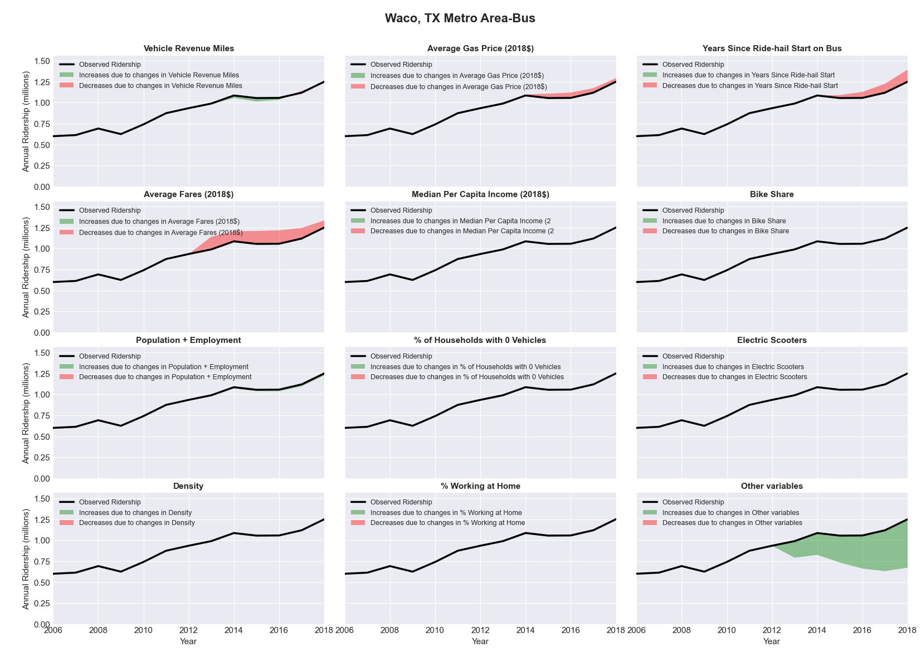

|  |  |  |  |  |  |  |
| --- | --- | --- | --- | --- | --- | --- |
| Washington-Arlington-Alexandria, DC-VA-MD-WV Metro Area-Bus | | | | | | |
|  |  |  |  |  |  | |
|  | **Average Values** | | | **Ridership Effect** | | |
| **Description** | **2012** | **2018** | **% Diff** | **Absolute** | **% Diff** | |
|  |  |  |  |  |  | |
| **Vehicle Revenue Miles** | 71,106,130 | 72,283,800 | 1.7% | 1,457,940 | | **0.8%** | |
| **Average Fare (2018$)** | 1.09 | 1.11 | 1.5% | -1,536,590 | | **-0.8%** | |
| **Network Restructure** | - | - | - | - | | **0.0%** | |
| **Major Maintenance Event** | - | - | - | - | | **0.0%** | |
| **Population + Employment** | 8,826,440 | 9,562,820 | 8.3% | 3,102,010 | | **1.6%** | |
| **Share of Population and Employment in Transit Supportive Density** | 0.53 | 0.53 | -0.6% | -249,840 | | **-0.1%** | |
| **Average Gas Price (2018$)** | 3.95 | 2.71 | -31.3% | -7,774,590 | | **-4.0%** | |
| **Median Per Capita Income (2018$)** | 44,970 | 48,510 | 7.9% | -881,850 | | **-0.5%** | |
| **% of Households with 0 Vehicles** | 10 | 9 | -12.2% | -430,090 | | **-0.2%** | |
| **% Working at Home** | 5.0 | 6.4 | 27.5% | -1,790,320 | | **-0.9%** | |
| **Years Since Ride-hail Start** | 1.0 | 7 | 6 | -20,434,730 | | **-10.6%** | |
| **Bike Share** | 1.00 | 1 | - | - | | **0.0%** | |
| **Electric Scooters** | - | 1 | 1 | - 6,307,740 | | **-3.3%** | |
| **New Reporters** |  |  |  | - | | **0.0%** | |
| **Total Modeled Ridership** | 192,798,596 | 158,334,349 | -17.88% | -34464246.8 | | **-17.9%** | |
| **Total Observed Ridership** | 186,302,248 | 157,384,475 | -15.52% | -28917773 | | **-15.5%** | |
| **Unexplained Change** |  |  |  |  | | **2.4%** | |

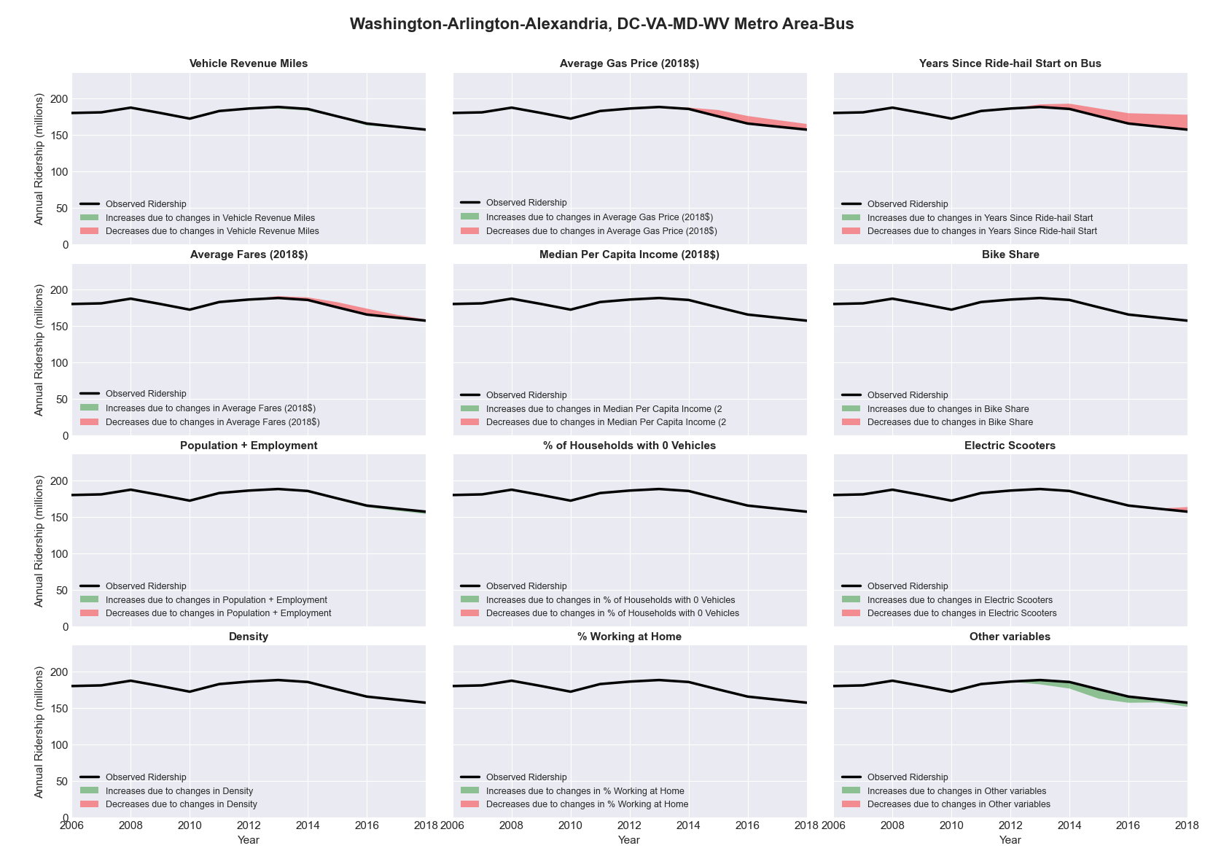

|  |  |  |  |  |  |  |
| --- | --- | --- | --- | --- | --- | --- |
| Washington-Arlington-Alexandria, DC-VA-MD-WV Metro Area-Rail | | | | | | |
|  |  |  |  |  |  | |
|  | **Average Values** | | | **Ridership Effect** | | |
| **Description** | **2012** | **2018** | **% Diff** | **Absolute** | **% Diff** | |
|  |  |  |  |  |  | |
| **Vehicle Revenue Miles** | 75,874,570 | 85,666,380 | 12.9% | 21,233,450 | | **7.8%** | |
| **Average Fare (2018$)** | 2.32 | 2.20 | -5.1% | 1,731,380 | | **0.6%** | |
| **Network Restructure** | - | - | - | - | | **0.0%** | |
| **Major Maintenance Event** | - | 1 | - | - 18,462,651 | | **-6.5%** | |
| **Population + Employment** | 8,826,440 | 9,562,820 | 8.3% | 4,590,670 | | **1.7%** | |
| **Share of Population and Employment in Transit Supportive Density** | 0.53 | 0.53 | -0.6% | -365,890 | | **-0.1%** | |
| **Average Gas Price (2018$)** | 3.95 | 2.71 | -31.3% | -11,644,380 | | **-4.3%** | |
| **Median Per Capita Income (2018$)** | 44,970 | 48,510 | 7.9% | -1,281,610 | | **-0.5%** | |
| **% of Households with 0 Vehicles** | 10 | 9 | -12.2% | -627,560 | | **-0.2%** | |
| **% Working at Home** | 5.0 | 6.4 | 27.5% | -2,637,990 | | **-1.0%** | |
| **Years Since Ride-hail Start** | 1.0 | 7 | 6 | 3,426,880 | | **1.3%** | |
| **Bike Share** | 1.00 | 1 | - | - | | **0.0%** | |
| **Electric Scooters** | - | 1 | 1 | - 9,189,850 | | **-3.4%** | |
| **New Reporters** |  |  |  | - | | **0.0%** | |
| **Total Modeled Ridership** | 271,722,778 | 260,081,229 | -4.28% | -11641548.35 | | **-4.3%** | |
| **Total Observed Ridership** | 283,212,684 | 233,283,293 | -17.63% | -49929391 | | **-17.6%** | |
| **Unexplained Change** |  |  |  |  | | **-13.3%** | |

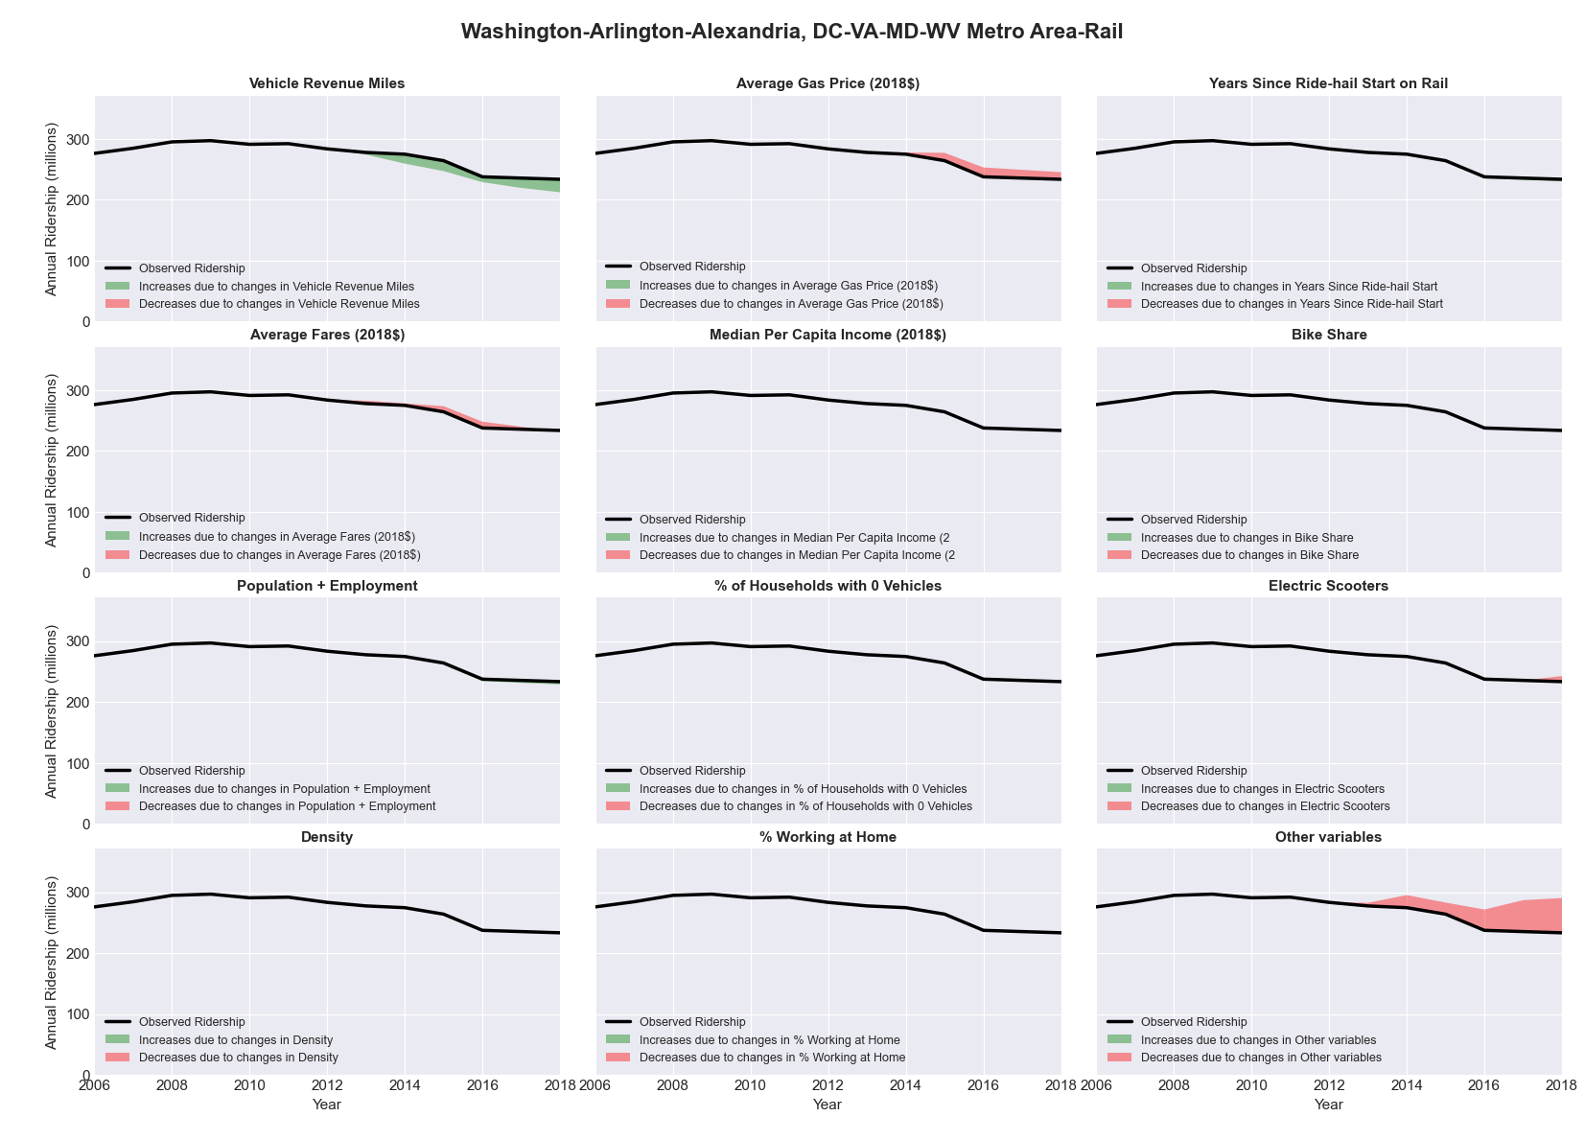

|  |  |  |  |  |  |  |
| --- | --- | --- | --- | --- | --- | --- |
| Wenatchee-East Wenatchee, WA Metro Area-Bus | | | | | | |
|  |  |  |  |  |  | |
|  | **Average Values** | | | **Ridership Effect** | | |
| **Description** | **2012** | **2018** | **% Diff** | **Absolute** | **% Diff** | |
|  |  |  |  |  |  | |
| **Vehicle Revenue Miles** | 1,593,730 | 1,797,060 | 12.8% | 53,350 | | **5.9%** | |
| **Average Fare (2018$)** | 0.92 | 0.62 | -32.9% | 91,550 | | **10.0%** | |
| **Network Restructure** | - | - | - | - | | **0.0%** | |
| **Major Maintenance Event** | - | - | - | - | | **0.0%** | |
| **Population + Employment** | 168,630 | 182,820 | 8.4% | 17,090 | | **1.9%** | |
| **Share of Population and Employment in Transit Supportive Density** | 0.09 | 0.09 | 3.4% | 1,020 | | **0.1%** | |
| **Average Gas Price (2018$)** | 4.35 | 3.40 | -21.8% | -26,720 | | **-2.9%** | |
| **Median Per Capita Income (2018$)** | 24,710 | 27,520 | 11.4% | -7,390 | | **-0.8%** | |
| **% of Households with 0 Vehicles** | 6 | 4 | -37.2% | -5,020 | | **-0.6%** | |
| **% Working at Home** | 3.2 | 7.1 | 120.3% | -27,390 | | **-3.0%** | |
| **Years Since Ride-hail Start** | - | 2 | 2 | -64,320 | | **-7.1%** | |
| **Bike Share** | - | - | - | - | | **0.0%** | |
| **Electric Scooters** | - | - | - | - | | **0.0%** | |
| **New Reporters** |  |  |  | - | | **0.0%** | |
| **Total Modeled Ridership** | 911,224 | 943,646 | 3.56% | 32422.47891 | | **3.6%** | |
| **Total Observed Ridership** | 861,913 | 947,095 | 9.88% | 85182 | | **9.9%** | |
| **Unexplained Change** |  |  |  |  | | **6.3%** | |

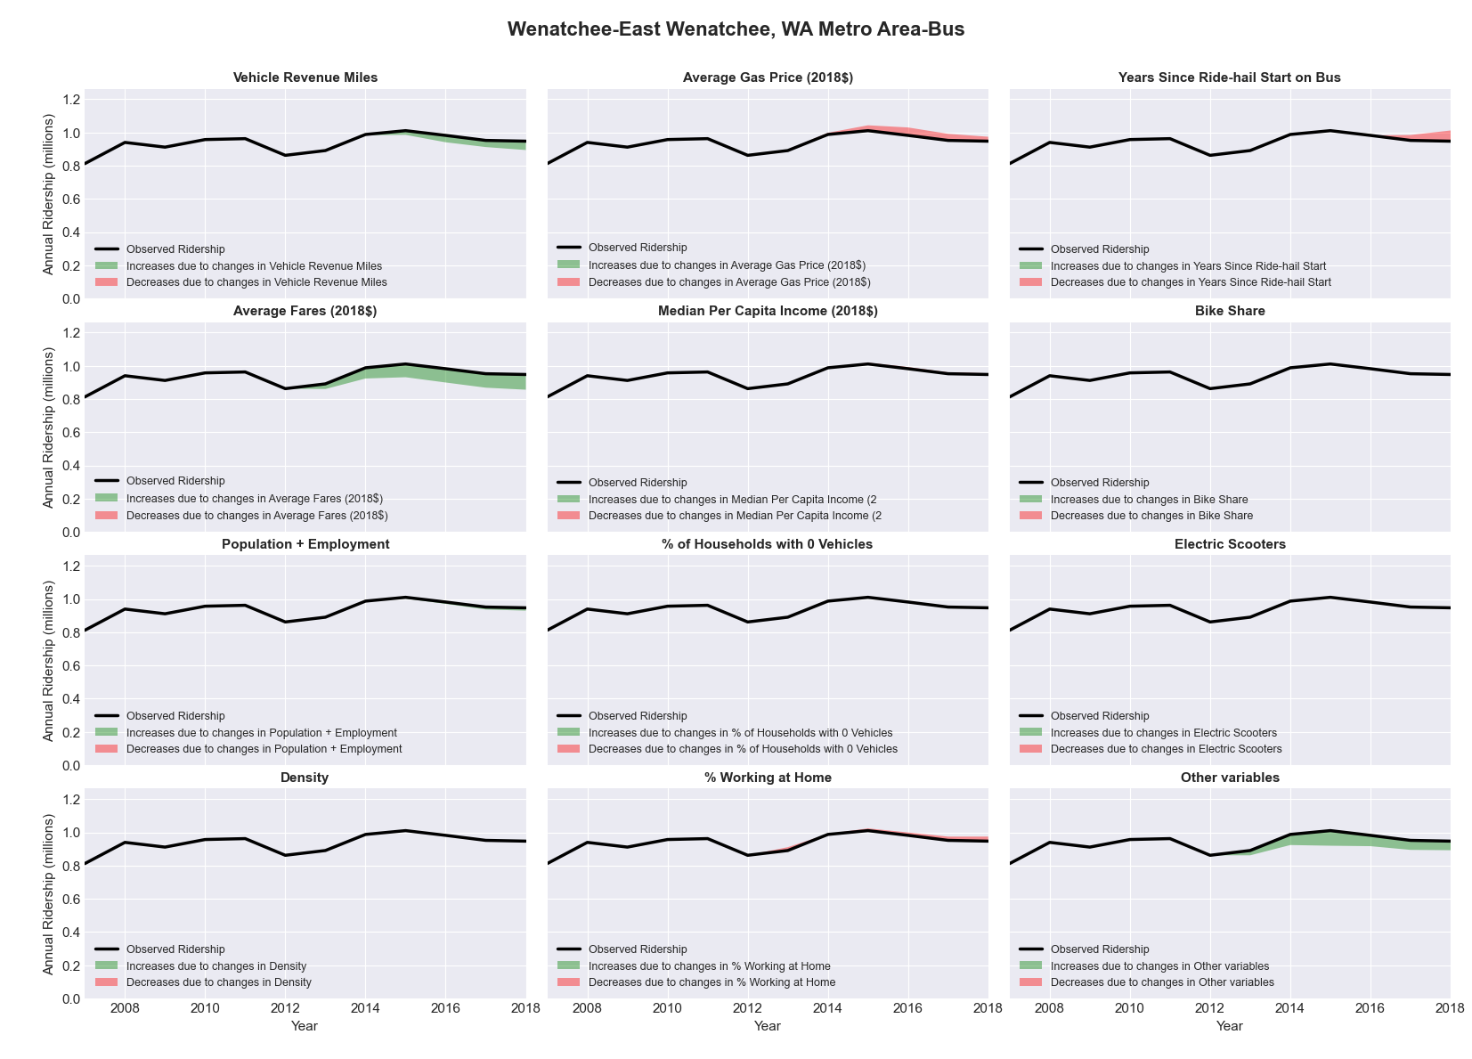

|  |  |  |  |  |  |  |
| --- | --- | --- | --- | --- | --- | --- |
| Wheeling, WV-OH Metro Area-Bus | | | | | | |
|  |  |  |  |  |  | |
|  | **Average Values** | | | **Ridership Effect** | | |
| **Description** | **2012** | **2018** | **% Diff** | **Absolute** | **% Diff** | |
|  |  |  |  |  |  | |
| **Vehicle Revenue Miles** | 701,920 | 717,450 | 2.2% | 4,420 | | **1.1%** | |
| **Average Fare (2018$)** | 1.04 | 1.12 | 7.9% | -9,100 | | **-2.2%** | |
| **Network Restructure** | - | - | - | - | | **0.0%** | |
| **Major Maintenance Event** | - | - | - | - | | **0.0%** | |
| **Population + Employment** | 208,690 | 200,770 | -3.8% | -3,350 | | **-0.8%** | |
| **Share of Population and Employment in Transit Supportive Density** | 0.24 | 0.24 | 0.3% | 0,100 | | **0.0%** | |
| **Average Gas Price (2018$)** | 3.93 | 2.72 | -30.9% | -17,590 | | **-4.3%** | |
| **Median Per Capita Income (2018$)** | 23,480 | 27,130 | 15.5% | -4,090 | | **-1.0%** | |
| **% of Households with 0 Vehicles** | 10 | 6 | -40.2% | -3,110 | | **-0.8%** | |
| **% Working at Home** | 2.8 | 2.4 | -14.3% | 0,950 | | **0.2%** | |
| **Years Since Ride-hail Start** | - | 1 | 1 | -12,190 | | **-3.0%** | |
| **Bike Share** | - | - | - | - | | **0.0%** | |
| **Electric Scooters** | - | - | - | - | | **0.0%** | |
| **New Reporters** |  |  |  | - | | **0.0%** | |
| **Total Modeled Ridership** | 411,860 | 368,675 | -10.49% | -43185.40464 | | **-10.5%** | |
| **Total Observed Ridership** | 413,551 | 353,457 | -14.53% | -60094 | | **-14.5%** | |
| **Unexplained Change** |  |  |  |  | | **-4.0%** | |

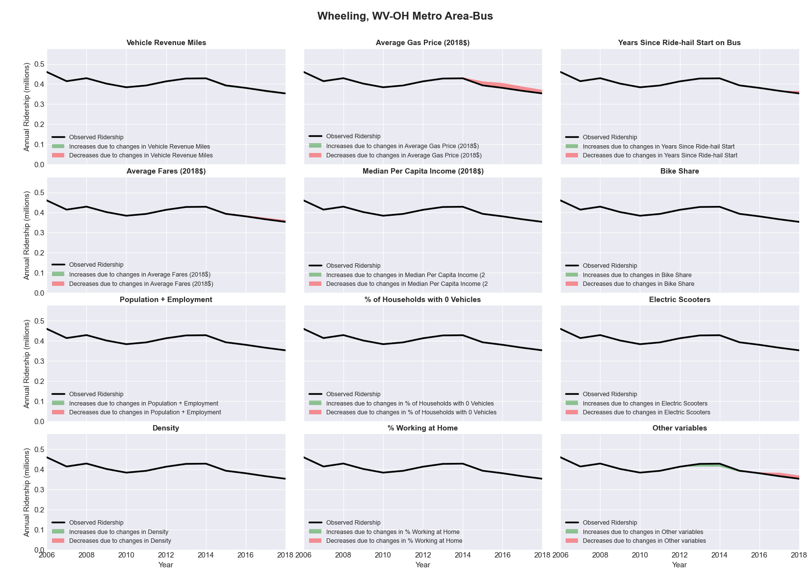

|  |  |  |  |  |  |  |
| --- | --- | --- | --- | --- | --- | --- |
| Wichita, KS Metro Area-Bus | | | | | | |
|  |  |  |  |  |  | |
|  | **Average Values** | | | **Ridership Effect** | | |
| **Description** | **2012** | **2018** | **% Diff** | **Absolute** | **% Diff** | |
|  |  |  |  |  |  | |
| **Vehicle Revenue Miles** | 1,519,830 | 1,800,240 | 18.5% | 119,650 | | **7.1%** | |
| **Average Fare (2018$)** | 1.02 | 0.92 | -9.8% | 11,680 | | **0.7%** | |
| **Network Restructure** | - | - | - | - | | **0.0%** | |
| **Major Maintenance Event** | - | - | - | - | | **0.0%** | |
| **Population + Employment** | 914,890 | 940,320 | 2.8% | 11,140 | | **0.7%** | |
| **Share of Population and Employment in Transit Supportive Density** | 0.14 | 0.14 | -2.4% | -2,540 | | **-0.2%** | |
| **Average Gas Price (2018$)** | 3.93 | 2.72 | -30.9% | -86,150 | | **-5.1%** | |
| **Median Per Capita Income (2018$)** | 28,750 | 29,190 | 1.5% | -4,020 | | **-0.2%** | |
| **% of Households with 0 Vehicles** | 6 | 6 | 11.2% | 2,080 | | **0.1%** | |
| **% Working at Home** | 3.4 | 2.9 | -15.4% | 4,030 | | **0.2%** | |
| **Years Since Ride-hail Start** | - | 4 | 4 | -207,810 | | **-12.3%** | |
| **Bike Share** | - | 1 | 1 | - 13,310 | | **-0.8%** | |
| **Electric Scooters** | - | - | - | - | | **0.0%** | |
| **New Reporters** |  |  |  | - | | **0.0%** | |
| **Total Modeled Ridership** | 1,687,716 | 1,570,300 | -6.96% | -117416.2052 | | **-7.0%** | |
| **Total Observed Ridership** | 1,933,525 | 1,421,737 | -26.47% | -511788 | | **-26.5%** | |
| **Unexplained Change** |  |  |  |  | | **-19.5%** | |

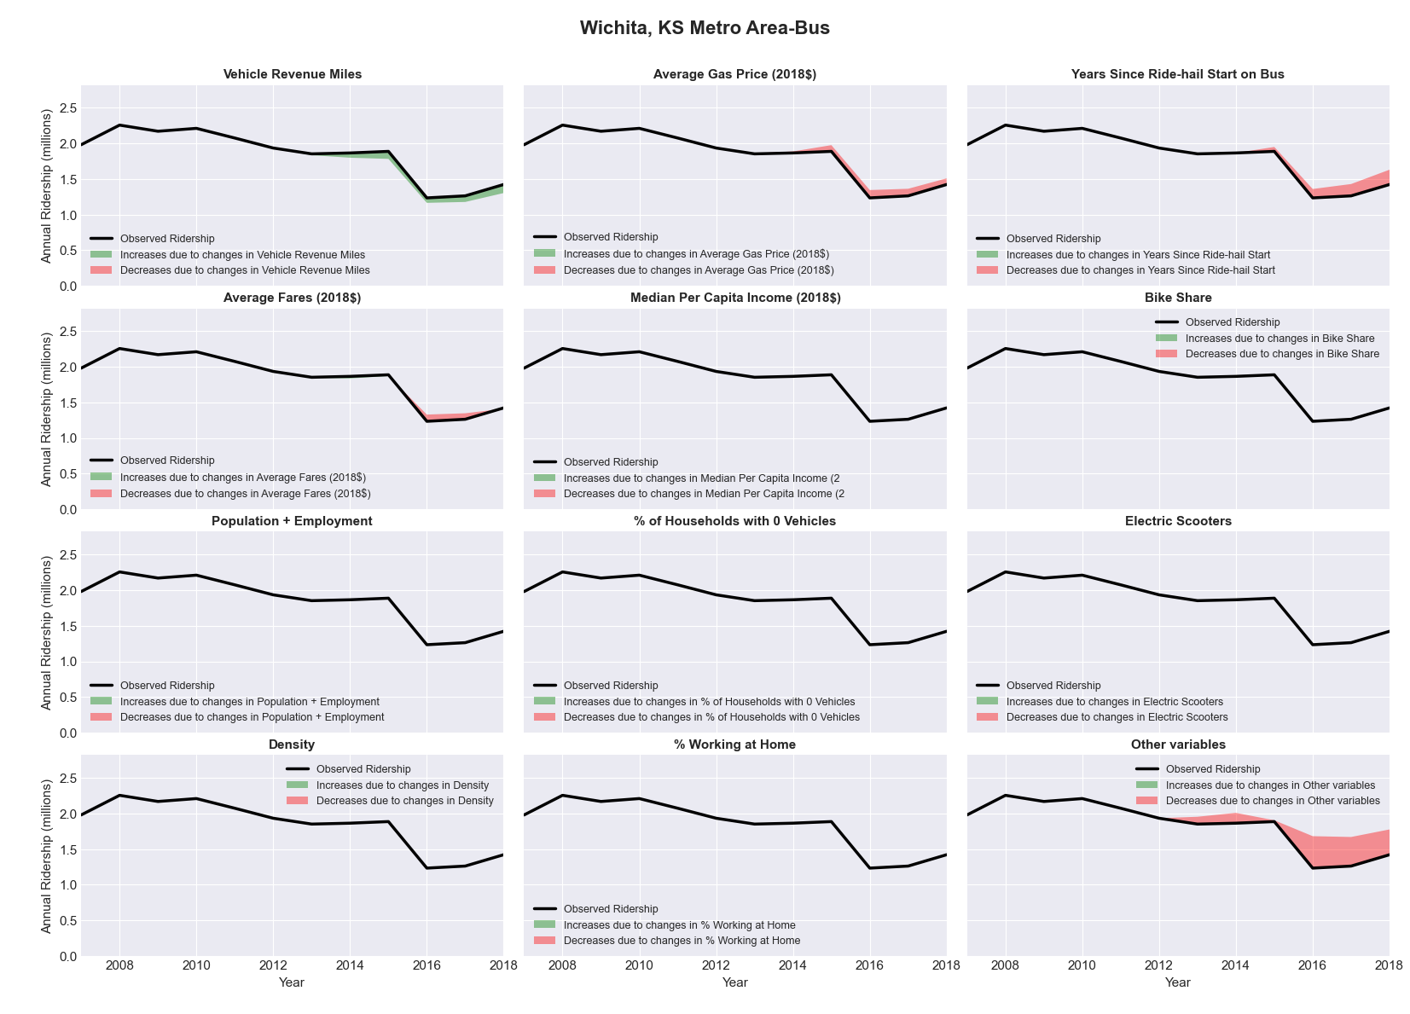

|  |  |  |  |  |  |  |
| --- | --- | --- | --- | --- | --- | --- |
| Williamsport, PA Metro Area-Bus | | | | | | |
|  |  |  |  |  |  | |
|  | **Average Values** | | | **Ridership Effect** | | |
| **Description** | **2012** | **2018** | **% Diff** | **Absolute** | **% Diff** | |
|  |  |  |  |  |  | |
| **Vehicle Revenue Miles** | 826,820 | 992,430 | 20.0% | 108,730 | | **8.2%** | |
| **Average Fare (2018$)** | 0.68 | 0.62 | -8.6% | 28,450 | | **2.1%** | |
| **Network Restructure** | - | - | - | - | | **0.0%** | |
| **Major Maintenance Event** | - | - | - | - | | **0.0%** | |
| **Population + Employment** | 174,980 | 166,050 | -5.1% | -14,880 | | **-1.1%** | |
| **Share of Population and Employment in Transit Supportive Density** | 0.19 | 0.20 | 4.4% | 4,210 | | **0.3%** | |
| **Average Gas Price (2018$)** | 4.11 | 2.92 | -28.9% | -49,800 | | **-3.7%** | |
| **Median Per Capita Income (2018$)** | 26,340 | 26,410 | 0.3% | 0,260 | | **0.0%** | |
| **% of Households with 0 Vehicles** | 8 | 4 | -53.5% | -10,900 | | **-0.8%** | |
| **% Working at Home** | 2.4 | 4.7 | 95.8% | -22,770 | | **-1.7%** | |
| **Years Since Ride-hail Start** | - | 2 | 2 | -85,780 | | **-6.4%** | |
| **Bike Share** | - | - | - | - | | **0.0%** | |
| **Electric Scooters** | - | - | - | - | | **0.0%** | |
| **New Reporters** |  |  |  | - | | **0.0%** | |
| **Total Modeled Ridership** | 1,333,356 | 1,284,354 | -3.68% | -49002.75855 | | **-3.7%** | |
| **Total Observed Ridership** | 1,385,824 | 1,312,783 | -5.27% | -73041 | | **-5.3%** | |
| **Unexplained Change** |  |  |  |  | | **-1.6%** | |

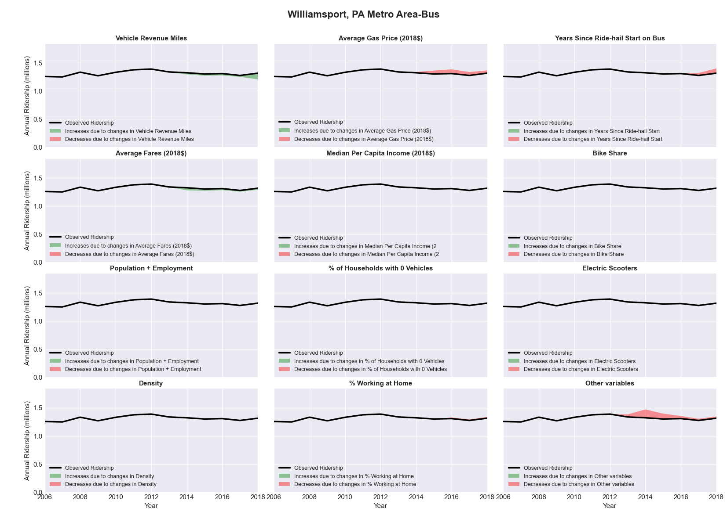

|  |  |  |  |  |  |  |
| --- | --- | --- | --- | --- | --- | --- |
| Winston-Salem, NC Metro Area-Bus | | | | | | |
|  |  |  |  |  |  | |
|  | **Average Values** | | | **Ridership Effect** | | |
| **Description** | **2012** | **2018** | **% Diff** | **Absolute** | **% Diff** | |
|  |  |  |  |  |  | |
| **Vehicle Revenue Miles** | 1,323,070 | 1,878,220 | 42.0% | 375,750 | | **14.7%** | |
| **Average Fare (2018$)** | 0.60 | 0.53 | -11.5% | 46,920 | | **1.8%** | |
| **Network Restructure** | - | - | - | - | | **0.0%** | |
| **Major Maintenance Event** | - | - | - | - | | **0.0%** | |
| **Population + Employment** | 700,030 | 910,110 | 30.0% | 169,460 | | **6.6%** | |
| **Share of Population and Employment in Transit Supportive Density** | 0.10 | 0.08 | -13.2% | -15,630 | | **-0.6%** | |
| **Average Gas Price (2018$)** | 3.95 | 2.71 | -31.3% | -125,600 | | **-4.9%** | |
| **Median Per Capita Income (2018$)** | 25,660 | 28,850 | 12.4% | -21,350 | | **-0.8%** | |
| **% of Households with 0 Vehicles** | 7 | 6 | -15.8% | -5,560 | | **-0.2%** | |
| **% Working at Home** | 4.2 | 4.9 | 16.7% | -13,170 | | **-0.5%** | |
| **Years Since Ride-hail Start** | - | 4 | 4 | -337,470 | | **-13.2%** | |
| **Bike Share** | - | 1 | 1 | - 27,230 | | **-1.1%** | |
| **Electric Scooters** | - | - | - | - | | **0.0%** | |
| **New Reporters** |  |  |  | - | | **0.0%** | |
| **Total Modeled Ridership** | 2,560,545 | 2,643,571 | 3.24% | 83025.81762 | | **3.2%** | |
| **Total Observed Ridership** | 2,968,748 | 2,133,710 | -28.13% | -835038 | | **-28.1%** | |
| **Unexplained Change** |  |  |  |  | | **-31.4%** | |

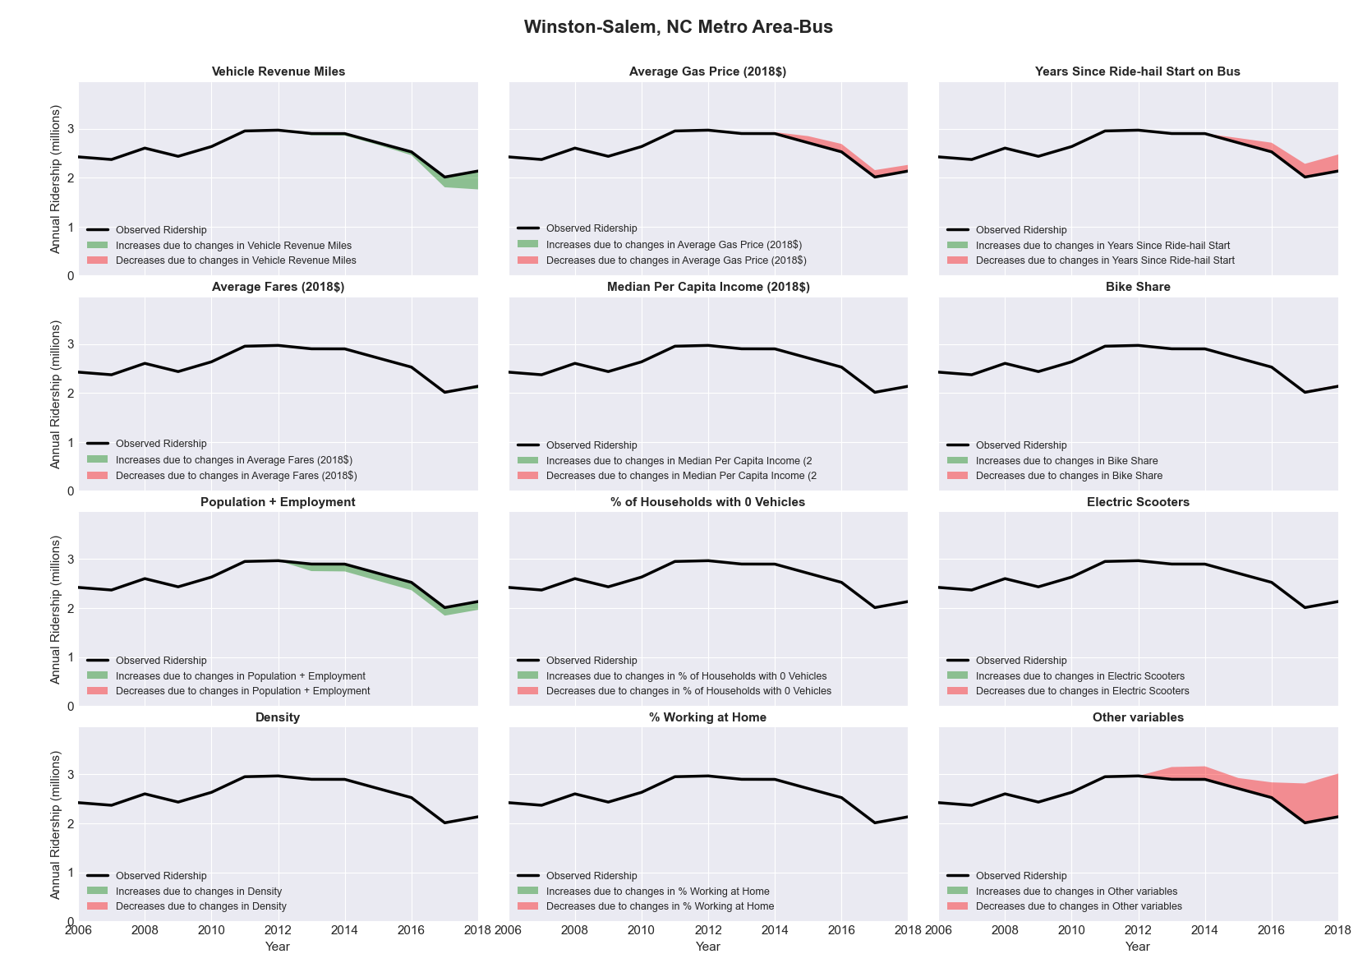

|  |  |  |  |  |  |  |
| --- | --- | --- | --- | --- | --- | --- |
| Worcester, MA Metro Area-Bus | | | | | | |
|  |  |  |  |  |  | |
|  | **Average Values** | | | **Ridership Effect** | | |
| **Description** | **2012** | **2018** | **% Diff** | **Absolute** | **% Diff** | |
|  |  |  |  |  |  | |
| **Vehicle Revenue Miles** | 2,158,540 | 2,596,170 | 20.3% | 331,200 | | **8.5%** | |
| **Average Fare (2018$)** | 1.11 | 1.02 | -7.7% | 103,970 | | **2.7%** | |
| **Network Restructure** | - | - | - | - | | **0.0%** | |
| **Major Maintenance Event** | - | - | - | - | | **0.0%** | |
| **Population + Employment** | 1,194,130 | 1,380,880 | 15.6% | 124,430 | | **3.2%** | |
| **Share of Population and Employment in Transit Supportive Density** | 0.11 | 0.12 | 4.1% | 8,050 | | **0.2%** | |
| **Average Gas Price (2018$)** | 4.13 | 2.85 | -31.0% | -179,640 | | **-4.6%** | |
| **Median Per Capita Income (2018$)** | 33,210 | 34,200 | 3.0% | -9,860 | | **-0.3%** | |
| **% of Households with 0 Vehicles** | 9 | 11 | 21.6% | 15,810 | | **0.4%** | |
| **% Working at Home** | 3.7 | 6.3 | 68.9% | -79,600 | | **-2.1%** | |
| **Years Since Ride-hail Start** | - | 4 | 4 | -549,740 | | **-14.2%** | |
| **Bike Share** | - | - | - | - | | **0.0%** | |
| **Electric Scooters** | - | - | - | - | | **0.0%** | |
| **New Reporters** |  |  |  | - | | **0.0%** | |
| **Total Modeled Ridership** | 3,875,233 | 3,672,948 | -5.22% | -202285.2878 | | **-5.2%** | |
| **Total Observed Ridership** | 3,834,744 | 3,373,789 | -12.02% | -460955 | | **-12.0%** | |
| **Unexplained Change** |  |  |  |  | | **-6.8%** | |

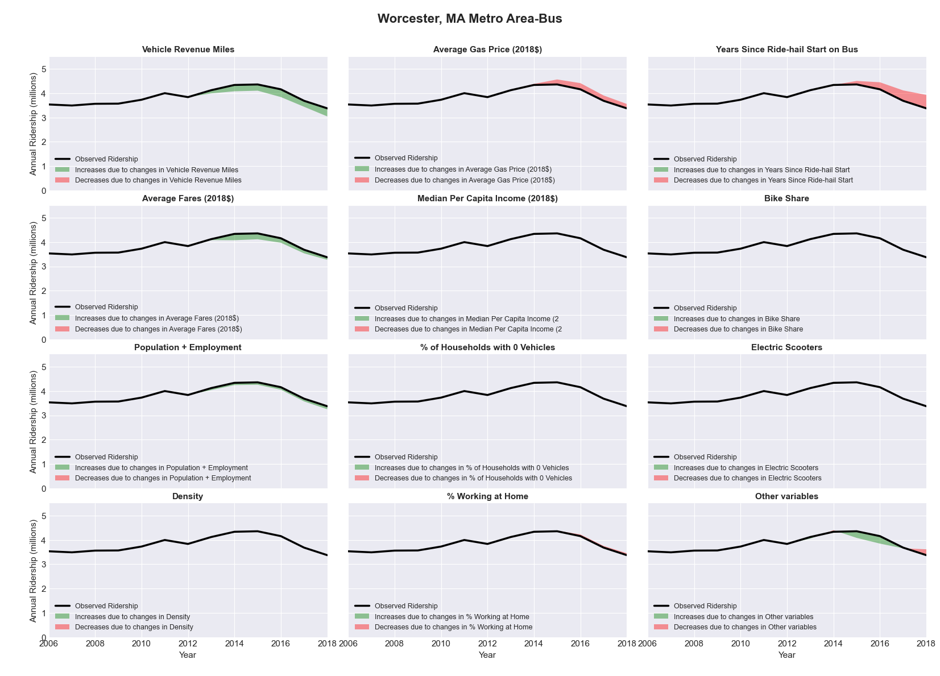

|  |  |  |  |  |  |  |
| --- | --- | --- | --- | --- | --- | --- |
| York-Hanover, PA Metro Area-Bus | | | | | | |
|  |  |  |  |  |  | |
|  | **Average Values** | | | **Ridership Effect** | | |
| **Description** | **2012** | **2018** | **% Diff** | **Absolute** | **% Diff** | |
|  |  |  |  |  |  | |
| **Vehicle Revenue Miles** | 1,838,860 | 1,677,010 | -8.8% | -74,370 | | **-4.1%** | |
| **Average Fare (2018$)** | 1.15 | 1.14 | -1.2% | 7,090 | | **0.4%** | |
| **Network Restructure** | - | - | - | - | | **0.0%** | |
| **Major Maintenance Event** | - | - | - | - | | **0.0%** | |
| **Population + Employment** | 653,750 | 672,990 | 2.9% | 10,570 | | **0.6%** | |
| **Share of Population and Employment in Transit Supportive Density** | 0.17 | 0.18 | 4.2% | 4,850 | | **0.3%** | |
| **Average Gas Price (2018$)** | 4.11 | 2.92 | -28.9% | -62,880 | | **-3.5%** | |
| **Median Per Capita Income (2018$)** | 30,530 | 32,730 | 7.2% | -7,940 | | **-0.4%** | |
| **% of Households with 0 Vehicles** | 6 | 7 | 12.7% | 2,460 | | **0.1%** | |
| **% Working at Home** | 3.1 | 4.5 | 44.4% | -17,380 | | **-1.0%** | |
| **Years Since Ride-hail Start** | - | 2 | 2 | -108,100 | | **-5.9%** | |
| **Bike Share** | - | 1 | 1 | - 17,780 | | **-1.0%** | |
| **Electric Scooters** | - | - | - | - | | **0.0%** | |
| **New Reporters** |  |  |  | - | | **0.0%** | |
| **Total Modeled Ridership** | 1,817,743 | 1,550,720 | -14.69% | -267023.6695 | | **-14.7%** | |
| **Total Observed Ridership** | 1,812,077 | 1,632,435 | -9.91% | -179642 | | **-9.9%** | |
| **Unexplained Change** |  |  |  |  | | **4.8%** | |

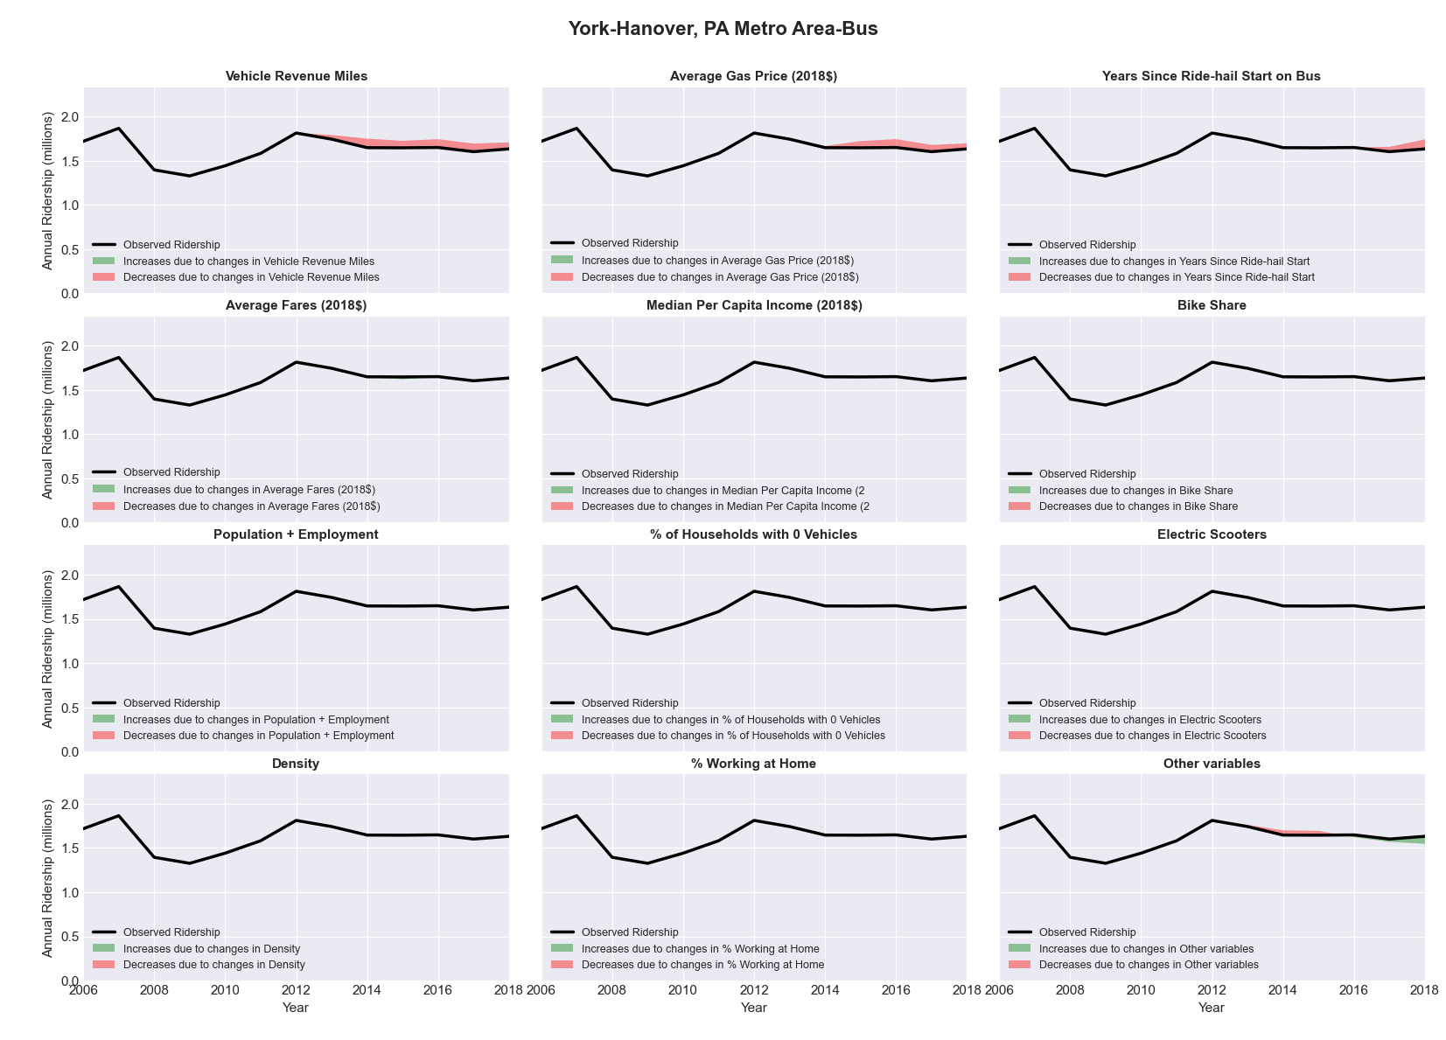

|  |  |  |  |  |  |  |
| --- | --- | --- | --- | --- | --- | --- |
| Youngstown-Warren-Boardman, OH-PA Metro Area-Bus | | | | | | |
|  |  |  |  |  |  | |
|  | **Average Values** | | | **Ridership Effect** | | |
| **Description** | **2012** | **2018** | **% Diff** | **Absolute** | **% Diff** | |
|  |  |  |  |  |  | |
| **Vehicle Revenue Miles** | 1,001,750 | 1,319,290 | 31.7% | 180,120 | | **12.8%** | |
| **Average Fare (2018$)** | 0.70 | 0.62 | -11.1% | 38,860 | | **2.8%** | |
| **Network Restructure** | - | - | - | - | | **0.0%** | |
| **Major Maintenance Event** | - | - | - | - | | **0.0%** | |
| **Population + Employment** | 796,260 | 765,380 | -3.9% | -12,570 | | **-0.9%** | |
| **Share of Population and Employment in Transit Supportive Density** | 0.04 | 0.04 | -7.9% | -1,940 | | **-0.1%** | |
| **Average Gas Price (2018$)** | 4.11 | 2.92 | -28.9% | -57,690 | | **-4.1%** | |
| **Median Per Capita Income (2018$)** | 23,700 | 26,490 | 11.8% | -11,560 | | **-0.8%** | |
| **% of Households with 0 Vehicles** | 8 | 9 | 8.4% | 1,520 | | **0.1%** | |
| **% Working at Home** | 3.0 | 2.8 | -6.7% | 1,430 | | **0.1%** | |
| **Years Since Ride-hail Start** | - | 2 | 2 | -96,680 | | **-6.9%** | |
| **Bike Share** | - | - | - | - | | **0.0%** | |
| **Electric Scooters** | - | - | - | - | | **0.0%** | |
| **New Reporters** |  |  |  | - | | **0.0%** | |
| **Total Modeled Ridership** | 1,403,076 | 1,446,656 | 3.11% | 43580.2662 | | **3.1%** | |
| **Total Observed Ridership** | 1,344,315 | 1,406,727 | 4.64% | 62412 | | **4.6%** | |
| **Unexplained Change** |  |  |  |  | | **1.5%** | |

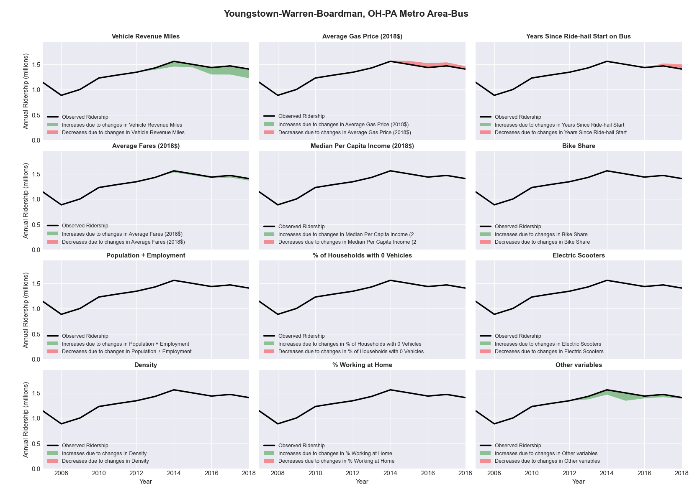

|  |  |  |  |  |  |  |
| --- | --- | --- | --- | --- | --- | --- |
| Yuba City, CA Metro Area-Bus | | | | | | |
|  |  |  |  |  |  | |
|  | **Average Values** | | | **Ridership Effect** | | |
| **Description** | **2012** | **2018** | **% Diff** | **Absolute** | **% Diff** | |
|  |  |  |  |  |  | |
| **Vehicle Revenue Miles** | 1,001,750 | 1,319,290 | 31.7% | 180,120 | | **12.8%** | |
| **Average Fare (2018$)** | 0.70 | 0.62 | -11.1% | 38,860 | | **2.8%** | |
| **Network Restructure** | - | - | - | - | | **0.0%** | |
| **Major Maintenance Event** | - | - | - | - | | **0.0%** | |
| **Population + Employment** | 796,260 | 765,380 | -3.9% | -12,570 | | **-0.9%** | |
| **Share of Population and Employment in Transit Supportive Density** | 0.04 | 0.04 | -7.9% | -1,940 | | **-0.1%** | |
| **Average Gas Price (2018$)** | 4.11 | 2.92 | -28.9% | -57,690 | | **-4.1%** | |
| **Median Per Capita Income (2018$)** | 23,700 | 26,490 | 11.8% | -11,560 | | **-0.8%** | |
| **% of Households with 0 Vehicles** | 8 | 9 | 8.4% | 1,520 | | **0.1%** | |
| **% Working at Home** | 3.0 | 2.8 | -6.7% | 1,430 | | **0.1%** | |
| **Years Since Ride-hail Start** | - | 2 | 2 | -96,680 | | **-6.9%** | |
| **Bike Share** | - | - | - | - | | **0.0%** | |
| **Electric Scooters** | - | - | - | - | | **0.0%** | |
| **New Reporters** |  |  |  | - | | **0.0%** | |
| **Total Modeled Ridership** | 1,403,076 | 1,446,656 | 3.11% | 43580.2662 | | **3.1%** | |
| **Total Observed Ridership** | 1,344,315 | 1,406,727 | 4.64% | 62412 | | **4.6%** | |
| **Unexplained Change** |  |  |  |  | | **1.5%** | |

